*Jose Collado San Pedro*

*17202360*

*Skateboard Eggfight*

# Download project

# Home Screen

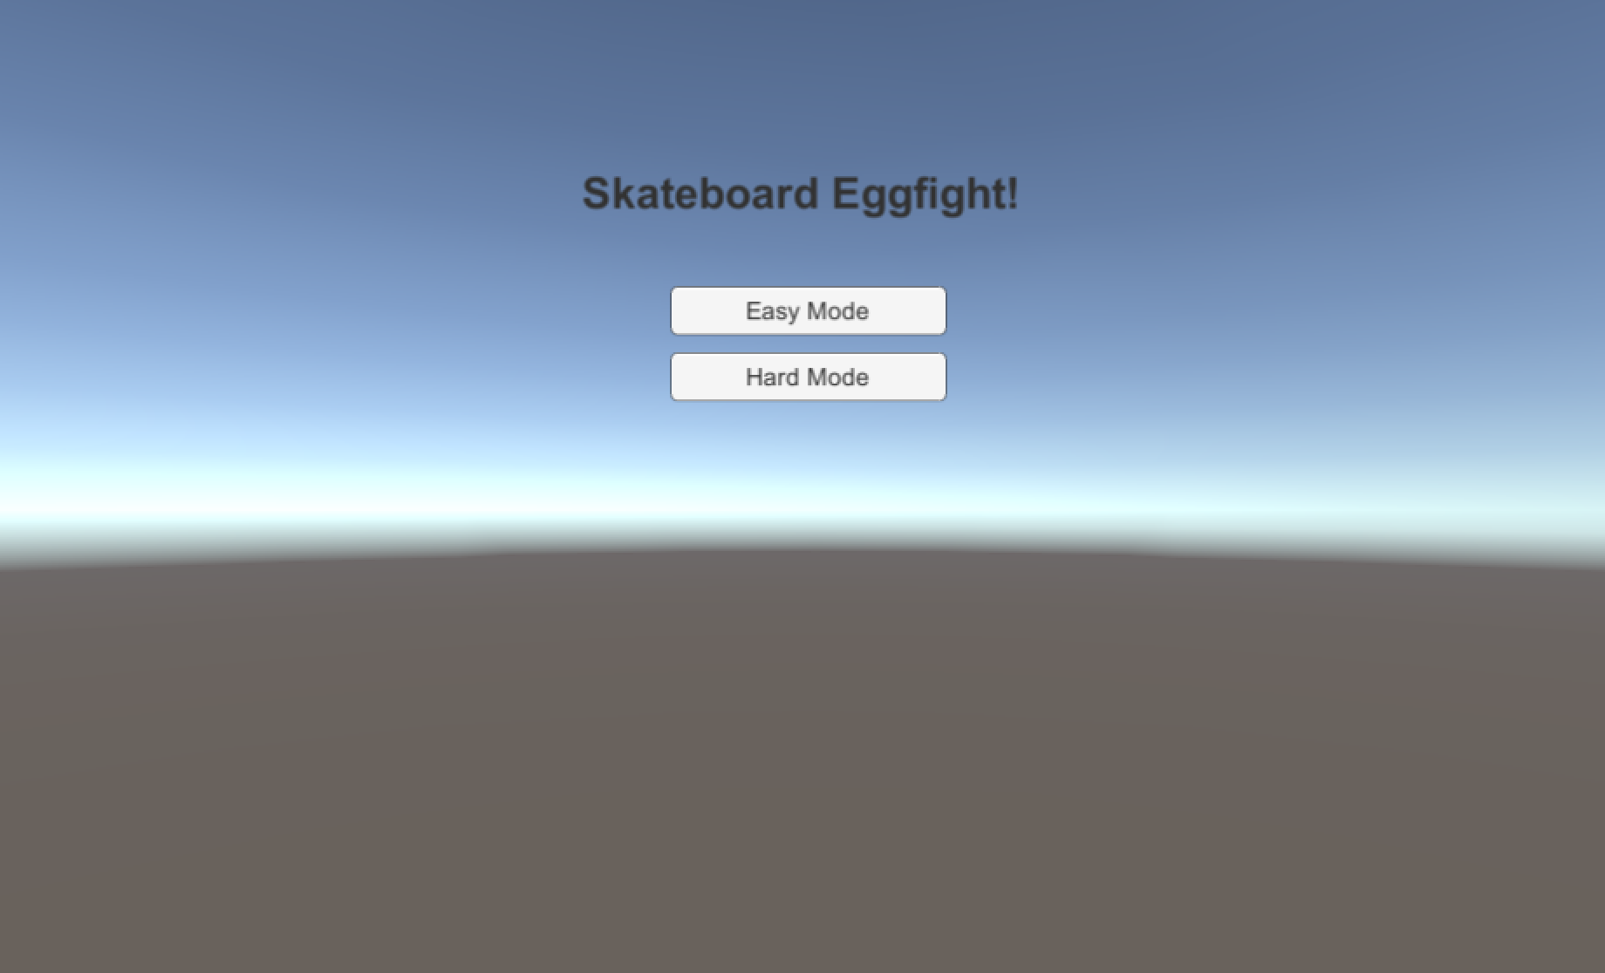

The first screen that we have when we open the game is a very basic screen with 2 buttons that allows the user to select the difficulty of the game.

Easy mode provides the player with 20 eggs and the enemy throws an egg every 6 seconds. The hard mode only provides 10 eggs and the spawn rate is 3 seconds.

# Game Screen

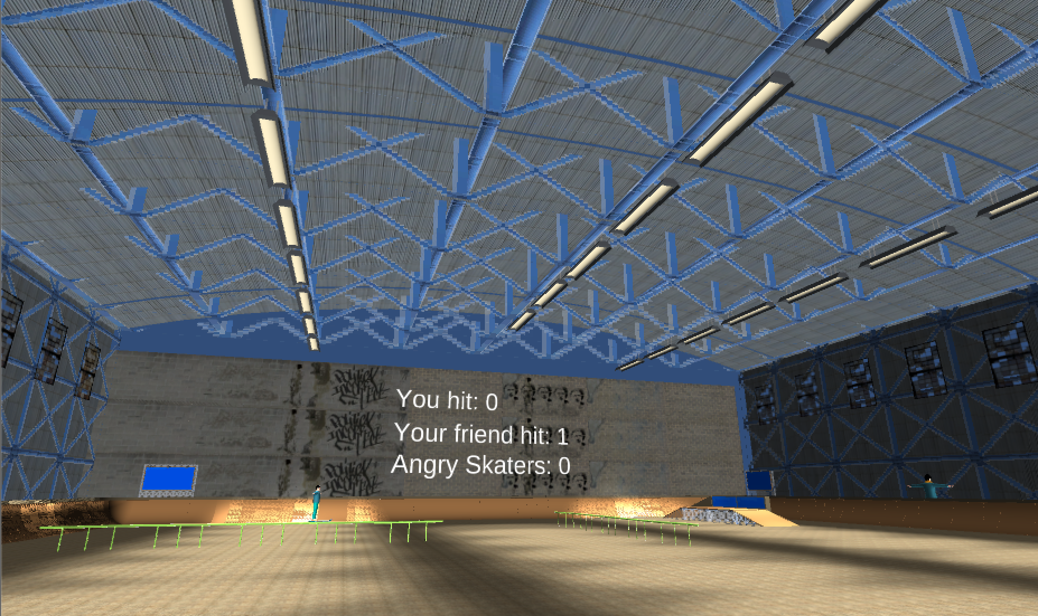

In the screen game we can see 3 texts displaying the information of the game (eggs you hit to your friend, eggs that your friend hit you and the eggs you hit to other skaters that aren’t your friend). Your friend is the character with blue t-shirt and blue jeans. He also tries to hit you with eggs.

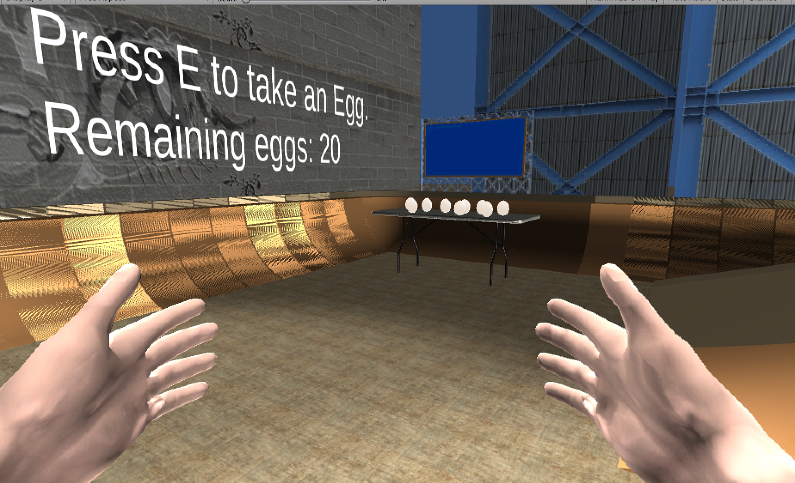

This is the place where the eggs are. You can take one going close to the table and pressing E. When you take one, it appears close to your hand and you can throw it pressing the left button of the mouse.

The game has sound when the player moves with the skate and when it jumps with the space bar.

# End Game Screen

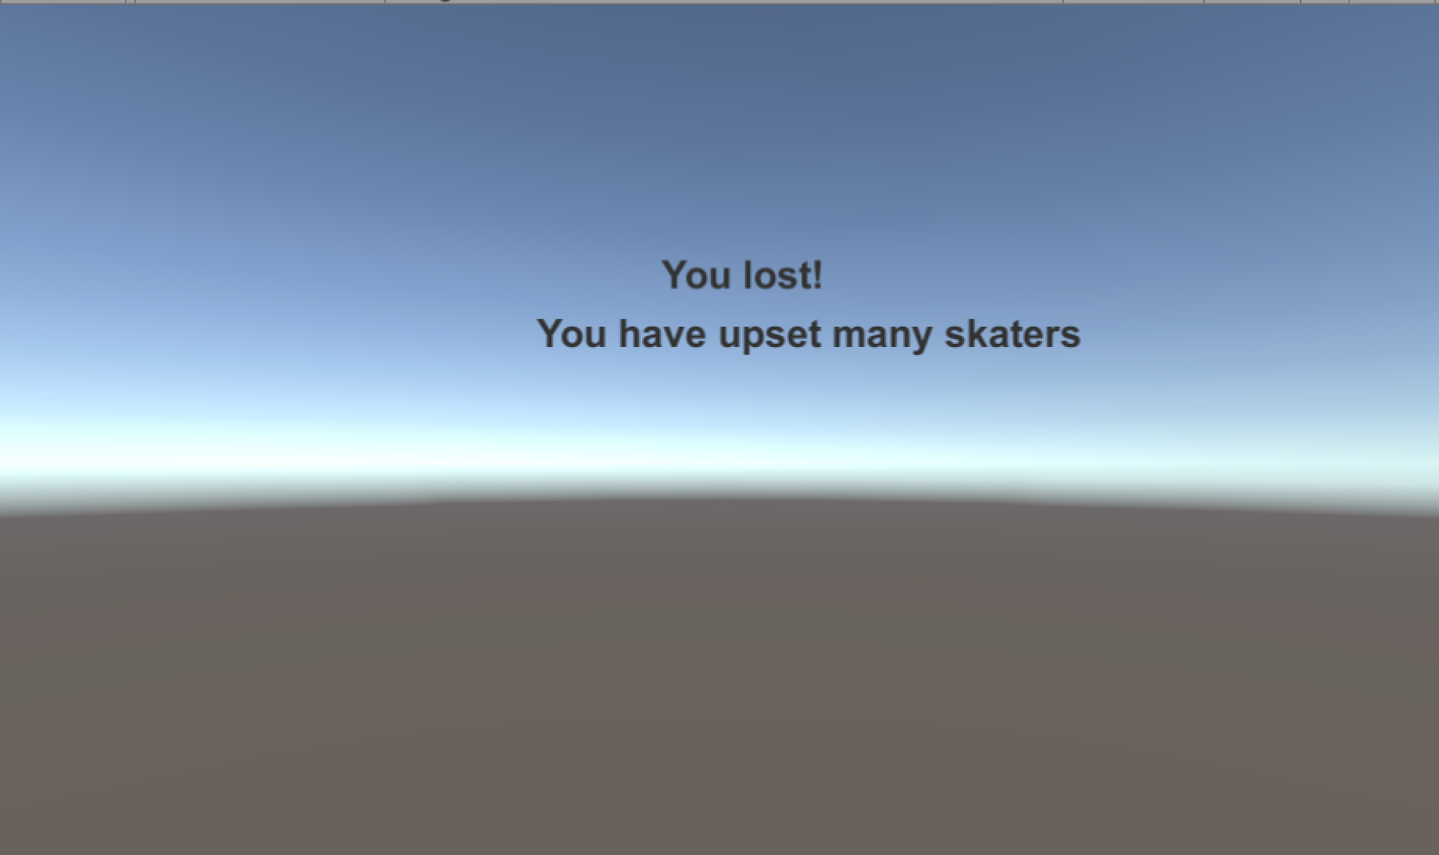

This is the last screen of the game. It shows if you won or lost and the reason.

You can lose if you run out of eggs and you friend hit more eggs than you, if you hit 5 times the other skaters or if you collide with your friend. You won if you run out of eggs but you hit more eggs than your friend.