Guangzhou HC Information Technology Co., Ltd.

Product Data Sheet

Module Data Sheet

Rev 1
1．0 | 1.01
2010/5/15 | 2011/4/6

DRAWN BY : | Ling Xin |  | MODEL :  HC-05
CHECKED BY : | Eric Huang |  | Description:  BC04 has external 8M Flash and EDR mode  HC-03 is industrial, and compatible with civil HC-05
APPD. BY： | Simon Mok |  | REV : 2.0 | PAGES:
Former version introduction | Linvaor is the former of Wavesen.

Contents
1. Product’s picture
2. Feature
3. Pins description
4. The parameters and mode of product
5. Block diagram
6. Debugging device
7. Characteristic of test
8. Test diagram
9. AT command set

1.Product’s picture
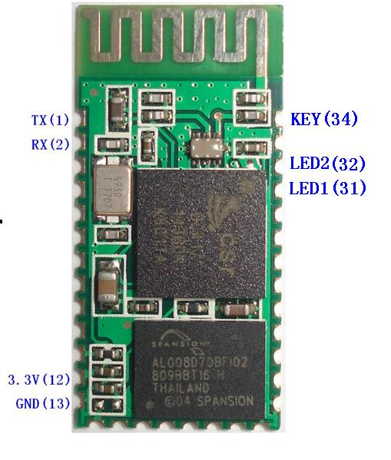
Figure 1. A Bluetooth module

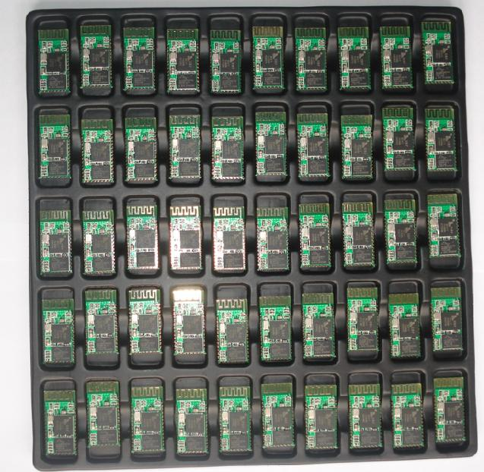
Figure 2 50 pieces chips in an anti-static blister package

2. Feature
- Wireless transceiver
  - Sensitivity (Bit error rate) can reach -80dBm.
  - The change range of output’s power: -4 - +6dBm.
- Function description (perfect Bluetooth solution)
- Has an EDR module; and the change range of modulation depth: 2Mbps - 3Mbps.
- Has a build-in 2.4GHz antenna; user needn’t test antenna.
- Has the external 8Mbit FLASH
- Can work at the low voltage (3.1V~4.2V). The current in pairing is in the range of 30～40mA. The current in communication is 8mA.
- PIO control can be switched.
- Has the standard HCI Port (UART or USB)
- The USB protocol is Full Speed USB1.1, and compliant with 2.0.
- This module can be used in the SMD.
- It’s made through RoHS process.
- The board PIN is half hole size.
- Has a 2.4GHz digital wireless transceiver.
- Bases at CSR BC04 Bluetooth technology.
- Has the function of adaptive frequency hopping.
- Small (27mm×13mm×2mm).
- Peripheral circuit is simple.
- It’s at the Bluetooth class 2 power level.
- Storage temperature range: -40 ℃ - 85℃, operating temperature range: -25 ℃ - +75℃
- Any wave inter Interference: 2.4MHz，the power of emitting: 3 dBm.
- Bit error rate: 0. Only the signal decays at the transmission link, bit error may be produced. For example, when RS232 or TTL is being processed, some signals may decay.
- Low power consumption
- Has high-performance wireless transceiver system
- Low Cost
- Application fields:
- Bluetooth Car Handsfree Device
- Bluetooth GPS
- Bluetooth PCMCIA , USB Dongle
- Bluetooth Data Transfer
- Software
- CSR
3．PINs description

Figure 3 PIN configuration
The PINs at this block diagram is same as the physical one.
PIN Name | PIN # | Pad type | Description | Note
GND | 13 21 22 | VSS | Ground pot
1V8 | 14 | VDD | Integrated 1.8V (+) supply with On-chip linear regulator output within 1.7-1.9V
VCC | 12 | 3.3V
AIO0 | 9 | Bi-Directional | Programmable input/output line
AIO1 | 10 | Bi-Directional | Programmable input/output line
PIO0 | 23 | Bi-Directional  RX EN | Programmable input/output line, control output for LNA(if fitted)
PIO1 | 24 | Bi-Directional  TX EN | Programmable input/output line, control output for PA(if fitted)
PIO2 | 25 | Bi-Directional | Programmable input/output line
PIO3 | 26 | Bi-Directional | Programmable input/output line
PIO4 | 27 | Bi-Directional | Programmable input/output line
PIO5 | 28 | Bi-Directional | Programmable input/output line
PIO6 | 29 | Bi-Directional | Programmable input/output line | CLK_REQ
PIO7 | 30 | Bi-Directional | Programmable input/output line | CLK_OUT
PIO8 | 31 | Bi-Directional | Programmable input/output line
PIO9 | 32 | Bi-Directional | Programmable input/output line
PIO10 | 33 | Bi-Directional | Programmable input/output line
PIO11 | 34 | Bi-Directional | Programmable input/output line
RESETB | 11 | CMOS Input with weak intemal pull-down
UART_RTS | 4 | CMOS output, tri-stable with weak internal pull-up | UART request to send, active low
UART_CTS | 3 | CMOS input with weak internal pull-down | UART clear to send, active low
UART_RX | 2 | CMOS input with weak internal pull-down | UART Data input
UART_TX | 1 | CMOS output, Tri-stable with weak internal pull-up | UART Data output
SPI_MOSI | 17 | CMOS input with weak internal pull-down | Serial peripheral interface data input
SPI_CSB | 16 | CMOS input with weak internal pull-up | Chip select for serial peripheral interface, active low
SPI_CLK | 19 | CMOS input with weak internal pull-down | Serial peripheral interface clock
SPI_MISO | 18 | CMOS input with weak internal pull-down | Serial peripheral interface data Output
USB_- | 15 | Bi-Directional
USB_+ | 20 | Bi-Directional
1.8V | 14 |  | 1.8V external power supply input | Default :  1.8V internal power supply.
PCM_CLK | 5 | Bi-Directional
PCM_OUT | 6 | CMOS output
PCM_IN | 7 | CMOS Input
PCM_SYNC | 8 | Bi-Directional

4. The parameters and mode of product
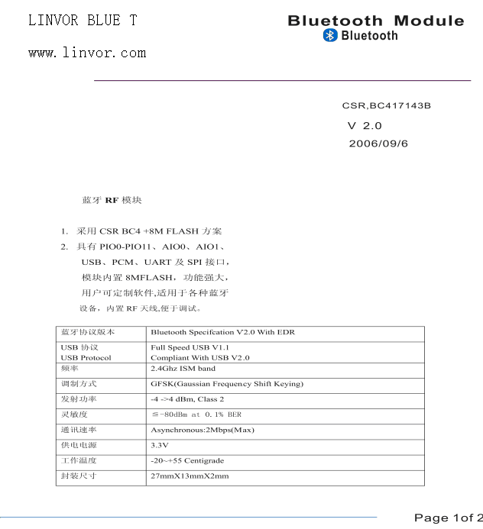
If you want more information, please visit www.wavesen.com.
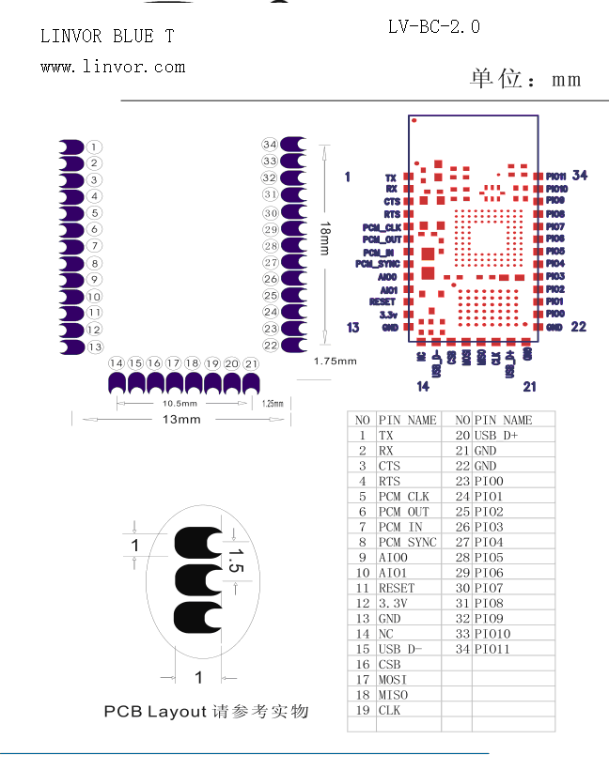
5. Block diagram
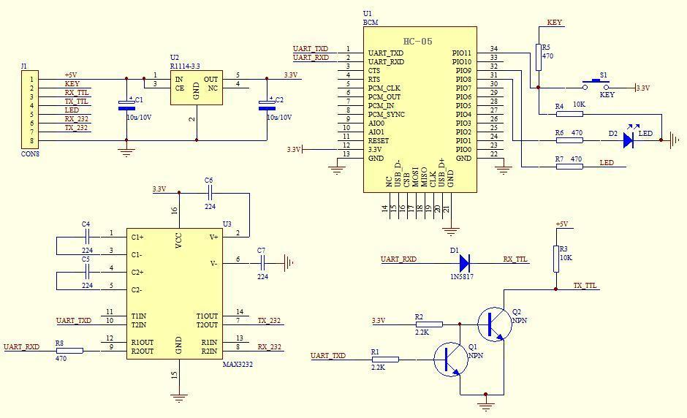
Figure 5 Block diagram

6. Debugging device
6.1 Device
PC, hardware, 3G，3G Frequency Counter (SP3386), 3.15V DC power supply, Shielding，Bluetooth Test box.
6.2 Software

7. Characteristic of test

Test Condition 25℃ RH 65%

Min Typ Max Unit
1. Carrier Freq. ( ISM Band ) 2.4 2.4835 MHz
2. RF O/P Power -6 2 4 dBm
3. Step size of Power control 2 8 dB
4. Freq. Offset ( Typical Carrier freq.) -75 75 KHz
5. Carrier Freq. drift ( Hopping on, drift rate/50uS ) -20 20 KHz
1 slot packet -25 25 KHz
3 slot packet -40 -40 KHz
6. Average Freq. Deviations ( Hopping off, modulation ) 140 175 KHz
Freq. Deviation 115 KHz
Ratio of Freq. Deviation 0.8
7 . Receive Sensitivity @< 0.1% BER( Bit error rate ) -83 dBm

8. Test diagram
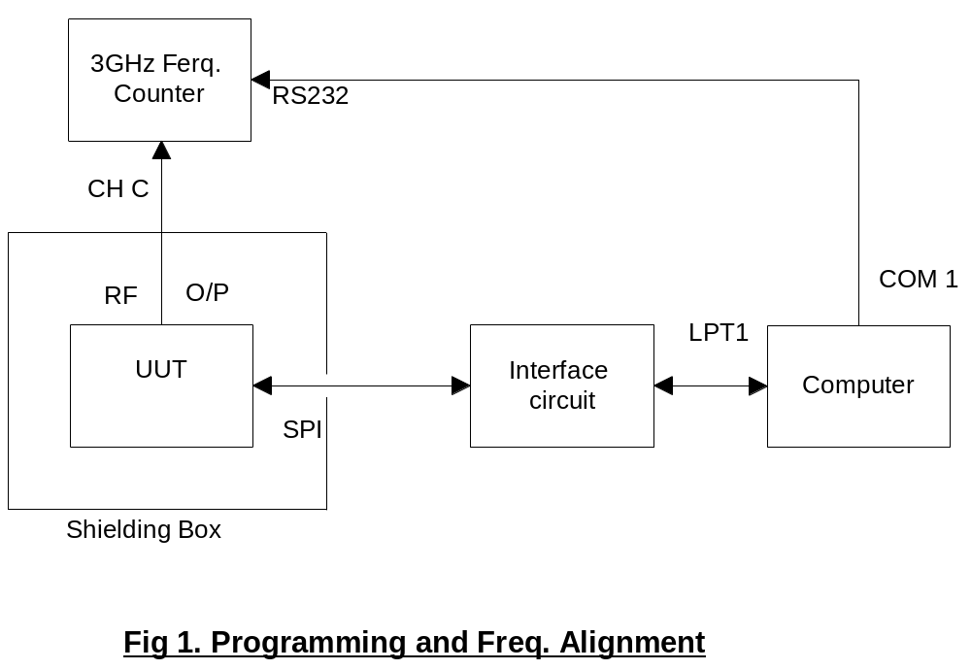

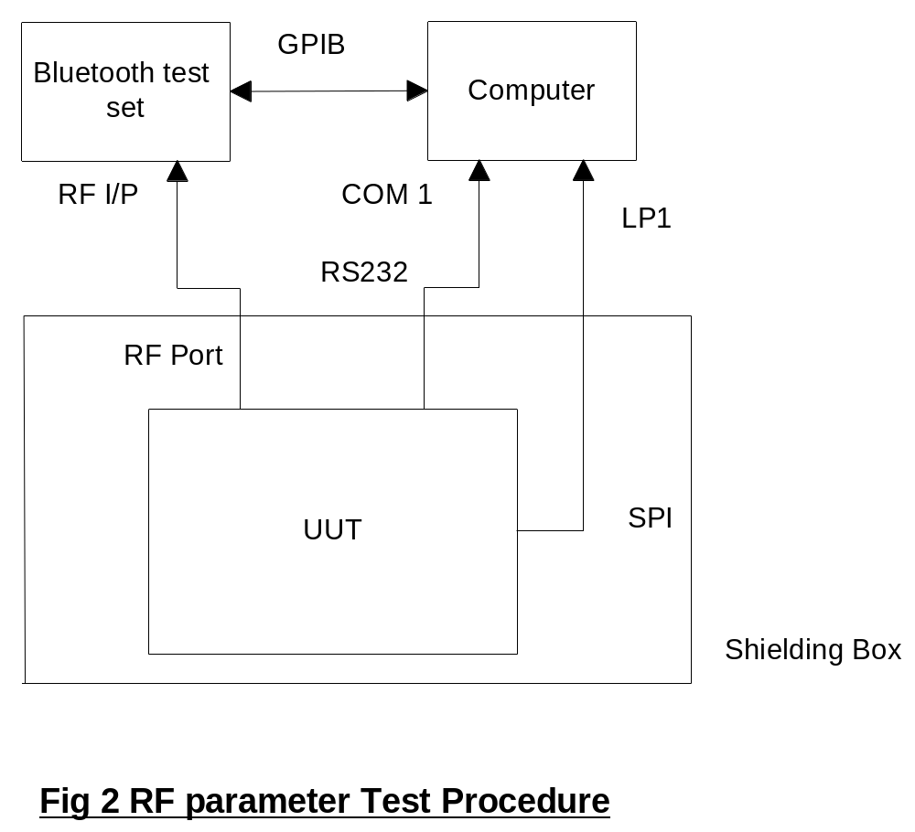
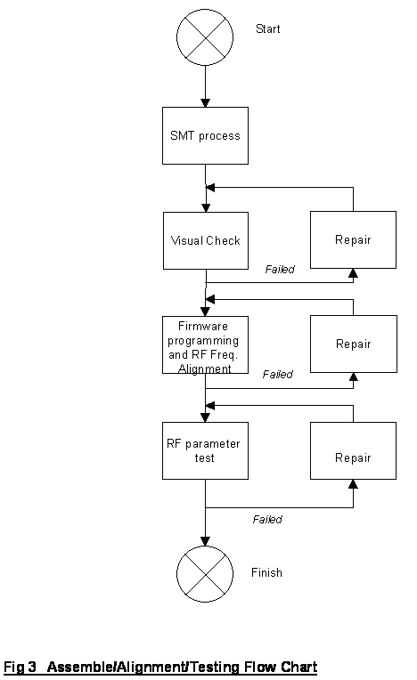

9．AT command set
More information about command set is provided at HC-05 master-salve bluetooth serial module command set.pdf. Please download it from our company website www.wavesen.com.

