**To Do**

1. Program the breadboarded microcontroller transmitter/receiver for a test of design
2. Figure out how we want to layout the parts on the protoboard
3. Put together receiver parts to find necessary dimensions for a case. Create 3D model to print from inventor
4. Cut the protoboard (7 holes wide, 14 long)

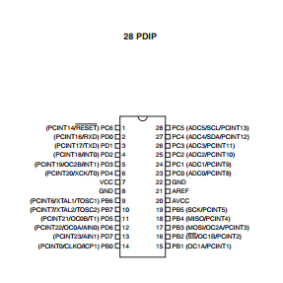

Pin 9 = XTAL1, Pin 10 = XTAL2, Pin 4 = INT0, Pin 12 = OC0A

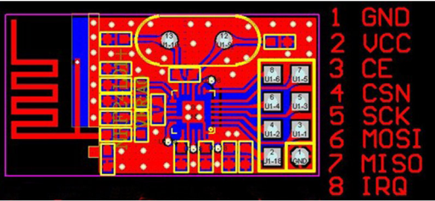Pin 7 = VCC, Pin 8 = GND, Pin 15 = OC1A, Pin 16 = OC1B, Pin 17 = MOSI, Pin 18 = MISO

1 purple/brown (tx/rx)

2 red/yellow

3 yellow/black

4 orange/green

5 green/white

6 blue/blue

7 gray/gray

8 white/purple

Setting fuse bits:

Avrdude –c USBtiny –p m328p –F -U lfuse:w:0xff:m -U hfuse:w:0xd9:m -U efuse:w:0xff:m

To Send/Receive data from the NRF module:

1. Begin with CSN Pin High.

2. Bring CSN Pin low to alert NRF that it is about to receive SPI data (keep pin low)

3. Transmit the command byte (get from data table)

Note: If you are receiving data bytes for this instruction, you must then send one byte to the 24L01 for every one byte that you wish to get out of the 24L01. If you are just sending the 24L01 data, you simply send your data bytes and generally don’t worry about what it sends back to you. When receiving data from the 24L01, it makes absolutely no difference what is contained in the data bytes you send after the command byte, just so long as you send the correct number of them.

4. Once you have transmitted and/or read all of the bytes that you need, you bring CSN back high. Finally, you can process this data in your micro at will.

Example Command:

As an example, let’s say you are going to execute the R_REGISTER instruction

on TX_ADDR register, which will read the contents of the TX address register out of the

24L01 and into your micro (more on the instruction set next). The TX_ADDR register is

5 bytes wide, and we’ll assume that you are using 5-byte addresses.

First, you would bring CSN low and then send the command byte ‘00010000’ to

the 24L01. This instructs the 24L01 that you want to read register 0x10, which is the

TX_ADDR register. Then you would send five dummy data bytes (it makes absolutely

no difference what the data bytes contain), and the 24L01 will send back to you the

contents of the TX_ADDR register. Finally, you would bring the CSN pin back high.

All totaled, you will receive six bytes. When you send any command byte, the

24L01 always returns to you the STATUS register. After that, you will have received the five bytes that are contained in the TX_ADDR register.

Register 0 = config – must set PWR UP bit or device will do nothing.

Also PRIM_RX = 1 is receiver, while 0 makes it transmitter.