Paper Task 2

Jesse Conway

4/8/2019

Upload the data:

library(readxl)  
DataVAR <- read_excel("~/Desktop/FinalPaperR/FinalVAR.xls")

## New names:  
## * FDI -> FDI..2  
## * IR -> IR..3  
## * `` -> `..4`  
## * rGDPgrowth -> rGDPgrowth..5  
## * NXGDP -> NXGDP..6  
## * … and 15 more

#View(DataVAR)  
library(forecast)  
library(vars)

## Loading required package: MASS

## Loading required package: strucchange

## Loading required package: zoo

##   
## Attaching package: 'zoo'

## The following objects are masked from 'package:base':  
##   
## as.Date, as.Date.numeric

## Loading required package: sandwich

## Loading required package: urca

## Loading required package: lmtest

First, I will run a VAR of income receipts on US assets abroad and FDI in the US both as shares of GDP.

I used FDI as the first variable as I beliee it to be the least contemporaneously volatile.

Set Up Time Series:

x1 <- DataVAR[1:152,2:3]  
y1 <- ts(data = x1, start = c(1981,1), frequency = 4, end = c(2018,4)) # data start in 1973Q1 and end in 2018Q4)

VAR, p = 4 >> 4 lags

var1 <- VAR(y1, p=4)   
summary(var1)

##   
## VAR Estimation Results:  
## =========================   
## Endogenous variables: FDI..2, IR..3   
## Deterministic variables: const   
## Sample size: 148   
## Log Likelihood: 793.654   
## Roots of the characteristic polynomial:  
## 0.976 0.8362 0.7223 0.5649 0.5649 0.2645 0.2645 0.02893  
## Call:  
## VAR(y = y1, p = 4)  
##   
##   
## Estimation results for equation FDI..2:   
## =======================================   
## FDI..2 = FDI..2.l1 + IR..3.l1 + FDI..2.l2 + IR..3.l2 + FDI..2.l3 + IR..3.l3 + FDI..2.l4 + IR..3.l4 + const   
##   
## Estimate Std. Error t value Pr(>|t|)   
## FDI..2.l1 0.235948 0.084176 2.803 0.00579 **   
## IR..3.l1 0.004574 0.021650 0.211 0.83300   
## FDI..2.l2 0.293323 0.086361 3.396 0.00089 ***  
## IR..3.l2 0.005465 0.026222 0.208 0.83521   
## FDI..2.l3 0.038388 0.087566 0.438 0.66178   
## IR..3.l3 -0.037568 0.026219 -1.433 0.15415   
## FDI..2.l4 0.123607 0.085341 1.448 0.14976   
## IR..3.l4 0.027124 0.021722 1.249 0.21387   
## const 0.004042 0.001767 2.287 0.02368 *   
## ---  
## Signif. codes: 0 '***' 0.001 '**' 0.01 '*' 0.05 '.' 0.1 ' ' 1  
##   
##   
## Residual standard error: 0.008701 on 139 degrees of freedom  
## Multiple R-Squared: 0.2934, Adjusted R-squared: 0.2527   
## F-statistic: 7.215 on 8 and 139 DF, p-value: 5.618e-08   
##   
##   
## Estimation results for equation IR..3:   
## ======================================   
## IR..3 = FDI..2.l1 + IR..3.l1 + FDI..2.l2 + IR..3.l2 + FDI..2.l3 + IR..3.l3 + FDI..2.l4 + IR..3.l4 + const   
##   
## Estimate Std. Error t value Pr(>|t|)   
## FDI..2.l1 -0.02628 0.32531 -0.081 0.936   
## IR..3.l1 0.67807 0.08367 8.104 2.46e-13 ***  
## FDI..2.l2 0.19149 0.33376 0.574 0.567   
## IR..3.l2 0.23121 0.10134 2.282 0.024 *   
## FDI..2.l3 0.02647 0.33841 0.078 0.938   
## IR..3.l3 -0.04721 0.10133 -0.466 0.642   
## FDI..2.l4 0.45570 0.32981 1.382 0.169   
## IR..3.l4 0.10308 0.08395 1.228 0.222   
## const -0.00247 0.00683 -0.362 0.718   
## ---  
## Signif. codes: 0 '***' 0.001 '**' 0.01 '*' 0.05 '.' 0.1 ' ' 1  
##   
##   
## Residual standard error: 0.03363 on 139 degrees of freedom  
## Multiple R-Squared: 0.903, Adjusted R-squared: 0.8974   
## F-statistic: 161.7 on 8 and 139 DF, p-value: < 2.2e-16   
##   
##   
##   
## Covariance matrix of residuals:  
## FDI..2 IR..3  
## FDI..2 7.571e-05 -1.251e-05  
## IR..3 -1.251e-05 1.131e-03  
##   
## Correlation matrix of residuals:  
## FDI..2 IR..3  
## FDI..2 1.00000 -0.04277  
## IR..3 -0.04277 1.00000

Impies (3 years x 4 quarters per year = 12 quarters)

impies <- irf(var1, n.ahead=8)  
plot(impies)

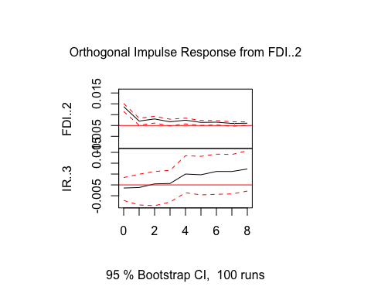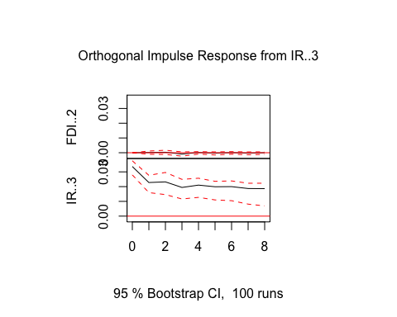

Here, we see that a shock to FDI in time t has a positive shock in itself during this time, which remains over time but decreases. Next, IR also shows a positive but small reaction to itself, which also decreases over time. Further, FDI appears to show some change in relation to a shock in IR, but no motion appears to be significant. This all corresponds with the logic that IR and FDI effect each other less significantly in short term shocks.

Forecasting from VAR 3 years out:

fcst1 <- predict(var1, n.ahead = 8)  
plot(fcst1)

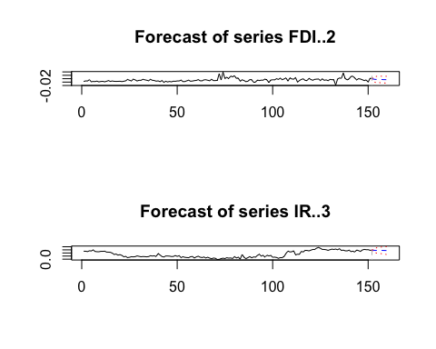

summary(fcst1)

## Length Class Mode   
## fcst 2 -none- list   
## endog 304 mts numeric  
## model 10 varest list   
## exo.fcst 0 -none- NULL

print(fcst1)

## $FDI..2  
## fcst lower upper CI  
## [1,] 0.01701385 -3.988097e-05 0.03406758 0.01705373  
## [2,] 0.01561748 -1.904162e-03 0.03313912 0.01752164  
## [3,] 0.01610672 -2.399666e-03 0.03461310 0.01850638  
## [4,] 0.01566066 -3.226562e-03 0.03454788 0.01888722  
## [5,] 0.01523878 -4.252943e-03 0.03473050 0.01949172  
## [6,] 0.01458063 -5.115344e-03 0.03427661 0.01969598  
## [7,] 0.01440164 -5.522363e-03 0.03432565 0.01992401  
## [8,] 0.01412762 -5.890616e-03 0.03414586 0.02001824  
##   
## $IR..3  
## fcst lower upper CI  
## [1,] 0.2870137 0.2211068 0.3529205 0.06590688  
## [2,] 0.2812337 0.2015923 0.3608751 0.07964142  
## [3,] 0.2842410 0.1925186 0.3759634 0.09172241  
## [4,] 0.2844649 0.1851357 0.3837941 0.09932921  
## [5,] 0.2832816 0.1752965 0.3912666 0.10798507  
## [6,] 0.2810955 0.1659154 0.3962755 0.11518003  
## [7,] 0.2797866 0.1575191 0.4020542 0.12226753  
## [8,] 0.2781369 0.1499157 0.4063581 0.12822121

The forecast of FDI/GDP is said to increase slightly over the next 3 years, which is consistant with other forecasts created from VAR and arima modeling. It also has IR/GDP forecasted to slightly decrease, but very subtly. This is also consistant with previous models prediction.

My next VAR is a regression on real GDP growth, the exchange rate with china (Yuan to 1 USD) and net imports as a fraction of GDP. I am putting GDP growth first followed by NX/GDP because even though a change in the exchange rate would theoretically have large effects on exports and imports, I believe these changes would not occur contemporaneously. Rather, I believe the exchange rate would be more sensitive to these types of rapid movements. Lasty, GDP growth would be least affected by either variable in time t, so it is first.

Set Up Time Series:

x2 <- DataVAR[1:152,5:7]  
y2 <- ts(data = x2, start = c(1981,1), frequency = 4, end = c(2018,4)) # data start in 1973Q1 and end in 2018Q4)

VAR, p = 4 >> 4 lags

var2 <- VAR(y2, p=4)   
summary(var2)

##   
## VAR Estimation Results:  
## =========================   
## Endogenous variables: rGDPgrowth..5, NXGDP..6, ER   
## Deterministic variables: const   
## Sample size: 148   
## Log Likelihood: -326.793   
## Roots of the characteristic polynomial:  
## 0.9656 0.9656 0.5993 0.5993 0.5652 0.5652 0.4519 0.4519 0.4198 0.4198 0.4124 0.3861  
## Call:  
## VAR(y = y2, p = 4)  
##   
##   
## Estimation results for equation rGDPgrowth..5:   
## ==============================================   
## rGDPgrowth..5 = rGDPgrowth..5.l1 + NXGDP..6.l1 + ER.l1 + rGDPgrowth..5.l2 + NXGDP..6.l2 + ER.l2 + rGDPgrowth..5.l3 + NXGDP..6.l3 + ER.l3 + rGDPgrowth..5.l4 + NXGDP..6.l4 + ER.l4 + const   
##   
## Estimate Std. Error t value Pr(>|t|)   
## rGDPgrowth..5.l1 0.37203 0.08264 4.502 1.44e-05 ***  
## NXGDP..6.l1 -1.63086 0.76744 -2.125 0.03540 *   
## ER.l1 0.29971 0.70986 0.422 0.67355   
## rGDPgrowth..5.l2 0.07579 0.09780 0.775 0.43969   
## NXGDP..6.l2 2.22211 1.16064 1.915 0.05767 .   
## ER.l2 -0.81503 1.00736 -0.809 0.41990   
## rGDPgrowth..5.l3 0.09465 0.08735 1.084 0.28046   
## NXGDP..6.l3 -0.46860 1.17627 -0.398 0.69098   
## ER.l3 0.77297 1.01429 0.762 0.44734   
## rGDPgrowth..5.l4 -0.06943 0.08332 -0.833 0.40611   
## NXGDP..6.l4 0.12048 0.77156 0.156 0.87615   
## ER.l4 -0.28102 0.71568 -0.393 0.69519   
## const 2.25474 0.70677 3.190 0.00177 **   
## ---  
## Signif. codes: 0 '***' 0.001 '**' 0.01 '*' 0.05 '.' 0.1 ' ' 1  
##   
##   
## Residual standard error: 2.226 on 135 degrees of freedom  
## Multiple R-Squared: 0.3227, Adjusted R-squared: 0.2625   
## F-statistic: 5.359 on 12 and 135 DF, p-value: 2.258e-07   
##   
##   
## Estimation results for equation NXGDP..6:   
## =========================================   
## NXGDP..6 = rGDPgrowth..5.l1 + NXGDP..6.l1 + ER.l1 + rGDPgrowth..5.l2 + NXGDP..6.l2 + ER.l2 + rGDPgrowth..5.l3 + NXGDP..6.l3 + ER.l3 + rGDPgrowth..5.l4 + NXGDP..6.l4 + ER.l4 + const   
##   
## Estimate Std. Error t value Pr(>|t|)   
## rGDPgrowth..5.l1 -0.055977 0.009197 -6.087 1.12e-08 ***  
## NXGDP..6.l1 1.136857 0.085402 13.312 < 2e-16 ***  
## ER.l1 0.067921 0.078995 0.860 0.39141   
## rGDPgrowth..5.l2 0.003614 0.010883 0.332 0.74037   
## NXGDP..6.l2 -0.214053 0.129159 -1.657 0.09978 .   
## ER.l2 -0.080102 0.112101 -0.715 0.47612   
## rGDPgrowth..5.l3 0.025792 0.009720 2.653 0.00892 **   
## NXGDP..6.l3 0.083526 0.130897 0.638 0.52449   
## ER.l3 -0.077338 0.112872 -0.685 0.49440   
## rGDPgrowth..5.l4 -0.006631 0.009272 -0.715 0.47571   
## NXGDP..6.l4 -0.030571 0.085861 -0.356 0.72236   
## ER.l4 0.077954 0.079642 0.979 0.32943   
## const 0.082191 0.078651 1.045 0.29789   
## ---  
## Signif. codes: 0 '***' 0.001 '**' 0.01 '*' 0.05 '.' 0.1 ' ' 1  
##   
##   
## Residual standard error: 0.2477 on 135 degrees of freedom  
## Multiple R-Squared: 0.9721, Adjusted R-squared: 0.9696   
## F-statistic: 392.2 on 12 and 135 DF, p-value: < 2.2e-16   
##   
##   
## Estimation results for equation ER:   
## ===================================   
## ER = rGDPgrowth..5.l1 + NXGDP..6.l1 + ER.l1 + rGDPgrowth..5.l2 + NXGDP..6.l2 + ER.l2 + rGDPgrowth..5.l3 + NXGDP..6.l3 + ER.l3 + rGDPgrowth..5.l4 + NXGDP..6.l4 + ER.l4 + const   
##   
## Estimate Std. Error t value Pr(>|t|)   
## rGDPgrowth..5.l1 0.006314 0.009968 0.633 0.5275   
## NXGDP..6.l1 0.004899 0.092559 0.053 0.9579   
## ER.l1 0.996374 0.085616 11.638 <2e-16 ***  
## rGDPgrowth..5.l2 -0.006059 0.011795 -0.514 0.6083   
## NXGDP..6.l2 0.059588 0.139983 0.426 0.6710   
## ER.l2 -0.059271 0.121496 -0.488 0.6265   
## rGDPgrowth..5.l3 0.004423 0.010535 0.420 0.6752   
## NXGDP..6.l3 -0.099257 0.141868 -0.700 0.4854   
## ER.l3 0.012391 0.122332 0.101 0.9195   
## rGDPgrowth..5.l4 -0.002128 0.010049 -0.212 0.8326   
## NXGDP..6.l4 0.070383 0.093056 0.756 0.4508   
## ER.l4 0.035153 0.086317 0.407 0.6845   
## const 0.222042 0.085243 2.605 0.0102 *   
## ---  
## Signif. codes: 0 '***' 0.001 '**' 0.01 '*' 0.05 '.' 0.1 ' ' 1  
##   
##   
## Residual standard error: 0.2685 on 135 degrees of freedom  
## Multiple R-Squared: 0.984, Adjusted R-squared: 0.9826   
## F-statistic: 692.1 on 12 and 135 DF, p-value: < 2.2e-16   
##   
##   
##   
## Covariance matrix of residuals:  
## rGDPgrowth..5 NXGDP..6 ER  
## rGDPgrowth..5 4.954451 0.0122377 -0.0086584  
## NXGDP..6 0.012238 0.0613544 -0.0005874  
## ER -0.008658 -0.0005874 0.0720694  
##   
## Correlation matrix of residuals:  
## rGDPgrowth..5 NXGDP..6 ER  
## rGDPgrowth..5 1.00000 0.022196 -0.014490  
## NXGDP..6 0.02220 1.000000 -0.008833  
## ER -0.01449 -0.008833 1.000000

Impies (3 years x 4 quarters per year = 12 quarters)

impies2 <- irf(var2, n.ahead=8)  
plot(impies2)

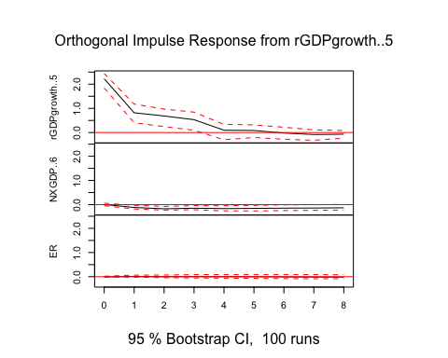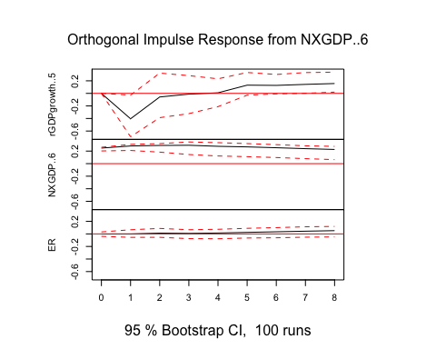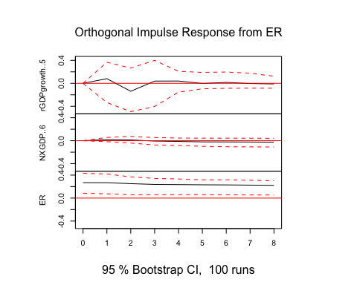

Here, we see real GDP growth has an effect on itself, but a non significant effect on both NX/GDP and the exchange rate with china. Net exports appears to have a decrease in period t+1, followed by oscillations, however none after the first initial decrease are significant. Also, a change in NX/GDP appears to have a significant negative effect on the exchange rate initially, which then increases back to normal.

Forecasting from VAR 3 years out:

fcst2 <- predict(var2, n.ahead = 8)  
plot(fcst2)

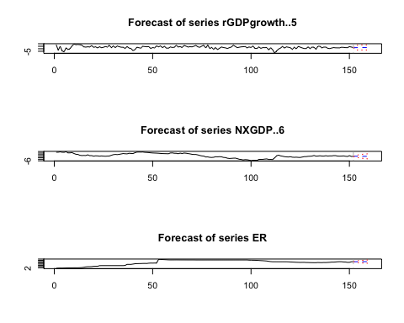

print(fcst2)

## $rGDPgrowth..5  
## fcst lower upper CI  
## [1,] 2.244118 -2.118487 6.606722 4.362605  
## [2,] 2.286936 -2.430682 7.004554 4.717618  
## [3,] 2.476293 -2.437375 7.389961 4.913668  
## [4,] 2.498378 -2.525459 7.522214 5.023837  
## [5,] 2.522797 -2.505206 7.550799 5.028003  
## [6,] 2.567664 -2.469650 7.604977 5.037313  
## [7,] 2.560574 -2.483139 7.604288 5.043713  
## [8,] 2.562568 -2.491500 7.616635 5.054067  
##   
## $NXGDP..6  
## fcst lower upper CI  
## [1,] -3.048992 -3.534471 -2.563512 0.4854794  
## [2,] -3.065129 -3.836584 -2.293675 0.7714546  
## [3,] -3.088684 -4.104889 -2.072478 1.0162053  
## [4,] -3.092467 -4.295345 -1.889589 1.2028778  
## [5,] -3.103111 -4.461160 -1.745062 1.3580489  
## [6,] -3.111479 -4.599205 -1.623752 1.4877266  
## [7,] -3.120914 -4.715511 -1.526318 1.5945965  
## [8,] -3.130239 -4.815430 -1.445048 1.6851911  
##   
## $ER  
## fcst lower upper CI  
## [1,] 6.856403 6.330236 7.382571 0.5261671  
## [2,] 6.880505 6.137520 7.623490 0.7429849  
## [3,] 6.893563 6.001942 7.785183 0.8916207  
## [4,] 6.900413 5.894441 7.906385 1.0059722  
## [5,] 6.911674 5.805018 8.018331 1.1066565  
## [6,] 6.925190 5.728354 8.122025 1.1968351  
## [7,] 6.936404 5.656249 8.216560 1.2801554  
## [8,] 6.947148 5.589896 8.304400 1.3572523

The forecast of GDP growth appears to be realtively constant with some ups and downs, which follows the overall trend pattern. NX/GDP is forecasted to slightly decrease over the next 3 years, which is consistant with the other forecasts. The exchange rate of the yuan to 1 USD is forecasted to increase in the next few years. While the strength of the US dollar in relation to the yuan changes constantly. Here, this forecast predicts an increase in relative power of the US dollar.

Lastly, I wanted to run a VAR using the dollar index and US GDP growth. GDP growth is the first variable as the dollar index is more likely to be a reactionary variable to GDP contemporaneously.

Set Up Time Series:

x3 <- DataVAR[1:152,9:10]  
y3 <- ts(data = x3, start = c(1981,1), frequency = 4, end = c(2018,4)) # data start in 1973Q1 and end in 2018Q4)

VAR, p = 4 >> 4 lags

var3 <- VAR(y3, p=4)   
summary(var3)

##   
## VAR Estimation Results:  
## =========================   
## Endogenous variables: rGDPgrowth..9, Dollar.Index..10   
## Deterministic variables: const   
## Sample size: 148   
## Log Likelihood: -645.156   
## Roots of the characteristic polynomial:  
## 0.9203 0.7361 0.6462 0.6462 0.5756 0.5756 0.5426 0.5426  
## Call:  
## VAR(y = y3, p = 4)  
##   
##   
## Estimation results for equation rGDPgrowth..9:   
## ==============================================   
## rGDPgrowth..9 = rGDPgrowth..9.l1 + Dollar.Index..10.l1 + rGDPgrowth..9.l2 + Dollar.Index..10.l2 + rGDPgrowth..9.l3 + Dollar.Index..10.l3 + rGDPgrowth..9.l4 + Dollar.Index..10.l4 + const   
##   
## Estimate Std. Error t value Pr(>|t|)   
## rGDPgrowth..9.l1 0.37175 0.08168 4.552 1.15e-05 ***  
## Dollar.Index..10.l1 0.05747 0.08467 0.679 0.4985   
## rGDPgrowth..9.l2 0.17911 0.08565 2.091 0.0383 *   
## Dollar.Index..10.l2 -0.07804 0.13707 -0.569 0.5700   
## rGDPgrowth..9.l3 0.07118 0.08229 0.865 0.3885   
## Dollar.Index..10.l3 0.13700 0.13674 1.002 0.3181   
## rGDPgrowth..9.l4 -0.12293 0.07753 -1.586 0.1151   
## Dollar.Index..10.l4 -0.08500 0.08370 -1.015 0.3117   
## const -1.62549 1.91865 -0.847 0.3983   
## ---  
## Signif. codes: 0 '***' 0.001 '**' 0.01 '*' 0.05 '.' 0.1 ' ' 1  
##   
##   
## Residual standard error: 2.245 on 139 degrees of freedom  
## Multiple R-Squared: 0.2903, Adjusted R-squared: 0.2495   
## F-statistic: 7.108 on 8 and 139 DF, p-value: 7.378e-08   
##   
##   
## Estimation results for equation Dollar.Index..10:   
## =================================================   
## Dollar.Index..10 = rGDPgrowth..9.l1 + Dollar.Index..10.l1 + rGDPgrowth..9.l2 + Dollar.Index..10.l2 + rGDPgrowth..9.l3 + Dollar.Index..10.l3 + rGDPgrowth..9.l4 + Dollar.Index..10.l4 + const   
##   
## Estimate Std. Error t value Pr(>|t|)   
## rGDPgrowth..9.l1 0.016430 0.079835 0.206 0.83725   
## Dollar.Index..10.l1 1.290769 0.082767 15.595 < 2e-16 ***  
## rGDPgrowth..9.l2 0.003315 0.083721 0.040 0.96847   
## Dollar.Index..10.l2 -0.394742 0.133980 -2.946 0.00377 **   
## rGDPgrowth..9.l3 0.058694 0.080436 0.730 0.46680   
## Dollar.Index..10.l3 0.209360 0.133659 1.566 0.11953   
## rGDPgrowth..9.l4 0.097544 0.075779 1.287 0.20016   
## Dollar.Index..10.l4 -0.157045 0.081817 -1.919 0.05697 .   
## const 4.540207 1.875429 2.421 0.01677 *   
## ---  
## Signif. codes: 0 '***' 0.001 '**' 0.01 '*' 0.05 '.' 0.1 ' ' 1  
##   
##   
## Residual standard error: 2.195 on 139 degrees of freedom  
## Multiple R-Squared: 0.9527, Adjusted R-squared: 0.9499   
## F-statistic: 349.7 on 8 and 139 DF, p-value: < 2.2e-16   
##   
##   
##   
## Covariance matrix of residuals:  
## rGDPgrowth..9 Dollar.Index..10  
## rGDPgrowth..9 5.0417 -0.7248  
## Dollar.Index..10 -0.7248 4.8171  
##   
## Correlation matrix of residuals:  
## rGDPgrowth..9 Dollar.Index..10  
## rGDPgrowth..9 1.0000 -0.1471  
## Dollar.Index..10 -0.1471 1.0000

Impies (3 years x 4 quarters per year = 12 quarters)

impies3 <- irf(var3, n.ahead=8)  
plot(impies3)

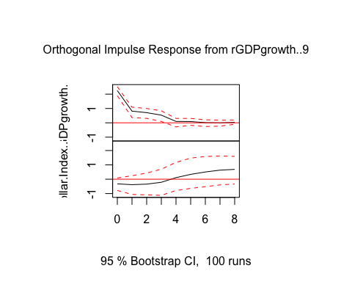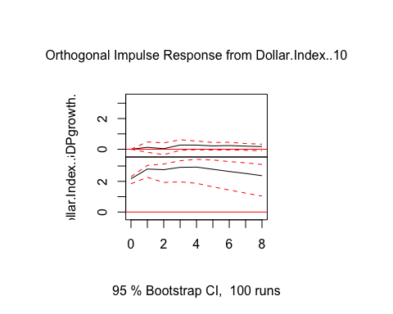 A shock to real GDP growth appears to have a significant positive relationship to itself in time 0, which is logical. A shock to real GDP growth also appears to have some effect on the dollar index, a slight increase in the strength of the dollar after 12 quarters. However, this is close to being insignificant. Lastly, it appears the dollar index has no significant effect on real GDP growth, but a positive and lasting effect on itself.

Forecasting from VAR 3 years out:

fcst3 <- predict(var3, n.ahead = 8)  
plot(fcst3)

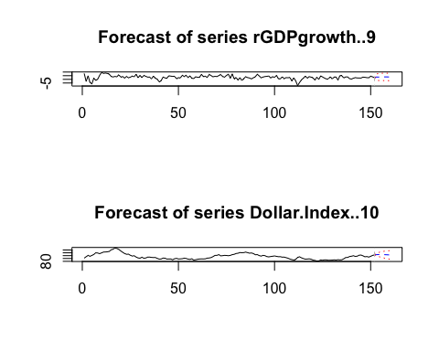

print(fcst3)

## $rGDPgrowth..9  
## fcst lower upper CI  
## [1,] 3.185752 -1.215091 7.586595 4.400843  
## [2,] 3.100016 -1.588918 7.788950 4.688934  
## [3,] 3.247484 -1.643562 8.138529 4.891046  
## [4,] 3.401081 -1.629964 8.432126 5.031045  
## [5,] 3.338887 -1.723312 8.401086 5.062199  
## [6,] 3.345133 -1.738093 8.428359 5.083226  
## [7,] 3.288839 -1.816167 8.393844 5.105006  
## [8,] 3.232802 -1.887463 8.353068 5.120265  
##   
## $Dollar.Index..10  
## fcst lower upper CI  
## [1,] 103.4308 99.12913 107.7325 4.301705  
## [2,] 103.9048 96.88898 110.9207 7.015851  
## [3,] 104.0392 95.15227 112.9261 8.886909  
## [4,] 103.8007 93.22796 114.3735 10.572759  
## [5,] 103.5239 91.49086 115.5570 12.033068  
## [6,] 103.2142 89.98146 116.4470 13.232776  
## [7,] 102.8760 88.63053 117.1216 14.245510  
## [8,] 102.5517 87.42686 117.6765 15.124821

Here, we see GDP growth expected to remain relatively constant, which less fluctuations as the previous VAR forecasted. The dollar index is forecasted to increase slightly in the next coming years, which is consistant with the previous VAR’s forecast of the exchange rate with China.

ADD: GDP growth and FDI (GDP then FDI because GDP less volatile)

x4 <- DataVAR[1:152,12:13]  
y4 <- ts(data = x4, start = c(1981,1), frequency = 4, end = c(2018,4)) # data start in 1973Q1 and end in 2018Q4)

VAR, p = 4 >> 4 lags

var4 <- VAR(y4, p=4)   
summary(var4)

##   
## VAR Estimation Results:  
## =========================   
## Endogenous variables: rGDPgrowth..12, FDI..13   
## Deterministic variables: const   
## Sample size: 148   
## Log Likelihood: -505.637   
## Roots of the characteristic polynomial:  
## 0.8299 0.6333 0.5899 0.5899 0.482 0.482 0.474 0.474  
## Call:  
## VAR(y = y4, p = 4)  
##   
##   
## Estimation results for equation rGDPgrowth..12:   
## ===============================================   
## rGDPgrowth..12 = rGDPgrowth..12.l1 + FDI..13.l1 + rGDPgrowth..12.l2 + FDI..13.l2 + rGDPgrowth..12.l3 + FDI..13.l3 + rGDPgrowth..12.l4 + FDI..13.l4 + const   
##   
## Estimate Std. Error t value Pr(>|t|)   
## rGDPgrowth..12.l1 0.36266 0.08081 4.488 1.50e-05 ***  
## FDI..13.l1 -0.23840 0.21478 -1.110 0.2689   
## rGDPgrowth..12.l2 0.18710 0.08448 2.215 0.0284 *   
## FDI..13.l2 -0.25455 0.22075 -1.153 0.2509   
## rGDPgrowth..12.l3 0.10468 0.08057 1.299 0.1960   
## FDI..13.l3 -0.35637 0.22397 -1.591 0.1138   
## rGDPgrowth..12.l4 -0.10443 0.07557 -1.382 0.1692   
## FDI..13.l4 0.38158 0.21978 1.736 0.0847 .   
## const 1.86042 0.46074 4.038 8.87e-05 ***  
## ---  
## Signif. codes: 0 '***' 0.001 '**' 0.01 '*' 0.05 '.' 0.1 ' ' 1  
##   
##   
## Residual standard error: 2.202 on 139 degrees of freedom  
## Multiple R-Squared: 0.3174, Adjusted R-squared: 0.2781   
## F-statistic: 8.078 on 8 and 139 DF, p-value: 6.389e-09   
##   
##   
## Estimation results for equation FDI..13:   
## ========================================   
## FDI..13 = rGDPgrowth..12.l1 + FDI..13.l1 + rGDPgrowth..12.l2 + FDI..13.l2 + rGDPgrowth..12.l3 + FDI..13.l3 + rGDPgrowth..12.l4 + FDI..13.l4 + const   
##   
## Estimate Std. Error t value Pr(>|t|)   
## rGDPgrowth..12.l1 0.0009315 0.0317573 0.029 0.97664   
## FDI..13.l1 0.2166634 0.0844080 2.567 0.01132 *   
## rGDPgrowth..12.l2 0.0459963 0.0332023 1.385 0.16817   
## FDI..13.l2 0.2832092 0.0867560 3.264 0.00138 **  
## rGDPgrowth..12.l3 0.0227345 0.0316621 0.718 0.47394   
## FDI..13.l3 0.0521719 0.0880178 0.593 0.55432   
## rGDPgrowth..12.l4 -0.0185922 0.0296973 -0.626 0.53230   
## FDI..13.l4 0.1593098 0.0863715 1.844 0.06724 .   
## const 0.2339972 0.1810699 1.292 0.19840   
## ---  
## Signif. codes: 0 '***' 0.001 '**' 0.01 '*' 0.05 '.' 0.1 ' ' 1  
##   
##   
## Residual standard error: 0.8654 on 139 degrees of freedom  
## Multiple R-Squared: 0.301, Adjusted R-squared: 0.2607   
## F-statistic: 7.48 on 8 and 139 DF, p-value: 2.863e-08   
##   
##   
##   
## Covariance matrix of residuals:  
## rGDPgrowth..12 FDI..13  
## rGDPgrowth..12 4.8495 0.1614  
## FDI..13 0.1614 0.7490  
##   
## Correlation matrix of residuals:  
## rGDPgrowth..12 FDI..13  
## rGDPgrowth..12 1.0000 0.0847  
## FDI..13 0.0847 1.0000

Impies (3 years x 4 quarters per year = 12 quarters)

impies4 <- irf(var4, n.ahead=8)  
plot(impies4)

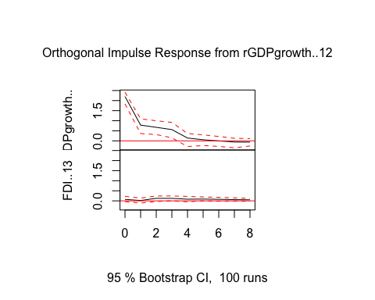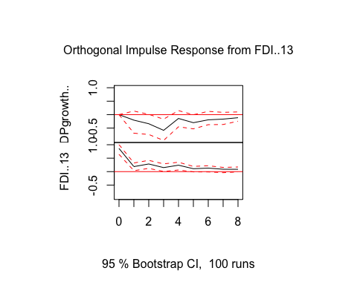

Forecasting from VAR 3 years out:

fcst4 <- predict(var4, n.ahead = 8)  
plot(fcst4)

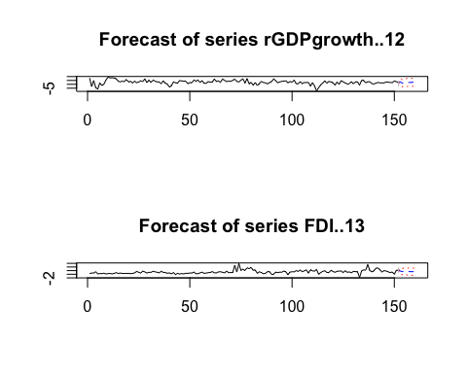

print(fcst4)

## $rGDPgrowth..12  
## fcst lower upper CI  
## [1,] 2.906337 -1.409818 7.222491 4.316155  
## [2,] 1.466131 -3.131228 6.063489 4.597359  
## [3,] 2.108646 -2.719694 6.936985 4.828340  
## [4,] 2.415662 -2.666267 7.497591 5.081929  
## [5,] 2.354605 -2.742426 7.451636 5.097031  
## [6,] 2.464009 -2.667988 7.596006 5.131997  
## [7,] 2.593391 -2.552495 7.739277 5.145886  
## [8,] 2.613597 -2.543918 7.771113 5.157515  
##   
## $FDI..13  
## fcst lower upper CI  
## [1,] 1.754679 0.05843929 3.450918 1.696239  
## [2,] 1.444521 -0.29115213 3.180194 1.735673  
## [3,] 1.637242 -0.20263331 3.477118 1.839876  
## [4,] 1.528407 -0.35026375 3.407078 1.878671  
## [5,] 1.462267 -0.48098064 3.405514 1.943247  
## [6,] 1.433205 -0.52930748 3.395718 1.962513  
## [7,] 1.425529 -0.55921978 3.410278 1.984749  
## [8,] 1.392903 -0.60305409 3.388860 1.995957

Dollar Index and IR

x5 <- DataVAR[1:152,15:16]  
y5 <- ts(data = x5, start = c(1981,1), frequency = 4, end = c(2018,4)) # data start in 1973Q1 and end in 2018Q4)

VAR, p = 4 >> 4 lags

var5 <- VAR(y5, p=4)   
summary(var5)

##   
## VAR Estimation Results:  
## =========================   
## Endogenous variables: IR..15, Dollar.Index..16   
## Deterministic variables: const   
## Sample size: 148   
## Log Likelihood: -18.85   
## Roots of the characteristic polynomial:  
## 0.9544 0.9544 0.6291 0.532 0.5154 0.5154 0.242 0.242  
## Call:  
## VAR(y = y5, p = 4)  
##   
##   
## Estimation results for equation IR..15:   
## =======================================   
## IR..15 = IR..15.l1 + Dollar.Index..16.l1 + IR..15.l2 + Dollar.Index..16.l2 + IR..15.l3 + Dollar.Index..16.l3 + IR..15.l4 + Dollar.Index..16.l4 + const   
##   
## Estimate Std. Error t value Pr(>|t|)   
## IR..15.l1 0.615824 0.085021 7.243 2.74e-11 ***  
## Dollar.Index..16.l1 -0.003618 0.001254 -2.886 0.00453 **   
## IR..15.l2 0.288675 0.101163 2.854 0.00498 **   
## Dollar.Index..16.l2 0.002540 0.002019 1.258 0.21048   
## IR..15.l3 -0.021614 0.101115 -0.214 0.83105   
## Dollar.Index..16.l3 0.001622 0.002029 0.800 0.42531   
## IR..15.l4 0.085931 0.085590 1.004 0.31713   
## Dollar.Index..16.l4 -0.001022 0.001264 -0.809 0.42017   
## const 0.051182 0.029844 1.715 0.08858 .   
## ---  
## Signif. codes: 0 '***' 0.001 '**' 0.01 '*' 0.05 '.' 0.1 ' ' 1  
##   
##   
## Residual standard error: 0.03277 on 139 degrees of freedom  
## Multiple R-Squared: 0.9079, Adjusted R-squared: 0.9026   
## F-statistic: 171.2 on 8 and 139 DF, p-value: < 2.2e-16   
##   
##   
## Estimation results for equation Dollar.Index..16:   
## =================================================   
## Dollar.Index..16 = IR..15.l1 + Dollar.Index..16.l1 + IR..15.l2 + Dollar.Index..16.l2 + IR..15.l3 + Dollar.Index..16.l3 + IR..15.l4 + Dollar.Index..16.l4 + const   
##   
## Estimate Std. Error t value Pr(>|t|)   
## IR..15.l1 6.96854 5.69881 1.223 0.22347   
## Dollar.Index..16.l1 1.31160 0.08403 15.608 < 2e-16 ***  
## IR..15.l2 -3.24843 6.78081 -0.479 0.63265   
## Dollar.Index..16.l2 -0.38490 0.13532 -2.844 0.00512 **   
## IR..15.l3 -5.79559 6.77760 -0.855 0.39396   
## Dollar.Index..16.l3 0.15082 0.13597 1.109 0.26925   
## IR..15.l4 4.74309 5.73699 0.827 0.40979   
## Dollar.Index..16.l4 -0.11160 0.08475 -1.317 0.19003   
## const 2.91610 2.00043 1.458 0.14717   
## ---  
## Signif. codes: 0 '***' 0.001 '**' 0.01 '*' 0.05 '.' 0.1 ' ' 1  
##   
##   
## Residual standard error: 2.197 on 139 degrees of freedom  
## Multiple R-Squared: 0.9526, Adjusted R-squared: 0.9499   
## F-statistic: 349 on 8 and 139 DF, p-value: < 2.2e-16   
##   
##   
##   
## Covariance matrix of residuals:  
## IR..15 Dollar.Index..16  
## IR..15 0.001074 -0.01298  
## Dollar.Index..16 -0.012980 4.82530  
##   
## Correlation matrix of residuals:  
## IR..15 Dollar.Index..16  
## IR..15 1.0000 -0.1803  
## Dollar.Index..16 -0.1803 1.0000

Impies

impies5 <- irf(var5, n.ahead=8)  
plot(impies5)

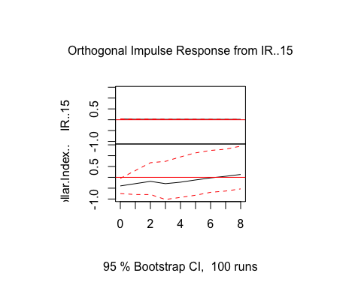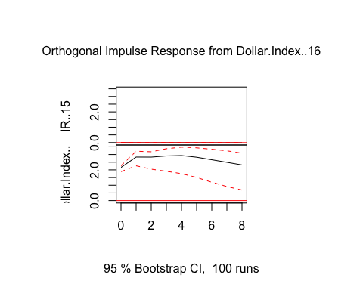

Forecasting from VAR 2 years out:

fcst5 <- predict(var5, n.ahead = 8)  
plot(fcst5)

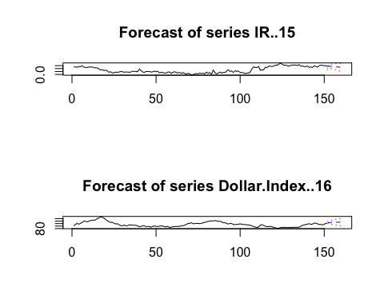

print(fcst5)

## $IR..15  
## fcst lower upper CI  
## [1,] 0.2778319 0.2136001 0.3420637 0.06423180  
## [2,] 0.2748954 0.1964409 0.3533499 0.07845452  
## [3,] 0.2681155 0.1758785 0.3603526 0.09223704  
## [4,] 0.2633481 0.1628339 0.3638624 0.10051427  
## [5,] 0.2577523 0.1478788 0.3676257 0.10987344  
## [6,] 0.2529853 0.1350045 0.3709660 0.11798072  
## [7,] 0.2480535 0.1226120 0.3734950 0.12544150  
## [8,] 0.2434287 0.1113875 0.3754700 0.13204124  
##   
## $Dollar.Index..16  
## fcst lower upper CI  
## [1,] 103.7872 99.48184 108.0926 4.305368  
## [2,] 104.5651 97.51436 111.6158 7.050737  
## [3,] 105.0665 96.08709 114.0459 8.979381  
## [4,] 105.4009 94.75137 116.0504 10.649528  
## [5,] 105.5962 93.48725 117.7051 12.108918  
## [6,] 105.7142 92.39884 119.0296 13.315374  
## [7,] 105.7688 91.47049 120.0671 14.298305  
## [8,] 105.7780 90.66864 120.8874 15.109375

Dollar Index, interest rates, GDP:

x6 <- DataVAR[1:152,18:20]  
y6 <- ts(data = x6, start = c(1981,1), frequency = 4, end = c(2018,4)) # data start in 1973Q1 and end in 2018Q4)

VAR, p = 4 >> 4 lags

var6 <- VAR(y6, p=4)   
summary(var6)

##   
## VAR Estimation Results:  
## =========================   
## Endogenous variables: Tbill, rGDPgrowth..19, Dollar.Index..20   
## Deterministic variables: const   
## Sample size: 148   
## Log Likelihood: -711.7   
## Roots of the characteristic polynomial:  
## 0.9444 0.8788 0.755 0.755 0.6677 0.6677 0.6188 0.6188 0.5493 0.5493 0.5487 0.5487  
## Call:  
## VAR(y = y6, p = 4)  
##   
##   
## Estimation results for equation Tbill:   
## ======================================   
## Tbill = Tbill.l1 + rGDPgrowth..19.l1 + Dollar.Index..20.l1 + Tbill.l2 + rGDPgrowth..19.l2 + Dollar.Index..20.l2 + Tbill.l3 + rGDPgrowth..19.l3 + Dollar.Index..20.l3 + Tbill.l4 + rGDPgrowth..19.l4 + Dollar.Index..20.l4 + const   
##   
## Estimate Std. Error t value Pr(>|t|)   
## Tbill.l1 1.188792 0.078825 15.081 < 2e-16 ***  
## rGDPgrowth..19.l1 0.033362 0.017048 1.957 0.05242 .   
## Dollar.Index..20.l1 -0.041236 0.016594 -2.485 0.01418 *   
## Tbill.l2 -0.364958 0.117185 -3.114 0.00225 **   
## rGDPgrowth..19.l2 0.035356 0.017493 2.021 0.04524 *   
## Dollar.Index..20.l2 0.052884 0.027337 1.935 0.05514 .   
## Tbill.l3 0.360448 0.117442 3.069 0.00260 **   
## rGDPgrowth..19.l3 0.004550 0.017432 0.261 0.79450   
## Dollar.Index..20.l3 0.001202 0.027596 0.044 0.96532   
## Tbill.l4 -0.220160 0.073565 -2.993 0.00329 **   
## rGDPgrowth..19.l4 0.005563 0.015734 0.354 0.72422   
## Dollar.Index..20.l4 -0.018036 0.016734 -1.078 0.28304   
## const 0.387564 0.401744 0.965 0.33642   
## ---  
## Signif. codes: 0 '***' 0.001 '**' 0.01 '*' 0.05 '.' 0.1 ' ' 1  
##   
##   
## Residual standard error: 0.4345 on 135 degrees of freedom  
## Multiple R-Squared: 0.9811, Adjusted R-squared: 0.9794   
## F-statistic: 583.3 on 12 and 135 DF, p-value: < 2.2e-16   
##   
##   
## Estimation results for equation rGDPgrowth..19:   
## ===============================================   
## rGDPgrowth..19 = Tbill.l1 + rGDPgrowth..19.l1 + Dollar.Index..20.l1 + Tbill.l2 + rGDPgrowth..19.l2 + Dollar.Index..20.l2 + Tbill.l3 + rGDPgrowth..19.l3 + Dollar.Index..20.l3 + Tbill.l4 + rGDPgrowth..19.l4 + Dollar.Index..20.l4 + const   
##   
## Estimate Std. Error t value Pr(>|t|)   
## Tbill.l1 0.959682 0.401745 2.389 0.018287 *   
## rGDPgrowth..19.l1 0.320006 0.086888 3.683 0.000332 ***  
## Dollar.Index..20.l1 0.033207 0.084575 0.393 0.695208   
## Tbill.l2 -1.524492 0.597254 -2.553 0.011808 *   
## rGDPgrowth..19.l2 0.222803 0.089157 2.499 0.013654 *   
## Dollar.Index..20.l2 0.006862 0.139326 0.049 0.960792   
## Tbill.l3 0.446075 0.598563 0.745 0.457421   
## rGDPgrowth..19.l3 0.031558 0.088846 0.355 0.723000   
## Dollar.Index..20.l3 0.047803 0.140648 0.340 0.734479   
## Tbill.l4 0.145678 0.374936 0.389 0.698228   
## rGDPgrowth..19.l4 -0.101800 0.080193 -1.269 0.206466   
## Dollar.Index..20.l4 -0.057949 0.085289 -0.679 0.498020   
## const -1.497493 2.047561 -0.731 0.465830   
## ---  
## Signif. codes: 0 '***' 0.001 '**' 0.01 '*' 0.05 '.' 0.1 ' ' 1  
##   
##   
## Residual standard error: 2.215 on 135 degrees of freedom  
## Multiple R-Squared: 0.3295, Adjusted R-squared: 0.2699   
## F-statistic: 5.529 on 12 and 135 DF, p-value: 1.255e-07   
##   
##   
## Estimation results for equation Dollar.Index..20:   
## =================================================   
## Dollar.Index..20 = Tbill.l1 + rGDPgrowth..19.l1 + Dollar.Index..20.l1 + Tbill.l2 + rGDPgrowth..19.l2 + Dollar.Index..20.l2 + Tbill.l3 + rGDPgrowth..19.l3 + Dollar.Index..20.l3 + Tbill.l4 + rGDPgrowth..19.l4 + Dollar.Index..20.l4 + const   
##   
## Estimate Std. Error t value Pr(>|t|)   
## Tbill.l1 -0.355215 0.389216 -0.913 0.36306   
## rGDPgrowth..19.l1 -0.006433 0.084178 -0.076 0.93920   
## Dollar.Index..20.l1 1.295791 0.081938 15.814 < 2e-16 ***  
## Tbill.l2 1.042939 0.578629 1.802 0.07371 .   
## rGDPgrowth..19.l2 0.011505 0.086377 0.133 0.89424   
## Dollar.Index..20.l2 -0.452029 0.134981 -3.349 0.00105 **   
## Tbill.l3 -1.505006 0.579897 -2.595 0.01050 *   
## rGDPgrowth..19.l3 0.143266 0.086076 1.664 0.09835 .   
## Dollar.Index..20.l3 0.283329 0.136262 2.079 0.03948 *   
## Tbill.l4 0.908318 0.363243 2.501 0.01360 *   
## rGDPgrowth..19.l4 0.067743 0.077692 0.872 0.38479   
## Dollar.Index..20.l4 -0.200501 0.082630 -2.427 0.01656 *   
## const 6.114075 1.983707 3.082 0.00249 **   
## ---  
## Signif. codes: 0 '***' 0.001 '**' 0.01 '*' 0.05 '.' 0.1 ' ' 1  
##   
##   
## Residual standard error: 2.145 on 135 degrees of freedom  
## Multiple R-Squared: 0.9561, Adjusted R-squared: 0.9522   
## F-statistic: 244.8 on 12 and 135 DF, p-value: < 2.2e-16   
##   
##   
##   
## Covariance matrix of residuals:  
## Tbill rGDPgrowth..19 Dollar.Index..20  
## Tbill 0.18880 0.2016 0.03707  
## rGDPgrowth..19 0.20163 4.9043 -0.66837  
## Dollar.Index..20 0.03707 -0.6684 4.60315  
##   
## Correlation matrix of residuals:  
## Tbill rGDPgrowth..19 Dollar.Index..20  
## Tbill 1.00000 0.2095 0.03976  
## rGDPgrowth..19 0.20954 1.0000 -0.14067  
## Dollar.Index..20 0.03976 -0.1407 1.00000

Impies

impies6 <- irf(var6, n.ahead=8)  
plot(impies6)

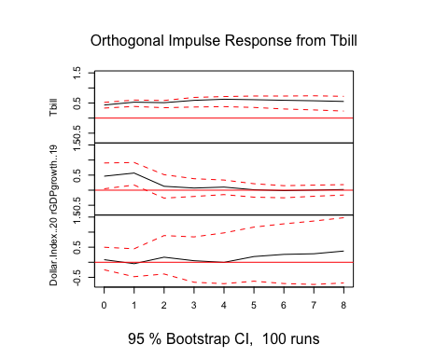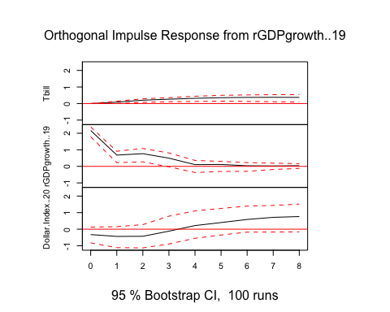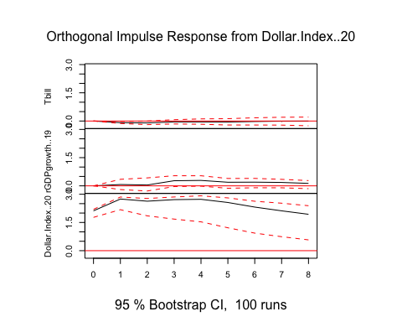

Forecasting from VAR 2 years out:

fcst6 <- predict(var6, n.ahead = 8)  
plot(fcst6)

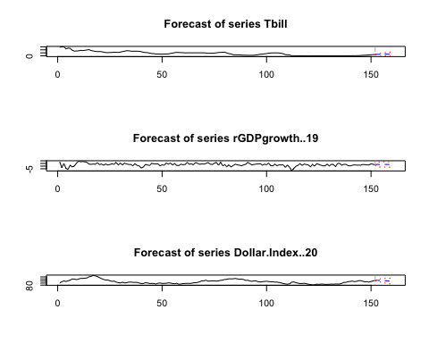

print(fcst6)

## $Tbill  
## fcst lower upper CI  
## [1,] 2.437100 1.58547650 3.288723 0.851623  
## [2,] 2.537728 1.17545125 3.900006 1.362277  
## [3,] 2.652013 0.90326854 4.400757 1.748744  
## [4,] 2.714050 0.55439058 4.873709 2.159659  
## [5,] 2.768704 0.20762846 5.329781 2.561076  
## [6,] 2.815439 -0.09678932 5.727668 2.912229  
## [7,] 2.844849 -0.37351166 6.063210 3.218361  
## [8,] 2.865990 -0.62317301 6.355152 3.489163  
##   
## $rGDPgrowth..19  
## fcst lower upper CI  
## [1,] 3.303468 -1.036981 7.643918 4.340449  
## [2,] 2.994999 -1.683296 7.673294 4.678295  
## [3,] 3.175349 -1.745353 8.096051 4.920702  
## [4,] 3.255700 -1.790189 8.301588 5.045889  
## [5,] 3.101010 -1.984446 8.186466 5.085456  
## [6,] 3.074548 -2.029767 8.178863 5.104315  
## [7,] 2.983218 -2.136140 8.102577 5.119358  
## [8,] 2.905280 -2.226581 8.037141 5.131861  
##   
## $Dollar.Index..20  
## fcst lower upper CI  
## [1,] 103.06966 98.86457 107.2748 4.205091  
## [2,] 103.10806 96.22467 109.9915 6.883391  
## [3,] 102.61054 93.96329 111.2578 8.647249  
## [4,] 101.84971 91.69460 112.0048 10.155104  
## [5,] 101.11964 89.63301 112.6063 11.486633  
## [6,] 100.34043 87.77495 112.9059 12.565480  
## [7,] 99.61790 86.19769 113.0381 13.420215  
## [8,] 98.97553 84.84746 113.1036 14.128066

x7 <- DataVAR[1:152,22:23]  
y7 <- ts(data = x7, start = c(1981,1), frequency = 4, end = c(2018,4)) # data start in 1973Q1 and end in 2018Q4)

VAR, p = 4 >> 4 lags

var7 <- VAR(y7, p=4)   
summary(var7)

##   
## VAR Estimation Results:  
## =========================   
## Endogenous variables: Dollar.Index..22, IR..23   
## Deterministic variables: const   
## Sample size: 148   
## Log Likelihood: 662.715   
## Roots of the characteristic polynomial:  
## 0.9544 0.9544 0.6291 0.532 0.5154 0.5154 0.242 0.242  
## Call:  
## VAR(y = y7, p = 4)  
##   
##   
## Estimation results for equation Dollar.Index..22:   
## =================================================   
## Dollar.Index..22 = Dollar.Index..22.l1 + IR..23.l1 + Dollar.Index..22.l2 + IR..23.l2 + Dollar.Index..22.l3 + IR..23.l3 + Dollar.Index..22.l4 + IR..23.l4 + const   
##   
## Estimate Std. Error t value Pr(>|t|)   
## Dollar.Index..22.l1 1.31160 0.08403 15.608 < 2e-16 ***  
## IR..23.l1 696.85417 569.88100 1.223 0.22347   
## Dollar.Index..22.l2 -0.38490 0.13532 -2.844 0.00512 **   
## IR..23.l2 -324.84284 678.08130 -0.479 0.63265   
## Dollar.Index..22.l3 0.15082 0.13597 1.109 0.26925   
## IR..23.l3 -579.55930 677.75956 -0.855 0.39396   
## Dollar.Index..22.l4 -0.11160 0.08475 -1.317 0.19003   
## IR..23.l4 474.30869 573.69885 0.827 0.40979   
## const 2.91610 2.00043 1.458 0.14717   
## ---  
## Signif. codes: 0 '***' 0.001 '**' 0.01 '*' 0.05 '.' 0.1 ' ' 1  
##   
##   
## Residual standard error: 2.197 on 139 degrees of freedom  
## Multiple R-Squared: 0.9526, Adjusted R-squared: 0.9499   
## F-statistic: 349 on 8 and 139 DF, p-value: < 2.2e-16   
##   
##   
## Estimation results for equation IR..23:   
## =======================================   
## IR..23 = Dollar.Index..22.l1 + IR..23.l1 + Dollar.Index..22.l2 + IR..23.l2 + Dollar.Index..22.l3 + IR..23.l3 + Dollar.Index..22.l4 + IR..23.l4 + const   
##   
## Estimate Std. Error t value Pr(>|t|)   
## Dollar.Index..22.l1 -3.618e-05 1.254e-05 -2.886 0.00453 **   
## IR..23.l1 6.158e-01 8.502e-02 7.243 2.74e-11 ***  
## Dollar.Index..22.l2 2.540e-05 2.019e-05 1.258 0.21048   
## IR..23.l2 2.887e-01 1.012e-01 2.854 0.00498 **   
## Dollar.Index..22.l3 1.622e-05 2.029e-05 0.800 0.42531   
## IR..23.l3 -2.161e-02 1.011e-01 -0.214 0.83105   
## Dollar.Index..22.l4 -1.022e-05 1.264e-05 -0.809 0.42017   
## IR..23.l4 8.593e-02 8.559e-02 1.004 0.31713   
## const 5.118e-04 2.984e-04 1.715 0.08858 .   
## ---  
## Signif. codes: 0 '***' 0.001 '**' 0.01 '*' 0.05 '.' 0.1 ' ' 1  
##   
##   
## Residual standard error: 0.0003277 on 139 degrees of freedom  
## Multiple R-Squared: 0.9079, Adjusted R-squared: 0.9026   
## F-statistic: 171.2 on 8 and 139 DF, p-value: < 2.2e-16   
##   
##   
##   
## Covariance matrix of residuals:  
## Dollar.Index..22 IR..23  
## Dollar.Index..22 4.8253017 -1.298e-04  
## IR..23 -0.0001298 1.074e-07  
##   
## Correlation matrix of residuals:  
## Dollar.Index..22 IR..23  
## Dollar.Index..22 1.0000 -0.1803  
## IR..23 -0.1803 1.0000

Impies

impies7 <- irf(var7, n.ahead=8)  
plot(impies7)

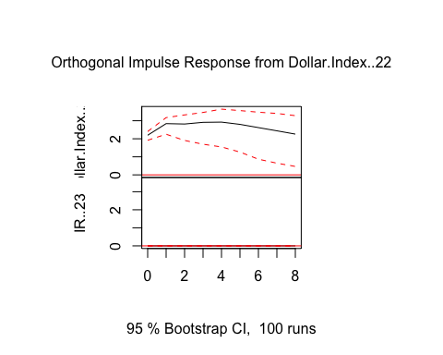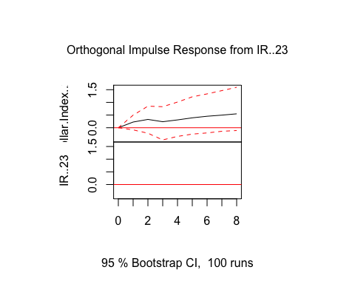

Forecasting from VAR 2 years out:

fcst7 <- predict(var7, n.ahead = 8)  
plot(fcst7)

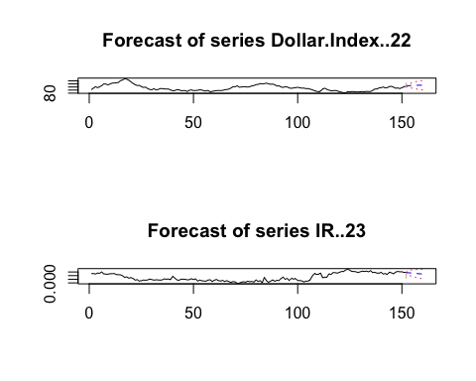

print(fcst7)

## $Dollar.Index..22  
## fcst lower upper CI  
## [1,] 103.7872 99.48184 108.0926 4.305368  
## [2,] 104.5651 97.51436 111.6158 7.050737  
## [3,] 105.0665 96.08709 114.0459 8.979381  
## [4,] 105.4009 94.75137 116.0504 10.649528  
## [5,] 105.5962 93.48725 117.7051 12.108918  
## [6,] 105.7142 92.39884 119.0296 13.315374  
## [7,] 105.7688 91.47049 120.0671 14.298305  
## [8,] 105.7780 90.66864 120.8874 15.109375  
##   
## $IR..23  
## fcst lower upper CI  
## [1,] 0.002778319 0.002136001 0.003420637 0.0006423180  
## [2,] 0.002748954 0.001964409 0.003533499 0.0007845452  
## [3,] 0.002681155 0.001758785 0.003603526 0.0009223704  
## [4,] 0.002633481 0.001628339 0.003638624 0.0010051427  
## [5,] 0.002577523 0.001478788 0.003676257 0.0010987344  
## [6,] 0.002529853 0.001350045 0.003709660 0.0011798072  
## [7,] 0.002480535 0.001226120 0.003734950 0.0012544150  
## [8,] 0.002434287 0.001113875 0.003754700 0.0013204124