MXP Developers Guide V 0.5 (updated 9/22/14)

1. Open NI Multisim 13.0 or later, and create a new design (**CTRL+N**).
2. On the left side of the dialog box, select “*Installed Templates*”, then select “*NI myRIO Single MXP*” and click “*Create*”.  
   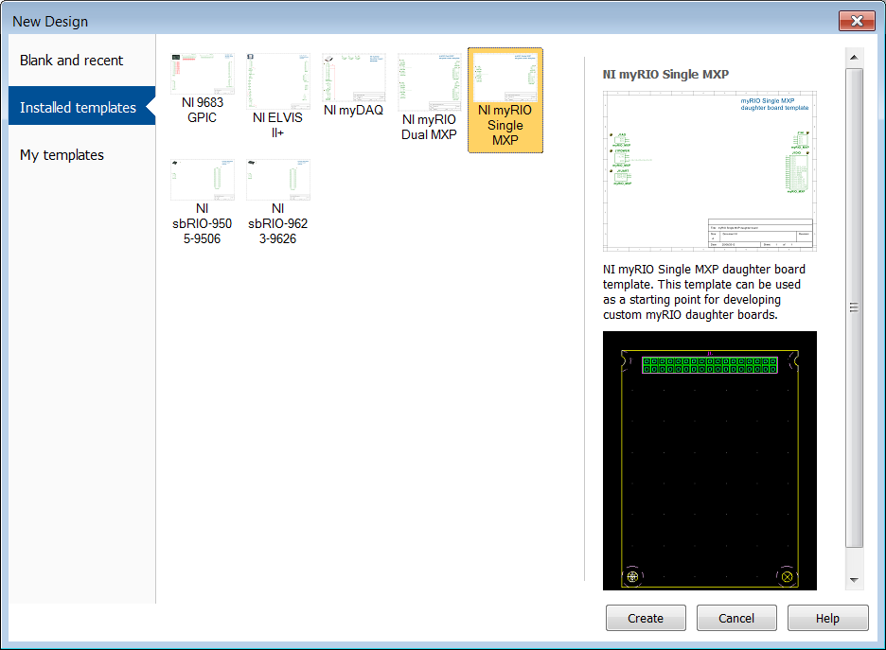
3. A schematic with symbols for the MXP connector will appear, as well as a pre-designed PCB template. You may now design your board, enjoy!

## Example Projects

**Simple Breakout Board** – This is a board which simply breaks out all I/O available in the MXP port. It is broken up into five banks of 4 I/O headers, each of which has adjustable +3.3V or +5V voltage pins, as well as ground pins. Additionally, there is a bank of two analog outputs and a dedicated UART port, each with their own voltage select. The voltage can be selected temporarily or semi-permanently by either jumping or soldering the power select jumper, respectively, for each bank. The holes along the side of the board allow for convenient use of zip-ties to restrain wires connected to the board.

**Positional Sensor Breakout Board** – This is a board designed to connect easily with most positional sensors, such as potentiometers and quadrature encoders. It is broken up into four banks of 4 I/O headers, each of which has adjustable +3.3V or +5V voltage pins, as well as ground pins. The voltage can be selected temporarily or semi-permanently by either jumping or soldering the power select jumper, respectively, for each bank. The holes along the center of the board allow for convenient use of zip-ties to restrain wires connected to the board.

## Mechanical Drawings

## 

## 

## Recommended Parts

|  |  |  |
| --- | --- | --- |
| Name | Part Number | Manufacturer |
| Vertical MXP Connector | SH2-34G-P | On-Shore Technology, Inc. |
| 3-Pin Header | 68000-103HLF | FCI |
| 4-Pin Header | 68002-404HLF | FCI |
| Board Mount Screw | #4-40 x 3/16" | N/A |
| Taller Vert. MXP Connector | ESW-117-23-L-D | Samtec |
| Spacer for Taller Connector | 4500-440-AL-7 | RAF Electronic Hardware |

## MXP Pinout

The RoboRIO uses the standard myRIO eXpansion Port (MXP), which is can be seen in Figure 1, and comes with a pre-flashed FPGA image which provides additional functionality on certain pins; these pins and peripherals can be found in Figure 2 below. It is important to note that any DIO line can generate simple PWM signals and decode quadrature encoders.

## 

Figure 2 - RoboRIO Additional Pin Functionality

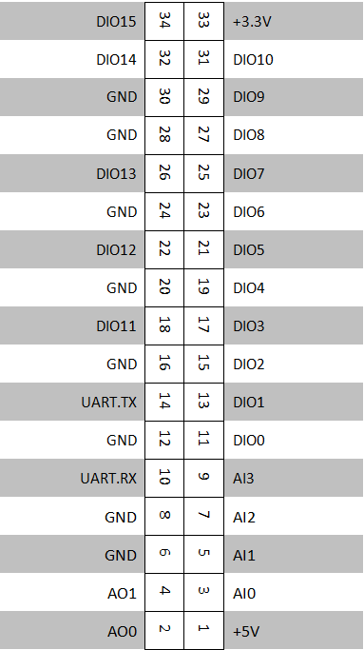

Figure 1 - MXP Connector Standard Pinout

## Notes

* You may widen the module beyond 2.230”, but the relative placement of screw holes and the connector must remain the same.
* Be careful to obey the .065” maximum component height on the bottom of the board.
* If you need more room for tall components on the bottom of the board, you may use an MXP connector which is taller than the recommended one, but be sure to place spacers between the module and the RoboRIO in order to keep the board mounted level.
* DIO14 and DIO15 each have an internal 2.21kΩ pull up resistor that can be utilized for applications such as I2C.