

EEL 4914 Senior Design

01/12/2022

Project Abstract

**Title: Theremania- Theremin Vocoder**

Submitted By:

Jackson Cornell, 407-491-1408, [jcornell@ufl.edu](mailto:jcornell@ufl.edu)

Eric Barkuloo, 850-630-1165, [jbarkuloo@ufl.edu](mailto:jbarkuloo@ufl.edu)

# Abstract

The *Theremania* is a modern take on the theremin, an instrument popularized in music throughout the 20th century. The *Theremania* will involve a classic theremin, with the pitch of the instrument being controlled by the hands using an antenna. The output of this theremin will be modified by a digital signal processing stage, in which the pitch can be modified by vocal input through a microphone into a phase vocoder. Additionally, in this stage there will be options to change the signal note output of the theremin into more complex musical outputs such as chords and harmonies. In addition to this functionality, the *Theremania* will also feature conversion of the theremin output to a MIDI signal, allowing the theremin to be used as a virtual instrument controlled in any audio software allowing MIDI as an input.

The *Theremania* presents unique technical challenges, particularly regarding the signal processing required in order to provide all the planned project features. The modification of the signal via a phase vocoder, the conversion of the control voltage signal to MIDI, and the inclusion of other pitch shifting audio effects create a technically challenging project, in addition to the task of designing a working version of the original theremin instrument. The *Theremania* promises to create a flexible instrument with many creative capabilities, and provide an update to a classic instrument to modernize it and increase its usability.

# Introduction

The *Theremania: Theremin Vocoder* finds applications in the consumer musical instrument market, targeted towards professional musicians and hobbyists alike. The *Theremania* tackles two unique challenges in this market: a theremin MIDI controller for virtual instruments, and a unique vocoding effect on the human voice. There are currently no products that tackle either of these challenges.

Due to the unique nature of this effect, the project has a great potential to be utilized in both professional and hobbyist communities. The synth community in particular is a large consumer of similar instruments and effects, and can be attached to both analog and digital rigs. The *Theremania* will also be able to be utilized in a live setting, which will make it a prime candidate for performers looking for a unique sound.

# Technical Objectives

The design should be portable, run on wall wart power, and perform in real-time with acceptable sound quality. The technical challenges that will needed to be met to meet these objectives include:

* A cheap and low-noise analog design. The analog components of this design include the theremin circuit and antenna, microphone, line-out, MIDI adaptor, and audio codec.
* An accurate pitch-detection algorithm for both vocals and the theremin. This is crucial for converting the theremin to MIDI and for an accurate pitch shifting algorithm.
* A phase vocoder algorithm that runs in real-time. It is necessary to have a DSP that runs at the necessary clock speed, as well as code with low overhead.
* An enclosure that adequately protects the internal electronics as well as looks visually pleasing to the eye.
* Efficient CV to MIDI conversion code within a microcontroller, as well as a MIDI adaptor to allow for output to a computer. If time allows, inclusion of MIDI via usb instead of MIDI cable.

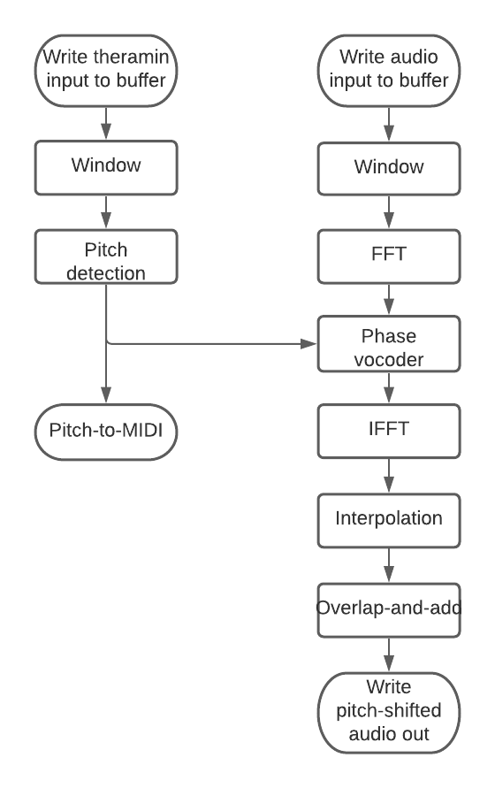

*Figure 1: Software Block Diagram*

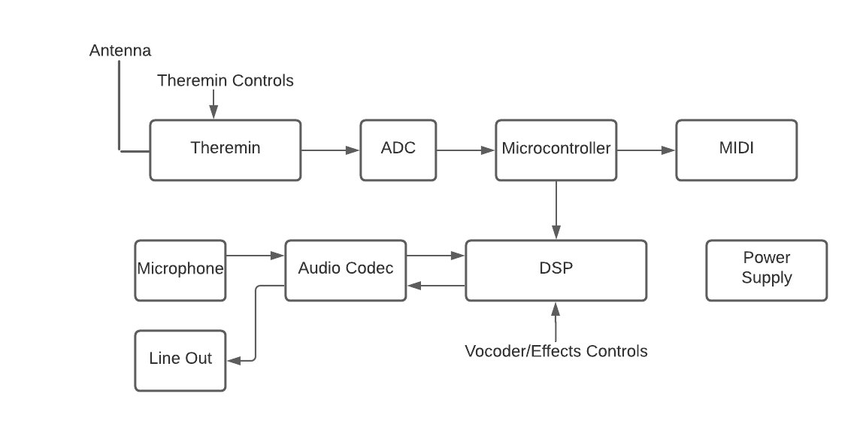

*Figure 2: Hardware Block Diagram*