Table Test include table borders, rows, columns and cells

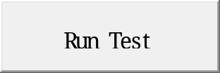

Bookmark1

