clif plugin for jenkins (jenkins-clif-plugin)

Go to /configure

Configure at least one Clif installation

Click “Add Clif”

Standard installation
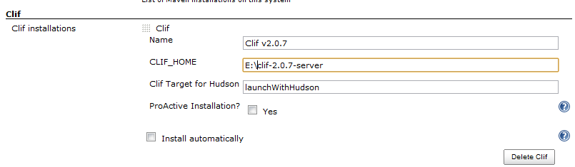

Proactive installation
Check “Proactive installation”

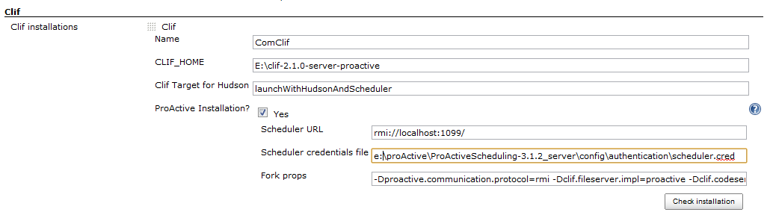
Verify that default parameters fulfill your needs

CAUTION
default value for “Clif Target for Hudson” is not a correct one for a proactive installation
Correct value is “launchWithHudsonAndScheduler”
This must be done manually

Optionally configure where test data will be located

default location is ${JENKINS_HOME}/clif

- path is relative to ${JENKINS_HOME}
- full path can be used

Verify
Clif plugin enables a new root action
This action is available under the root page ( / ) and has label “Import a Clif zip”

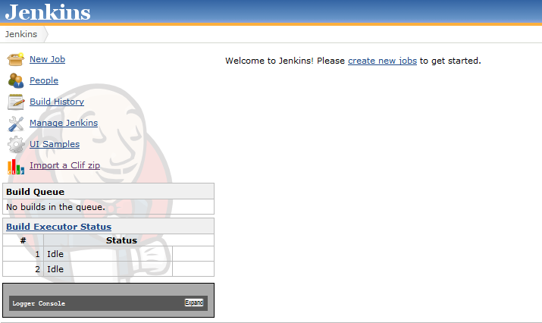

Workflow is the following
- choose a clif zip file
- import
- preview and confim what is to be done
- jobs are created

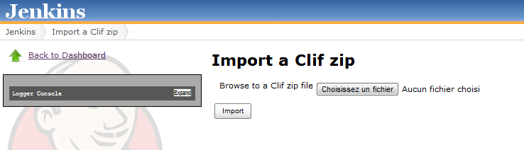

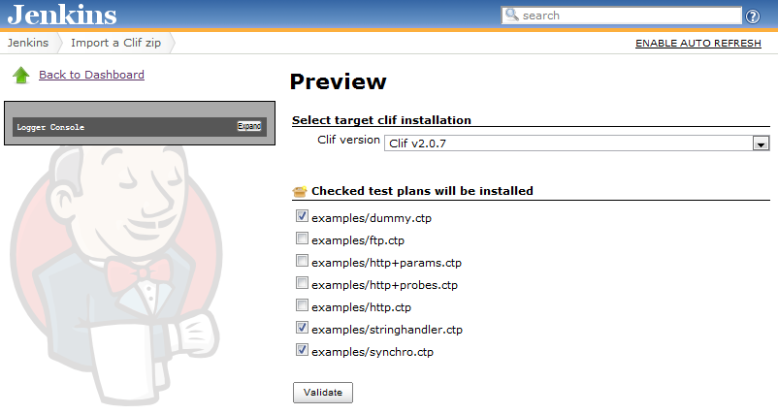
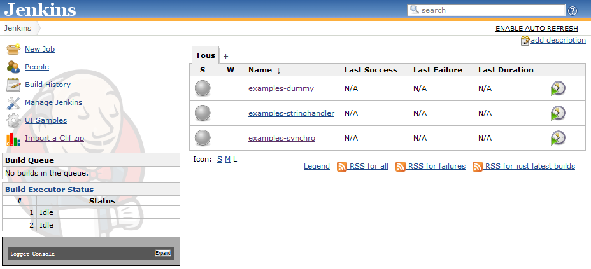

Check and Execute a clif test plan
Default job configuration should be fine
- execute clif test plan
- build reports out of test measures, as a separate publishing action

Known caveat : the more action there is in test measures, the more time the publisher will take (approx 10 images per action)

A workaround can be to tell publisher to merge similar actions, using “Action alias” functionality, that is a regular expression

