Costa Rican Bulk Rock Compositions

Julie M. Coulombe

August 14, 2020

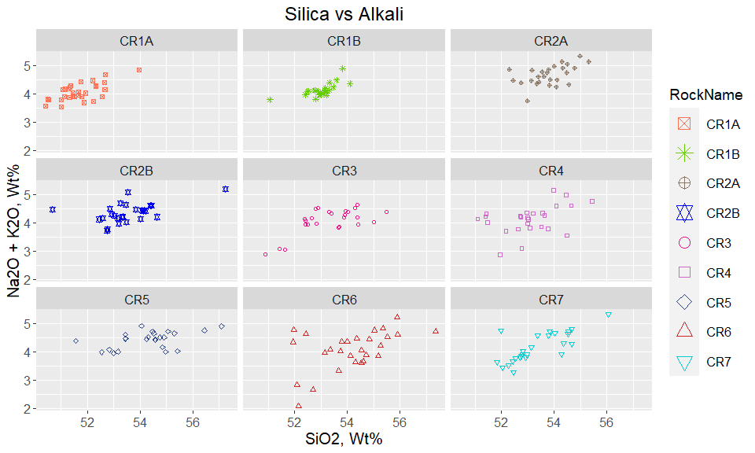

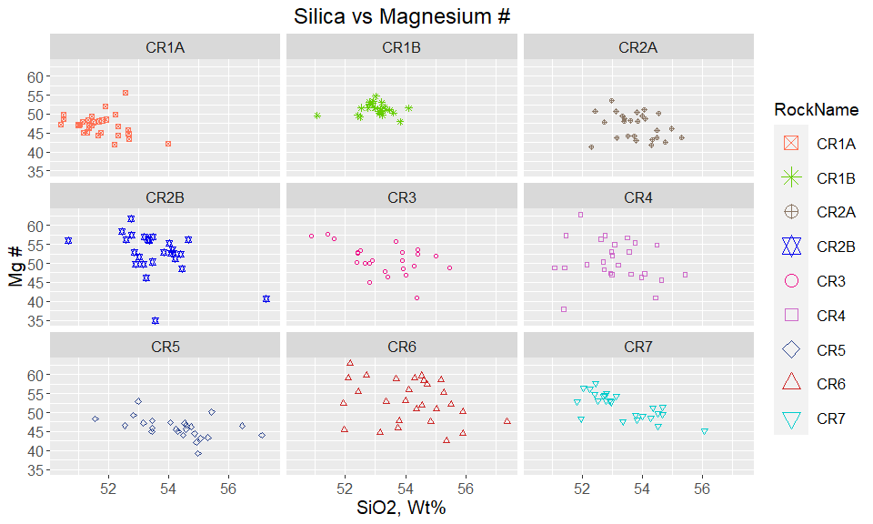

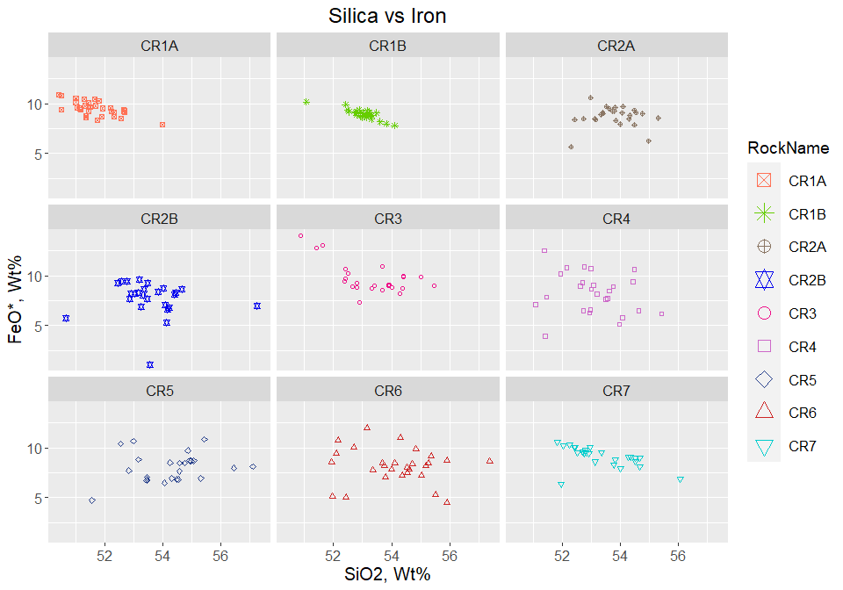

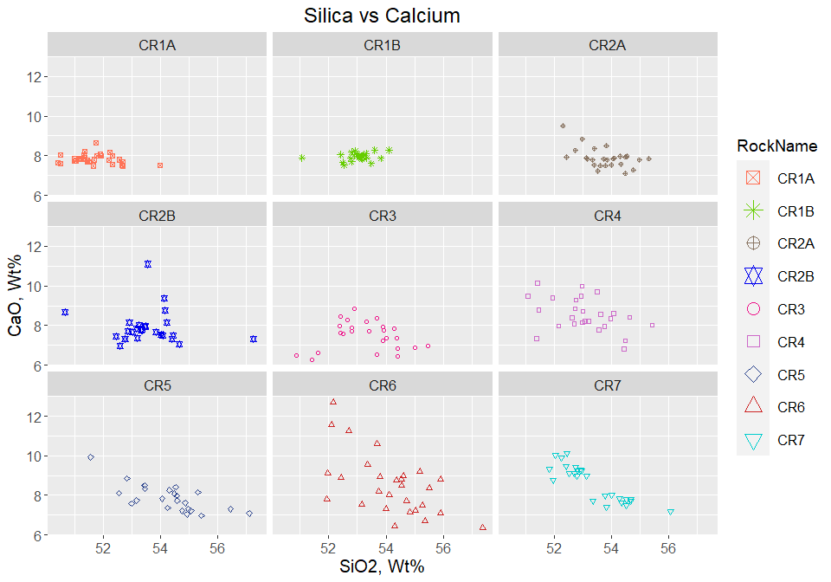

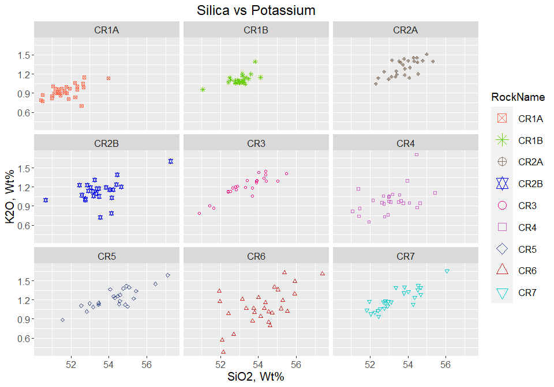

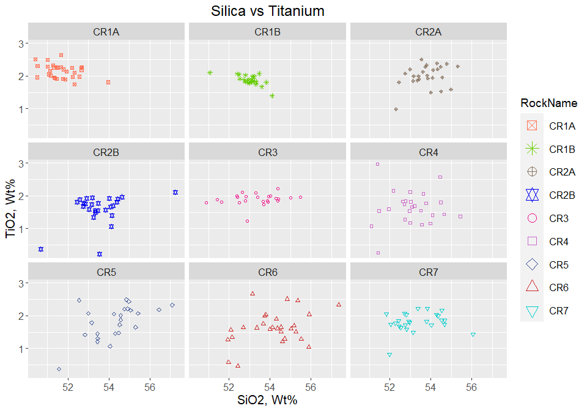

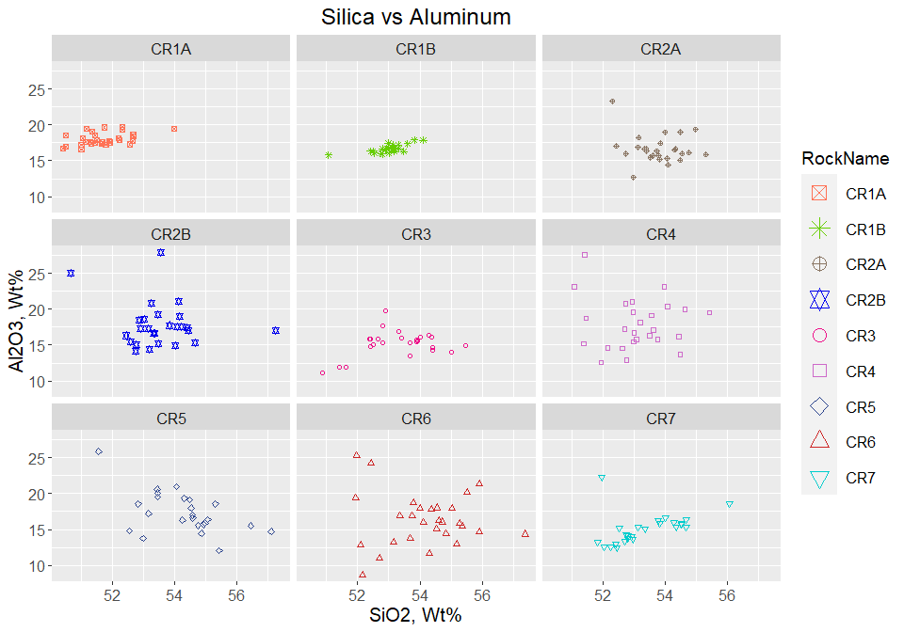

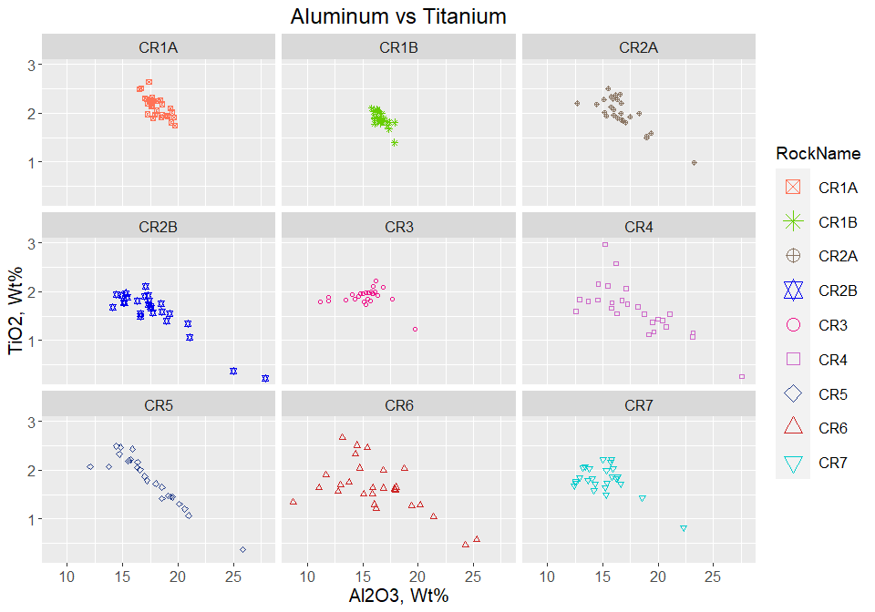

Plot Alkali by Rock Name - Bulk Composition 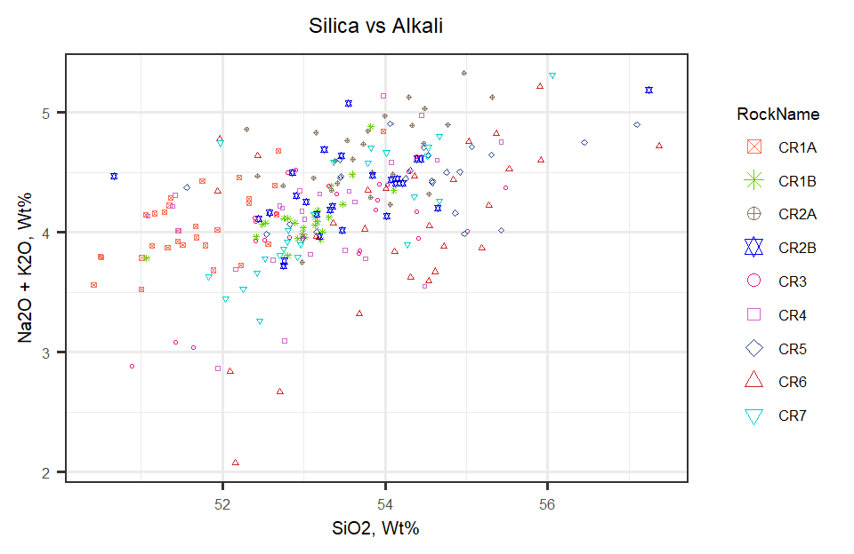

Overlay Alkali Plot on TAS Diagram

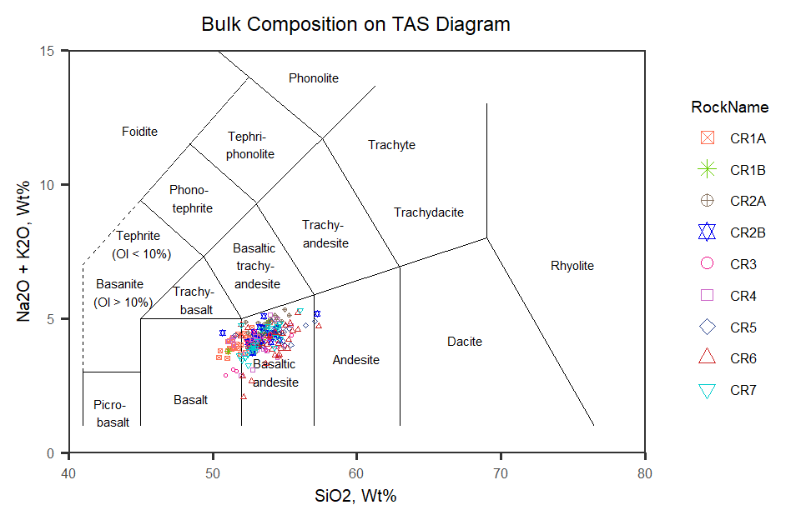

Figure 1: TAS Diagram for bulk rock compositions

Now to look at Harker Diagrams of all rocks plotted together

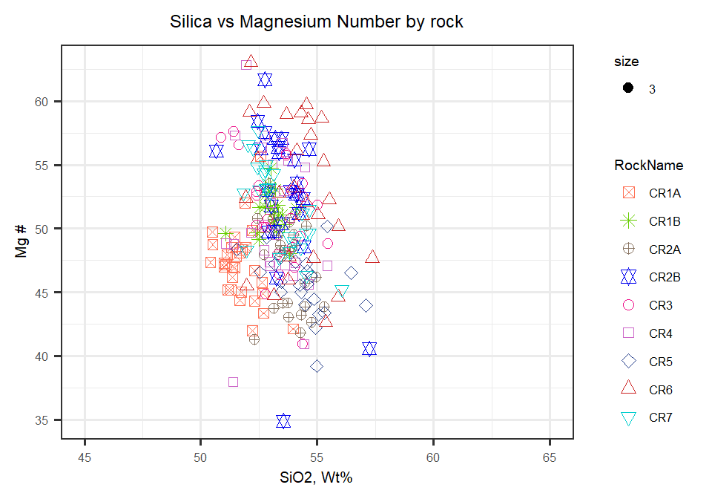

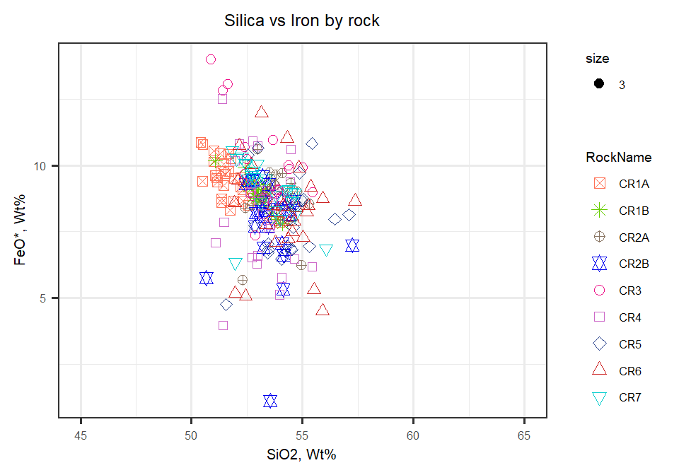

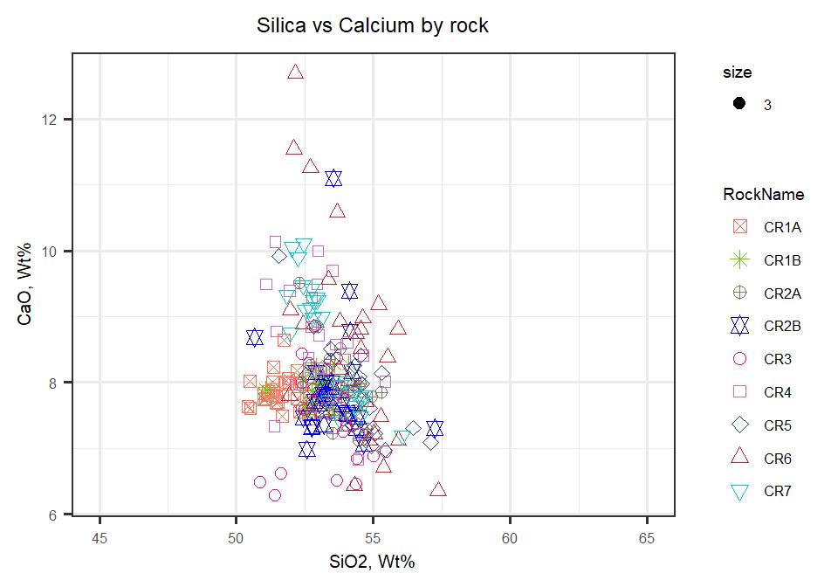

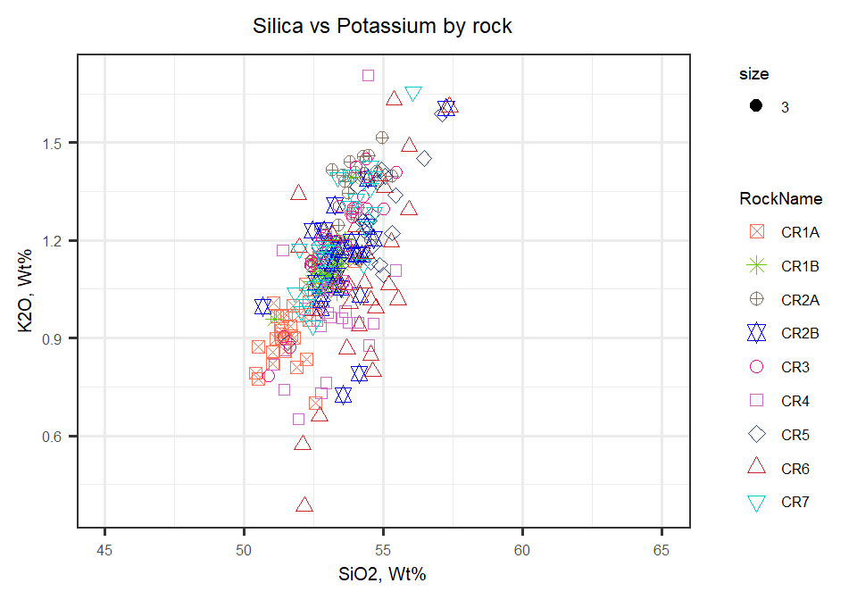

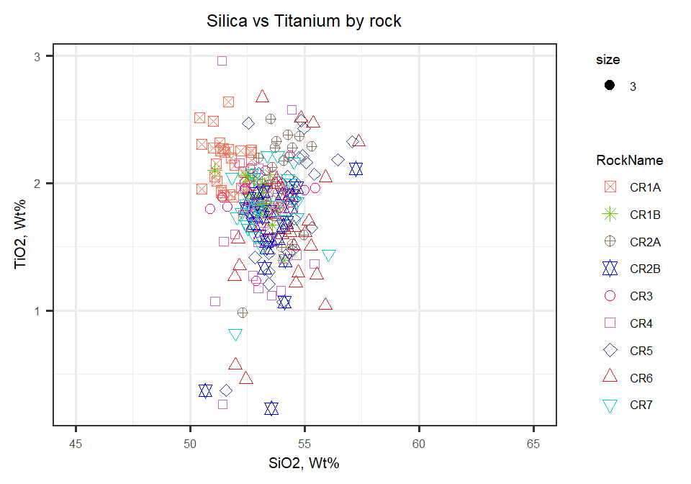

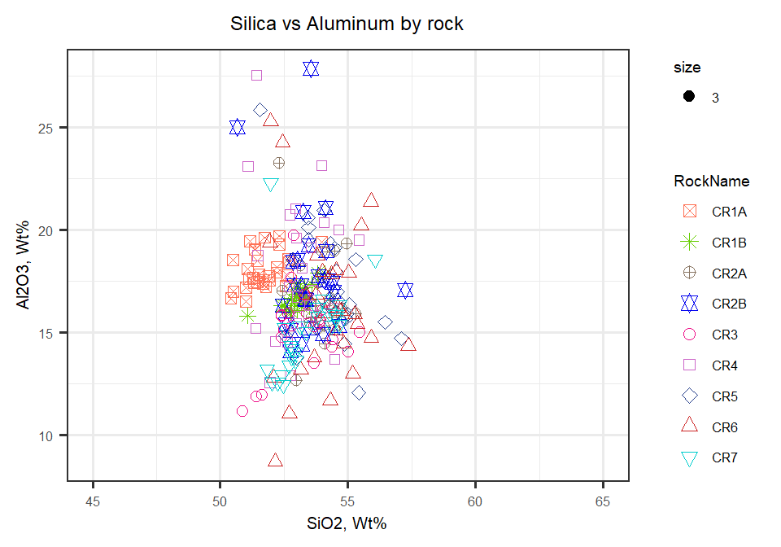

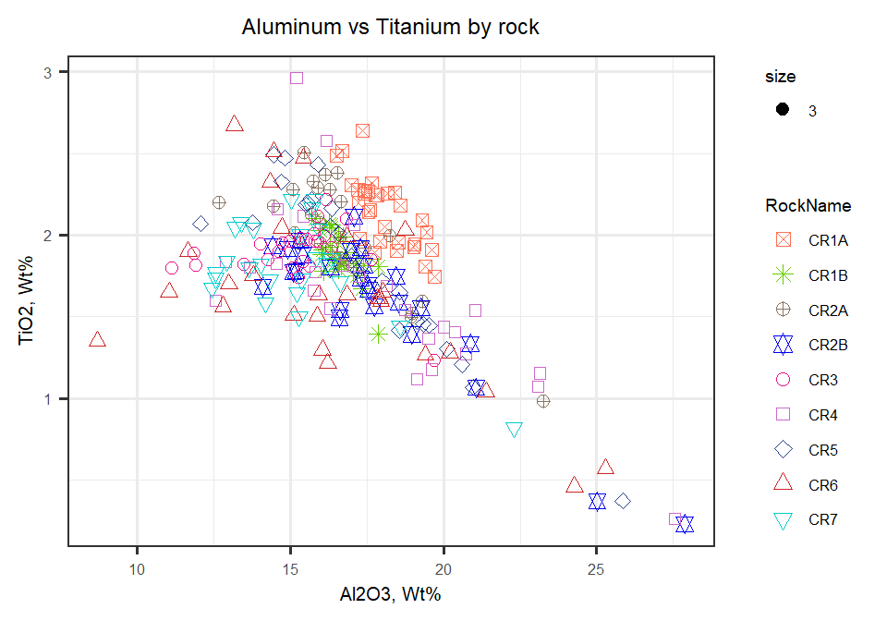

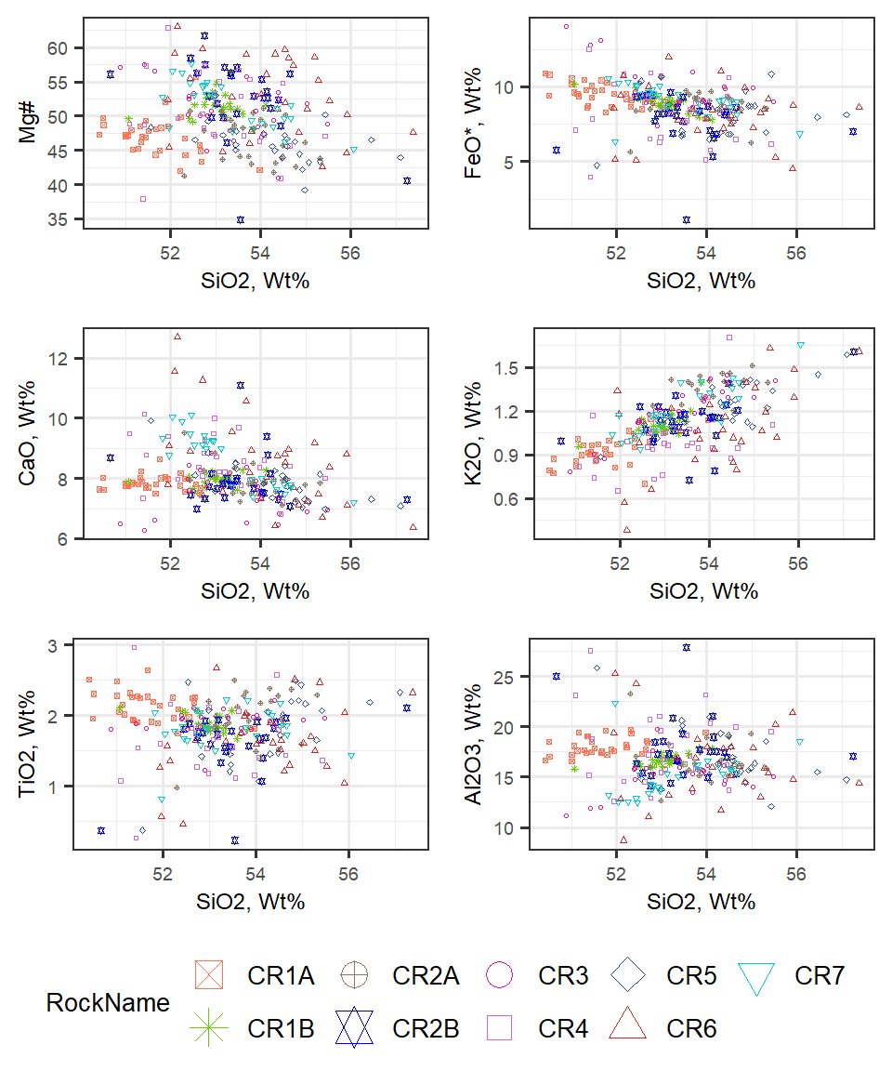

Figure 2: Major elements plotted against SiO2. All Wt% except Mg#

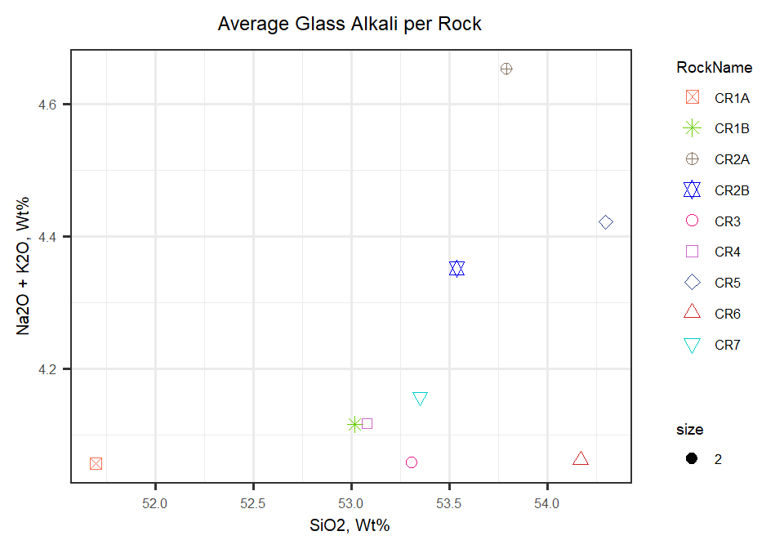

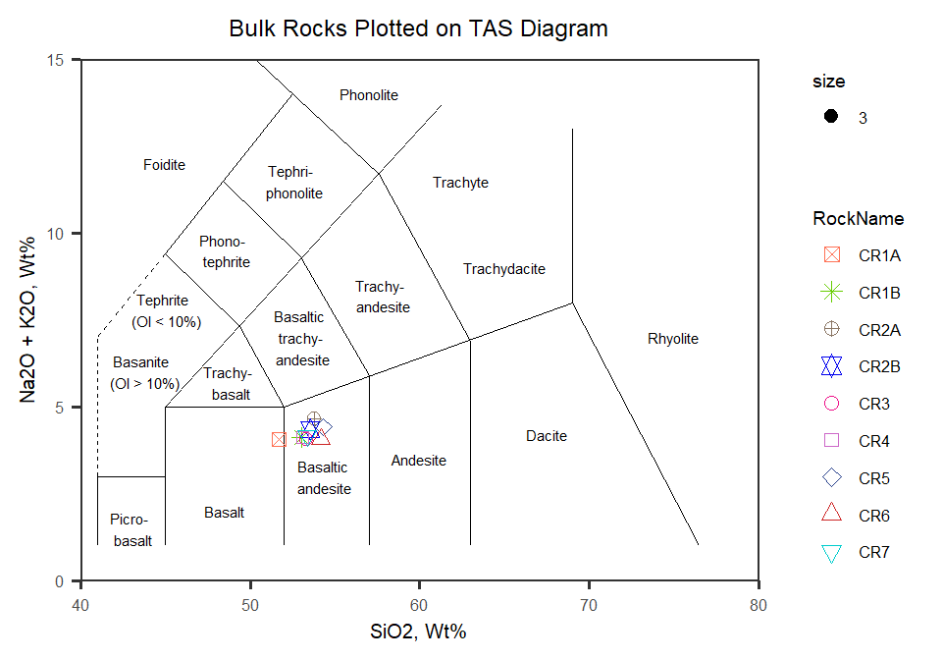

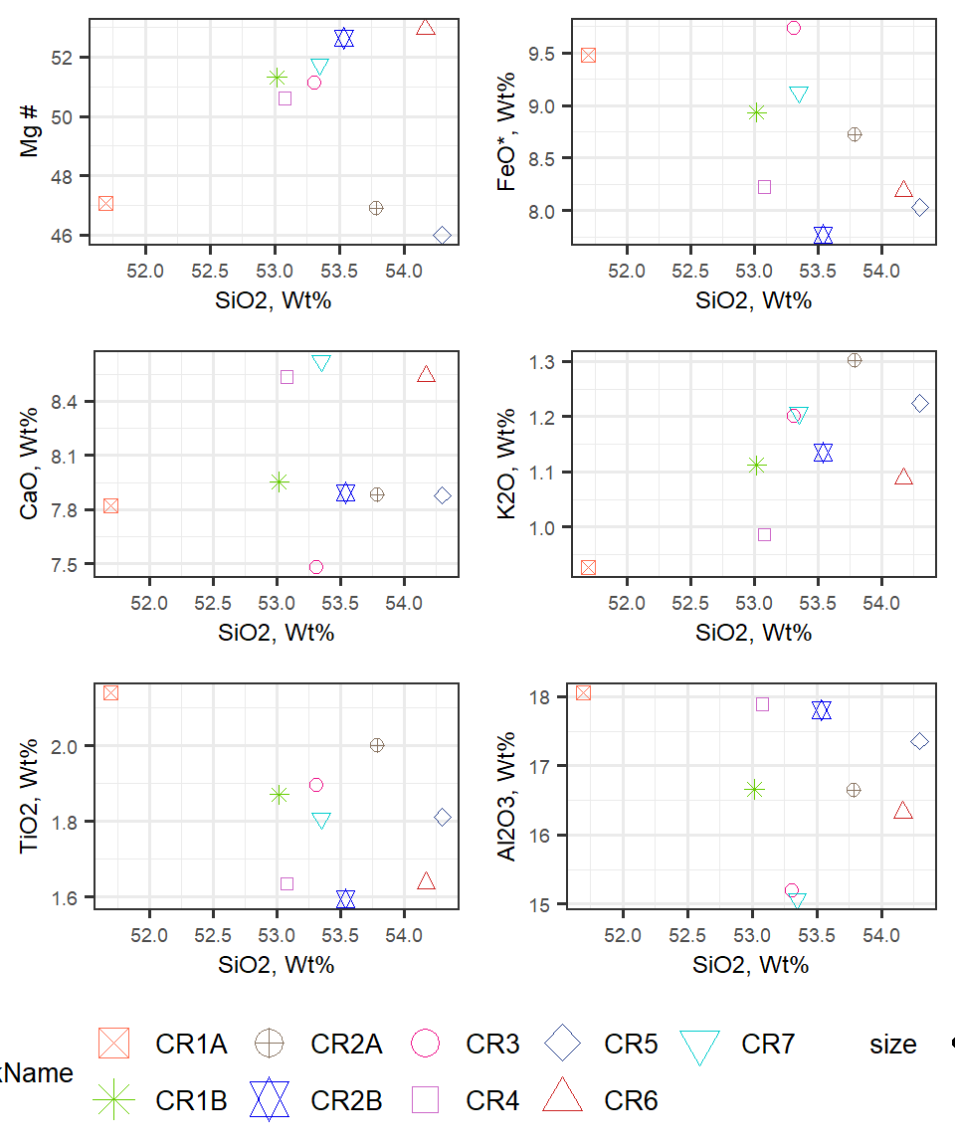

Figure 3: Bulk averages plotted against SiO2. All wt% except Mg#

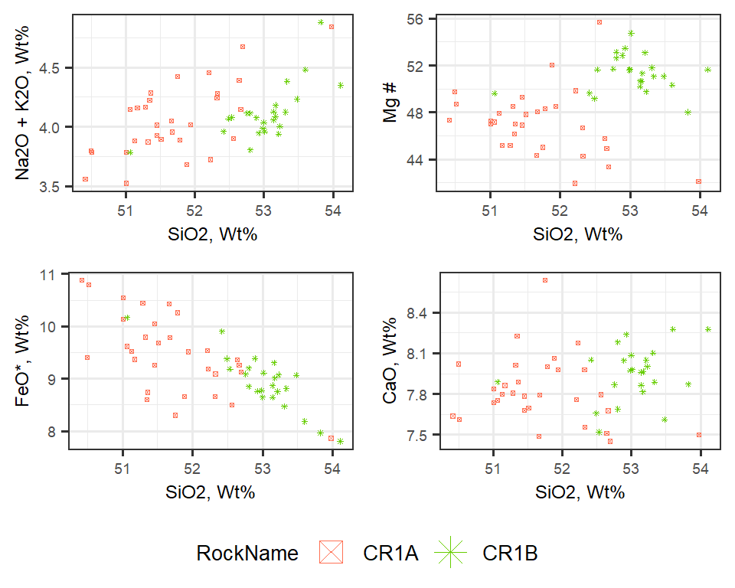

Figure 4: Comparision of CR1A to CR1B

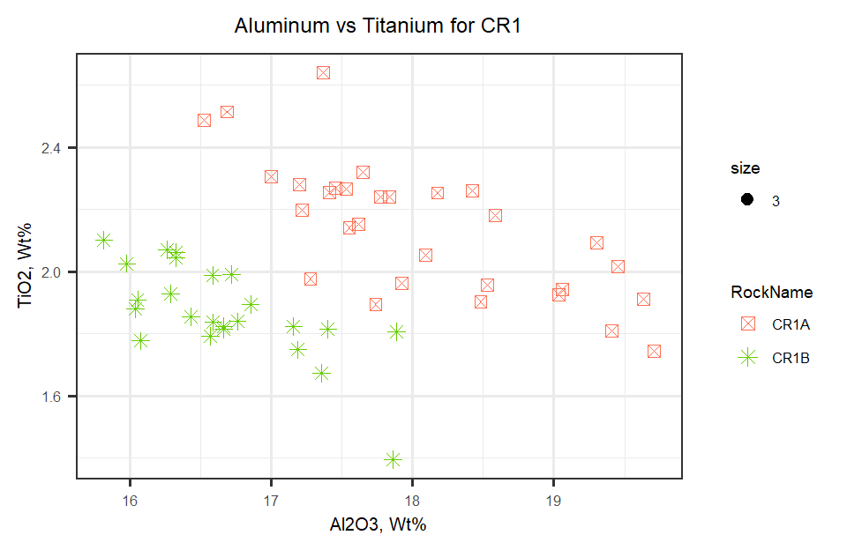

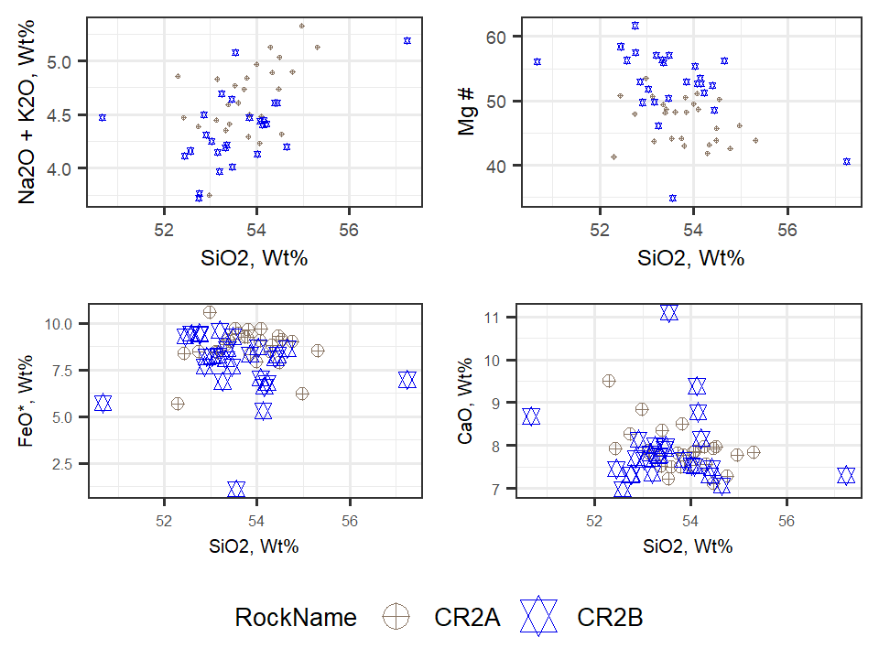

Figure 5: Comparision of CR2A to CR2B

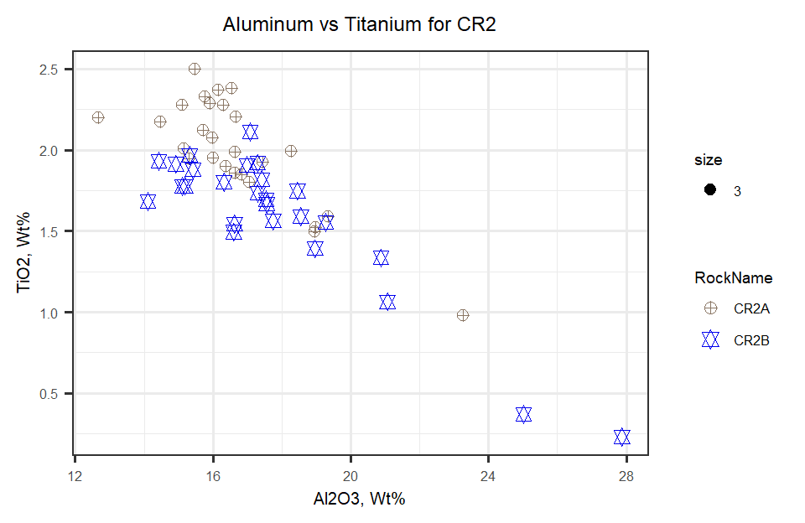

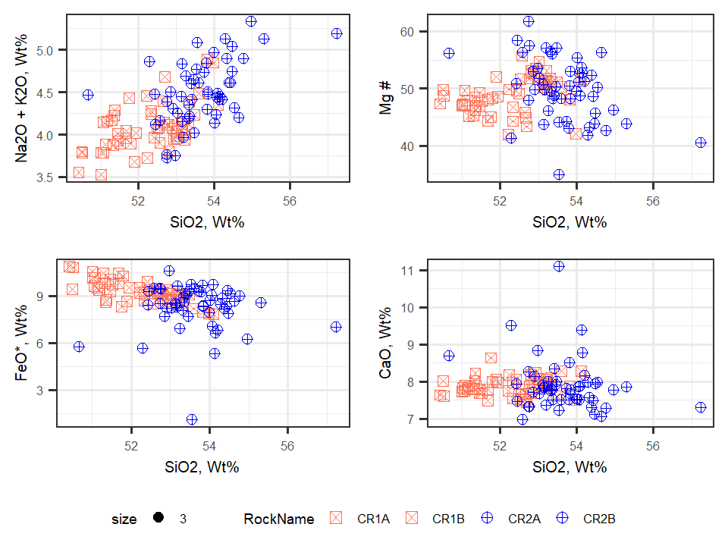

Figure 6: Comparision of CR1 to CR2

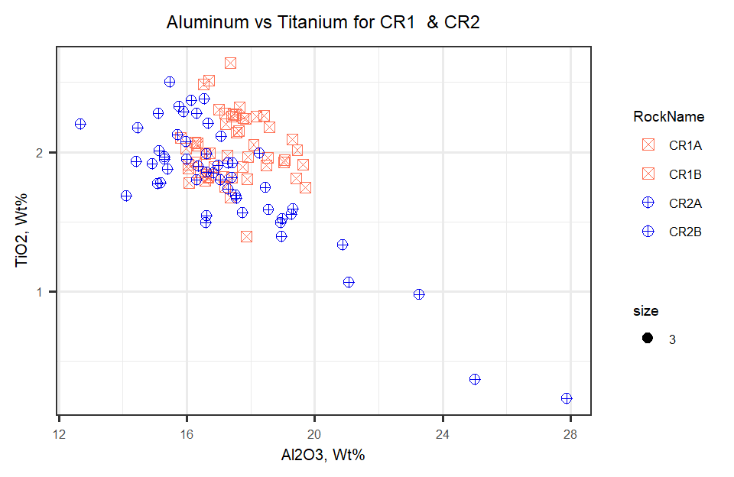

Table indicating mean averages for elements by rock

|  |  |  |  |  |  |  |  |  |  |
| --- | --- | --- | --- | --- | --- | --- | --- | --- | --- |
|  | CR1A | CR1B | CR2A | CR2B | CR3 | CR4 | CR5 | CR6 | CR7 |
| n | 30.000 | 24.000 | 26.000 | 26.000 | 25.000 | 26.000 | 24.000 | 28.000 | 25.000 |
| M SiO2 | 51.696 | 53.016 | 53.789 | 53.535 | 53.307 | 53.076 | 54.295 | 54.168 | 53.348 |
| SD SiO2 | 0.772 | 0.575 | 0.755 | 1.121 | 1.125 | 1.090 | 1.232 | 1.353 | 1.070 |
| M TiO2 | 2.140 | 1.871 | 2.000 | 1.594 | 1.896 | 1.635 | 1.811 | 1.637 | 1.807 |
| SD TiO2 | 0.214 | 0.152 | 0.335 | 0.443 | 0.178 | 0.519 | 0.518 | 0.512 | 0.294 |
| M Al2O3 | 18.055 | 16.662 | 16.651 | 17.806 | 15.197 | 17.891 | 17.357 | 16.327 | 15.070 |
| SD Al2O3 | 0.893 | 0.568 | 1.971 | 3.127 | 1.805 | 3.508 | 2.915 | 3.705 | 2.129 |
| M Cr | 0.022 | 0.026 | 0.017 | 0.024 | 0.026 | 0.030 | 0.025 | 0.028 | 0.029 |
| SD Cr | 0.015 | 0.013 | 0.017 | 0.021 | 0.018 | 0.024 | 0.024 | 0.019 | 0.021 |
| M MgO | 4.757 | 5.291 | 4.380 | 5.102 | 5.881 | 4.890 | 3.873 | 5.378 | 5.593 |
| SD MgO | 0.633 | 0.437 | 0.911 | 1.734 | 1.824 | 1.814 | 0.973 | 1.916 | 1.246 |
| M CaO | 7.823 | 7.952 | 7.882 | 7.892 | 7.481 | 8.533 | 7.877 | 8.536 | 8.623 |
| SD CaO | 0.253 | 0.201 | 0.505 | 0.850 | 0.706 | 0.839 | 0.687 | 1.537 | 0.913 |
| M MnO | 0.149 | 0.147 | 0.134 | 0.131 | 0.168 | 0.139 | 0.128 | 0.148 | 0.162 |
| SD MnO | 0.021 | 0.018 | 0.028 | 0.036 | 0.038 | 0.045 | 0.027 | 0.038 | 0.037 |
| M FeO | 9.479 | 8.933 | 8.721 | 7.765 | 9.729 | 8.224 | 8.031 | 8.185 | 9.123 |
| SD FeO | 0.752 | 0.532 | 1.017 | 1.776 | 1.555 | 2.053 | 1.455 | 1.760 | 1.028 |
| M Na2O | 3.129 | 3.003 | 3.352 | 3.216 | 2.858 | 3.131 | 3.197 | 2.974 | 2.951 |
| SD Na2O | 0.227 | 0.169 | 0.262 | 0.333 | 0.324 | 0.401 | 0.241 | 0.481 | 0.363 |
| M K2O | 0.928 | 1.112 | 1.301 | 1.135 | 1.200 | 0.986 | 1.224 | 1.087 | 1.206 |
| SD K2O | 0.101 | 0.080 | 0.131 | 0.171 | 0.168 | 0.205 | 0.157 | 0.290 | 0.172 |
| M S | 0.007 | 0.009 | 0.007 | 0.007 | 0.008 | 0.005 | 0.007 | 0.004 | 0.007 |
| SD S | 0.007 | 0.009 | 0.007 | 0.007 | 0.008 | 0.007 | 0.008 | 0.006 | 0.008 |
| M P2O5 | 0.395 | 0.349 | 0.421 | 0.322 | 0.349 | 0.255 | 0.275 | 0.299 | 0.346 |
| SD P2O5 | 0.061 | 0.034 | 0.164 | 0.098 | 0.070 | 0.089 | 0.090 | 0.116 | 0.082 |
| M MgN | 47.072 | 51.310 | 46.885 | 52.628 | 51.122 | 50.607 | 45.997 | 52.952 | 51.736 |
| SD MgN | 2.802 | 1.540 | 3.414 | 5.641 | 4.009 | 5.489 | 2.803 | 5.645 | 3.386 |
| M Total | 98.820 | 98.826 | 98.943 | 99.010 | 98.836 | 99.071 | 98.520 | 98.894 | 98.858 |
| SD Total | 0.444 | 0.384 | 0.515 | 0.436 | 0.331 | 0.422 | 0.388 | 0.344 | 0.252 |

Mean averages for major elements

|  |  |  |  |  |  |  |  |  |  |
| --- | --- | --- | --- | --- | --- | --- | --- | --- | --- |
|  | CR1A | CR1B | CR2A | CR2B | CR3 | CR4 | CR5 | CR6 | CR7 |
| n | 30.000 | 24.000 | 26.000 | 26.000 | 25.000 | 26.000 | 24.000 | 28.000 | 25.000 |
| SiO2 | 51.696 | 53.016 | 53.789 | 53.535 | 53.307 | 53.076 | 54.295 | 54.168 | 53.348 |
| TiO2 | 2.140 | 1.871 | 2.000 | 1.594 | 1.896 | 1.635 | 1.811 | 1.637 | 1.807 |
| Al2O3 | 18.055 | 16.662 | 16.651 | 17.806 | 15.197 | 17.891 | 17.357 | 16.327 | 15.070 |
| Cr | 0.022 | 0.026 | 0.017 | 0.024 | 0.026 | 0.030 | 0.025 | 0.028 | 0.029 |
| MgO | 4.757 | 5.291 | 4.380 | 5.102 | 5.881 | 4.890 | 3.873 | 5.378 | 5.593 |
| CaO | 7.823 | 7.952 | 7.882 | 7.892 | 7.481 | 8.533 | 7.877 | 8.536 | 8.623 |
| MnO | 0.149 | 0.147 | 0.134 | 0.131 | 0.168 | 0.139 | 0.128 | 0.148 | 0.162 |
| FeO | 9.479 | 8.933 | 8.721 | 7.765 | 9.729 | 8.224 | 8.031 | 8.185 | 9.123 |
| Na2O | 3.129 | 3.003 | 3.352 | 3.216 | 2.858 | 3.131 | 3.197 | 2.974 | 2.951 |
| K2O | 0.928 | 1.112 | 1.301 | 1.135 | 1.200 | 0.986 | 1.224 | 1.087 | 1.206 |
| S | 0.007 | 0.009 | 0.007 | 0.007 | 0.008 | 0.005 | 0.007 | 0.004 | 0.007 |
| P2O5 | 0.395 | 0.349 | 0.421 | 0.322 | 0.349 | 0.255 | 0.275 | 0.299 | 0.346 |
| MgN | 47.072 | 51.310 | 46.885 | 52.628 | 51.122 | 50.607 | 45.997 | 52.952 | 51.736 |
| Total | 98.820 | 98.826 | 98.943 | 99.010 | 98.836 | 99.071 | 98.520 | 98.894 | 98.858 |