Costa Rican Bulk Rock Compositions

Julie M. Coulombe

September 21, 2020

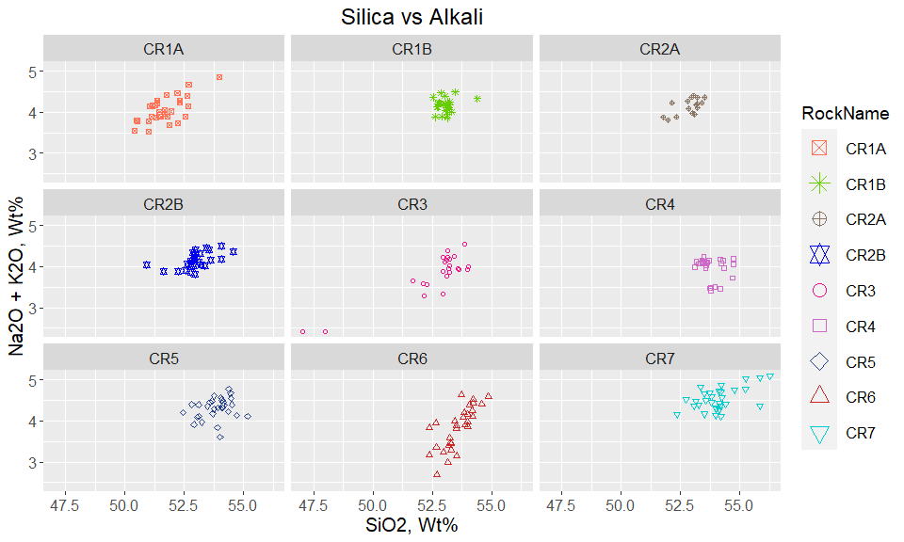

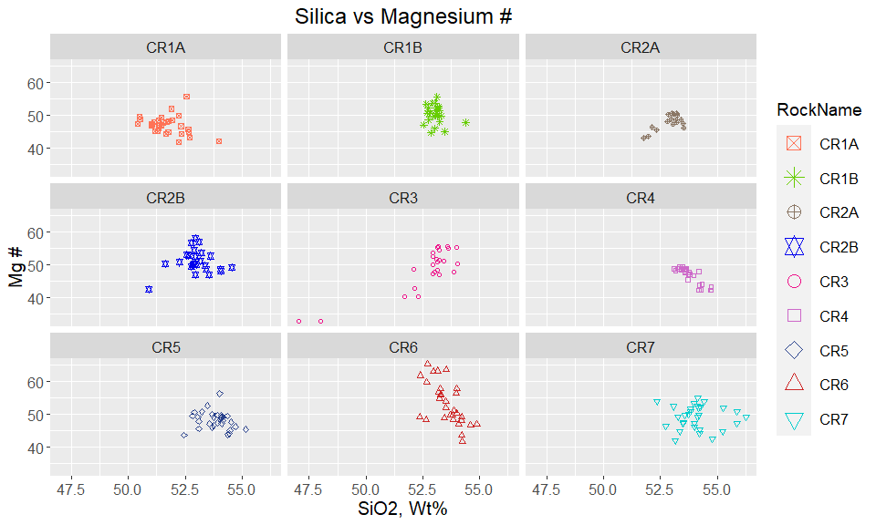

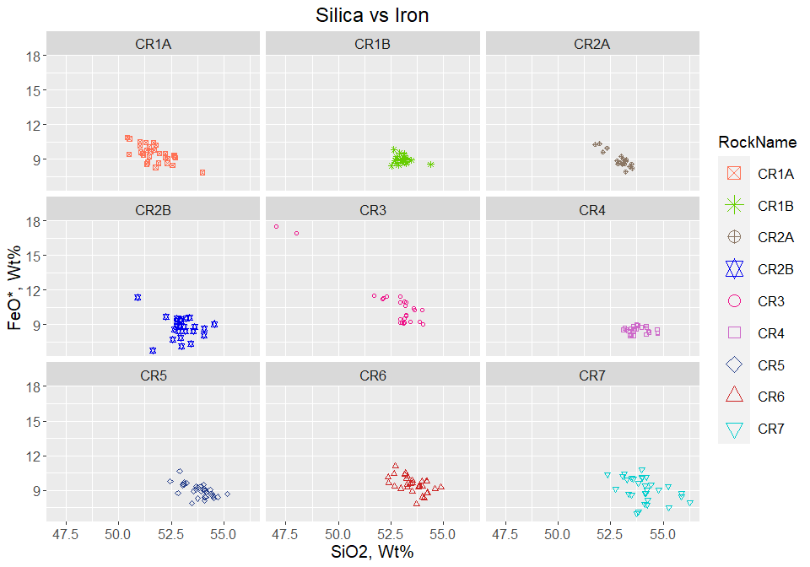

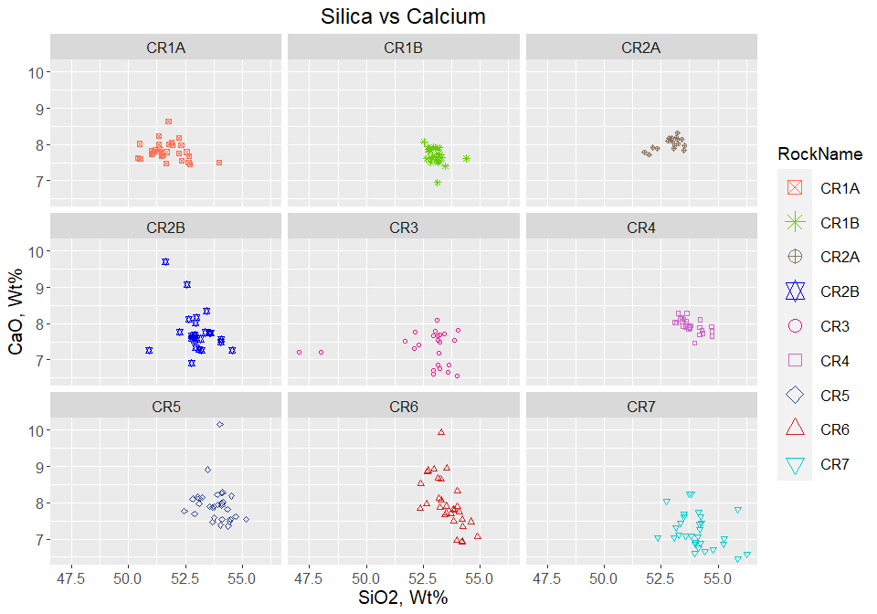

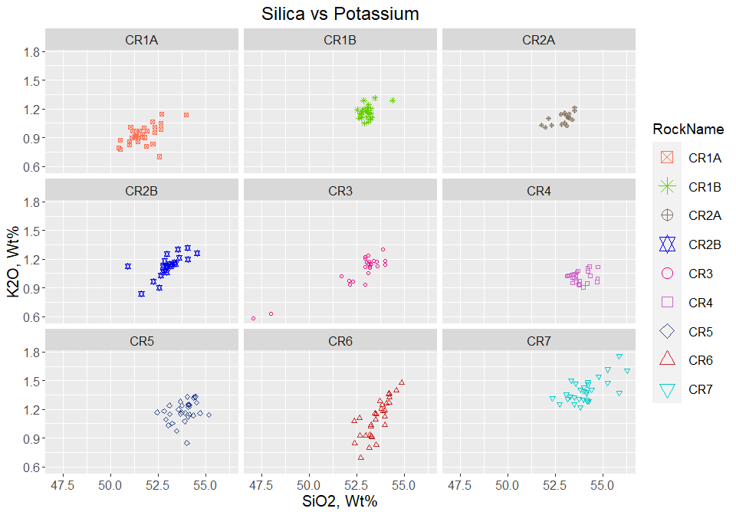

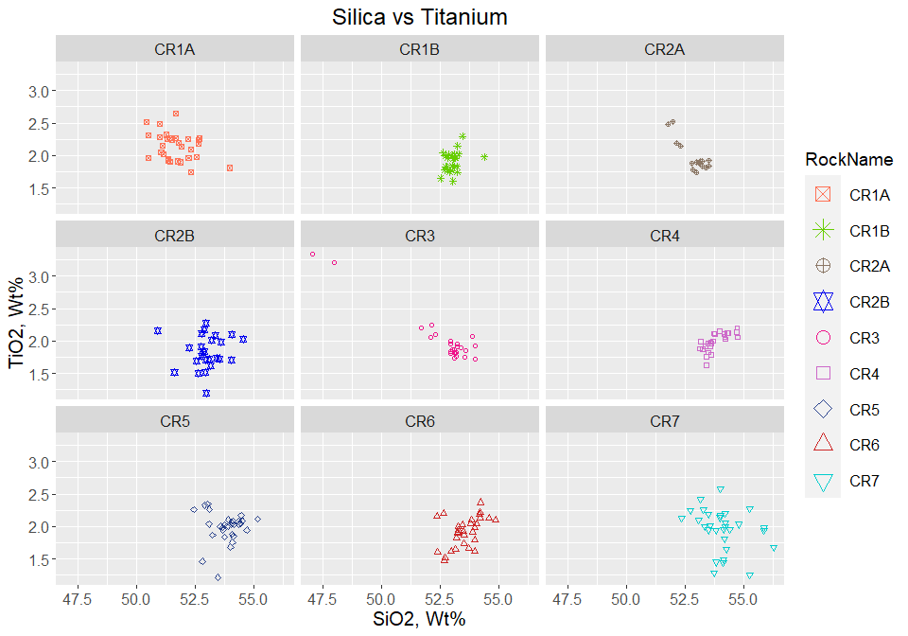

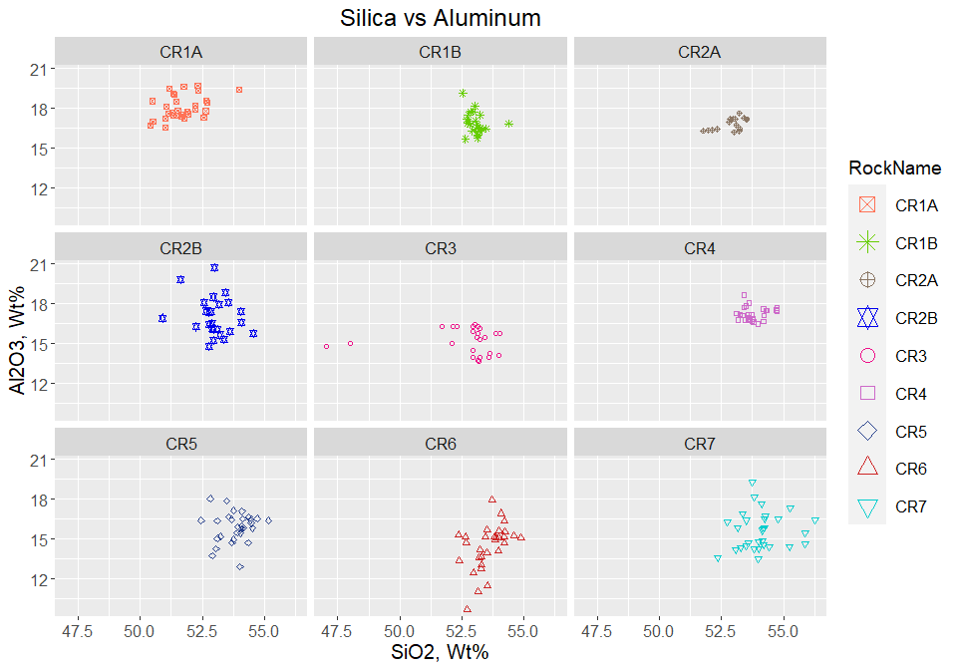

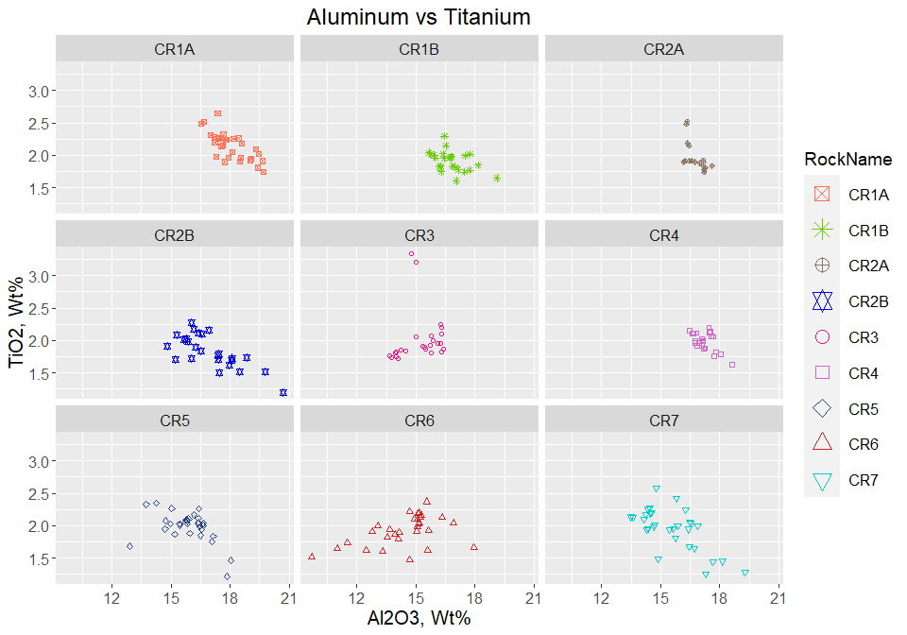

Plot Alkali by Rock Name - Bulk Composition 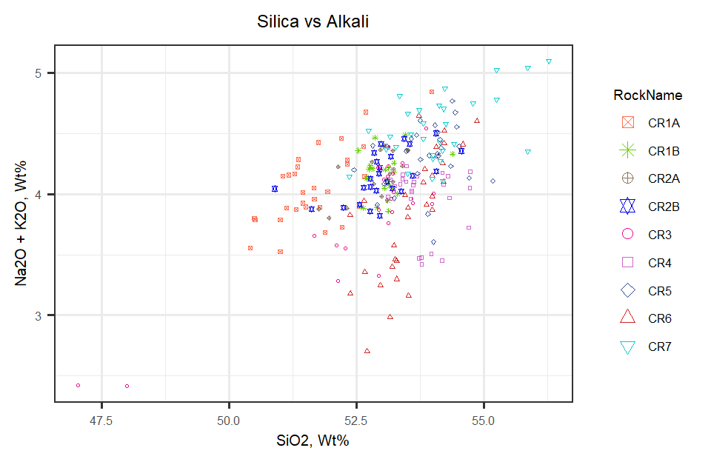

Overlay Alkali Plot on TAS Diagram

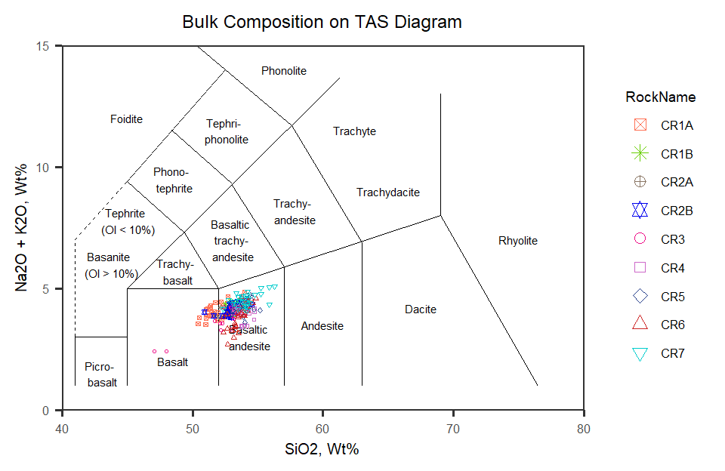

Figure 1: TAS Diagram for bulk rock compositions

Now to look at Harker Diagrams of all rocks plotted together

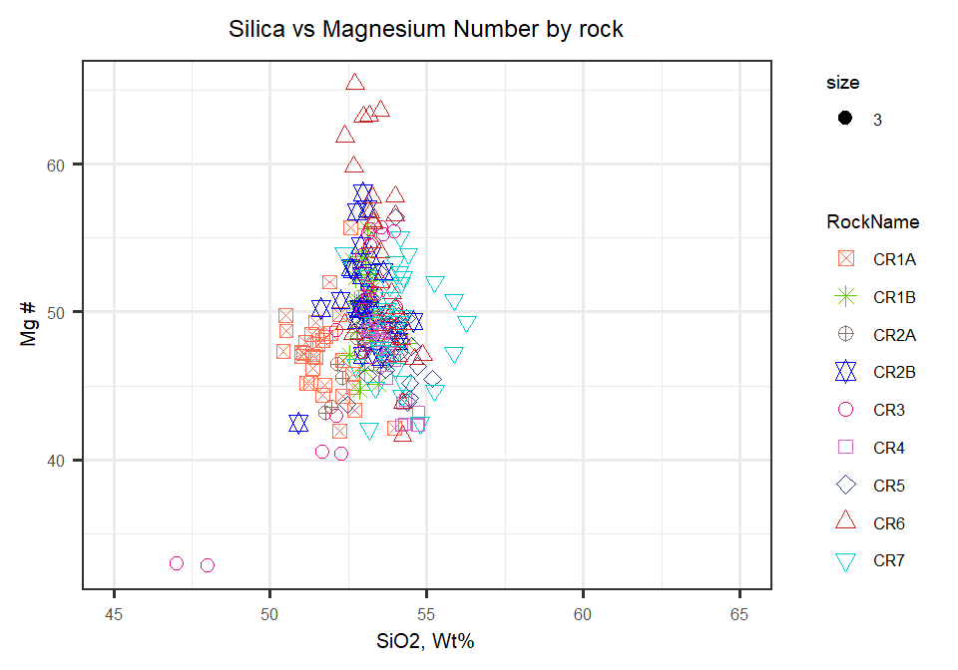

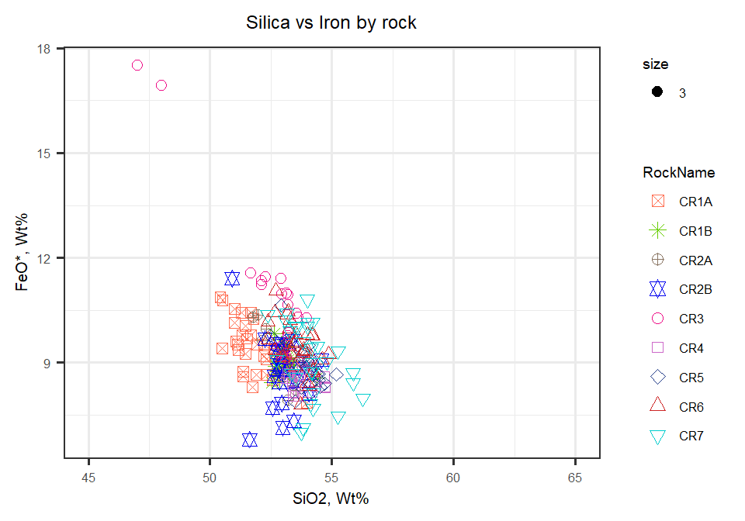

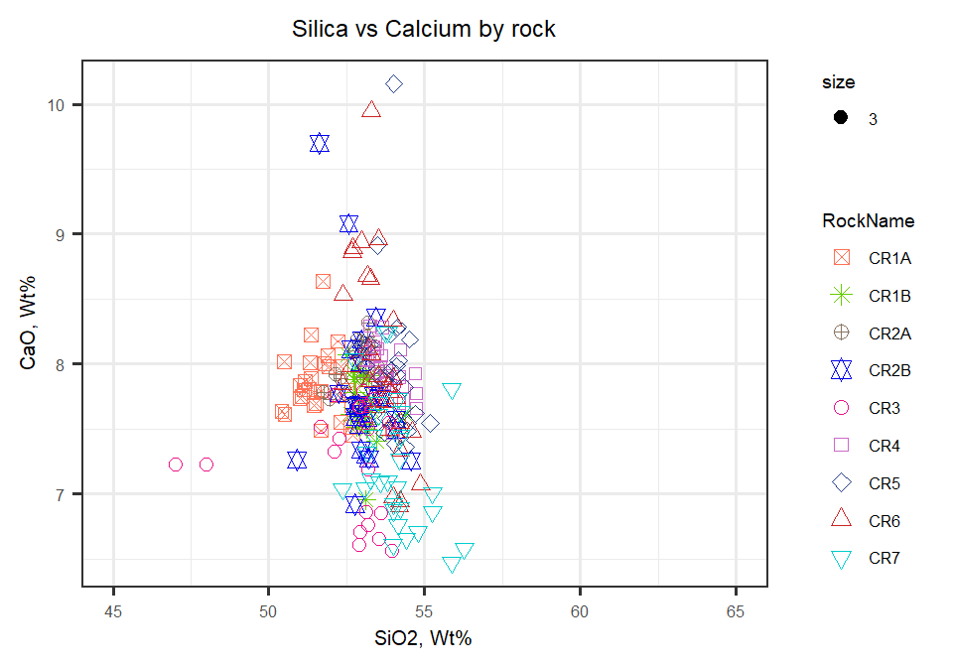

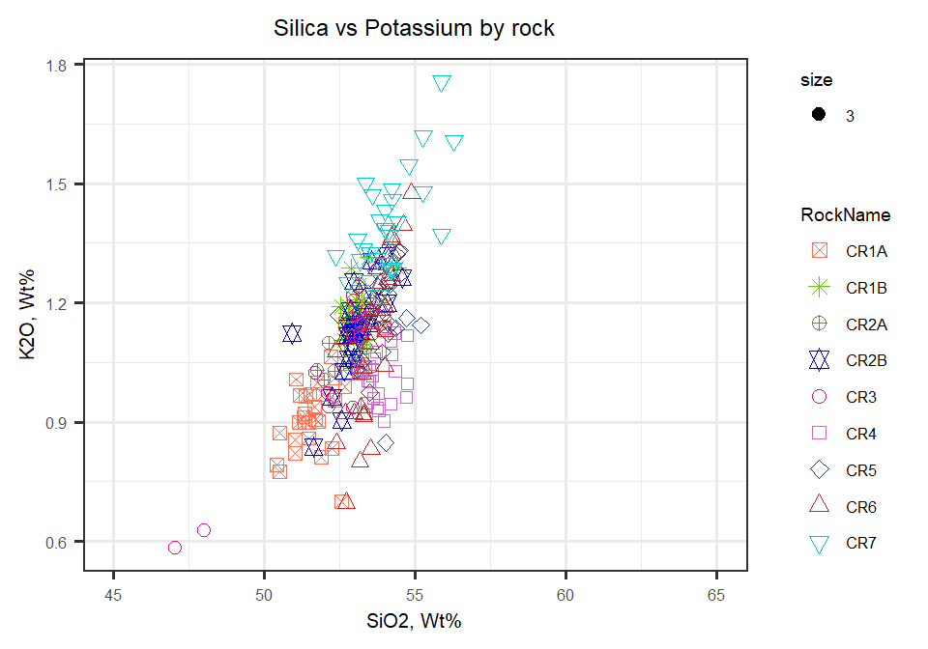

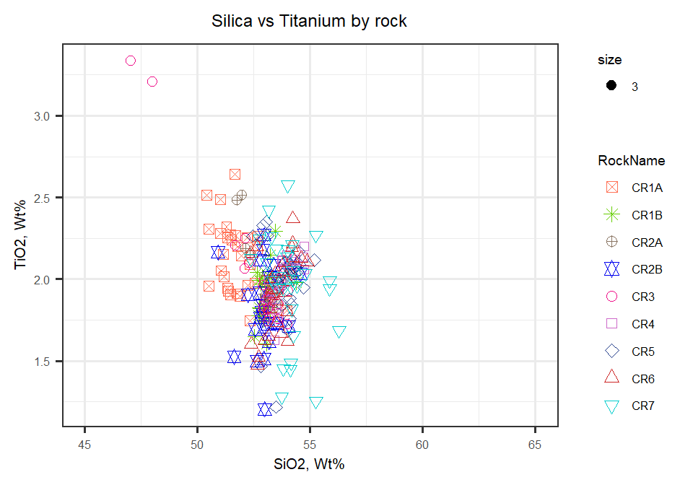

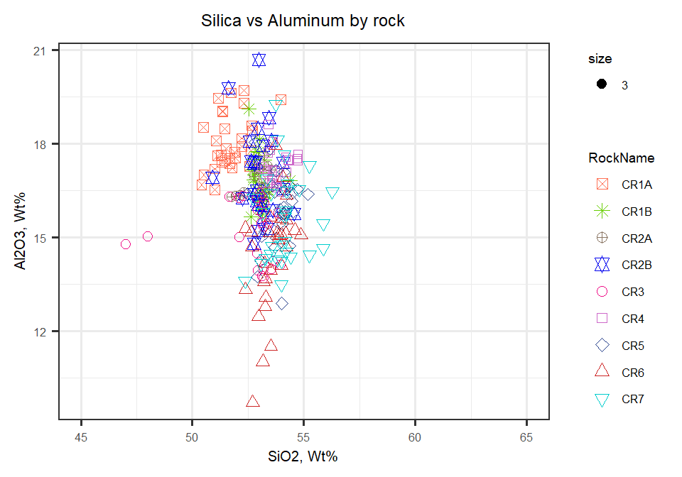

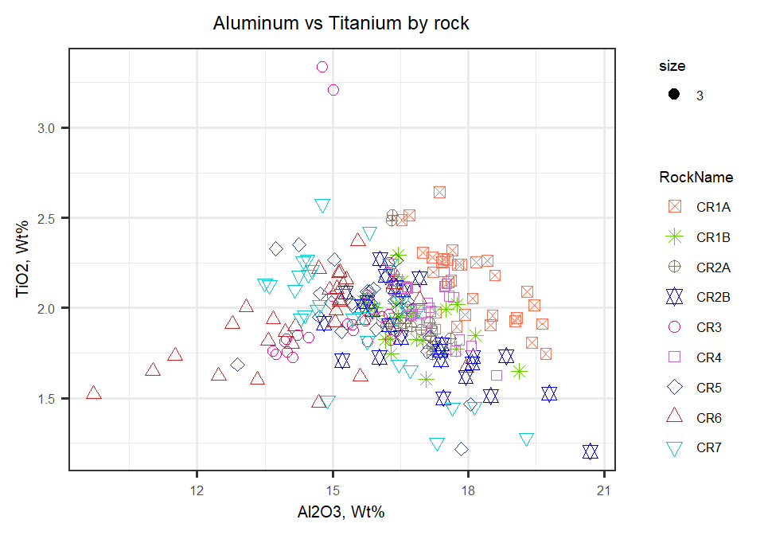

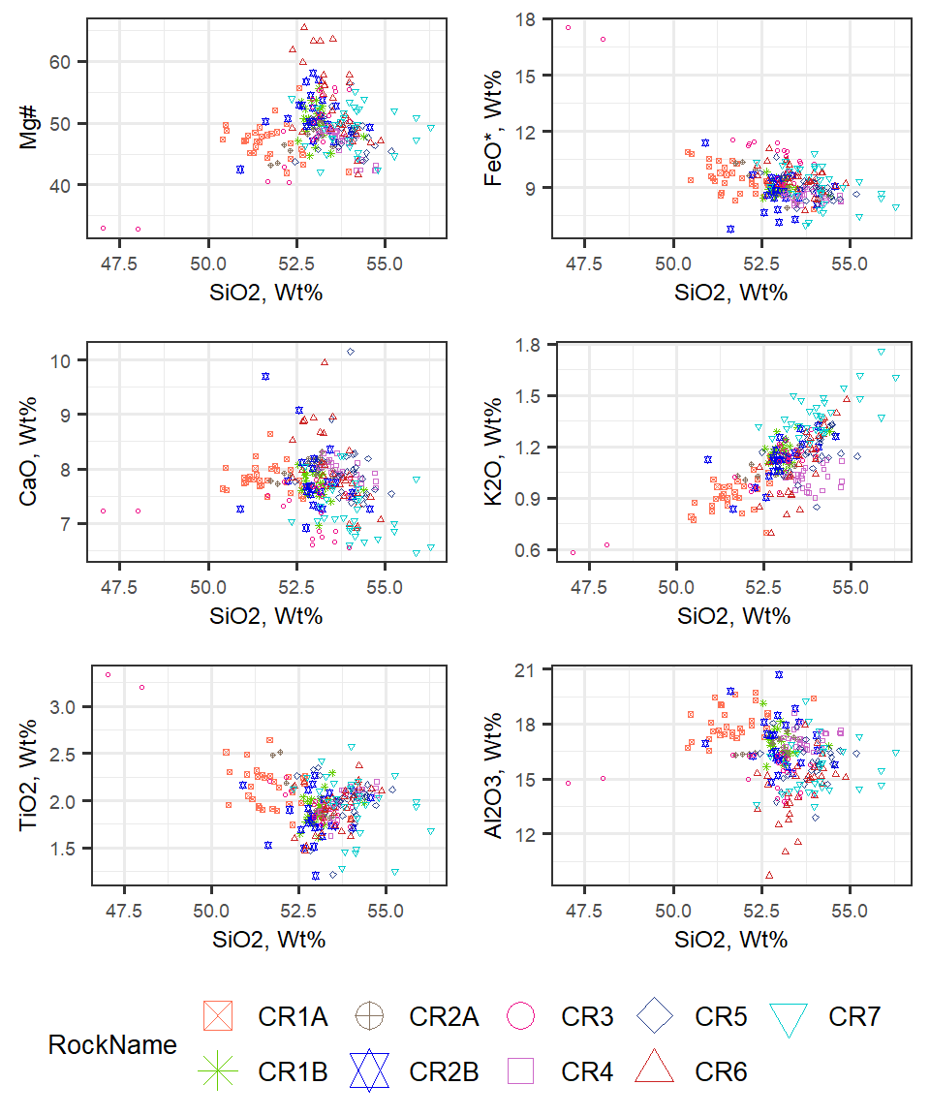

Figure 2: Major elements plotted against SiO2. All Wt% except Mg#

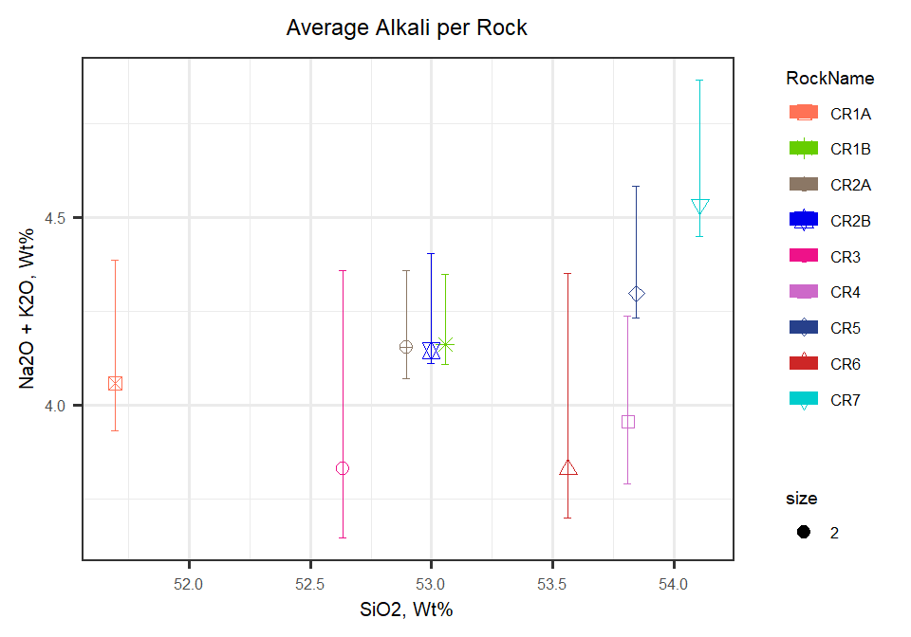

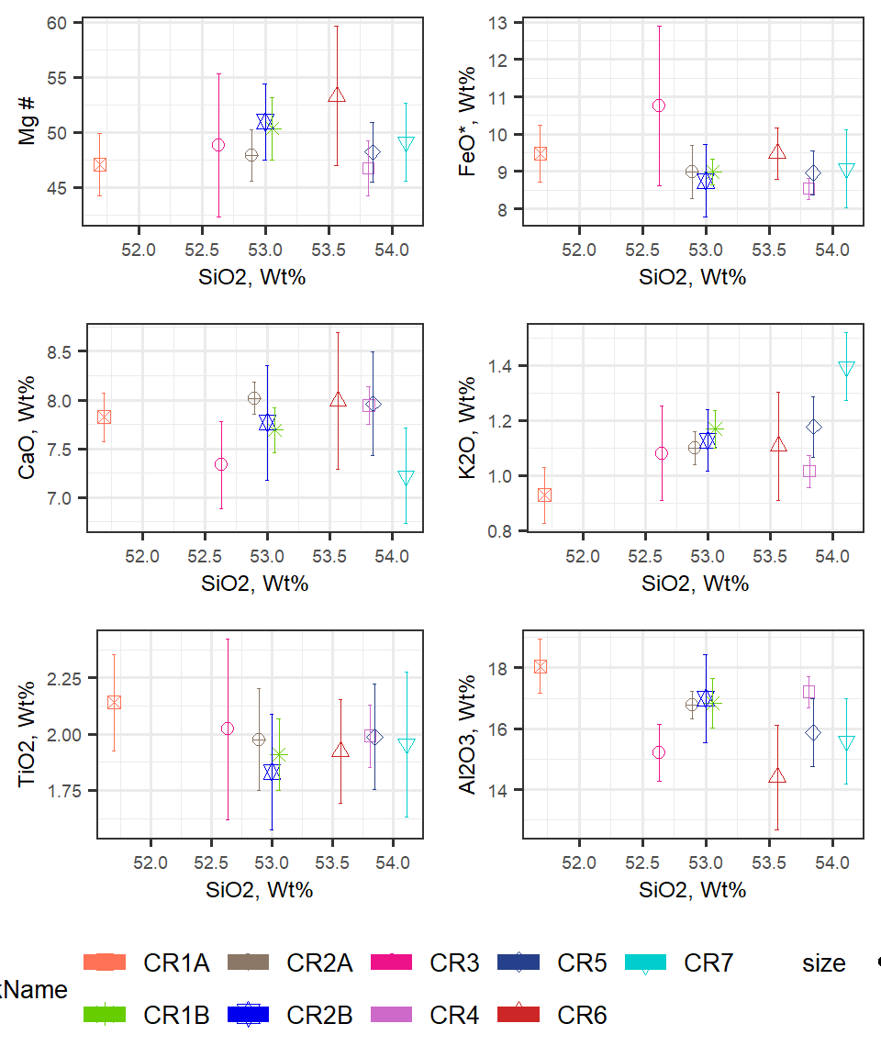

Figure 3: Bulk averages plotted against SiO2. All wt% except Mg#

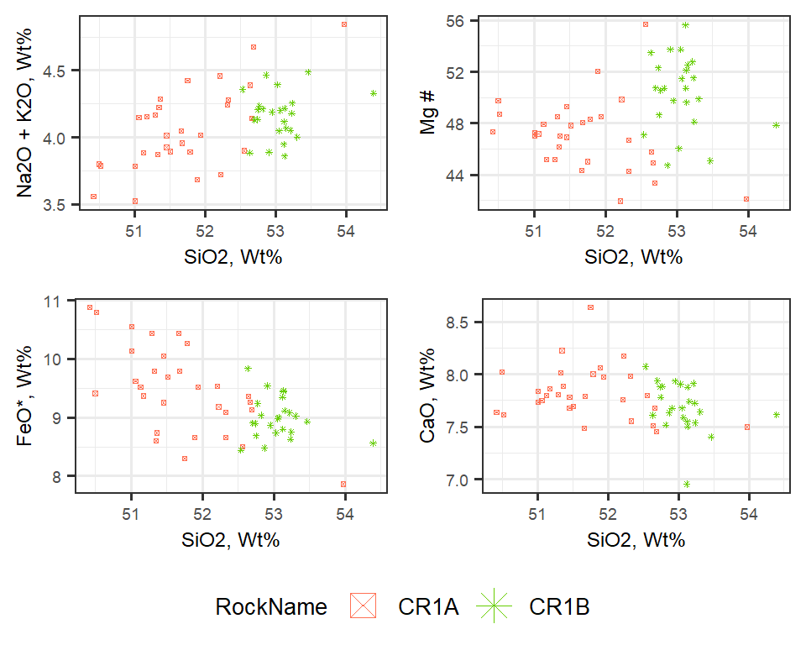

Figure 4: Comparision of CR1A to CR1B

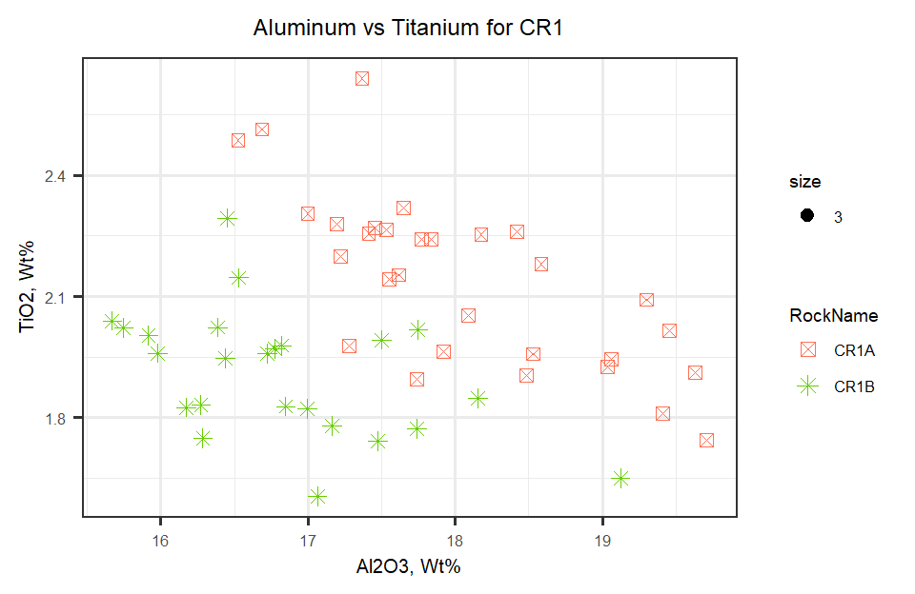

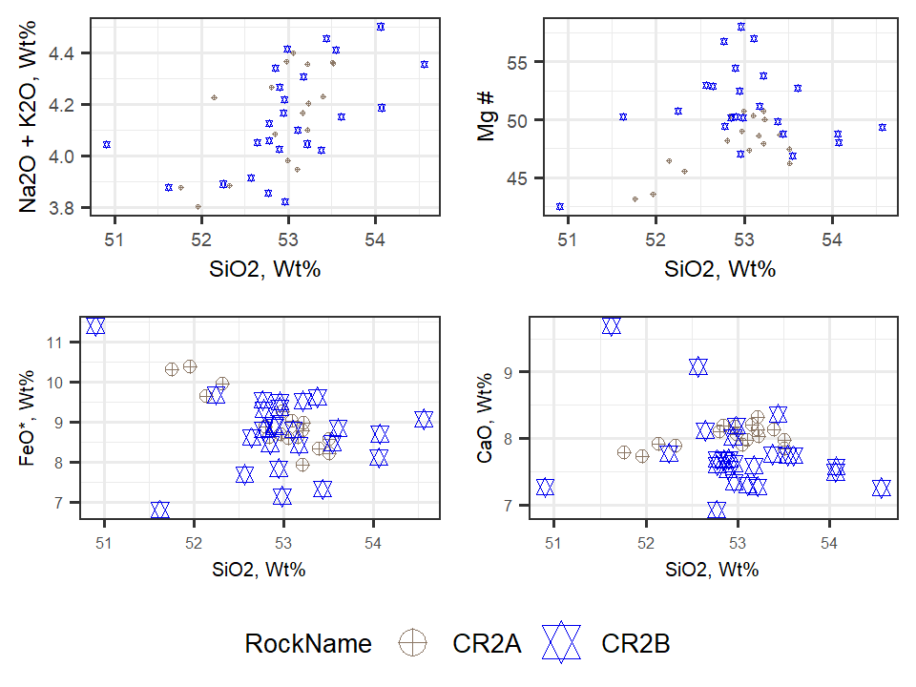

Figure 5: Comparision of CR2A to CR2B

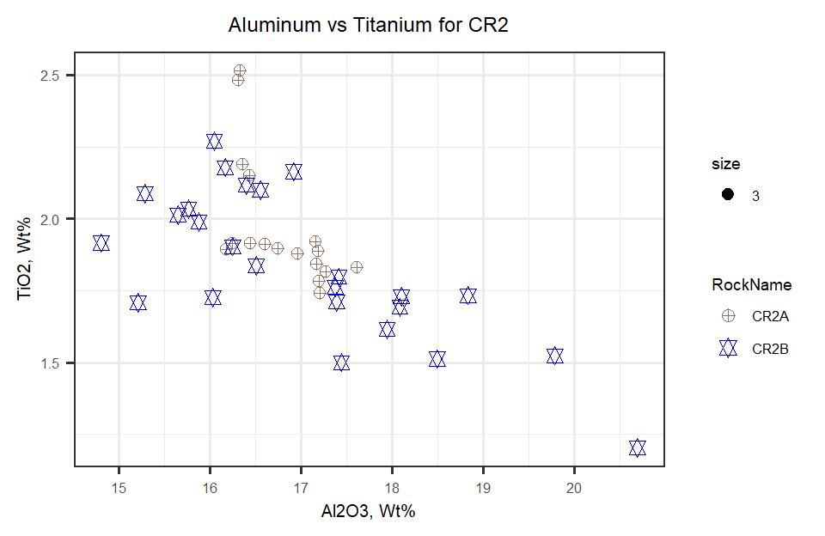

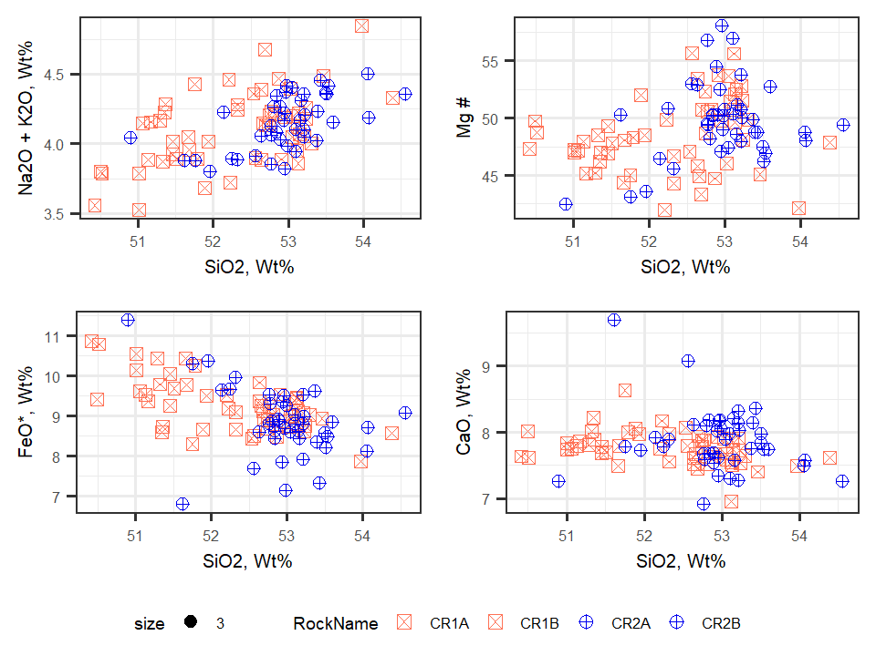

Figure 6: Comparision of CR1 to CR2

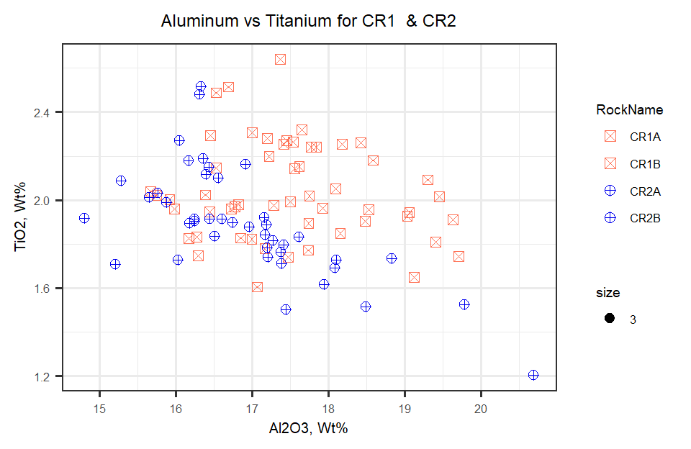

Table indicating mean averages for elements by rock

|  |  |  |  |  |  |  |  |  |  |
| --- | --- | --- | --- | --- | --- | --- | --- | --- | --- |
|  | CR1A | CR1B | CR2A | CR2B | CR3 | CR4 | CR5 | CR6 | CR7 |
| n | 30.000 | 24.000 | 17.000 | 25.000 | 25.000 | 26.000 | 30.000 | 30.000 | 30.000 |
| SiO2 m | 51.696 | 53.055 | 52.895 | 52.998 | 52.635 | 53.810 | 53.845 | 53.563 | 54.107 |
| SiO2 sd | 0.772 | 0.367 | 0.533 | 0.741 | 1.644 | 0.477 | 0.616 | 0.635 | 0.903 |
| TiO2 m | 2.140 | 1.908 | 1.975 | 1.833 | 2.022 | 1.992 | 1.986 | 1.923 | 1.955 |
| TiO2 sd | 0.214 | 0.158 | 0.227 | 0.257 | 0.401 | 0.139 | 0.234 | 0.231 | 0.322 |
| Al2O3 m | 18.055 | 16.832 | 16.788 | 16.999 | 15.212 | 17.215 | 15.868 | 14.402 | 15.588 |
| Al2O3 sd | 0.893 | 0.820 | 0.454 | 1.451 | 0.947 | 0.513 | 1.121 | 1.714 | 1.407 |
| Cr m | 0.022 | 0.022 | 0.028 | 0.039 | 0.026 | 0.025 | 0.030 | 0.042 | 0.024 |
| Cr sd | 0.015 | 0.012 | 0.014 | 0.017 | 0.011 | 0.012 | 0.012 | 0.029 | 0.014 |
| MgO m | 4.757 | 5.164 | 4.634 | 5.145 | 5.756 | 4.223 | 4.709 | 6.338 | 4.969 |
| MgO sd | 0.633 | 0.722 | 0.375 | 0.914 | 1.148 | 0.447 | 0.634 | 1.965 | 0.925 |
| CaO m | 7.823 | 7.690 | 8.019 | 7.768 | 7.334 | 7.944 | 7.963 | 7.988 | 7.223 |
| CaO sd | 0.253 | 0.233 | 0.164 | 0.589 | 0.448 | 0.190 | 0.534 | 0.702 | 0.486 |
| MnO m | 0.149 | 0.148 | 0.134 | 0.141 | 0.169 | 0.132 | 0.146 | 0.156 | 0.145 |
| MnO sd | 0.021 | 0.019 | 0.014 | 0.020 | 0.024 | 0.015 | 0.016 | 0.023 | 0.022 |
| FeO m | 9.479 | 8.991 | 8.983 | 8.750 | 10.750 | 8.537 | 8.963 | 9.482 | 9.075 |
| FeO sd | 0.752 | 0.350 | 0.707 | 0.965 | 2.134 | 0.288 | 0.583 | 0.695 | 1.044 |
| Na2O m | 3.129 | 2.993 | 3.055 | 3.018 | 2.751 | 2.940 | 3.120 | 2.722 | 3.140 |
| Na2O sd | 0.227 | 0.120 | 0.143 | 0.146 | 0.356 | 0.224 | 0.175 | 0.326 | 0.208 |
| K2O m | 0.928 | 1.168 | 1.098 | 1.126 | 1.080 | 1.015 | 1.176 | 1.106 | 1.394 |
| K2O sd | 0.101 | 0.068 | 0.060 | 0.112 | 0.171 | 0.058 | 0.110 | 0.196 | 0.124 |
| S m | 0.007 | 0.009 | 0.007 | 0.008 | 0.009 | 0.008 | 0.008 | 0.007 | 0.010 |
| S sd | 0.007 | 0.007 | 0.006 | 0.006 | 0.007 | 0.005 | 0.006 | 0.006 | 0.006 |
| P2O5 m | 0.395 | 0.330 | 0.290 | 0.327 | 0.266 | 0.260 | 0.319 | 0.310 | 0.323 |
| P2O5 sd | 0.061 | 0.032 | 0.059 | 0.046 | 0.088 | 0.048 | 0.061 | 0.052 | 0.063 |
| MgN m | 47.072 | 50.366 | 47.903 | 50.960 | 48.818 | 46.739 | 48.205 | 53.294 | 49.160 |
| MgN sd | 2.802 | 2.832 | 2.338 | 3.452 | 6.476 | 2.531 | 2.681 | 6.320 | 3.538 |
| Total m | 98.820 | 98.749 | 98.666 | 98.839 | 98.827 | 98.886 | 98.944 | 98.796 | 98.791 |
| Total sd | 0.444 | 0.319 | 0.187 | 0.264 | 0.255 | 0.279 | 0.253 | 0.271 | 0.358 |

Mean averages for major elements

|  |  |  |  |  |  |  |  |  |  |
| --- | --- | --- | --- | --- | --- | --- | --- | --- | --- |
|  | CR1A | CR1B | CR2A | CR2B | CR3 | CR4 | CR5 | CR6 | CR7 |
| n | 30.000 | 24.000 | 17.000 | 25.000 | 25.000 | 26.000 | 30.000 | 30.000 | 30.000 |
| SiO2 | 51.696 | 53.055 | 52.895 | 52.998 | 52.635 | 53.810 | 53.845 | 53.563 | 54.107 |
| TiO2 | 2.140 | 1.908 | 1.975 | 1.833 | 2.022 | 1.992 | 1.986 | 1.923 | 1.955 |
| Al2O3 | 18.055 | 16.832 | 16.788 | 16.999 | 15.212 | 17.215 | 15.868 | 14.402 | 15.588 |
| Cr | 0.022 | 0.022 | 0.028 | 0.039 | 0.026 | 0.025 | 0.030 | 0.042 | 0.024 |
| MgO | 4.757 | 5.164 | 4.634 | 5.145 | 5.756 | 4.223 | 4.709 | 6.338 | 4.969 |
| CaO | 7.823 | 7.690 | 8.019 | 7.768 | 7.334 | 7.944 | 7.963 | 7.988 | 7.223 |
| MnO | 0.149 | 0.148 | 0.134 | 0.141 | 0.169 | 0.132 | 0.146 | 0.156 | 0.145 |
| FeO | 9.479 | 8.991 | 8.983 | 8.750 | 10.750 | 8.537 | 8.963 | 9.482 | 9.075 |
| Na2O | 3.129 | 2.993 | 3.055 | 3.018 | 2.751 | 2.940 | 3.120 | 2.722 | 3.140 |
| K2O | 0.928 | 1.168 | 1.098 | 1.126 | 1.080 | 1.015 | 1.176 | 1.106 | 1.394 |
| S | 0.007 | 0.009 | 0.007 | 0.008 | 0.009 | 0.008 | 0.008 | 0.007 | 0.010 |
| P2O5 | 0.395 | 0.330 | 0.290 | 0.327 | 0.266 | 0.260 | 0.319 | 0.310 | 0.323 |
| MgN | 47.072 | 50.366 | 47.903 | 50.960 | 48.818 | 46.739 | 48.205 | 53.294 | 49.160 |
| Total | 98.820 | 98.749 | 98.666 | 98.839 | 98.827 | 98.886 | 98.944 | 98.796 | 98.791 |