Costa Rican Bulk Rock Compositions

Julie M. Coulombe

4/1/2020

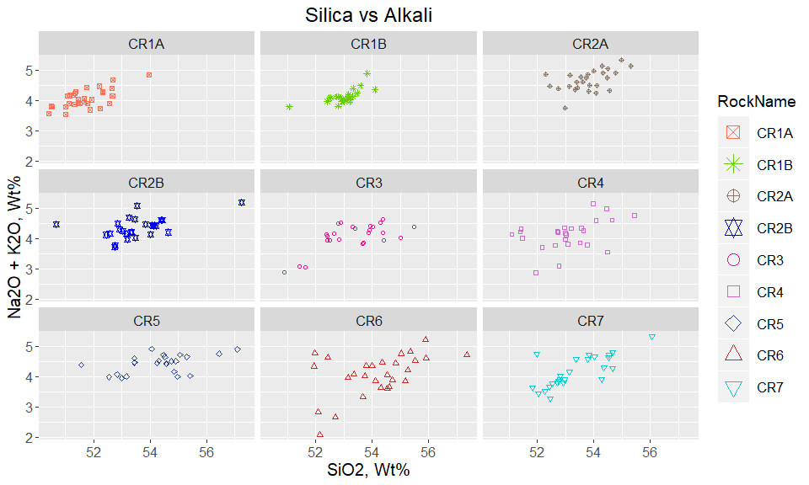

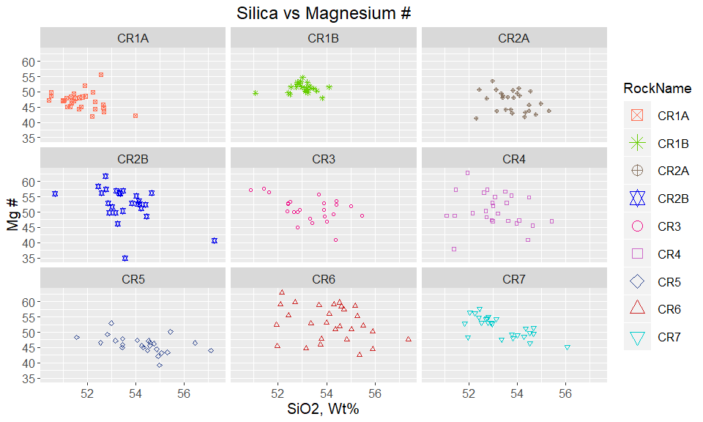

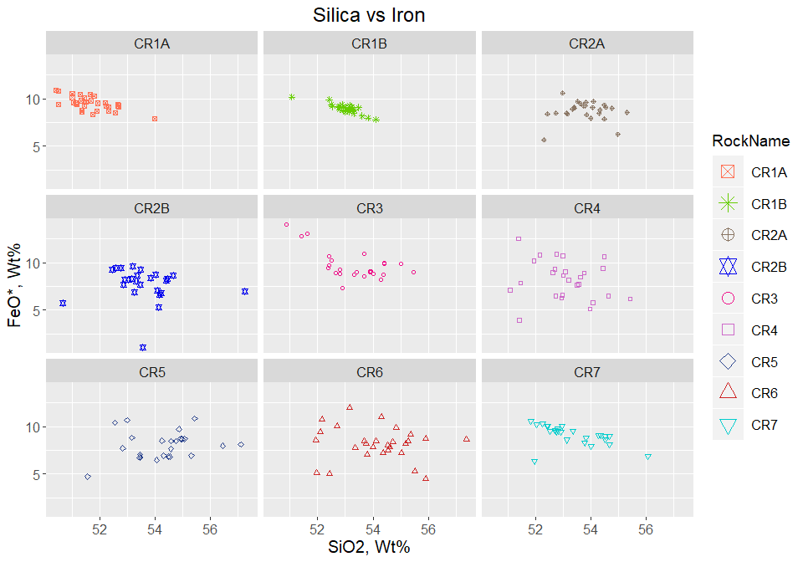

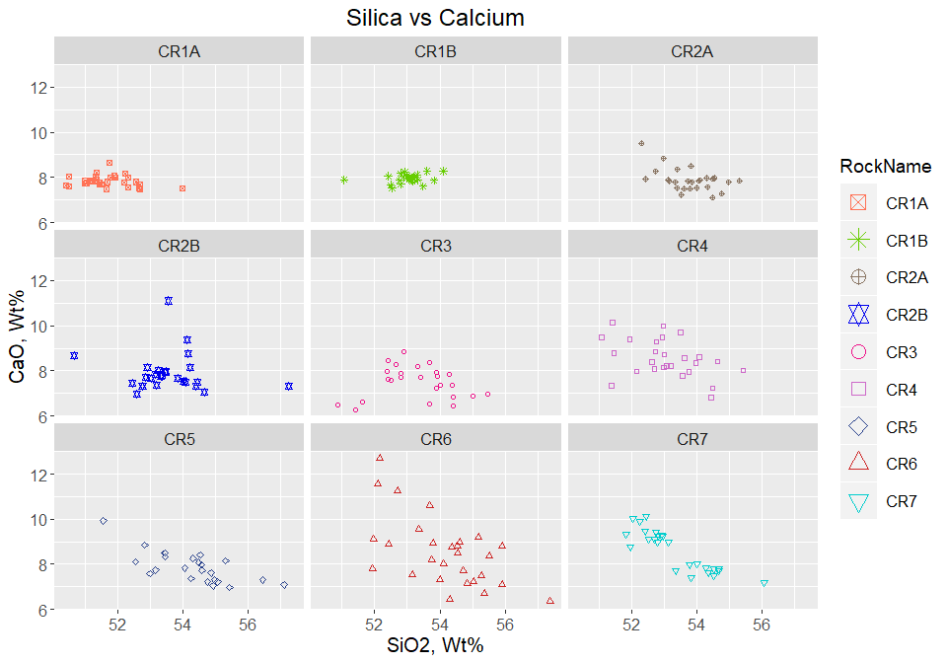

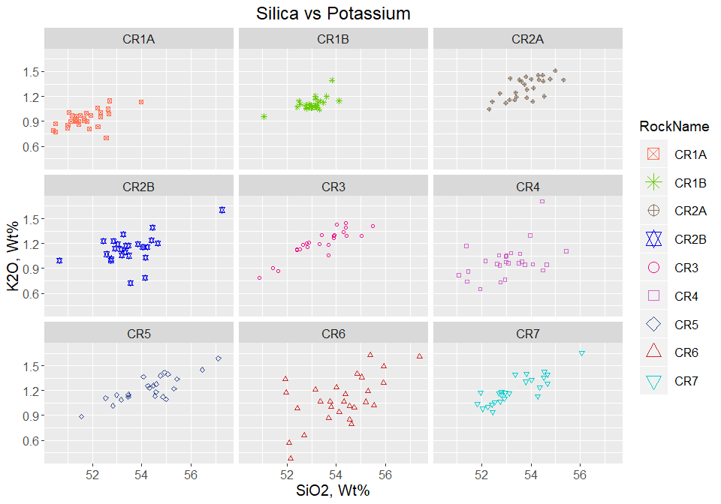

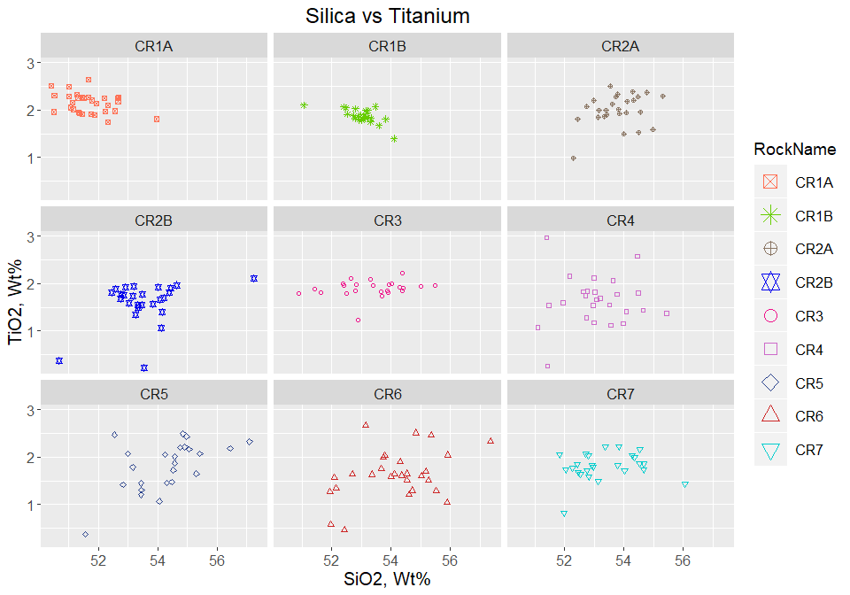

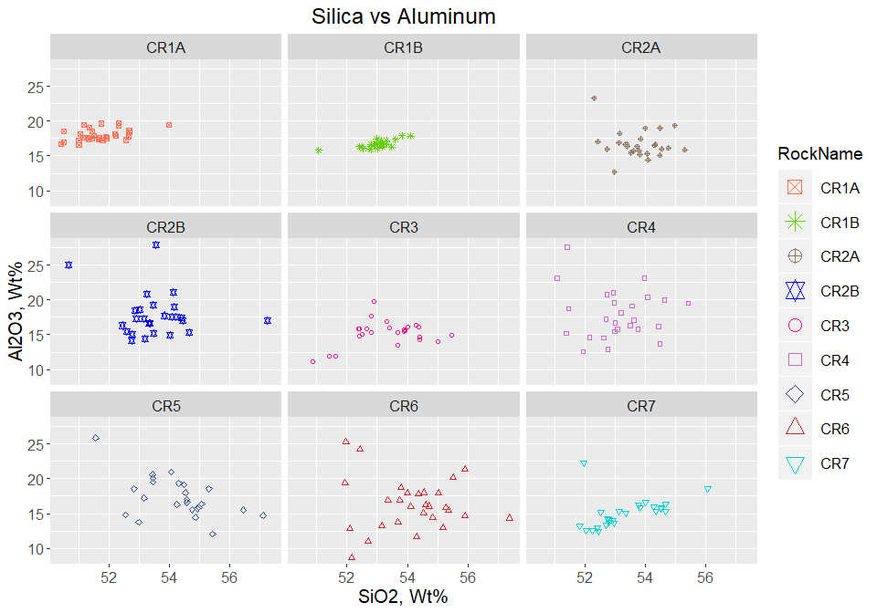

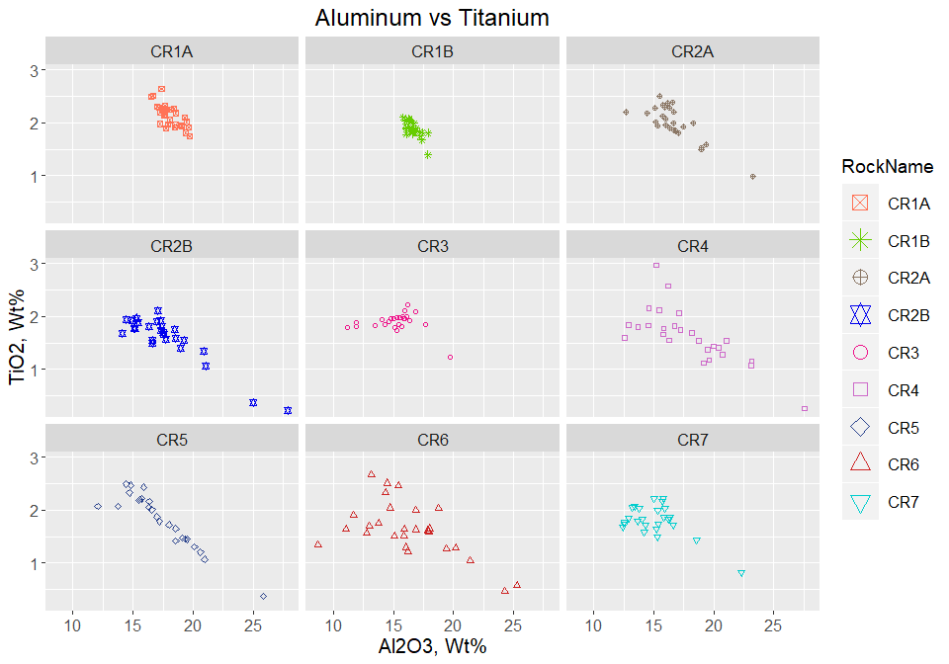

Plot Alkali by Rock Name - Bulk Composition 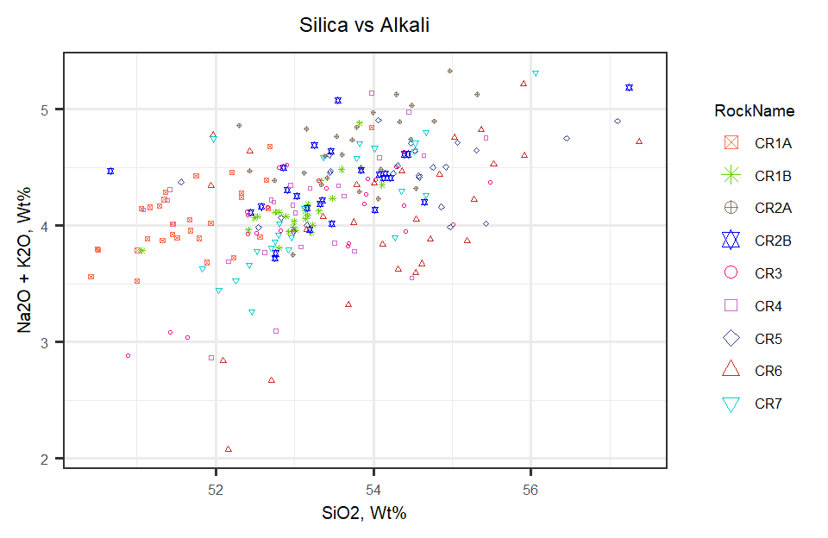

Overlay Alkali Plot on TAS Diagram

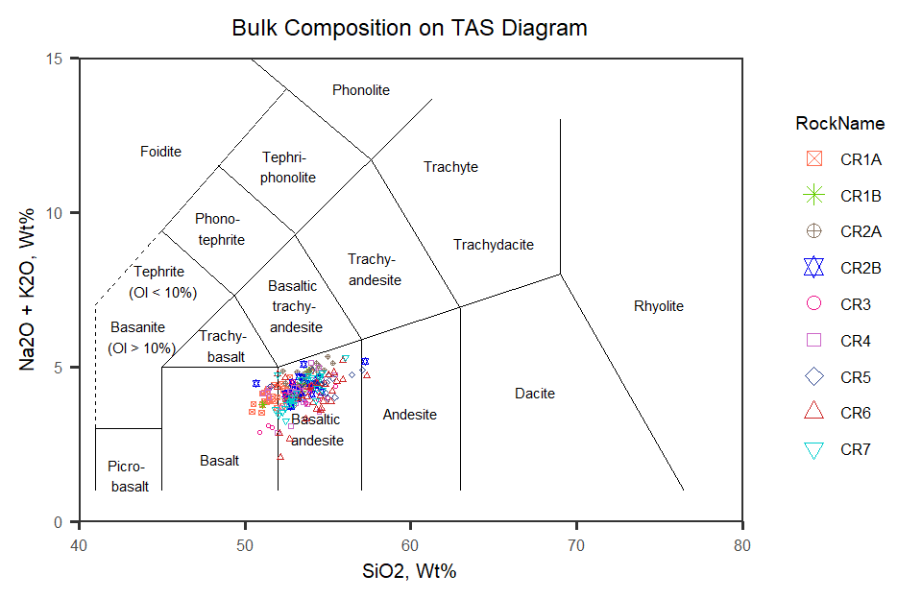

Figure 1: TAS Diagram for bulk rock compositions

Now to look at Harker Diagrams of all rocks plotted together

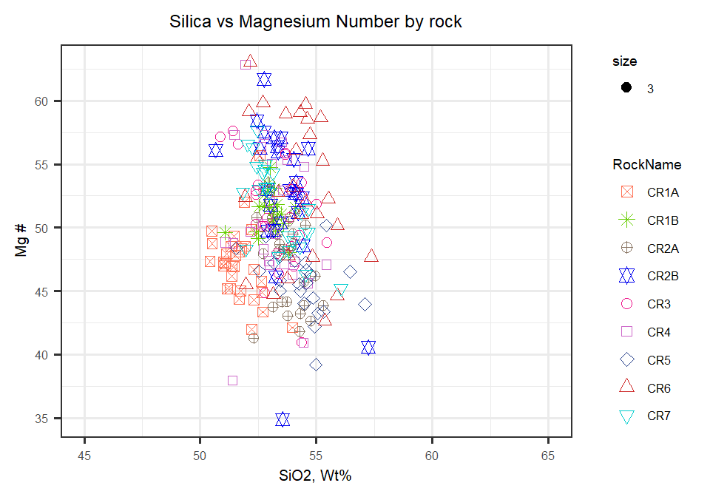

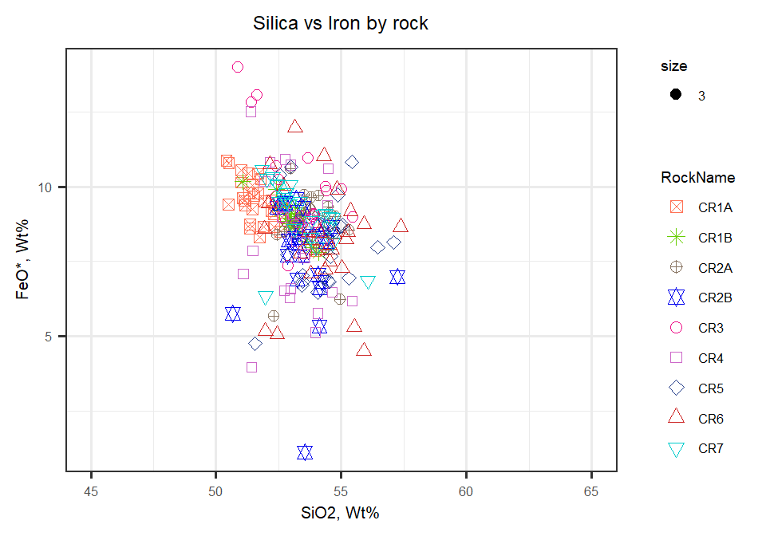

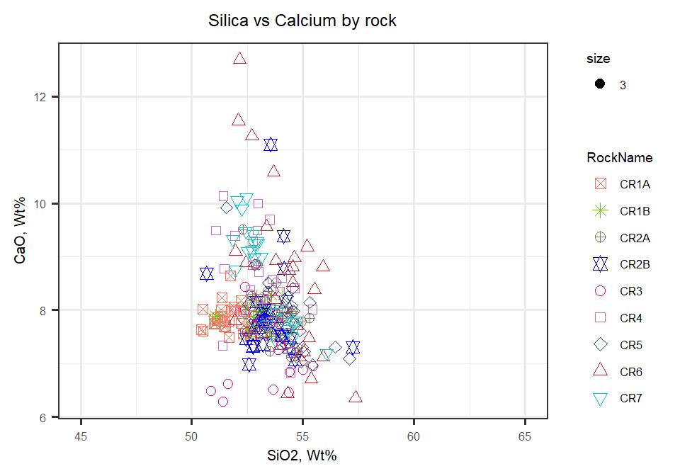

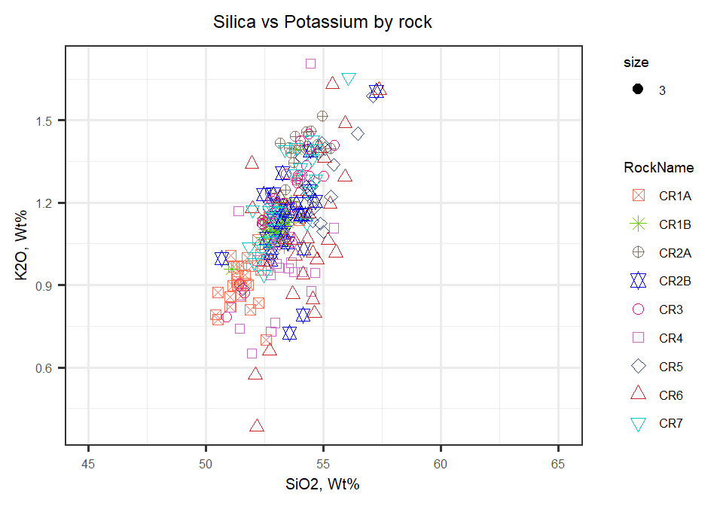

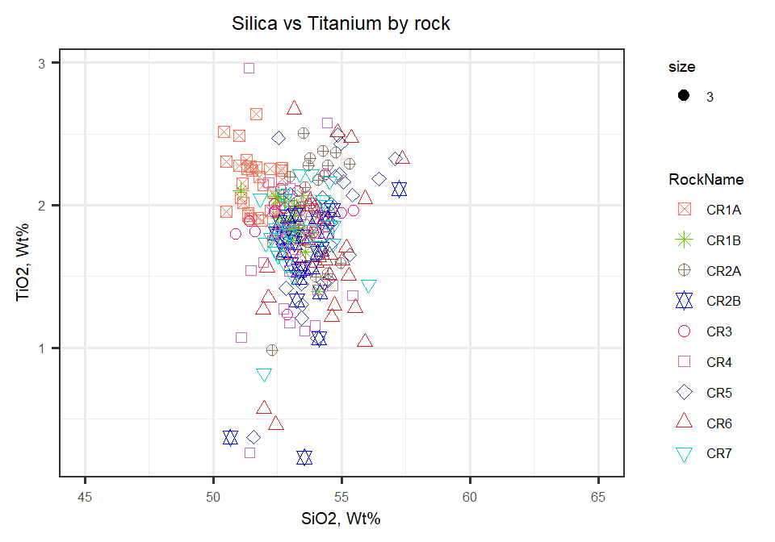

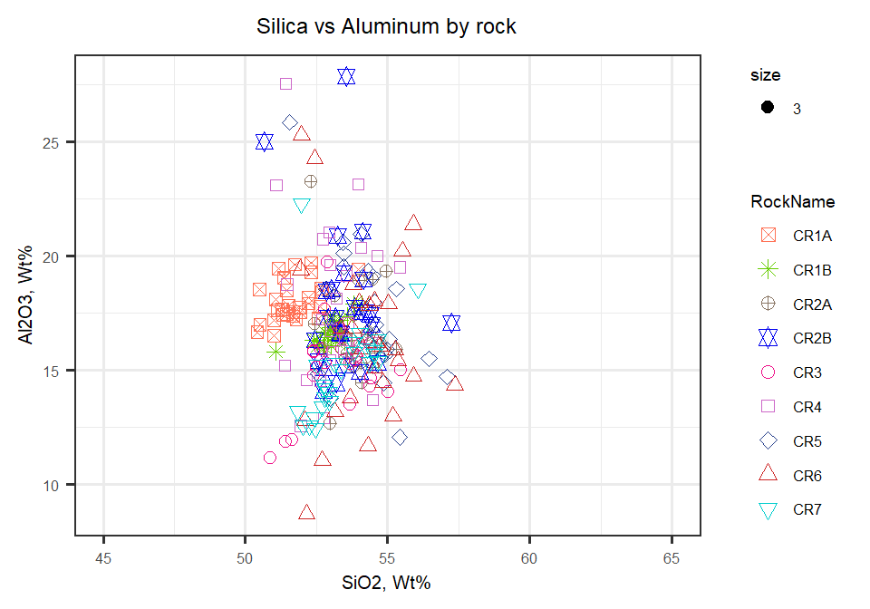

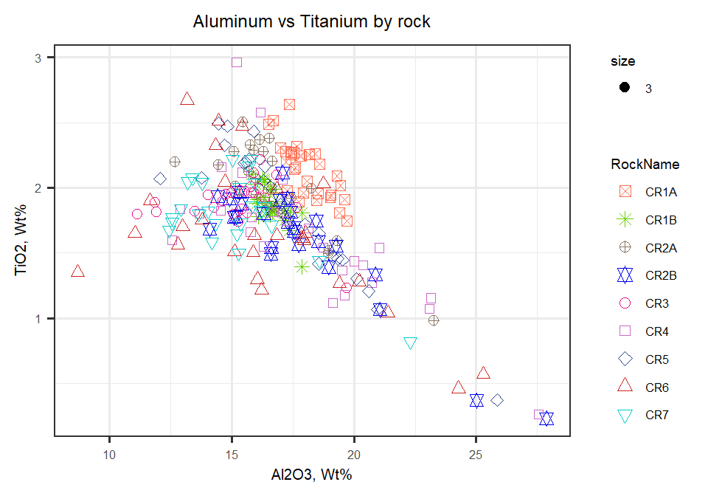

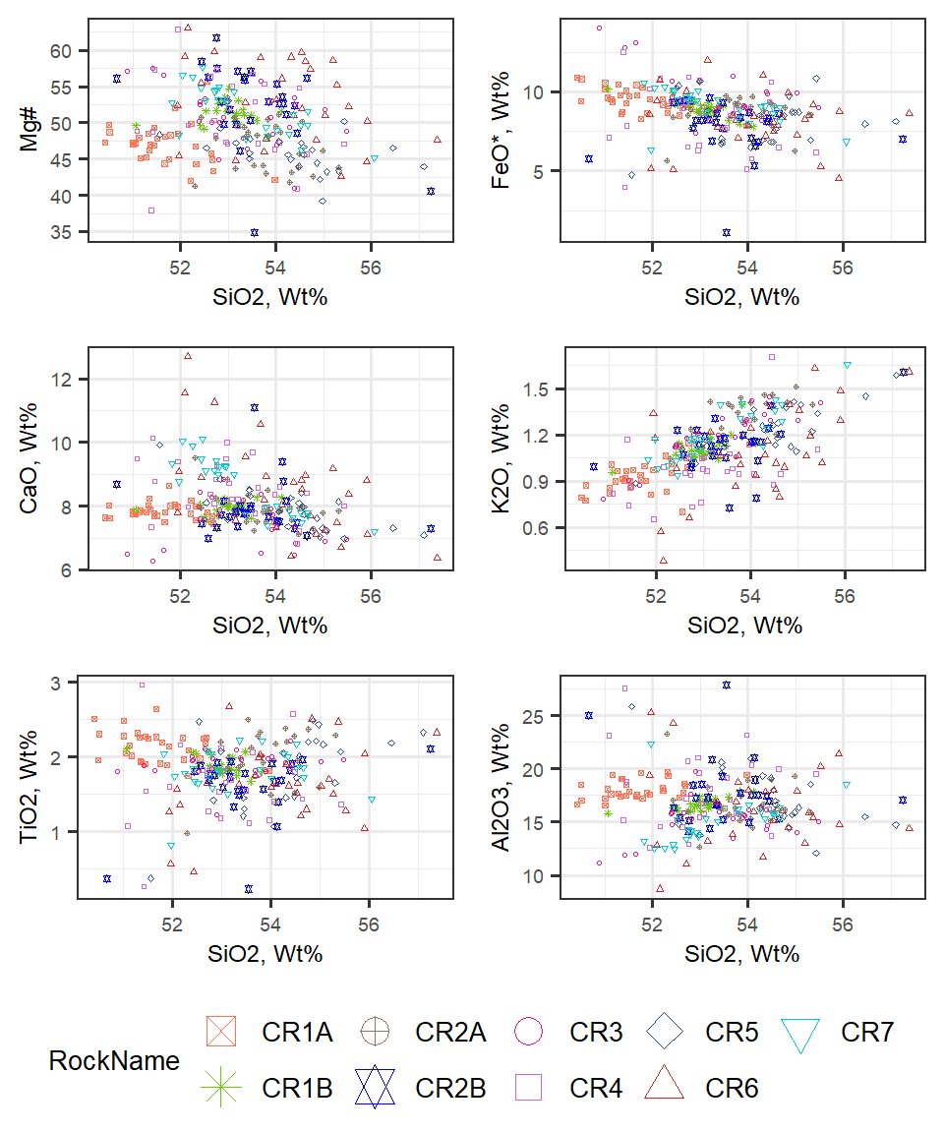

Figure 2: Major elements plotted against SiO2. All Wt% except Mg#

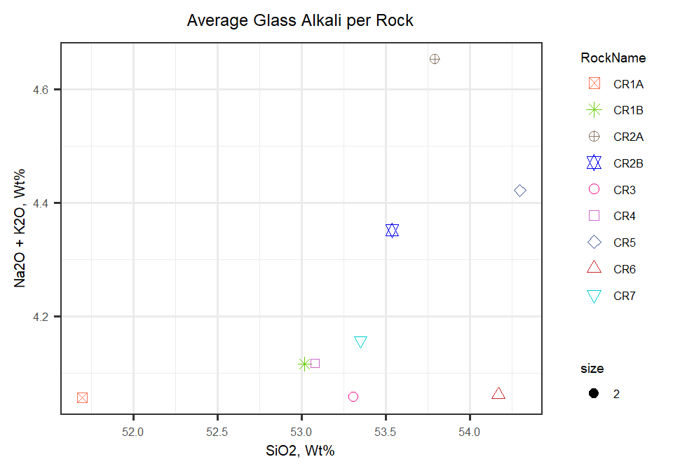

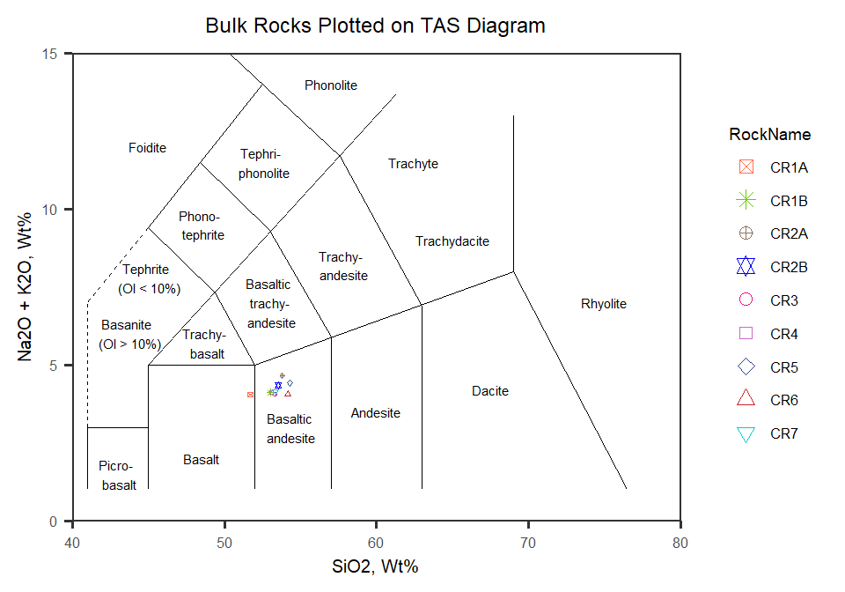

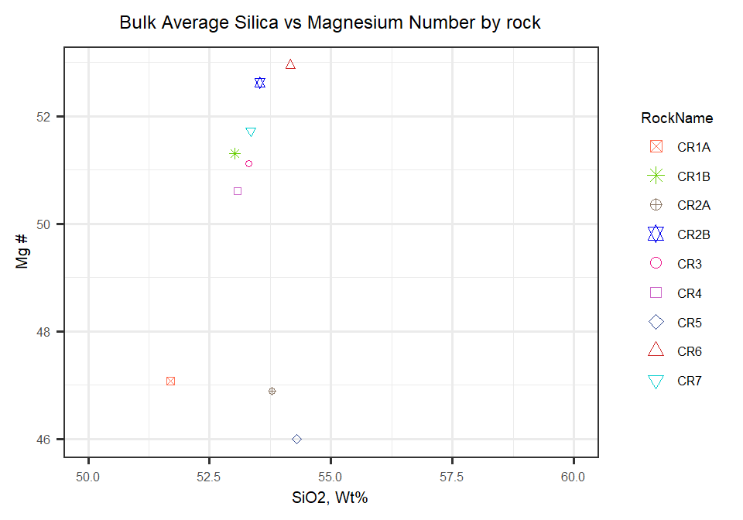

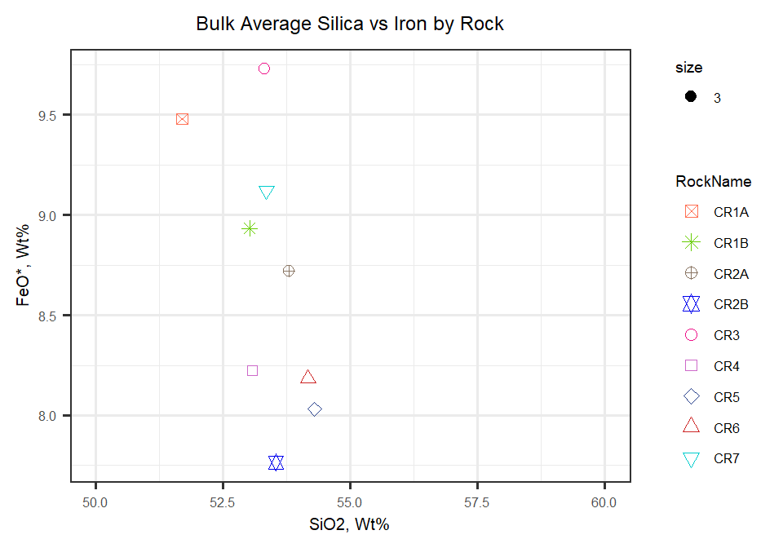

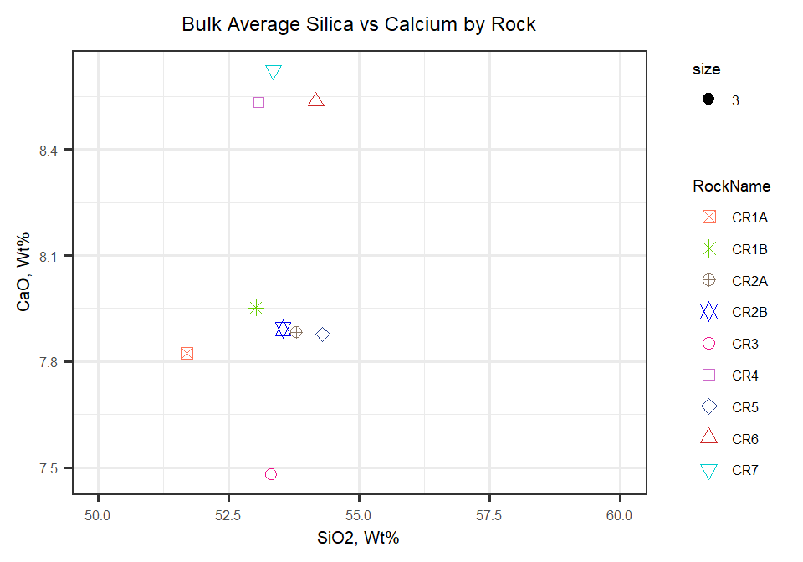

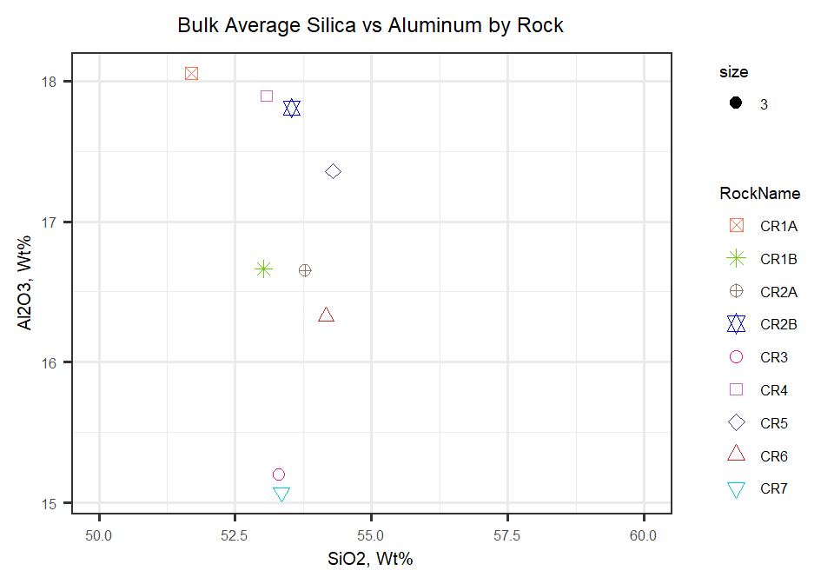

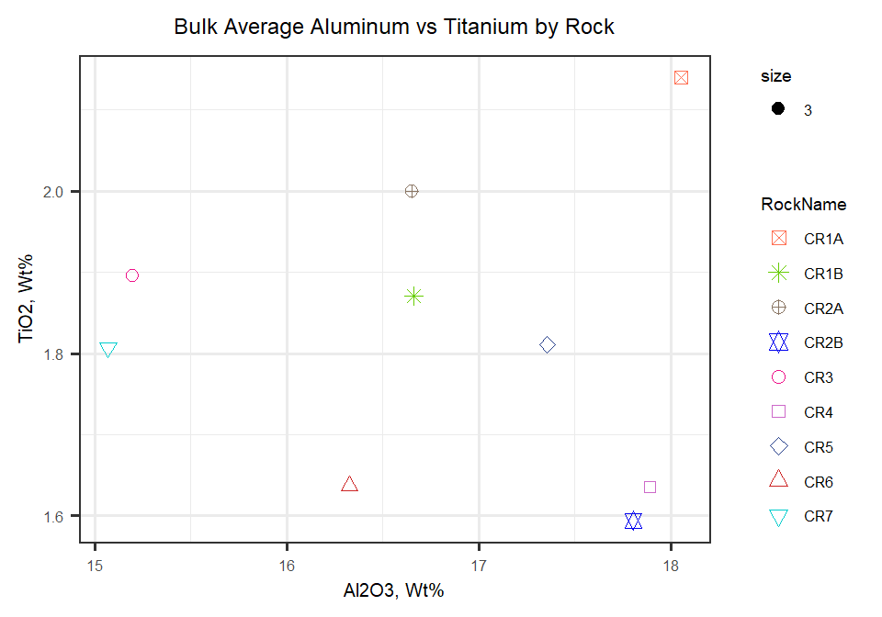

Compare CR1A to CR1B Harker Diagrams

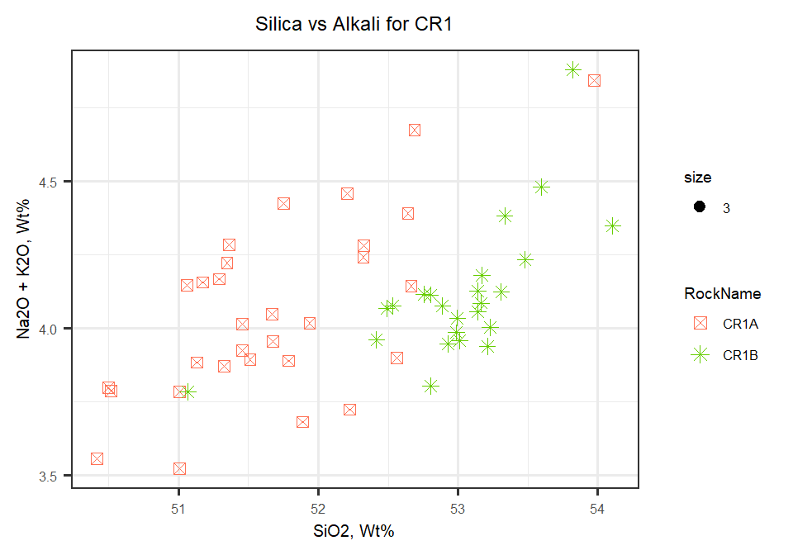

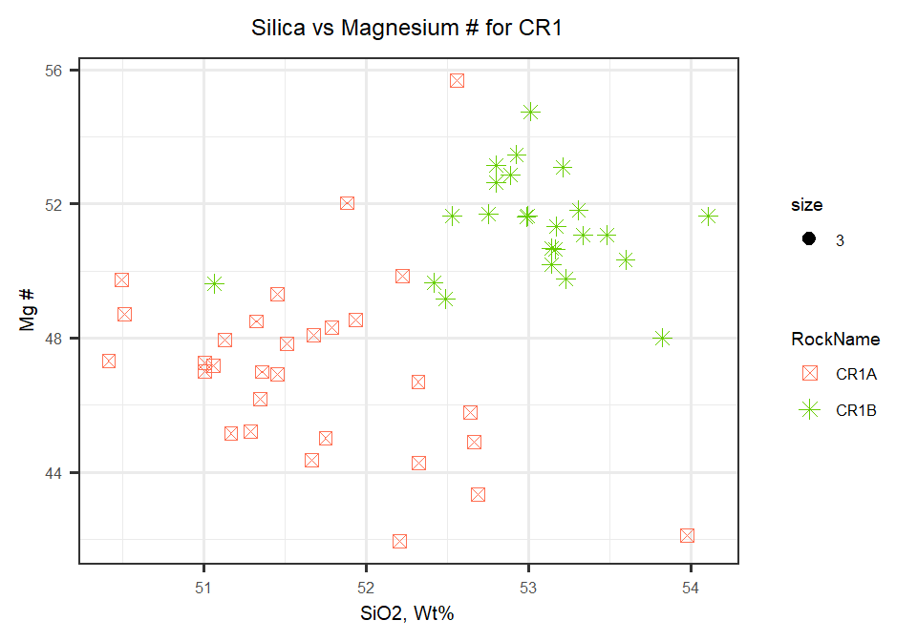

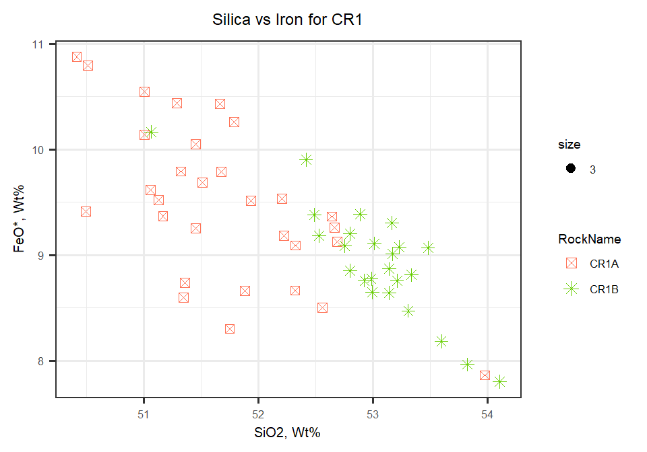

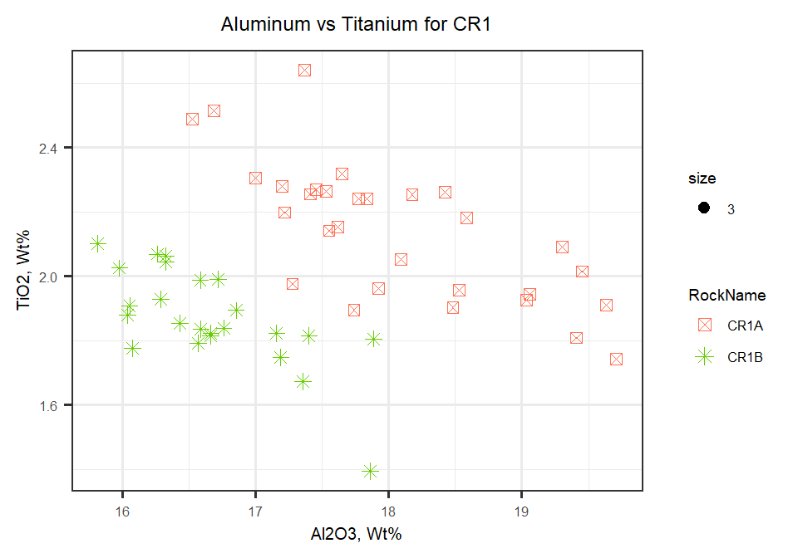

Compare CR2A to CR2B Harker Diagrams

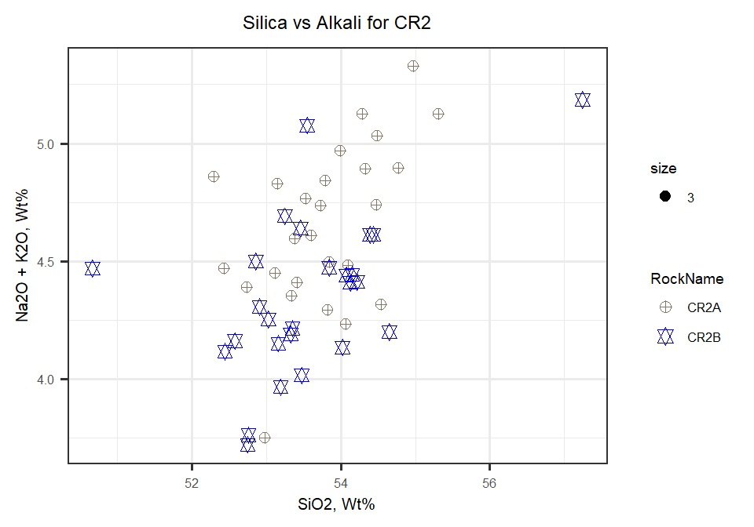

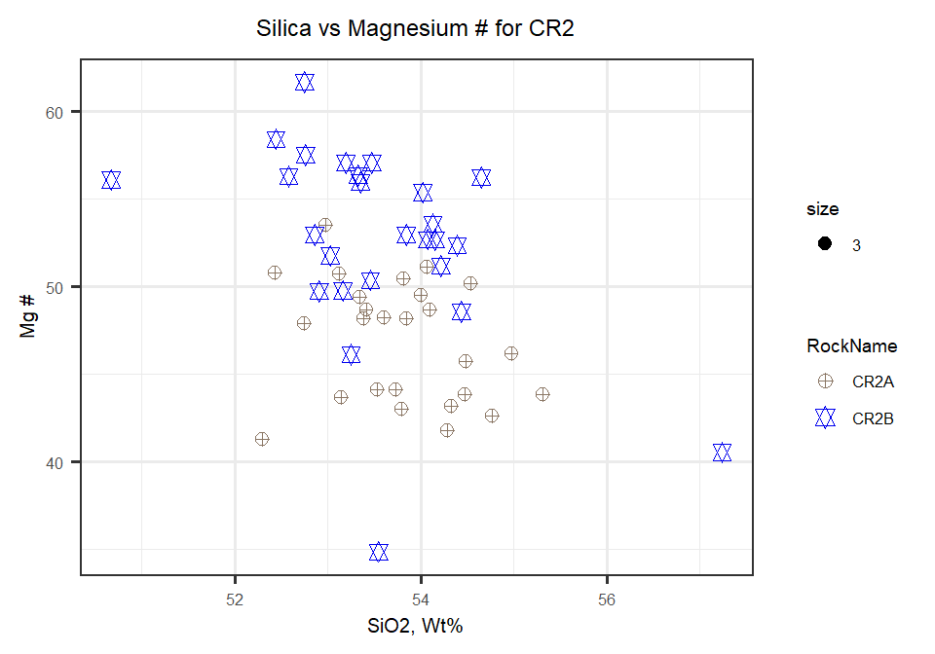

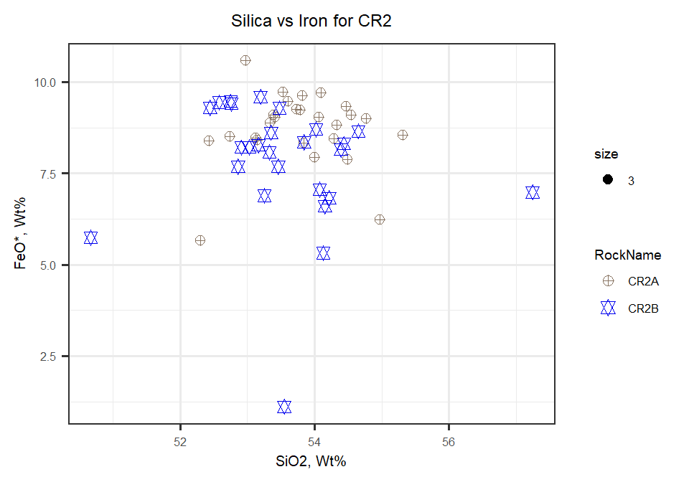

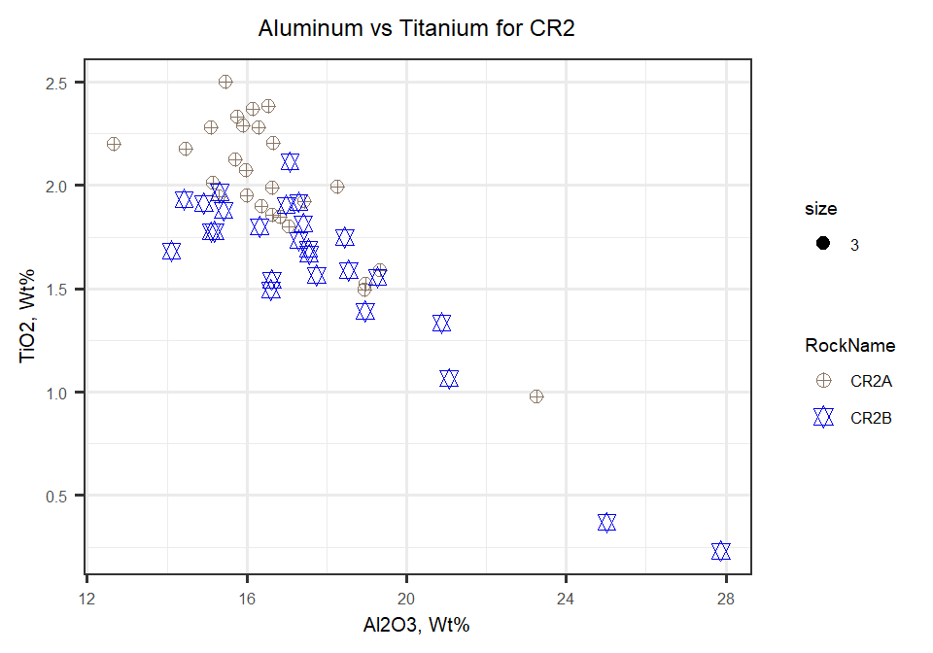

And finally, comparing CR1 to CR2 Harker Diagrams

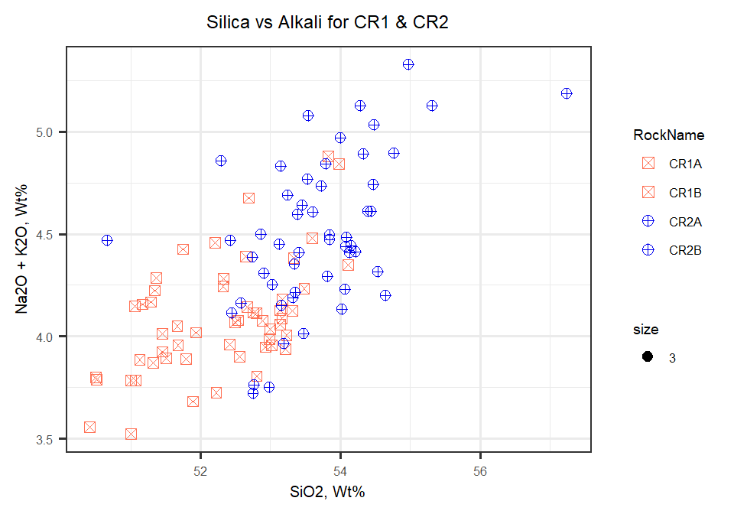

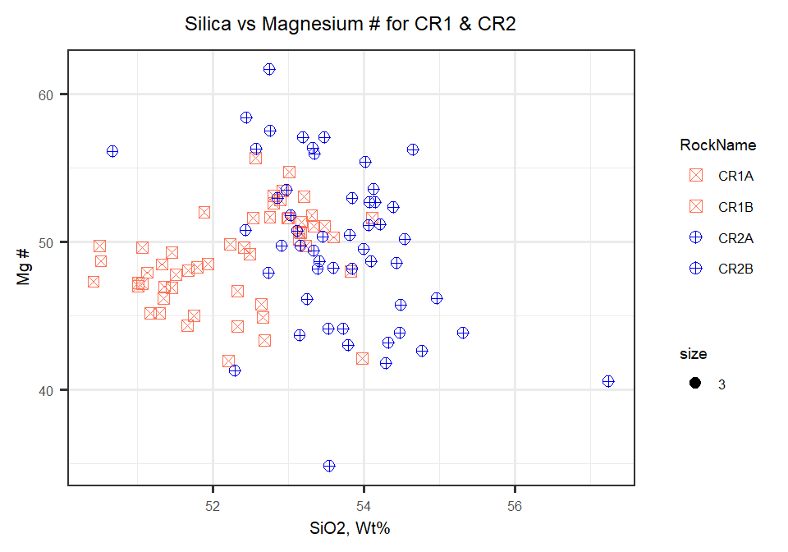

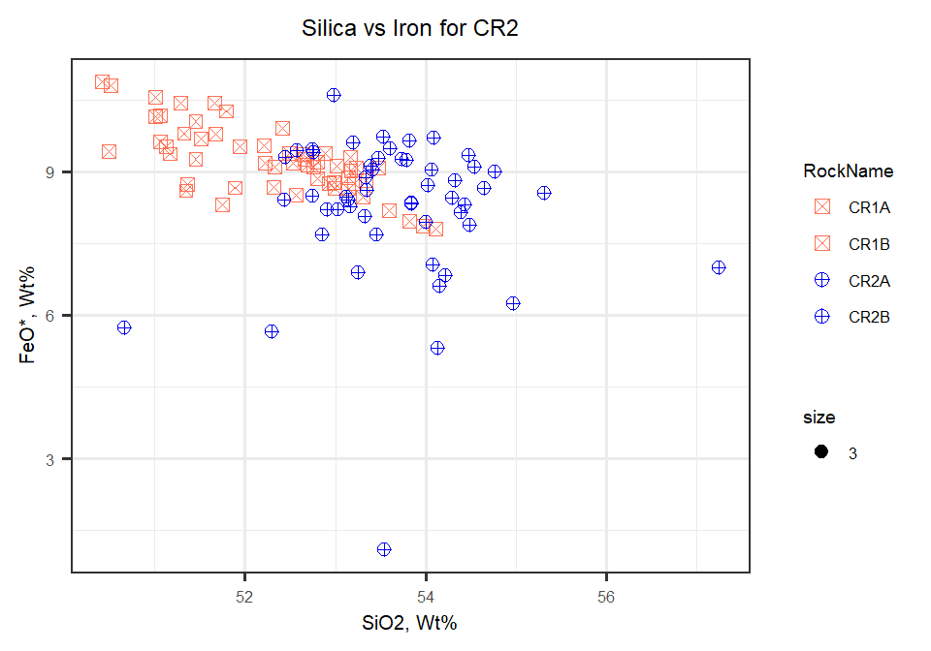

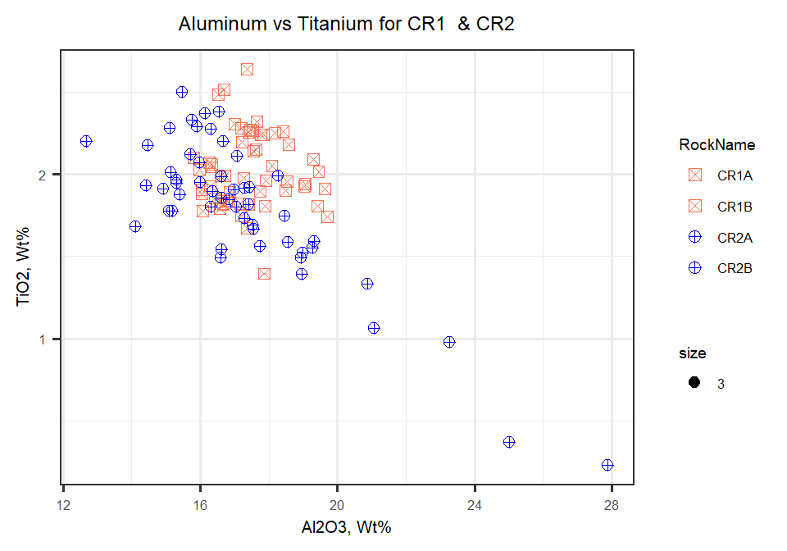

Table indicating mean averages for elements by rock

|  |  |  |  |  |  |  |  |  |  |
| --- | --- | --- | --- | --- | --- | --- | --- | --- | --- |
| **Element** | **CR1A** | **CR1B** | **CR2A** | **CR2B** | **CR3** | **CR4** | **CR5** | **CR6** | **CR7** |
| n | 30 | 24 | 26 | 26 | 25 | 26 | 24 | 28 | 25 |
| M SiO2 | 51.7 | 53 | 53.8 | 53.5 | 53.3 | 53.1 | 54.3 | 54.2 | 53.3 |
| SD SiO2 | 0.772 | 0.575 | 0.755 | 1.12 | 1.13 | 1.09 | 1.23 | 1.35 | 1.07 |
| M TiO2 | 2.14 | 1.87 | 2 | 1.59 | 1.9 | 1.64 | 1.81 | 1.64 | 1.81 |
| SD TiO2 | 0.214 | 0.152 | 0.335 | 0.443 | 0.178 | 0.519 | 0.518 | 0.512 | 0.294 |
| M Al2O3 | 18.1 | 16.7 | 16.7 | 17.8 | 15.2 | 17.9 | 17.4 | 16.3 | 15.1 |
| SD Al2O3 | 0.893 | 0.568 | 1.97 | 3.13 | 1.8 | 3.51 | 2.91 | 3.7 | 2.13 |
| M Cr | 0.022 | 0.0264 | 0.0171 | 0.0244 | 0.0261 | 0.0302 | 0.0247 | 0.0281 | 0.0285 |
| SD Cr | 0.0145 | 0.0132 | 0.0172 | 0.0213 | 0.018 | 0.0237 | 0.0238 | 0.0191 | 0.0214 |
| M MgO | 4.76 | 5.29 | 4.38 | 5.1 | 5.88 | 4.89 | 3.87 | 5.38 | 5.59 |
| SD MgO | 0.633 | 0.437 | 0.911 | 1.73 | 1.82 | 1.81 | 0.973 | 1.92 | 1.25 |
| M CaO | 7.82 | 7.95 | 7.88 | 7.89 | 7.48 | 8.53 | 7.88 | 8.54 | 8.62 |
| SD CaO | 0.253 | 0.201 | 0.505 | 0.85 | 0.706 | 0.839 | 0.687 | 1.54 | 0.913 |
| M MnO | 0.149 | 0.147 | 0.134 | 0.131 | 0.168 | 0.139 | 0.128 | 0.148 | 0.162 |
| SD MnO | 0.0214 | 0.0177 | 0.0283 | 0.0361 | 0.0384 | 0.0447 | 0.0266 | 0.038 | 0.037 |
| M FeO | 9.48 | 8.93 | 8.72 | 7.77 | 9.73 | 8.22 | 8.03 | 8.19 | 9.12 |
| SD FeO | 0.752 | 0.532 | 1.02 | 1.78 | 1.56 | 2.05 | 1.46 | 1.76 | 1.03 |
| M Na2O | 3.13 | 3 | 3.35 | 3.22 | 2.86 | 3.13 | 3.2 | 2.97 | 2.95 |
| SD Na2O | 0.227 | 0.169 | 0.262 | 0.333 | 0.324 | 0.401 | 0.241 | 0.481 | 0.363 |
| M K2O | 0.928 | 1.11 | 1.3 | 1.13 | 1.2 | 0.986 | 1.22 | 1.09 | 1.21 |
| SD K2O | 0.101 | 0.0804 | 0.131 | 0.171 | 0.168 | 0.205 | 0.157 | 0.29 | 0.172 |
| M S | 0.00706 | 0.00881 | 0.00694 | 0.00706 | 0.00784 | 0.00473 | 0.00656 | 0.00379 | 0.00736 |
| SD S | 0.00673 | 0.00909 | 0.00719 | 0.00736 | 0.00776 | 0.00676 | 0.00801 | 0.00613 | 0.00832 |
| M P2O5 | 0.395 | 0.349 | 0.421 | 0.322 | 0.349 | 0.255 | 0.275 | 0.299 | 0.346 |
| SD P2O5 | 0.0607 | 0.0345 | 0.164 | 0.0984 | 0.0699 | 0.0885 | 0.0897 | 0.116 | 0.0821 |
| M MgN | 47.1 | 51.3 | 46.9 | 52.6 | 51.1 | 50.6 | 46 | 53 | 51.7 |
| SD MgN | 2.8 | 1.54 | 3.41 | 5.64 | 4.01 | 5.49 | 2.8 | 5.65 | 3.39 |
| M Total | 98.8 | 98.8 | 98.9 | 99 | 98.8 | 99.1 | 98.5 | 98.9 | 98.9 |
| SD Total | 0.444 | 0.384 | 0.515 | 0.436 | 0.331 | 0.422 | 0.388 | 0.344 | 0.252 |

Table with no Standard Deviation

|  |  |  |  |  |  |  |  |  |  |
| --- | --- | --- | --- | --- | --- | --- | --- | --- | --- |
| **Element** | **CR1A** | **CR1B** | **CR2A** | **CR2B** | **CR3** | **CR4** | **CR5** | **CR6** | **CR7** |
| n | 30 | 24 | 26 | 26 | 25 | 26 | 24 | 28 | 25 |
| SiO2 | 51.7 | 53 | 53.8 | 53.5 | 53.3 | 53.1 | 54.3 | 54.2 | 53.3 |
| TiO2 | 2.14 | 1.87 | 2 | 1.59 | 1.9 | 1.64 | 1.81 | 1.64 | 1.81 |
| Al2O3 | 18.1 | 16.7 | 16.7 | 17.8 | 15.2 | 17.9 | 17.4 | 16.3 | 15.1 |
| Cr | 0.022 | 0.0264 | 0.0171 | 0.0244 | 0.0261 | 0.0302 | 0.0247 | 0.0281 | 0.0285 |
| MgO | 4.76 | 5.29 | 4.38 | 5.1 | 5.88 | 4.89 | 3.87 | 5.38 | 5.59 |
| CaO | 7.82 | 7.95 | 7.88 | 7.89 | 7.48 | 8.53 | 7.88 | 8.54 | 8.62 |
| MnO | 0.149 | 0.147 | 0.134 | 0.131 | 0.168 | 0.139 | 0.128 | 0.148 | 0.162 |
| FeO | 9.48 | 8.93 | 8.72 | 7.77 | 9.73 | 8.22 | 8.03 | 8.19 | 9.12 |
| Na2O | 3.13 | 3 | 3.35 | 3.22 | 2.86 | 3.13 | 3.2 | 2.97 | 2.95 |
| K2O | 0.928 | 1.11 | 1.3 | 1.13 | 1.2 | 0.986 | 1.22 | 1.09 | 1.21 |
| S | 0.00706 | 0.00881 | 0.00694 | 0.00706 | 0.00784 | 0.00473 | 0.00656 | 0.00379 | 0.00736 |
| P2O5 | 0.395 | 0.349 | 0.421 | 0.322 | 0.349 | 0.255 | 0.275 | 0.299 | 0.346 |
| MgN | 47.1 | 51.3 | 46.9 | 52.6 | 51.1 | 50.6 | 46 | 53 | 51.7 |
| Total | 98.8 | 98.8 | 98.9 | 99 | 98.8 | 99.1 | 98.5 | 98.9 | 98.9 |