Costa Rican Bulk Rock Compositions

Julie M. Coulombe

4/1/2020

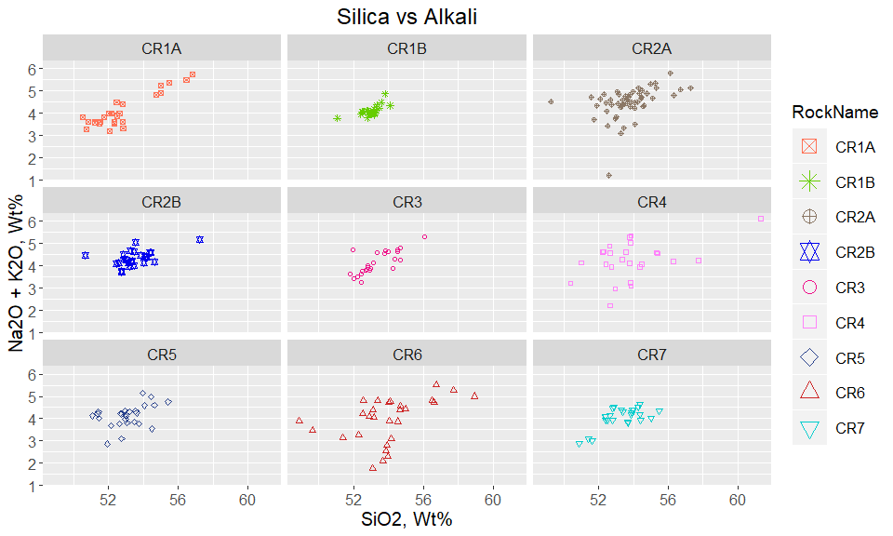

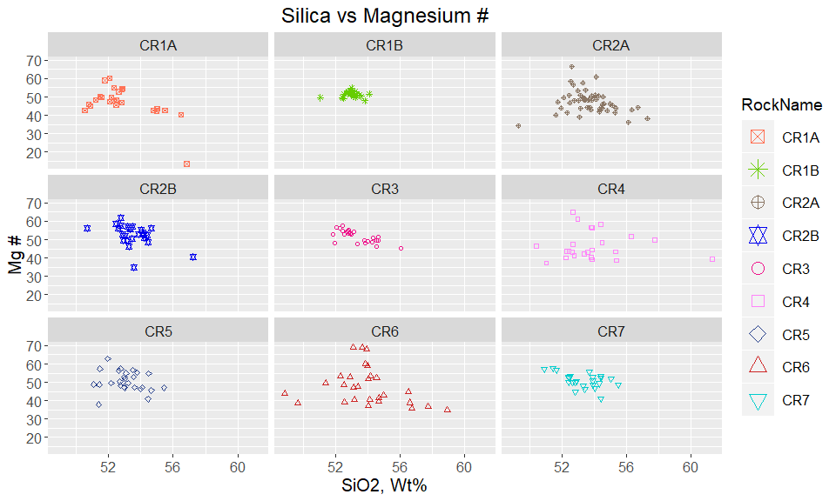

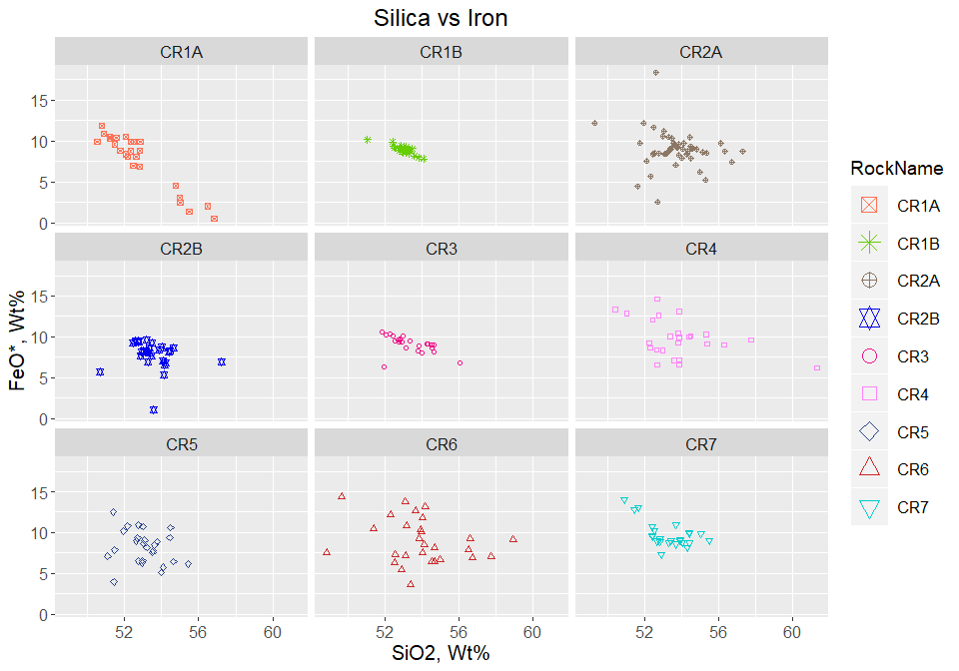

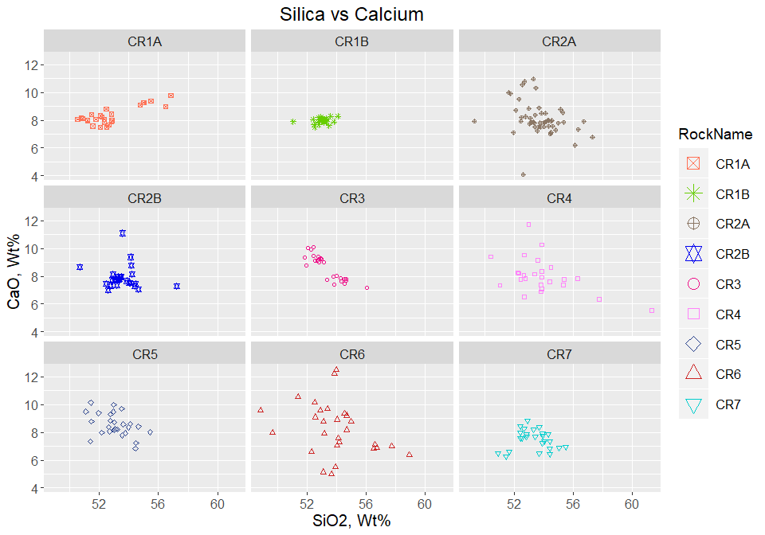

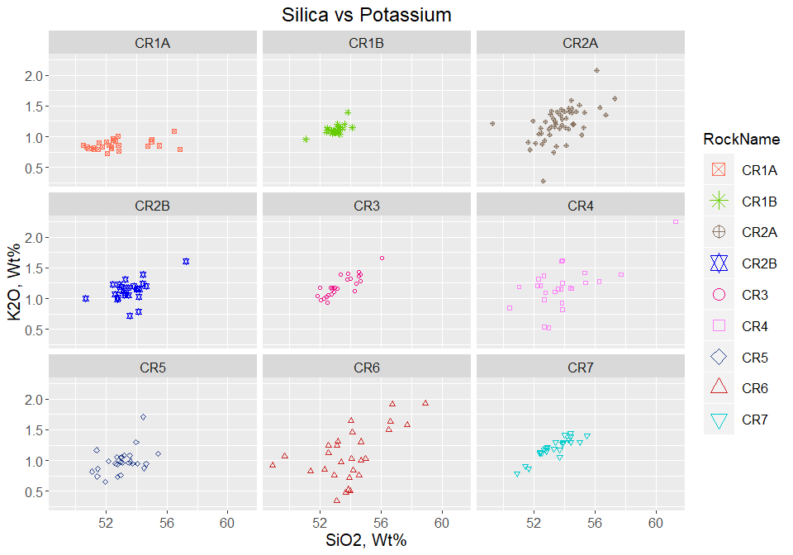

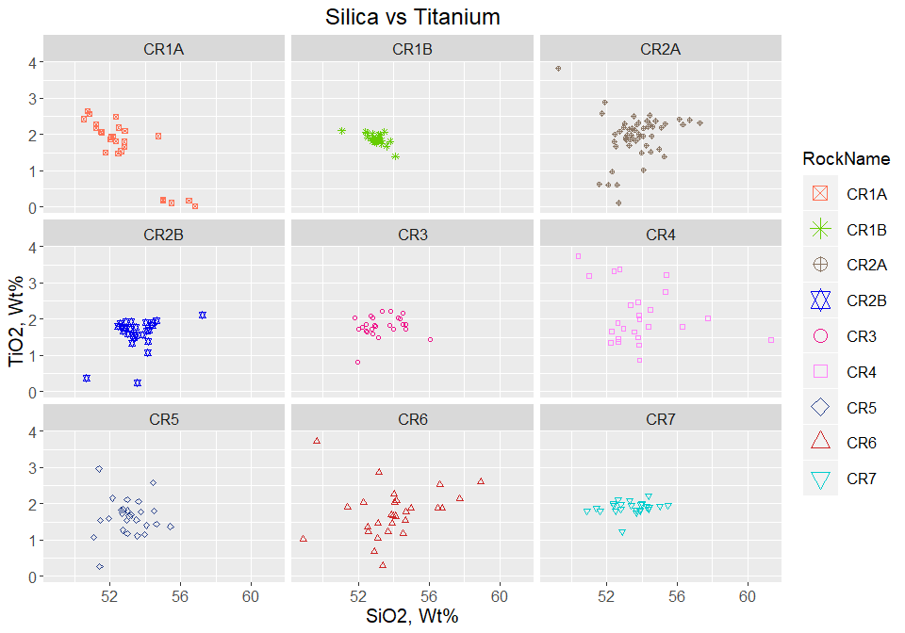

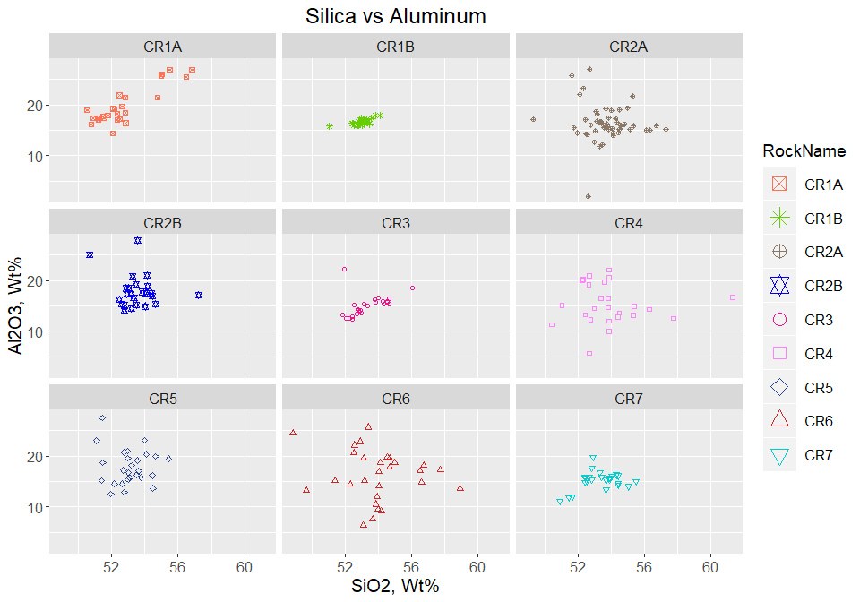

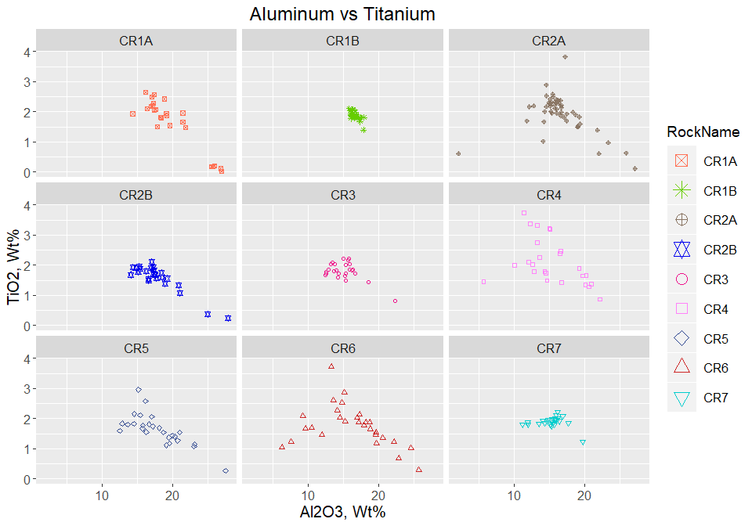

Plot Alkali by Rock Name - Bulk Composition 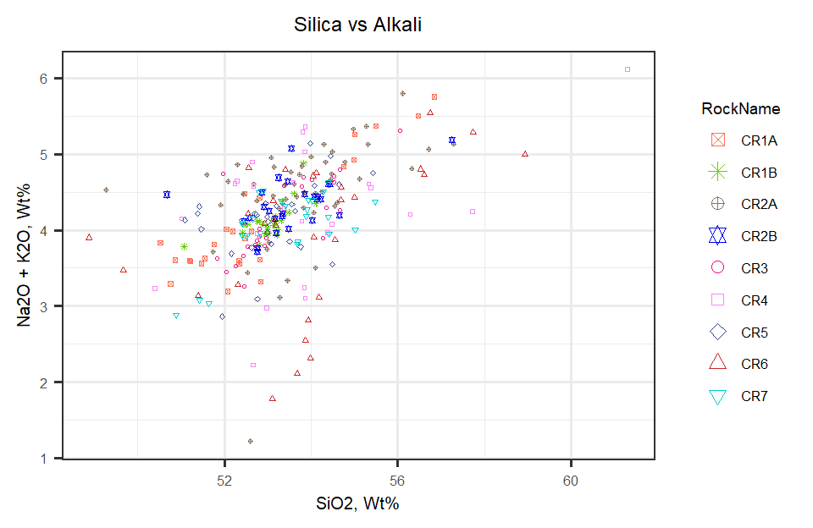

Overlay Alkali Plot on TAS Diagram

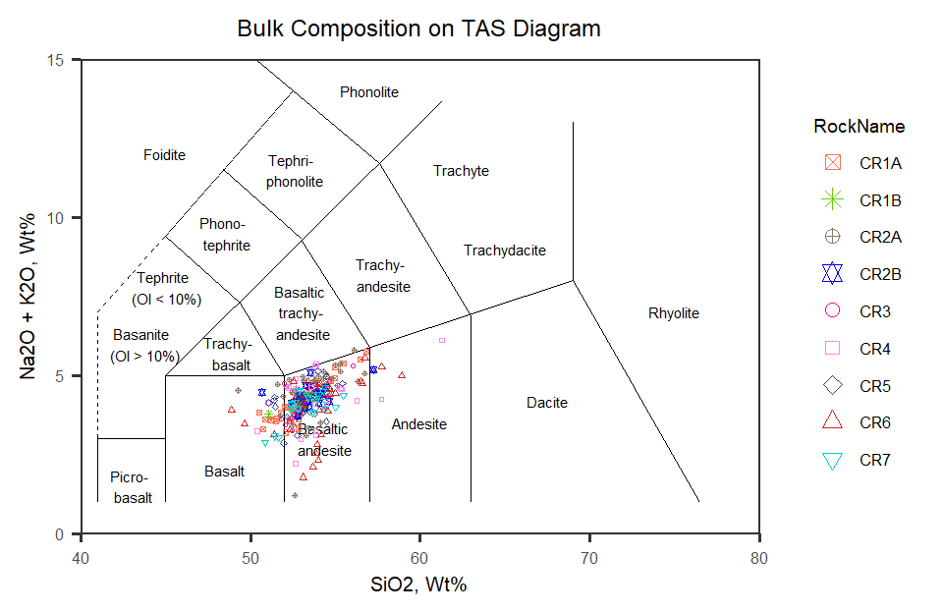

Figure 1: TAS Diagram for bulk rock compositions

Now to look at Harker Diagrams of all rocks plotted together

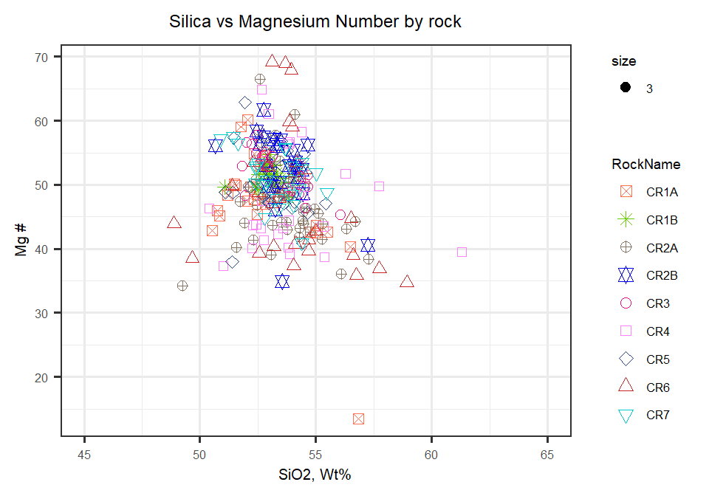

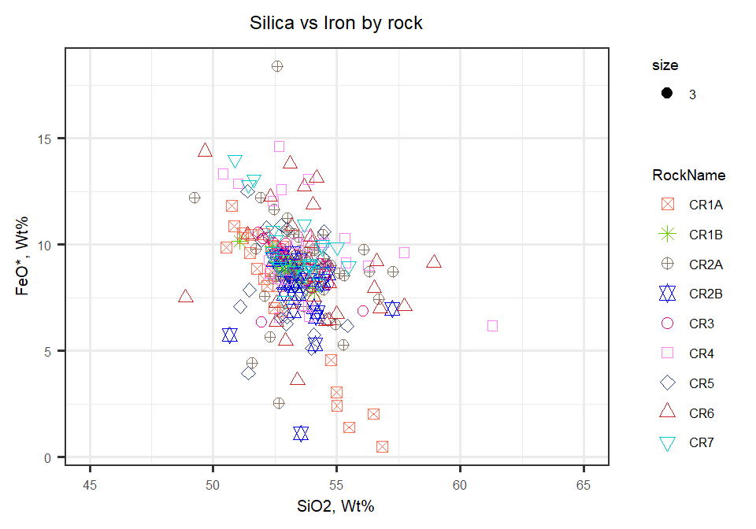

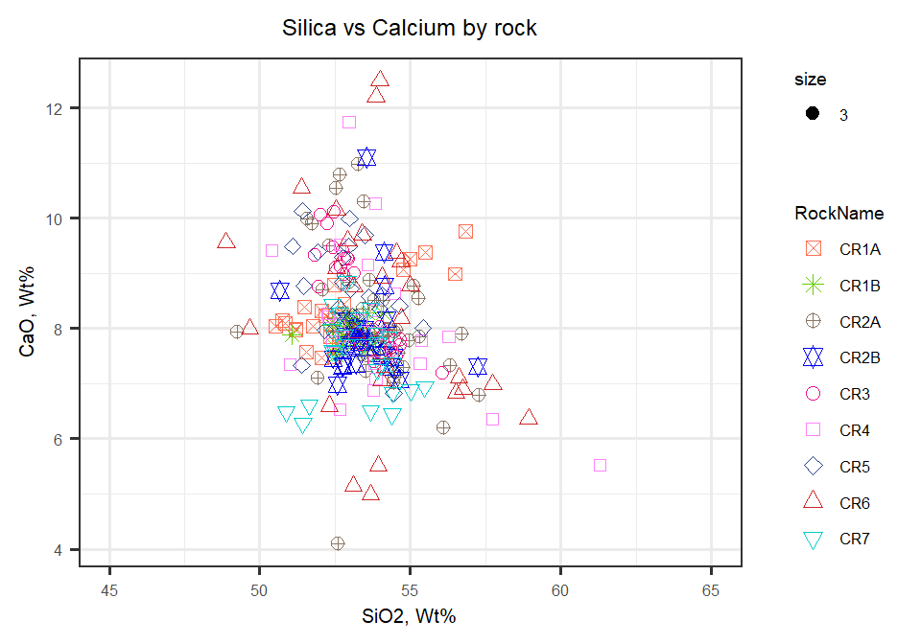

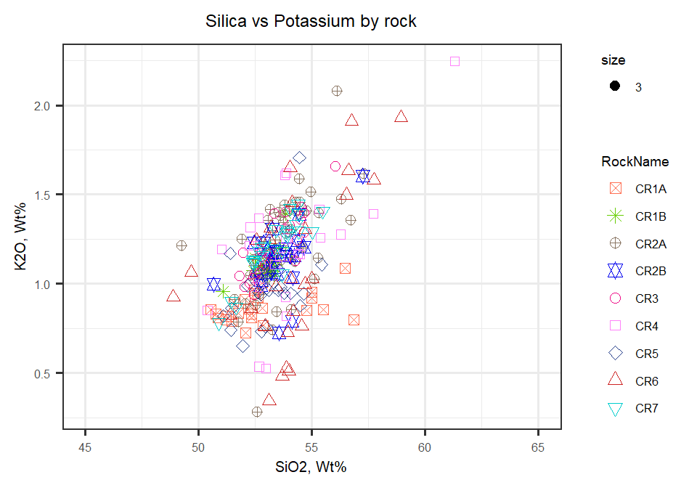

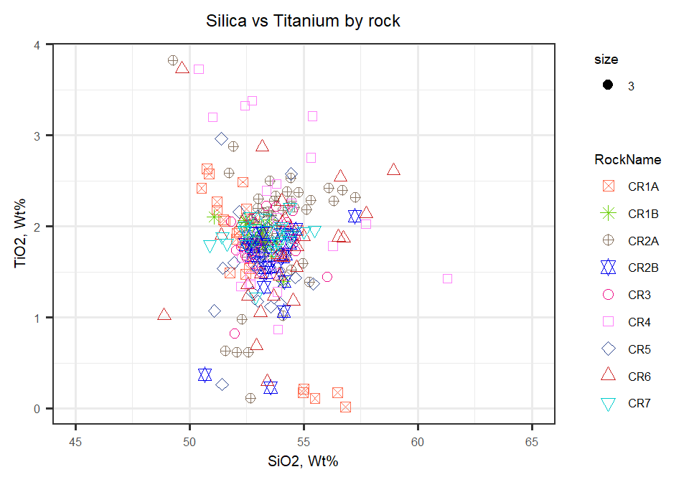

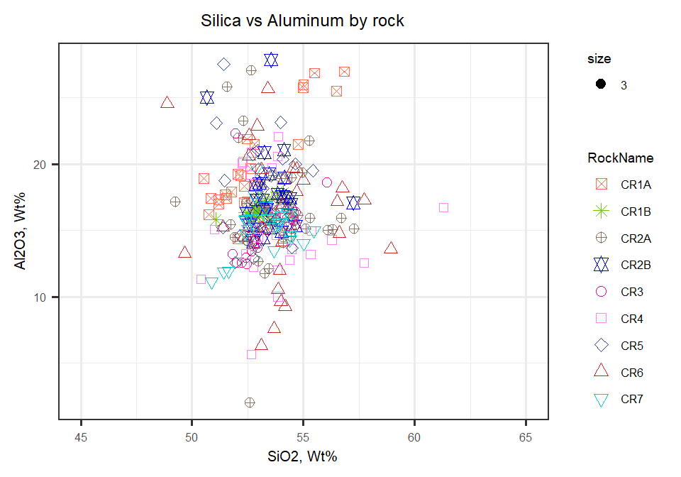

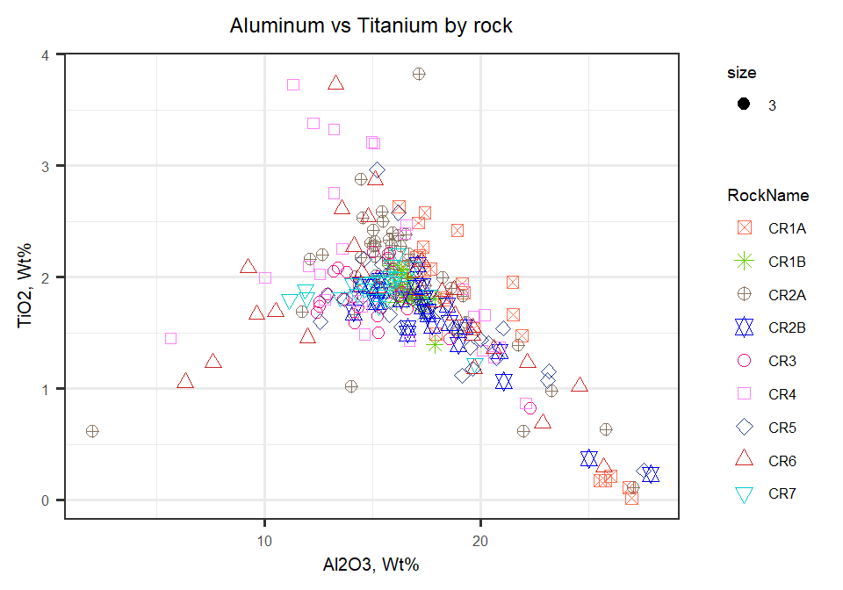

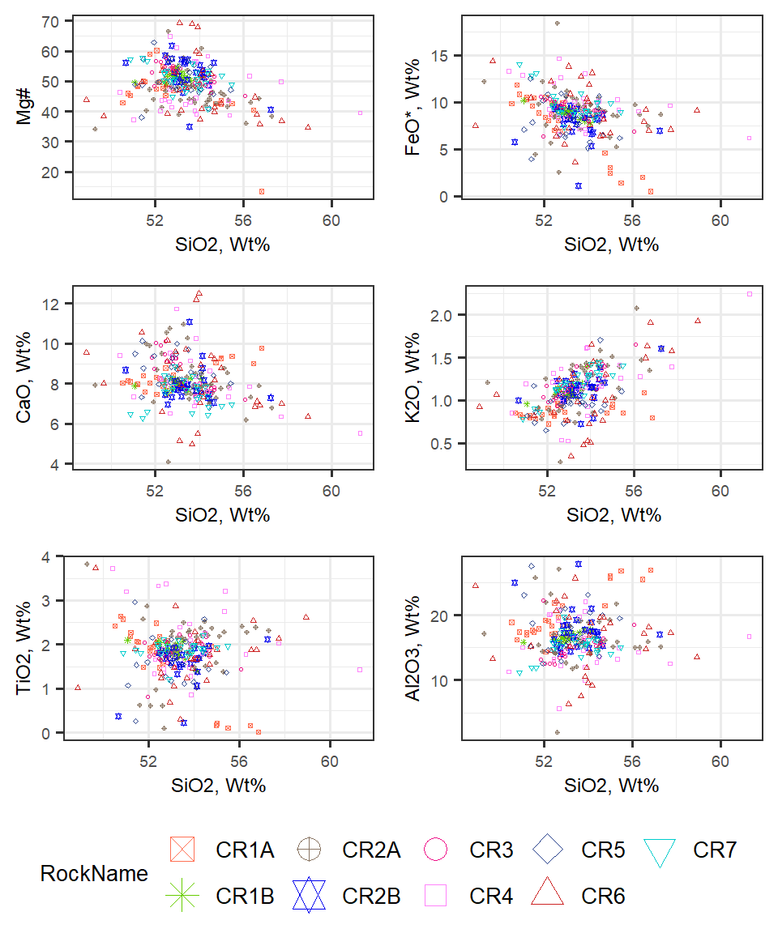

Figure 2: Major elements plotted against SiO2. All Wt% except Mg#

Compare CR1A to CR1B Harker Diagrams

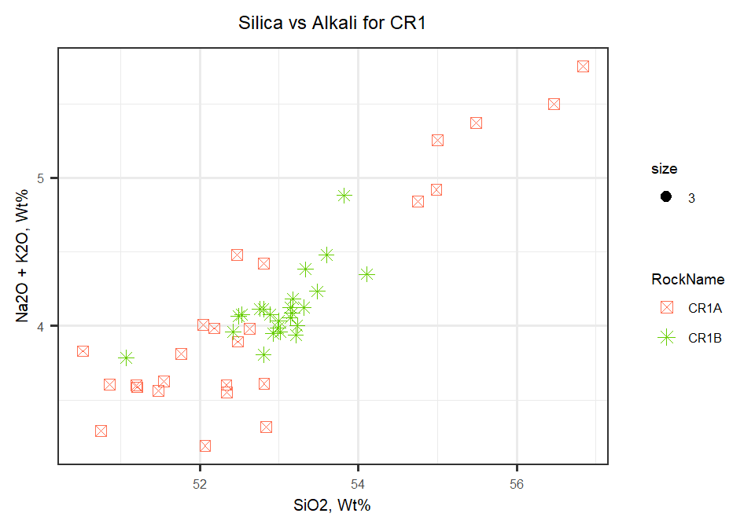

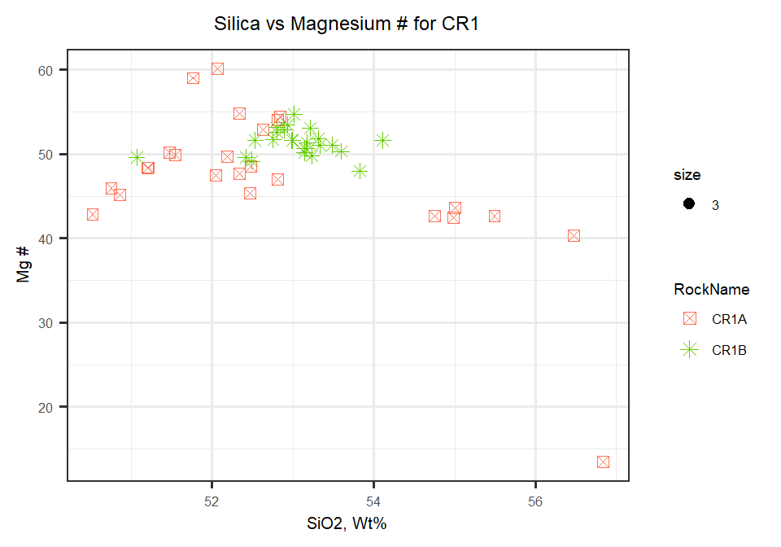

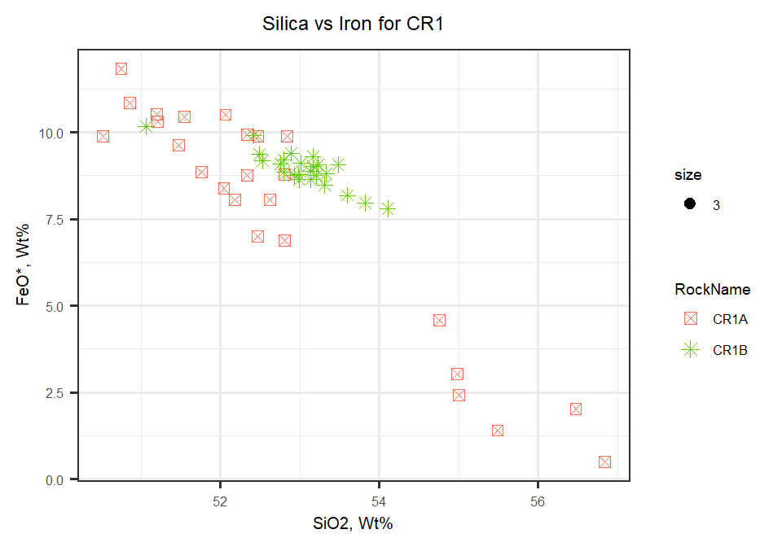

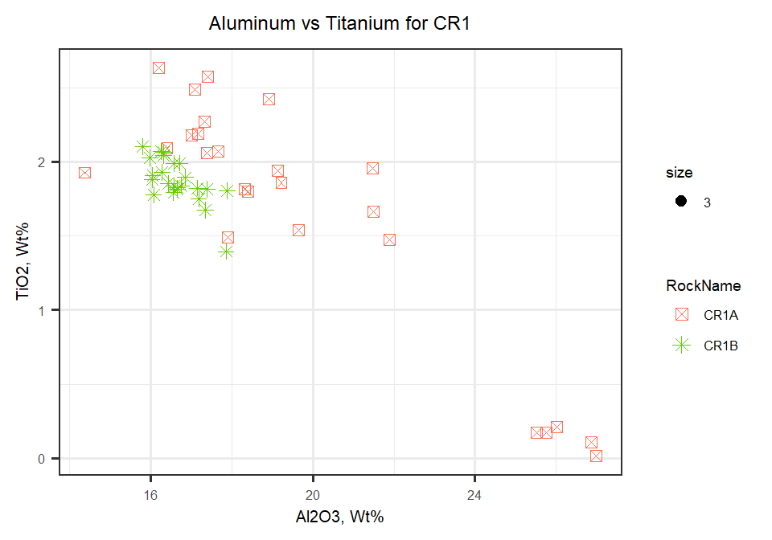

Compare CR2A to CR2B Harker Diagrams

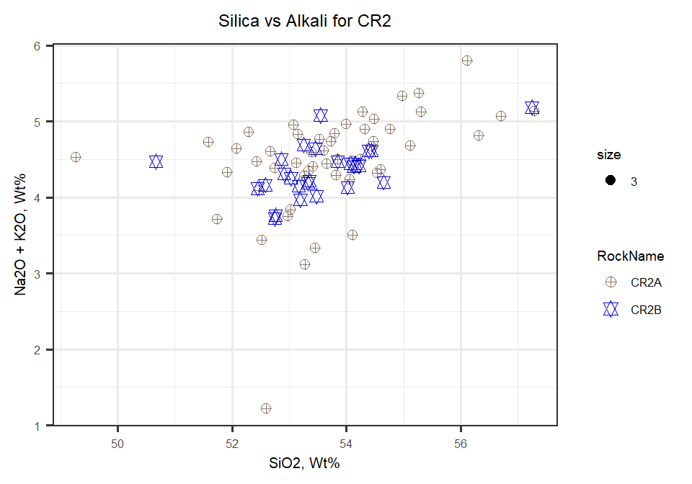

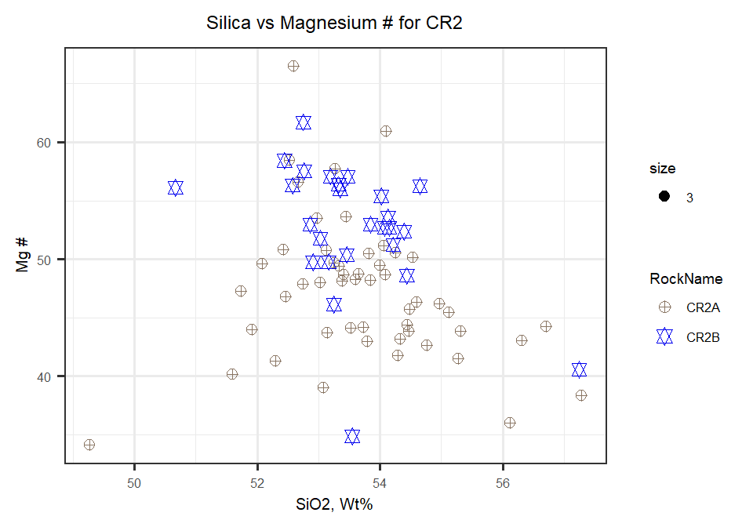

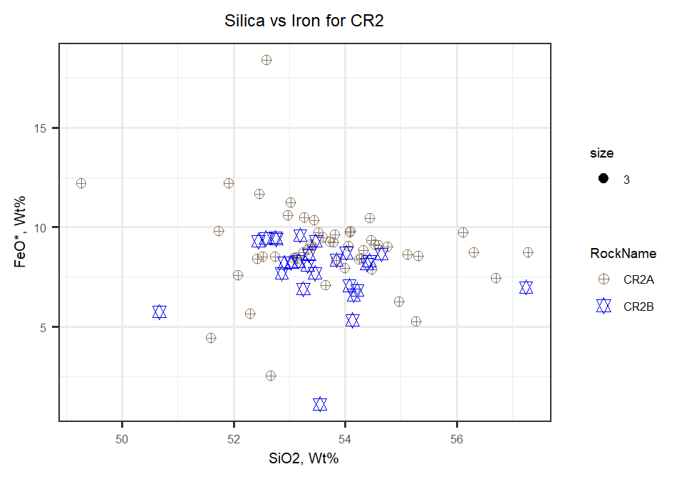

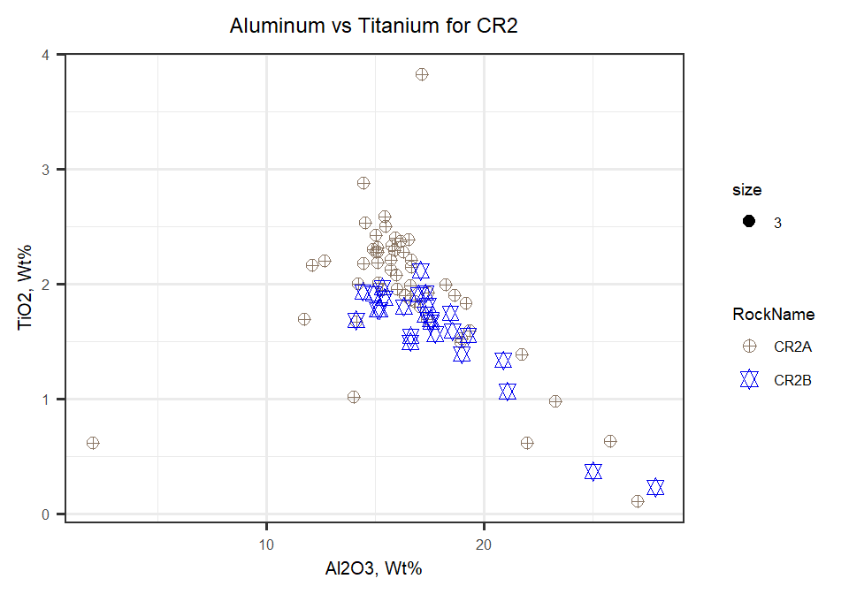

And finally, comparing CR1 to CR2 Harker Diagrams

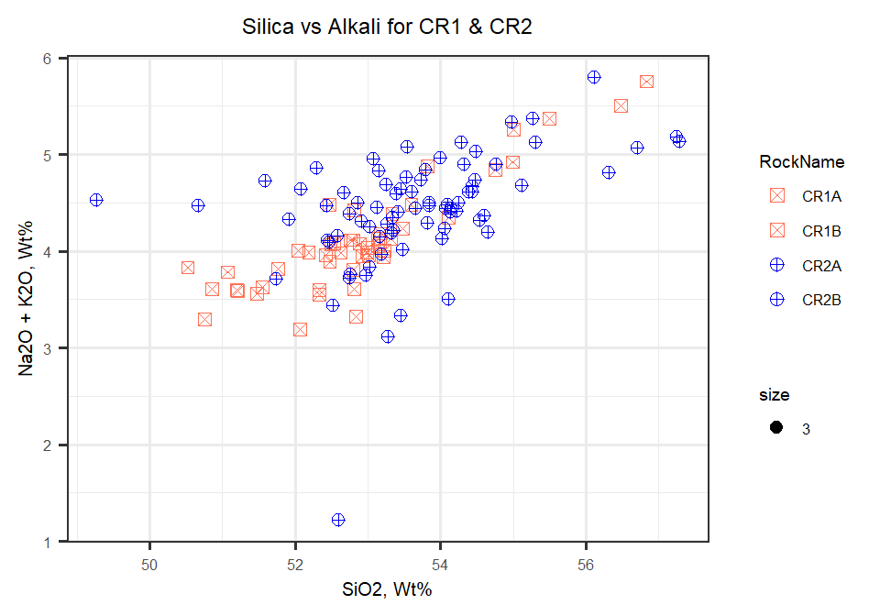

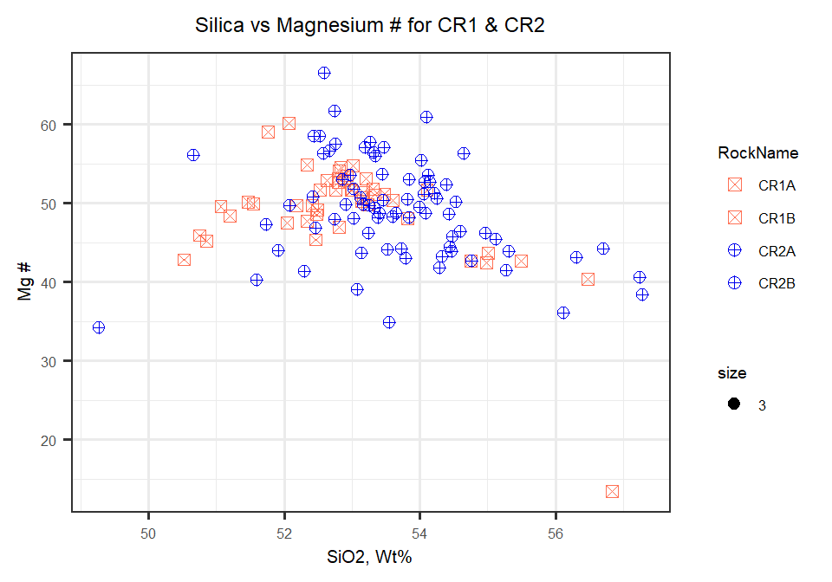

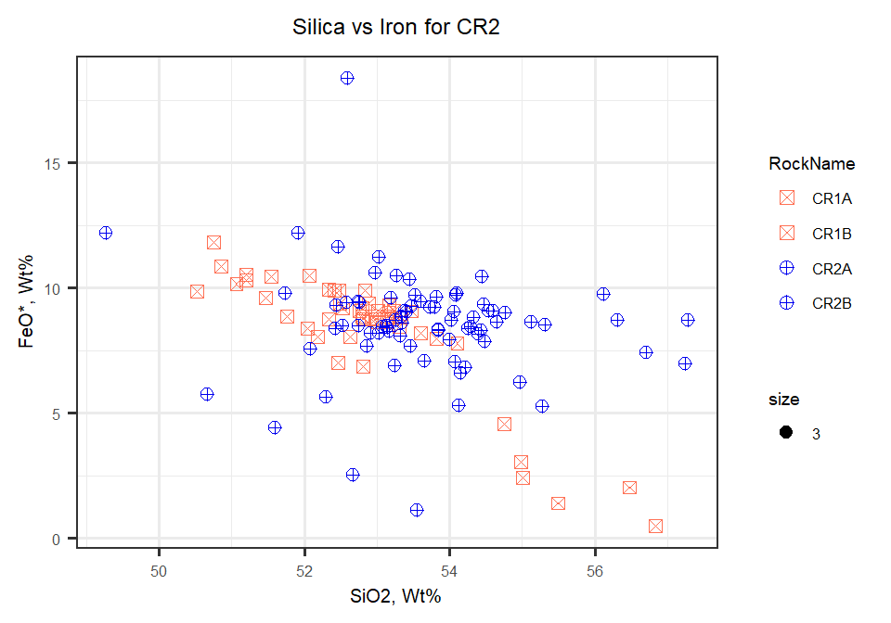

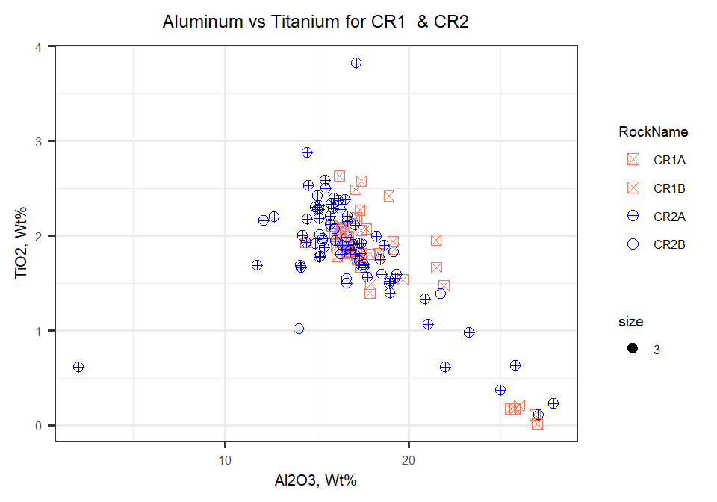

Table indicating mean averages for elements by rock

|  |  |  |  |  |  |  |  |  |  |
| --- | --- | --- | --- | --- | --- | --- | --- | --- | --- |
| **Element** | **CR1A** | **CR1B** | **CR2A** | **CR2B** | **CR3** | **CR4** | **CR5** | **CR6** | **CR7** |
| n | 25 | 24 | 51 | 26 | 25 | 25 | 26 | 28 | 25 |
| M SiO2 | 52.8 | 53 | 53.7 | 53.5 | 53.3 | 53.9 | 53.1 | 53.9 | 53.3 |
| SD SiO2 | 1.77 | 0.575 | 1.38 | 1.12 | 1.07 | 2.19 | 1.09 | 2.14 | 1.13 |
| M TiO2 | 1.64 | 1.87 | 1.95 | 1.59 | 1.81 | 2.1 | 1.64 | 1.76 | 1.9 |
| SD TiO2 | 0.829 | 0.152 | 0.618 | 0.443 | 0.294 | 0.771 | 0.519 | 0.689 | 0.178 |
| M Al2O3 | 19.8 | 16.7 | 16.4 | 17.8 | 15.1 | 15.3 | 17.9 | 16.3 | 15.2 |
| SD Al2O3 | 3.68 | 0.568 | 3.62 | 3.13 | 2.13 | 3.96 | 3.51 | 4.94 | 1.8 |
| M Cr | 0.0311 | 0.0264 | 0.0187 | 0.0244 | 0.0285 | 0.0283 | 0.0302 | 0.0322 | 0.0261 |
| SD Cr | 0.0208 | 0.0132 | 0.0175 | 0.0213 | 0.0214 | 0.0334 | 0.0237 | 0.0318 | 0.018 |
| M MgO | 4.32 | 5.29 | 4.75 | 5.1 | 5.59 | 5.28 | 4.89 | 5.33 | 5.88 |
| SD MgO | 2.26 | 0.437 | 2.64 | 1.73 | 1.25 | 2.79 | 1.81 | 3.99 | 1.82 |
| M CaO | 8.33 | 7.95 | 8.09 | 7.89 | 8.62 | 8.04 | 8.53 | 8.24 | 7.48 |
| SD CaO | 0.635 | 0.201 | 1.16 | 0.85 | 0.913 | 1.29 | 0.839 | 1.89 | 0.706 |
| M MnO | 0.11 | 0.147 | 0.14 | 0.131 | 0.162 | 0.15 | 0.139 | 0.158 | 0.168 |
| SD MnO | 0.0548 | 0.0177 | 0.0643 | 0.0361 | 0.037 | 0.0505 | 0.0447 | 0.0653 | 0.0384 |
| M FeO | 7.7 | 8.93 | 8.95 | 7.77 | 9.12 | 9.79 | 8.22 | 8.95 | 9.73 |
| SD FeO | 3.35 | 0.532 | 2.2 | 1.78 | 1.03 | 2.28 | 2.05 | 2.71 | 1.56 |
| M Na2O | 3.24 | 3 | 3.26 | 3.22 | 2.95 | 3.05 | 3.13 | 2.87 | 2.86 |
| SD Na2O | 0.71 | 0.169 | 0.5 | 0.333 | 0.363 | 0.543 | 0.401 | 0.651 | 0.324 |
| M K2O | 0.868 | 1.11 | 1.21 | 1.13 | 1.21 | 1.19 | 0.986 | 1.09 | 1.2 |
| SD K2O | 0.0811 | 0.0804 | 0.277 | 0.171 | 0.172 | 0.347 | 0.205 | 0.423 | 0.168 |
| M S | 0.00635 | 0.00881 | 0.00746 | 0.00706 | 0.00736 | 0.00604 | 0.00473 | 0.00902 | 0.00784 |
| SD S | 0.00691 | 0.00909 | 0.007 | 0.00736 | 0.00832 | 0.0068 | 0.00676 | 0.00941 | 0.00776 |
| M P2O5 | 0.302 | 0.349 | 0.378 | 0.322 | 0.346 | 0.323 | 0.255 | 0.301 | 0.349 |
| SD P2O5 | 0.154 | 0.0345 | 0.154 | 0.0984 | 0.0821 | 0.12 | 0.0885 | 0.135 | 0.0699 |
| M MgN | 47.1 | 51.3 | 47.3 | 52.6 | 51.7 | 47.1 | 50.6 | 47.8 | 51.1 |
| SD MgN | 8.7 | 1.54 | 6.03 | 5.64 | 3.39 | 7.77 | 5.49 | 10.1 | 4.01 |
| M Total | 99.3 | 98.8 | 99.1 | 99 | 98.9 | 99.2 | 99.1 | 99.1 | 98.8 |
| SD Total | 0.369 | 0.384 | 0.529 | 0.436 | 0.252 | 0.448 | 0.422 | 0.398 | 0.331 |

Table with no Standard Deviation

|  |  |  |  |  |  |  |  |  |  |
| --- | --- | --- | --- | --- | --- | --- | --- | --- | --- |
| **Element** | **CR1A** | **CR1B** | **CR2A** | **CR2B** | **CR3** | **CR4** | **CR5** | **CR6** | **CR7** |
| n | 25 | 24 | 51 | 26 | 25 | 25 | 26 | 28 | 25 |
| SiO2 | 52.8 | 53 | 53.7 | 53.5 | 53.3 | 53.9 | 53.1 | 53.9 | 53.3 |
| TiO2 | 1.64 | 1.87 | 1.95 | 1.59 | 1.81 | 2.1 | 1.64 | 1.76 | 1.9 |
| Al2O3 | 19.8 | 16.7 | 16.4 | 17.8 | 15.1 | 15.3 | 17.9 | 16.3 | 15.2 |
| Cr | 0.0311 | 0.0264 | 0.0187 | 0.0244 | 0.0285 | 0.0283 | 0.0302 | 0.0322 | 0.0261 |
| MgO | 4.32 | 5.29 | 4.75 | 5.1 | 5.59 | 5.28 | 4.89 | 5.33 | 5.88 |
| CaO | 8.33 | 7.95 | 8.09 | 7.89 | 8.62 | 8.04 | 8.53 | 8.24 | 7.48 |
| MnO | 0.11 | 0.147 | 0.14 | 0.131 | 0.162 | 0.15 | 0.139 | 0.158 | 0.168 |
| FeO | 7.7 | 8.93 | 8.95 | 7.77 | 9.12 | 9.79 | 8.22 | 8.95 | 9.73 |
| Na2O | 3.24 | 3 | 3.26 | 3.22 | 2.95 | 3.05 | 3.13 | 2.87 | 2.86 |
| K2O | 0.868 | 1.11 | 1.21 | 1.13 | 1.21 | 1.19 | 0.986 | 1.09 | 1.2 |
| S | 0.00635 | 0.00881 | 0.00746 | 0.00706 | 0.00736 | 0.00604 | 0.00473 | 0.00902 | 0.00784 |
| P2O5 | 0.302 | 0.349 | 0.378 | 0.322 | 0.346 | 0.323 | 0.255 | 0.301 | 0.349 |
| MgN | 47.1 | 51.3 | 47.3 | 52.6 | 51.7 | 47.1 | 50.6 | 47.8 | 51.1 |
| Total | 99.3 | 98.8 | 99.1 | 99 | 98.9 | 99.2 | 99.1 | 99.1 | 98.8 |