Costa Rican Glass Compositions

Julie M. Coulombe

September 15, 2020

An analysis of volcanic glass sampled from the Tajo La Florida quarry at Barva Volcano in Costa Rica. Samples collected are from potentially different lava flows. Data was acquired by using an electron microprobe.

Data points were constrained as follows:

Wt% Totals > 95.0 and < 101.0  
SiO2 < 90.0 and > 40.0 Al2O3 > 9.0 and < 22.0  
K2O > 1.0

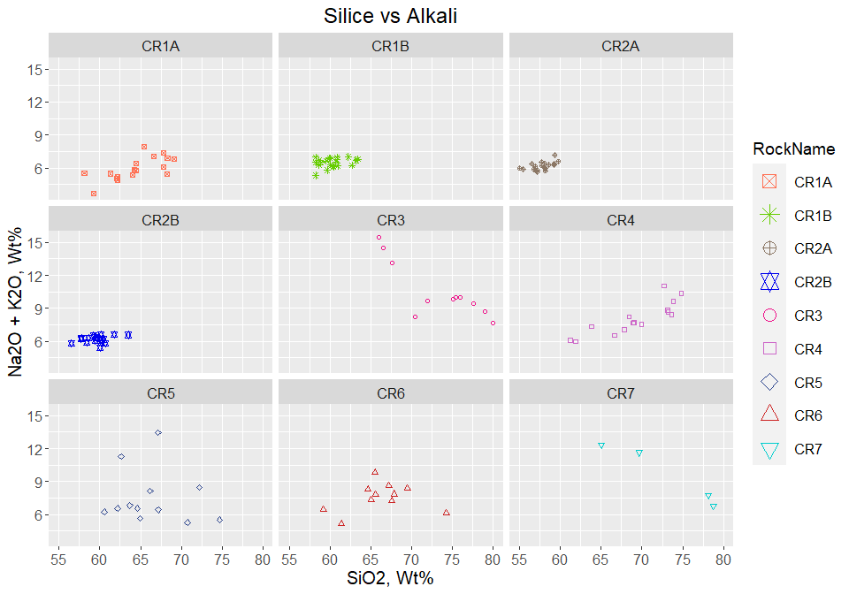

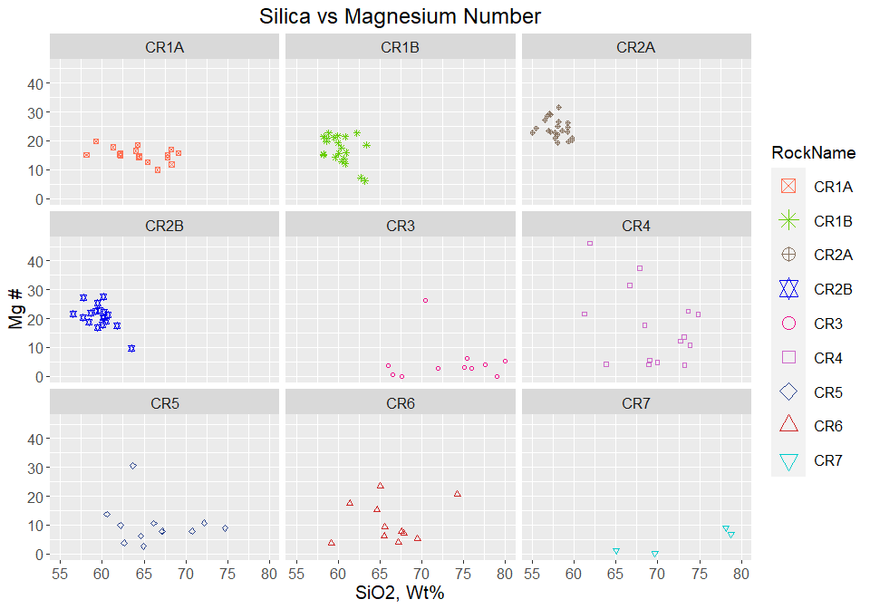

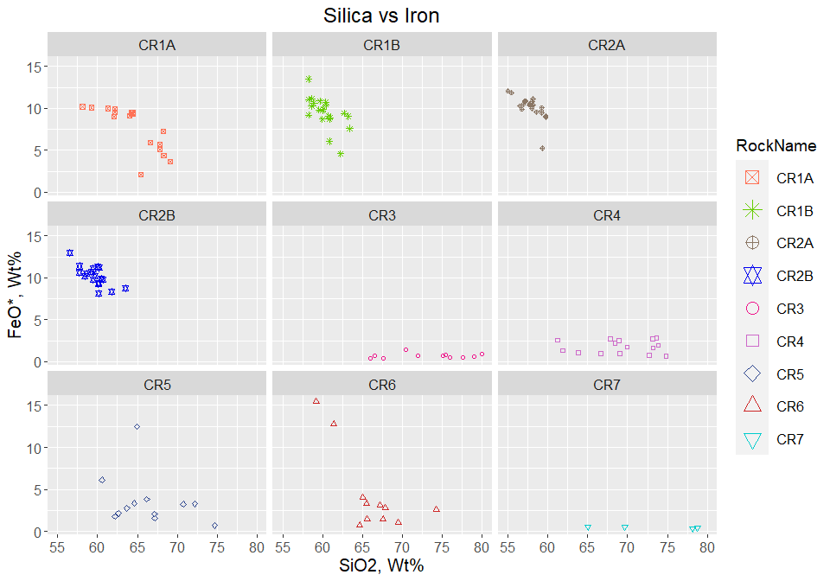

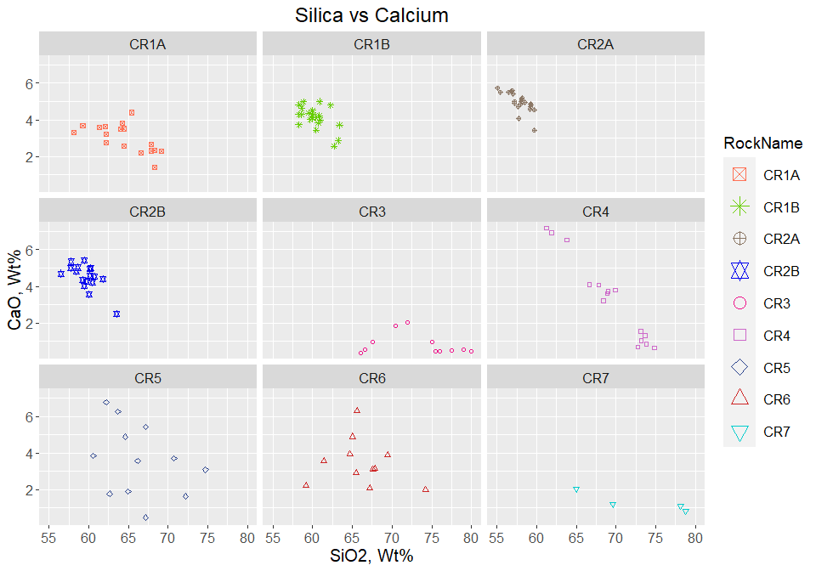

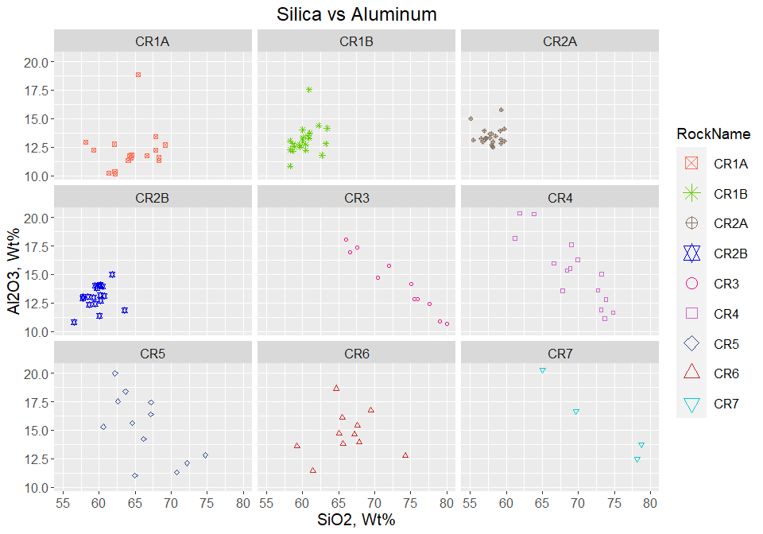

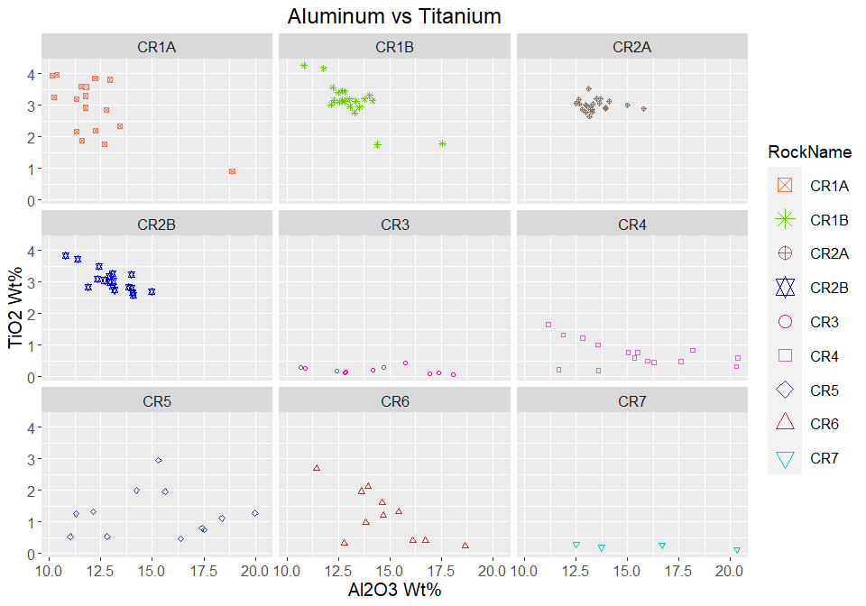

Plot Alkali by Rock Name

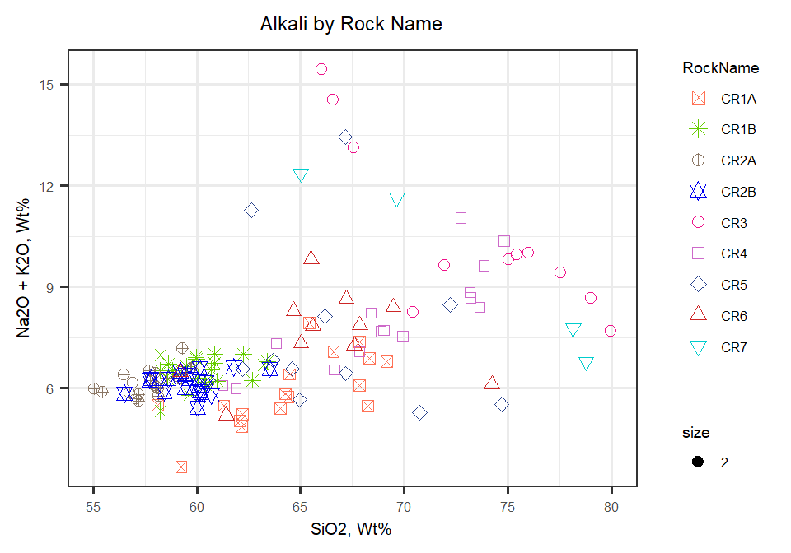

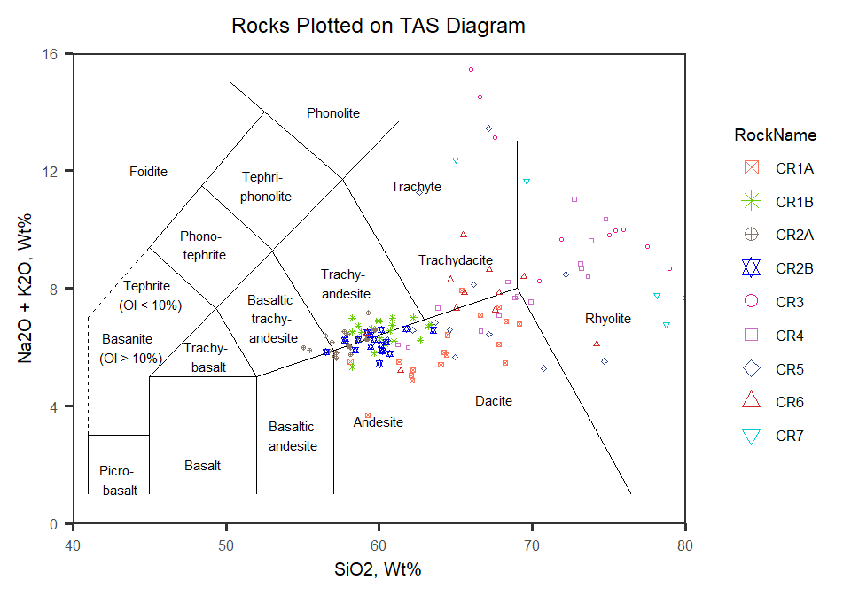

Now to look at plots of all rocks together

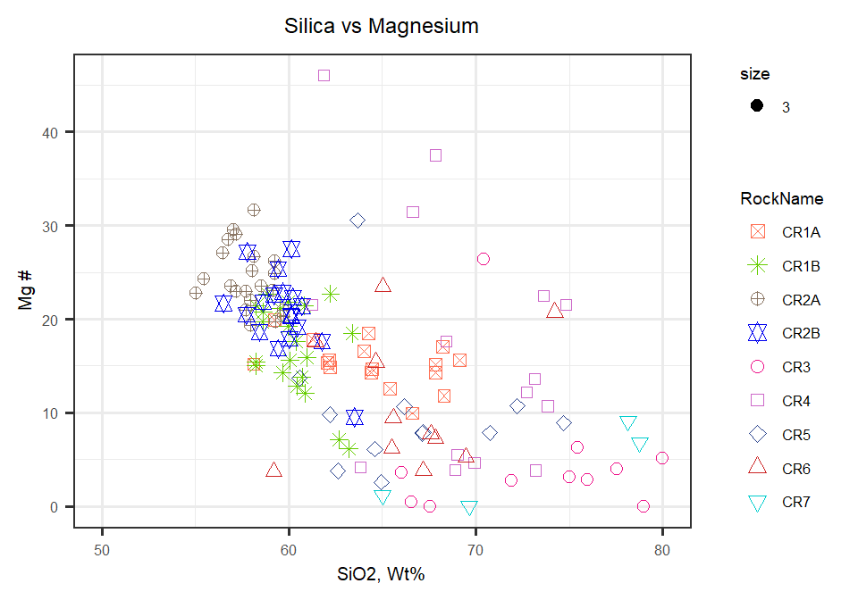

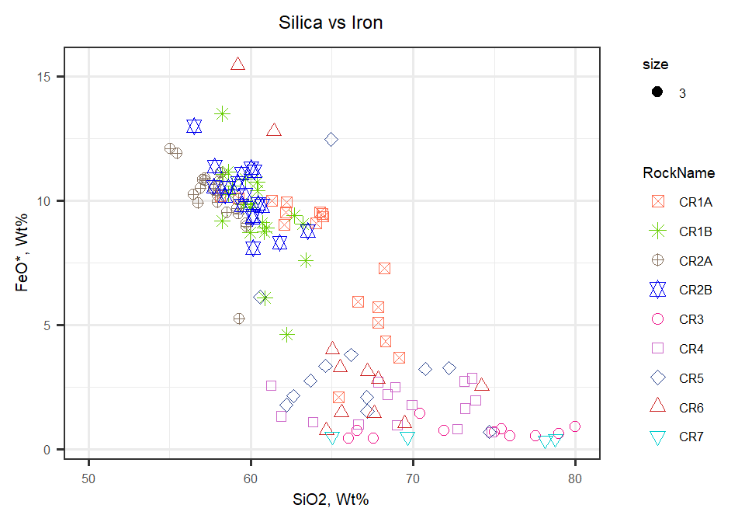

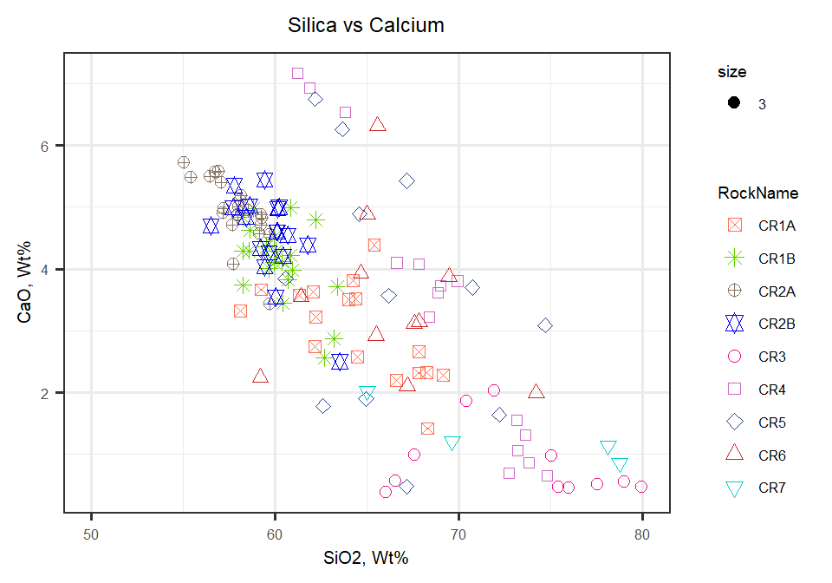

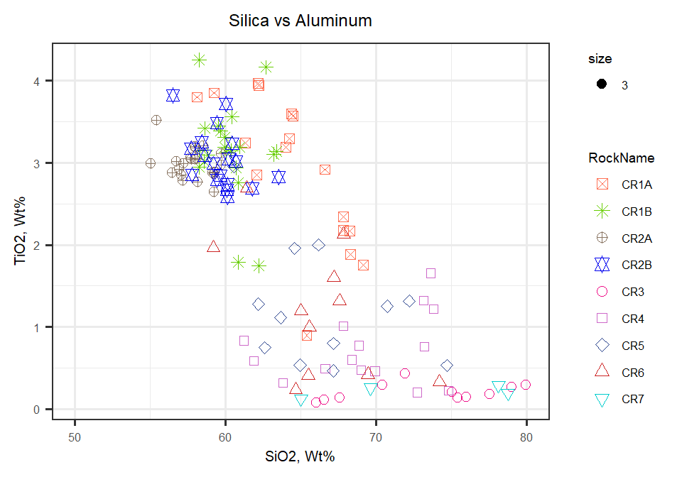

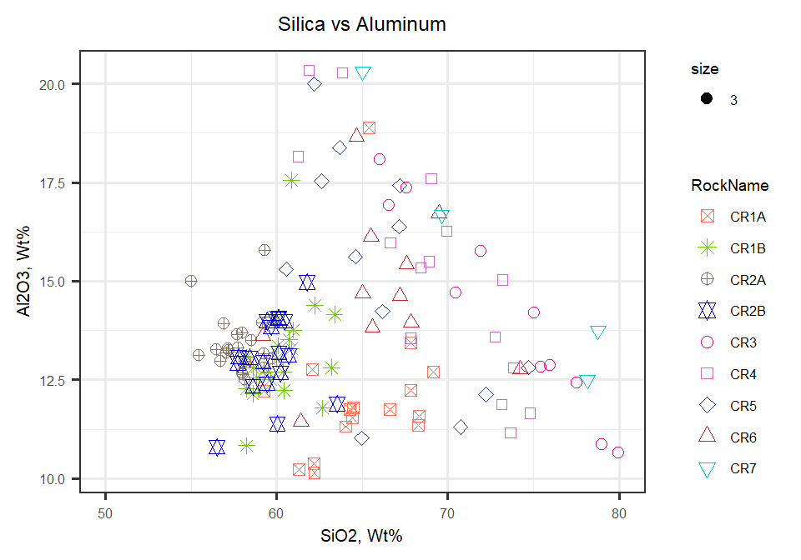

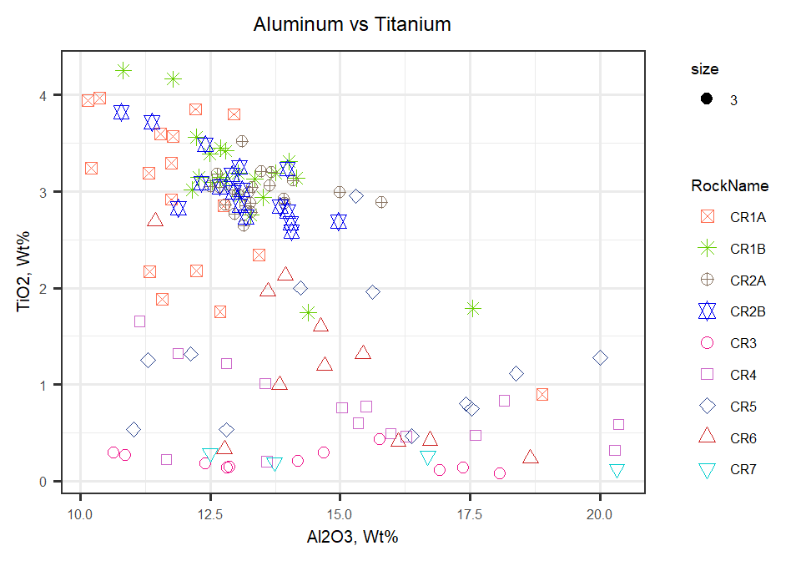

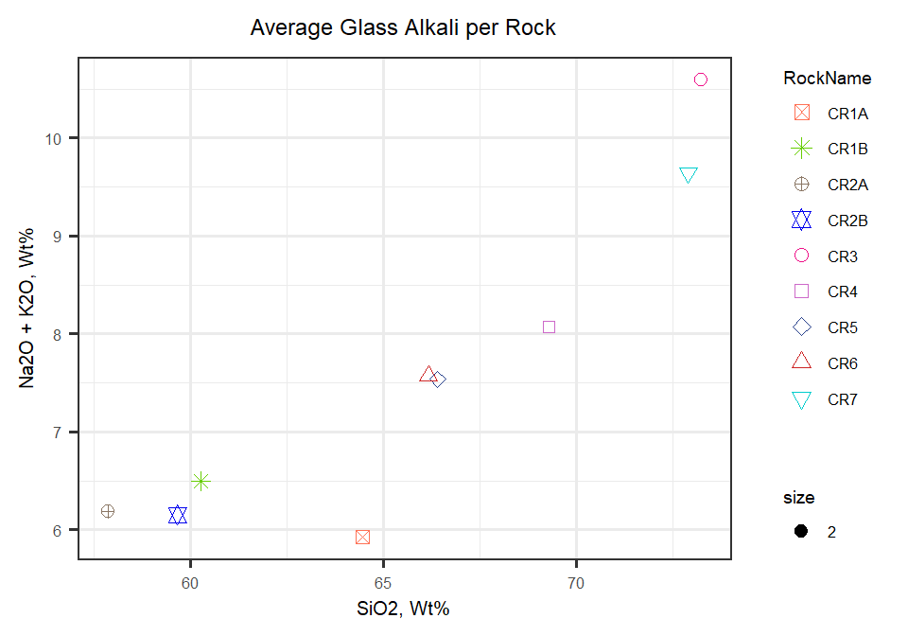

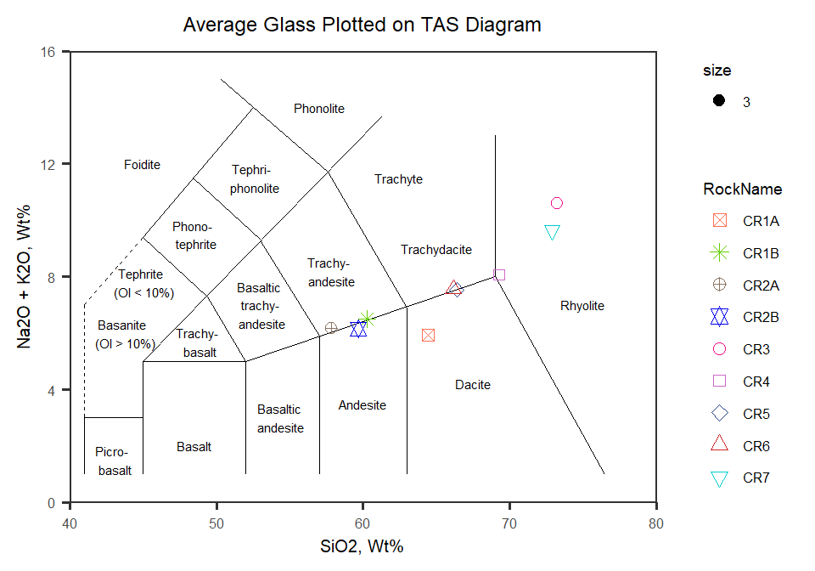

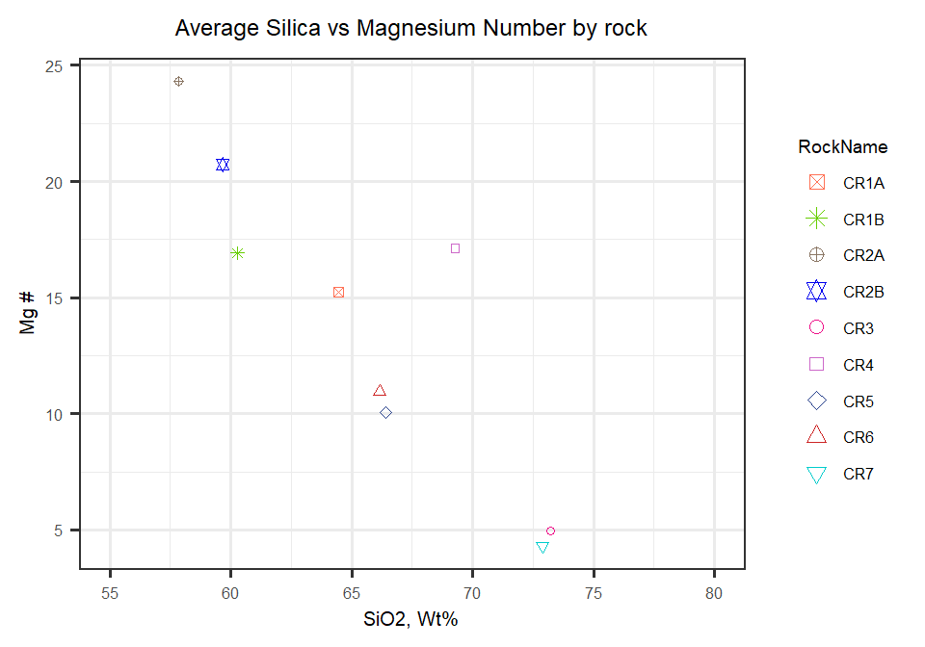

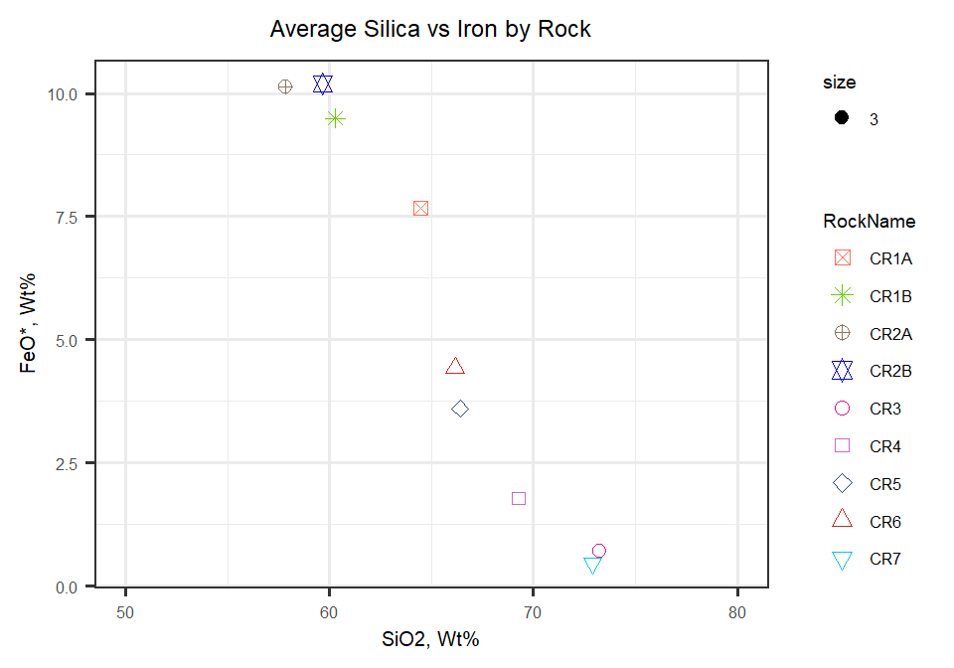

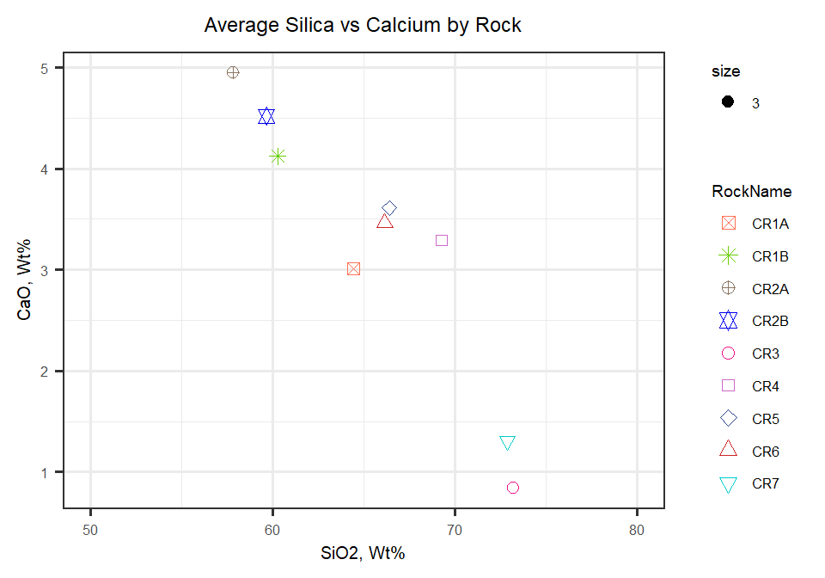

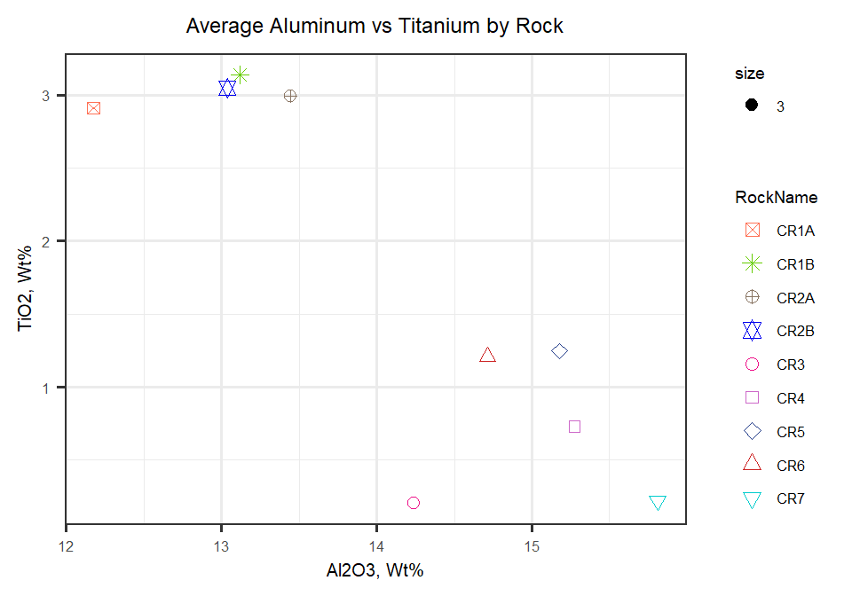

Table laying out representative glass samples

|  |  |  |  |  |  |  |  |  |
| --- | --- | --- | --- | --- | --- | --- | --- | --- |
| **wt %** | **CR1A2_2 Pt1** | **CR1B_1 Pt15** | **CR2A2_3 PT1** | **CR2B2_1 PT2** | **CR31_3 PT7** | **CR42_1 PT6** | **CR51_2 PT5** | **CR72_3 Pt1** |
| SiO2 | 64.5 | 60.4 | 59.2 | 59.7 | 71.9 | 69 | 66.2 | 69.6 |
| TiO2 | 3.57 | 3.15 | 2.87 | 2.84 | 0.43 | 0.473 | 2 | 0.26 |
| Al2O3 | 11.8 | 12.7 | 12.8 | 13.8 | 15.8 | 17.6 | 14.2 | 16.7 |
| Cr2O3 | 0.0336 | 0.0312 | 0 | 0 | 0 | 0.0078 | 0.0106 | 0.037 |
| MgO | 0.901 | 1.29 | 1.86 | 1.7 | 0.0119 | 0.0313 | 0.254 | 0.0002 |
| CaO | 2.57 | 4.12 | 4.71 | 4.26 | 2.03 | 3.73 | 3.57 | 1.21 |
| MnO | 0.154 | 0.125 | 0.117 | 0.151 | 0 | 0.0008 | 0.0356 | 0.003 |
| FeO | 9.36 | 10.8 | 10 | 10.2 | 0.741 | 0.954 | 3.8 | 0.503 |
| Na2O | 2.22 | 3.02 | 3.23 | 3.86 | 4.66 | 3.35 | 2.42 | 4.7 |
| K2O | 4.19 | 3.15 | 3.17 | 2.41 | 4.99 | 4.38 | 5.71 | 6.94 |
| S | 0 | 0.0067 | 0.0116 | 0.0021 | 0.0109 | 0.0207 | 0.0068 | 0.0163 |
| P2O5 | 1.13 | 0.889 | 0.663 | 0.735 | 0.118 | 0.0725 | 1.77 | 0.0859 |
| Total | 100 | 99.6 | 98.7 | 99.7 | 101 | 99.6 | 100 | 100 |

Table showing glass averages

|  |  |  |  |  |  |  |  |  |  |  |  |  |  |  |  |  |  |  |  |  |  |  |  |  |  |  |  |  |  |
| --- | --- | --- | --- | --- | --- | --- | --- | --- | --- | --- | --- | --- | --- | --- | --- | --- | --- | --- | --- | --- | --- | --- | --- | --- | --- | --- | --- | --- | --- |
| **RockName** | **n** | **SiO2 m** | **SiO2 sd** | **TiO2 m** | **TiO2 sd** | **Al2O3 m** | **Al2O3 sd** | **Cr m** | **CR sd** | **MgO m** | **MgO sd** | **CaO m** | **CaO sd** | **MnO m** | **MnO sd** | **FeO m** | **FeO sd** | **Na2O m** | **Na2O sd** | **K2O m** | **K2O sd** | **S m** | **S sd** | **P2O5 m** | **P2O5 sd** | **MgN m** | **MgN sd** | **Total m** | **Total sd** |
| CR1A | 17 | 64.5 | 3.29 | 2.91 | 0.899 | 12.2 | 1.96 | 0.00774 | 0.0116 | 0.804 | 0.358 | 3.01 | 0.766 | 0.127 | 0.0432 | 7.67 | 2.64 | 2.63 | 1.16 | 3.3 | 1.08 | 0.00842 | 0.00617 | 0.98 | 0.307 | 15.2 | 2.42 | 98.1 | 1.83 |
| CR1B | 21 | 60.3 | 1.59 | 3.14 | 0.581 | 13.1 | 1.31 | 0.00709 | 0.009 | 1.1 | 0.41 | 4.12 | 0.629 | 0.125 | 0.0407 | 9.5 | 1.85 | 3.52 | 0.657 | 2.97 | 0.376 | 0.00944 | 0.00641 | 0.816 | 0.119 | 16.9 | 4.78 | 98.7 | 0.978 |
| CR2A | 22 | 57.9 | 1.28 | 2.99 | 0.185 | 13.4 | 0.77 | 0.00515 | 0.00841 | 1.85 | 0.463 | 4.95 | 0.524 | 0.137 | 0.0364 | 10.1 | 1.34 | 3.58 | 0.358 | 2.6 | 0.394 | 0.00768 | 0.00788 | 0.655 | 0.0882 | 24.3 | 3.36 | 98.2 | 0.782 |
| CR2B | 18 | 59.7 | 1.58 | 3.05 | 0.353 | 13 | 1.04 | 0.00963 | 0.0106 | 1.53 | 0.43 | 4.52 | 0.69 | 0.14 | 0.026 | 10.2 | 1.2 | 3.44 | 0.592 | 2.71 | 0.583 | 0.0106 | 0.00935 | 0.738 | 0.055 | 20.7 | 4.12 | 99 | 1.09 |
| CR3 | 11 | 73.2 | 5.01 | 0.206 | 0.104 | 14.2 | 2.56 | 0.0132 | 0.0123 | 0.0364 | 0.0839 | 0.843 | 0.581 | 0.0126 | 0.0157 | 0.715 | 0.283 | 2.68 | 1.12 | 7.91 | 2.96 | 0.00373 | 0.00467 | 0.0588 | 0.086 | 4.95 | 7.39 | 100 | 0.951 |
| CR4 | 15 | 69.3 | 4.41 | 0.729 | 0.421 | 15.3 | 2.92 | 0.00804 | 0.00897 | 0.244 | 0.259 | 3.29 | 2.27 | 0.0273 | 0.0255 | 1.78 | 0.775 | 3.08 | 1.17 | 4.99 | 2.5 | 0.0102 | 0.0101 | 0.439 | 0.426 | 17.1 | 13.1 | 99.2 | 1.42 |
| CR5 | 12 | 66.4 | 4.28 | 1.25 | 0.744 | 15.2 | 2.92 | 0.00668 | 0.0126 | 0.211 | 0.201 | 3.61 | 1.96 | 0.0269 | 0.0198 | 3.6 | 3.11 | 3.5 | 1.03 | 4.04 | 3.02 | 0.00725 | 0.00609 | 0.881 | 0.459 | 10 | 7.15 | 98.7 | 1.53 |
| CR6 | 11 | 66.2 | 3.97 | 1.21 | 0.825 | 14.7 | 1.98 | 0.0123 | 0.0127 | 0.318 | 0.446 | 3.46 | 1.29 | 0.0483 | 0.0561 | 4.43 | 4.93 | 3.21 | 0.721 | 4.36 | 1.43 | 0.00714 | 0.00901 | 0.779 | 0.591 | 11 | 7.08 | 98.7 | 1.25 |
| CR7 | 4 | 72.9 | 6.7 | 0.219 | 0.0715 | 15.8 | 3.48 | 0.0174 | 0.0157 | 0.0103 | 0.0098 | 1.31 | 0.504 | 0.0144 | 0.0229 | 0.451 | 0.0788 | 4.43 | 1.39 | 5.21 | 1.57 | 0.01 | 0.0106 | 0.0341 | 0.0352 | 4.3 | 4.36 | 100 | 0.317 |

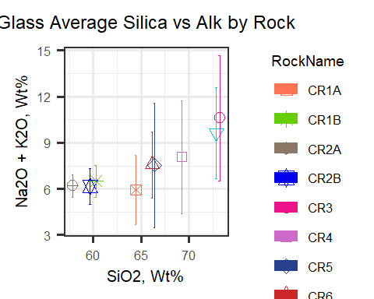

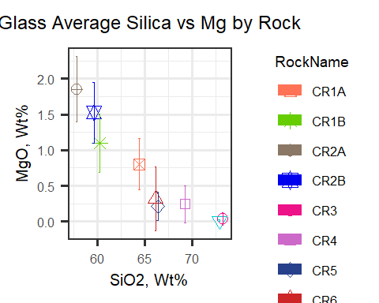

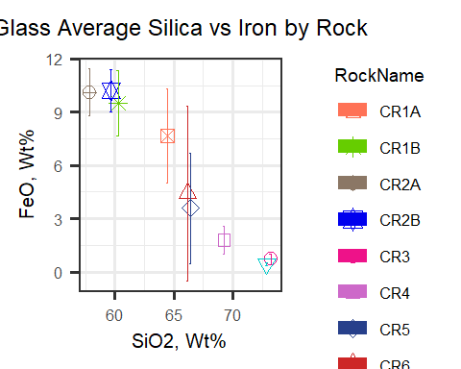

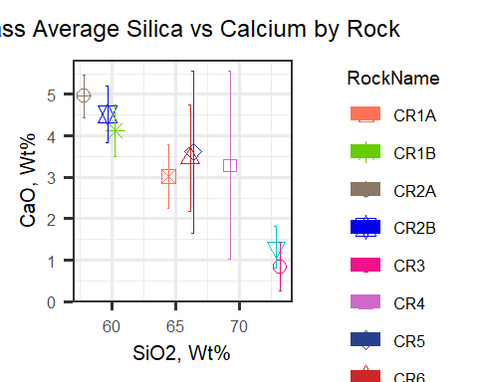

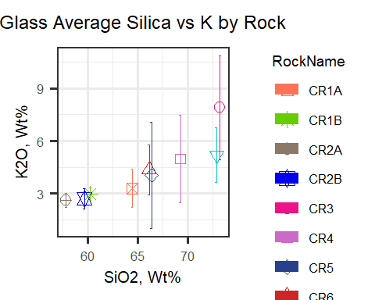

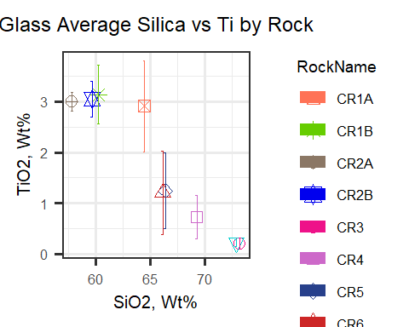

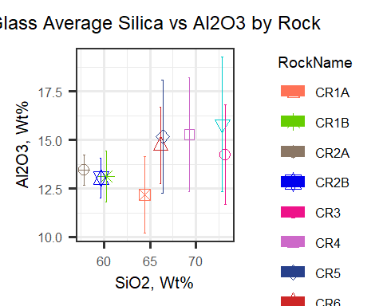

Taking a look at comparing CR1A to CR1B (two samples from the same flow)

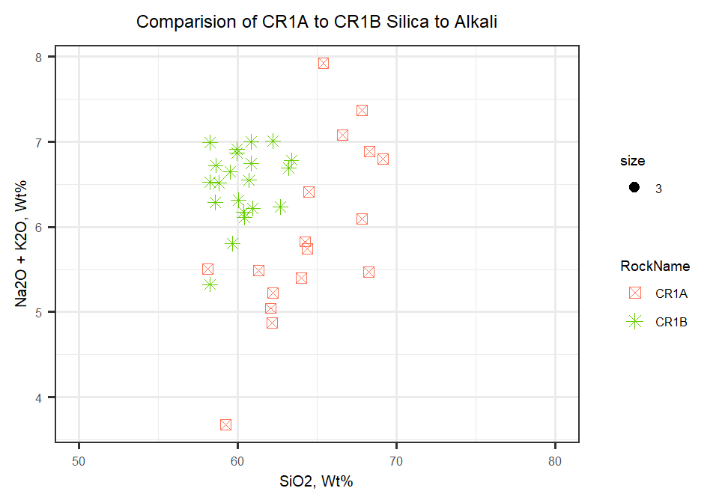

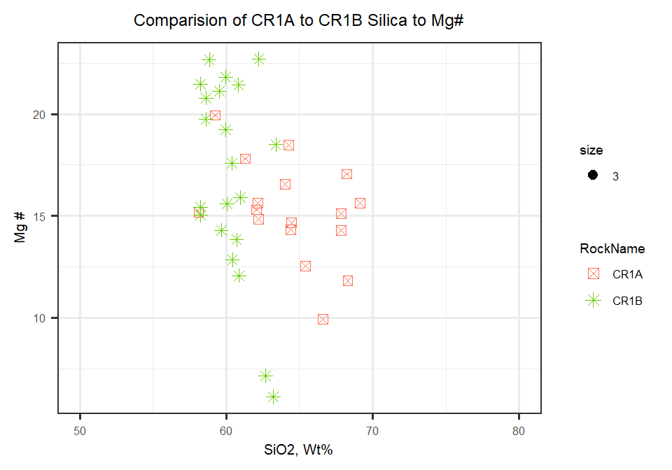

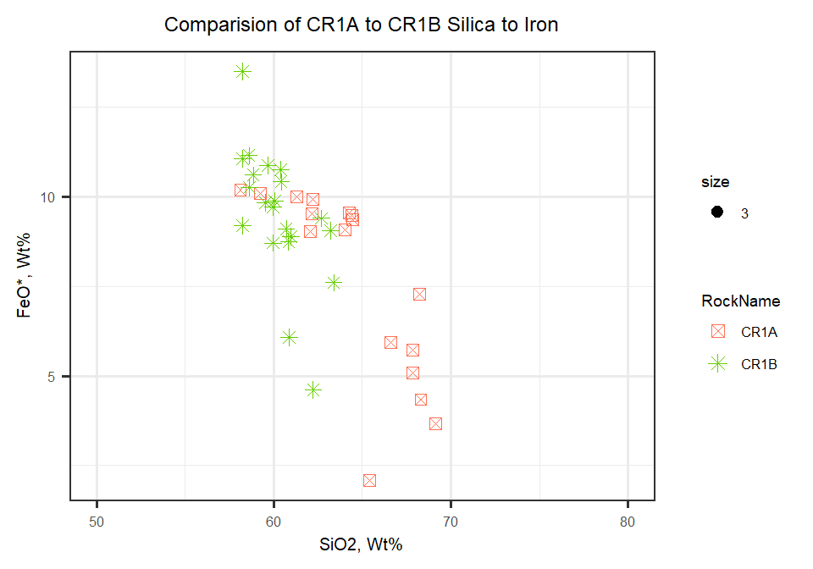

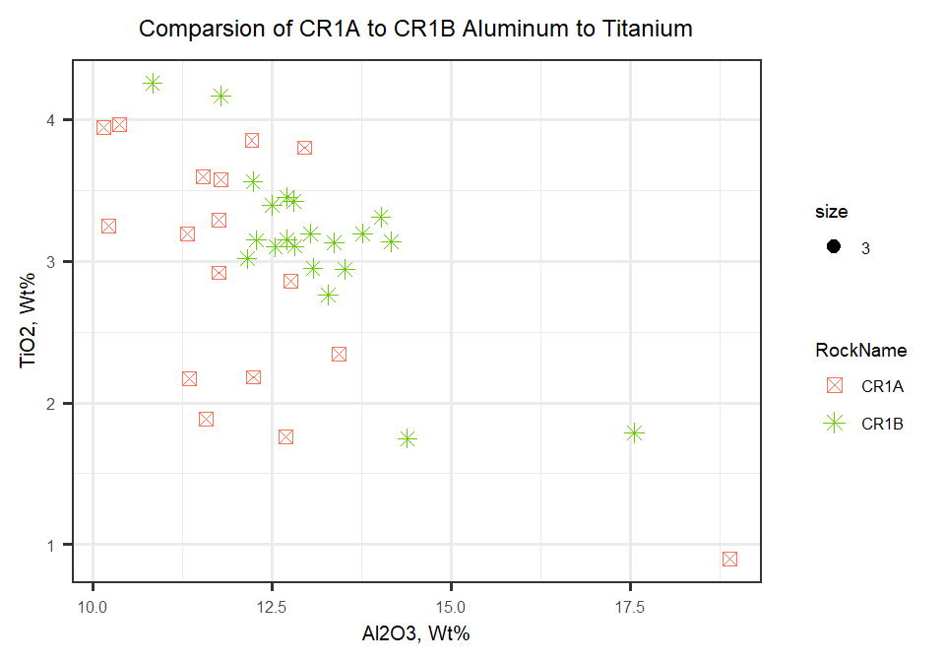

Taking a look at comparing CR2A to CR2B

