table_test

Julie M. Coulombe

7/17/2020

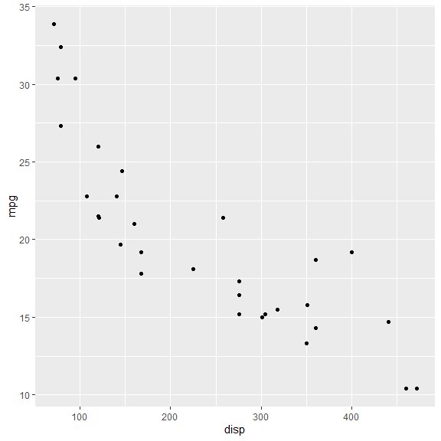

Funtions 4 6 8  
1 n 11.000000 7.000000 14.000000  
2 Disp 105.136364 183.314286 353.100000  
3 Hp 82.636364 122.285714 209.214286  
4 Drat 4.070909 3.585714 3.229286  
5 Wt 2.285727 3.117143 3.999214  
6 Qsec 19.137273 17.977143 16.772143

Element CR3 CR4  
1 n 25.000000 26.000000  
2 SiO2 53.306964 53.076396  
3 TiO2 1.895696 1.635331  
4 Al2O3 15.196552 17.891377

|  |  |  |
| --- | --- | --- |
|  | CR3 | CR4 |
| n | 25.000000 | 26.000000 |
| SiO2 | 53.306964 | 53.076396 |
| TiO2 | 1.895696 | 1.635331 |
| Al2O3 | 15.196552 | 17.891377 |