University of California, San Diego

U.S. Foreign Policy in the Persian Gulf:

Pax Americana

Jordan Kellar Coursey (A11605033)  
The Political Economy of Global Energy

Professor Herberg

**EXECUTIVE SUMMARY:** This essay will answer why the United States has had and continues to have such a strong hegemonic presence, militarily, diplomatically, and economically, in the Persian Gulf and go into detail about why it has waxed and waned throughout the modern era.  It will trace through and delineate the Persian Gulf conflict, a geopolitical problem that is faced by governments, from the Arab-Israeli issue, an issue that stems from resentment from common people in the Arab world. After World War II, a dilapidated Great Britain could no longer maintain peace between newly created Israel and the Arab World. The U.S. became, by necessity, the hegemonic force that ensured the free flow of oil, creating the Pax Americana. The U.S. only became seriously involved in Middle Eastern affairs after the 1973 Arab oil embargo, the first oil shock, and even more so after the Iranian Revolution, the second oil shock. In 1980, the Carter Doctrine defined our position as the sole hegemonic force in the region specifically to counter Soviet encroachment after its invasion of Afghanistan. Since the Ayatollah took power of Iran, it has been a belligerent force in the Persian Gulf, specifically when it began attacking Kuwaiti tankers in 1986. Our willingness to put troops on the ground is also demonstrated through liberating Kuwait in 1990 as well as through expelling Saddam Hussein in 2003. Lastly, this essay will discuss the geopolitics of oil in its current state. The U.S. public is experiencing hegemonic fatigue after spending so much blood and treasure in the Persian Gulf. This unfavorable view of US involvement in the Persian Gulf is characterized by Obama’s withdrawal of ground troops from Iraq and bolstered by the Unconventional Revolution, which has made the U.S. much less dependent on the Middle East for domestic oil. In conclusion, this essay will show that although the United States is much less reliant on Persian Gulf oil today, it is still vital to the health of the global economy and therefore, our hegemony is necessary. Energy independence is a facile argument and the goal for the U.S. in the long run should be energy security.

**INTRODUCTION:** The United States has grappled with the issue of securing the flow of oil out of the Persian Gulf and into the global market since the onset of the Suez War as the old colonial powers pulled out. The Persian Gulf oil is hugely influential to the global economy due to its sheer amount. Even as the U.S. becomes less dependent on Persian Gulf oil for domestic supply with the dawning of the “Unconventional Revolution,” securing the flow of oil is still a national interest. A supply disruption in the Persian Gulf oil has resounding effects on global oil prices and on the global economy, to which the United States is inextricably connected. Import-heavy Asia is the most vulnerable to a supply disruption, and because our economies are so intertwined, securing these shipping lanes continues to be a cornerstone of U.S. foreign energy policy. First the essay will lay foundational information that is key to discerning the root causes of U.S. involvement in the Persian Gulf and understanding the present-day situation and the outlook. This includes explaining how oil supply disruptions affect the global economy and why supply disruptions in the Persian Gulf are distinct from any other oil producing area in the world. It will then go on to give context for U.S. presence in the Middle East and lay down the perception the U.S. garners as a result of the Arab-Israeli issue. It will then emphasize the significance of the Arab Oil embargo and OPEC as a legitimate actor. This directly resulted in a significant U.S. presence in the region which has continued to this day. From this context, the interplay between the various belligerent actors in the region will be discussed. This includes conflicts involving countries like Iran and Iraq. It will analyze how the way the U.S. responded to each was determined by the question of a continued flow of oil and how their role of mitigating Middle Eastern conflict would become more and more involved. The last topic will look at the current U.S. outlook on energy policy in the Persian Gulf. With the Unconventional Revolution causing decreased oil importation and hegemonic fatigue, the U.S. becomes less willing to shed blood and resources to stabilize a region with which it has a waning connection to. The essay will conclude that although the U.S. might not depend on the Persian Gulf for its domestic oil supply, it is still reliant on the free flow of oil to ensure a healthy global economy and stabilize prices. Therefore, ensuring the hegemony in the Persian Gulf is still a key national interest. However, as experts will testify, this responsibility can easily be shared with countries that have a growing stake in the region, such as China and Japan.

**THE MIDDLE EAST AND OIL:** Slight supply disruptions can have catastrophic economic effects, especially when they take place in the Persian Gulf. Seventeen million barrels a day flow out of the Strait of Hormuz. That is most of the world’s exports. Political instability in the region causes panic in the market. For example, after the 1979 oil shock, the total world oil supply only dropped by 4%, but prices doubled[1] due to mass panic caused by the Iranian Revolution, plunging the world into the second global oil shock. This ended up having deep economic ramifications that lasted for years.

The reason why the Persian Gulf is a key interest to the United States is simply because of the sheer amount of cheaply attainable oil reserves. Currently the Middle East holds 47% of proven oil reserves producible at today’s prices, most of which is centered around a strip of inhospitable desert[2].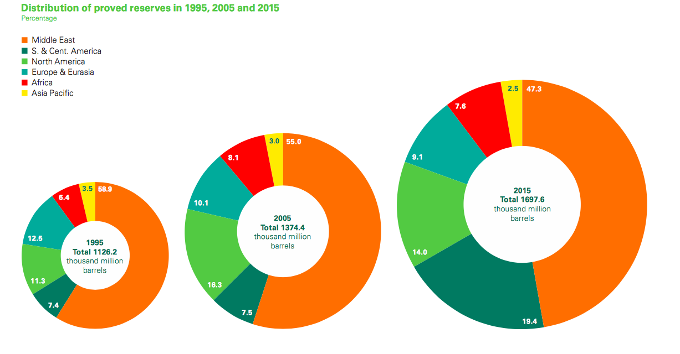

The United States and the small Gulf States have an unwritten protection agreement. They ensure the steady flow of oil at sustainable prices, acting as “price doves” taking the economic blow of “price hawks,” such as Nigeria and Venezuela, which generally produce above the OPEC quota.  The Gulf States are small states with a small population and autocratic governments propped up by their nationalized oil revenues. They generally lack military power and so are vulnerable to aggressive neighbors like Iraq and Iran. The U.S. is a natural ally, as it was historically the largest consumer of oil (source) and has the largest military.

**ARAB-ISRAELI QUESTION.** The Middle East is a powder keg of conflict and it is easy to conflate two major issues that are faced by the U.S. when conducting diplomacy and intervening in the region: The Persian Gulf question and the Arab-Israeli conflict. The Arab-Israeli conflict besets the entire Arab world and mainly complicates U.S. public image among Muslim civilians in the region. This essay focuses on the energy politics of the Persian Gulf, which are dominated by actors such as the G.C.C., Iraq, and Iran. The Arab-Israeli question will be mentioned and is a persistent negative force for the U.S. and is therefore relevant and imperative in understanding why actions were carried out in a certain way or why they were made in the first place. Arab nations that would rather be close to us militarily such as Saudi Arabia, and especially the often bullied Kuwait, have to keep an arm’s length relationship because a majority of Arabs see the U.S. as responsible for the Israeli-Palestine conflict[3].

**CREATION OF PAX AMERICANA.** In the aftermath of World War I and the toppling of the Ottoman Empire, the “Eastern Question” was finally answered for the Europeans. France and Great Britain became the hegemonic force for stability in the Middle East, for better or for worse. World War II left European powers dilapidated and the United States saw itself filling the shoes of the old colonial powers, assuming the mess made by European powers and becoming the chief backers of the state of Israel. This assumption of power became what is known as the “Pax Americana,” a set of alliances that govern all global relations.2 With the Marshall Plan and the reconstruction of Japan, a steady source of oil was needed if the United States was to give the promised economic growth to the battle-worn nations following World War II. This strategy was defined by the Truman Doctrine, which sought to protect the sovereignty of all nations from Soviet encroachment. It also emphasized the need to secure oil to global markets for the purpose of reconstruction. Economic success meant less civil unrest which would mean less of a chance of any communist threats permeating from the U.S.S.R. Following the Suez War, the United States assumed the role as sole hegemonic power of the Middle East, replacing France and Great Britain. At the time, the United States was the largest military and navy and was the most economically prosperous in the immediate post-war era. Obviously, this was not undertaken solely out of a sense of responsibility: there was a very clear economic and political interest in the Middle East at the time.[4]

**OPEC AND 1973 OIL CRISIS:** In 1960, “The Seven Sisters,” the consortium of oil companies that controlled international oil trade, cut oil prices without consulting any oil producing country. In response, Venezuela took the initiative to form OPEC, the organization of petroleum exporting countries, along with Iran, Iraq, Kuwait, and Saudi Arabia. In 1973, an Egyptian-Syrian coalition invaded Israeli-occupied lands, which started what was later to be known as the Yom Kippur War. Israel devastated the Egyptian lead coalition. In retaliation, Gulf producers announced the Arab Oil Embargo, which stopped the flow of oil to anyone that did not support Egypt during the conflict. This supply disruption raised oil prices from $19/barrel to $52/barrel, the first global oil shock.[5]  The result was a global recession and inflation that took a toll on the American population. After 1973, energy became vital to any candidate running and is where the notion of energy independence would become the forefront of the U.S. political discussion.

The domestic hardships brought on by the supply shock had devastating economic as well as psychological impacts in the United States. The EPCA, the Energy Policy and Conservation Act, was signed into law by President Ford on December 22, 19754. This lead to the crude oil export ban, which was an effort to keep domestic supplies within the U.S. not tied up in long-term oil contracts and to make the U.S. become self-sufficient. It also paved way for the Strategic Petroleum Reserve and the creation of the IEA, which requires a minimum of a 90-day oil stockpile by each member country. The U.S. has 700 million barrels, and in total the IEA has around 1.5 billion barrels of oil stockpiled in the case of a supply shock[6]. This demonstrated to OPEC and particularly the Saudis that the developed world is willing to spend an enormous amount of resources to halt supply disruptions, and has been proven effective. The only times we have used the reserves, prices dropped immediately. Aside from tests, the SPR has only been released on two occasions, and only for emergencies: once during Operation Desert Storm, and another after Hurricane Katrina[7]. These domestic and international actions were a part of our strategy to counter the influence of the oil cartel, OPEC, and protect our economic interests that are tied up in oil.

This was a turning point in U.S. involvement in the Persian Gulf. The Arab Oil Embargo demonstrated that the Saudis and the Gulf were not to be trifled with. OPEC still holds about 70% of all oiland can severely affect prices if it were to choose to do so, even forty years after this initial devastating supply shock[8]**.** Arabs set the price of oil on a monthly basis as whatever they saw fit. After continual high prices and overproduction, however, Saudi oil began to lose market share and the pricing scheme was finally replaced by spot markets, namely the WTI and Brent Indices in 1986-1987.

The lasting legacy of the Arab Oil Embargo was forty years of heavy United States involvement in the Persian Gulf Region. American politicians had learned firsthand that one small hiccup can have catastrophic effects on the economy.

**’79 IRANIAN REVOLUTION:** After years of exploitation by western powers, a wave of nationalism began to spread throughout the Middle East. In the year 1951, the Iranian Majlis (parliament) nationalized their domestic oil, expropriating the Anglo-Iranian Oil Company (today British Petroleum) of all its oil assets in Iran. In what is possibly the most blatant form of intervention the West made in the Middle East, an Anglo-American-backed coup d’état toppled the democratically elected nationalist government of Iran, restoring the shah to power. In return, American oil companies received the right to 40% of Iranian oil. This blatant act of foreign intervention sowed the seeds for the specifically anti-American tones of the radical Islamic Iranian Revolution of 1979.[9]

The belligerence of Iran towards the United States and the western world in general would not be so complicated if it were not for its geographic location to the Persian Gulf. Iran flanks the entire northern side of the Gulf, which, as shown below, can be treacherous when dealing with a hostile country just miles away from tankers carrying millions of dollars’ worth of crude oil.

Seventeen million barrels a day flow out of Hormuz.[10] If the Persian Gulf were the heart of the global economy, then the Strait would be its jugular vein. It is because of this fact that the U.S. is willing to maintain constant military presence there, keeping an aircraft carrier in the

gulf at any given time.[11]

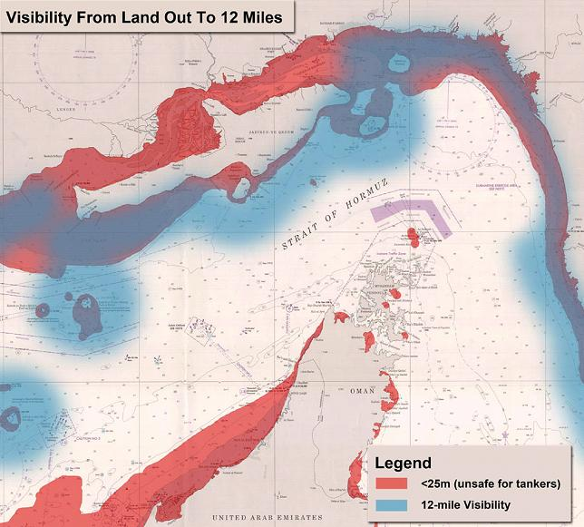

After the U.S. lost its most critical ally in the region, it had to make even more costly involvements in the Gulf if it were to remain hegemon. Its only allies left, the relatively weak Gulf States, are and still continue to be unfit in exerting a dominant military force over their larger neighbors. After this point, the U.S. would have to expend personal troops in the region.

Since then, Iran has been a constant thorn to U.S. diplomacy in the Persian Gulf. Prior to the takeover by the Ayatollah, the Shah was seen by the U.S. as the moderating force in the Middle East. Iran is a populous nation with a fairly diversified economy, and has the ability to exert regional military hegemony much more effectively than the relatively sparsely populated Gulf States.

Saudi Arabia notably began to increase production during the Iranian revolution to make up for the potential supply shock. This demonstrated a willingness to lose money to maintain global stability, which proved them to be a stabilizing force in the region. At a time that the U.S. lost its closest ally in the region, Saudi Arabia proved to be reliable in stabilizing global oil prices, which it does to this day.

**CARTER DOCTRINE:** In President Jimmy Carter’s 1980 State of the Union Address, he stated that the sovereignty of the Persian Gulf is a vital U.S. interest and that the United States would be willing to use military force against any belligerent force that would jeopardize its safety. This was modelled after the Truman Doctrine, which sought to curb Soviet incursion. When Carter made the address, the Soviets had just invaded Afghanistan, which was seen as the first attempt at breaking their way into the Middle Eastern arena to access the oil fields. The Carter Doctrine is significant to U.S. foreign policy because it set the legal precedent for direct military intervention to protect the Gulf States.

**IRAN IRAQ WAR:** In 1980, the psychopath, Saddam Hussein, tried to take advantage of the Iranian Revolution and capture territory bordering the Gulf. There was a significant fear that the war would spread beyond Iran and Iraq and thus put in danger the vast oil supplies that were held in the Persian Gulf. The U.S. supported Iraq in this war. This demonstrates again, the U.S. willingness tosupport unsavory characters in the interest of preserving the balance of power. Henry Kissinger is quoted as saying, “It’s a pity they both can’t lose.”[12]

**OPERATION EARNEST WILL**: Saddam Hussein attacked Iranian oil tankers in the hopes of provoking extreme retaliation, such as closing the Strait of Hormuz. Such an audacious move would definitely bring in the Americans and tip the war in his favor. The Soviets and the United States both supported Iraq, believing that Iran was too irrational to hold power over the entire Middle East.

**OPERATION DESERT STORM:** In 1990, Saddam Hussein aggressively invaded Kuwait, a former ally, in an obvious grab for oil, which posed a clear threat to the other Gulf States.After supporting Saddam Hussein just ten years’ prior, the United States launched a multinational effort to expel Iraq in Operation Desert Storm.  Hussein wanted to take control of the small oil-wealthy nations of the Gulf. This demonstrated the first time the U.S.  was willing to substantiate the Carter Doctrine with troops on the ground and a military invasion. This was unlike the “Tanker War” a few years’ prior which was really only a naval skirmish, as opposed to Operation Desert Storm, which was a full scale invasion. This further solidified the United States’ unwritten role as the protector of the Gulf States.   
 **2nd IRAQ WAR:**  Saddam Hussein told the world he had weapons of mass destruction, which made the Gulf States fearful of possible takeover and a possible Kuwait invasion situation all over again. Through this posturing, he exerted influence over the Gulf States through intimidation. The United States attacked Iraq because it wanted to protect oil flowing out of the Gulf States by making sure that they were not intimidated by Iraq, since if they were intimidated that could put the oil prices at the mercy of an aggressive, irrational dictator. This shows how important the Gulf oil is and just how precarious the balance of power was and still is. This could not be left up to chance because even slight supply disruptions cause major economic problems.

**THE UNCONVENTIONAL REVOLUTION**: With the price of oil peaking on the NYMEX at $145/barrel in 2008 and $110/barrel in 2011, the United States was pushed further and further to find cheap alternatives to importing oil. The existence of shale oil and gas has been known for the last 60 or so years, but has always been too costly to produce at a profitable margin. The plentiful flow of capital in the oil industry allowed investors and small companies to develop technology to obtain this hard-to-reach oil. As shown in the graph prices were reaching an unprecedented level.[13]

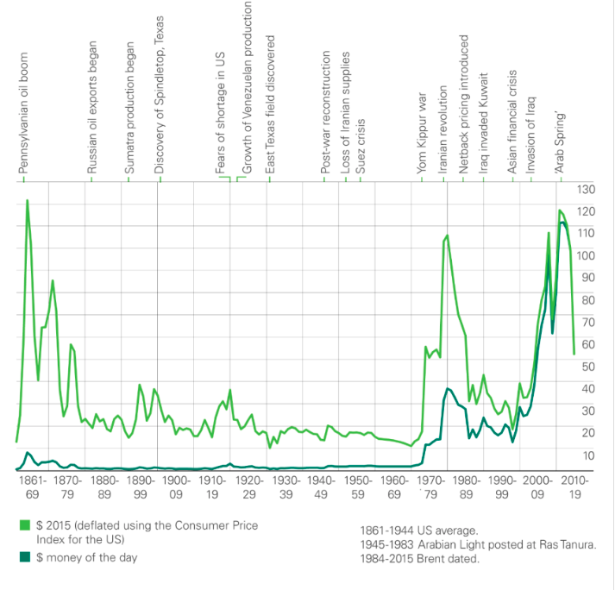  
 The oil taken from fracking is light and sweet, while the U.S. refineries are equipped for heavier grades. Since 2015, Obama has lifted the ban on exporting oil and the U.S. has begun exporting much of its newly acquired expensive fracking oil products. The United States has the potential to be a stabilizing actor in the global energy market by providing LNG to Europe, which can now opt out of the stranglehold of Russia. It will also give the United States’ import-heavy East Asian allies some geopolitical leverage with China and other not-so-friendly nations. The Unconventional Revolution has the ability to “… roll back the clock to the situation that existed before 1973, when an abundance of oil in Texas allowed the U.S. to increase production to respond to shortfalls in the global market.”[14] The United States continues to set record numbers, producing 12.7 mb/d of oil and 74.2 bcf/dof natural gas in 2015.[15]

**Hegemonic fatigue under Obama/Arab Spring**: After almost 14 years in Iraq and even longer in Afghanistan, both politicians and civilians in the United States are growing weary of the Middle Eastern quagmire. This is mainly public perception of the war on terror and is reflected in political pressure to end involvement in the Middle East. For the first time since 1973, the U.S. has actually wanted to take a step back from the situation in the Middle East, since for the first time since 1973 other interests are equally if not more important than our desire to secure oil. This is because we do not have as much of a stake in Persian Gulf Oil due to the Unconventional Revolution.

**Energy Independence**: Since the 1970s, the idea of “energy independence” has been on the forefront of political campaigns. With each skirmish in the Middle East, the U.S. public grew more and more wary. The simple fact is that energy independence does not exist and is impossible as long as the global economy still uses oil.

The U.S. can and will lessen imports from the Persian Gulf, but because we are so intertwined with other countries that are dependent on oil and because we are inextricably tied to the global economy, the economic health of oil-dependent countries is paramount to our own. Japan imports 100% of its oil, 83% of which comes from the Middle East[16]. Similarly, South Korea has no natural oil reserves.

To give a brief example of how globalization affects the U.S. domestic economy, suppose there is a supply disruption in the Persian Gulf. For example, a belligerent Iran attacks major ports along the Persian Gulf and halts the export of oil out of the Strait of Hormuz. A supply disruption of this magnitude would cause the price of energy to increase around the world, but since Japan and South Korea receive more than 80% of their oil from the Middle East, they would be hit the hardest. Sustained energy prices would lead to industrial and civil catastrophe. All things imported from East Asia—consumer vehicles, cellphones, appliances, etc.—would either become very costly or temporarily cease to be produced. Already, the domestic U.S. market would take a hit. Domestic goods would increase in price due to high demand caused by a lack of Asian imports. This would have a rippling effect around the world. As much as politicians try to campaign on the concept of energy independence, it is a facile argument as long as the world economy still runs on oil. The world economy is deeply globalized, so when China, Japan, or South Korea lose a major source of energy, the entire global economy is thrown out of balance.

Furthermore, the price of crude oil in the U.S. is determined by a market, the NYMEX, on the WTI pricing index. Even if the United States could domestically produce all of its oil needs the price of oil would still not be insulated from the global market. A perfect example of global markets affecting the domestic market can be found in Venezuela. Venezuela is a historically resource-rich, yet tragically mismanaged country. When oil prices fell to an all-time low in 2016, their economy was thrown into chaos, even though they are a huge exporter of oil, because so much of their economy is based on the oil producing revenue for the country. The same goes for Saudi Arabia, a well-managed country, which after the price collapse in 2016 has lately been digging very deeply into its sovereign wealth fund, which dropped to $582.4Billion as of June 2016, when it was above $700Billion a year and a half prior.[17] On the other hand, if there was a supply drop and the prices skyrocketed, the U.S. could make no decision that would not be harmful to its economy. The U.S. could sell oil on the market freely and see prices rise domestically as demand grows or they could ban oil exports and keep prices stable domestically at the expense of hindering foreign economies, which would inevitably affect the U.S. economy due to the nature of a globalized world.

In conclusion, the U.S. hegemonic presence safeguards the steady flow of oil, stabilizes the global economy, and maintains U.S. global hegemony, which is a benefit to the United States in and of itself. Being the global police ensures that our interests are met and protected above all else. Although China might be a fair protector of sovereignty in the Persian Gulf and could ensure stable prices and a steady flow of oil, it would not guarantee that U.S. interests are met. As the global hegemon, the U.S. calls the shots and is in a position to make decisions. For example, when it negotiates with China or Japan, it is not lost on them who controls the Strait of Hormuz and the Strait of Malacca, through which almost all of their imported oil comes. This gives the U.S. an upper hand when conducting foreign policy and is therefore inherently a national interest.

**WHAT INDEPENDENCE HAS THE U.S. ACHIEVED?:** It might seem odd that the United States expresses freedom from Middle Eastern oil while in the year 2016 it imported 1,097 thousand b/d from Saudi Arabia (11% of total imports) and 418 thousand b/d from Iraq (5% of total imports), its 2nd largest and 4th largest importers respectively[18]. What is important is the overall decline in U.S. crude imports due to the aforementioned unconventional oil production, as shown in this long term graph.[19]Total%20US%20Oil%20Imports.pdf

Saudi Arabia owns a U.S. refining system called Motiva, which is partnered with Shell. For this reason, Saudi Arabia imports much of its crude to the U.S. instead of elsewhere. In fact, if they did not have such large refineries in the U.S., experts suggest we would import a lot less of their crude.2 The decision to build a refining system on United States soil is part of a much larger strategy by Saudi Arabia to embed themselves as the key importer of reliable oil to the US and therefore integral to the question of energy security. The Kingdom of Saudi Arabia believes that this will cement their relationship with the U.S., solidifying the unwritten U.S.-Saudi security alliance built on oil for security. They are therefore supplying the U.S. with oil for two reasons: to fill their refining systems and to portray themselves as a reliable supply of oil for the U.S. domestic market. Despite their efforts, Persian Gulf oil exports to the U.S. are still declining, which is directly correlated with the decline in imports[20]

US-Persian%20Gulf%20Imports.pdf

To further the notion of oil for security, Saudi Arabia insisted on being the primary U.S. importer of oil for decades, only to be surpassed by Canada beginning the late 90’s, correlating with the increase of pipelines between the U.S. and Canada.[21]canda%20compared%20to%20saudi.pdf

The United States can and has been more dismissive of Middle Eastern affairs since the onset of the Unconventional Revolution. The rise of ISIS demonstrates and the disruption in oil supply prove this fact very clearly.

Although the U.S. imports a large percentage of oil from the Middle East, it is demonstrably inconsequential. The only reason we continue to import oil from these regions is because of contracts. Even when the U.S. does not receive Middle Eastern oil, it compensates with alternatives. For example, Iraqi oil exports to the US are contracted for a decade at a time with Chevron to fill refineries in California. In the case of Iraq, we see that imports dipped down to 83 million barrels in 2015, and dramatically shot up to 154 million barrels the following year[22]. 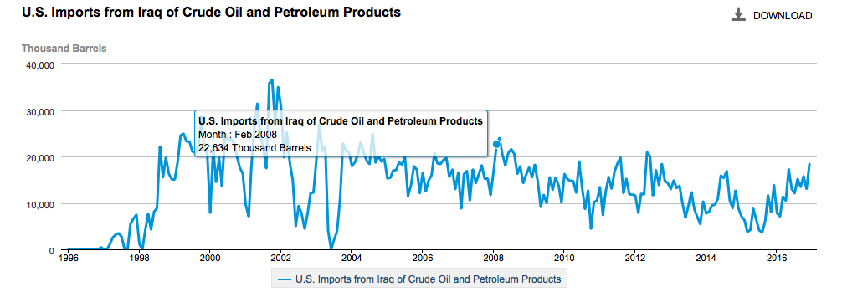

Without a doubt, this supply drop and hike correlate precisely with ISIS and Iraqi government interplay, as the Iraqi government becomes desperate to generate money from oil sales to fight the insurgency. What is most important to note is that despite this supply disruption from the United States’ second largest Middle Eastern oil exporter, alternative markets were easily found in more stable parts of the world. This only furthers US domestic political pressure to withdraw from the Middle East, and let countries that have a greater stake in Middle Eastern oil protect its secured flow.

It is not that we will stop importing oil from the Persian Gulf in the near future, nor is it that we are not still dependent on it in one fashion or another. It is rather that we are much less dependent on it now than before, because of our declining demand for imports driven by the increasing economic viability of unconventional sources, as well as proof that alternate sources of oil can fill small supply disruptions.

**OUTLOOK:** Experts say that the U.S. could and should act freely in the international realm. The U.S. spends billions of dollars on protecting the region with decreasing returns on investment. The U.S. is not the sole hegemonic power willing to spill blood and treasure, so although it should remain involved in the Middle East, it should secure cooperation from other countries as well. While the Persian Gulf becomes less important for the United States, the necessity of oil only increases in Asia, one economic miracle after another.[23] 50% of China’s oil imports and 80% of Japan’s come from the Middle East. Asia as a region has the fastest growth in energy demand[24]. Chinese ambassadors joyfully cite a long historic friendship with Iran. China has also acted as an arbiter during negotiations between Iran and the United States. China has had problems with its minority Muslim Uighur population and so shares an interest in quelling Radical Islam at its source.[25] Therefore, China has a vested political and economic interest in cooperating with the United States in the Persian Gulf, both improving the economic conditions of Iran and completing its One Belt One Road Campaign as well as quelling radical Islam.

**CONCLUSION:** U.S. actions are mostly characterized as a balancing act, not letting one despotic state grow too powerful, while also not letting any Arab state gain too much power over Israel. Energy independence is a fantasy, since the United States still relies on the global oil market to supply oil to the global economy and to keep prices stable. It is in the U.S. national interest to maintain its hegemony in the Persian Gulf because it gives it an upper hand in diplomatic negotiation, but there is a good argument for future cooperation with China and Japan in the Middle East stemming from a shared interest and large oil dependency.  The more important long term question for the United States national interest is energy security as opposed to energy independence. Energy security entails maintaining a constant supply, keeping the cost of crude oil affordable, and answering environmental concerns. Maintaining a constant supply can be ensured by tapping into alternate markets and maintaining stability in the Persian Gulf. Keeping the cost of crude oil at an affordable price sustains economic growth and also meets international demand. Lastly, environmental concerns can be answered by pushing the boundary on renewable energy technology and reducing greenhouse gases with a clean cheap energy mix.

1. "Oil prices." Bp.com. Accessed March 23, 2017. http://www.bp.com/en/global/corporate/energy-economics/statistical-review-of-world-energy/oil/oil-prices.html.
2. "Oil reserves." Bp.com. Accessed March 23, 2017. http://www.bp.com/en/global/corporate/energy-economics/statistical-review-of-world-energy/oil/oil-reserves.html.  
   oil reserves
3. Telhami, Shibley. "The Persian Gulf: Understanding the American Oil Strategy | Brookings Institution." Brookings. July 28, 2016. Accessed March 23, 2017. https://www.brookings.edu/articles/the-persian-gulf-understanding-the-american-oil-strategy/.
4. Gelvin, James L. *The modern Middle East: a history*. New York: Oxford University Press, 2016.
5. "Oil prices." Bp.com. Accessed March 23, 2017. http://www.bp.com/en/global/corporate/energy-economics/statistical-review-of-world-energy/oil/oil-prices.html.
6. "United States." Oil Stocks. Accessed March 23, 2017. https://www.iea.org/countries/membercountries/unitedstates/oilstocks/
7. "History of SPR Releases." History of SPR Releases | Department of Energy. Accessed March 23, 2017. https://energy.gov/fe/services/petroleum-reserves/strategic-petroleum-reserve/releasing-oil-spr.
8. "Oil reserves." Bp.com. Accessed March 23, 2017. http://www.bp.com/en/global/corporate/energy-economics/statistical-review-of-world-energy/oil/oil-reserves.html.
9. Gelvin, James L. *The modern Middle East: a history*. New York: Oxford University Press, 2016.
10. **Anthony Cordesman, "Rethinking a Key U.S. Strategic Interest: Energy Stability, Energy Independence, and the United States as a Net Exporter," Rethinking a Key U.S. Strategic Interest: Energy Stability, Energy Independence, and the United States as a Net Exporter | Center for Strategic and International Studies, March 23, 2017, , accessed March 23, 2017, https://www.csis.org/analysis/rethinking-key-us-strategic-interest-energy-stability-energy-independence-and-united-states.**
11. Roberts, Elizabeth. "Geography | Hormuz." Geography | Hormuz. Accessed March 23, 2017. https://www.strausscenter.org/hormuz/geography.html.
12. McCarthy, Andrew C. (3 March 2012). ["It's a Pity Somebody Has to Win"](http://www.nationalreview.com/articles/292496/it-s-pity-somebody-has-win-andrew-c-mccarthy). *National Review Online*. Accessed 7 November 2012.
13. "Oil prices." Bp.com. Accessed March 23, 2017. http://www.bp.com/en/global/corporate/energy-economics/statistical-review-of-world-energy/oil/oil-prices.html.
14. “Shale Gas Revolution - How the Shale Revolution Will Transform U.S. Policy ” – Amy Jaffe. Acessed March, 23 2017
15. "US." Bp.com. Accessed March 23, 2017. http://www.bp.com/en/global/corporate/energy-economics/statistical-review-of-world-energy/country-and-regional-insights/united-states.html.
16. "Natural Gas and Petroleum Navigator Error Page." Natural Gas and Petroleum Navigator Error Page. Accessed March 23, 2017. https://www.eia.gov/dnav/pet/hist/LeafHandler.ashx?n=PET&s=RWTC&f=DF.
17. "Fund Rankings | SWFI - Sovereign Wealth Fund Institute." Source on Sovereign Wealth Funds, Pensions and Institutional Investors. Accessed March 23, 2017. http://www.swfinstitute.org/fund-rankings/.
18. "U.S. Energy Information Administration - EIA - Independent Statistics and Analysis." Company Level Imports. Accessed March 23, 2017. https://www.eia.gov/petroleum/imports/companylevel/.
19. "U.S. Energy Information Administration - EIA - Independent Statistics and Analysis." Company Level Imports. Accessed March 23, 2017
20. "U.S. Energy Information Administration - EIA - Independent Statistics and Analysis." Company Level Imports. Accessed March 23, 2017
21. "U.S. Energy Information Administration - EIA - Independent Statistics and Analysis." Company Level Imports. Accessed March 23, 2017
22. "U.S. Energy Information Administration - EIA - Independent Statistics and Analysis." Company Level Imports. Accessed March 23, 2017
23. "Http://www.nbr.org - NBR - The National Bureau of Asian Research." U.S., Japanese, and Asian Energy Security in a New Energy Era. Accessed March 23, 2017. http://www.nbr.org/publications/element.aspx?id=812.
24. "Natural Gas and Petroleum Navigator Error Page." Natural Gas and Petroleum Navigator Error Page. Accessed March 23, 2017. https://www.eia.gov/dnav/pet/hist/LeafHandler.ashx?n=PET&s=RWTC&f=DF.
25. "An Emerging Partnership Post- Sanctions John W. Garver." Accessed March 23, 2017.