Jason Cowan

Graduate Project Proposal

Triple Triad Remake

Triple Triad Remake

## Introduction and Basic Gameplay

Triple Triad is a game that was invented by Squaresoft and released as a mini-game inside of the multi award-winning video game Final Fantasy VIII. Triple Triad is a card game that is played on a three-by-three grid of blank spaces, exactly like a tic-tac-toe grid – by two players. Each player is given five cards to start and will eventually fill the blank spaces on the grid with their cards. Each card has four values associated with it that correspond to the cardinal directions of the card (North, South, East, West).

The gameplay begins by having a player chosen at random to place a card in any one of the slots that are available on the board. Once placed, it becomes the other players turn. The other player’s objective at this state is to attempt to capture the opponent’s placed card. The player can accomplish this by laying a card next to any of the open position adjacent to the previously placed card and if his card’s value on the connected edge of the two cards is greater than the previously placed card, then the player captures this card.

An example of the game follows

Here is an example of the beginning state of the game

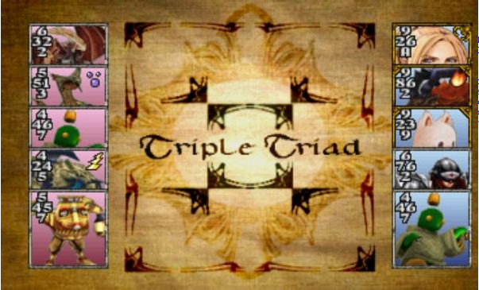

The game then proceeds with a randomly picked player picking a position to place their card.

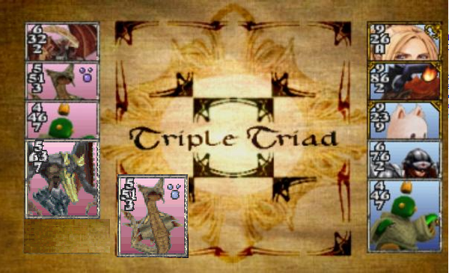

Once placed, it becomes the other players turn. By looking at the above example we can see that it is the blue players turn. The blue player has the option to place a card anywhere they want, but if the player places their card to the right or above the red player’s card, then they have a chance to take over that card. The values of the red card are 5 on the top and 1 on the right. Looking at the blue player’s cards they have many cards that could overtake it. The card would either need at least 6 on the bottom or at least a two on the left, and place them in their respective slots, to overtake the red player’s card.

At the end the cards are counted and the player with the most cards wins, if the players have the same amount, it becomes a draw.

The game continues with this by alternating turns until no more places exist on the board. Once finished, whichever player has the most cards belonging to them is declared the winner. The flowing shows after the blue player has won.

The complete rules of the game can be found here: <http://finalfantasy.wikia.com/wiki/Triple_Triad>

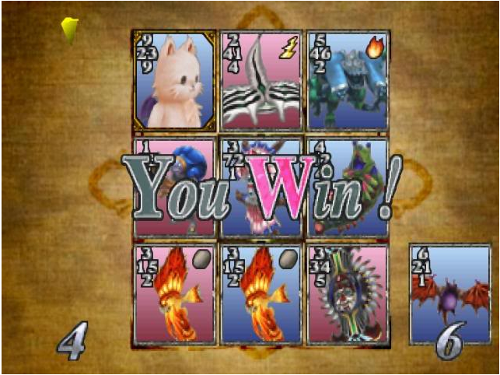

## Gameplay for this game

For this version of Triple Triad it needs to be simple to get the proof of concept for the AI. So I will be only choosing to do the “Open” rule – where all the cards are visible to each player and I will choose not to enforce the elements – the icons in the upper-right hand corner of the card which symbolize: lightning, fire, rock, and more - associated with the cards.

## Timeline and Deliverables

**Deliverables**

* The game will read cards from a datastore
* Each player will be assigned 5 cards
* A player will be selected at random to start the game
* One of the players will be a computer controlled by AI
* At each of the player’s turns, the selected player will be able to select a card and place it onto an open place on the game board.
* When the turn is the computers, the AI will use one or more algorithms to determine placement of the card.
* If a player lays down a card and that card is greater than the alternate player’s card adjacent to it, then the player who laid down the card will now have that card count towards his score.
* The players will continue alternating turns until n-1 cards are on the game board
* Once all the positions are laid out onto the table, the game then counts who owns which cards and declares a winner or a draw.

**Timeline**

* 9/30/2012
  + The game will read from a datastore
  + Each player will be assigned five cards
* 10/14/2012
  + A player will be selected at random to start the game
  + At each of the player’s turns, the selected player will be able to select a card and place it onto an open place on the game board.
* 11/3/2012
  + If a player lays down a card and that card is greater than the alternate player’s card adjacent to it, then the player who laid down the card will now have that card count towards his score.
  + The players will continue alternating turns until n-1 cards are on the game board
  + Once all the positions are laid out onto the table, the game then counts who owns which cards and declares a winner or a draw.
* 11/30/2012
  + One of the players will be a computer controlled by AI
  + When the turn is the computers, the AI will use one or more algorithms to determine placement of the card.

## References to be used

Triple Triad. (n.d.). Retrieved September 8, 2012 from the Final Fantasy Wiki: http://finalfantasy.wikia.com/wiki/Triple_Triad

Louis Victor Allis (n.d.). Searching for Solutions in Games and Artificial Intelligence. Retrieved from <http://fragrieu.free.fr/SearchingForSolutions.pdf>