Inventory Search – Code Test

Generate an Angular App to create a cleaner looking version of this.
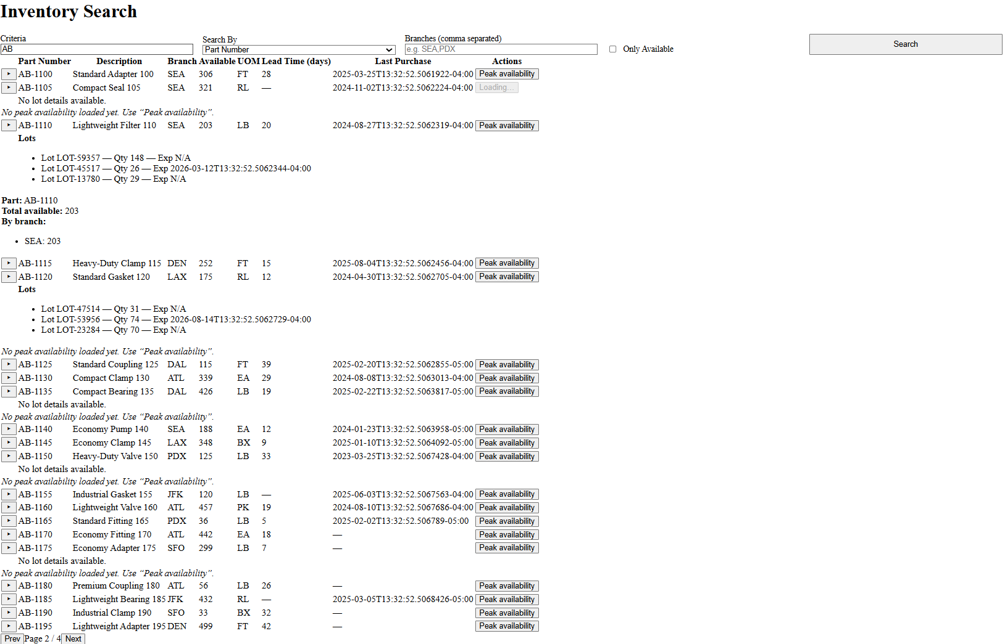
Code Test Brief
Goals
1. Build a small Angular feature called “Inventory Search” that lets users search inventory and view availability results.
2. Convert the given inventory-mock-server to a C# .NET project.
Basic outlines are given for both to help as a starting point
Looking to get a well designed solution.
Looking to see what your design choices are for the UI with regards to look and feel. The example given above is an ugly UI looking for something much cleaner with a professional look to it.

Requirements
- Use Angular 18 preferred
  - HttpClient for API calls
  - Strong typing via TypeScript interfaces
  - Reactive forms
- Basic Structure to the code is supplied in attached Zip File
- Behavior:
  - Show a loading indicator while searching
  - Cancel in-flight requests if a new search is fired
  - Emit a toast-style warning if API responds with isFailed=true
  - Cache the most recent 5 unique searches for 60 seconds (avoid duplicate API calls within TTL)
- Acceptance criteria:
  - Functional form with validation, loading state, error toast, cancel-on-new-search
  - Results with sorting, pagination, and expandable rows
  - Caching prevents duplicate API calls within 60 seconds for last 5 distinct queries
- Deliverables:
  - Source code for the feature (TypeScript, HTML, SCSS)
  - C# files required to build the Server
  - Minimal unit tests:
    - Service: caches a repeated request for 60s
    - Component: disables Search when invalid; toggles loading
    - Component: emits toast on isFailed
    - Service layer unit tests for the C# project
  - Quick start instructions (README)
- API Contract (you can stub a mock or point to a real one; the code should compile and run even if the API is down)
Search
GET api/inventory/search?criteria={string}&by={string}&branches={commaSeparated}&onlyAvailable={boolean}&page={number}&size={number}&sort={field}:{asc|desc}
Response: { "isFailed": boolean, "message"?: string, "data"?: { "total": number, "items": Array<{ "partNumber": string, "description": string, "branch": string, "availableQty": number, "uom": string, "leadTimeDays": number | null, "lastPurchaseDate": string | null, "lots"?: Array<{ "lotNumber": string, "qty": number, "expirationDate": string | null }> }> } }

“Peak availability” button on each row to fetch GET /api/inventory/availability/peak?partNumber={string} and show a small inline panel with the result
Inventory-mock-api is the server supplied to allow you to test your angular code
Inventory-Search contains a starting point for the angular code
InventoryServer contains a starting point for the C# .NET project
Please be creative what I want to see is well structured easily readable, understandable and expandable code.
You are free to modify the API if you deem it appropriate. If doing so please give reasons as to why this is a better solution.
The is no limit on how you choose to develop the solution, I would like a reasoning as to the why and how for using any tools. As software developers our day to day tasks often require the use of these tools this code test should be treated no differently.

