1.
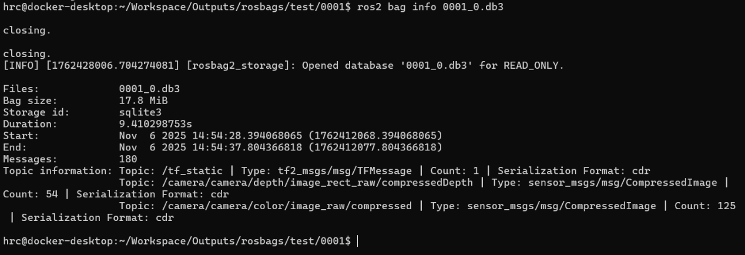
2.
以下是我的程式碼，電腦跑不動了所以沒有結果，還請見諒。
import rclpy
from rclpy.node import Node
from sensor_msgs.msg import CompressedImage
import std_msgs.msg

class ImageSubscriber(Node):
def __init__(self):
super().__init__('image_subscriber')
self.subscription = self.create_subscription(
CompressedImage,
'/camera/color/image_raw/compressed',
self.image_callback,
10
)
self.subscription # 防止未使用的變數警告

def image_callback(self, msg):
# 提取時間戳並進行日誌輸出
timestamp = msg.header.stamp.sec # 獲取時間戳的秒數
self.get_logger().info(f"Received Image at timestamp: {timestamp}, notice: Color image received.")

def main(args=None):
rclpy.init(args=args)

# 創建並啟動節點
image_subscriber = ImageSubscriber()

# 讓節點持續運行並處理回調
rclpy.spin(image_subscriber)

# 清理並關閉節點
image_subscriber.destroy_node()
rclpy.shutdown()

if __name__ == '__main__':
main()

