**REPORTE DE CUMPLIMIENTO ANTE FALLAS**

|  |  |  |  |  |  |
| --- | --- | --- | --- | --- | --- |
| **EMPRESA** | **CENTRAL** | **UNIDAD** | **PTO MEDICIÓN** | **PORCENTAJE** | **RA** |
| AGUAS Y ENERGIA PERU | CENTRAL HIDROELÉCTRICA PÍAS 1 | G1 | 455 | 16.67% | 0.0078 |
| AGUAS Y ENERGIA PERU | CENTRAL HIDROELÉCTRICA PÍAS 1 | G2 | 456 | 83.33% | 0.1051 |
| CELEPSA | CH EL PLATANAL | G1 | 435 | 33.33% | 0.0796 |
| CELEPSA | CH EL PLATANAL | G2 | 436 | 16.67% | 0.3614 |
| CHINANGO S.A.C. | C.H. CHIMAY | G1 | 342 | 50.00% | 0.0204 |
| CHINANGO S.A.C. | C.H. CHIMAY | G2 | 343 | 66.67% | 0.0764 |
| CHINANGO S.A.C. | C.H. YANANGO | G1 | 53 | 50.00% | 0.0912 |
| EDEGEL | C.H. CALLAHUANCA | G1 | 54 | 66.67% | 0.0220 |
| EDEGEL | C.H. CALLAHUANCA | G2 | 55 | 100.00% | 0.0335 |
| EDEGEL | C.H. CALLAHUANCA | G3 | 56 | 100.00% | 0.0010 |
| EDEGEL | C.H. CALLAHUANCA | G4 | 57 | 83.33% | 0.0765 |
| EDEGEL | C.H. HUAMPANI | G1 | 62 | 50.00% | 0.0031 |
| EDEGEL | C.H. HUAMPANI | G2 | 63 | 83.33% | 0.0094 |
| EDEGEL | C.H. HUINCO | G1 | 58 | 83.33% | 0.0268 |
| EDEGEL | C.H. HUINCO | G2 | 59 | 100.00% | 0.0402 |
| EDEGEL | C.H. HUINCO | G3 | 60 | 100.00% | 0.0634 |
| EDEGEL | C.H. HUINCO | G4 | 61 | 83.33% | 0.2321 |
| EDEGEL | C.H. MATUCANA | G1 | 64 | 16.67% | 0.0272 |
| EDEGEL | C.H. MATUCANA | G2 | 65 | 50.00% | 0.1077 |
| EDEGEL | C.H. MOYOPAMPA | G1 | 66 | 100.00% | 0.0272 |
| EDEGEL | C.H. MOYOPAMPA | G2 | 67 | 83.33% | 0.0592 |
| EDEGEL | C.H. MOYOPAMPA | G3 | 68 | 66.67% | 0.0448 |
| EDEGEL | C.T. STA ROSA UTI | UTI5 | 70 | 100.00% | 0.0000 |
| EDEGEL | C.T. STA ROSA UTI | UTI6 | 71 | 100.00% | 0.0000 |
| EDEGEL | C.T. STA.ROSA | TG8 | 434 | 100.00% | 0.0000 |
| EDEGEL | C.T. VENTANILLA | TG3 | 45 | 50.00% | 0.0929 |
| EDEGEL | C.T. VENTANILLA | TG4 | 46 | 33.33% | 0.1859 |
| EDEGEL | C.T. VENTANILLA | TV | 420 | 16.67% | 0.1109 |
| EEPSA | C.T. MALACAS | TG4 | 30 | 33.33% | 0.1875 |
| EGASA | C.H. CHARCANI IV | G1 | 357 | 100.00% | 0.0169 |
| EGASA | C.H. CHARCANI IV | G2 | 358 | 66.67% | 0.0186 |
| EGASA | C.H. CHARCANI IV | G3 | 359 | 100.00% | 0.0165 |
| EGASA | C.H. CHARCANI V | G2 | 361 | 100.00% | 0.1416 |
| EGASA | C.H. CHARCANI V | G3 | 362 | 50.00% | 0.1642 |
| EGASA | C.T. PISCO | TG1 | 447 | 83.33% | 0.1069 |
| EGEMSA | C.H. MACHUPICCHU | CENTRAL | 30626 | 66.67% | 0.0485 |
| EGENOR | C.H. CARHUAQUERO | G1 | 72 | 16.67% | 0.0543 |
| EGENOR | C.H. CARHUAQUERO | G3 | 74 | 16.67% | 0.0299 |
| EGENOR | C.H. CAÑON DEL PATO | G1 | 75 | 50.00% | 0.0029 |
| EGENOR | C.H. CAÑON DEL PATO | G2 | 76 | 33.33% | 0.1325 |
| EGENOR | C.H. CAÑON DEL PATO | G3 | 77 | 16.67% | 0.0234 |
| EGENOR | C.H. CAÑON DEL PATO | G4 | 78 | 33.33% | 0.0379 |
| EGENOR | C.H. CAÑON DEL PATO | G5 | 79 | 33.33% | 0.0384 |
| EGENOR | C.H. CAÑON DEL PATO | G6 | 80 | 100.00% | 0.0499 |
| EGESUR | C.T. INDEPENDENCIA | INDEP_G1 | 449 | 66.67% | 0.0268 |
| EGESUR | C.T. INDEPENDENCIA | INDEP_G2 | 450 | 16.67% | 0.0230 |
| EGESUR | C.T. INDEPENDENCIA | INDEP_G3 | 451 | 50.00% | 0.0114 |
| EGESUR | C.T. INDEPENDENCIA | INDEP_G4 | 452 | 50.00% | 0.0306 |
| ELECTROPERU | C.H. MANTARO | G1 | 31 | 100.00% | 0.1660 |
| ELECTROPERU | C.H. MANTARO | G2 | 32 | 100.00% | 0.1677 |
| ELECTROPERU | C.H. MANTARO | G3 | 33 | 100.00% | 0.1650 |
| ELECTROPERU | C.H. MANTARO | G4 | 34 | 100.00% | 0.1718 |
| ELECTROPERU | C.H. MANTARO | G5 | 35 | 100.00% | 0.1241 |
| ELECTROPERU | C.H. MANTARO | G6 | 36 | 100.00% | 0.1211 |
| ELECTROPERU | C.H. MANTARO | G7 | 37 | 100.00% | 0.1244 |
| ELECTROPERU | C.H. RESTITUCION | G1 | 38 | 100.00% | 0.1125 |
| ELECTROPERU | C.H. RESTITUCION | G2 | 39 | 100.00% | 0.1132 |
| ELECTROPERU | C.H. RESTITUCION | G3 | 40 | 100.00% | 0.1165 |
| EMPRESA ELECTRICA RIO DOBLE | C.H. LAS PIZARRAS | G1 | 480 | 100.00% | 0.1628 |
| EMPRESA ELECTRICA RIO DOBLE | C.H. LAS PIZARRAS | G2 | 481 | 50.00% | 0.1626 |
| ENERSUR | C.H. YUNCAN | G1 | 412 | 50.00% | 0.0727 |
| ENERSUR | C.H. YUNCAN | G2 | 413 | 16.67% | 0.0947 |
| ENERSUR | C.H. YUNCAN | G3 | 414 | 33.33% | 0.0907 |
| ENERSUR | C.T. CHILCA 1 | CENTRAL | 30627 | 16.67% | 0.0746 |
| FENIX POWER PERÚ | CENTRAL TERMICA FENIX | GT11 | 491 | 16.67% | 0.4447 |
| FENIX POWER PERÚ | CENTRAL TERMICA FENIX | GT12 | 487 | 100.00% | 0.4883 |
| FENIX POWER PERÚ | CENTRAL TERMICA FENIX | TV10 | 488 | 16.67% | 0.1838 |
| KALLPA GENERACION | C.T. KALLPA | TG1 | 423 | 16.67% | 0.6512 |
| KALLPA GENERACION | C.T. KALLPA | TG2 | 429 | 16.67% | 0.4024 |
| KALLPA GENERACION | C.T. KALLPA | TG3 | 438 | 16.67% | 0.4204 |
| KALLPA GENERACION | C.T. KALLPA | TV | 466 | 16.67% | 0.1495 |
| SAN GABAN | C.H. SAN GABAN II | G1 | 383 | 100.00% | 0.0968 |
| SAN GABAN | C.H. SAN GABAN II | G2 | 384 | 33.33% | 0.0039 |
| STATKRAFT | C.H. CAHUA | G1 | 3 | 33.33% | 0.0297 |
| STATKRAFT | C.H. CAHUA | G2 | 98 | 66.67% | 0.0375 |
| STATKRAFT | C.H. GALLITO CIEGO | G2 | 6 | 83.33% | 0.0872 |
| STATKRAFT | C.H. MALPASO | G1 | 16 | 33.33% | 0.0268 |
| STATKRAFT | C.H. MALPASO | G2 | 17 | 83.33% | 0.0160 |
| STATKRAFT | C.H. MALPASO | G3 | 18 | 16.67% | 0.0195 |
| STATKRAFT | C.H. MALPASO | G4 | 19 | 33.33% | 0.0231 |
| STATKRAFT | C.H. YAUPI | G1 | 11 | 16.67% | 0.0152 |
| STATKRAFT | C.H. YAUPI | G2 | 12 | 66.67% | 0.0127 |
| STATKRAFT | C.H. YAUPI | G3 | 13 | 66.67% | 0.0199 |
| STATKRAFT | C.H. YAUPI | G4 | 14 | 50.00% | 0.0458 |
| STATKRAFT | C.H. YAUPI | G5 | 15 | 16.67% | 0.0373 |
| TERMOSELVA | C.T. AGUAYTIA | TG1 | 1 | 16.67% | 0.1088 |

**1. AGUAS Y ENERGIA PERU CENTRAL HIDROELÉCTRICA PÍAS 1 - G1 (16.67%)**

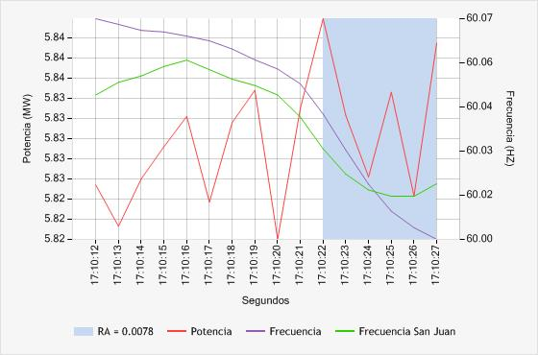

**2. AGUAS Y ENERGIA PERU CENTRAL HIDROELÉCTRICA PÍAS 1 - G2 (83.33%)**

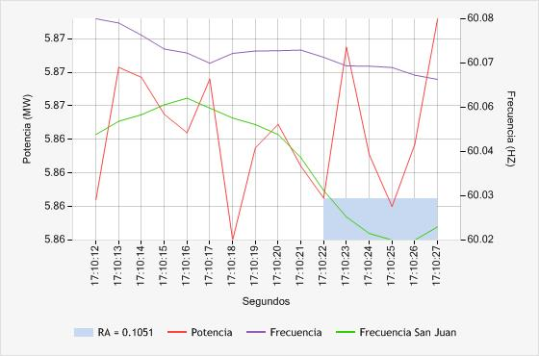

**3. CELEPSA CH EL PLATANAL - G1 (33.33%)**

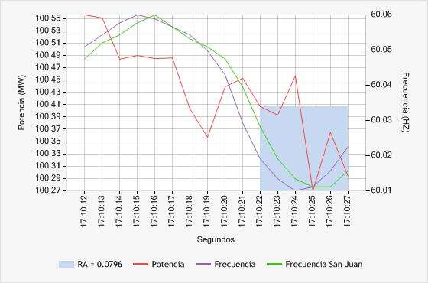

**4. CELEPSA CH EL PLATANAL - G2 (16.67%)**

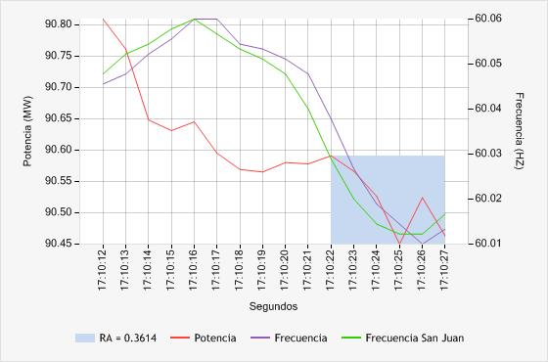

**5. CHINANGO S.A.C. C.H. CHIMAY - G1 (50.00%)**

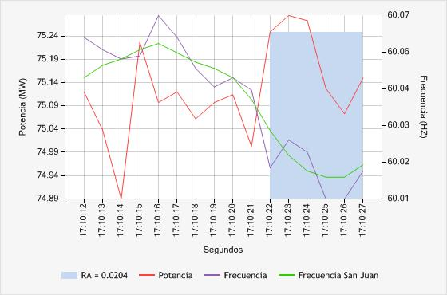

**6. CHINANGO S.A.C. C.H. CHIMAY - G2 (66.67%)**

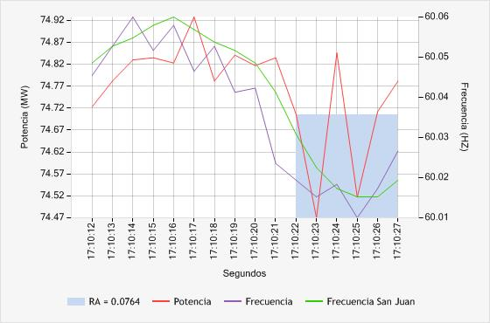

**7. CHINANGO S.A.C. C.H. YANANGO - G1 (50.00%)**

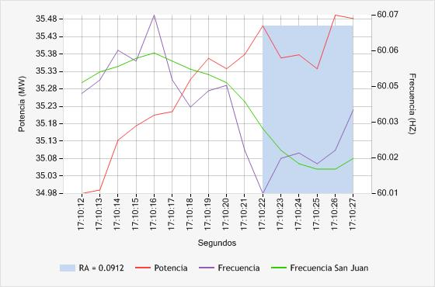

**8. EDEGEL C.H. CALLAHUANCA - G1 (66.67%)**

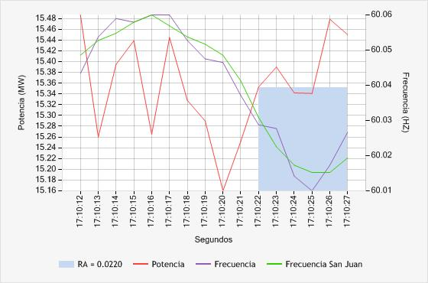

**9. EDEGEL C.H. CALLAHUANCA - G2 (100.00%)**

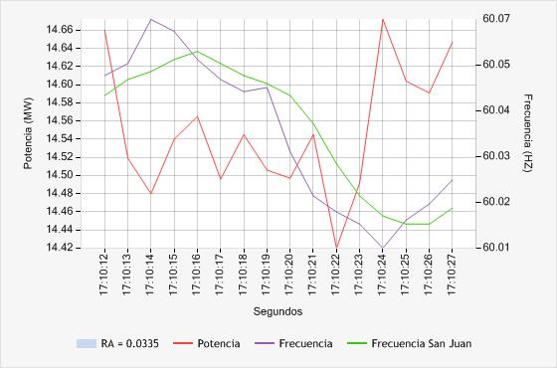

**10. EDEGEL C.H. CALLAHUANCA - G3 (100.00%)**

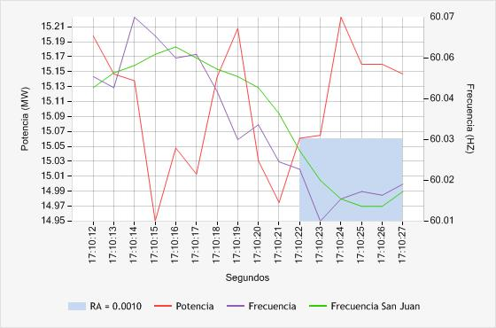

**11. EDEGEL C.H. CALLAHUANCA - G4 (83.33%)**

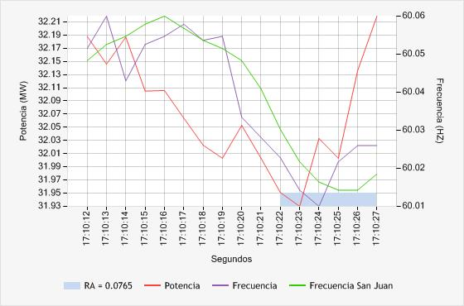

**12. EDEGEL C.H. HUAMPANI - G1 (50.00%)**

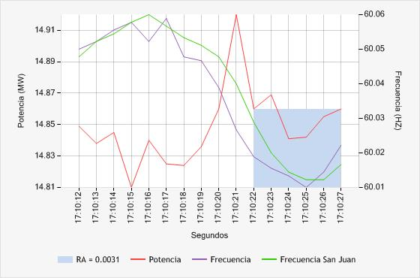

**13. EDEGEL C.H. HUAMPANI - G2 (83.33%)**

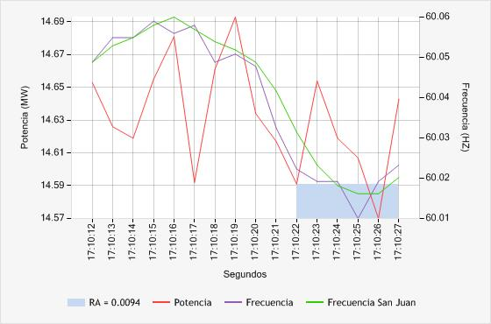

**14. EDEGEL C.H. HUINCO - G1 (83.33%)**

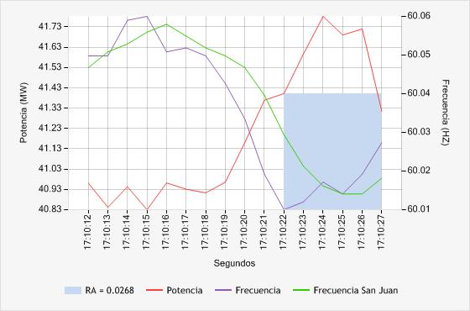

**15. EDEGEL C.H. HUINCO - G2 (100.00%)**

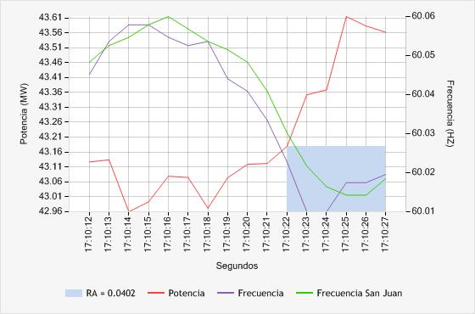

**16. EDEGEL C.H. HUINCO - G3 (100.00%)**

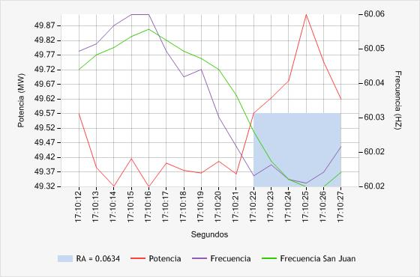

**17. EDEGEL C.H. HUINCO - G4 (83.33%)**

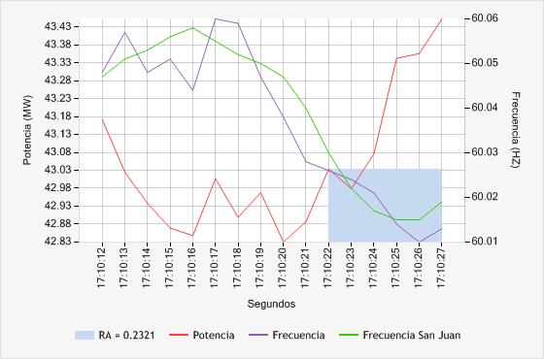

**18. EDEGEL C.H. MATUCANA - G1 (16.67%)**

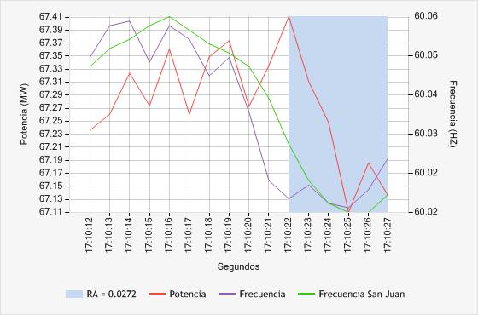

**19. EDEGEL C.H. MATUCANA - G2 (50.00%)**

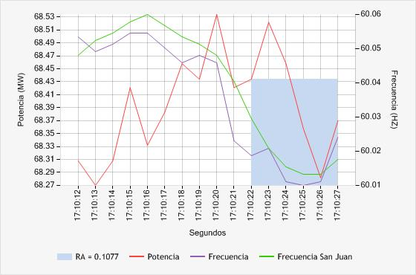

**20. EDEGEL C.H. MOYOPAMPA - G1 (100.00%)**

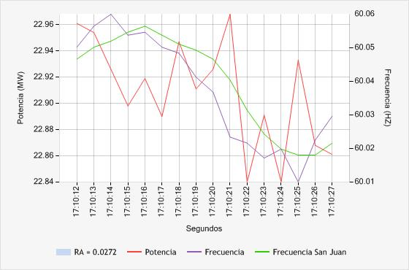

**21. EDEGEL C.H. MOYOPAMPA - G2 (83.33%)**

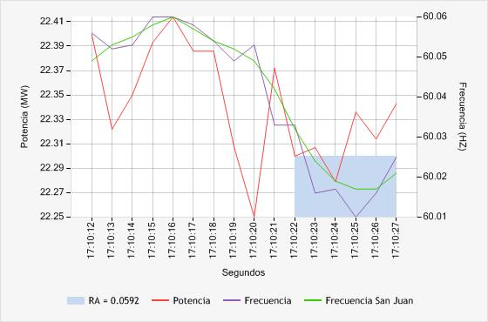

**22. EDEGEL C.H. MOYOPAMPA - G3 (66.67%)**

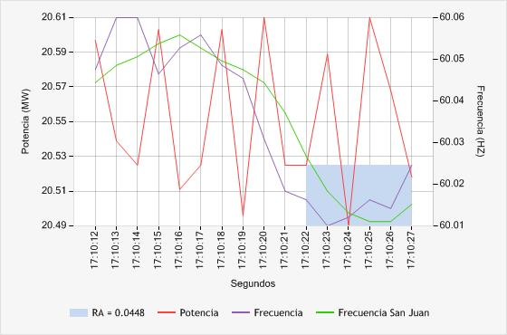

**23. EDEGEL C.T. STA ROSA UTI - UTI5 (100.00%)**

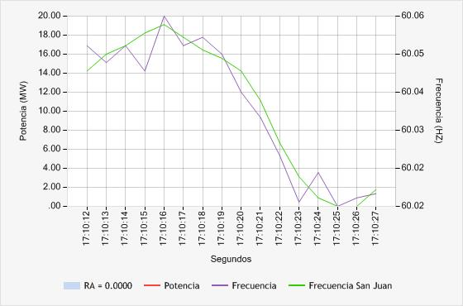

**24. EDEGEL C.T. STA ROSA UTI - UTI6 (100.00%)**

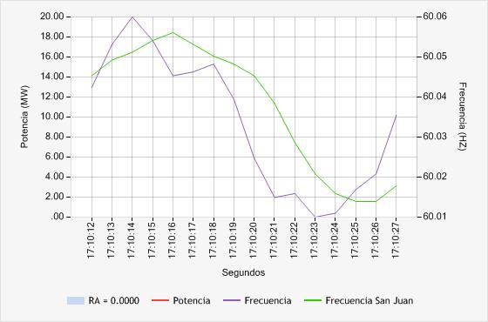

**25. EDEGEL C.T. STA.ROSA - TG8 (100.00%)**

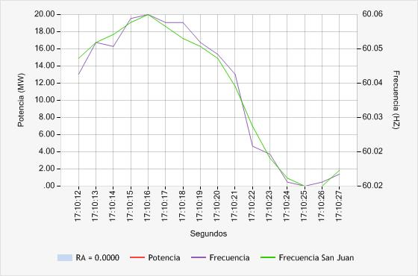

**26. EDEGEL C.T. VENTANILLA - TG3 (50.00%)**

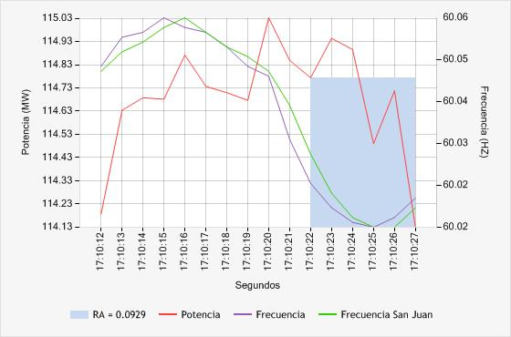

**27. EDEGEL C.T. VENTANILLA - TG4 (33.33%)**

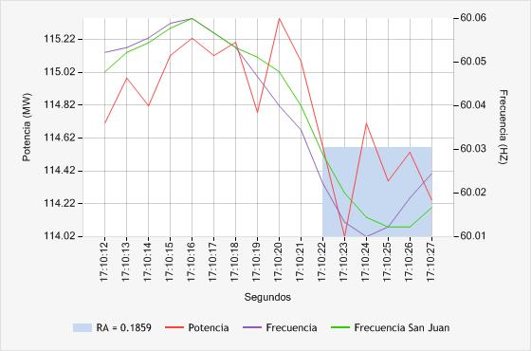

**28. EDEGEL C.T. VENTANILLA - TV (16.67%)**

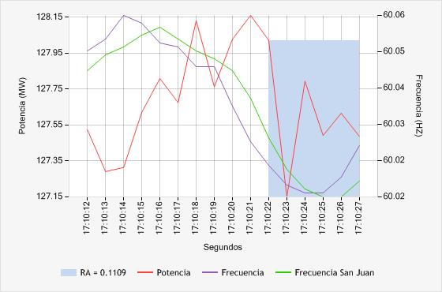

**29. EEPSA C.T. MALACAS - TG4 (33.33%)**

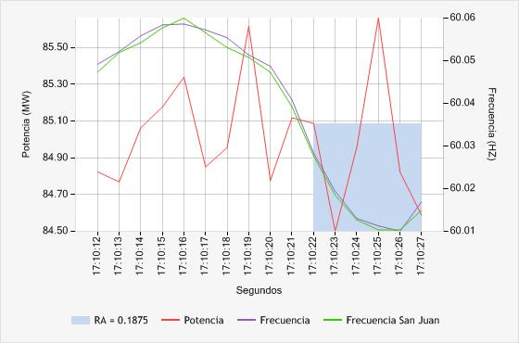

**30. EGASA C.H. CHARCANI IV - G1 (100.00%)**

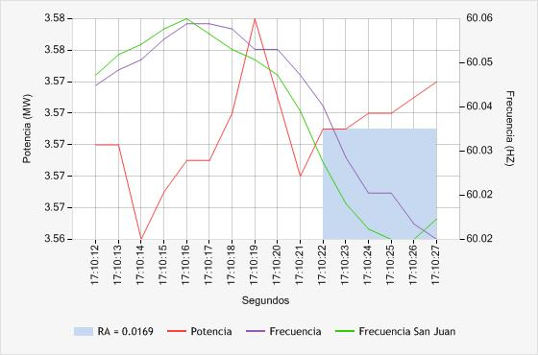

**31. EGASA C.H. CHARCANI IV - G2 (66.67%)**

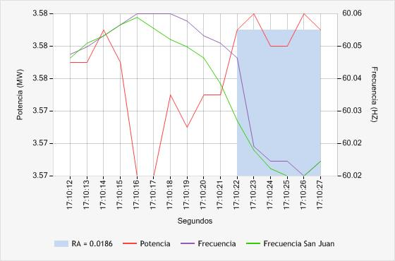

**32. EGASA C.H. CHARCANI IV - G3 (100.00%)**

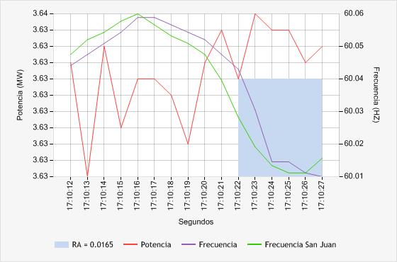

**33. EGASA C.H. CHARCANI V - G2 (100.00%)**

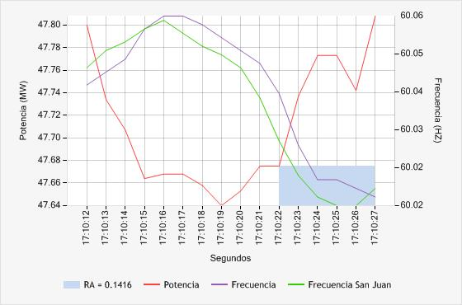

**34. EGASA C.H. CHARCANI V - G3 (50.00%)**

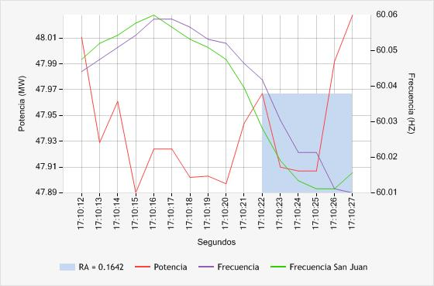

**35. EGASA C.T. PISCO - TG1 (83.33%)**

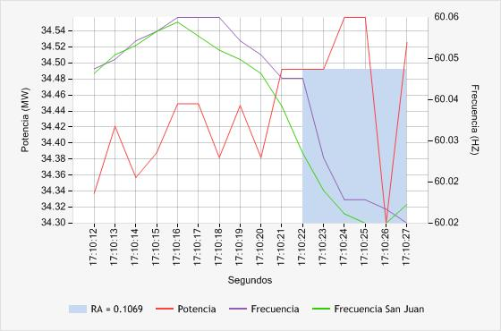

**36. EGEMSA C.H. MACHUPICCHU - CENTRAL (66.67%)**

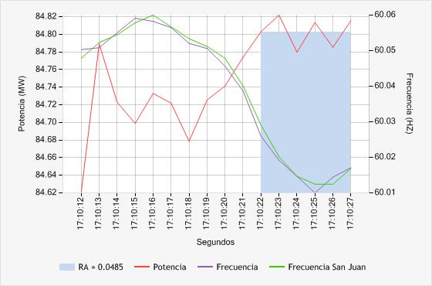

**37. EGENOR C.H. CARHUAQUERO - G1 (16.67%)**

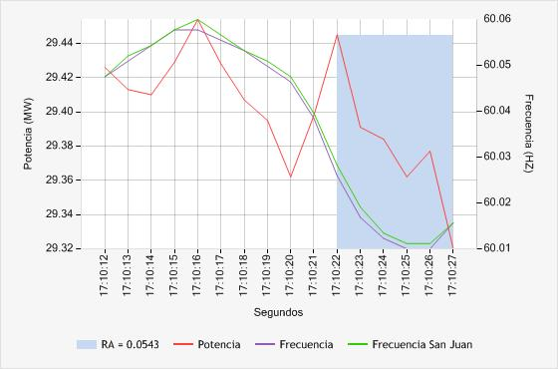

**38. EGENOR C.H. CARHUAQUERO - G3 (16.67%)**

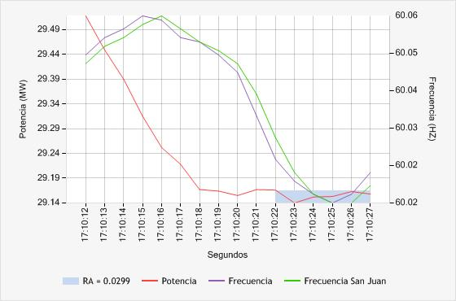

**39. EGENOR C.H. CAÑON DEL PATO - G1 (50.00%)**

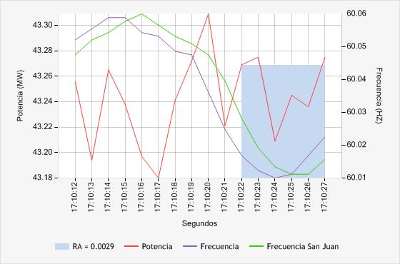

**40. EGENOR C.H. CAÑON DEL PATO - G2 (33.33%)**

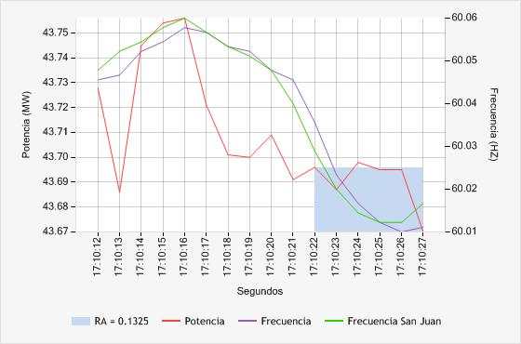

**41. EGENOR C.H. CAÑON DEL PATO - G3 (16.67%)**

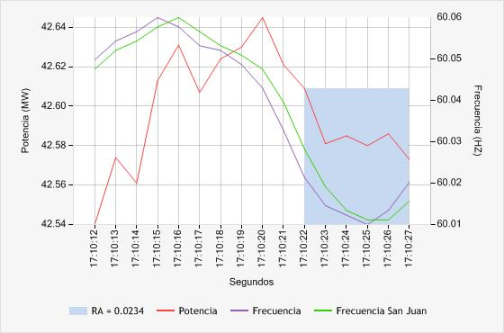

**42. EGENOR C.H. CAÑON DEL PATO - G4 (33.33%)**

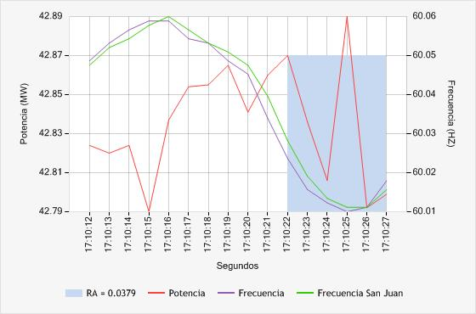

**43. EGENOR C.H. CAÑON DEL PATO - G5 (33.33%)**

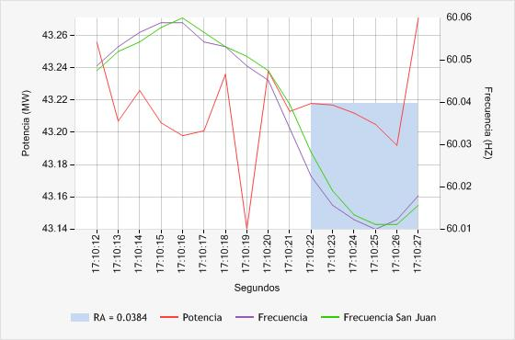

**44. EGENOR C.H. CAÑON DEL PATO - G6 (100.00%)**

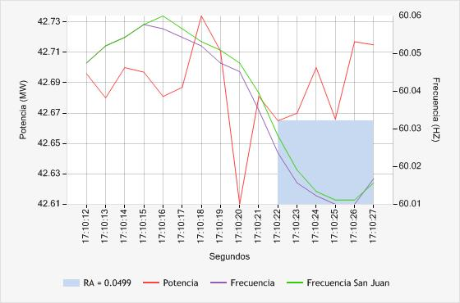

**45. EGESUR C.T. INDEPENDENCIA - INDEP_G1 (66.67%)**

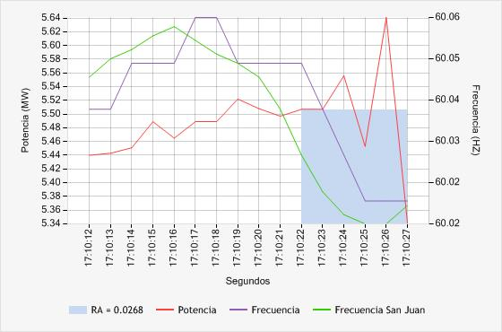

**46. EGESUR C.T. INDEPENDENCIA - INDEP_G2 (16.67%)**

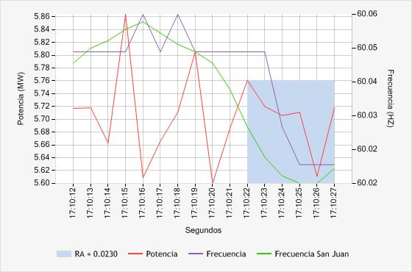

**47. EGESUR C.T. INDEPENDENCIA - INDEP_G3 (50.00%)**

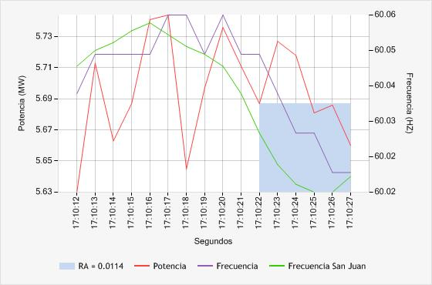

**48. EGESUR C.T. INDEPENDENCIA - INDEP_G4 (50.00%)**

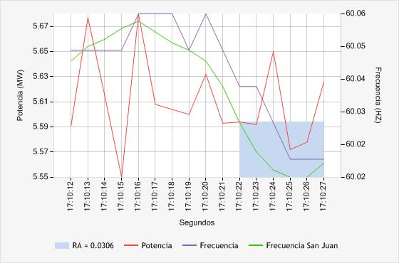

**49. ELECTROPERU C.H. MANTARO - G1 (100.00%)**

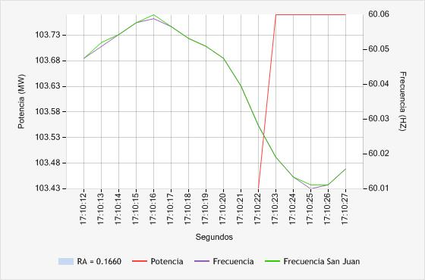

**50. ELECTROPERU C.H. MANTARO - G2 (100.00%)**

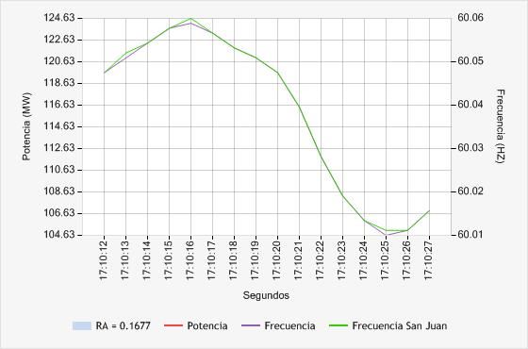

**51. ELECTROPERU C.H. MANTARO - G3 (100.00%)**

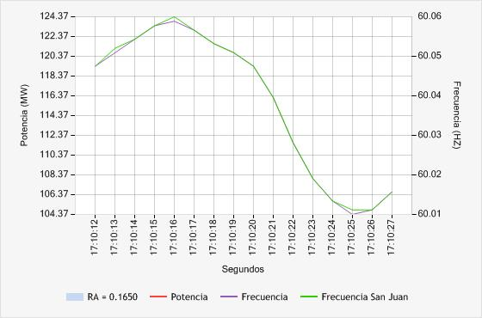

**52. ELECTROPERU C.H. MANTARO - G4 (100.00%)**

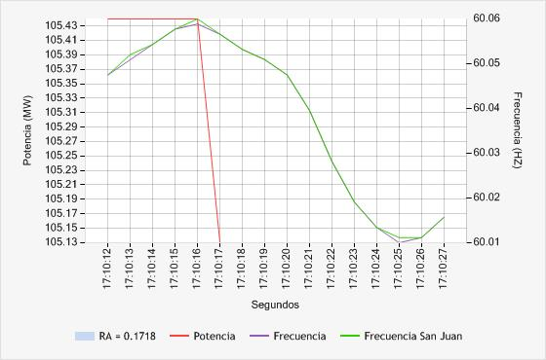

**53. ELECTROPERU C.H. MANTARO - G5 (100.00%)**

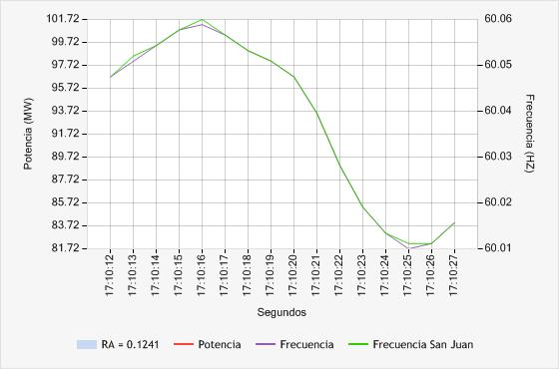

**54. ELECTROPERU C.H. MANTARO - G6 (100.00%)**

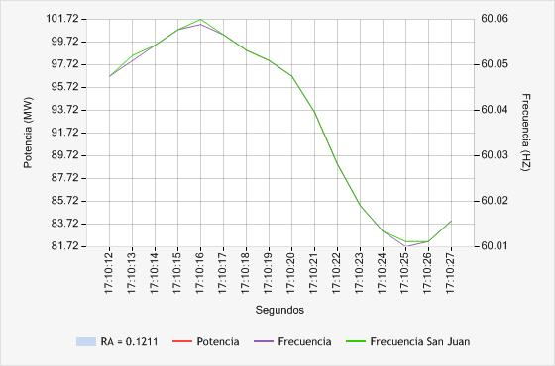

**55. ELECTROPERU C.H. MANTARO - G7 (100.00%)**

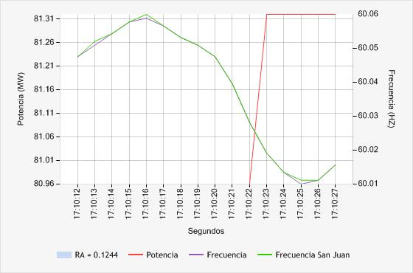

**56. ELECTROPERU C.H. RESTITUCION - G1 (100.00%)**

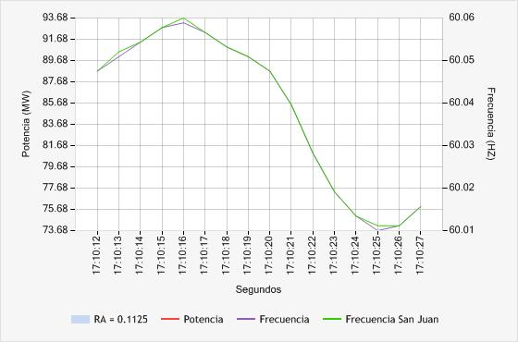

**57. ELECTROPERU C.H. RESTITUCION - G2 (100.00%)**

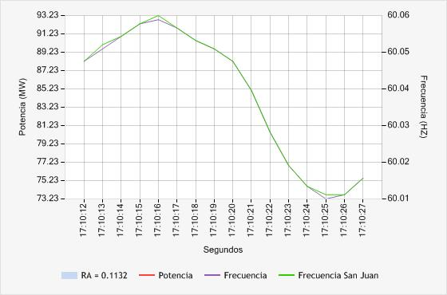

**58. ELECTROPERU C.H. RESTITUCION - G3 (100.00%)**

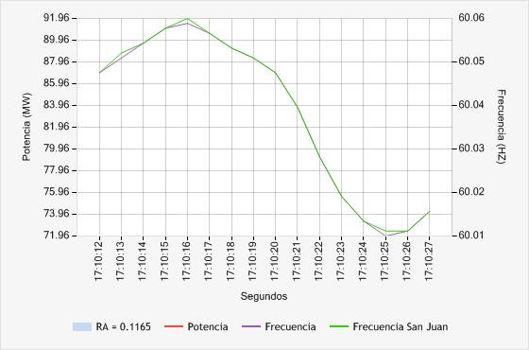

**59. EMPRESA ELECTRICA RIO DOBLE C.H. LAS PIZARRAS - G1 (100.00%)**

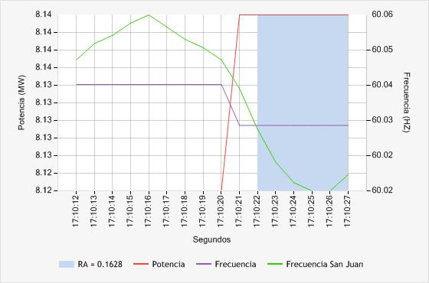

**60. EMPRESA ELECTRICA RIO DOBLE C.H. LAS PIZARRAS - G2 (50.00%)**

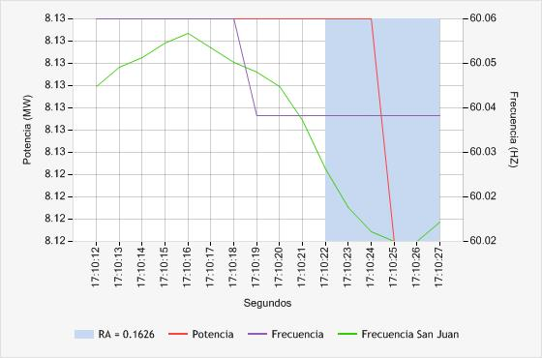

**61. ENERSUR C.H. YUNCAN - G1 (50.00%)**

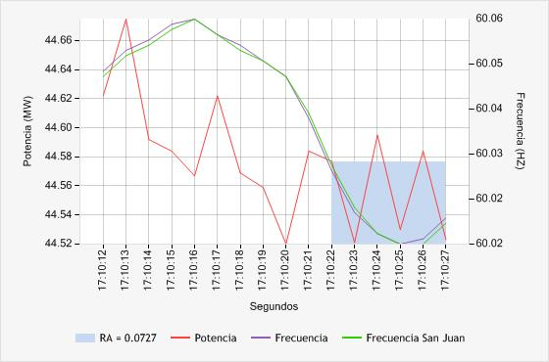

**62. ENERSUR C.H. YUNCAN - G2 (16.67%)**

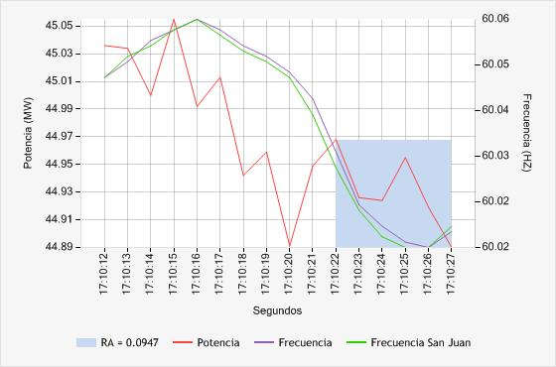

**63. ENERSUR C.H. YUNCAN - G3 (33.33%)**

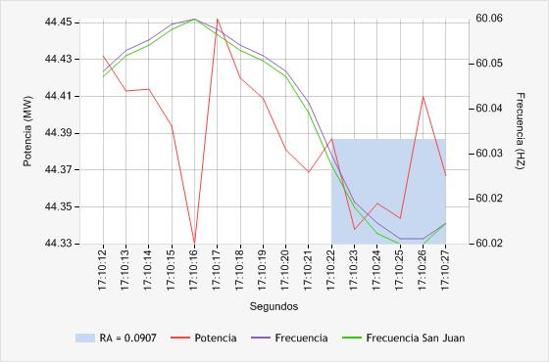

**64. ENERSUR C.T. CHILCA 1 - CENTRAL (16.67%)**

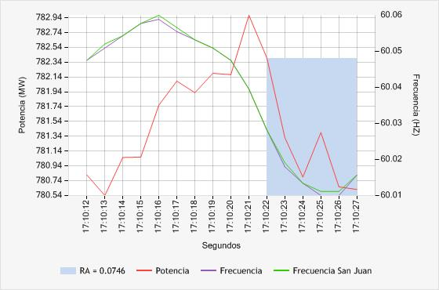

**65. FENIX POWER PERÚ CENTRAL TERMICA FENIX - GT11 (16.67%)**

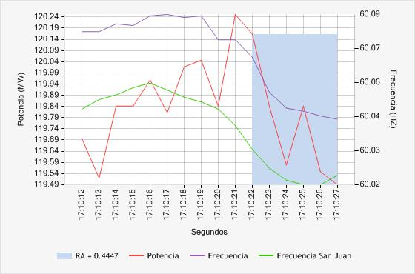

**66. FENIX POWER PERÚ CENTRAL TERMICA FENIX - GT12 (100.00%)**

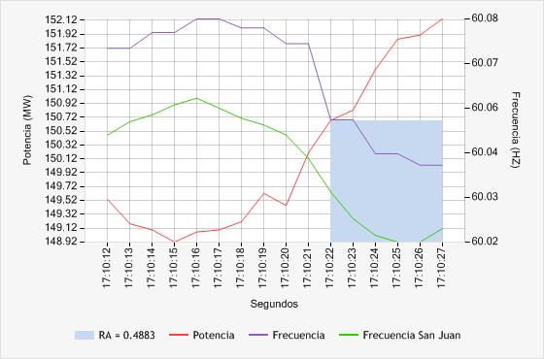

**67. FENIX POWER PERÚ CENTRAL TERMICA FENIX - TV10 (16.67%)**

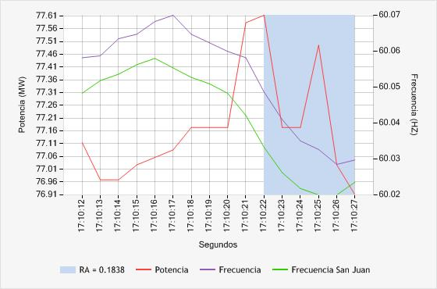

**68. KALLPA GENERACION C.T. KALLPA - TG1 (16.67%)**

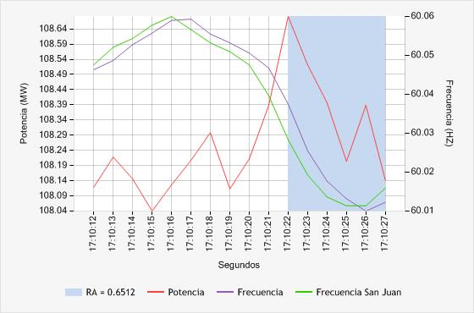

**69. KALLPA GENERACION C.T. KALLPA - TG2 (16.67%)**

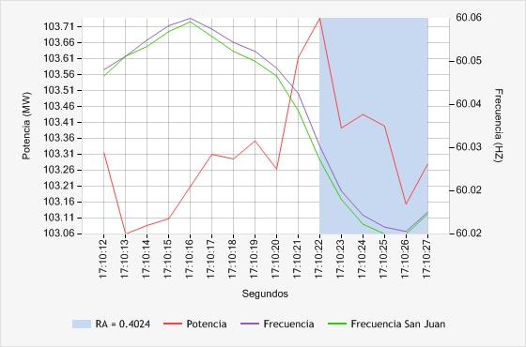

**70. KALLPA GENERACION C.T. KALLPA - TG3 (16.67%)**

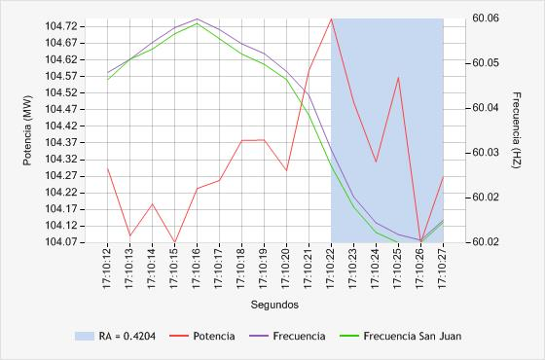

**71. KALLPA GENERACION C.T. KALLPA - TV (16.67%)**

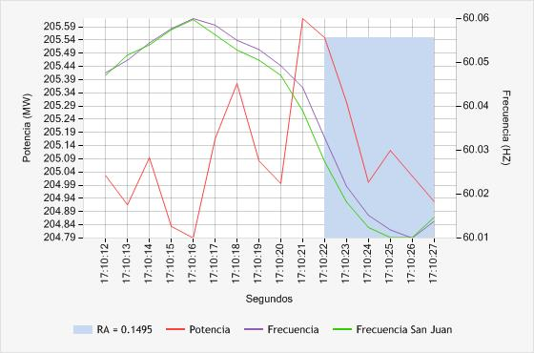

**72. SAN GABAN C.H. SAN GABAN II - G1 (100.00%)**

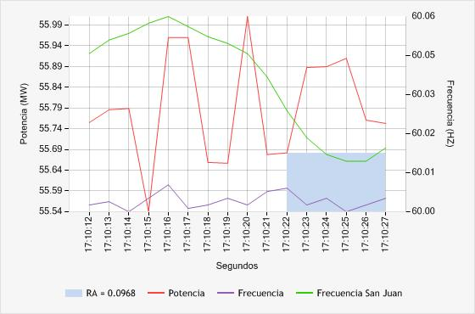

**73. SAN GABAN C.H. SAN GABAN II - G2 (33.33%)**

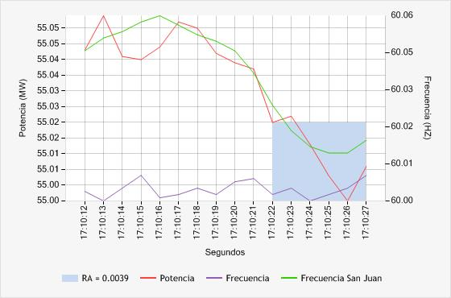

**74. STATKRAFT C.H. CAHUA - G1 (33.33%)**

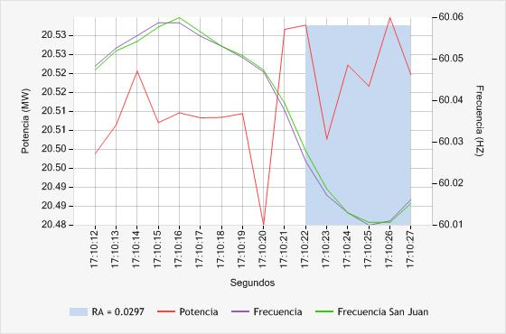

**75. STATKRAFT C.H. CAHUA - G2 (66.67%)**

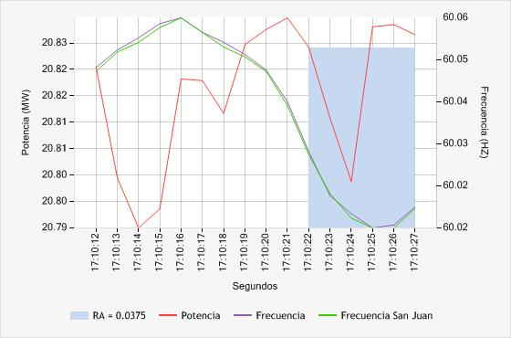

**76. STATKRAFT C.H. GALLITO CIEGO - G2 (83.33%)**

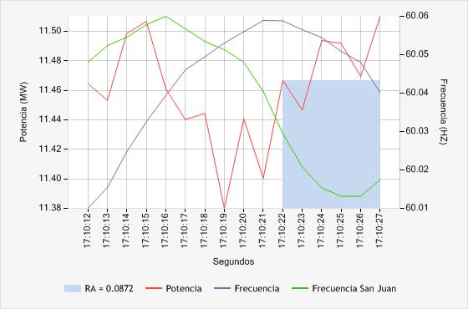

**77. STATKRAFT C.H. MALPASO - G1 (33.33%)**

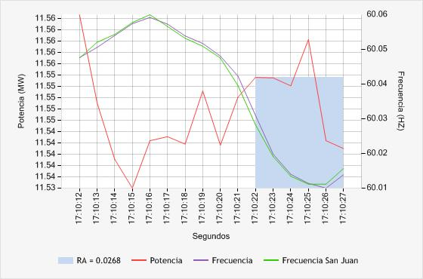

**78. STATKRAFT C.H. MALPASO - G2 (83.33%)**

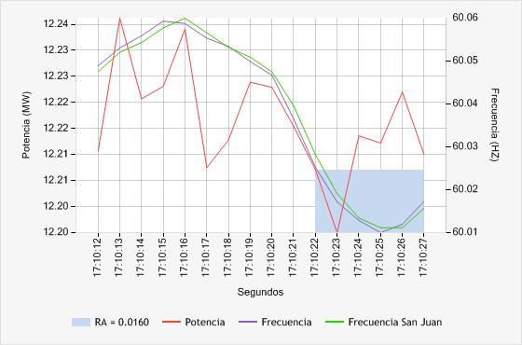

**79. STATKRAFT C.H. MALPASO - G3 (16.67%)**

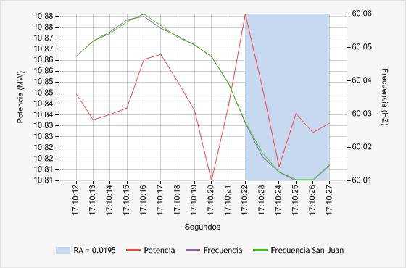

**80. STATKRAFT C.H. MALPASO - G4 (33.33%)**

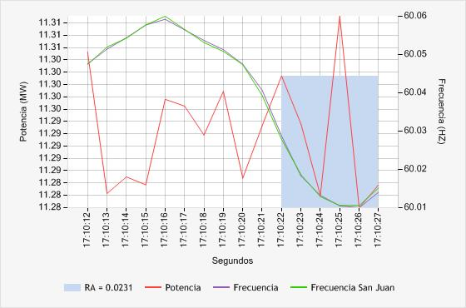

**81. STATKRAFT C.H. YAUPI - G1 (16.67%)**

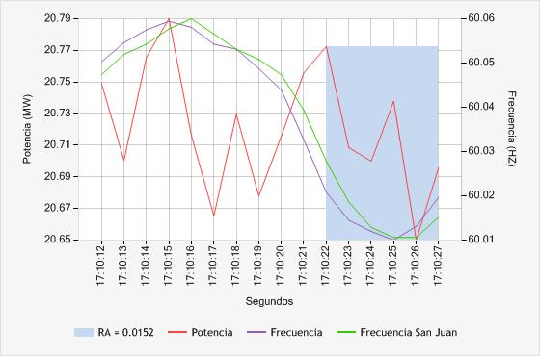

**82. STATKRAFT C.H. YAUPI - G2 (66.67%)**

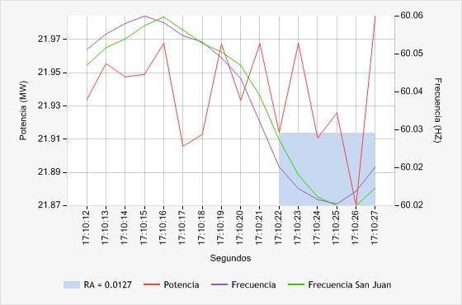

**83. STATKRAFT C.H. YAUPI - G3 (66.67%)**

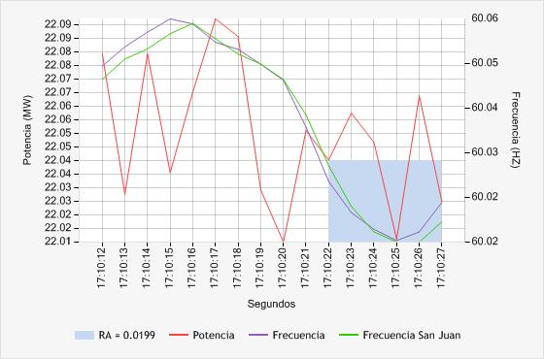

**84. STATKRAFT C.H. YAUPI - G4 (50.00%)**

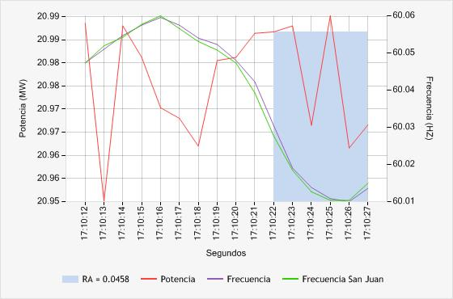

**85. STATKRAFT C.H. YAUPI - G5 (16.67%)**

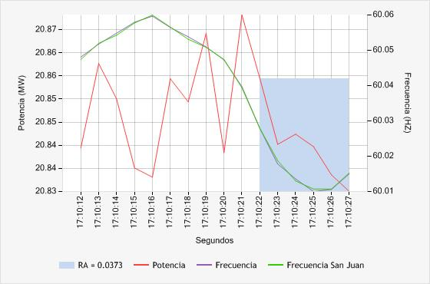

**86. TERMOSELVA C.T. AGUAYTIA - TG1 (16.67%)**

