**REPORTE DE CUMPLIMIENTO RPF**

|  |  |  |  |  |  |  |  |
| --- | --- | --- | --- | --- | --- | --- | --- |
| **EMPRESA** | **CENTRAL** | **UNIDAD** | **PTO MEDICIÓN** | **HORA INICIO** | **HORA FIN** | **PORCENTAJE** | **CUMPLIMIENTO** |
| AGUAS Y ENERGIA PERU | CENTRAL HIDROELÉCTRICA PÍAS 1 | G2 | 456 | 04:04:32 | 04:09:32 | 48.40% | No |
| CELEPSA | CH EL PLATANAL | G2 | 436 | 21:07:29 | 21:12:29 | 41.00% | No |
| EDEGEL | C.H. HUAMPANI | G1 | 62 | 04:04:32 | 04:09:32 | 42.35% | No |
| EDEGEL | C.H. HUAMPANI | G2 | 63 | 04:04:32 | 04:09:32 | 45.20% | No |
| EDEGEL | C.H. HUINCO | G3 | 60 | 21:07:29 | 21:12:29 | 42.00% | No |
| EDEGEL | C.H. MATUCANA | G1 | 64 | 04:04:32 | 04:09:32 | 41.99% | No |
| EDEGEL | C.H. MATUCANA | G2 | 65 | 04:04:32 | 04:09:32 | 42.50% | No |
| EDEGEL | C.H. MOYOPAMPA | G1 | 66 | 04:04:32 | 04:09:32 | 44.84% | No |
| EDEGEL | C.H. MOYOPAMPA | G2 | 67 | 04:04:32 | 04:09:32 | 48.04% | No |
| EEPSA | C.T. MALACAS | TG4 | 30 | 04:04:32 | 04:09:32 | 43.57% | No |
| EGASA | C.T. PISCO | TG1 | 447 | 04:04:32 | 04:09:32 | 62.28% | No |
| EGASA | C.H. CHARCANI IV | G1 | 357 | 21:07:29 | 21:12:29 | 42.00% | No |
| EGASA | C.H. CHARCANI IV | G2 | 358 | 04:04:32 | 04:09:32 | 48.40% | No |
| EGASA | C.H. CHARCANI IV | G3 | 359 | 04:04:32 | 04:09:32 | 51.25% | No |
| EGASA | C.H. CHARCANI V | G2 | 361 | 21:07:29 | 21:12:29 | 35.67% | No |
| EGASA | C.H. CHARCANI V | G3 | 362 | 21:07:29 | 21:12:29 | 35.00% | No |
| EGASA | C.T. PISCO | TG2 | 448 | 04:04:32 | 04:09:32 | 41.64% | No |
| EGEMSA | C.H. MACHUPICCHU | CENTRAL | 30626 | 04:04:32 | 04:09:32 | 49.11% | No |
| EGENOR | C.H. CARHUAQUERO | G1 | 72 | 21:07:29 | 21:12:29 | 41.00% | No |
| EGENOR | C.H. CARHUAQUERO | G2 | 73 | 21:07:29 | 21:12:29 | 37.33% | No |
| EGESUR | C.T. INDEPENDENCIA | INDEP_G2 | 450 | 21:07:29 | 21:12:29 | 31.67% | No |
| EGESUR | C.T. INDEPENDENCIA | INDEP_G3 | 451 | 21:07:29 | 21:12:29 | 37.33% | No |
| EGESUR | C.T. INDEPENDENCIA | INDEP_G4 | 452 | 21:07:29 | 21:12:29 | 30.00% | No |
| EGESUR | C.T. INDEPENDENCIA | INDEP_G1 | 449 | 21:07:29 | 21:12:29 | 34.33% | No |
| ELECTROPERU | C.H. RESTITUCION | G2 | 39 | 04:04:32 | 04:09:32 | 50.89% | No |
| ELECTROPERU | C.H. RESTITUCION | G3 | 40 | 04:04:32 | 04:09:32 | 46.62% | No |
| ELECTROPERU | C.H. MANTARO | G1 | 31 | 04:04:32 | 04:09:32 | 51.25% | No |
| FENIX POWER PERÚ | CENTRAL TERMICA FENIX | GT12 | 487 | 06:42:51 | 06:47:51 | 26.35% | No |
| FENIX POWER PERÚ | CENTRAL TERMICA FENIX | TV10 | 488 | 21:07:29 | 21:12:29 | 52.33% | No |
| KALLPA GENERACION | C.T. KALLPA | TV | 466 | 04:04:32 | 04:09:32 | 9.64% | RSF - A |
| KALLPA GENERACION | C.T. KALLPA | TG3 | 438 | 21:07:29 | 21:12:29 | 50.67% | No |
| KALLPA GENERACION | C.T. KALLPA | TG2 | 429 | 21:07:29 | 21:12:29 | 51.33% | No |
| KALLPA GENERACION | C.T. KALLPA | TG1 | 423 | 04:04:32 | 04:09:32 | 48.04% | RSF - A |
| EDEGEL | C.H. HUINCO | G1 | 58 |  |  | .00% | No rango |
| EDEGEL | C.H. HUINCO | G2 | 59 |  |  | .00% | No rango |
| EDEGEL | C.H. HUINCO | G4 | 61 |  |  | .00% | No rango |
| EEPSA | C.T. MALACAS | TG5 | 479 |  |  | .00% | No rango |
| EGASA | C.H. CHARCANI V | G1 | 360 |  |  | .00% | No rango |
| AGUAS Y ENERGIA PERU | CENTRAL HIDROELÉCTRICA PÍAS 1 | G1 | 455 |  |  | .00% | P o F en 0 |
| EDEGEL | C.T. STA ROSA UTI | UTI6 | 71 |  |  | .00% | P o F en 0 |
| EEPSA | C.T. MALACAS | TG1 | 27 |  |  | .00% | P o F en 0 |
| EGASA | C.T. MOLLENDO DIESEL | GD1 | 369 |  |  | .00% | P o F en 0 |
| EGASA | C.T. CHILINA DIESEL | SLZ2 | 365 |  |  | .00% | P o F en 0 |
| FENIX POWER PERÚ | CENTRAL TERMICA FENIX | GT11 | 491 |  |  | .00% | P o F en 0 |
| KALLPA GENERACION | C.T. LAS FLORES | TG1 | 440 |  |  | .00% | P o F en 0 |
| MAPLE ETANOL | C.T. MAPLE ETANOL | TV | 467 |  |  | .00% | P o F en 0 |
| AGRO INDUSTRIAL PARAMONGA | PARAMONGA | TV-01 | 437 |  |  | .00% | No envío |
| EGEMSA | C.H. MACHUPICCHU | G2 | 399 |  |  | .00% | No envío |
| EGENOR | C.T. CHIMBOTE | TG3 | 82 |  |  | .00% | No envío |
| EGESUR | C.H. ARICOTA II | G1 | 376 |  |  | .00% | No envío |
| EGESUR | C.H. ARICOTA I | G1 | 374 |  |  | .00% | No envío |
| EGESUR | C.H. ARICOTA I | G2 | 375 |  |  | .00% | No envío |
| ELECTROPERU | C.T. TUMBES | MAK1 | 41 |  |  | .00% | No envío |
| ELECTROPERU | C.T. TUMBES | MAK2 | 341 |  |  | .00% | No envío |
| HIDROELECTRICA SANTA CRUZ | HUASAHUASI II | G2 | 30625 |  |  | .00% | No envío |
| HIDROELECTRICA SANTA CRUZ | HUASAHUASI II | G1 | 30624 |  |  | .00% | No envío |
| MINERA CORONA | C.H. HUANCHOR | G1 | 402 |  |  | .00% | No envío |
| CELEPSA | CH EL PLATANAL | G1 | 435 |  |  | .00% | No sospechoso |
| EDEGEL | C.T. STA ROSA UTI | UTI5 | 70 |  |  | .00% | No sospechoso |
| EDEGEL | C.H. MOYOPAMPA | G3 | 68 |  |  | .00% | No sospechoso |
| EDEGEL | C.T. VENTANILLA | TV | 420 |  |  | .00% | No sospechoso |
| EDEGEL | C.T. VENTANILLA | TG3 | 45 |  |  | .00% | No sospechoso |
| EDEGEL | C.T. VENTANILLA | TG4 | 46 |  |  | .00% | No sospechoso |
| EDEGEL | C.H. YANANGO | G1 | 53 |  |  | .00% | No sospechoso |
| EDEGEL | C.T. STA.ROSA | TG8 | 434 |  |  | .00% | No sospechoso |
| EDEGEL | C.H. CHIMAY | G1 | 342 |  |  | .00% | No sospechoso |
| EDEGEL | C.H. CHIMAY | G2 | 343 |  |  | .00% | No sospechoso |
| EDEGEL | C.H. CALLAHUANCA | G1 | 54 |  |  | .00% | No sospechoso |
| EDEGEL | C.H. CALLAHUANCA | G2 | 55 |  |  | .00% | No sospechoso |
| EDEGEL | C.H. CALLAHUANCA | G3 | 56 |  |  | .00% | No sospechoso |
| EDEGEL | C.H. CALLAHUANCA | G4 | 57 |  |  | .00% | No sospechoso |
| EGASA | C.T. CHILINA DIESEL | SLZ1 | 364 |  |  | .00% | No sospechoso |
| EGASA | C.T. CHILINA VAPOR | CCOMB | 366 |  |  | .00% | No sospechoso |
| EGASA | C.T. CHILINA VAPOR | TV3 | 368 |  |  | .00% | No sospechoso |
| EGASA | C.T. CHILINA VAPOR | TV2 | 367 |  |  | .00% | No sospechoso |
| EGASA | C.T. MOLLENDO DIESEL | GD3 | 371 |  |  | .00% | No sospechoso |
| EGASA | C.T. MOLLENDO DIESEL | GD2 | 370 |  |  | .00% | No sospechoso |
| EGEMSA | C.H. MACHUPICCHU | G3 | 400 |  |  | .00% | No sospechoso |
| EGEMSA | C.H. MACHUPICCHU | G1 | 398 |  |  | .00% | No sospechoso |
| EGENOR | C.H. CAÑON DEL PATO | G5 | 79 |  |  | .00% | No sospechoso |
| EGENOR | C.H. CAÑON DEL PATO | G3 | 77 |  |  | .00% | No sospechoso |
| EGENOR | C.H. CAÑON DEL PATO | G6 | 80 |  |  | .00% | No sospechoso |
| EGENOR | C.H. CAÑON DEL PATO | G4 | 78 |  |  | .00% | No sospechoso |
| EGENOR | C.H. CAÑON DEL PATO | G2 | 76 |  |  | .00% | No sospechoso |
| EGENOR | C.H. CAÑON DEL PATO | G1 | 75 |  |  | .00% | No sospechoso |
| EGENOR | C.H. CARHUAQUERO | G3 | 74 |  |  | .00% | No sospechoso |
| EGENOR | C.T. PIURA RESIDUAL | TGPIU | 84 |  |  | .00% | No sospechoso |
| ELECTROPERU | C.H. MANTARO | G2 | 32 |  |  | .00% | No sospechoso |
| ELECTROPERU | C.H. MANTARO | G3 | 33 |  |  | .00% | No sospechoso |
| ELECTROPERU | C.H. MANTARO | G4 | 34 |  |  | .00% | No sospechoso |
| ELECTROPERU | C.H. MANTARO | G5 | 35 |  |  | .00% | No sospechoso |
| ELECTROPERU | C.H. MANTARO | G6 | 36 |  |  | .00% | No sospechoso |
| ELECTROPERU | C.H. MANTARO | G7 | 37 |  |  | .00% | No sospechoso |
| ELECTROPERU | C.H. RESTITUCION | G1 | 38 |  |  | .00% | No sospechoso |
| EMPRESA DE GENERACION HUANZA | C.H HUANZA | 1GER | 489 |  |  | .00% | No sospechoso |
| EMPRESA DE GENERACION HUANZA | C.H HUANZA | 2GER | 490 |  |  | .00% | No sospechoso |
| EMPRESA ELECTRICA RIO DOBLE | C.H. LAS PIZARRAS | G1 | 480 |  |  | .00% | No sospechoso |
| EMPRESA ELECTRICA RIO DOBLE | C.H. LAS PIZARRAS | G2 | 481 |  |  | .00% | No sospechoso |
| ENERSUR | C.H. YUNCAN | G1 | 412 |  |  | .00% | No sospechoso |
| ENERSUR | C.H. YUNCAN | G2 | 413 |  |  | .00% | No sospechoso |
| ENERSUR | C.H. YUNCAN | G3 | 414 |  |  | .00% | No sospechoso |
| ENERSUR | C.T. ILO 1 | TV3 | 346 |  |  | .00% | No sospechoso |
| ENERSUR | C.T. ILO 1 | TV4 | 347 |  |  | .00% | No sospechoso |
| ENERSUR | C.T. ILO 1 | TG1 | 348 |  |  | .00% | No sospechoso |
| ENERSUR | C.T. ILO 1 | TG2 | 349 |  |  | .00% | No sospechoso |
| ENERSUR | C.T. ILO 2 | TV21 | 351 |  |  | .00% | No sospechoso |
| ENERSUR | C.T. CHILCA 1 | CENTRAL | 30627 |  |  | .00% | No sospechoso |
| ENERSUR | C.T. CHILCA 1 | TG1 | 421 |  |  | .00% | No sospechoso |
| ENERSUR | C.T. CHILCA 1 | TG2 | 422 |  |  | .00% | No sospechoso |
| ENERSUR | C.T. CHILCA 1 | TG3 | 431 |  |  | .00% | No sospechoso |
| ENERSUR | C.T. CHILCA 1 | TV | 471 |  |  | .00% | No sospechoso |
| ENERSUR | C.T. RESERVA FRIA PLANTA ILO | TG2 | 477 |  |  | .00% | No sospechoso |
| ENERSUR | C.T. RESERVA FRIA PLANTA ILO | TG3 | 478 |  |  | .00% | No sospechoso |
| ENERSUR | C.T. RESERVA FRIA PLANTA ILO | TG1 | 476 |  |  | .00% | No sospechoso |
| HIDROELECTRICA SANTA CRUZ | HUASAHUASI II | HUASAHUASI II | 463 |  |  | .00% | No sospechoso |
| MINERA CORONA | C.H. HUANCHOR | G2 | 403 |  |  | .00% | No sospechoso |
| SAN GABAN | C.H. SAN GABAN II | G1 | 383 |  |  | .00% | No sospechoso |
| SAN GABAN | C.H. SAN GABAN II | G2 | 384 |  |  | .00% | No sospechoso |
| SDE PIURA | C.T. Tablazo | TG1 | 461 |  |  | .00% | No sospechoso |
| SDF ENERGIA | C.T. OQUENDO | TG1 | 426 |  |  | .00% | No sospechoso |
| SHOUGESA | C.T. SAN NICOLAS | TV2 | 48 |  |  | .00% | No sospechoso |
| SHOUGESA | C.T. SAN NICOLAS | TV3 | 49 |  |  | .00% | No sospechoso |
| SHOUGESA | C.T. SAN NICOLAS | TV1 | 47 |  |  | .00% | No sospechoso |
| SINERSA | C.H. POECHOS II | G2 | 444 |  |  | .00% | No sospechoso |
| SINERSA | C.H. POECHOS II | G1 | 443 |  |  | .00% | No sospechoso |
| SN POWER | C.H. CAHUA | G2 | 98 |  |  | .00% | No sospechoso |
| SN POWER | C.H. CAHUA | G1 | 3 |  |  | .00% | No sospechoso |
| SN POWER | C.H. GALLITO CIEGO | G2 | 6 |  |  | .00% | No sospechoso |
| SN POWER | C.H. GALLITO CIEGO | G1 | 5 |  |  | .00% | No sospechoso |
| SN POWER | C.H. YAUPI | G5 | 15 |  |  | .00% | No sospechoso |
| SN POWER | C.H. YAUPI | G4 | 14 |  |  | .00% | No sospechoso |
| SN POWER | C.H. YAUPI | G3 | 13 |  |  | .00% | No sospechoso |
| SN POWER | C.H. YAUPI | G2 | 12 |  |  | .00% | No sospechoso |
| SN POWER | C.H. YAUPI | G1 | 11 |  |  | .00% | No sospechoso |
| SN POWER | C.H. MALPASO | G4 | 19 |  |  | .00% | No sospechoso |
| SN POWER | C.H. MALPASO | G3 | 18 |  |  | .00% | No sospechoso |
| SN POWER | C.H. MALPASO | G1 | 16 |  |  | .00% | No sospechoso |
| SN POWER | C.H. MALPASO | G2 | 17 |  |  | .00% | No sospechoso |
| TERMOCHILCA | CT OLLEROS | TG1 | 486 |  |  | .00% | No sospechoso |
| TERMOSELVA | C.T. AGUAYTIA | TG2 | 2 |  |  | .00% | No sospechoso |
| TERMOSELVA | C.T. AGUAYTIA | TG1 | 1 |  |  | .00% | No sospechoso |

**1. AGUAS Y ENERGIA PERU CENTRAL HIDROELÉCTRICA PÍAS 1 - G2 (48.40%)**

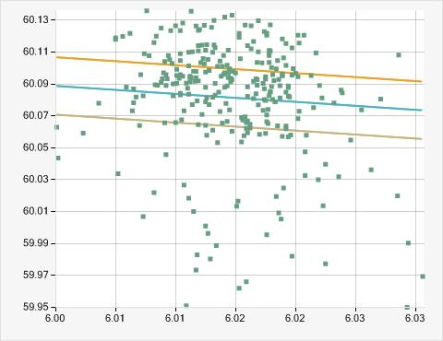

**2. CELEPSA CH EL PLATANAL - G2 (41.00%)**

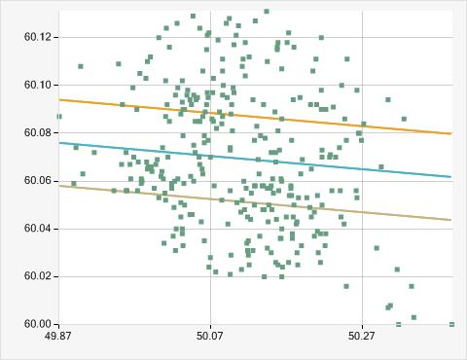

**3. EDEGEL C.H. HUAMPANI - G1 (42.35%)**

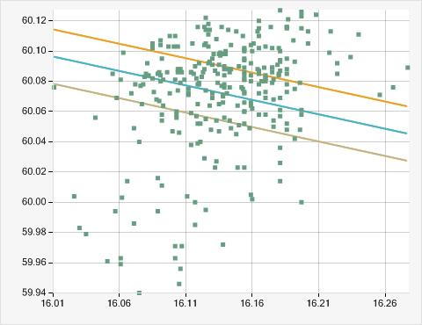

**4. EDEGEL C.H. HUAMPANI - G2 (45.20%)**

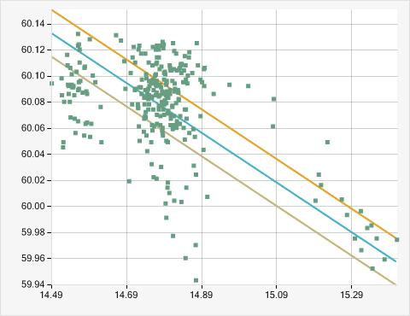

**5. EDEGEL C.H. HUINCO - G3 (42.00%)**

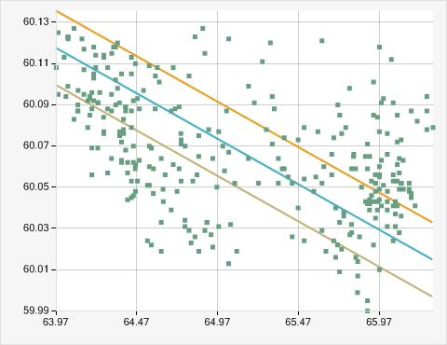

**6. EDEGEL C.H. MATUCANA - G1 (41.99%)**

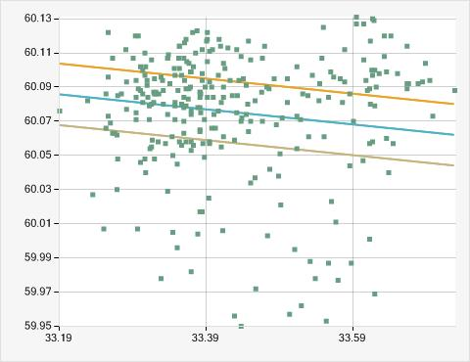

**7. EDEGEL C.H. MATUCANA - G2 (42.50%)**

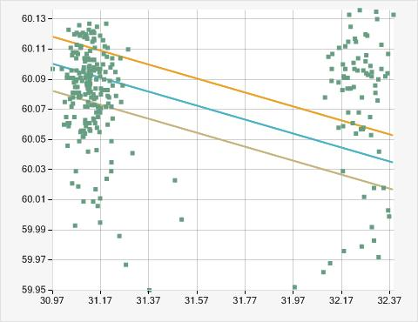

**8. EDEGEL C.H. MOYOPAMPA - G1 (44.84%)**

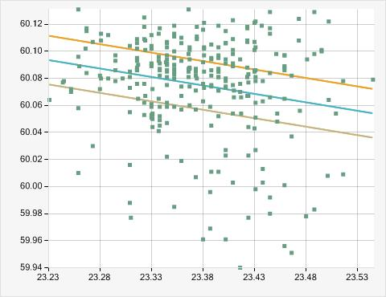

**9. EDEGEL C.H. MOYOPAMPA - G2 (48.04%)**

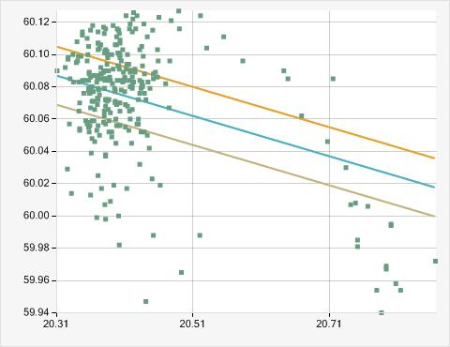

**10. EEPSA C.T. MALACAS - TG4 (43.57%)**

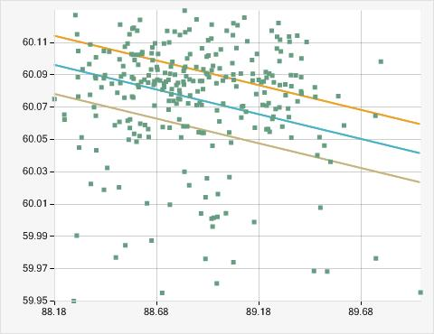

**11. EGASA C.T. PISCO - TG1 (62.28%)**

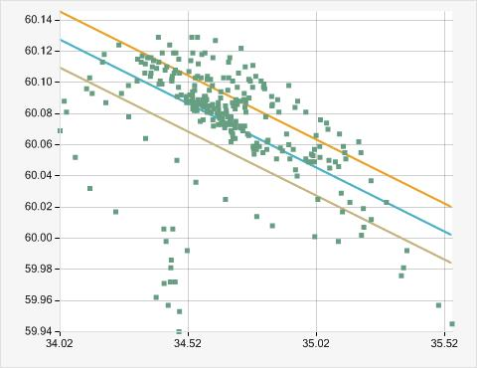

**12. EGASA C.H. CHARCANI IV - G1 (42.00%)**

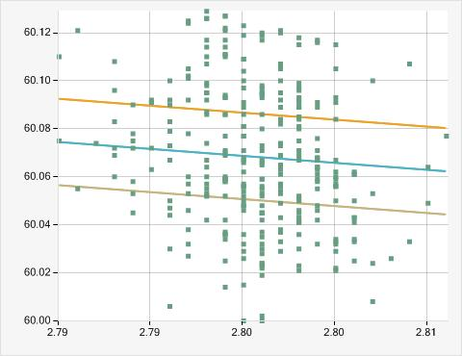

**13. EGASA C.H. CHARCANI IV - G2 (48.40%)**

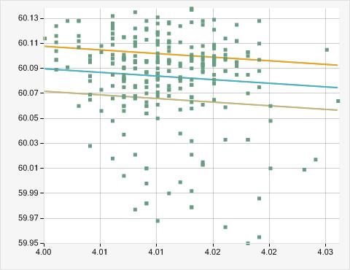

**14. EGASA C.H. CHARCANI IV - G3 (51.25%)**

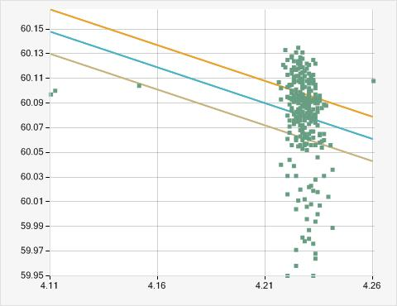

**15. EGASA C.H. CHARCANI V - G2 (35.67%)**

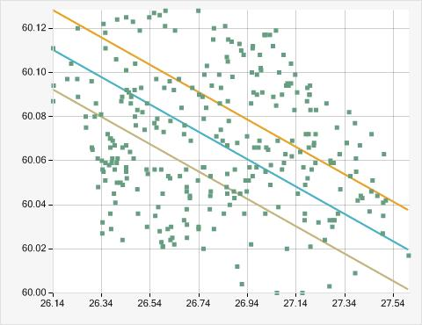

**16. EGASA C.H. CHARCANI V - G3 (35.00%)**

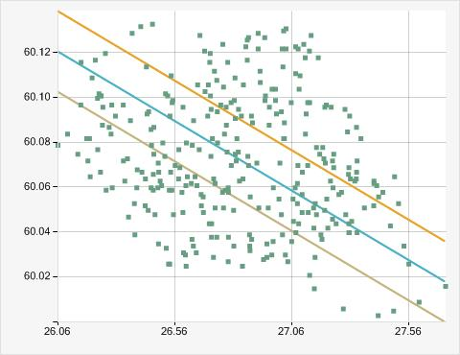

**17. EGASA C.T. PISCO - TG2 (41.64%)**

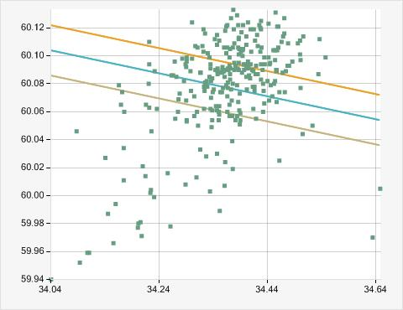

**18. EGEMSA C.H. MACHUPICCHU - CENTRAL (49.11%)**

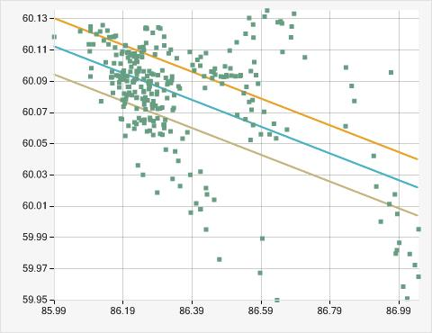

**19. EGENOR C.H. CARHUAQUERO - G1 (41.00%)**

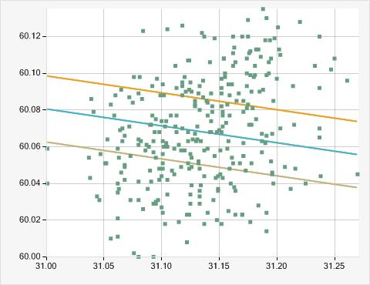

**20. EGENOR C.H. CARHUAQUERO - G2 (37.33%)**

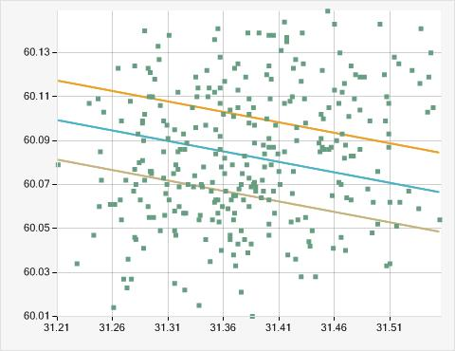

**21. EGESUR C.T. INDEPENDENCIA - INDEP_G2 (31.67%)**

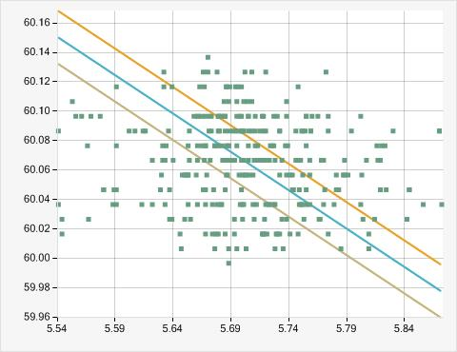

**22. EGESUR C.T. INDEPENDENCIA - INDEP_G3 (37.33%)**

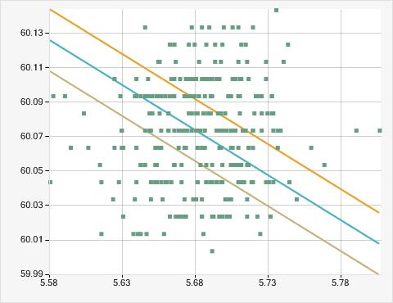

**23. EGESUR C.T. INDEPENDENCIA - INDEP_G4 (30.00%)**

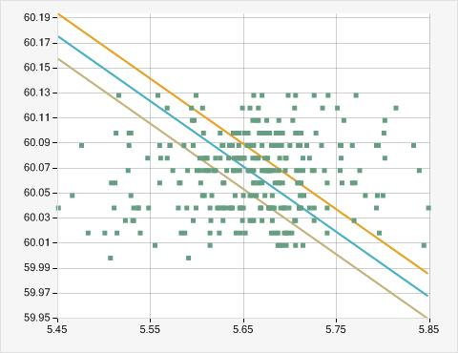

**24. EGESUR C.T. INDEPENDENCIA - INDEP_G1 (34.33%)**

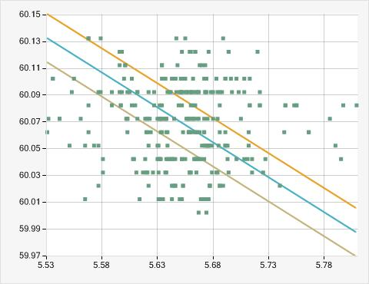

**25. ELECTROPERU C.H. RESTITUCION - G2 (50.89%)**

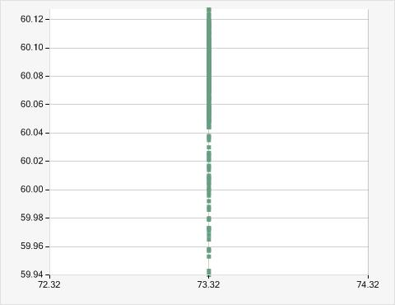

**26. ELECTROPERU C.H. RESTITUCION - G3 (46.62%)**

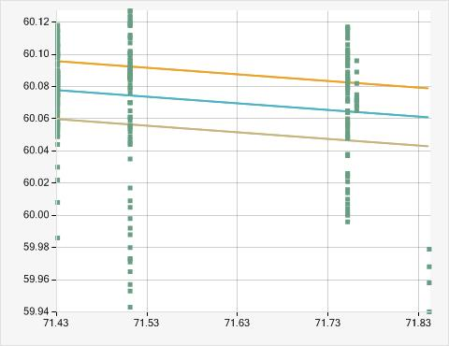

**27. ELECTROPERU C.H. MANTARO - G1 (51.25%)**

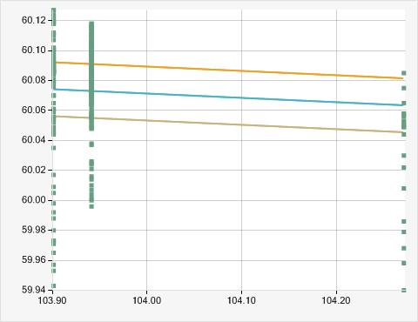

**28. FENIX POWER PERÚ CENTRAL TERMICA FENIX - GT12 (26.35%)**

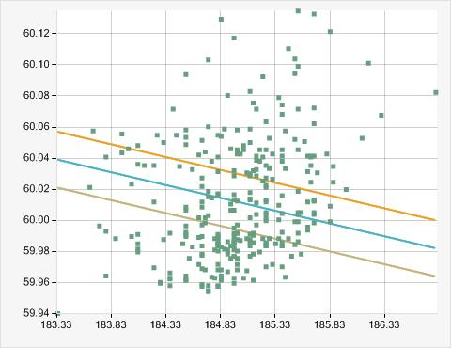

**29. FENIX POWER PERÚ CENTRAL TERMICA FENIX - TV10 (52.33%)**

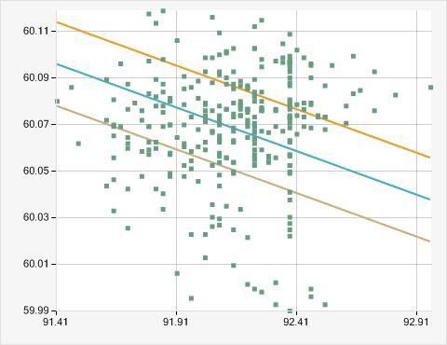

**30. KALLPA GENERACION C.T. KALLPA - TV (9.64%)**

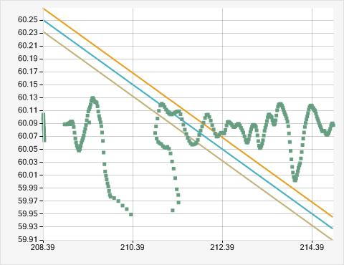

**31. KALLPA GENERACION C.T. KALLPA - TG3 (50.67%)**

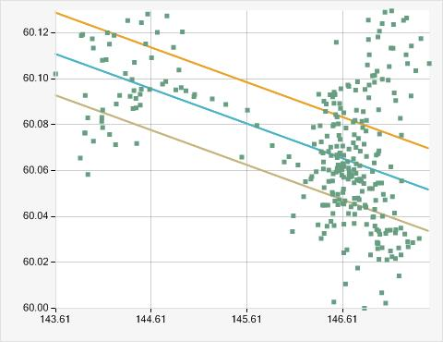

**32. KALLPA GENERACION C.T. KALLPA - TG2 (51.33%)**

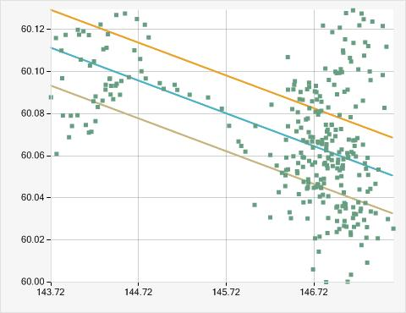

**33. KALLPA GENERACION C.T. KALLPA - TG1 (48.04%)**

