xxxx

**xxx**

**Prepared By:**

**Job Number:**

**Date:**

Table of Contents

1.0: Design Codes & Standards 3

2.0: Design Material 3

3.0: Analysis Method 3

4.0: Design Loads 3

5.0: Structural Members Check 4

# 1.0: Design Codes & Standards

* AISC Specification for Structural Steel Buildings 15th Edition – Allowable Stress Design
* CSA S269.1-16

# 2.0: Design Material

**Material Grade: Q235**

Modulus of Elasticity (E) = 200 GPa (29x106 psi)

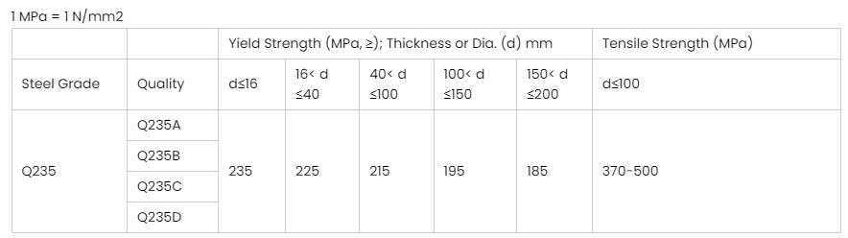

# 3.0: Analysis Method

The analysis method of the system was completed through hand calculations.

# 4.0: Design Loads

The circular column forms (respective of diameter) designed are to be capable of supporting a maximum pour pressure of 143.6 kPa (3000 psf).

Per CSA S269.1-16, Clause 6.1.2.1.2, WSD calculated loads and rated capacities of the system or components is determined by analysis based on the specific material standards with a reduction factor, applied to the ultimate capacity, as specified in the standard. The reduction factor for metal panels, per Table 7, is to be considered as 2.0.

# 5.0: Structural Members Check





