Developer compensation and statistical uncertainty
MIE1624 · Assignment 1 | Julian Peinado · 1012953314
Introduction to Data Science, Analytics, and AI · Fall 2026
Bonus dashboard — interactive charts and results

Q1 Exploratory data analysis
How does developer pay vary with work arrangement and education? Among the 20,407 respondents in this dataset, remote workers report higher mean and median salaries, while US and Canadian degree groups differ in average pay. The analysis explores how robust these patterns are. All salaries are positive, finite annual USD; the dataset contains 168 variables.
The first step is to establish what the data can support. For satisfaction, I exclude 3,449 missing ratings and one value of 60, using a working scale of 0–10. The age plot omits 10 missing ages. Each row has one supplied job category. I use the recorded numeric ages because their cleaning history is unknown. Finally the only entry for “retired” was removed since it is out of the scope of the analysis.
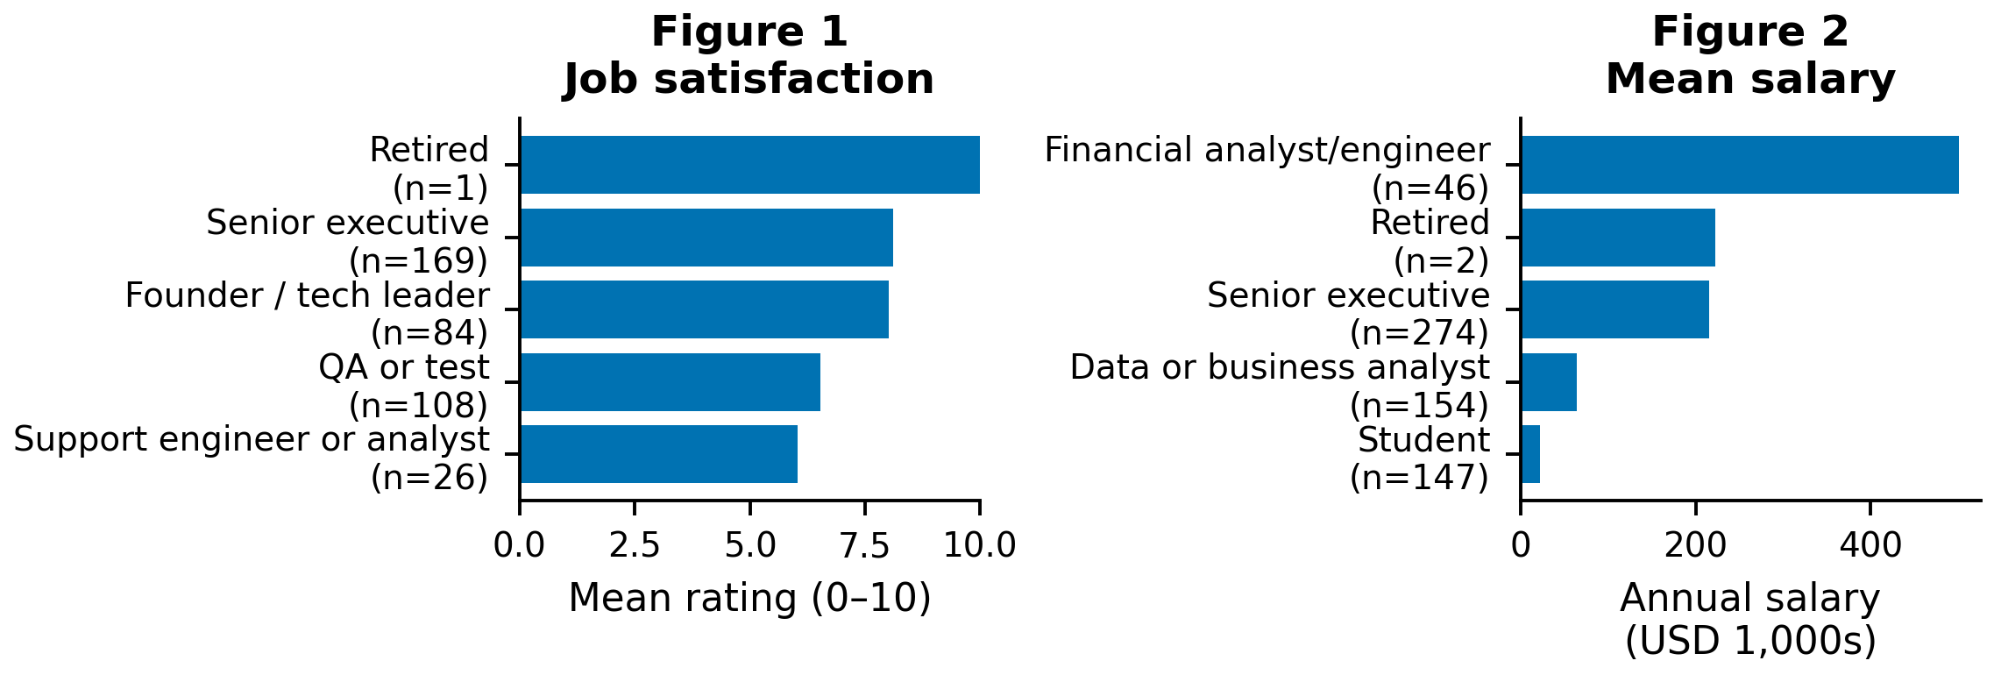
The rankings immediately show why averages need context. The data shows the. Financial analysts/engineers have a mean salary of $501,248 against a median of $87,249, suggesting strong influence from high earners. Figures 1–2 show the lowest two and highest three means; the notebook covers all 32 titles. Labels include valid counts.
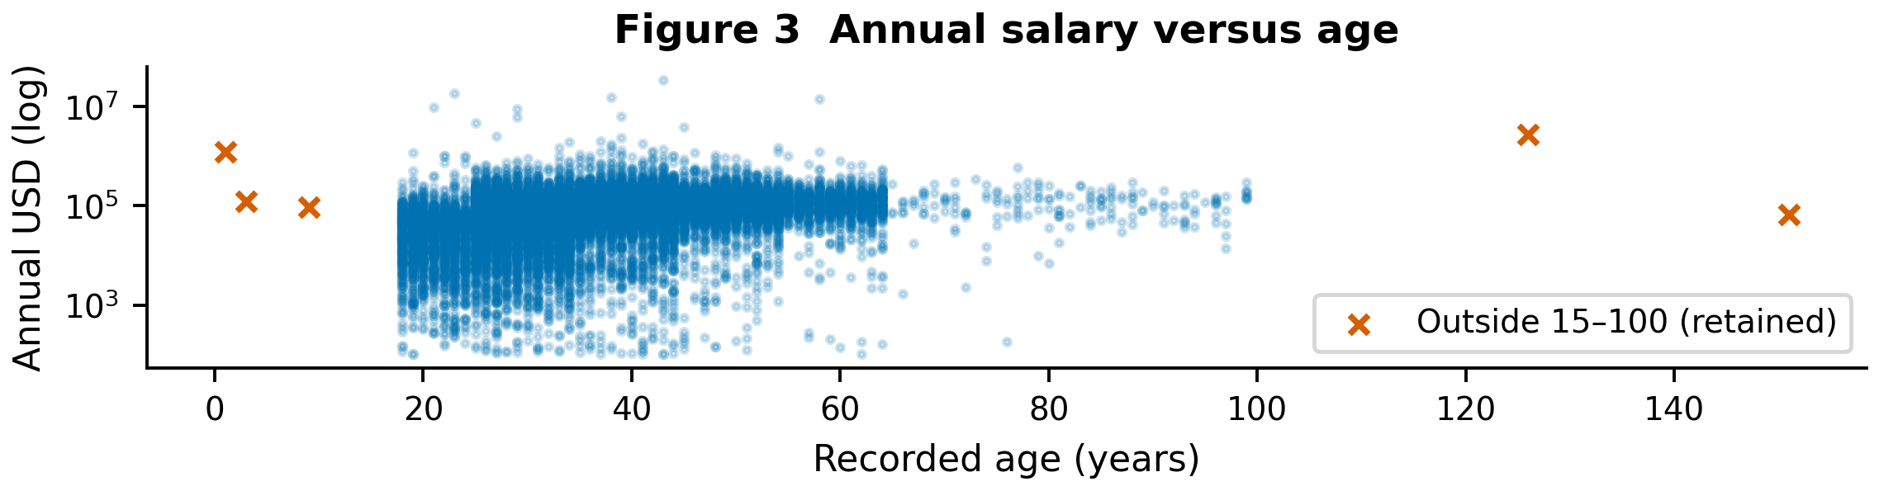
Figure 3 shows the full salary range, from $102 to $33.55 million, on a logarithmic axis. Five recorded ages fall outside 15–100 and warrant caution when interpreting the pattern. All nonmissing ages remain visible, and these display choices do not remove salaries from the statistical tests.

Q2 Hybrid and remote salaries

Q2(a): Descriptive statistics and outliers
I compare the exact labels “Remote” and “Hybrid”, excluding the other 5,670 respondents. All salaries in these groups remain in the primary analysis. Throughout Q2, positive Remote − Hybrid differences indicate higher remote pay.
Table 1. Original salaries. SD describes individual salary dispersion; all amounts are USD.
Group | n | Mean | Median | SD
Remote | 6,934 | 118,683.78 | 90,527.50 | 442,809.92
Hybrid | 7,803 | 101,790.28 | 77,730.00 | 347,264.84
The gap extends beyond the averages. The middle half of salaries spans $47,650–150,000 for Remote and $47,566–116,015 for Hybrid. The minimum values are $102 and $104, respectively.
The largest hybrid salary is $18,387,548, reported by a financial analyst/engineer in Poland; the largest remote salary is $33,552,715, from a full-stack developer in Ukraine. They contribute 2.32% and 4.08% of group salary totals. Their influence is substantial, but size alone does not establish an error, so I retain them.
A sensitivity check restricts salaries to each group’s Q1 − 1.5×IQR and Q3 + 1.5×IQR fences. Upper limits are $303,525 (Remote) and $218,688.50 (Hybrid); both lower limits are negative. Removing 204 (2.94%) and 403 (5.16%) leaves 6,730 and 7,400 salaries. Means fall to $98,709 and $79,921, but the gap remains $18,787.84 (pooled p = 2.487×10⁻⁸⁰). The pattern survives, although these restricted distributions answer a different question and do not justify the exclusions.

Q2(b): Two-sided pooled t-test
Is the mean gap consistent with equal population means? I test H₀: μR − μH = 0 against H₁: μR − μH ≠ 0 at α = 0.05. Using n − 1, the variances are sR² = 196,080,623,864.35 and sH² = 120,592,867,982.18 USD². The pooled calculation is:
$$sₚ² = [(nR - 1)sR² + (nH - 1)sH²] / (nR + nH - 2)$$
$$SE = sₚ√(1/nR + 1/nH); t = (x̄R - x̄H) / SE$$
Here n is group size, x̄ the sample mean, s² sample variance and sₚ pooled salary SD. The results are sₚ = $395,108.58 and SE = $6,520.76. SE describes uncertainty in the estimated gap; salary SD describes variation between people.
Table 2. Original-data tests of Remote − Hybrid.
Method | t | df | Two-sided p
Manual pooled | 2.59073 | 14,735 | 0.009587
SciPy pooled | 2.59073 | 14,735 | 0.009587
Welch supplement | 2.55456 | 13,103.88 | 0.01064
The manual and built-in results agree to numerical precision and reject H₀ at 0.05. The $16,893.50 gap is 16.6% of the hybrid mean, but this test cannot explain why it exists.
Independence is unverified, and strong skew may weaken normal approximations. A variance ratio of 1.63 (median-centered Levene p = 0.01654) questions equal variances. Welch’s test allows unequal variances and also rejects. A p-value describes the statistic’s extremeness under H₀ and the model, not the probability that H₀ is true.

Q2(c): Bootstrap analysis
Bootstrapping offers another view of uncertainty. I resample within each group, with replacement, keeping 6,934 Remote and 7,803 Hybrid salaries per draw. I use 10,000 replications, seed 16242026 and separate named NumPy streams. The mean SEs are $5,339.19 and $3,919.82; the difference SE is $6,608.75. These distributions describe variation in estimated means, rather than between individual salaries.
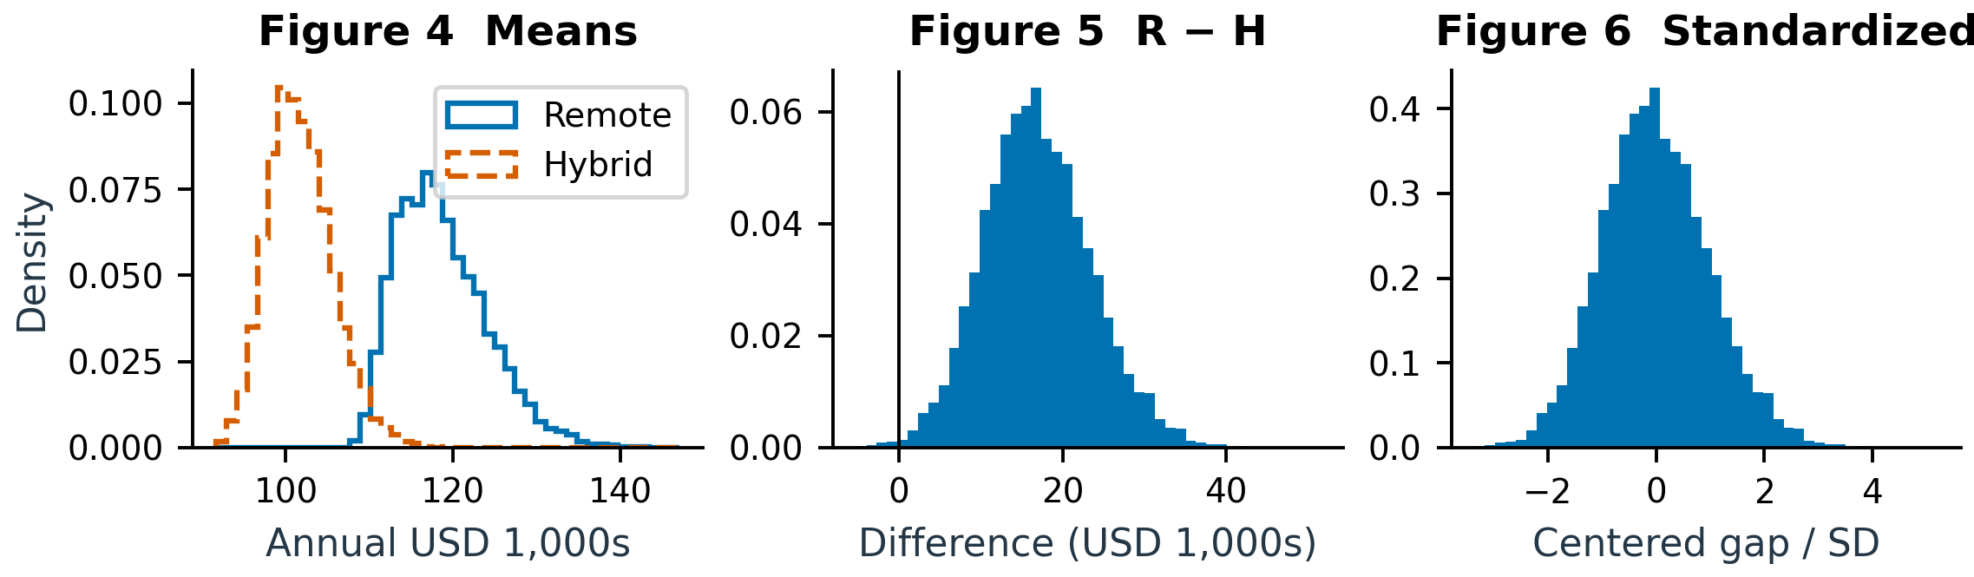
Figures 4–6 move from bootstrap means to Remote − Hybrid differences and standardized differences. Vertical axes show probability density; Figure 5 marks zero. All simulated ranges are retained.
$$Δ^{*} = {x̄}_{R}^{*} - {x̄}_{H}^{*}; z = (Δ^{*} - mean(Δ^{*})) / SD(Δ^{*})$$
Figure 6 subtracts the bootstrap mean and divides by the sample SD, using B − 1. Its mean is therefore zero and its SD one. This standardization helps compare shapes but does not impose or test equal population means.

Q2(d): T-test using bootstrapped data
The required pooled t-test on two arrays of 10,000 unshifted bootstrap means gives t = 255.542, df = 19,998 and p < 10⁻³⁰⁰ (numerical underflow). It rejects at 0.05, but these simulations reuse the same respondents. Their nominal SE falls as 1/√B: more replications can reduce p without adding population evidence.
For a separate test under H₀, I shift each group to the combined mean, preserving its empirical shape and variance. Resamples retain the original sizes and recalculate the pooled SE. Comparing |T₀*| = |(Δ* − Δ̂)/SE*| with |2.59073| yields 69 extreme draws: p = (69 + 1)/10,001 = 0.006999. This also rejects H₀. It provides an approximate null calibration; tail behavior and simulation error explain differences from the classical p-value.

Q2(e): Confidence intervals for the mean difference
Table 3. 95% intervals for Remote − Hybrid (USD).
Method | Lower | Upper | Width
Pooled t | 4,112.00 | 29,675.01 | 25,563.01
Bootstrap percentile | 4,678.28 | 30,680.25 | 26,001.97
Both intervals exclude zero, supporting a positive mean gap. The analytical interval is Δ̂ ± t₀.₉₇₅,₁₄₇₃₅SE = $16,893.50 ± $12,781.51. The bootstrap interval uses the 2.5th and 97.5th percentiles of unshifted Δ*. It is $438.96 wider and asymmetric, reflecting skewness and different variance estimates. Under their assumptions, these procedures aim for 95% coverage of the fixed population gap across repeated samples. This is not a 95% probability for that parameter. Percentile intervals and t-tests need not always agree.

Q2(f): Median comparison
Does the gap remain when attention shifts to a typical salary? The Remote median is $90,527.50, compared with $77,730.00 for Hybrid, a difference of $12,797.50. Mood’s test counts salaries above versus at/below the pooled median of $81,912. The one Remote tie is assigned below; Hybrid has none. With Yates correction, χ²(1) = 109.2991 and p = 1.396×10⁻²⁵, rejecting equal medians at 0.05.
I also bootstrap the median difference 10,000 times at the original group sizes. Shifting each group to the pooled median is equivalent to subtracting the observed median gap from each simulated gap. None of the absolute null gaps reaches $12,797.50. The plus-one estimate, 1/10,001 = 0.000100, supports rejection under this approximate shift model. It is the simulation floor, not a precise tail estimate; the 95% Monte Carlo upper bound is 0.000369.
The two methods agree on the direction of the result despite measuring evidence differently. Mood’s test uses threshold counts and a chi-square approximation; the bootstrap uses dollar-valued gaps and empirical distributions. Because medians are less sensitive to extremes, this agreement shows that the remote advantage is also present at the center of these samples.

Q3 Education and salary

Q3(a): Population and descriptive statistics
I next examine education within the United States and Canada. These countries contribute 5,468 respondents; selecting the exact labels “Bachelor’s degree”, “Master’s degree” and “Professional degree” leaves 4,363. B, M and P abbreviate those categories below. “Professional” is used as supplied, without assuming which qualifications it contains. Other countries and degrees are outside scope, and all salaries in the selected groups remain.
Table 4. US/Canada salaries by degree (USD).
Degree | n | Mean | Median | SD
B | 2,978 | 160,987.60 | 140,000 | 113,742.42
M | 1,084 | 182,220.48 | 157,000 | 161,910.83
P | 301 | 197,700.96 | 160,000 | 194,866.38
Table 4 shows higher means for M and P, but their upper tails deserve scrutiny. The middle-half ranges are $100,000–190,000 (B), $110,750–215,000 (M) and $108,000–217,000 (P); maxima are $1.95m, $3.90m and $2.346m. A separate 1.5×IQR check flags 151/54/21 salaries, leaving 2,827/1,030/280. Means become $142,387/$160,073/$159,507. M now exceeds P, showing that their ranking depends on extreme salaries. ANOVA remains significant (p = 1.365×10⁻¹⁴).

Q3(b): Original-data ANOVA
To test the overall pattern, I compare H₀: μB = μM = μP with the alternative that at least one mean differs. ANOVA gives F(2, 4,360) = 17.4966 and p = 2.702×10⁻⁸, rejecting H₀ at 0.05. This does not identify which pairs differ. The exact F reference assumes independence, equal variances and normal errors. Skewness, unequal group sizes and a variance ratio of 2.94 (Levene p = 1.987×10⁻⁵) warrant caution. Welch ANOVA also rejects: F(2, 696.68) = 12.2065, p = 6.160×10⁻⁶.

Q3(c): Bootstrap means and pairwise differences
The bootstrap reveals unequal precision across degrees. Using 10,000 independent within-group resamples of sizes 2,978 (B), 1,084 (M) and 301 (P), the mean SEs are $2,113.64, $4,880.18 and $11,188.00. Separate streams use seed 16242026. The same group draws form each contrast, preserving their dependence. Observed B − M, B − P and M − P gaps are −$21,232.87, −$36,713.36 and −$15,480.48.
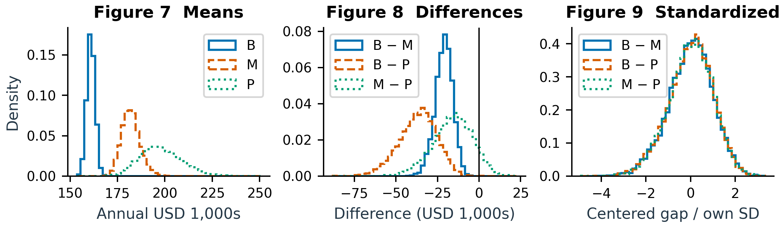
Figures 7–9 show degree means, pairwise differences and standardized differences as probability densities. Each contrast is centered and scaled using its own bootstrap mean and SD. These plots describe uncertainty; they are neither null distributions nor formal post-hoc tests.

Q3(d): ANOVA using bootstrapped data
ANOVA on the three sets of 10,000 unshifted bootstrap means gives F(2, 29,997) = 67,054.3828 and p < 10⁻³⁰⁰ (numerical underflow). It rejects at 0.05, but increasing B adds simulations rather than respondents. As in Q2, this provides no independent confirmation and identifies no significant pair.
The separate null bootstrap shifts each degree group to the combined mean and resamples at the original sizes, preserving within-group variances. One of 10,000 null F* values reaches the observed 17.4966: p = (1 + 1)/10,001 = 0.000200. This approximate test rejects while allowing unequal empirical shapes and variances. Sparse tail counts limit precision, and neither omnibus test identifies which pairs differ. No formal post-hoc tests were performed.

Conclusions and limitations
The analysis tells a consistent but qualified story. Remote respondents earn more at both the mean and median, and US/Canada degree groups differ overall. These comparisons cannot isolate the effects of work mode or education: country, role and experience may also explain the gaps. Self-reported pay, survey selection and uncertain independence further limit generalization. Bootstrapping does not remove these concerns. Eight identical rows remain because respondent identity is unverified, and no overall multiplicity adjustment was applied.

AI-use appendix and references
OpenAI Codex assisted with analysis, drafting and editing; Python and Sites supported the dashboard. Actual prompts included “Create the written report”, “reduce it to 5 page” and “make it natural, and story telling”. This revision checked source consistency and rendered pages. Earlier checks covered notebook execution, manual/library agreement and dashboard behavior. Colab and private/incognito testing remain unverified; student review is still necessary.
Sources: supplied assignment PDF, CSV and executed notebook; SciPy statistical tests; Shalizi, The Bootstrap §5.2.4; official UofT logo source.

