Developer compensation and statistical uncertainty
MIE1624 · Assignment 1 | Julian Peinado · 1012953314
Introduction to Data Science, Analytics, and AI · Fall 2026
Updated October 14, 2026 | Selected-population analysis

Study Population and Sample Selection Criteria
The study aims to examine workforce participation. I exclude explicit retired classifications and recorded ages greater than 80 as researcher-defined scope decisions based on engineering judgment. Age 80 remains eligible. These criteria do not identify data errors or statistical outliers and are distinct from satisfaction cleaning and salary-IQR sensitivity analysis.
The original sample contains 20,407 respondents. Retirement excludes 2; age >80 identifies 93 exclusions; their overlap is 0. Applying retirement first removes 2, then age removes 93, leaving 20,312 respondents. All reported analyses use this selected sample.
Employment has four supplied categories: Employed; Independent contractor, freelancer, or self-employed; Student; and Not employed. Neither Employment nor supplementary activities explicitly labels anyone Retired. Two DevType records do, although both say Employed. I prioritize their explicit retired classification without resolving the underlying inconsistency. Supplementary activities are semicolon-delimited; transitioning to retirement does not establish completed retirement and is retained.
The retained employment counts are Employed: 18,827; Independent contractor, freelancer, or self-employed: 1,106; Student: 321; Not employed: 58. Employment/self-employment or supplementary paid work is reported by 20,312; 0 lack that affirmative indicator. These fields support self-reported indicators, not independent verification of current employment. Students and respondents marked not employed remain because no additional employed-only restriction is imposed.
There are 6 retained respondents aged exactly 80. The 10 missing ages remain in analyses not requiring age, since missingness does not establish age >80; they are omitted from the age plot. The age ceiling therefore cannot be verified for every retained respondent. Findings concern selected salary-reporting respondents, not a verified population of actively employed workers.

Q1 Exploratory data analysis
How does developer pay vary with work arrangement and education? Among the 20,312 selected respondents, remote workers report higher mean and median salaries, while US and Canadian degree groups differ in average pay. The analysis explores how robust these patterns are. Salaries are positive, finite annual USD; the source contains 168 variables.
Within the selected sample, satisfaction analysis excludes 3,428 missing ratings and 1 rating outside the working scale of 0–10. The age plot omits 10 missing ages. Each row has one supplied job category; recorded ages have an unknown cleaning history.
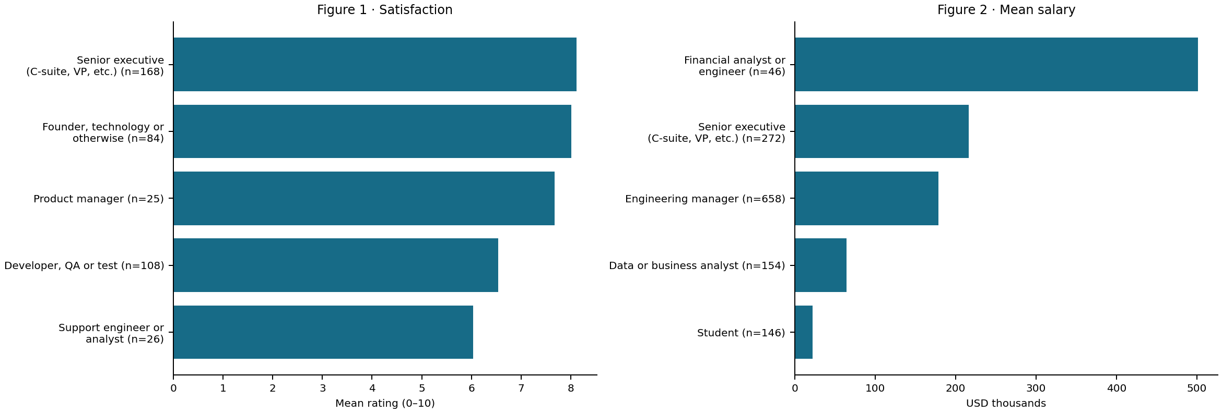
Figures 1–2 show the lowest two and highest three means, with valid counts; the notebook covers all 31 retained titles. Senior executive (C-suite, VP, etc.) has the highest average valid rating (8.12/10, n=168), but the UX, Research Ops or UI design professional category’s valid sample size of 11 makes its ranking unstable. Financial analyst or engineer has the largest mean salary ($501,248.00, n=46), compared with its median of $87,248.50, highlighting the sensitivity of the mean to the upper tail.
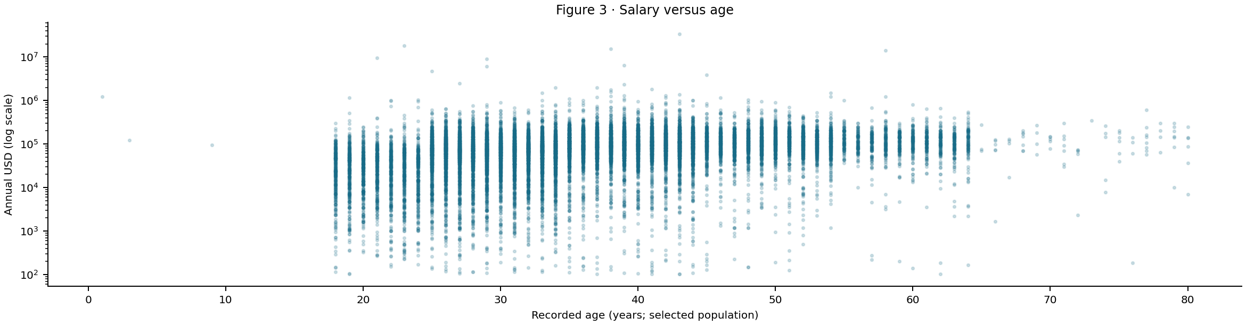
Figure 3 uses a logarithmic salary axis. Salaries span $102.00 to $33,552,715.00 across recorded ages, and 3 ages outside 15–100 signal data-quality concerns that limit interpretation of the apparent age–salary pattern. The population age ceiling applies to all tests; the remaining diagnostic flags cause no additional exclusions.

Q2 Hybrid and remote salaries

Q2(a): Descriptive statistics and outliers
I compare exact labels Remote and Hybrid, excluding 5,648 other selected respondents. All salaries in these groups remain in the primary analysis. Positive Remote − Hybrid differences indicate higher remote pay.
Table 1. Original salaries. SD describes individual salary dispersion; all amounts are USD.
Group | n | Mean | Median | SD
Remote | 6,888 | 118,666.90 | 90,491.00 | 444,251.01
Hybrid | 7,776 | 101,422.99 | 77,730.00 | 346,625.92
The middle half of salaries spans $47,566.00–$150,000.00 for Remote and $47,492.25–$116,015.00 for Hybrid. Minimum values are $102.00 and $104.00.
The largest Hybrid and Remote salaries are $18,387,548.00 and $33,552,715.00, contributing 2.33% and 4.10% of their group salary totals. Size alone does not establish an error, so these remain in the selected population.
A separate sensitivity check uses each group’s Q1 − 1.5×IQR and Q3 + 1.5×IQR fences. Upper limits are $303,651.00 and $218,799.12; both lower limits are negative. It removes 204 and 400, leaving 6,684 and 7,376. Means become $98,554.14 and $79,849.19; the gap is $18,704.95 (pooled p=2.364e-79). These truncated distributions answer a different question; the primary analyses retain salary extremes.

Q2(b): Two-sided pooled t-test
I test H₀: μR − μH = 0 against H₁: μR − μH ≠ 0 at α=0.05. Using n−1, sample variances are 197,358,963,571.47 and 120,149,529,197.14 USD². The pooled calculation is:
$$sₚ² = [(nR - 1)sR² + (nH - 1)sH²] / (nR + nH - 2)$$
$$SE = sₚ√(1/nR + 1/nH); t = (x̄R - x̄H) / SE$$
Here n is group size, x̄ the mean, s² sample variance and sₚ pooled SD. Results are sₚ=$395,494.83 and SE=$6,543.99. SE describes uncertainty in the gap; SD describes variation between individuals.
Table 2. Original-data tests of Remote − Hybrid.
Method | t | df | Two-sided p
Manual pooled | 2.63508 | 14,662 | 0.008421
SciPy pooled | 2.63508 | 14,662 | 0.008421
Welch supplement | 2.59655 | 12,975.28 | 0.009427
Manual and built-in results agree and reject H₀ at 0.05. The $17,243.91 gap is 17.0% of the Hybrid mean, but this test cannot explain why it exists.
Independence is unverified, and skew may weaken normal approximations. The variance ratio is 1.64 (median-centered Levene p=0.01435). Welch’s test allows unequal variances and also rejects. A p-value is not the probability that H₀ is true.

Q2(c): Bootstrap analysis
I resample within each group with replacement, retaining 6,888 Remote and 7,776 Hybrid salaries per draw. There are 10,000 replications, seed 16242026, and separate named NumPy streams. Mean SEs are $5,362.02 and $3,890.15; the difference SE is $6,605.63. These describe estimated means, not individual salary dispersion.
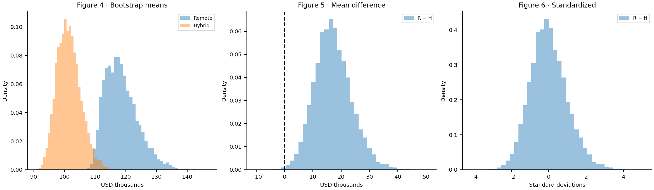
Figures 4–6 move from bootstrap means to Remote − Hybrid differences and standardized differences. Vertical axes show probability density; Figure 5 marks zero. All simulated ranges are retained.
$$Δ^{*} = {x̄}_{R}^{*} - {x̄}_{H}^{*}; z = (Δ^{*} - mean(Δ^{*})) / SD(Δ^{*})$$
Figure 6 subtracts the bootstrap mean and divides by the sample SD, using B − 1. Its mean is therefore zero and its SD one. This standardization helps compare shapes but does not impose or test equal population means.

Q2(d): T-test using bootstrapped data
The required pooled t-test on two arrays of 10,000 unshifted bootstrap means gives t=258.685, df=19,998 and p below floating-point resolution. It rejects, but simulations reuse the same respondents. The nominal SE falls as 1/√B; more replications can reduce p without adding population evidence.
For a separate null test, each group is shifted to the combined mean, preserving shape and variance. Resamples retain original sizes and recalculate the pooled SE. Comparing |T₀*|=|(Δ*−Δ̂)/SE*| with |2.63508| yields 50 extreme draws: p=(50+1)/10,001=0.005099. This rejects under an approximate null calibration; empirical tails and simulation error affect the result.

Q2(e): Confidence intervals for the mean difference
Table 3. 95% intervals for Remote − Hybrid (USD).
Method | Lower | Upper | Width
Pooled t | 4,416.88 | 30,070.95 | 25,654.07
Bootstrap percentile | 5,247.87 | 31,125.76 | 25,877.88
Both intervals exclude zero. The analytical interval is Δ̂ ± t(0.975, 14,662)SE = $17,243.91 ± $12,827.04. The bootstrap interval uses the 2.5th and 97.5th percentiles of unshifted Δ*. Its width differs from the pooled interval by $223.81. Coverage concerns repeated sampling of a fixed parameter, not its probability. Percentile intervals and t-tests need not always agree.

Q2(f): Median comparison
Remote and Hybrid medians are $90,491.00 and $77,730.00, a gap of $12,761.00. Mood’s test counts salaries above versus at/below the pooled median $81,870.00. Ties (11 Remote; 5 Hybrid) go below. With Yates correction, χ²(1)=109.1245, p=1.524e-25, rejecting equal medians.
I bootstrap the median difference 10,000 times at original group sizes. Shifting each group to the pooled median is equivalent to subtracting the observed gap from each simulated gap. There are 0 extreme absolute null gaps; plus-one p=9.999e-05. The 95% Monte Carlo upper bound is 0.0003688. A zero exceedance count identifies the simulation floor, not a precise population tail probability.
The two methods agree on the direction of the result despite measuring evidence differently. Mood’s test uses threshold counts and a chi-square approximation; the bootstrap uses dollar-valued gaps and empirical distributions. Because medians are less sensitive to extremes, this agreement shows that the remote advantage is also present at the center of these samples.

Q3 Education and salary

Q3(a): Population and descriptive statistics
The selected sample includes 5,413 US/Canada respondents. Exact Bachelor’s, Master’s and Professional degree categories leave 4,316. B, M and P abbreviate those categories. Professional is used as supplied, without assuming its qualifications. Other countries and degrees are outside Q3 scope; all eligible salaries remain.
Table 4. US/Canada salaries by degree (USD).
Degree | n | Mean | Median | SD
B | 2,954 | 161,010.57 | 140,000.00 | 114,048.10
M | 1,067 | 183,133.08 | 160,000.00 | 162,860.32
P | 295 | 199,595.75 | 160,000.00 | 196,280.64
The degree-group IQR check flags 151/54/21 salaries, leaving 2,803/1,013/274. Restricted means are $142,251.76/$160,662.59/$160,710.76. Their ordering illustrates tail sensitivity; restricted ANOVA p=9.382e-16. This is separate from population selection.

Q3(b): Original-data ANOVA
For H₀: μB=μM=μP, ordinary ANOVA gives F(2, 4,313)=18.7362, p=7.909e-09, rejecting equality. It does not identify which pairs differ. The exact reference assumes independent normal errors and equal variances. The variance ratio is 2.96 (Levene p=1.626e-05). Welch ANOVA also rejects: F(2, 682.27)=12.9764, p=2.944e-06.

Q3(c): Bootstrap means and pairwise differences
Using 10,000 independent resamples of sizes 2,954/1,067/295 (B/M/P), mean SEs are $2,100.56/$5,000.74/$11,546.91. Separate streams use seed 16242026. Shared group draws preserve contrast dependence. Observed B−M, B−P and M−P gaps are $-22,122.51/$-38,585.18/$-16,462.67.
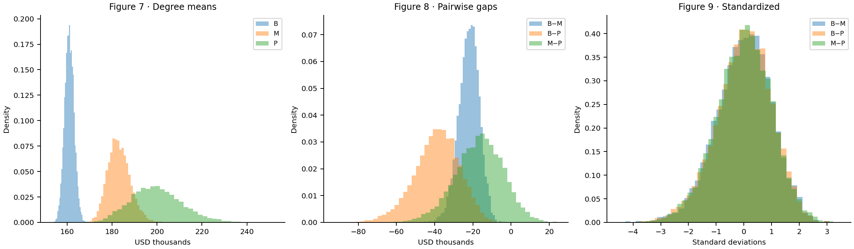
Figures 7–9 show degree means, pairwise differences and standardized differences as probability densities. Each contrast is centered and scaled using its own bootstrap mean and SD. These plots describe uncertainty; they are neither null distributions nor formal post-hoc tests.

Q3(d): ANOVA using bootstrapped data
ANOVA on three sets of 10,000 unshifted bootstrap means gives F(2, 29,997)=69,977.6132, p below floating-point resolution. It rejects, but increasing B adds simulations, not respondents. This provides no independent confirmation or significant pair identification.
The separate null bootstrap shifts each degree group to the combined mean and resamples at original sizes, preserving within-group variances. There are 0 extreme F* values out of 10,000: p=(0+1)/10,001=9.999e-05. This approximate test rejects while allowing unequal empirical shapes and variances. Sparse tail counts limit precision. No formal post-hoc tests were performed.

Conclusions and limitations
Remote respondents have higher mean and median pay, and US/Canada degree groups differ overall. These are associations within the selected salary-reporting sample. Country, role and experience can confound comparisons; survey selection, self-report and uncertain independence limit generalization. The two exclusions do not establish an employed-only population or verify missing ages. Bootstrap resampling cannot repair these limitations. The 8 identical rows remain because respondent identities are unverified. No overall multiplicity correction was applied.

AI-use appendix and references
OpenAI Codex assisted with analysis and report revision. The current request was to exclude retired respondents and ages above 80, rerun all analyses, and document scope and employment limitations. Numerical checks cover selection, manual/library agreement, bootstrap calculations and source integrity. Earlier reports and the published dashboard describe a previous population and are superseded by this report. Colab execution and independent student review remain unverified.
Sources: supplied CSV and executed assignment notebook. Statistical methods follow the SciPy references and Shalizi, The Bootstrap §5.2.4, linked in the notebook.

