

Developer compensation and statistical uncertainty
MIE1624 · Assignment 1 | Julian Peinado · 1012953314
Introduction to Data Science, Analytics, and AI · Fall 2026
Bonus dashboard — interactive charts and results

Q1 Exploratory data analysis
The analysis compares salary by work arrangement and education. The CSV has 20,407 respondents and 168 variables; all salaries are positive, finite annual USD. Higher remote mean and median salaries are associations, not causal effects.
Figure 1 excludes 3,449 missing JobSat ratings and one rating of 60 (working valid scale 0–10). Figure 3 omits 10 missing ages. DevType has one supplied category per row; no multiple-response expansion is imposed. Age is numeric with unknown cleaning history; no age-range midpoints are invented.
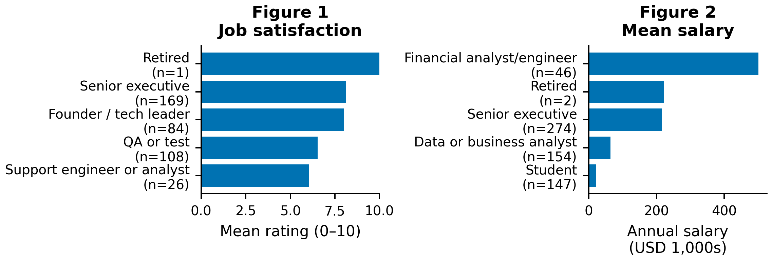
Figures 1–2 show the lowest two and highest three means (all 32 titles in the notebook); labels abbreviate titles and give valid counts. Retired ranks highest in satisfaction (10/10, n=1), an unstable result. Financial analyst/engineer mean salary is $501,248 versus median $87,249, revealing tail influence.
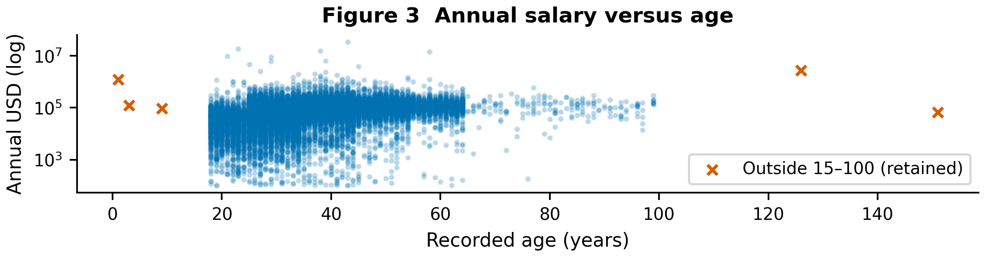
Figure 3 retains all nonmissing ages and salaries, including five ages outside 15–100. The log salary axis displays the full $102–$33.55 million range; anomalous ages limit interpretation. Plot selection and scaling do not remove salaries from inference.

Q2 Hybrid and remote salaries

Q2(a): Descriptive statistics and outliers
Select exact RemoteWork labels “Remote” and “Hybrid”; no categories are consolidated. Exclude the other 5,670 respondents from this comparison. Retain every salary in these two groups in the primary analysis: zero outlier exclusions. All Q2 differences are Remote − Hybrid.
Table 1. Original salaries. SD describes individual salary dispersion; all amounts are USD.
Group | n | Mean | Median | SD
Remote | 6,934 | 118,683.78 | 90,527.50 | 442,809.92
Hybrid | 7,803 | 101,790.28 | 77,730.00 | 347,264.84
The middle 50% spans $47,650–150,000 for Remote and $47,566–116,015 for Hybrid. Minimum salaries are $102 and $104, respectively.
The $18,387,548 hybrid entry is a financial analyst/engineer in Poland; the $33,552,715 remote entry is a full-stack developer in Ukraine. Each accounts for 2.32% and 4.08% of its group’s total salary, respectively. No source record verifies an error: size alone cannot justify deletion. Retention preserves the full-salary mean, while the large SDs disclose its instability.
For sensitivity only, remove salaries outside each group’s Q1 − 1.5×IQR to Q3 + 1.5×IQR fences. Upper fences are $303,525 (Remote) and $218,688.50 (Hybrid); lower fences are negative. This excludes 204 (2.94%) and 403 (5.16%), leaving 6,730 and 7,400. Means become $98,709 and $79,921; the gap is $18,787.84 (pooled p = 2.487×10⁻⁸⁰). The positive association persists, but this comparison targets different, group-truncated distributions; it does not validate the exclusions.

Q2(b): Two-sided pooled t-test
H₀: μR − μH = 0; H₁: μR − μH ≠ 0; α = 0.05. With sample variances calculated using n − 1, sR² = 196,080,623,864.35 and sH² = 120,592,867,982.18 USD². The manual calculation is:
$$sₚ² = [(nR - 1)sR² + (nH - 1)sH²] / (nR + nH - 2)$$
$$SE = sₚ√(1/nR + 1/nH); t = (x̄R - x̄H) / SE$$
Here n is group size, x̄ is the sample mean, s² is sample variance, and sₚ is pooled salary SD. The standard error (SE) measures uncertainty in the estimated gap, not individual salary dispersion: sₚ = $395,108.58 and SE = $6,520.76.
Table 2. Original-data tests of Remote − Hybrid.
Method | t | df | Two-sided p
Manual pooled | 2.59073 | 14,735 | 0.009587
SciPy pooled | 2.59073 | 14,735 | 0.009587
Welch supplement | 2.55456 | 13,103.88 | 0.01064
The manual and matching built-in results agree to numerical precision. Reject H₀ at 0.05. The $16,893.50 gap is 16.6% of the hybrid mean; practical importance depends on context and uncertainty.
Independence is assumed, not verified. Severe right skew can weaken normal approximations despite large groups. The variance ratio is 1.63 (median-centered Levene p = 0.01654), making equal population variances questionable. Welch’s unequal-variance test gives the same decision (Table 2). A p-value is the probability of a statistic at least this extreme under H₀ and the model—not the probability that H₀ is true.

Q2(c): Bootstrap analysis
Resample independently with replacement within each observed group, retaining nR = 6,934 and nH = 7,803 draws per replication. Use B = 10,000 and seed 16242026 with separate named NumPy random streams. These distributions describe uncertainty in estimated means, not dispersion of individual salaries. Bootstrap standard errors (SDs of simulated means) are $5,339.19 (Remote) and $3,919.82 (Hybrid); the difference SD is $6,608.75.
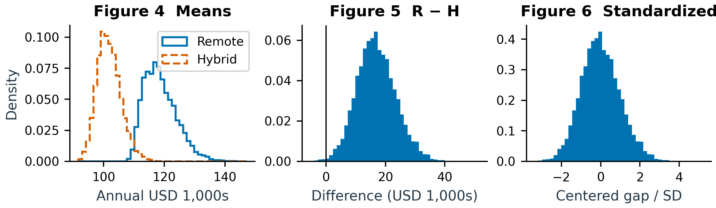
Figures 4–6. Bootstrap means, Remote − Hybrid differences, and standardized differences. All panels show probability density. Figure 5 marks zero; full simulated ranges are retained. The long salary tail remains visible.
$$Δ^{*} = {x̄}_{R}^{*} - {x̄}_{H}^{*}; z = (Δ^{*} - mean(Δ^{*})) / SD(Δ^{*})$$
SD uses B − 1. Figure 6 is centered on the bootstrap mean and scaled to SD one; it is not a distribution generated under the null of equal population means. Centering a plot does not test H₀.

Q2(d): T-test using bootstrapped data
The required pooled t-test receives the two arrays of 10,000 unshifted bootstrap means: t = 255.542, df = 19,998, p < 10⁻³⁰⁰ (numerical underflow). It rejects at 0.05, as in Q2(b). However, these are simulations from the same respondents. Its nominal SE decreases as 1/√B, so increasing replications can make p misleadingly small without adding data. This is not independent population-level confirmation.
A separate null-centered bootstrap shifts each group to the combined mean while retaining its empirical shape and variance. Recalculate the pooled SE in each replication and compare |T₀*| = |(Δ* − Δ̂)/SE*| with |2.59073|. With 69 extreme draws, p = (69 + 1)/(10,000 + 1) = 0.006999. Reject H₀. This is approximate empirical calibration at the original sample sizes, not the t-test on simulated means; tail shape and Monte Carlo error explain differing p-values.

Q2(e): Confidence intervals for the mean difference
Table 3. 95% intervals for Remote − Hybrid (USD).
Method | Lower | Upper | Width
Pooled t | 4,112.00 | 29,675.01 | 25,563.01
Bootstrap percentile | 4,678.28 | 30,680.25 | 26,001.97
The analytical interval is Δ̂ ± t₀.₉₇₅,₁₄₇₃₅SE = $16,893.50 ± $12,781.51. The percentile interval uses the 2.5th and 97.5th percentiles of unshifted Δ*. Both exclude zero; the bootstrap interval is $438.96 wider and asymmetric about the observed gap. Skewness and empirical versus pooled variance estimates explain differences. Under repeated sampling and the respective assumptions, these procedures aim for 95% coverage of the fixed population gap; this is not a 95% probability assigned to that fixed parameter. Percentile intervals and t-tests need not always agree.

Q2(f): Median comparison
Remote median = $90,527.50; Hybrid = $77,730.00; difference = $12,797.50. Mood’s test classifies observations above versus at/below the pooled median of $81,912. The one Remote tie and zero Hybrid ties are assigned below; Yates correction is enabled. χ²(1) = 109.2991, p = 1.396×10⁻²⁵: reject equal medians at 0.05 under the test assumptions.
For the separate median bootstrap, independently resample each group at its original size 10,000 times. Shift each empirical group so its median equals the pooled median; equivalently, subtract the observed median difference from each bootstrap median difference. Count absolute null gaps at least $12,797.50: zero exceedances. The plus-one estimate is 1/10,001 = 0.000100, the simulation floor, not a precise tail probability (95% Monte Carlo upper bound 0.000369). Reject H₀ under this approximate equal-median shift model.
Mood uses threshold counts and a chi-square approximation; the bootstrap uses dollar-valued median gaps and empirical distributions. Their p-values need not agree. Both find a higher remote median here. Medians downweight salary extremes, so median and mean conclusions can differ in heavy-tailed data.

Q3 Education and salary

Q3(a): Population and descriptive statistics
First restrict Country to “United States of America” or “Canada” (5,468 rows); then select exact EdLevel labels “Bachelor’s degree”, “Master’s degree”, and “Professional degree” (4,363 rows). B, M and P below abbreviate those supplied categories; no unprovided composition is inferred for Professional. Other countries and degrees are outside scope. No salaries are removed from the primary Q3 analysis.
Table 4. US/Canada salaries by degree (USD).
Degree | n | Mean | Median | SD
B | 2,978 | 160,987.60 | 140,000 | 113,742.42
M | 1,084 | 182,220.48 | 157,000 | 161,910.83
P | 301 | 197,700.96 | 160,000 | 194,866.38
Q1–Q3 ranges are $100,000–190,000 (B), $110,750–215,000 (M), and $108,000–217,000 (P); maxima are $1.95m, $3.90m and $2.346m. Retain extremes for the same reason as Q2(a). Separate 1.5×IQR filtering flags 151/54/21, leaving 2,827/1,030/280 and means $142,387/$160,073/$159,507. The M–P ordering reverses, showing tail sensitivity; ordinary ANOVA remains significant (p = 1.365×10⁻¹⁴).

Q3(b): Original-data ANOVA
H₀: μB = μM = μP; H₁: at least one mean differs. Ordinary ANOVA gives F(2, 4,360) = 17.4966, p = 2.702×10⁻⁸: reject H₀ at 0.05. This does not establish that every pair differs. Independence, equal variances and normal errors support the exact F reference. Here skew, unequal sizes and variance ratio 2.94 (Levene p = 1.987×10⁻⁵) warrant caution. Supplementary Welch ANOVA gives F(2, 696.68) = 12.2065, p = 6.160×10⁻⁶, also rejecting H₀.

Q3(c): Bootstrap means and pairwise differences
Use 10,000 independent within-degree resamples of sizes 2,978 (B), 1,084 (M) and 301 (P), with separate streams from seed 16242026. Bootstrap standard errors (SDs of simulated means) are $2,113.64/$4,880.18/$11,188.00. Reuse group draws for the three contrasts, preserving their dependence. Observed B − M, B − P and M − P gaps are −$21,232.87, −$36,713.36 and −$15,480.48.
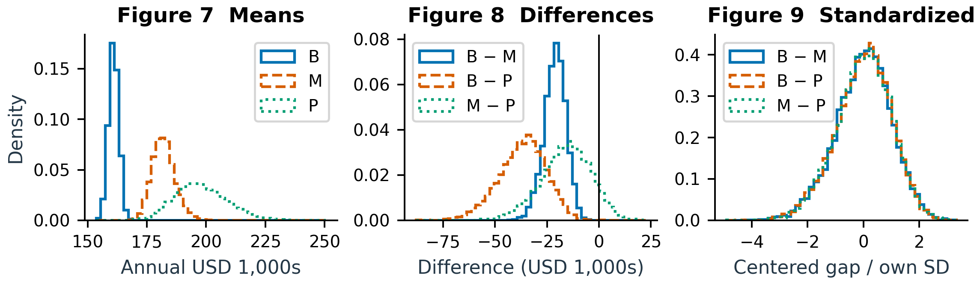
Figures 7–9. Degree means, directed pairwise gaps, and standardized gaps; all vertical axes show probability density. Each contrast uses its own bootstrap mean and SD, as in Q2(c). Centered distributions are not null distributions or post-hoc tests.

Q3(d): ANOVA using bootstrapped data
The required ANOVA on three arrays of 10,000 unshifted bootstrap means gives F(2, 29,997) = 67,054.3828, p < 10⁻³⁰⁰ (numerical underflow). It rejects at 0.05, like Q3(b), but its magnitude depends on B: simulated means are not additional respondents. It provides no independent confirmation and identifies no significant pair.
Separately shift every degree group to the common combined mean and bootstrap at original group sizes, preserving within-group variances. Compare each null F* with the observed F = 17.4966. One of 10,000 draws is as large: p = (1 + 1)/10,001 = 0.000200; reject. This approximate null calibration preserves unequal empirical shapes and variances, unlike the classical F reference. Sparse tail counts limit precision; neither test establishes which pairs differ, and no formal post-hoc tests are claimed.

Conclusions and limitations
Remote salaries are higher in mean and median; US/Canada degree means differ overall. Self-reported compensation, survey selection, uncertain independence, and country, role and experience differences limit generalization and causal interpretation. Bootstrapping does not remove these limitations. Eight identical rows remain because respondent identity is unverified. No overall multiplicity adjustment is applied.

AI-use appendix and references
OpenAI Codex assisted with analysis, writing and revision; Python and the Sites plugin built the aggregate-only dashboard. Actual prompts included “reduce it to 5 page”, “Build Question 4” and “please de-bug”. Checks covered notebook execution, manual/library agreement, source hashes, nine figures, browser controls and desktop/mobile rendering. Public access was checked without login; private/incognito mode was unavailable. Colab has not been run; student review remains necessary.
Sources: supplied assignment PDF, CSV and executed notebook; SciPy statistical tests; Shalizi, The Bootstrap §5.2.4; official UofT logo source.

