Creating a Route

‘My Maps’ by Google
Go to: https://mymaps.google.com/
Log in to iastate or other gmail account
Click on ‘Create A New Map’ button
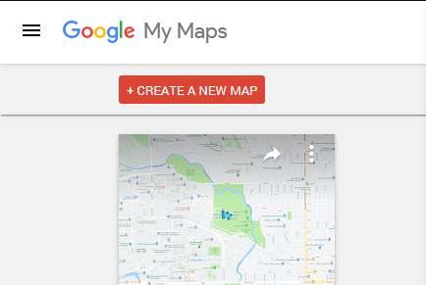

Adding Waypoints
Use the toolbar at the top to perform various functions on the map
The most important function will be placing waypoints (highlighted button in picture)
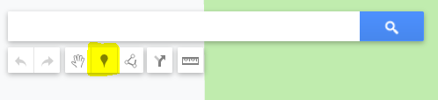
A practically infinite number of these waypoints may be added to the map (~1000)

Downloading Map Data
Once you have finished adding waypoints your map should look something like this
(Interconnection lines and shaded region not necessary)
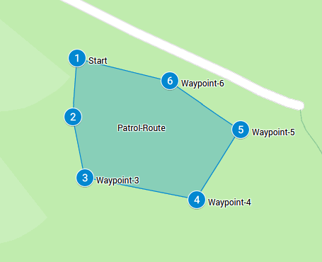
From here click on the three vertical dots to the right of the map title
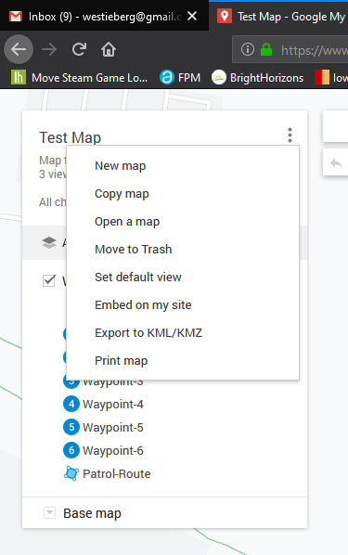
Select option to ‘Export to KML/KMZ’
Choose to only export the waypoints and make sure to select the checkbox to export as KML
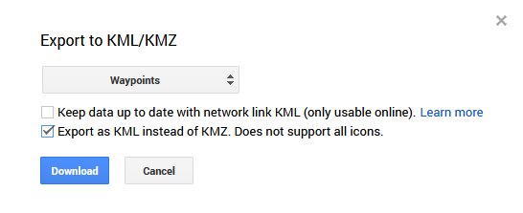
KMZ is essentially the compressed version of a KML file and not useful for us

Convert Map Data
Use the ‘kml_conversion.py’ script to convert the KML data into a usable format for the robot
Example script usage for converting KML data
To CSV: python kml_conversion.py -c kml_data_file.kml outfile
To JSON: python kml_conversion.py -j kml_data_file.kml outfile
To XML: python kml_conversion.py -x kml_data_file.kml outfile

Transfer To Robot
The last step is to get the converted data onto the robot
This can be accomplished easily with tools like SCP/WinSCP
Make sure to copy the file generated by the script to: /path/to/coordinate/data

Done!

