Data Visualisation II

Jerome Piahana

URL: <https://jcpia1.github.io/FIT3139_Data_Vis_2/>

Word Count:1,107

## Domain, Why and Who:

The domain selected for this visualisation is the analysis of bushfires in Australia, and the amount of land they have burned from 1899-2022. Bushfires have been a significant concern in Australia due to their frequency, intensity, and the vast areas they affect. This visualisation targets the general Australian public, aiming to provide insight into the distribution, frequency, and severity of these fires across different states.

## What:

The dataset used for this visualisation is sourced from Digital Atlas Australia, an initiative of the Australian Government. Specifically, it is the "Historical Bushfire Boundaries" dataset, curated by Geoscience Australia (GA) as part of the Australian Research Data Commons (ARDC) Bushfire Data Challenge Project. This initiative was a collaborative partnership between the ARDC, Geoscience Australia, and the Emergency Management Spatial Information Network, aiming to harmonise and present a nationally consistent historical bushfire boundary data derived from various authoritative state and territory agencies.

Key highlights of the dataset:

* Represents historical bushfire boundaries, covering both bushfires and prescribed burns, from the early 1899 to 2022.
* Each state's data attributes have been modified by Geoscience Australia to ensure the dataset adhered with the nationally approved data dictionary for fire history.
* Data collection is reflective of the information provided by participating state agencies, and it might not encapsulate the entire fire history within a state.
* Notably, the Northern Australia Fire Information (NAFI) data is intentionally excluded from this dataset, and there wasn’t any other data available for the Northern Territory, hence, it couldn’t be included in the visualisation.

## Why and How:

**Chloropleth Map**: The core of the visualisation is a choropleth map of Australia, which provides a geographical representation of data across states. It offers an instant visual cue about the amount of land (in hectares) was burned by bush fires in each period.

Colourbrewer2.org was used to choose the legend colours. The ‘5-Class Reds’ theme was chosen because it is intuitive for fire to be associated with the colour red. The 5 classes of red were chosen to ensure there would be enough colour range to show differences between data which was similar, but not so large that the darkest red colour would become aesthetically unappealing.

The base map was made to be a cool, pastel blue/green to contrast the red marks of states which did have data.

Black stroke marks were applied to the state boundaries to really contrast it from the white background of the visualisation, giving it an animated look and making it more appealing to look at.

**Interactive Slider**: An interactive slider allows users to filter data between specific years, providing a temporal dimension to the analysis. Users can track the progression or regression of bushfires over time.



The red was chosen to be the same colour as the maximum value of the choropleth map legend, and the background was chosen to neutral colours so that it blends into the background, pushing the slider into the foreground.

**Donut Charts**: Four donut charts complement the map by offering statistical breakdowns. These charts provide visual proportionality that the choropleth cannot.

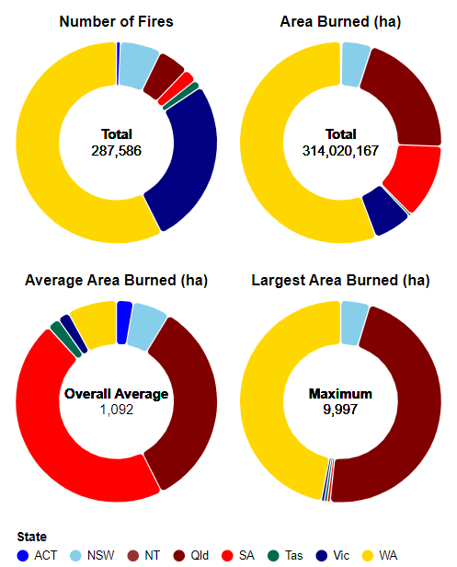

The colours were chosen to be the official colour of each state.

Values in the middle of each donut provide a total of the statistic being presented, which is the nationwide value.

Padding and rounding the corners between arcs was applied to better show separation between arcs. Arc outlines (stroke) was omitted because it would make smaller arcs harder to read.

A checkbox was included to set the arc angles to equal. The point of this is to allow the user to hover over the state and read the values via a tooltip.

**List of Top 5 Bushfires**: This list serves to highlight the most devastating bushfires in order of total land burned, helping users grasp the severity of certain incidents. The intention of this was for the user to be able to set the range slider to the years shown in the list and see how the area burned in compared to the rest of the states over that time period, however this is not currently possible due to the dataset being incomplete.

## Design

**Layout**: The layout is structured with the choropleth map as the central focus because it is the largest and most visually appealing visualisation, immediately drawing the users’ eyes to the centre. The donut chart to the right, where more detailed statistics are shown. Text is placed on the left because it is natural to justify text to the left, and that would both align it to the left border and provide more whitespace around the choropleth map in the centre. The slider spans the length of the header so that it is aesthetically pleasing and provides the user more precise control. Legends span their respective visualisations and are aligned with each other. The layout is made horizontally symmetrical, and elements are aligned with each other as best as possible.

**Colour**: Red colours are chosen to represent the intensity of bushfires, with a gradient indicating the severity. The consistent application of these colours across the whole visualisation ensures coherence and is aesthetically appealing. The use of neutral colour for the slider and the white background pushes the text and visualisations into the foreground and provide a sense of space around them.

**Figure-ground:** The primary data, represented by the choropleth map, stands out prominently against a neutral background, with the pastel blue/green base map contrasting sharply against the fiery reds of the bushfire data. The black strokes outlining state boundaries against the white background further enhance this relationship, imparting an animated quality to the map.

The donut charts and textual data are distinctly set against the backdrop, with the state colours in the donut charts emphasizing the data. Interactive elements, like the slider, are designed in neutral colours to blend with the background while remaining easily interactable, ensuring they support rather than overshadow the primary data.

**Typography**: Whilst the typefaces used aren’t inherently bad for this visualisation, they could be improved by using consistent font usage across all elements, from map labels to legends, which can unify the design. Additionally, colour contrast considerations can ensure textual elements remain both readable and aesthetically harmonious.

**Storytelling**: The combined elements of the map, charts, and list weave a narrative about bushfires in Australia. Annotations and interactive elements further guide the user through the visualisation, enabling a comprehensive understanding. The list of top 5 bush fires, along with their period and amount of land burned, encourages users to interact with the slider to dig deeper.

## References:

[1] Digital Atlas Australia, "Historical Bushfire Boundaries," Digital Atlas Australia, [Online]. Available: https://digital.atlas.gov.au/datasets/digitalatlas::historical-bushfire-boundaries-2/about. [Accessed: 18-10-2023].