URL: [**https://jcpia1.github.io/HW_Week10/**](https://jcpia1.github.io/HW_Week10/)

Screenshot:

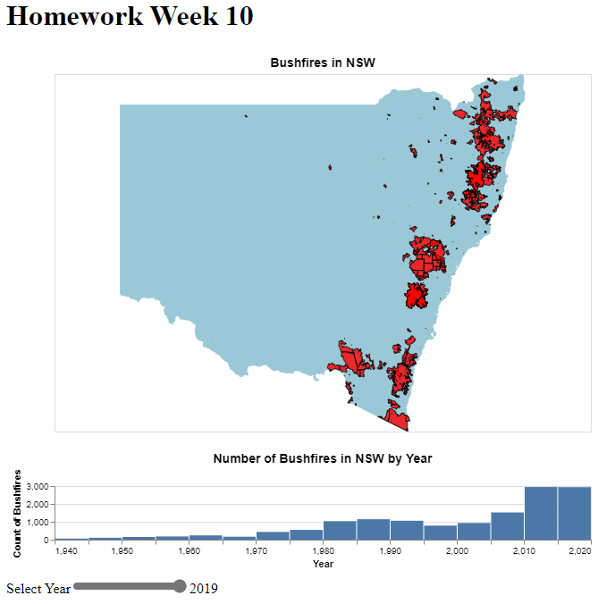

Domain:

* Bushfires in NSW, Australia over the last 80 years.

Dataset:

* University of New South Wales. (2023). 100 Years of Bushfires in Australia. <https://100-yearsof-bushfire-unsw-au.opendata.arcgis.com/>

Justification:

* The dataset I chose had the geography of the boundaries of the bushfires. The addition of the bar graph to show the count of the bushfires per year, and the slider clears up the map, showing only bushfires of the selected year.