Check no graphical interface
1. Verify that no graphical interface is in use.We will use the command:

systemctl get-default

Si devuelve multi-user.target, es solo consola
Si devuelve graphical.target, está preparado para entorno gráfico.

Check UFW
1. Check that the UFW service is in use:

sudo ufw status

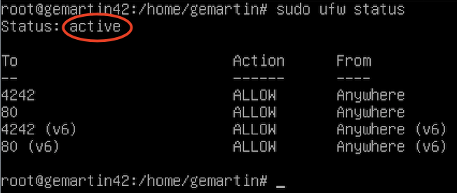

sudo service ufw status

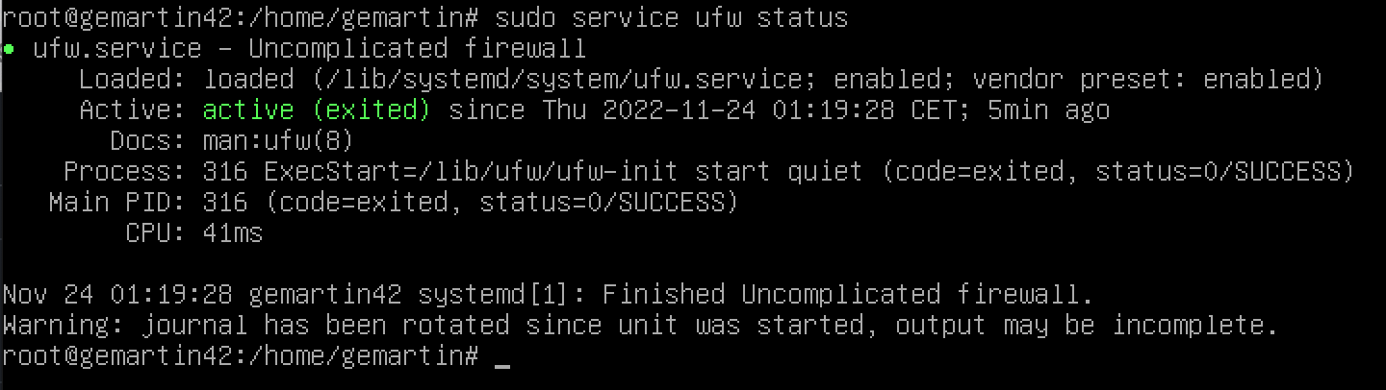

Check SSH service
1. Check that the SSH service is in use.

sudo service ssh status

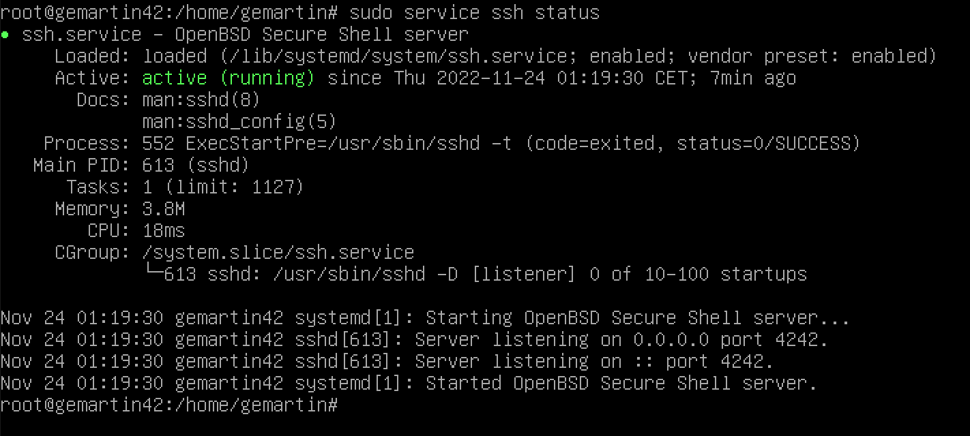

Check OS
1. Check that you are using the Debian or Centos operating system.

Uname -a

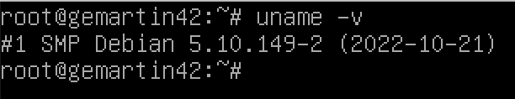
Check user and group
1. Check that your user is within the "sudo" and "user42" groups.

Comprobar sudo user
getent group sudo jceraval42
getent group sudo user42

comprobar group
getent group jceraval42
getent group user42

nombre
del grupo SUDO Contrasena encriptada Num identificador usuario

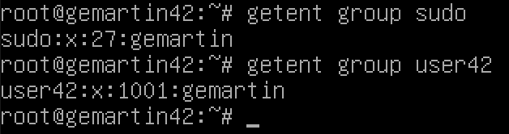
clear
Igual para los grupos

Add user and check password policy
1. Create a new user and show that it follows the password policy we have created.

sudo adduser name_user

and enter a password that follows the policy.
Pedira un password de mas de 10 caracteres Abuelo2025

Check group creation
1. We create a new group named "evaluating".

sudo addgroup evaluating

Check adding to group
1. We add the new user to the new group.

sudo adduser name_user evaluating

Check hostname
1. Check that the machine's hostname is correct login42.

Hostname

Check change hostname

1. Modify hostname to replace your login with the evaluator's. In this case, we will replace it with student42.

sudo nano /etc/hostname

and replace our login with the new one.

sudo nano etc/hosts
and replace our login with the new one
Los nombres de hostname deben estar iguales en host o no W

Finally reboot the machine.
sudo reboot

and check with this command:
hostname

Borrar un usuario y borar el usuario de SUDO

Borrar usuario del sudo
sudo deluser usuario sudo comprobar borrado con getent group sudo
borrar usuario
sudo deluser --remove-home nombre_usuario comprobar no existe: id Nombre_usuario

borrar grupo
sudo groupdel name_group comprobar con getent group name_group (no returno)

Check all partitions
1. Check that all partitions are as indicated in the subject.
lsblk

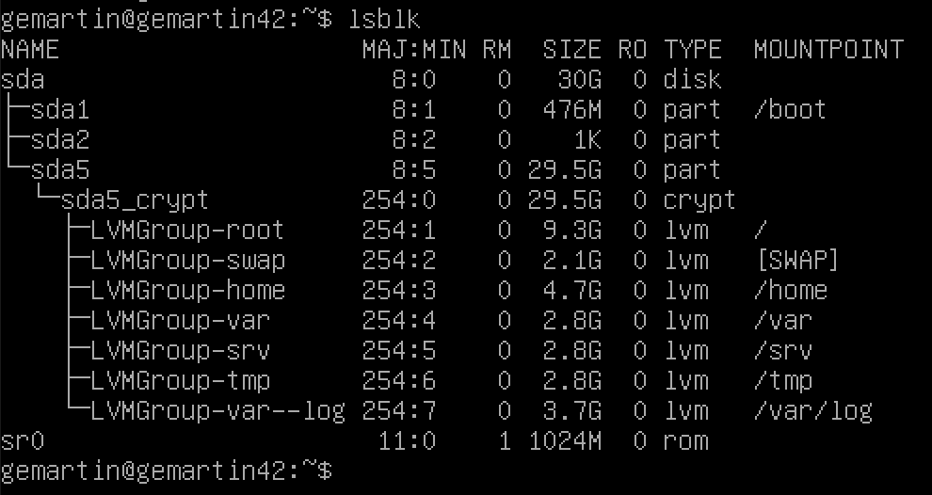

Check sudo
1. Check that sudo is installed.

which sudo

Devuelve la ruta de sudo /usr/bin/sudo

Check add user to sudo group
1. Add the new user to the sudo group.

sudo adduser name_user sudo

We check that it is within the group.(es el usuarioent group sudoque hemos anadido antes)

getent group sudo

Check sudo rules
1. Show the application of the rules imposed for sudo by the subject.

nano /etc/sudoers.d/sudo_config

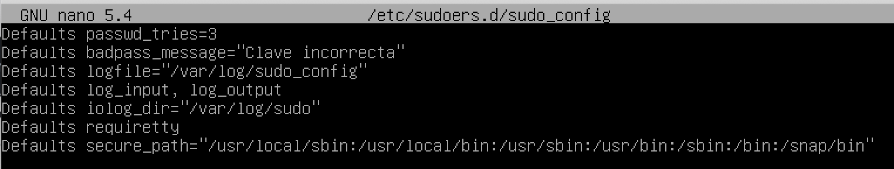
Check sudo logs
1. Show that the path /var/log/sudo/ exists and contains at least one file, in this we should see a history of the commands used with sudo.

sudo -i o sudo su Vamos al root que si tiene permisos para acceder a los logs de sudo

Los logs de sudo, estan protejidos por ello debemos de acceder desde el root.

cd /var/log/sudo

ls
cat sudo.log

Check UFW advanced
1. Check that the UFW program is installed on the virtual machine and check that it works correctly.

dpkg -s ufw

dpkg: Es la herramienta de gestión de paquetes de bajo nivel para sistemas Debian y derivados

-s : status

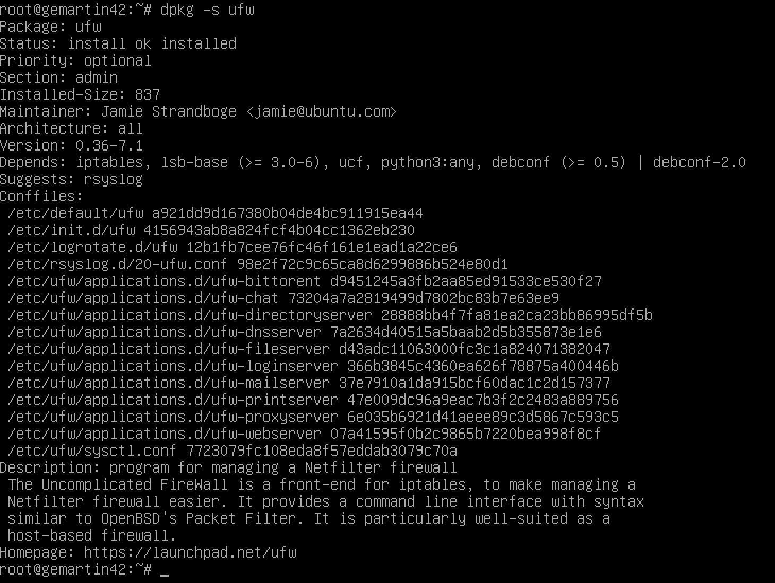
sudo service ufw status
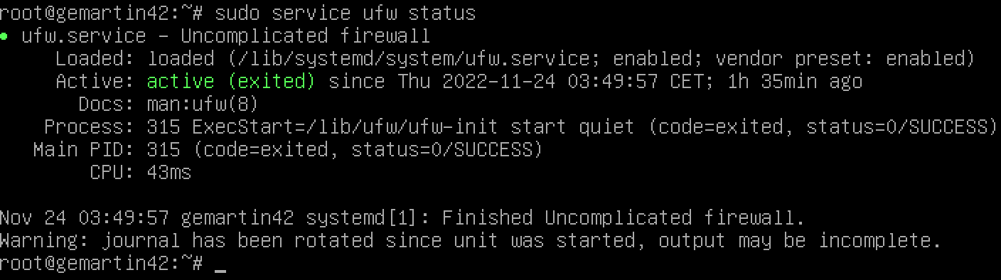
Check UFW active rules

1. List the active rules in UFW, if the bonus part is not done, the rule for port 4241 should only appear.

sudo ufw status numbered

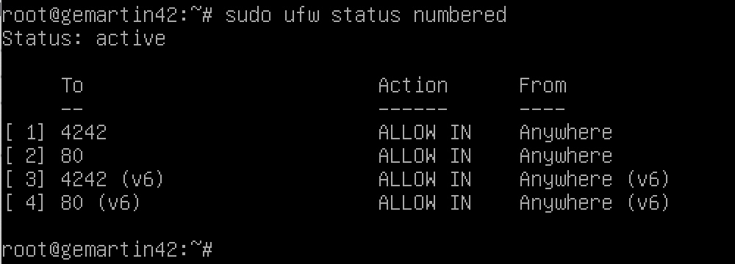
Check rule creation

1. Create a new rule for port 8080. Verify that it has been added to the active rules and then you can delete it.

sudo ufw allow 8080

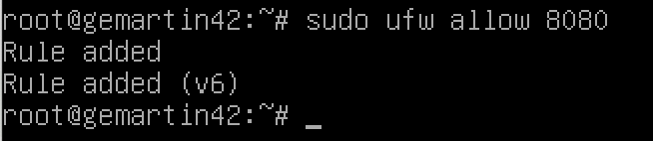
sudo ufw status numbered

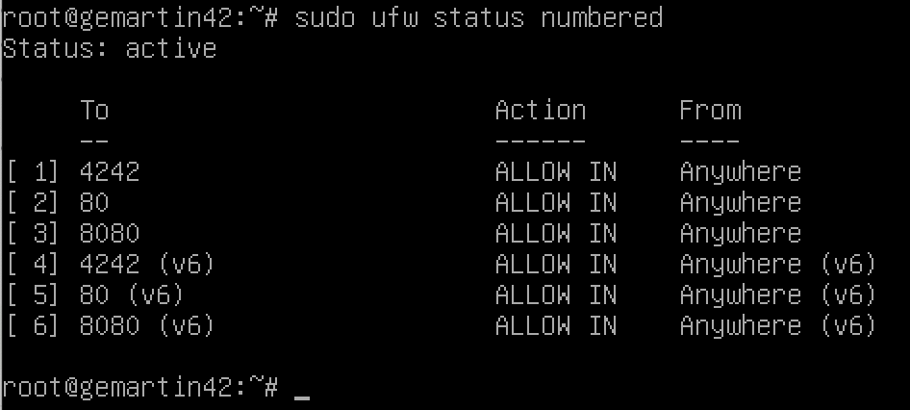
To delete the rule, we must use the command:

sudo ufw delete num_rule

We check that it has been deleted

sudo ufw status numbered

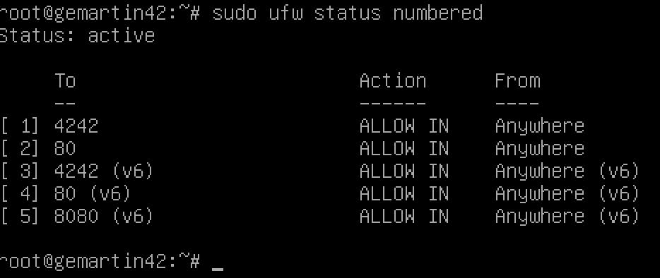

and we see the number of the next rule that needs to be deleted..

Delete the new rule.

sudo ufw delete 5

We check that only the required rules in the subject remain:

sudo ufw status numbered

Check SSH advanced

1. Check that the ssh service is installed on the virtual machine, that it works correctly, and that it only works on port 4242.
To see if ssh is present:

which ssh

To see if is running:

sudo service ssh status

Check SSH usage
1. Use ssh to log in with the newly created user. Make sure that you cannot use ssh with the root user.
We try to connect over ssh with the root user but we do not have permission. To avoid force atacks

ssh root@localhost -p 4241

We connect via ssh with the new user using the command:

ssh jceraval@localhost -p 4243
passwd Born2beroot

Check crontab of script

1. Modify the runtime of the script from 10 minutes to 1.
We run the following command to modify the crontab file:

sudo crontab -u root -e

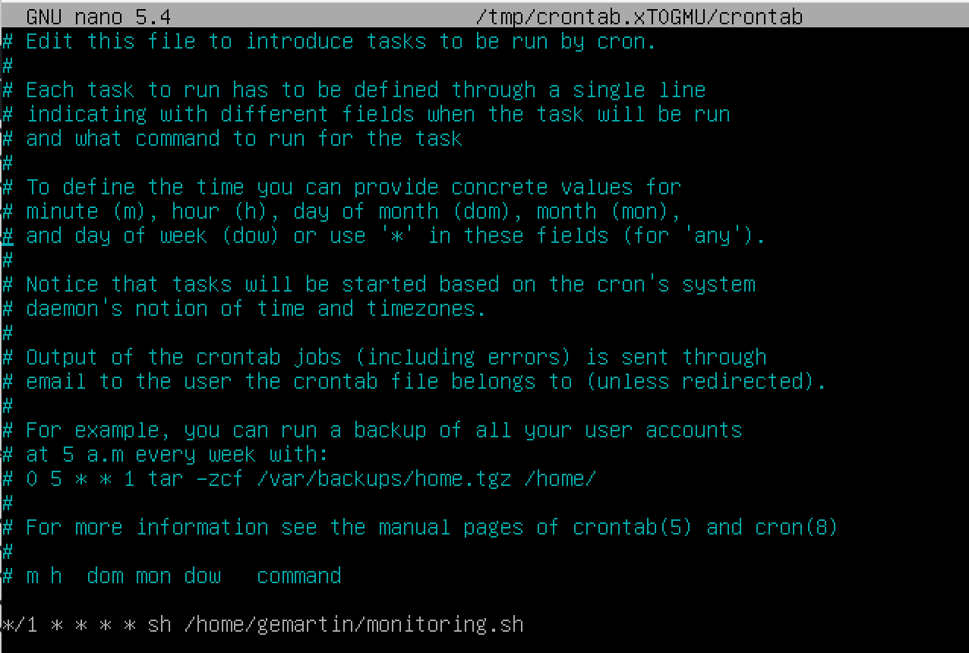

We modify the first parameter, instead of 10 we change it to 1.

ruta a monitoring.sh

/usr/local/bin/monitoring.sh

