Much current music composition, and technology scholarship is being pigeonholed into a STEM paradigm. Although I have suspicions about why this is, I lack the space to give this theory its full treatment here. There seems to be a stigma against exploring thoroughly the “less scientific” aspects.
First there is a stimulus or stimuli. In this document, the stimuli of VR, dreams, psychedelic drugs, and music have been explored. As soon as this material is perceived by the audience, precognitive pattern recognition takes place. This is the stage of perception that precedes conscious thought. It is the animal brain component of every human that would have allowed us to see patterns in the foliage so that we would quickly recognize a lurking predator breaking up the pattern. It is also the aural animal brain component that would have brought our attention to disruptions in ambient environmental noise to alert us to the sound of the same predator stepping on a twig. Once “pattern” and “non-pattern” are precognitively established, the sense data goes through one or more relating circuits. This stage resides somewhere between precognition and conscious thought. It is to some degree influenced by training, and to some degree inbuilt. It is the grey area between the animal brain and conscious thought. The research of Claude Lévi-Strauss suggests that in the domain of music, there are three main types of relating circuits; code, message, and myth (Lévi-Strauss 1969, 30).
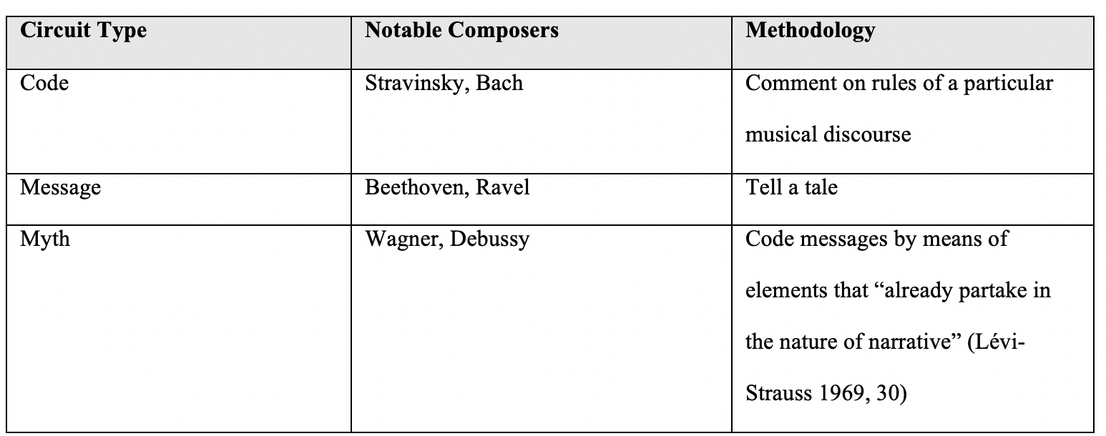
Although Lévi-Strauss categorized these composers separately, those familiar with their works can see that these delineations are not clear-cut. Beethoven’s primary focus may have been on telling messages through music, but archetypal elements are clearly perceived in many of his works. One such example would be the invocation of the “hero” archetype in his Symphony No. 3 in E major, Op. 55. Another example can be easily seen in the work of Bach. Undoubtedly Bach’s main focus was pushing the norms of Baroque era composition to their absolute limits. However, one would be foolish to deny the presence of archetype in the listener’s mind when experiencing a performance of St. Matthew Passion. Therefore, multiple relating circuits may be at play in the listener’s mind, but myth, i.e. archetypal story, is so inbuilt as a function of culture that it is always at play wittingly or unwittingly. The final theoretical section of this document will focus on the components that make up a myth, provide a framework for how post-modal artists can use the concept as a framework for creating pieces in any medium.

