Name: Sean Lee

Github Username: jcpssean

Purdue Username: 0033038684

Instructor: Ghasemi

Problem1_writeup

**Estimated Functions:**











**Data Visualization:**

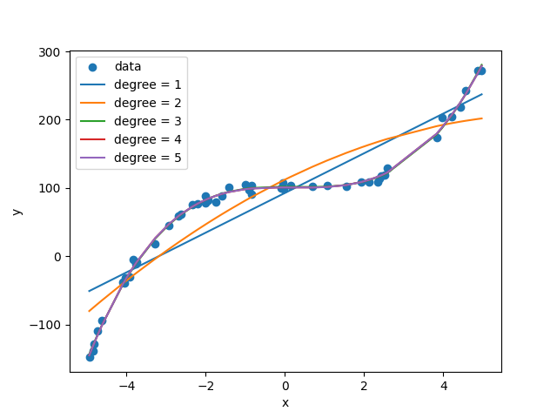

The first and second order polynomials seems to be quite off the data. However, starting from degree = 3, the polynomials have fitted quite well. Therefore, they are pretty much overlapped. In my opinion, I believe the third order polynomial would be a better fit. Although the higher order polynomials may seem to be fitting the data better, but there may be some kind of over fitting occur for the higher order polynomials.

If we measured a new data point, x = 2, the corresponding predicted value would be 