Name: Sean Lee

Github Username: jcpssean

Purdue Username: 0033038684

Instructor: Ghasemi

Problem2_writeup

**Finding best Lambda:**

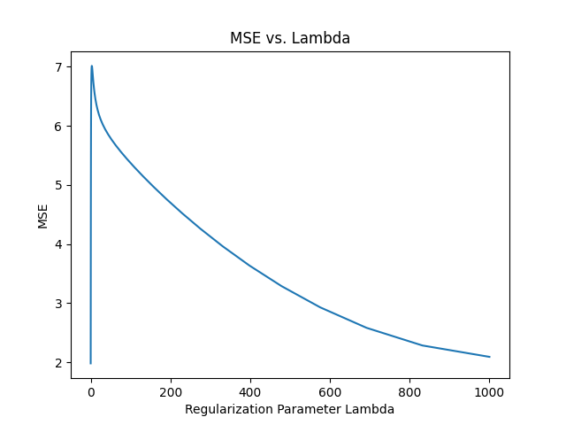

Based on the range of Lambda values tested, the best lambda value is 0.1, which yields an MSE of 1.981514407520046 as shown on the plot above.

**Equation of best fitted model:**



**Sample prediction plot of Google data:**

