**FIRST DRAFT**

# Effects of growth and recruitment assumptions in the status and management advice of the Chilean yellow lobster squat, *Cervimunida johni.*

**Autores:**

T. Mariella, Canalesa

Juan, Carlos, Quirozb

Rodrigo, Wiffa

Dante, Queiroloc

Doris, Bucareyb.

*aCenter of Applied Ecology and Sustainability (CAPES), Pontificia Universidad Católica de Chile, Av. Alameda 340, Santiago, Chile. Email:* [*mariella.canales@gmail.com*](mailto:mariella.canales@gmail.com)*.*

*bInstituto de Fomento Pesquero, Departamento de Evaluación de Recursos, Blanco 839, Valparaíso, Chile*. [juancarlos.quiroz@ifop.cl](mailto:juancarlos.quiroz@ifop.cl), [doris.bucarey@ifop.cl](mailto:doris.bucarey@ifop.cl)

*cEscuela de Ciencias del Mar, Pontificia Universidad Católica de Valparaíso, PO Box 1020, Valparaíso, Chile.* [dante.queirolo@pucv.cl](mailto:dante.queirolo@pucv.cl)

*Corresponding author phone: +1(760) 944 7103,

*E-mail address: [mariella.canales@](mailto:mariella.canales@ifop.cl)gmail.com (T. Mariella Canales)

**Abstract**

**Keywords:**

# 1. Introduction

The crustacean fisheries off central south Chile date back to 1953 when the species yellow squat lobster (*Cervimunida johni*) and red squat lobster (*Pleuroncodes monodon*) began to be exploited. Since 1972 landings of both species started to differentiate and the maximum landings (10.322 tones) of yellow squat lobster was registered in 1997 (Canales and Arana, 2012). The yellow squat lobster was divided in two fisheries units in 1996 that nowadays correspond to 26º03’LS - 30º30’LS (North Unit) and 30º30’LS -38º48’LS (South Unit) (Bucarey et al. 2015; Canales and Arana, 2012). This work is developed for the North fishery unit of the Chilean yellow squat lobster.

The current fishery management of the squat lobster fisheries in Chile is based on the total allowed catch (TAC) system. Decisions about catch level are based on the status of the squat lobsters referred to the current level of spawning biomass that allow the stock to be near or around the maximum sustainable yield (MSY) (Bucarey et al. 2015). To estimate the spawning biomass a single-species stock assessment model is used. The model corresponds to an integrated age-structure model (Maunder and Punt 2013) that encompasses multiple data types to reveal the population dynamics and estimate both model parameters and derived population and management outputs. However, because in crustacean species age assignation is difficult, length composition data is used to fit the model.

Maunder and Piner (2015) discussed that critical biological and fisheries processes such as growth, natural mortality, recruitment, and selectivity are still issues that remain unsolved in stock assessment models, and without this knowledge, assumptions need to be made. However incorrect assumptions can have a substantial impact on stock assessment results and management advice. For instance, Aires-da-Silva et al. (2015) showed that the estimated depletion level (ratio of the spawning biomass) and fishing mortality rates were highly sensitive to the assumed value of $L_{∞}$ as well as the variability of length-at-age.

In the Chilean yellow squat lobster stock assessment model, two important population process, individual growth and recruitment, carried important assumptions. The mean length-at age in the growth process follows the von Bertalanffy function with parameters *k* and $L_{∞}$ assumed fixed and obtained from external studies. The mean length at the first age (L1) as well as the coefficient of variation of the mean length at age (VLA) are estimated in the model in order to fit the length composition data that is converted to age through a simulated length-at-age key. The recruitment process is modelled with underlying the assumption that a Beverton and Holt (BH) stock-recruitment relationship exist with a steepness value of *h*=1. The assumption is based in the lack of reliability of the Chilean yellow squat lobster data to estimate the BH stock recruitment relationship (Paya et al. 2014). Thus, the recruitment is modelled through annual random deviations that follows a lognormal distribution with a variance that is assumed fixed, while the averaged recruitment and annual deviations are parameters to be estimated.

Here, we aim to investigate the impact of the assumptions of growth and recruitment process in the stock assessment results and management advice indicators of the Chilean yellow squat lobster fishery. We used the stock assessment models developed for the Chilean squat lobster fisheries (Bucarey et al. 2015) to carry a sensitivity analysis of different scenarios of the L1 and VLA, in combination with scenarios of *h* and the coefficient of variation of the recruitment (CVR). The response of five variables of the stock assessment results were analyzed as well as five used for management advice. Later, a simulation analysis was conducted to assess the precision of the stock assessment model in estimates the parameters that cause the higher variation in the stock assessment results and management advice variables.

# 2. Methods

### *2.1 Yellow squat lobster stock assessment model*

The Chilean yellow squat lobster model assume that in the north part (26°03’-30°30’ LS) of the distribution area of the species there is a closed stock of yellow squat lobster independently of south stock. The assessment covers a period of time from 1985 to 2015 and encompasses the following sources of data, i) official landings, ii) catch per unit effort (CPUE), iii) survey biomass and iv) length composition of the catches and survey. Biological parameters such us, natural mortality, maturity and growth are estimated outside the model. Growth is differentiated by sex, natural mortality is invariant and the vulnerability to the fishing gear and survey is invariant and follows a logistic function. The observation model of the landings, CPUE, and biomass survey assume a lognormal distribution of the error and the length composition of the catches and survey assume a multinomial distribution. The parameters are estimated by the minimization of the sum of the negative log-likelihood of each time series. The yellow squat lobster model is implemented in a computational routine in the software AD Model Builder for non-lineal statistical models (<http://admb-project.org/)>. Although the stock assessment model of the yellow squat lobster is available at [www.ifop.cl](http://www.ifop.cl). we present in the Appendix section a summary of the mathematical description of the stock assessment model.

### *2.2 Performance measures*

To measures the impact of the effect of the assumptions of growth and recruitment in the stock assessment result and management advice indicators the following variable were used. Total biomass in the last year (*TB*), spawning biomass in the last year (*SB*), averaged recruitment ($\overline{R}$), yield at the target referent point ($Y_{MSY}$), virginal spawning biomass (*BDo*). We also analyzed the effect in the following MA indicators, the ratio between the last year yield (Y) and yield at the target reference point ($Y/{Y_{MSY}}$), the ratio of last year of the fishing mortality (F) and the target fishing mortality ($F/{F_{MSY}}$), the spawning biomass of the last year (*SB*), and the virginal spawning biomass ${SB}/{{SB}_{o}}$, the fishing mortality of the last year (*F)* and target fishing mortality ($F_{MSY})$. All the measures were standardized with regarding to the Base scenario, this means all the SAR and MAI variables were divided their values in Base scenario in order to be comparable.

### *2.3 Sensitivity analysis*

#### 2.3.1 Sensitivity analysis to growth assumptions

Here we explored the effects of the changes in the mean length-at-entry age (L1) and the variation of the length-at-age (VLA) of the von Bertalanffy growth model in the SAI and MAI (see the last section for a detail description of performance measures). A total of nine (9) scenarios were assessed that contain changes in L1 and VLA (Table 1). VLA is obtain as $cv={σ_{a}}/{{\hat{l}}_{a}}$ where *cv* correspond to coefficient of variation at age $σ_{a}$ is the standard deviation of the length-at-age and ${\hat{l}}_{a}$ is the mean length-at-age. L1 is obtained as ${\hat{l}}_{a}=L_{∞}\left(1-e^{-k}\right)+e^{-k}{\hat{l}}_{a-1}$ with $L_{∞}$ and *k* obtained from external studies. The changes were made comparing the values used in the current stock assessment of the yellow squat lobster named here as Base. Values of L1 and VLA were varied adding and subtracting a 10% to the base case. Values were used fixed in the stock assessment. The Base values corresponded to ${cv}_{f}=0.0683$ y ${cv}_{m}=0.0826$ for females (*f*) and males (*m*) respectively, while the L1 was $l_{f}=13.73$ cm for females and y $l_{m}=20.44$ cm for males. For each run the convergence was checked by proving the invertibility of hessian matrix.

#### 2.3.2 Sensitivity analysis to recruitment assumptions

In this sensitivity analysis we run different scenarios of recruitment variability and values of steepness, *h.* The Base scenario assumed a recruitment variance (VAR) of $σ_{R}^{2}=0.6$, and an steepness value of *h*=1. Combinations of steepness (*h*) values of 0.75 and 1, and VAR of 1, 0.6 and 0.2 were assessed (Table 2). All the scenarios shown in Table 1 were run for combination of VAR and *h* presented in Table 2. A total of 54 runs allow us to assess the effect of the assumptions of the growth and productivity for yellow squat lobster on the SAR and MAI.

### *2.4 Simulations analysis*

In this analysis we assessed how precisely the stock assessment model estimate the parameters that produce the highest variation in SAR and MAI. To do this the stock assessment model (section 2.1) was used as a simulation model (SM) and as the estimation model (EM) for the parameters L1, VLA and *h.* The SM was conditioned to data and parameters of the Base scenario, together with the virginal spawning biomass, averaged recruitment ($\overline{R}$), recruitment deviations and the capturability coefficients of the Base scenario. A total of 100 data sets were simulated through a Markov Chain Monte Carlo (MCMC) using the error from likelihood function of Base scenario. Process error of the anual recruitments were simulated asuming a value $σ_{R}^{2}=0.6$ and two scenarios of L1 and VLA were assessed (Table 3). Later, the simulated data sets were added to four scenarios of estimation to explore the predictibility of the L1, VLA and the impact of the a wrong asumption of the steepness level, *h*. The precision of the parameters was assessed comparing the values from the simulations with those from the estimation process. The median value was used as a measure of the biased of the estimation process as $MBR=median\left(\frac{\overline{θ}-θ}{θ}\right)$, where $\overline{θ}$ is then value of the parameter estimated, and $θ$ is the true parameter use in the simulation analysis. In all scenarios we calculate the coefficient of variation (CV) of each parameter studied.

# 3. Results

## *3.1 Sensitivity analysis*

The effects of the changes in the mean length-at-entry age (L1) and the variation of mean length at age (VLA) on the stock assessment results (SAR) for an steepness condition of *h*= 1 are summarized in Fig. 1a. The higher impacts are produced by changes in the L1 rather than VLA. The performance measures of the assessment most impacted was the $\overline{R}$. In all scenarios the increments of L1 and VLA have a positive impact in the $\overline{R}$ level. The deviation compare to base scenario was in average of a 20%. A less positive impact in the stock variables *TB, SB* and *SBo* was observed for the different combination L1 and VLA (Table 1).

The highest impact in the management advice indicators when the productivity *h=1* (Fig. 1b) was due to changes in L1 and then to the changes in VLA. Indeed, the L1 for escenarios of variation between -10% and +10% (Fig. 1b) affected the *F* and the ratio $F/{F_{MSY}}$ in similar magnitude and in average in a 15% compared to base scenario. In the same way, but in lower magnitude the management indicators *F* and the ratio $F/{F_{MSY}}$ are reduce when the VLA increases (Fig. 1b). Management indicators *FMSY* and $Y/{Y_{MSY}}$ were insentitive to most of the scenarios L1 and VLA, only an small variation of a 2% in average was observed. Fig. 1b also shown that the ratio ${SB}/{{SB}_{o}}$ increases near to a 4% when L1 y VLA increases. The effect is expected since the fishing mortality rate F reduces.

Fig. 2 summarize the results of the combination of the 9 scenarios of variation in L1 and VLA when the steepness value was, *h=*0.75. The impact of *h* and VAR in the stock assessment variables and management advice indicators are negligible compared to the effect when growth parameters changed (Fig. 1 and 2). For instance, we observed lightly changes in those scenarios where the recruitment variance arisen from a distribution with a variance of 0.6 ($σ_{R}^{2}=0.6$) when *h* goes from *h*=1 (Fig. 1) to *h*=0.75 (Fig.2). Similar results were observed when the variance was 1, $σ_{R}^{2}=1$ and *h* changed from 1 to 0.75.

The most notable effect was due to changes in the assumptions of the recruitment variation, when VAR was small ($σ_{R}^{2}=0.2$) and a constant average recruitment is assumed (*h*=1). In this case, both stock assessment variables and management advice indicators are highly impacted when the productivity *h* changes. In the scenarios where *h*=1 (Fig. 1) all the stock assessment variables with the exception of $\overline{R}$ underestimated the base scenario. The effect propagates to the management advice indicators showing a different pattern of change when is compared with the others combination of scenarios (Fig. 1 and 2).

## *3.2 Simulations*

Table 4 summarizes the median relative bias (MRB) between the estimated parameters and those used in the simulation analysis, and the coefficient of variation of the parameters that arise from a reliable solution of the optimization process (convergence). In the scenario 1, where the growth and recruitment parameters are estimated together L1 and *h* shown a low level of being estimated with confidence (MRS $≥$ 0.05). In addition, the parameter *h* presents a high variability (CV $≥$ 0.05). When the purpose of the simulation is focused only in the growth parameters (Table 4, scenario 2) the reliability of the estimation increases owing to that the bias of L1 and VLA are reduced. In this scenario the CV of the growth parameter are lower than a 5%. The reliability in the parameters estimated in the scenario 2 is shown also by the percentage of convergence equivalent. Indeed, when all parameters are estimated together (Table 4, scenario 1) the percentage of convergence was lower (46%) compared to the scenario where only growth parameter are estimated with a convergence level of 100% (Table 4, scenario 2).

The scenario 3 and 4 tried to explore which of the growth parameters show the greater estimability. Results in Table 4 reveal that VLA has higher reliability to be precisely estimated in at least 94% of the run, with bias level (MRB) and variability (CV) lower than a 5%. As it was expected L1 estimation shown the highest bias (Table 4, scenario 3) and variability because is the parameter that has the higher impact in the stock assessment variables and management advice indicators. As it was shown in Fig. 1 and 2 the recruitment (*R*) is the variable that have the higher impact respect to the variation in the growth parameters, therefore it is expected a level of confusion in the estimation of *h* and L1 (Table 4, scenario 1) because the increase in both parameters suggest a positive trend in the recruitment.

# 4. Discussion

* Summary and discussion of the main findings

The main findings of this work indicates that the stock assessment variables of the yellow squat lobster and management indicators sensitive to changes in the growth parameters are the recruitment *R,* fishing mortality (*F*) and the ratio of $F/{F_{MSY}}$ which are highly impacted by the changes in the growth assumption. On the contrary to what we expected changes in the productivity level of the stock (*h*) and in the assumptions of the recruitment variability shown less impact in the variables of the stock and management. Therefore, changes in the Chilean yellow squat lobster growth process seem an important driver of the changes in the size of population mediated through the recruitment.

Similar results have been found XX showing that XXX, together with particular issues of this findings that need a deepest insight.

the highest impact in the stock assessment variables and management advice indicators were due to changes in L1 and VLA.

En efecto, en el escenario 1 (todos los parámetros estimados a la vez) el porcentaje de convergencia fue reducido (46%) comparado al escenario 2 (100%), posiblemente debido a que la incorporación de los parámetros de reclutamiento tiende a confundir el proceso de estimación debido a la correlación entre el crecimiento y reclutamiento.

* Implications of this work

Ours simulation findings suggest that in the process of parameterized the Chilean squat lobster stock assessment model is better to avoid the combined estimation of the parameters that describe the growth and recruitment process. If the combined estimation is avoided, we believe the bias in the estimation of the stock assessment variable and management advice indicator will decrease. In addition, ours results could be apply to other stock assessment model with a similar framework than the one presented in Appendix, and in particular to other Chilean crustacean fisheries.

* Caveats and extensions

It is important to notice that all the simulated scenarios tested in this work were set specifically to answer the question about the precision of the growth parameters estimation, therefore issues about the performance of the model in other population or management process is beyond the scope of this work.

A way to reduce the impact of the assumption of individual growth on the management of yellow squat lobster stock assessment and other Chilean stocks would be to estimate the growth within the stock assessment model. Thus, information coming from external estimation of growth and their uncertainty would be included as any other type of information in an integrated model

(Aires-da-Silva et al 2015).

# Acknowledgements

This work was funded by the project XXXX.

T. M. Canales is now funded by the project Fondecyt Post-Doctoral 3160248.

J. C. Quiroz is funded by

Rodrigo Wiff is funded by xxx …

We grateful to the Instituto de Fomento Pesquero (IFOP) Chile to provide the stock assessment model of the yellow squat lobster used in this work.

# References

# Appendix A: Chilean yellow lobster squat stock assessment ([www.ifop.cl](http://www.ifop.cl) )

*A.1 Population Dynamics*

La dinámica poblacional esta modelada por:

$$N_{t+1,a,s}=\left\{\begin{aligned}R_{t+1,s a=1} \\ N_{t,a-1,a}e^{-{(F}_{t,a-1,s}+M)} 1<a<A-1 \\ {N_{t,a-1,s} e^{-(F_{t,a-1,s}+M)}}/{1-e^{-(F_{t,a,s}+M)}} a=A\end{aligned}\right\}$$

donde, *Nt+1,a,s* corresponde a la abundancia estimada al inicio del a $ñ$ o *t+1,* de los individuos de edad *a* y sexo *s.* La abundancia *N* es proyectada en función de las perdidas poblacionales por mortalidad por pesca, *Ft,a-1,s,* en el a $ñ$ o *t,* a la edad *a-1* y sexo *s,* y la mortalidad natural, *M,* es asumida invariante a través de los años. Los reclutamientos anuales *Rt+1,s* son las entradas anuales de individuos a la población.

Los reclutamientos anuales *Rt,s*son modelados asumiendo un desvió anual aleatorio descrito por $R_{t,s}=\overline{R}e^{η_{t}ξ}$, donde $\overline{R}$ corresponde al reclutamiento medio, $η_{t} c$ orresponde al desvió anual y $ξ$ es la proporción sexual en el reclutamiento.

La mortalidad por pesca para cada sexo (*Ft,a,s*) se asume bajo la hipótesis de separabilidad (Doubleday, 1976; Fournier y Archibald, 1982), es decir, tiene un componente anual y otro edad-específica según $F_{t,a,s}=F_{t}S_{a,s}$. Aquí, *Ft* representa la mortalidad por pesca en el año *t* y *Sa,t* corresponde a la selectividad de la flota edad *a* y sexo *s*. La selectividad *Sa,s* asume una función logística con la forma $S_{a,s}= \left(1+e^{(-\ln\left(19\right)\frac{a-a_{50,s}}{d_{95-50,s}})}\right)$, re-parametrizada en términos de la edad al 50% de vulnerabilidad (*a*50,*s*) y la diferencia entre las edades al 50% y 95% de vulnerabilidad (*d*95-50,*s*).

Para modelar la dinámica poblacional en edades es necesario transformar las estructuras de tallas a edades. Para ello, se utiliza una clave talla-edad modelo-basada en una función de probabilidad normal, que condiciona la talla *l* a la edad *a* de la siguiente forma:

$P\left(l | a,s\right)=\frac{1}{\sqrt{{2πσ}_{a,s}^{2}}} e\frac{{(l-{\hat{l}}_{a,s})}^{2}}{2σ_{a,s}^{2}},$

donde *l* corresponde a todas las posibles tallas de un individuo de edad *a* y sexo *s. ${\hat{l}}_{a,s}$* corresponde a la talla media a la edad *a* y sexo *s*, bajo cuya estimación subyace la función de crecimiento de von Bertalanffy. La talla media queda definida según:

$${\hat{l}}_{a,s}=L_{∞,s}\left(1-e^{-k_{s}}\right)+e^{{-k}_{s}} {\hat{l}}_{a-1,s}$$

donde, $L_{∞,s }$ representa la longitud asintótica del sexo *s*, mientras que *ks* es la tasa de crecimiento individual. El parámetro $σ_{a,s}$ corresponde a la desviación estándar de la longitud a la edad *a* y sexo *s,* que es asumida proporcional a la talla media ${\hat{l}}_{a}$ por medio de un coeficiente de variación edad-invariante de la forma $σ_{a,s}={cv}_{s}{\hat{l}}_{a}.$

La biomasa desovante (BD) corresponde a la sumatoria de las abundancias anuales (*Nt,a,s*) por edad ponderadas por la ojiva de madurez bajo la forma:

$${BD}_{t}=\sum_{a}{N_{t,a,s}e^{-Δ^{t}Z_{a,t}}{\overline{w}}_{a,t}m_{a}}$$

donde $Δ^{t}$ es la fracción del año donde ocurre el desove, ${\overline{w}}_{a,t}$ es el peso medio a la edad *a* de la hembras y *ma* es la madurez de la hembras a la edad *a*.

*A.2 Observation model*

*A.3 Error model*

*A.4 Optimization*

# Tables

**Table 1**. Scenarios of mean length-at-entry age (L1) and the variation of the length at age (VLA).

|  |  |  |
| --- | --- | --- |
| **Scenarios** | **L1** | **VLA** |
| 1 | -10% | -10% |
| 2 | Base | -10% |
| 3 | +10% | -10% |
| 4 | -10% | Base |
| 5 | Base | Base |
| 6 | +10% | Base |
| 7 | -10% | +10% |
| 8 | Base | +10% |
| 9 | +10% | +10% |

**Table 2**. Combinations of the steepness ($h$) values and recruitment variance (VAR) for each of nine (9) scenarios of L1 and VLA.

|  |  |  |  |
| --- | --- | --- | --- |
|  | *h* | $$σ_{R}^{2}$$ | *N° Scenarios* |
| Combination 1 | 1.0 | 0.2 | 9 |
| Combination 2 | 1.0 | 0.6 | 9 |
| Combination 3 | 1.0 | 1.0 | 9 |
| Combination 4 | 0.75 | 0.2 | 9 |
| Combination 5 | 0.75 | 0.6 | 9 |
| Combination 6 | 0.75 | 1.0 | 9 |

**Table 3.** Simulation scenarios to explore the predictability of the growth parameters L1 and VLA and productivity (*h*) with the assumption of a $σ_{R}^{2}=0.6$.

|  |  |  |  |  |  |  |  |
| --- | --- | --- | --- | --- | --- | --- | --- |
|  |  | ***Simulator*** |  |  | ***Estimator*** | | |
|  | LMA | VLA | $$h$$ |  | LMA | VLA | $$h$$ |
| *Simulation 1* | -10% | Base | 1.0 | *Scenario 1* | Estimated | Estimated | Estimated |
|  | -10% | Base | 1.0 | *Scenario 2* | Estimated | Estimated | Fixed |
| *Simulation 2* | +10% | Base | 0.75 | *Scenario 3* | Estimated | Fixed | Fixed |
|  | +10% | +10% | 0.75 | *Scenario 4* | Fixed | Estimated | Fixed |

**Table 4**. Values of median relative bias (MSR) ad variation coefficient (CV) for all simulation scenarios. All simulations were run with a recruitment variance of $σ_{R}^{2}$ =0.6. The percentage of convergence in each estimation scenarios

|  |  |  |  |  |  |  |  |
| --- | --- | --- | --- | --- | --- | --- | --- |
|  | **LMA** | | **VLA** | | *h* | | ***Convergence*** |
|  | MSR | CV | *MSR* | CV | MSR | CV | % |
| *Scenario 1* | 0.11 | 0.04 | 0.07 | 0.02 | 0.14 | 0.11 | 46 |
| *Scenario 2* | 0.09 | 0.04 | 0.03 | 0.02 | --- | --- | 100 |
| *Scenario 3* | -0.12 | 0.09 | --- | --- | --- | --- | 100 |
| *Scenario 4* | --- | --- | 0.05 | 0.03 | --- | --- | 94 |

# Figures

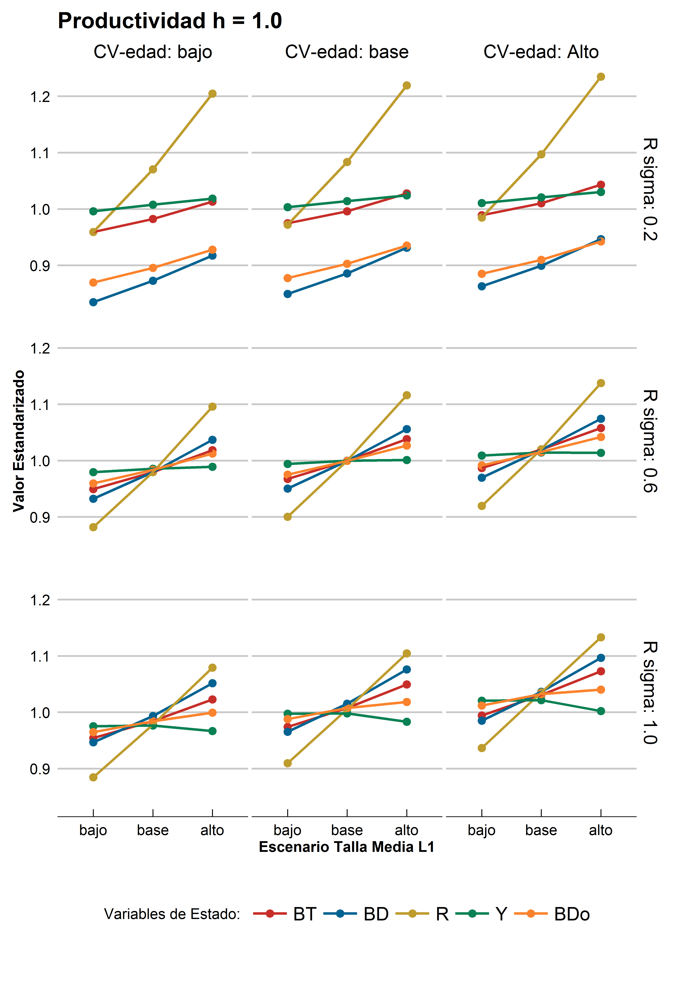 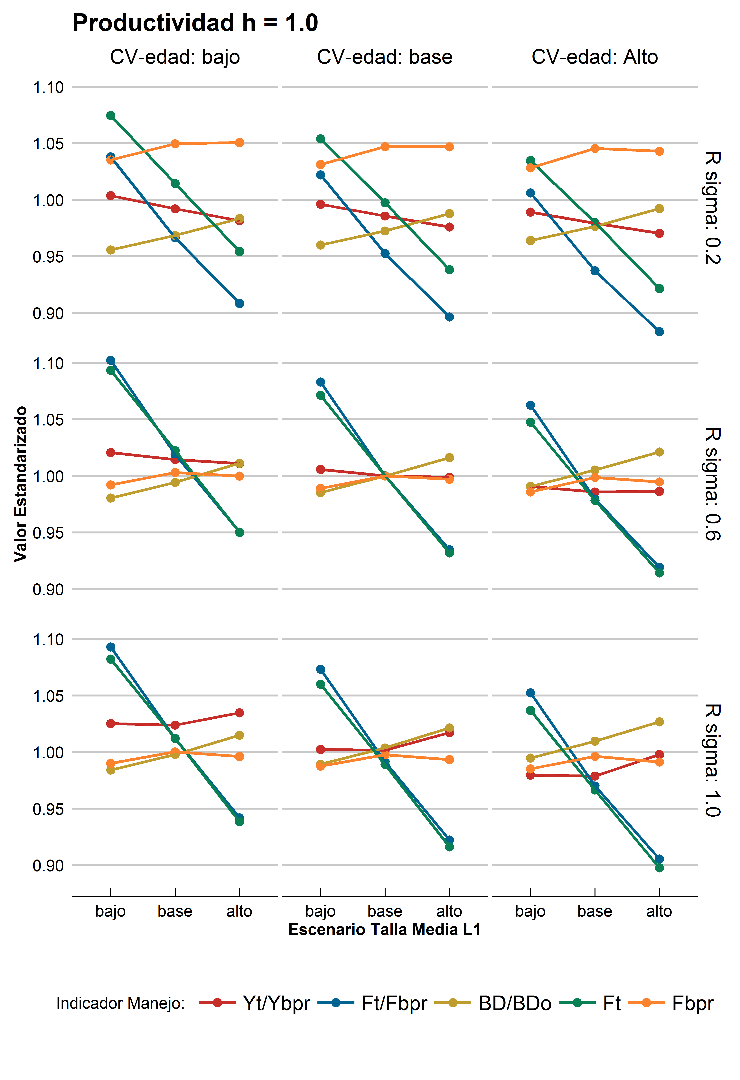

b)

a)

**Figure 1.** **(a)** Stock assessment variables and **(b)** Management advice indicators. Productivity scenario, *h*=1. **(a)** and **(b)** contained the results of nine (9) scenarios of growth, (x-axis: mean length at-age L1) low (-10%), Base, high (+10%). Each column in **(a)** and **(b)** correspond to scenario of VLA, low (-10%), Base, high (+10%). Each row in **(a)** and **(b)** correspond to a recruitment variance value $σ_{R}^{2}=\{0.2,0.6,1.0\}$. Dashed black rectangle indicates the Base Case and should be equal to *h=1*.

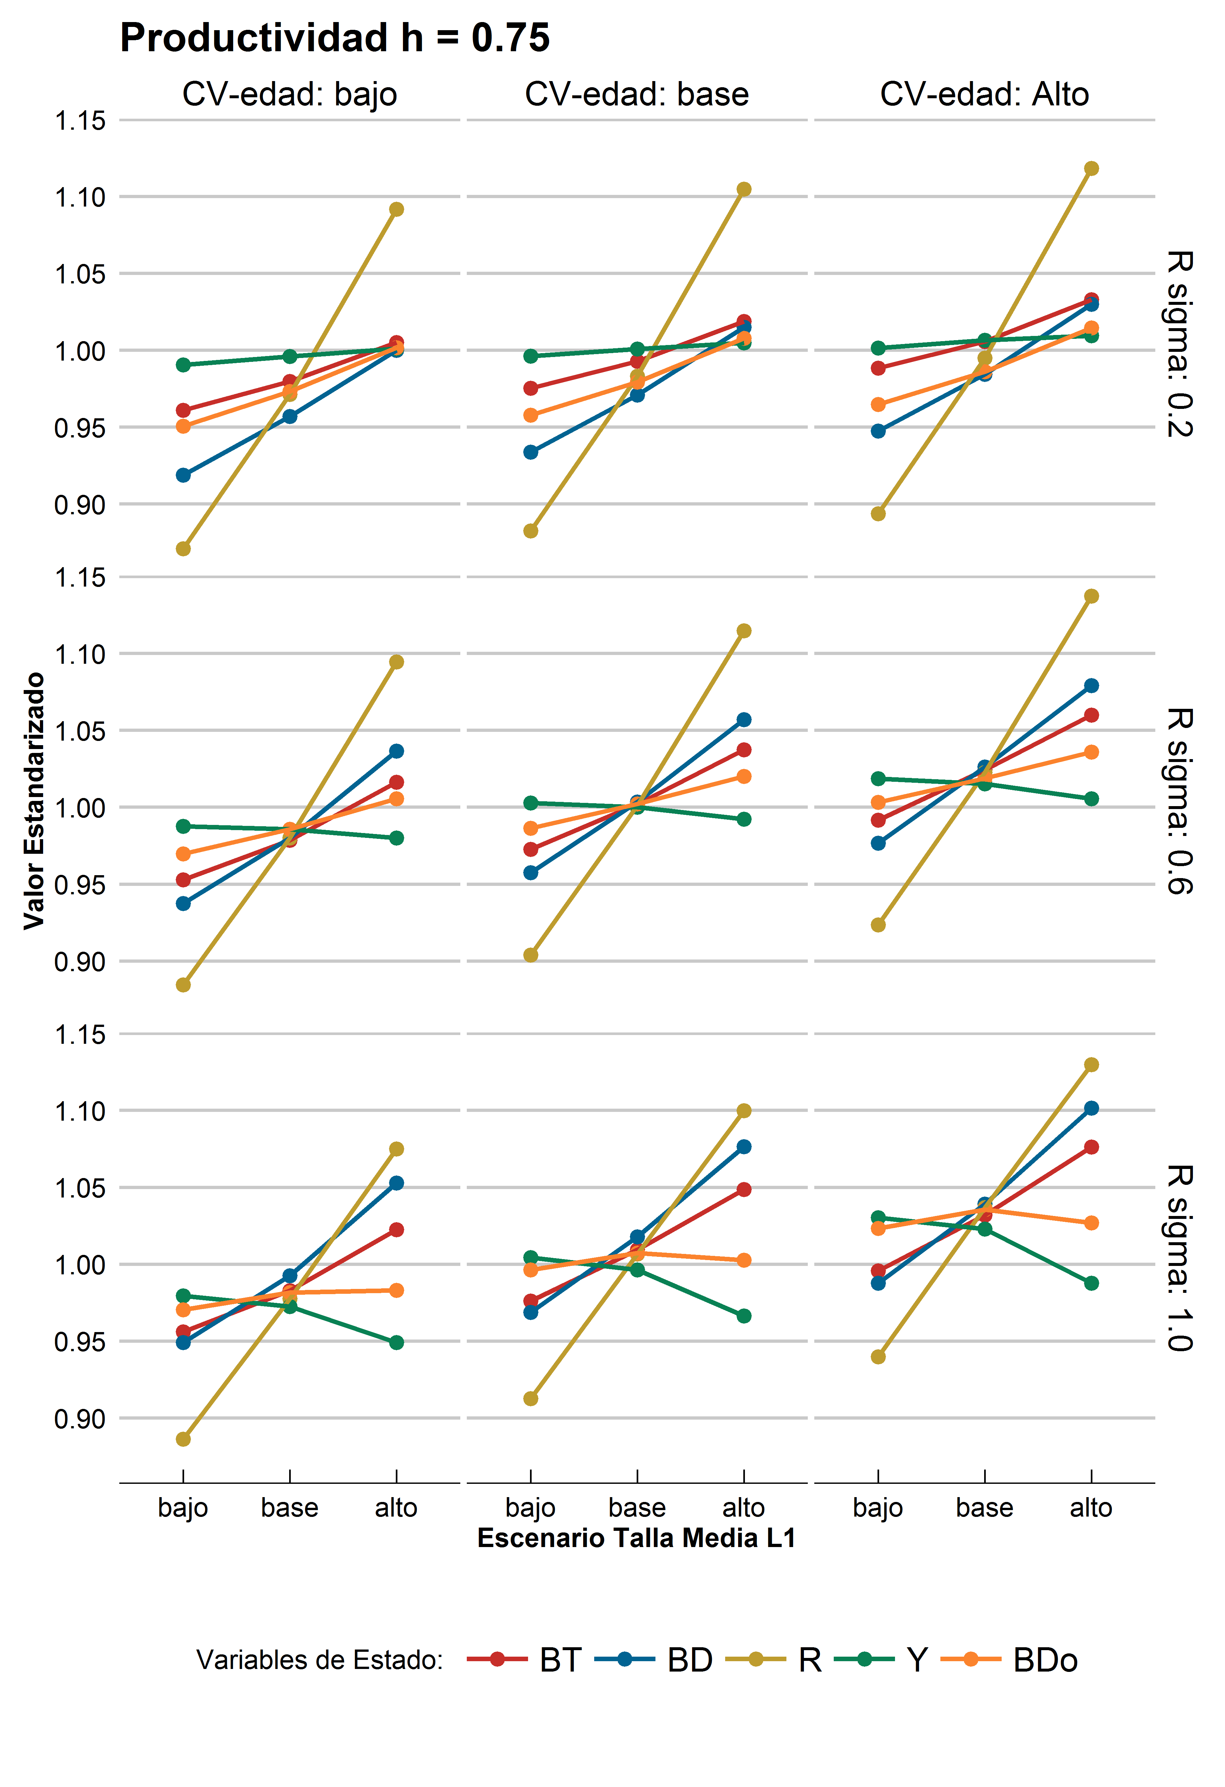 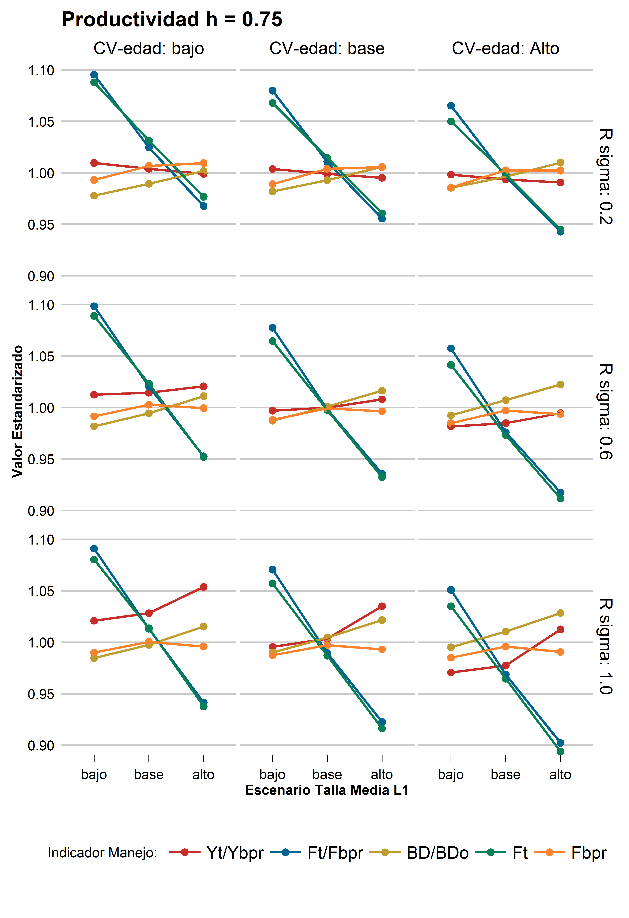

b)

a)

**Figure 2.** **Figure 1.** **(a)** Stock assessment variables and **(b)** Management advice indicators. Productivity scenario, *h*=0.75. **(a)** and **(b)** contained the results of nine (9) scenarios of growth, (x-axis: mean length at-age L1) low (-10%), Base, high (+10%). Each column in **(a)** and **(b)** correspond to scenario of VLA, low (-10%), Base, high (+10%). Each row in **(a)** and **(b)** correspond to a recruitment variance value $σ_{R}^{2}=\{0.2,0.6,1.0\}$. Dashed black rectangle indicates the Base Case and should be equal to *h=0.75*.