Figure 2: RMR by treatment interaction and night and day

Relationship between treatment interaction during night and daytime.

This plot shows the relationship between the interaction of predation risk and temperature on RMR at night time and day time. In general, RMRd and RMRn were higher at 23 than at 20. Predation risk, however, affected the RMR at 20 in different way between day time and night time resulting in RMRd>RMRn at 20C. So, lobster under risk did not modify their RMR between night and day, so they remained a bit similar. However, controlled animals reduced their RMRd as expected for the circadian pattern.

Linear mixed-effects model fit by REML

Data: RMR.final

AIC BIC logLik

-343.1226 -327.4838 178.5613

Random effects:

Formula: ~1 | fID

(Intercept) Residual

StdDev: 0.0144669 0.01153628

Fixed effects: list(Form.RMR)

Value Std.Error DF t-value p-value

(Intercept) 0.05966506 0.004949202 35 12.055492 0.0000

perxpredN.ctrl 0.01332121 0.003478318 34 3.829786 0.0005

perxpredD.pred 0.00501559 0.006196137 34 0.809471 0.4239

perxpredN.pred 0.00661427 0.006196137 34 1.067484 0.2933

ftemp23 0.02251127 0.005479188 35 4.108505 0.0002

Correlation:

(Intr) prxprdN.c prxpD. prxprdN.p

perxpredN.ctrl -0.351

perxpredD.pred -0.514 0.281

perxpredN.pred -0.514 0.281 0.769

ftemp23 -0.604 0.000 0.011 0.011

Standardized Within-Group Residuals:

Min Q1 Med Q3 Max

-2.10871944 -0.42947485 -0.07421286 0.46512330 1.95515853

Number of Observations: 74

Number of Groups: 37

> anova(lme.RMR)

numDF denDF F-value p-value

(Intercept) 1 35 819.2643 <.0001

perxpred 3 34 4.9506 0.0059

ftemp 1 35 16.8798 0.0002

> lsmeans.RMR<-lsmeans(lme.RMR, ~ perxpred+ftemp)

> summary(as.glht(pairs(lsmeans.RMR),by = NULL))

Note: df set to 34

Simultaneous Tests for General Linear Hypotheses

Linear Hypotheses:

Estimate Std. Error t value Pr(>|t|)

D.ctrl,20 - N.ctrl,20 == 0 -0.013321 0.003478 -3.830 0.00569 **

D.ctrl,20 - D.pred,20 == 0 -0.005016 0.006196 -0.809 0.93107

D.ctrl,20 - N.pred,20 == 0 -0.006614 0.006196 -1.067 0.83292

D.ctrl,20 - D.ctrl,23 == 0 -0.022511 0.005479 -4.109 0.00274 **

D.ctrl,20 - N.ctrl,23 == 0 -0.035832 0.006490 -5.521 < 0.001 ***

D.ctrl,20 - D.pred,23 == 0 -0.027527 0.008315 -3.310 0.02134 *

D.ctrl,20 - N.pred,23 == 0 -0.029126 0.008315 -3.503 0.01322 *

N.ctrl,20 - D.pred,20 == 0 0.008306 0.006196 1.340 0.68637

N.ctrl,20 - N.pred,20 == 0 0.006707 0.006196 1.082 0.82580

N.ctrl,20 - D.ctrl,23 == 0 -0.009190 0.006490 -1.416 0.64129

N.ctrl,20 - N.ctrl,23 == 0 -0.022511 0.005479 -4.109 0.00264 **

N.ctrl,20 - D.pred,23 == 0 -0.014206 0.008315 -1.708 0.46525

N.ctrl,20 - N.pred,23 == 0 -0.015804 0.008315 -1.901 0.35883

D.pred,20 - N.pred,20 == 0 -0.001599 0.004212 -0.380 0.99574

D.pred,20 - D.ctrl,23 == 0 -0.017496 0.008227 -2.127 0.25288

D.pred,20 - N.ctrl,23 == 0 -0.030817 0.008227 -3.746 0.00708 **

D.pred,20 - D.pred,23 == 0 -0.022511 0.005479 -4.109 0.00266 **

D.pred,20 - N.pred,23 == 0 -0.024110 0.006911 -3.488 0.01374 *

N.pred,20 - D.ctrl,23 == 0 -0.015897 0.008227 -1.932 0.34273

N.pred,20 - N.ctrl,23 == 0 -0.029218 0.008227 -3.551 0.01170 *

N.pred,20 - D.pred,23 == 0 -0.020913 0.006911 -3.026 0.04184 *

N.pred,20 - N.pred,23 == 0 -0.022511 0.005479 -4.109 0.00267 **

D.ctrl,23 - N.ctrl,23 == 0 -0.013321 0.003478 -3.830 0.00569 **

D.ctrl,23 - D.pred,23 == 0 -0.005016 0.006196 -0.809 0.93113

D.ctrl,23 - N.pred,23 == 0 -0.006614 0.006196 -1.067 0.83285

N.ctrl,23 - D.pred,23 == 0 0.008306 0.006196 1.340 0.68638

N.ctrl,23 - N.pred,23 == 0 0.006707 0.006196 1.082 0.82578

D.pred,23 - N.pred,23 == 0 -0.001599 0.004212 -0.380 0.99574

---

Signif. codes: 0 ‘***’ 0.001 ‘**’ 0.01 ‘*’ 0.05 ‘.’ 0.1 ‘ ’ 1

(Adjusted p values reported -- single-step method)

**MINIMUN METABOLIC RATES**

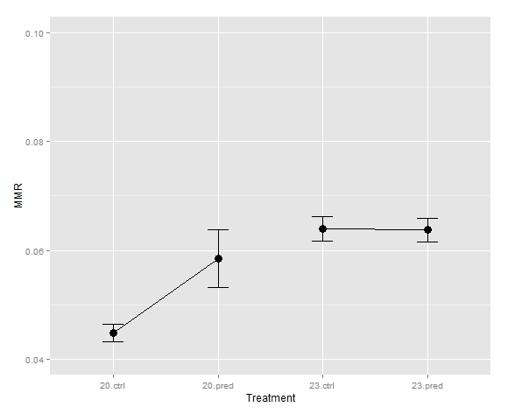

Figure: Minimum metabolic rates

Linear mixed-effects model fit by REML

Data: Table.1.MMR.D

AIC BIC logLik

-174.0777 -165.0987 93.03887

Random effects:

Formula: ~1 | fID

(Intercept) Residual

StdDev: 0.01182411 0.004434038

Fixed effects: list(Form.MMR.d)

Value Std.Error DF t-value p-value

(Intercept) 0.04474000 0.003993374 33 11.203559 0.0000

tempxpred23.ctrl 0.01926000 0.005407054 33 3.562014 0.0011

tempxpred20.pred 0.01371714 0.006223223 33 2.204186 0.0346

tempxpred23.pred 0.01901000 0.005990061 33 3.173591 0.0033

Correlation:

(Intr) tmpxprd23.c tmp20.

tempxpred23.ctrl -0.739

tempxpred20.pred -0.642 0.474

tempxpred23.pred -0.667 0.492 0.428

Standardized Within-Group Residuals:

Min Q1 Med Q3 Max

-0.52431876 -0.20436515 -0.08897530 0.08480459 1.02718811

Number of Observations: 37

Number of Groups: 37

> anova(lme.MMR)

numDF denDF F-value p-value

(Intercept) 1 33 772.2384 <.0001

tempxpred 3 33 5.1268 0.0051

> lsmeans.MMR<-lsmeans(lme.MMR, ~ tempxpred)

> summary(as.glht(pairs(lsmeans.MMR),by = NULL))

Note: df set to 33

Simultaneous Tests for General Linear Hypotheses

Linear Hypotheses:

Estimate Std. Error t value Pr(>|t|)

20.ctrl - 23.ctrl == 0 -0.019260 0.005407 -3.562 0.00611 **

20.ctrl - 20.pred == 0 -0.013717 0.006223 -2.204 0.14255

20.ctrl - 23.pred == 0 -0.019010 0.005990 -3.174 0.01636 *

23.ctrl - 20.pred == 0 0.005543 0.006006 0.923 0.79203

23.ctrl - 23.pred == 0 0.000250 0.005764 0.043 0.99997

20.pred - 23.pred == 0 -0.005293 0.006536 -0.810 0.84876

---

Signif. codes: 0 ‘***’ 0.001 ‘**’ 0.01 ‘*’ 0.05 ‘.’ 0.1 ‘ ’ 1

(Adjusted p values reported -- single-step method)

Linear mixed-effects model fit by REML

Data: MMR

AIC BIC logLik

-174.0777 -165.0987 93.03887

Random effects:

Formula: ~1 | ID

(Intercept) Residual

StdDev: 0.01182411 0.004434042

Fixed effects: list(Form.MMR.d)

Value Std.Error DF t-value p-value

(Intercept) 0.04474000 0.003993374 33 11.203559 0.0000

ftemp23 0.01926000 0.005407054 33 3.562014 0.0011

ftreatpred 0.01371714 0.006223223 33 2.204186 0.0346

ftemp23:ftreatpred -0.01396714 0.008482423 33 -1.646598 0.1091

Correlation:

(Intr) ftmp23 ftrtpr

ftemp23 -0.739

ftreatpred -0.642 0.474

ftemp23:ftreatpred 0.471 -0.637 -0.734

Standardized Within-Group Residuals:

Min Q1 Med Q3 Max

-0.52431920 -0.20436532 -0.08897538 0.08480466 1.02718897

Number of Observations: 37

Number of Groups: 37

ACTIVE METABOLIC RATE



INTERACTIONS

Linear mixed-effects model fit by REML

Data: Table.1.AMR

AIC BIC logLik

-136.05 -127.0709 74.02498

Random effects:

Formula: ~1 | fID

(Intercept) Residual

StdDev: 0.02103777 0.007889163

Fixed effects: list(Form.AMR)

Value Std.Error DF t-value p-value

(Intercept) 0.17130000 0.007105115 33 24.109391 0.0000

tempxpred23.ctrl -0.02305000 0.009620371 33 -2.395957 0.0224

tempxpred20.pred -0.00901429 0.011072522 33 -0.814113 0.4214

tempxpred23.pred -0.01905000 0.010657673 33 -1.787445 0.0831

Correlation:

(Intr) tmpxprd23.c tmp20.

tempxpred23.ctrl -0.739

tempxpred20.pred -0.642 0.474

tempxpred23.pred -0.667 0.492 0.428

Standardized Within-Group Residuals:

Min Q1 Med Q3 Max

-0.613378234 -0.269573873 -0.003906868 0.198692130 0.761839207

Number of Observations: 37

Number of Groups: 37

Simultaneous Tests for General Linear Hypotheses

Linear Hypotheses:

Estimate Std. Error t value Pr(>|t|)

20.ctrl - 23.ctrl == 0 0.023050 0.009620 2.396 0.0972 .

20.ctrl - 20.pred == 0 0.009014 0.011073 0.814 0.8467

20.ctrl - 23.pred == 0 0.019050 0.010658 1.787 0.2961

23.ctrl - 20.pred == 0 -0.014036 0.010686 -1.313 0.5599

23.ctrl - 23.pred == 0 -0.004000 0.010255 -0.390 0.9794

20.pred - 23.pred == 0 0.010036 0.011628 0.863 0.8230

---

Signif. codes: 0 ‘***’ 0.001 ‘**’ 0.01 ‘*’ 0.05 ‘.’ 0.1 ‘ ’ 1

(Adjusted p values reported -- single-step method)

Aerobic scope

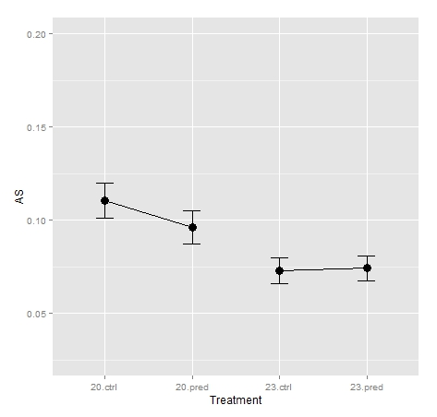

Linear mixed-effects model fit by REML

Data: Table.1.AS

AIC BIC logLik

-130.199 -121.2199 71.09948

Random effects:

Formula: ~1 | fID

(Intercept) Residual

StdDev: 0.02298796 0.008620507

Fixed effects: list(Form.AS)

Value Std.Error DF t-value p-value

(Intercept) 0.12656000 0.00776376 33 16.301380 0.0000

tempxpred23.ctrl -0.04231000 0.01051218 33 -4.024855 0.0003

tempxpred20.pred -0.02273143 0.01209895 33 -1.878794 0.0691

tempxpred23.pred -0.03806000 0.01164564 33 -3.268176 0.0025

Correlation:

(Intr) tmpxprd23.c tmp20.

tempxpred23.ctrl -0.739

tempxpred20.pred -0.642 0.474

tempxpred23.pred -0.667 0.492 0.428

Standardized Within-Group Residuals:

Min Q1 Med Q3 Max

-0.58964000 -0.24255738 -0.02359786 0.19593373 0.68991557

Number of Observations: 37

Number of Groups: 37

> anova(lme.AS)

numDF denDF F-value p-value

(Intercept) 1 33 617.6318 <.0001

tempxpred 3 33 6.1872 0.0019

> lsmeans.AS<-lsmeans(lme.AS, ~ ftreat*ftemp)

Error in lsmeans.character.ref.grid(object = <S4 object of class "ref.grid">, :

No variable named ftreat in the reference grid

> lsmeans.AS<-lsmeans(lme.AS, ~ tempxpred)

> summary(as.glht(pairs(lsmeans.AS),by = NULL))

Note: df set to 33

Simultaneous Tests for General Linear Hypotheses

Linear Hypotheses:

Estimate Std. Error t value Pr(>|t|)

20.ctrl - 23.ctrl == 0 0.04231 0.01051 4.025 0.0016 **

20.ctrl - 20.pred == 0 0.02273 0.01210 1.879 0.2555

20.ctrl - 23.pred == 0 0.03806 0.01165 3.268 0.0127 *

23.ctrl - 20.pred == 0 -0.01958 0.01168 -1.677 0.3505

23.ctrl - 23.pred == 0 -0.00425 0.01121 -0.379 0.9810

20.pred - 23.pred == 0 0.01533 0.01271 1.206 0.6261

---

Signif. codes: 0 ‘***’ 0.001 ‘**’ 0.01 ‘*’ 0.05 ‘.’ 0.1 ‘ ’ 1

(Adjusted p values reported -- single-step method)

STANDARD METABOLIC RATE

Linear mixed-effects model fit by REML

Data: SMR

AIC BIC logLik

-186.8868 -180.6654 97.44341

Random effects:

Formula: ~1 | fID

(Intercept) Residual

StdDev: 0.0128798 0.004829926

Fixed effects: list(Form.MMR.d)

Value Std.Error DF t-value p-value

(Intercept) 0.04425882 0.003336232 35 13.266112 0e+00

temp23 0.01812118 0.004537766 35 3.993414 3e-04

Correlation:

(Intr)

temp23 -0.735

Standardized Within-Group Residuals:

Min Q1 Med Q3 Max

-0.58658260 -0.20570782 -0.04744793 0.17207384 0.90412340

Number of Observations: 37

Number of Groups: 37

> anova(lme.SMR)

numDF denDF F-value p-value

(Intercept) 1 35 571.3430 <.0001

temp 1 35 15.9474 3e-04