

**(23CSE111)     OBJECT ORIENTED     PROGRAMMING**

**LAB MANUAL**

**CSE-1st YEAR II SEMESTER (2024-2025)**

|  |  |  |  |  |  |  |
| --- | --- | --- | --- | --- | --- | --- |
| **Submitted by** | | | | **Submitted to** | | |
| **NAME** | | | **J.CHAITHANYA RAM** | **NAME** | | **RAJ KUMAR BATCHU** |
| **ROLL NO:** | | | **AV.SC.U4CSE24129** | **DEPARTMENT** | | **CSE** |
| **SECTION:** | | | **CSE-B** | **DESIGNATION** | | **ASST.PROFESSOR** |
| **MARKS:** |  | | |
| **SIGNATURE:** |  | | |
| **DATE:** |  | | |

                                     INDEX

|  |  |  |  |  |
| --- | --- | --- | --- | --- |
| **S.no** | **Title** | **Date** | **Page no** | **marks** |
| 1.) | 1. To download and install java and  execute the the first java code to print the “student name, roll number, section |  |  |  |

    Week-1

**AIM:** Downloading, installing and executing the student name,roll number,section:

1.Open Google chrome and search for java download on oracle.

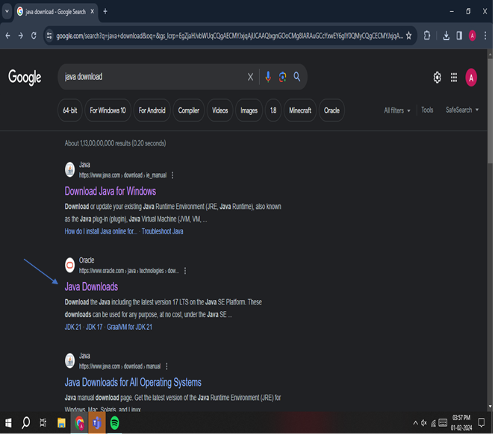

**2.**Open Oracle java download and select the operationg system and download accordingly.

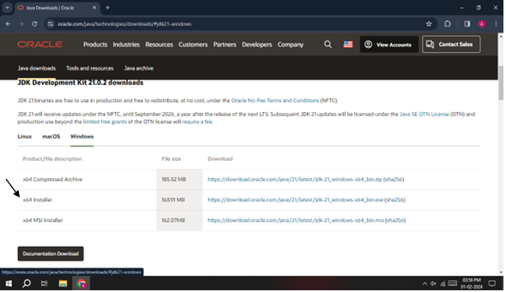

**3.**After downloading go to your files and open the location of file.

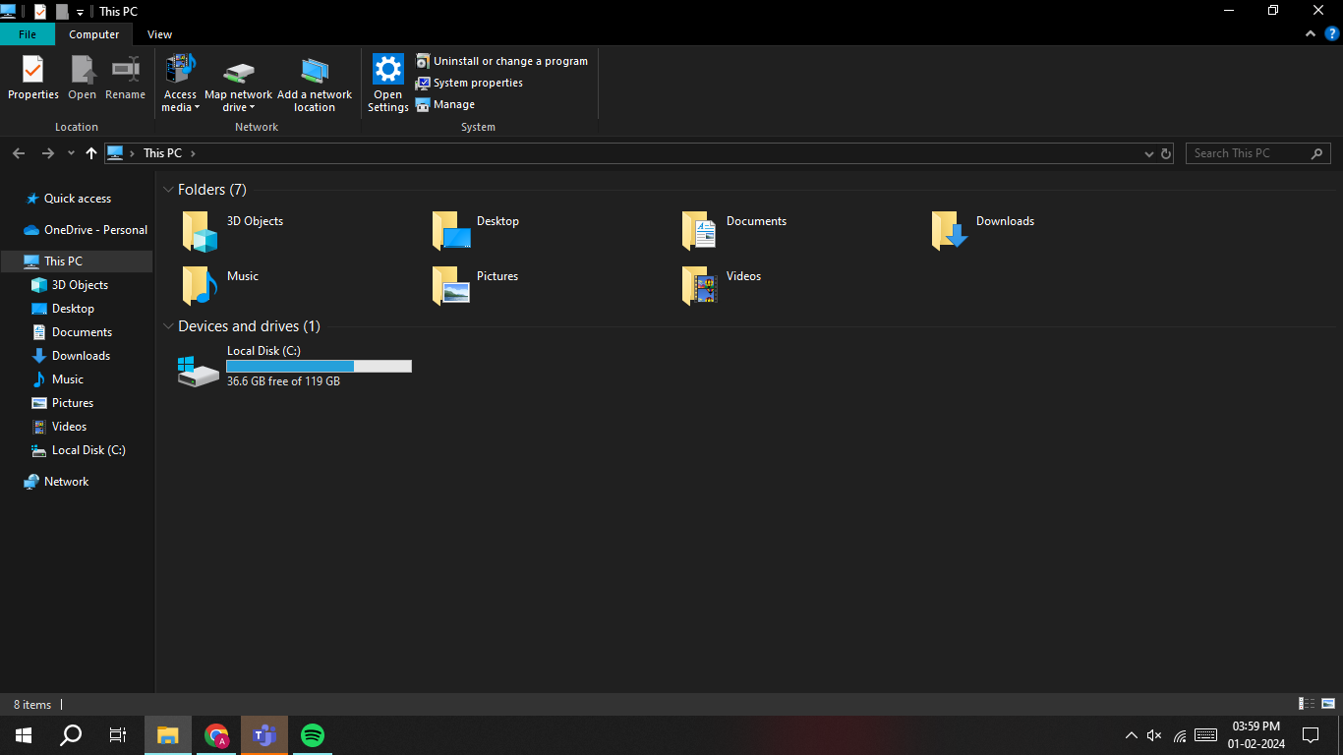

**4.**After opening the files click according to the following sequence.

Go to program files.

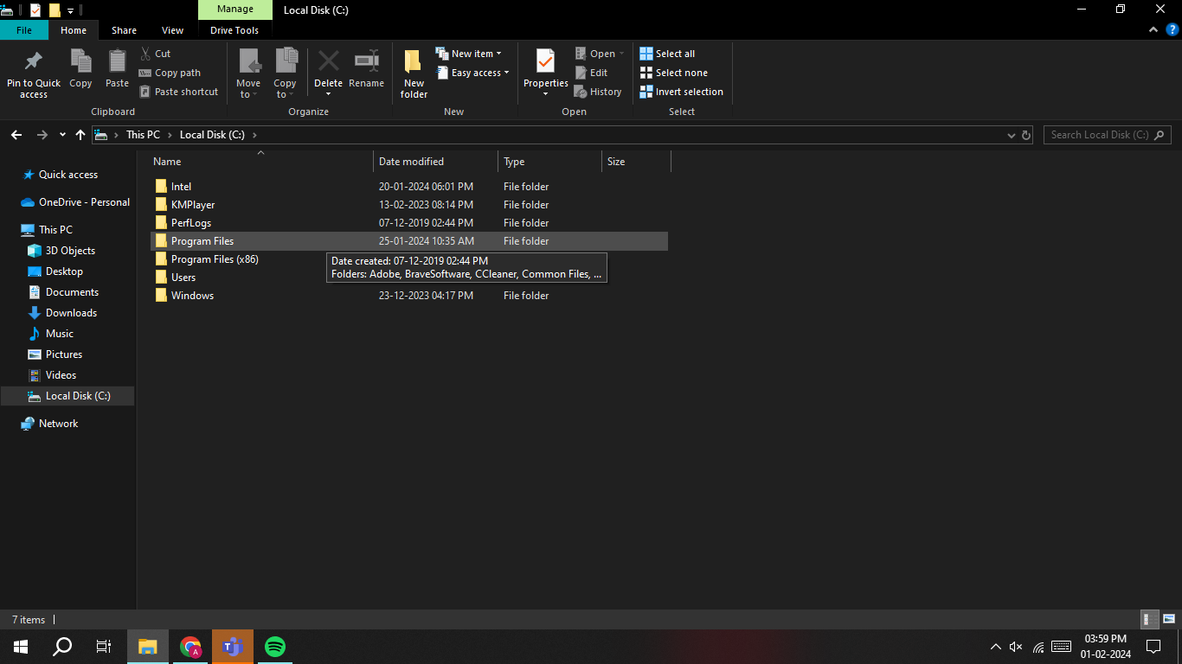

**5.**Click Java in the program files.

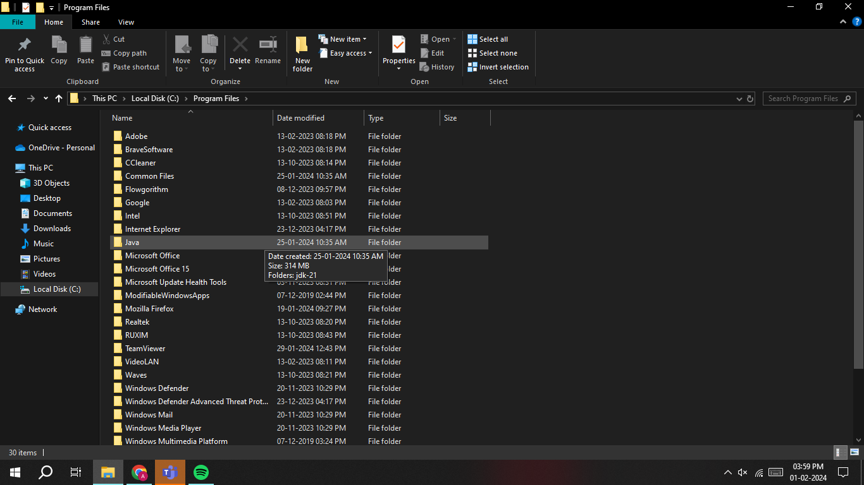

**6.**Click on jdk.21.

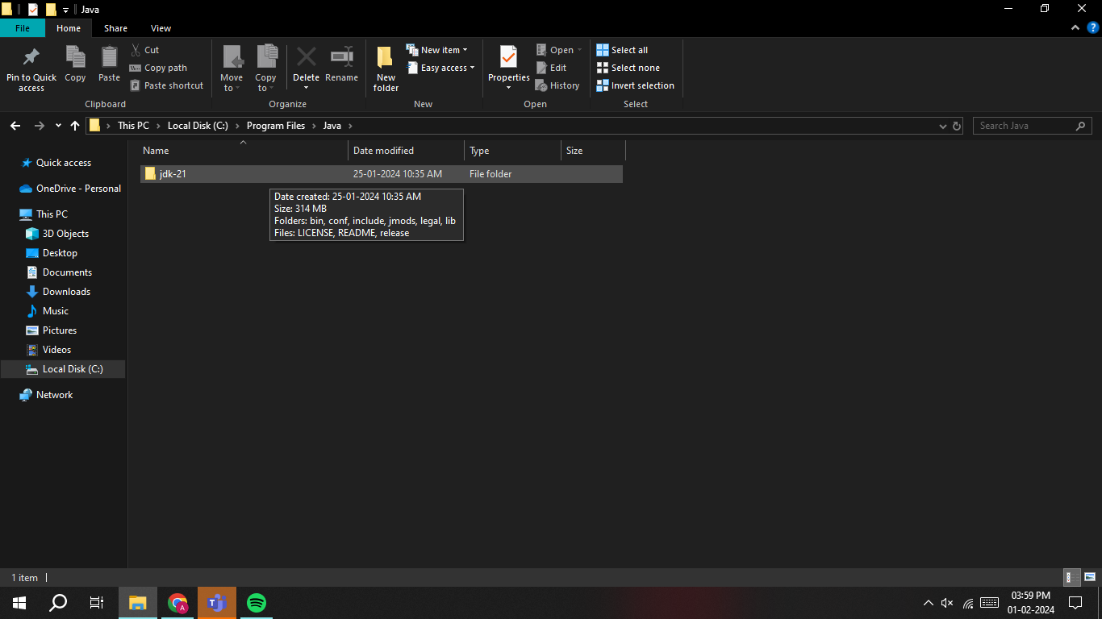

**7.**The following will be displayed on the screen.Click on bin.

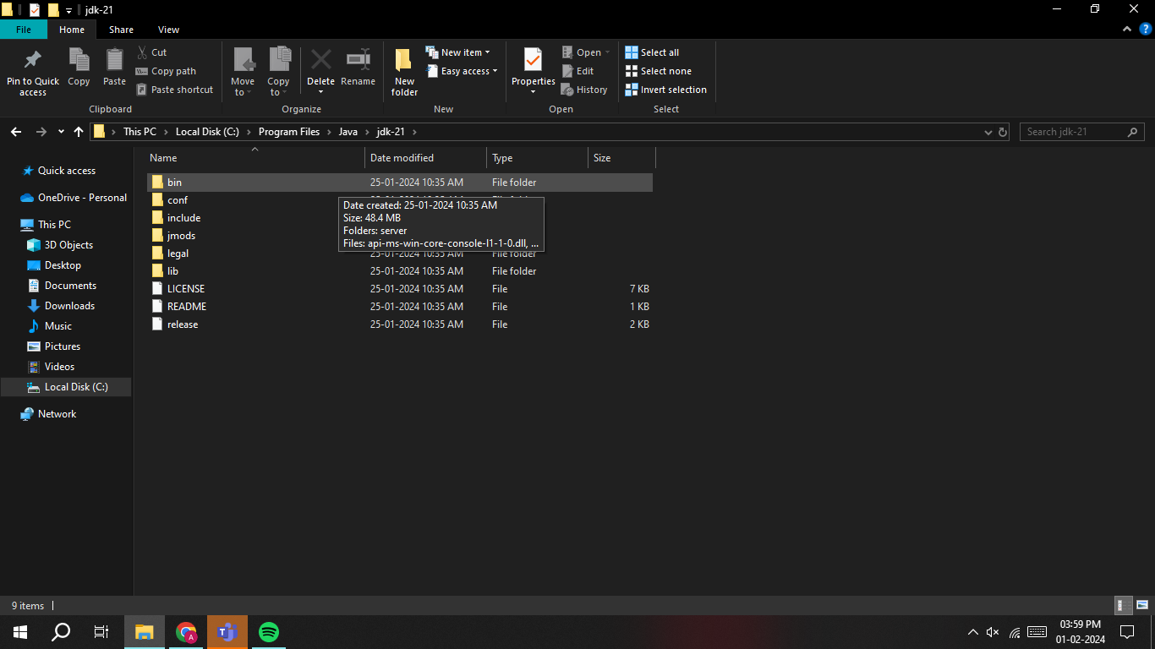

**8.**After clicking bin copy the path address of bin.

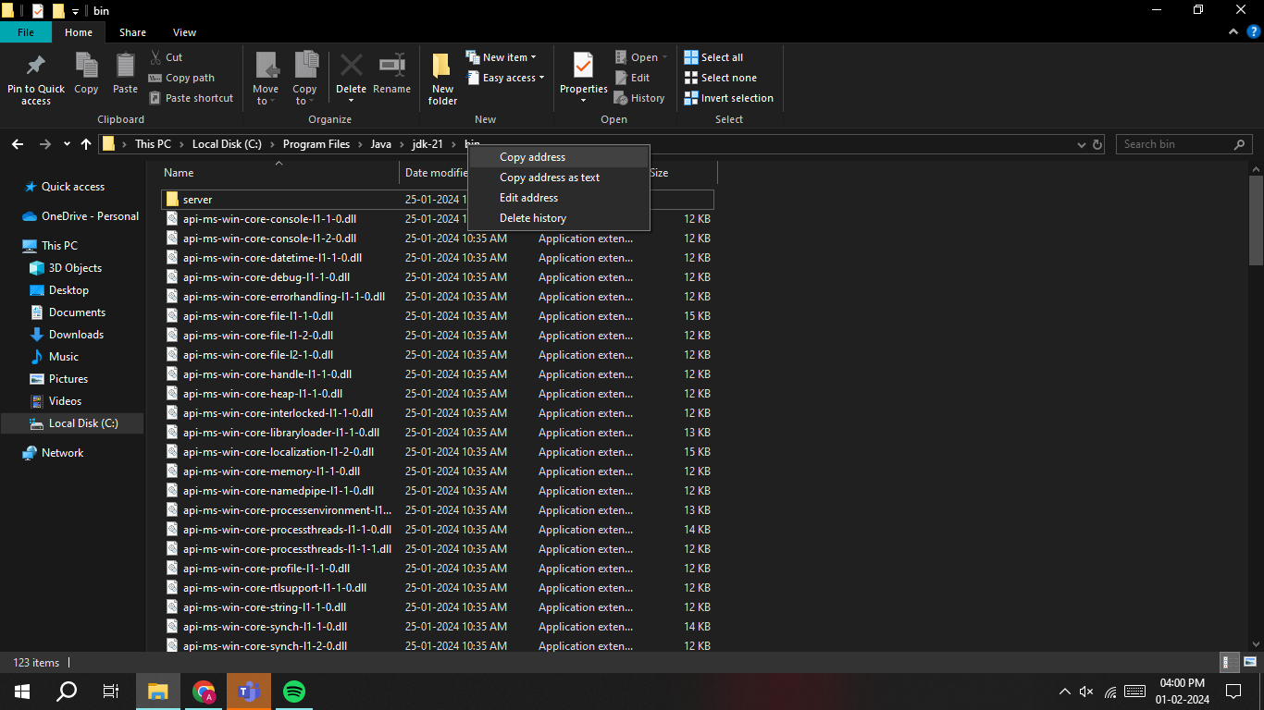

**9.**Setting the path-

For setting the path,enter environment variables on the search bar.



**10.**Click on the environment variables and follow the steps for setting the path.

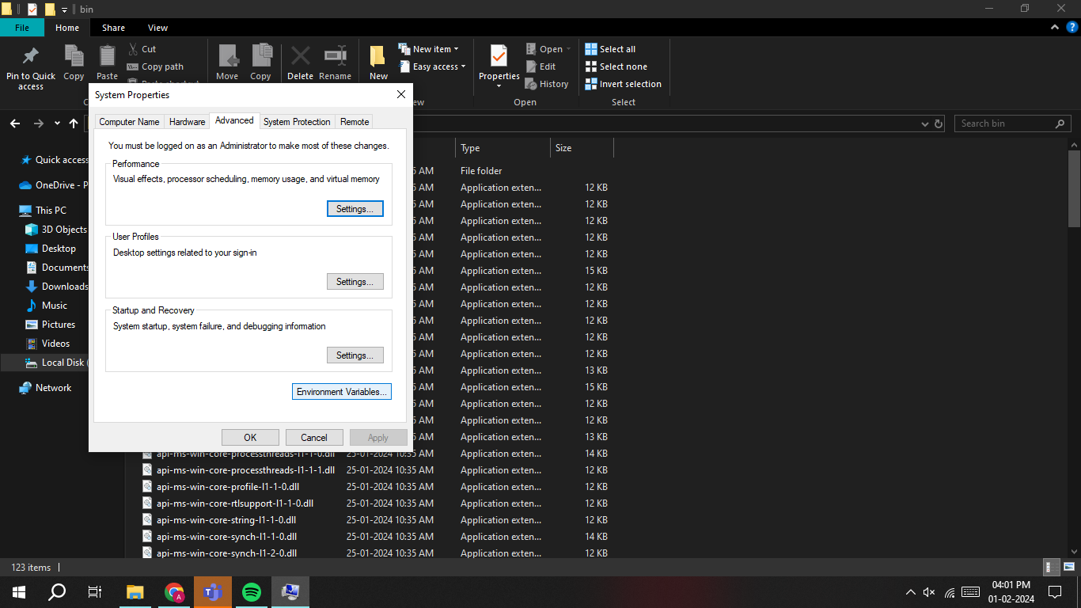

**11.**Click on path and then click on new the following will be displayed.

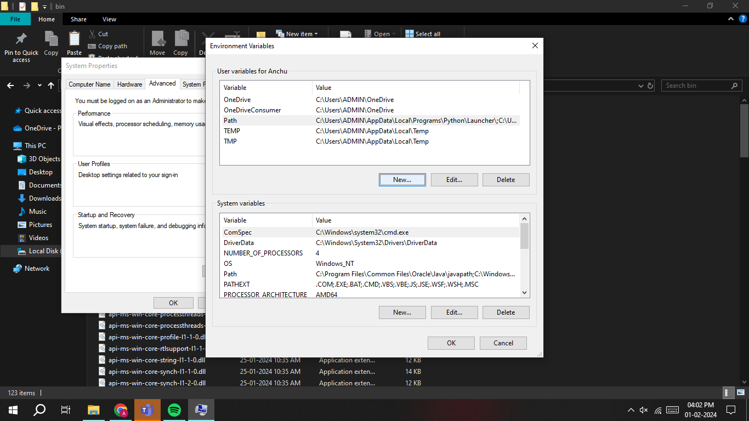

**12.**Then the following will be displayed.

Give variable name such as JAVA_HOME and now paste the path you have copied before in the variable value.

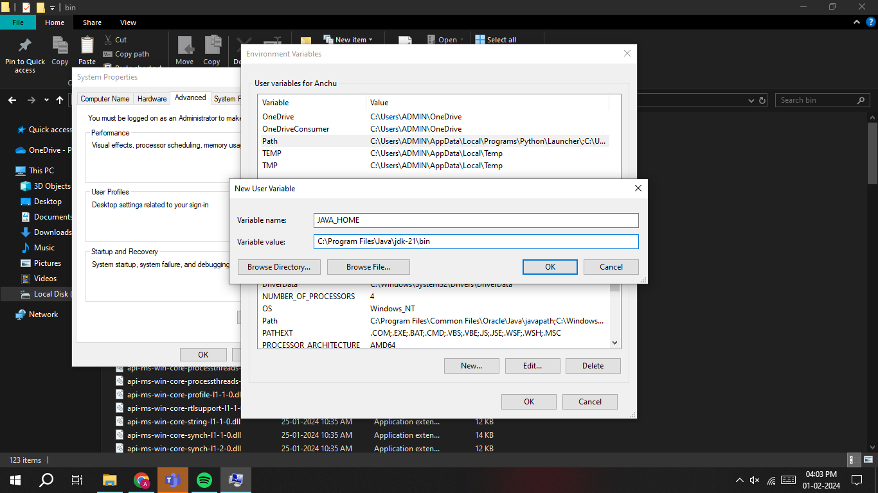

**13**.Now create a new folder.

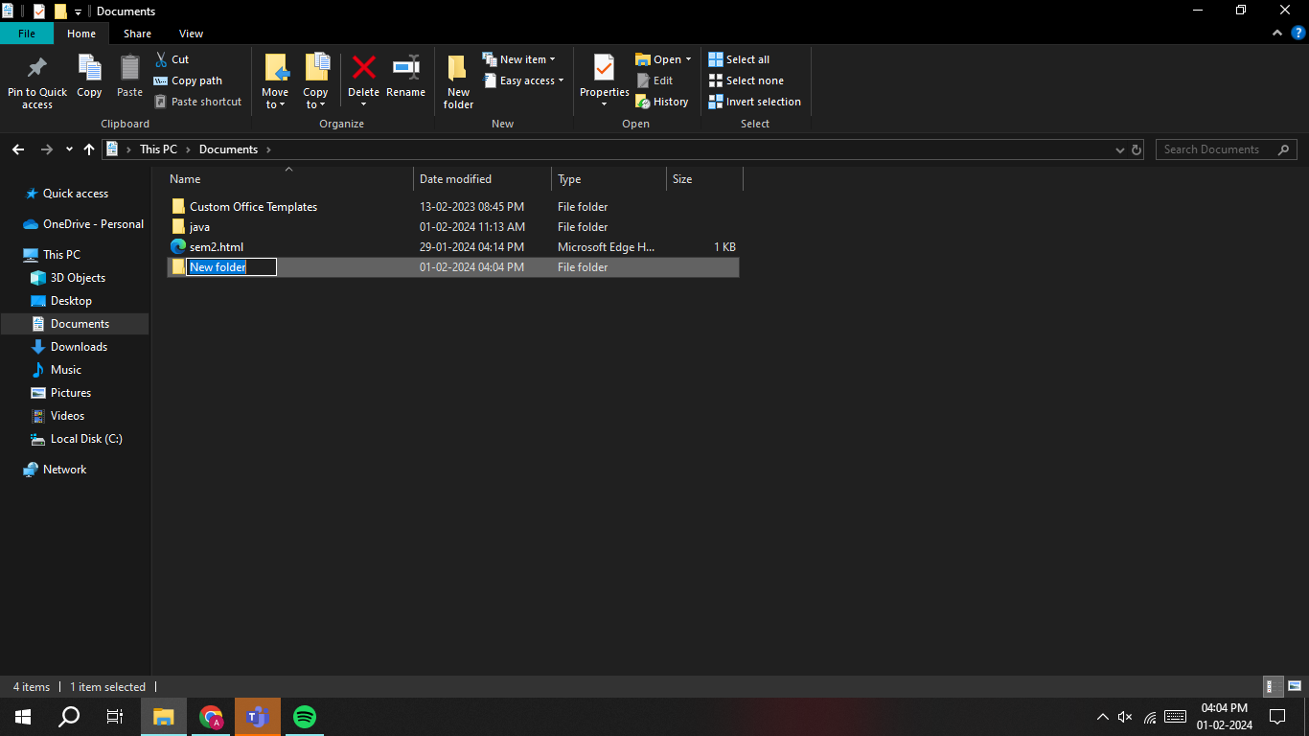

**14.**Create a file in the empty folder created as shown.

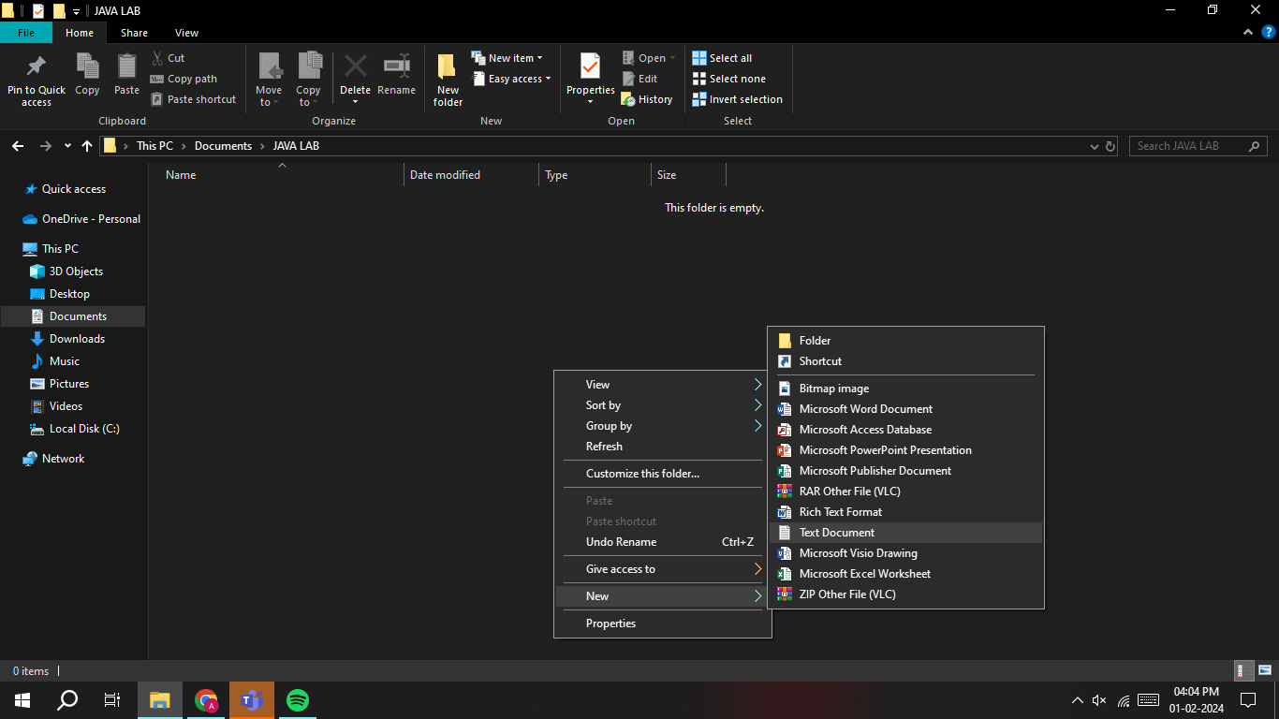

**15.**Now open the text document then the notepad will be opened write your java code in the notepad and save the file as file name.java.

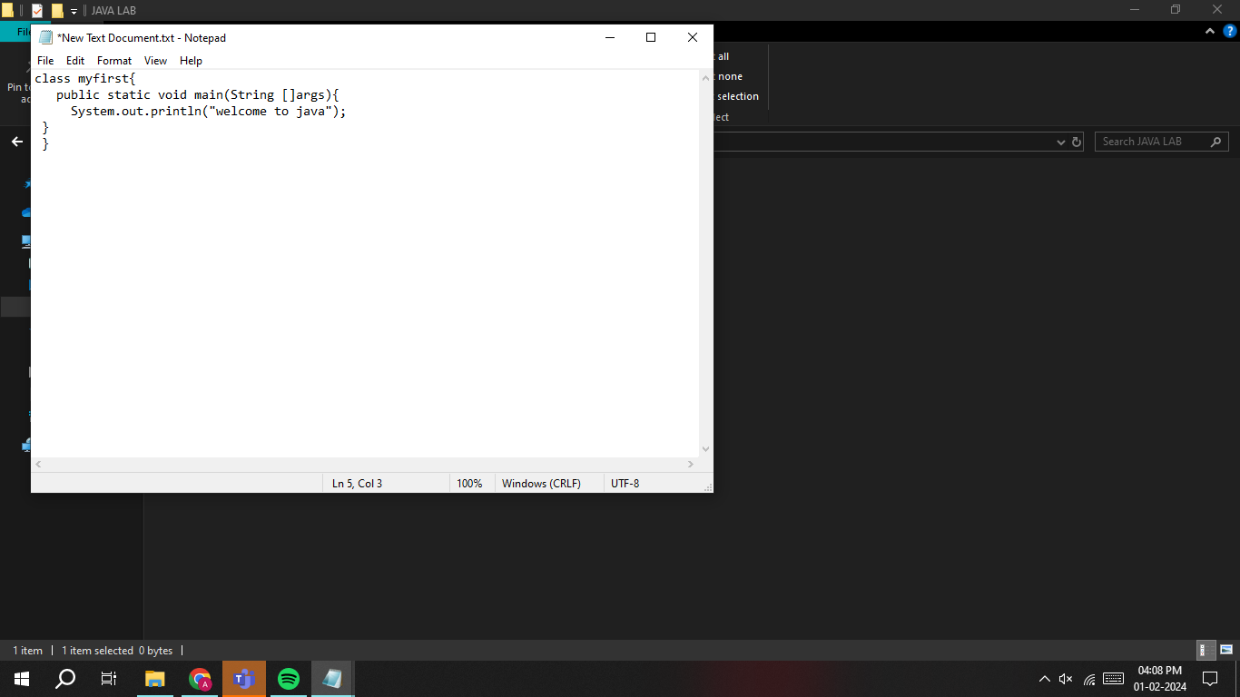

**16.**The file will be saved as txt document you should change it to java in order to get your output in command prompt.

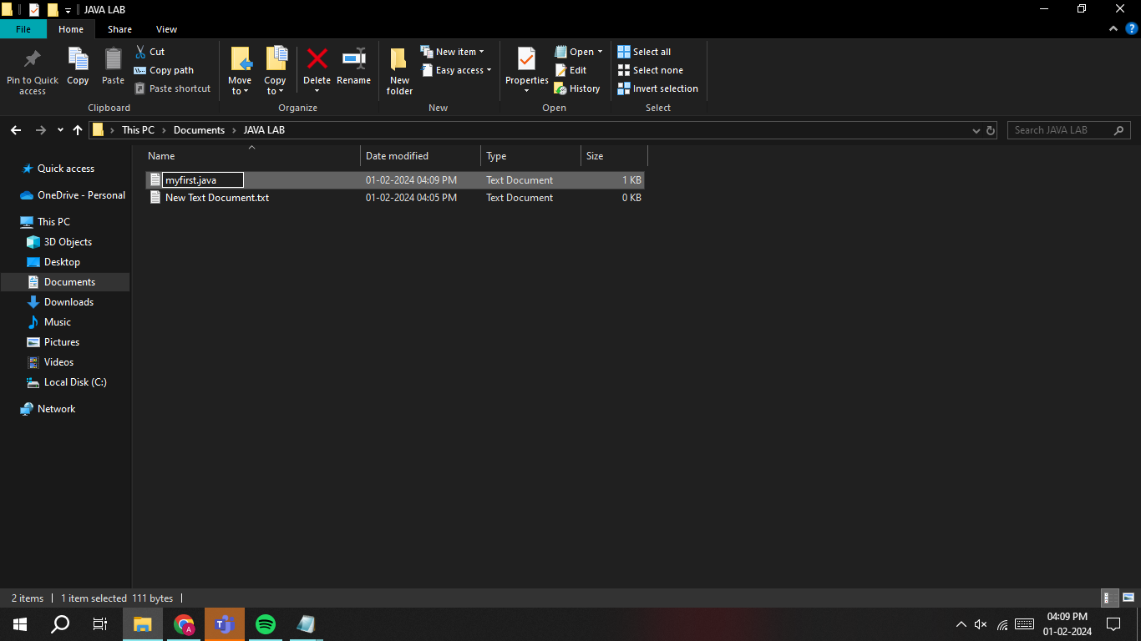

17.To get the output type cmd on the top and open then command prompt will be opened.

18.To check the java version open command prompt and check by typing java -–version.

19.To get the output first you should compile the java code by entering ‘javac filename.java’.

If there are no errors in the code the compiler enters to the next line else it displays the error.

After entering to the next line to get output type ‘java filename.java’

It will display the output as shown.

20.) To Print the student name,roll number and section in note pad and execute in command prompt:

public class StudentInfo {

public static void main(String[] args) {

String studentName = "Alice Wonderland";

int rollNumber = 12345;

String section = "A";

System.out.println("Student Name: " + studentName);

System.out.println("Roll Number: " + rollNumber);

System.out.println("Section: " + section);

}

}

*Execution of student name,roll numberand section in command prompt:

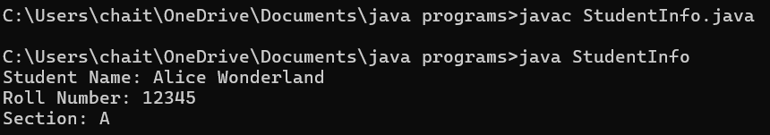

**Errors**:

|  |  |  |
| --- | --- | --- |
| S.NO | Expected Error | Reasons |
| 1. | S | Capital S is expected for String and System. |
| 2. | ; | ; is Expected at end |

    Week-2

1. Write a java program to clalculate area of rectangle.

 Code :   import java.util.Scanner;

                    public class area{

                       public static void main(String[] args){

                          Scanner input = new Scanner(System.in);

                          System.out.print("Enter a value : ");

                          int b = input.nextInt();

                          System.out.print("Enter a value : ");

                          int l = input.nextInt();

                  int area = b*l;

                System.out.print("The area of the rectangle is : "+ area);

               input.close();

   }

}

**Output :**

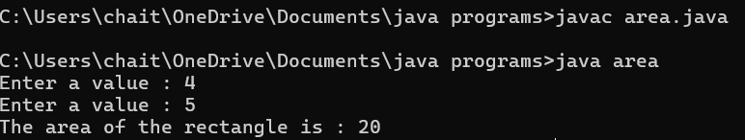

Errors:

|  |  |  |
| --- | --- | --- |
| s.no | Expected Error | Reason |
| 1 | area | Declaration of the int type variable |
| 2 | ; | ; is expected at end |

b.) **Write a java program to convert temperature from Celsius to Fahrenheit and vice versa.**

Code :   import java.util.Scanner;

                  class temp{

                   public static void main(String[] args){

                    Scanner input =new Scanner(System.in);

                    System.out.print("enter the the temperature in degrees:");

                     double deg=input.nextDouble();

                   System.out.println("the temperatuer in fahrenheit"+((deg*9/5)+32));

    }

}

Output:

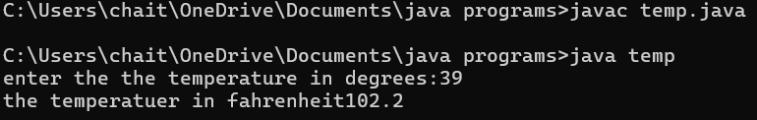

**Error:**

|  |  |  |
| --- | --- | --- |
| s.no | Expected Error | Reason |
| 1 | ; | **; is expected at end** |
| 2 | **Input.close();** | **The input is expected to be closed.** |

c**.)  Write a java program to calculate the simple interest.**

Code :   import java.util.Scanner;

                 public class si{

                  public static void main(String[] args){

                 Scanner input = new Scanner(System.in);

                 System.out.print("Enter principal amount : ");

                 int p = input.nextInt();

                 System.out.print("Enter rate of interest : ");

                 int r = input.nextInt();

                System.out.print("Enter the time period : ");

              int t = input.nextInt();

              int SI = p*r*t/100;

            System.out.print("The simple Interest is : " + SI);

            input.close();

     }

}

**Output:**

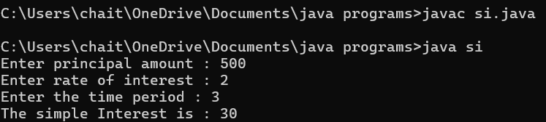

|  |  |  |
| --- | --- | --- |
| s.no | **Expected Error** | Reason |
| 1 | ; | **; is expected at end** |
| 2 | Int t | **Without declaring t the compiler cannot execute the program.** |

d**.) Write a java program to find the largest of three numbers using ternary operation**.

Code :

               import java.util.Scanner;

                public class largest{

                 public static void main(String[] args){

                 Scanner input = new Scanner(System.in);

                 System.out.print("Enter number a : ");

                 int a = input.nextInt();

                 System.out.print("Enter number b : ");

                 int b = input.nextInt();

                System.out.print("Enter number c : ");

                int c = input.nextInt();

                int largest = (a>=b) ? ((a>=c ) ? a : c) : ((b >=c) ? b : c);

               System.out.print("The largest number is : " + largest);

               input.close();

       }

    }

**Output:**

|  |  |  |
| --- | --- | --- |
| S.no | Expected Errors | Reason |
| 1 | ? | Checks the condition |
| 2 | : | Comparing between two variables |

e.)  **Write a java program to find the factorial of a number**

Code :  import java.util.Scanner;

                public class fac{

                  public static void main(String[] args){

        Scanner input = new Scanner(System.in);

        System.out.print("Enter the number n : ");

        int n = input.nextInt();

       int fac = 1;

     for(int i = 2; i<=n;i++){

      fac *= i;

 }

        System.out.println( "The factorial of the given number is :" + fac);

        input.close();

  }

}

|  |  |  |
| --- | --- | --- |
| s.no | Expected Error | Reason |
| 1 | } | To close for loop |
| 2 | System.out.print(); | **If we place the print statement inside the for loop it will print the each i value everytime but to print only the final value we must place it outside the for loop.** |

**Output:**

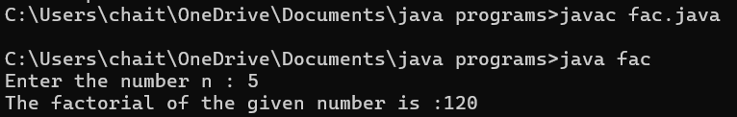

        Week-3

1. **Create the java program with the following instructions**
2. Create a class with name Car
3. Create 4 attributes named Car_Color , Car_brand, fuel_type, mileage
4. Create 3 method named Start( ) , Stop( ),  Service( )
5. Create 3 objects Car1 ,  Car2 , Car3
6. Create a constructor which should print “Welcome to Car Garage”

       Code:   public class Car{

                    public String carColor;

                    private String carBrand;

                    private String fuelType;

                    public int mileage;

                    Car(String carColor , String carBrand , String fuelType , int mileage){

                    this.carColor =  carColor;

                    this.carBrand = carBrand;

                    this.fuelType = fuelType;

                    this.mileage = mileage;

                    System.out.println(carColor + " " + carBrand + " " + fuelType + " " + mileage);

                    }

                    public void Start(){

                    System.out.println("The car has just started");

                    }

                    public void Stop(){

                    System.out.println("The car has just stopped");

                    }

                    public void Service(){

                    System.out.println("The car is in good condition");

                     }

                    public static void main(String[] args){

                   Car Car1 = new Car("Black","Hyundai","Petrol",100);

                   Car Car2 = new Car("White","Suzuki","Diesel",150);

                   Car Car3 = new Car("Red","Benz","Petrol",200);

                   Car1.Start();

                   }

                   }

**Output:**

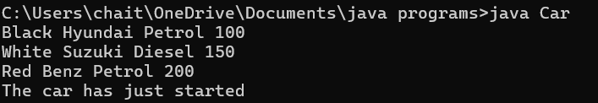

**Errors :**

|  |  |  |
| --- | --- | --- |
| **s.no** | **Expected Error** | **Reason** |
| 1 | } | } is expected at end of the calass |
| 2 | Setting the parameters inside  the constructer | Without setting the constructor we cannot pass the values |

**Class Diagram:**

|  |
| --- |
| Car |
| + carColor : String  - carBrand : String  - fuelType : String  + mileage : int |
| + Car( ) : void  + Start( ) : void  + Stop( ) : void  + Service( ) : void |

1. Write a java program to create a class BackAccount with two methods deposit( ) and withdraw( )

1. In deposit( ) whenever an amount is deposited it has to be updated with current amount
2. In withdraw( ) whenever an amount is withdrawn it has to be less than current amount else print “Insufficient funds”.

     Code :  public class BankAccount{

                  private String Name;

                  private int AccNo, CurrBal ;

                  BankAccount(String Name, int AccNo, int CurrBal){

      this.Name = Name;

      this.AccNo = AccNo;

      this.CurrBal = CurrBal;

      System.out.println("The customers are : " + this.Name + " ");

      }

      public int deposit(int dAmt){

      CurrBal = CurrBal + dAmt ;

      return CurrBal;

      }

      public void withdraw(int wAmount){

     if(wAmount < CurrBal){

     CurrBal = CurrBal - wAmount ;

    System.out.println(CurrBal);

    }

    else{

   System.out.println("Insufficient funds");

   }

   }

   public static void main(String[] args){

   BankAccount Srinivas = new BankAccount("Bhuvana",1500,10000);

   Srinivas.withdraw(25000);

   Srinivas.withdraw(1800);

   int FinalAmount =Srinivas .deposit(20000);

   System.out.println(FinalAmount);

   }

    }

**Output:**

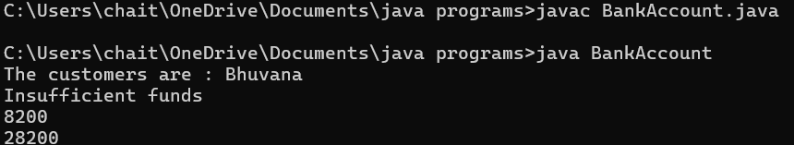

**Errors :**

|  |  |  |
| --- | --- | --- |
| **s.no** | **Expected Errors** | **Reason** |
| 1 | Giving the parameters inside the constuctor | We cannot pass the values inside the constructor without setting first |
| 2 | } | } is sometimes missing at the end of class |

|  |
| --- |
| **BankAccount** |
| -Name : String    - AccNo :String     -CurrlBal :String |
| + Bank Account() :  void   +deposit() :int   +withdraw() : void |

Class Diagram :