**Introduction**

This document will explain how to create a SliderViewer widget. The widget allows you to scroll through a stack of images, or play them as a movie. Read this entire document before doing anything else.

A couple caveats…

* Be warned…using custom widgets is a very manual process requiring a decent familiarity with computers. In theory, you could likely get by without knowing HTML, javascript, or CSS, but it’s better if you do.
* We haven’t used this widget extensively in our books, so it isn’t exactly battle-hardened. I expect bugs, and appreciate any feedback. That being said, as a free-time project being done by a busy neuro fellow, technical support will be spotty at best. If you find this walk-through extremely difficult / impossible to follow, this widget will likely be more trouble than it’s worth for you.

First, I’ll show you a working widget included with the files you downloaded. Next, we’ll recreate that working widget step-by-step.

**View the Sample Widget**

* Go to the “Sample” Folder
* This contains a widget (Images – CT.wdgt) that has been placed into a Sample.iba iBooks author file.
* Open the Sample.iba first.
* Go to Section 1, Page 1. You’ll see an HTML widget with the Images – CT.wdgt file included in it.

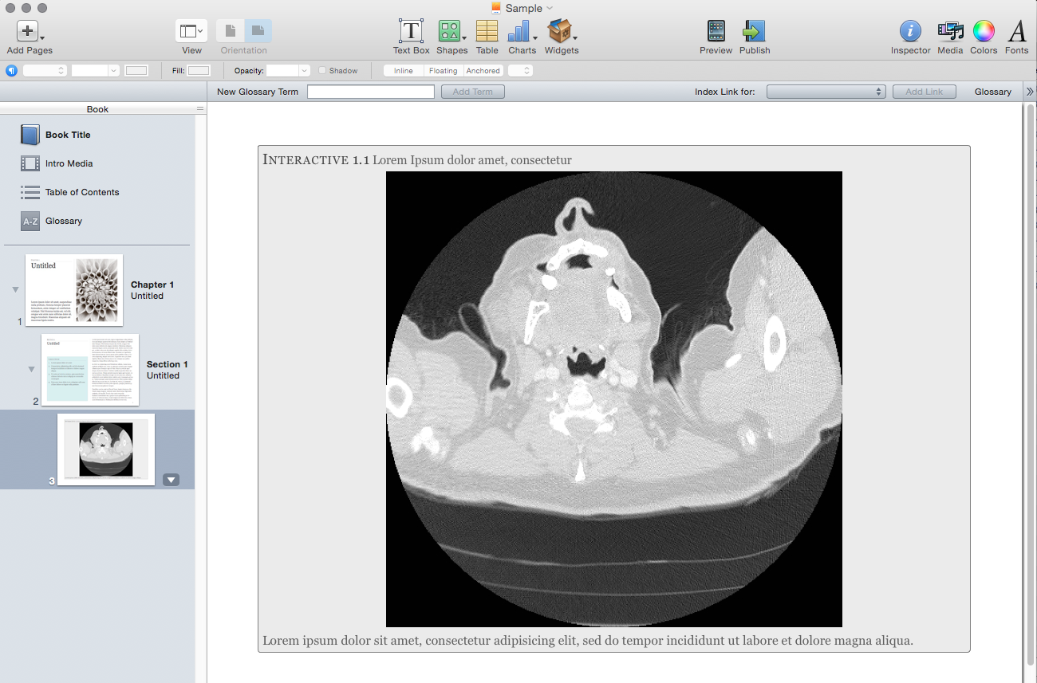

* To see the widget work, select “File🡪Preview Current Section Only” in iBooks Author. This will open the book in iBooks.

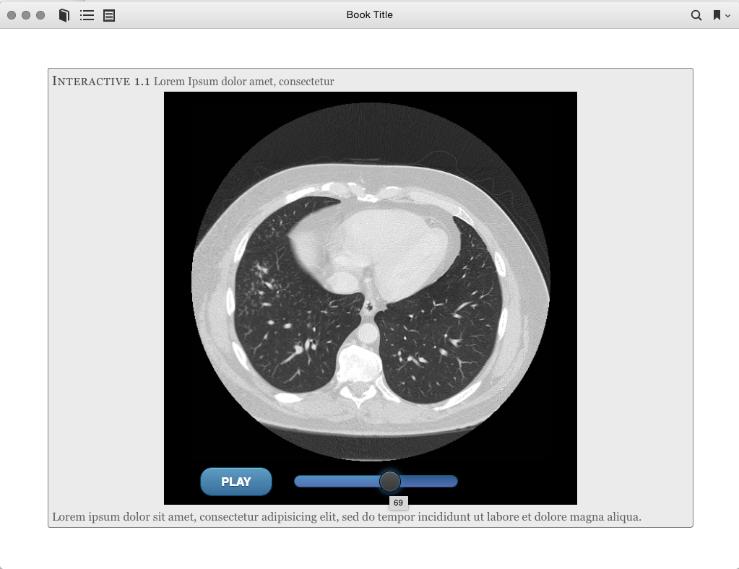

* It should look something like the above screenshot. If you can get this far, that’s reassuring you have everything installed correctly. Now we’ll examine the widget closer.

**Pick Apart the Sample Widget**

* First, read this document: <http://support.apple.com/en-us/HT5068>
  + This is Apple’s official “Here’s how you make custom widgets” document. It’s pretty short, but worth being familiar with.
* Next, a couple words about how a custom widget is implemented by Apple. It’s basically a webpage bundled into a .wdgt file. A webpage consists of an HTML file with supporting javascript and CSS. A .wdgt file is basically a zip file containing other files and folders.
* To illustrate this, right-click on the “Images – CT.wdgt” file in the “Sample” folder and select “Show Package Contents”. This will show you all the files contained within the .wdgt file. Let’s go through those quick:
  + Default.png
    - This image is what will show up in iBooks before the widget is activated. You can make it any image you want, just name it “Default.png”
  + Helvetica-PI-Regular.otf
    - This is a custom font I used for the widget. If you deleted this file, a default font would just be used.
  + Images Folder
    - This contains the images displayed in the widget. **It must contain only image files, and those images need to be numbered sequentially as you see them.** The widget won’t work otherwise.
  + Info.plist
    - This contains configuration information for the widget. **Importantly, this is how you specify the size of your widget in iBooks Author.** More on that later.
  + jquery-1.8.3.min.js, jquery.mobile-1.3.2.min.css, jquery.mobile-1.3.2.min.js
    - I use JQuery Mobile to create the slider at the bottom of the screen. Jquery is a javascript library that lets you put cool things onto websites. These files allow you to use jquery, and are required for the widget.
  + SliderViewer.html
    - This is basically the widget. It’s the HTML file that will display when you use your widget. You can open this up in any browser, so give it a try. Double-click on it to bring up the widget and play around with it a little.

**Create Your Own Widget Using the Creator**

* Automator is a Mac program that allows you to automate certain processes. I’ve created an Automator program that will create a widget for you. We’ll walk through using it.
* If you want to see the guts of the Automator program, open Automator and then open the “SliderViewer Widget Creator” file in Automator. It makes extensive use of ShellScript if you’re familiar.
* To get started, double-click on the “SliderViewer Widget Creator” file. This will run the program.
* First, you will be prompted to select your template .wdgt file. I created some templates that the program uses. There are currently 3:
  + SliderViewer Legend Left Template
    - A widget with a legend to the left of the images.
  + SliderViewer Legend Top Template
    - A widget with a legend at the top.
  + SliderViewer No Legend Template
    - A widget with no legend.
* Select the template in the “SliderViewer No Legend Template” as shown below.

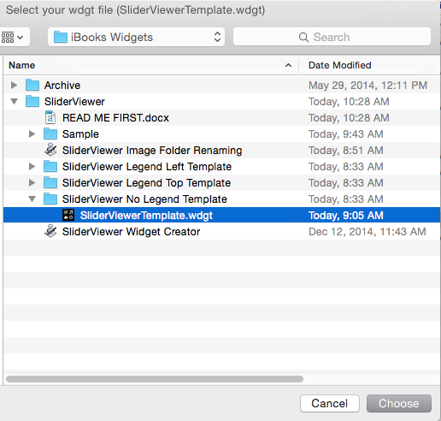

* Next, you will be prompted to enter a legend title. Since we’re not using a legend, just click “OK”

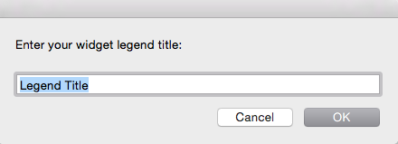

* Next, you will be prompted to enter legend text. Since we’re not using a legend, just click “OK”

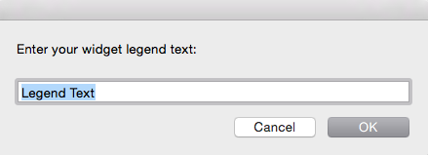

* Next, you’re prompted to enter your desired frames-per-second. This is how fast the movie will play in the widget. You can change this manually later. Refer to the “Create Your Own Widget By Modifying the Sample” section for this. Enter a number and click “OK”

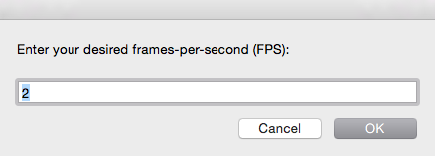

* Next, you’re prompted to select your “images” folder. This can be any folder containing ordered images, and should contain ONLY images, not any other files. I’ve included sample image folders containing a CT (Sample🡪Images – CT), fluoro study, and ultrasound study. You can select any of those folders and click “CHOOSE”.

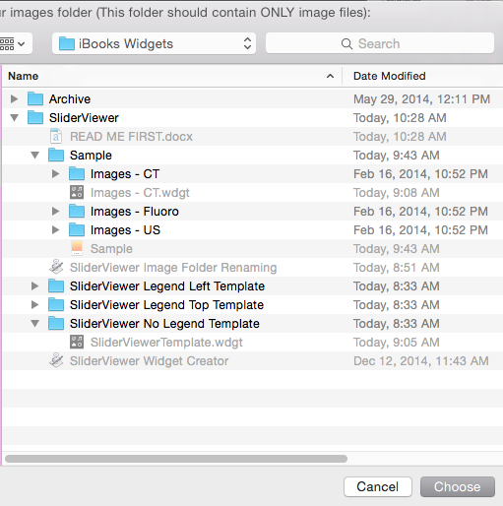

* Finally, you’re prompted to save your widget to a directory. Choose a directory. The program will finish, and you should see a .wdgt file in the directory you chose. The .wdgt file will get named whatever your images folder was called. You can manually change the name if you want.

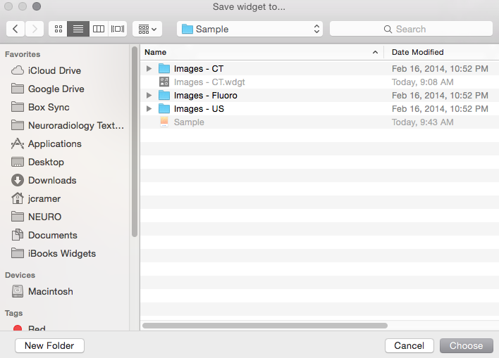

* Now we’ve created our widget. I chose the “Images – Fluoro” folder, so I have a “Images – Fluoro.wdgt” file.
* We’ll now put that into an iBook.
* Open iBooks Author, choose a template.
* Create a blank page.
* Insert an HTML widget. Your screen will look somewhat like this:

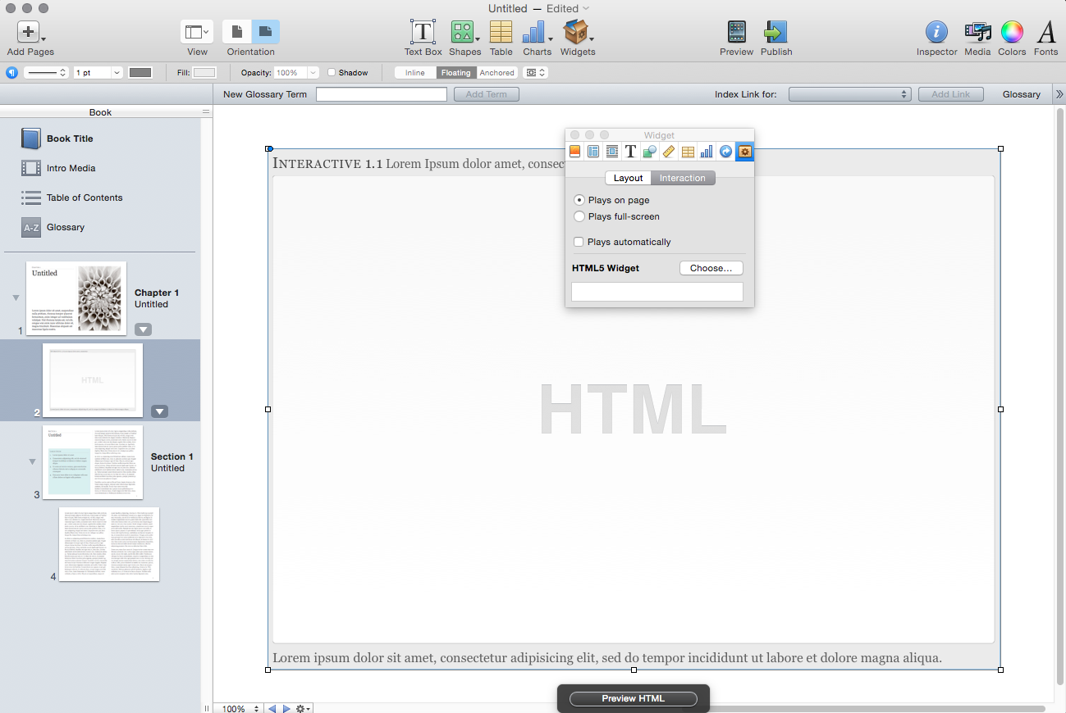

* Drag your .wdgt file into the “HTML” area. Now it should look like this:

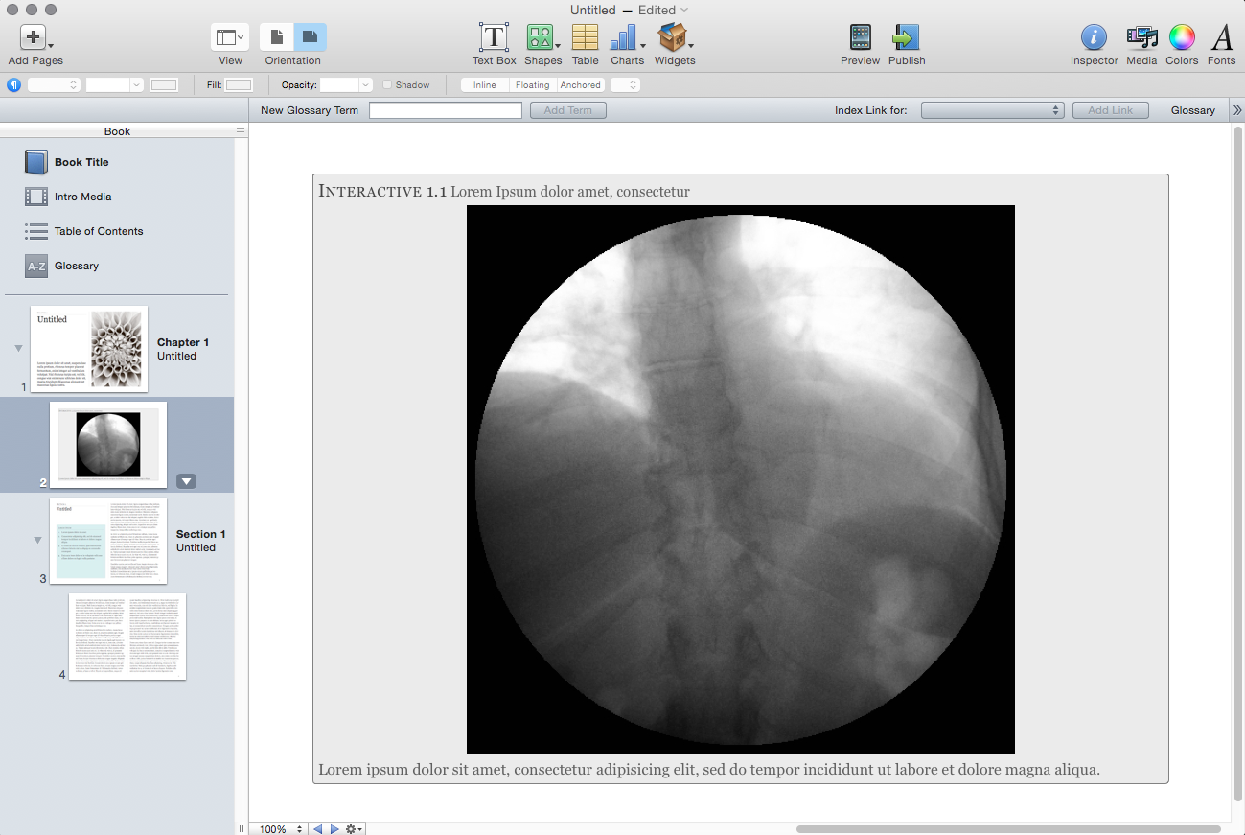

* Resize the widget to your liking.
* Click on the widget image. Select the “Inspector” button.
* Select the “Widget” section of the inspector. Make sure “Plays on Page” and “Plays Automatically” are selected.

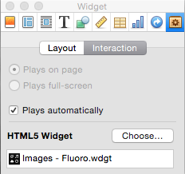

* Click on the Metrics section of the inspector (the ruler button). Note the size of the widget image in width and height. In my case, it’s 572 x 572.

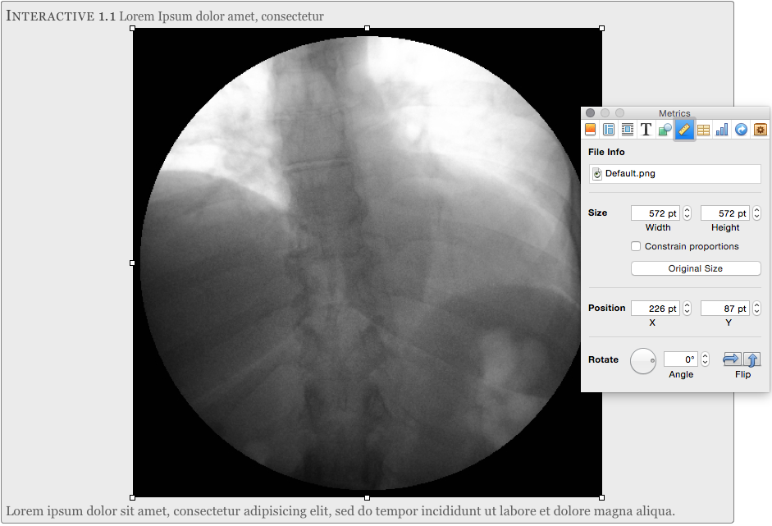

* Enter your .wdgt file by right-clicking and selecting “Show Package Contents”
* Open the “Info.plist” file. XCode works well as a program to open it with, but to keep it simple I’ll open it with the Text Editor.
* Notice the following:

<key>Height</key>

<integer>1024</integer>

<key>Width</key>

<integer>768</integer>

* Change the height and width to the height and width of your widget (again, in my case it’s 572 x 572). Save the Info.plist file and close it.
* Drag the .wdgt file into the iBooks Author widget again. (I realize this whole process is clunky. Play around with it and if you find a better way, let me know.)
* Now would be a good time to save the iBooks author file.
* Now, preview the widget! Select “File🡪Preview Current Section Only” in iBooks Author. This will open a book in iBooks author at the page of your widget. The widget should start automatically. Play around with it a little.
* A couple important points to note…
  + As you saw, we configured the widget to run from within the page. This is a brand-spanking new feature. It’s easier to interact with, and allows you use the widget legend instead of having a legend within the widget.
  + Before, you had to click the widget and open it in fullscreen mode. If you still wanted to do that, then “Plays full-screen” should be selected, and your width and height should be 1024x768 in the Info.plist file, respectively.
  + If you play your widget full-screen, you’ll want a legend as well, which you can specify while creating your widget. Just select a widget template that has a legend (top or left). You can always edit the legend from the SliderViewer.html file as well.

**Create Your Own Widget By Modifying the Sample**

* Kind of laborious, right? Say you wanted to create a bunch of widgets that were exactly the same. You would want to copy the .wdgt file, insert some new images, and be done. We’ll walk through how to do that now.
* Within the “Sample” folder, you’ll see the “Images – CT.wdgt” file included. This is a sample working widget. Let’s make it an ultrasound widget and add that to the “Sample.iba” iBook.
* Copy and paste the “Images – CT.wdgt” file into the same folder, and rename the new file “Images – US.wdgt”.

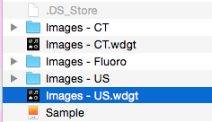

* Now we need a folder of sequentially-named ultrasound images to put in the widget. If you open the “Images – US” folder, you’ll see that they’re sequentially named, but not “1.jpg”, “2.jpg”, etc. So, we need to rename them. Fortunately, I wrote another automator program to do just that.
* Double-click the “SliderViewer Image Folder Renaming” automator program.
* You’re prompted to select your images folder. Choose the “Images – US” folder.
* The program will create a folder called “renamed_images” on your Desktop. You’ll see it now contains appropriately named images. Select all these images, right-click, and select “Copy”
* Right-click on the “Images – US.wdgt” file and “Show Package Contents” again. Go into the “images folder”.
* Select all the images in that folder and delete them. Then, paste the images from the “renamed_images” folder into the “images” folder.
* At this point, you could drag the new widget into iBooks Author and it would look ok, but now we’ll make some tweaks.
  + Open the “SliderViewer.html” file with a text editor. (TextEditor or XCode work well.)
  + You’ll see 3 JavaScript variables you may want to change:
    - filetype
      * The default is “jpg”, but if you are using png or gif, you’ll need to enter that ile extension.
    - num_images
      * This specifies the number of images in the folder. I know, I know…why can’t the program just figure that out? Because javascript has a limited ability to interact with files and folders…I tried. If you can figure it out please share.
      * You’ll need to change this for the “Images – US.wdgt” – there are a different number of images in that study.
    - framerate_fps
      * This specifies the framerate. Change this to your liking.
  + Notice that the “Default.png” file is still a CT image. To change this, convert one of the images from your “images” folder to a PNG. You can use Preview to do this. Open the jpg image in Preview, then select “File🡪Export”, specify PNG as the filetype, and name your file “Default.png”. Then delete the existing “Default.png” file and replace it with your new one.
  + Finally, you’ll notice the size of the files is different. When I dragged the widget into iBooks author, the size was 881x572. So, change your Info.plist file, then re-drag the widget into iBooks Author.

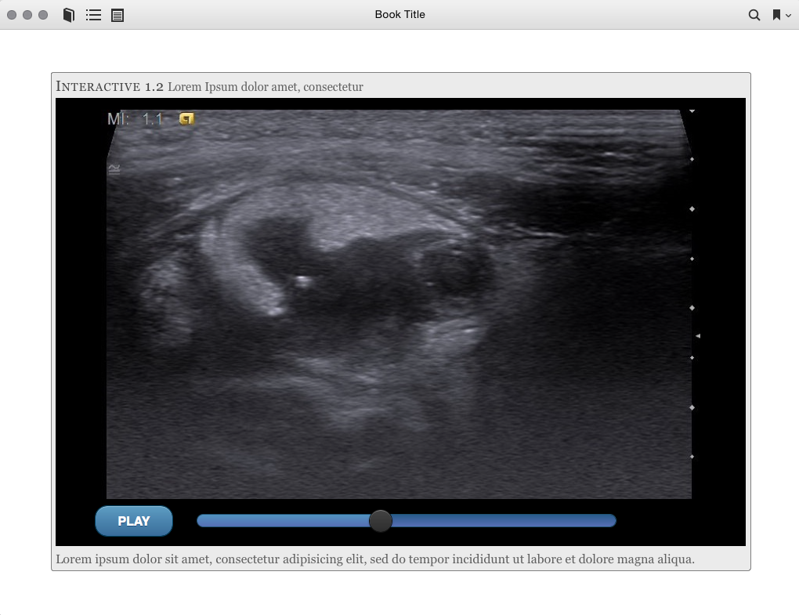

There it is! Hopefully you didn’t destroy your computer before this point… You may find it easier to tweak existing widgets to create new ones, or just use the widget creator each time. Clearly, this is a manual and somewhat complex process – I’ve automated it as much as possible given limited resources. The widget is pretty slick. If it’s worth it to you, give it a try, and let me know what you think.