Assignment 0918

Dating Websites

**Guideline Survey**

**General Assessment:**

**Learnability:**

E-harmony: Users were able to fill out profiles almost instantly. Searching was hard to understand and users became frustrated with the searching of the system.

Match.com: Menus were easy to understand and users could fill out profiles almost instantly. The searching function was easy to pick up on for users, and users could navigate the site with ease.

Christian Mingle: The site was very simple and easy to understand. Menus were clearly marked, and everything was labeled very quickly.

**Efficiency:**

E-harmony: E-harmony was efficient on every test except for search ability, which it tested very poorly in. Its search ability was foreign to users who were familiar with networking sites and caused users to be frustrated.

Math.com: Match.com was very intuitive to users for all aspects. Users felt that they could navigate the site quickly and efficiently with little errors and with a low learning curve.

Christian Mingle: Users liked how simple ChristianMingle.com was. They felt that the simplicity helped them navigate the site easily. The only thing that was not simple was updating profile information, which took users a few more clicks than necessary.

**Satisfaction:**

E-harmony: users felt this site was very good for something, but bad for dating itself. Users felt that it was next to impossible and very timely to connect with matches. Users had low satisfaction with the site.

Match.com: Users felt that this was the preferred choice in dating websites. It combined the comprehensiveness of E-harmony with the comprehensiveness of Match.com. Users were happy with how quick they picked up the site and how natural the interface was.

Christian Mingle: Users felt Christian Mingle was easy to use, but too simple. Users did not feel that the creating a profile interface was comprehensive enough. Although the menus were simple, they felt that the actions they wanted to take were not always available in the menus.

**Interface design choices:**

1. Headings, titles, and labels
2. Search

**Reference used: U.S. Dept. of Health and Human Services. The Research-Based Web Design & Usability Guidelines, Enlarged/Expanded edition. Washington: U.S. Government Printing Office, 2006. **

**Headings, titles, and labels**

**“These labels are clear and distinct, allowing users to distinguish paths quickly”**

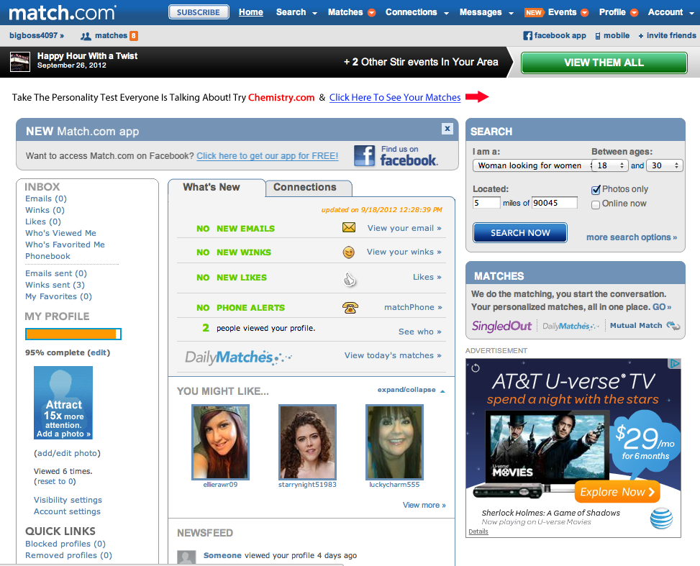

**Search**

**“Results of user searches provide the precise information being sought, and in a format that matches users’ expectations.”**

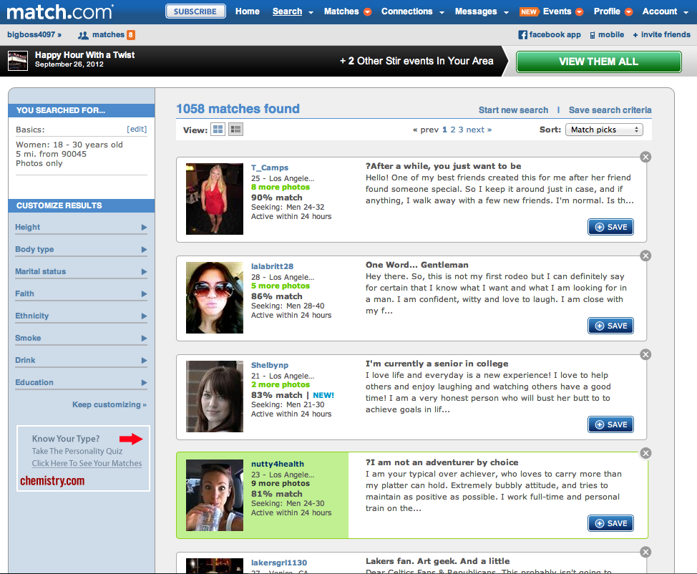

**Conclusion**

We found that most users would prefer to use Match.com as a dating website. The users we tested felt that eHarmony was too complex to understand and that searching and contacting matches online took too long. When setting up profiles, On Christian Mingle, they felt that the process of setting up a profile was too quick, and they did not feel that the system got an accurate assessment of which they are and what they are looking for in a partner. From the feedback we received, users felt Match.com was comprehensive during the online registration process, and appreciated the fact they could see and connect with their matches almost instantly. After making a profile, users could generally make changes to their profile very quickly. However, Christian Mingle profile changes were not so intuitive to change for the user. In conclusion, EHarmony seemed very complex and clunky, ChristianMingle seemed very simple and basic, and Match.com seemed the most comprehensive and intuitive.