Enquête logiciels SU - Septembre 2015

FEDORU

07/09/2015

# 7/9/2015

Reprise de l'exploitation des logiciels des SU

* fichier source: DATA/FEDORU - ENQUETE LOGICIEL 2015 - V2 (12 06 15) (3)
* création d'un dossier spécifique **Septembre2015** contenent un sous dossier **data** pour y stocker les résultats régionaux sous forme de fichier .csv.

## Récupération des fichiers csv

* les 5 premières lignes sont éliminées
* élimination du héader => il faudre en créer un

path = "./data/" # ./Septembre2015/data/ si console  
out.file <- NULL  
file.names <- dir(path, pattern =".csv") # seuls les fichiers se terminant par csv sont lus  
for(i in 1:length(file.names)){  
 file <- read.table(paste(path, file.names[i], sep=""), skip = 5, header = FALSE, sep=",", stringsAsFactors=FALSE)  
 # on ne garde que les 22 premières colonnes  
 file <- file[, 1:22]  
 # on ne garde que les lignes où les colonnes 1 à 5 ne sont pas vides (http://genometoolbox.blogspot.fr/2014/01/remove-rows-with-na-values-from-r-data.html)  
 file <- file[complete.cases(file[,1:5]),]  
 # remplacement de la virgule écimale par le point décimal (soirce: http://stackoverflow.com/questions/5487164/r-how-to-replace-parts-of-variable-strings-within-data-frame)  
 file <- as.data.frame(sapply(file, gsub, pattern = ",", replacement = "."))  
  
 out.file <- rbind(out.file, file)  
 }  
  
n <- c("Region", "Departement", "FINESS", "Hopital", "CP", "Routage","Logiciel_2014","Editeur", "RPU_transmis","Nb_RPU_T1_2015", "Logiciel_2015", "Version_2015", "Coment", "Freq_remontee", "DN_exhaus","DN_confor", "DP_exhaus", "DP_confor", "MS_exhaus", "MS_confor", "Jours_manquants", "coment2")  
 names(out.file) <- n  
  
write.table(out.file, file = "archive.csv", sep=",", row.names = FALSE, qmethod = "double", fileEncoding="utf-8")

## Récupération du fichier des données

* Nombre de régions participantes: 7
* Nombre de sites: 182

# Cartographie

Cartographie des régions participantes et des logiciels.

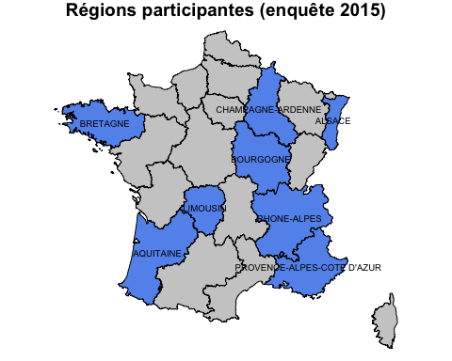

# Logiciels 2015

* Nombre de logiciels utilisés: 31

## Logiciels par ordre décroissant

TU-ORUPACA URQUAL RESURGENCES DMU   
 43 24 21 14   
 DXCARE SILLAGE DMU ATALANTE SIDSU   
 11 10 9 9   
 CROSSWAY POLYMEDIS DOPA URGENCES ANTARES   
 6 5 3 2   
HOPITAL MANAGER ORBIS SANOCOM SHAREGATE   
 2 2 2 2   
 SIGEMS AGFA EXAGON AXIGATE CLINICOM   
 2 1 1 1   
 M-PLUS MANUEL MEDIBASE MEDIBOARD   
 1 1 1 1   
 MEDINTUX MEDIS NAFAMA OSOFT   
 1 1 1 1   
 QCARE SPEC 4D TRACK CARE   
 1 1 1

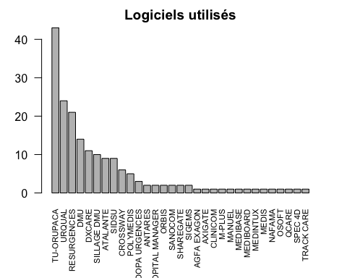

## Logiciels par région

ALSACE AQUITAINE BOURGOGNE BRETAGNE CHAMPAGNE ARDENNES  
 AGFA EXAGON 0 0 1 0 0  
 ANTARES 2 0 0 0 0  
 ATALANTE 8 0 1 0 0  
 AXIGATE 0 1 0 0 0  
 CLINICOM 1 0 0 0 0  
 CROSSWAY 0 3 3 0 0  
 DMU 2 0 7 0 3  
 DOPA URGENCES 0 1 0 0 2  
 DXCARE 3 6 1 0 1  
 HOPITAL MANAGER 0 0 2 0 0  
 M-PLUS 0 1 0 0 0  
 MANUEL 0 0 1 0 0  
 MEDIBASE 0 1 0 0 0  
 MEDIBOARD 0 0 0 1 0  
 MEDINTUX 0 0 0 0 0  
 MEDIS 0 0 0 1 0  
 NAFAMA 0 0 0 0 1  
 ORBIS 1 0 0 1 0  
 OSOFT 0 0 0 1 0  
 POLYMEDIS 0 0 0 0 5  
 QCARE 0 0 0 0 0  
 RESURGENCES 1 1 3 7 1  
 SANOCOM 0 2 0 0 0  
 SHAREGATE 0 2 0 0 0  
 SIDSU 0 9 0 0 0  
 SIGEMS 0 2 0 0 0  
 SILLAGE DMU 0 2 0 8 0  
 SPEC 4D 0 0 0 0 0  
 TRACK CARE 0 1 0 0 0  
 TU-ORUPACA 0 0 1 0 0  
 URQUAL 0 3 3 11 3  
   
 LIMOUSIN PACA  
 AGFA EXAGON 0 0  
 ANTARES 0 0  
 ATALANTE 0 0  
 AXIGATE 0 0  
 CLINICOM 0 0  
 CROSSWAY 0 0  
 DMU 0 2  
 DOPA URGENCES 0 0  
 DXCARE 0 0  
 HOPITAL MANAGER 0 0  
 M-PLUS 0 0  
 MANUEL 0 0  
 MEDIBASE 0 0  
 MEDIBOARD 0 0  
 MEDINTUX 0 1  
 MEDIS 0 0  
 NAFAMA 0 0  
 ORBIS 0 0  
 OSOFT 0 0  
 POLYMEDIS 0 0  
 QCARE 0 1  
 RESURGENCES 6 2  
 SANOCOM 0 0  
 SHAREGATE 0 0  
 SIDSU 0 0  
 SIGEMS 0 0  
 SILLAGE DMU 0 0  
 SPEC 4D 1 0  
 TRACK CARE 0 0  
 TU-ORUPACA 0 42  
 URQUAL 2 2

Nombre de logiciels différents par région

ALSACE AQUITAINE BOURGOGNE   
 7 14 10   
 BRETAGNE CHAMPAGNE ARDENNES LIMOUSIN   
 7 7 3   
 PACA   
 6

## Cartographie des logiciels

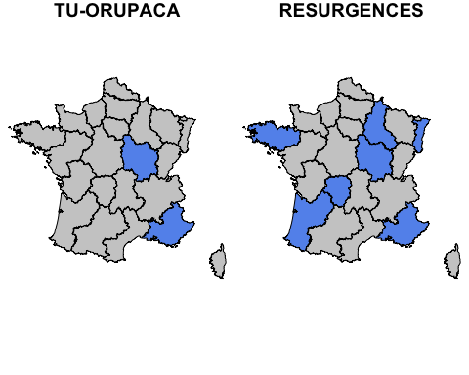 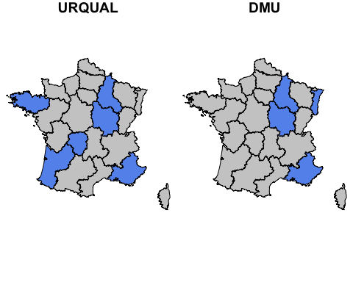 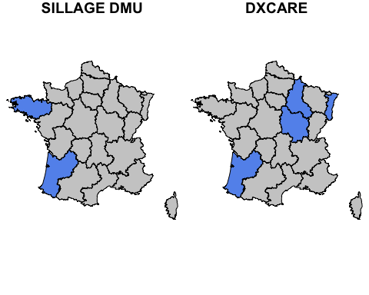 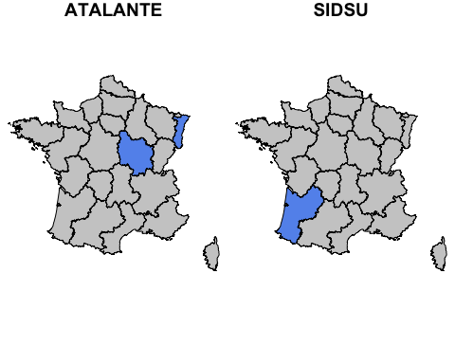

## Un logiciel est présent dans combien de régions ?

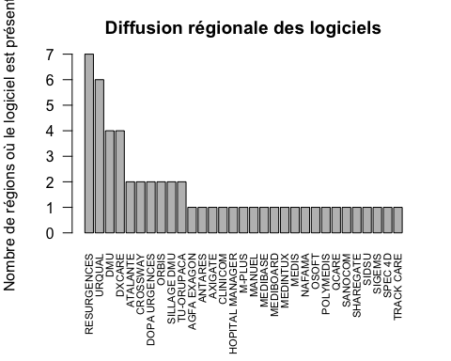

# Analyse des RPU

Nombre de RPU produits: 1239246

## Nombre de RPU par logiciel

Nb de RPU  
TU-ORUPACA 357014  
URQUAL 243561  
RESURGENCES 167160  
DXCARE 84584  
DMU 80896  
ATALANTE 44712  
SIDSU 44401  
SILLAGE DMU 44320  
CROSSWAY 23376  
POLYMEDIS 20363  
TRACK CARE 11345  
DOPA URGENCES 10420  
M-PLUS 9970  
ANTARES 8974  
SHAREGATE 8639  
SANOCOM 7150  
MEDIBOARD 7080  
CLINICOM 7023  
SPEC 4D 7015  
MEDIS 6974  
MEDINTUX 6224  
ORBIS 6204  
NAFAMA 5156  
QCARE 5131  
AXIGATE 4282  
OSOFT 3404  
SIGEMS 3266  
MEDIBASE 2913  
HOPITAL MANAGER 2644  
AGFA EXAGON 2541  
MANUEL 2504

## Nombre de jours manquants

### Par logiciel

Nb de jours manquants  
URQUAL 111  
TU-ORUPACA 90  
CROSSWAY 63  
SILLAGE DMU 42  
ORBIS 30  
RESURGENCES 5  
CLINICOM 4  
HOPITAL MANAGER 3  
ATALANTE 2  
DMU 2  
ANTARES 1  
AGFA EXAGON 0  
AXIGATE 0  
DOPA URGENCES 0  
DXCARE 0  
M-PLUS 0  
MANUEL 0  
MEDIBASE 0  
MEDIBOARD 0  
MEDINTUX 0  
MEDIS 0  
NAFAMA 0  
OSOFT 0  
POLYMEDIS 0  
QCARE 0  
SANOCOM 0  
SHAREGATE 0  
SIDSU 0  
SIGEMS 0  
SPEC 4D 0  
TRACK CARE 0

### Par région

Nb de jours manquants  
PACA 180  
AQUITAINE 63  
BRETAGNE 52  
ALSACE 34  
BOURGOGNE 21  
CHAMPAGNE ARDENNES 3  
LIMOUSIN 0

# Indicateurs

Trois indicateurs ont été retenus:

* Date de naissance
* Diagnostic principal (DP)
* Mode de sortie

Chaque indicateur a été évalué sur deux critères: **conformité** et **exhaustivité**.

## Date de naissance

* taux de conformité:

Min. 1st Qu. Median Mean 3rd Qu. Max. NA's   
 0.00 100.00 100.00 99.44 100.00 100.00 2

* conformité par outil:

Min Max moyenne ecart-type Nb  
AGFA EXAGON 100.00 100.00 100.00000 NA 1  
ANTARES 100.00 100.00 100.00000 0.00000000 2  
ATALANTE 100.00 100.00 100.00000 0.00000000 9  
AXIGATE 100.00 100.00 100.00000 NA 1  
CLINICOM 100.00 100.00 100.00000 NA 1  
CROSSWAY 100.00 100.00 100.00000 0.00000000 6  
DMU 100.00 100.00 100.00000 0.00000000 14  
DOPA URGENCES 100.00 100.00 100.00000 0.00000000 3  
DXCARE 100.00 100.00 100.00000 0.00000000 11  
HOPITAL MANAGER 100.00 100.00 100.00000 0.00000000 2  
M-PLUS 100.00 100.00 100.00000 NA 1  
MANUEL 100.00 100.00 100.00000 NA 1  
MEDIBASE 100.00 100.00 100.00000 NA 1  
MEDIBOARD 100.00 100.00 100.00000 NA 1  
MEDINTUX 99.92 99.92 99.92000 NA 1  
MEDIS 100.00 100.00 100.00000 NA 1  
NAFAMA 99.80 99.80 99.80000 NA 1  
ORBIS 100.00 100.00 100.00000 0.00000000 2  
OSOFT 100.00 100.00 100.00000 NA 1  
POLYMEDIS 100.00 100.00 100.00000 0.00000000 5  
QCARE 99.98 99.98 99.98000 NA 1  
RESURGENCES 99.95 100.00 99.99714 0.01101946 21  
SANOCOM 100.00 100.00 100.00000 0.00000000 2  
SHAREGATE 100.00 100.00 100.00000 0.00000000 2  
SIDSU 100.00 100.00 100.00000 0.00000000 9  
SIGEMS 100.00 100.00 100.00000 NA 2  
SILLAGE DMU 100.00 100.00 100.00000 0.00000000 10  
SPEC 4D 100.00 100.00 100.00000 NA 1  
TRACK CARE 100.00 100.00 100.00000 NA 1  
TU-ORUPACA 0.00 100.00 97.67442 15.24985703 43  
URQUAL 99.80 100.00 99.98958 0.04101741 24

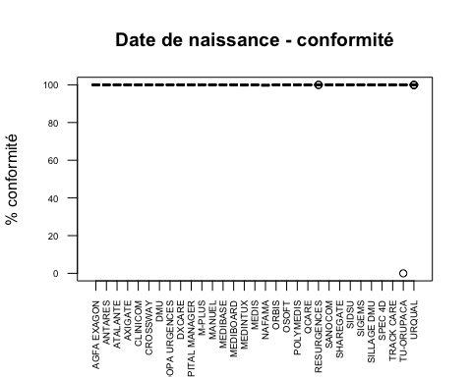

* taux d'exhaustivité:

Min. 1st Qu. Median Mean 3rd Qu. Max. NA's   
 0.00 100.00 100.00 99.44 100.00 100.00 2

* exhaustivité par outil

Min Max moyenne ecart-type Nb  
AGFA EXAGON 100.00 100.00 100.00000 NA 1  
ANTARES 100.00 100.00 100.00000 0.00000000 2  
ATALANTE 100.00 100.00 100.00000 0.00000000 9  
AXIGATE 100.00 100.00 100.00000 NA 1  
CLINICOM 100.00 100.00 100.00000 NA 1  
CROSSWAY 100.00 100.00 100.00000 0.00000000 6  
DMU 100.00 100.00 100.00000 0.00000000 14  
DOPA URGENCES 100.00 100.00 100.00000 0.00000000 3  
DXCARE 100.00 100.00 100.00000 0.00000000 11  
HOPITAL MANAGER 100.00 100.00 100.00000 0.00000000 2  
M-PLUS 100.00 100.00 100.00000 NA 1  
MANUEL 100.00 100.00 100.00000 NA 1  
MEDIBASE 100.00 100.00 100.00000 NA 1  
MEDIBOARD 100.00 100.00 100.00000 NA 1  
MEDINTUX 99.92 99.92 99.92000 NA 1  
MEDIS 100.00 100.00 100.00000 NA 1  
NAFAMA 99.80 99.80 99.80000 NA 1  
ORBIS 100.00 100.00 100.00000 0.00000000 2  
OSOFT 100.00 100.00 100.00000 NA 1  
POLYMEDIS 100.00 100.00 100.00000 0.00000000 5  
QCARE 99.98 99.98 99.98000 NA 1  
RESURGENCES 99.95 100.00 99.99714 0.01101946 21  
SANOCOM 100.00 100.00 100.00000 0.00000000 2  
SHAREGATE 100.00 100.00 100.00000 0.00000000 2  
SIDSU 100.00 100.00 100.00000 0.00000000 9  
SIGEMS 100.00 100.00 100.00000 NA 2  
SILLAGE DMU 100.00 100.00 100.00000 0.00000000 10  
SPEC 4D 100.00 100.00 100.00000 NA 1  
TRACK CARE 100.00 100.00 100.00000 NA 1  
TU-ORUPACA 0.00 100.00 97.67442 15.24985703 43  
URQUAL 100.00 100.00 100.00000 0.00000000 24

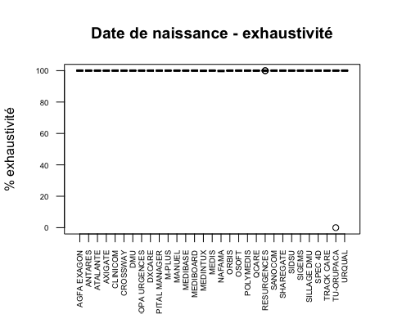

## Diagnostic (DP)

* taux de conformité:

Min. 1st Qu. Median Mean 3rd Qu. Max. NA's   
 0.00 52.24 93.80 71.48 98.32 100.00 3

* conformité par outil

Min Max moyenne ecart-type Nb  
AGFA EXAGON 12.00 12.00 12.00000 NA 1  
ANTARES 45.84 90.51 68.17500 31.58645992 2  
ATALANTE 0.00 98.95 38.23222 35.61581102 9  
AXIGATE 0.00 0.00 0.00000 NA 1  
CLINICOM 96.14 96.14 96.14000 NA 1  
CROSSWAY 0.00 94.30 24.66000 40.73362248 6  
DMU 56.80 100.00 91.39615 13.10928649 14  
DOPA URGENCES 0.00 62.90 20.96667 36.31533193 3  
DXCARE 0.00 98.90 55.91636 32.18636086 11  
HOPITAL MANAGER 95.00 100.00 97.50000 3.53553391 2  
M-PLUS 83.50 83.50 83.50000 NA 1  
MANUEL 98.00 98.00 98.00000 NA 1  
MEDIBASE 96.40 96.40 96.40000 NA 1  
MEDIBOARD 43.20 43.20 43.20000 NA 1  
MEDINTUX 92.15 92.15 92.15000 NA 1  
MEDIS 19.70 19.70 19.70000 NA 1  
NAFAMA 98.50 98.50 98.50000 NA 1  
ORBIS 0.00 0.00 0.00000 0.00000000 2  
OSOFT 98.60 98.60 98.60000 NA 1  
POLYMEDIS 97.40 99.70 98.50000 1.04403065 5  
QCARE 0.00 0.00 0.00000 NA 1  
RESURGENCES 76.00 100.00 95.90000 5.72101477 21  
SANOCOM 76.70 83.30 80.00000 4.66690476 2  
SHAREGATE 0.00 0.10 0.05000 0.07071068 2  
SIDSU 27.30 99.80 87.05556 22.82515669 9  
SIGEMS 8.40 8.40 8.40000 NA 2  
SILLAGE DMU 0.00 95.00 46.79000 43.62913018 10  
SPEC 4D 85.57 85.57 85.57000 NA 1  
TRACK CARE 96.30 96.30 96.30000 NA 1  
TU-ORUPACA 0.00 99.29 92.60605 15.96497910 43  
URQUAL 0.00 100.00 51.27750 44.46701525 24

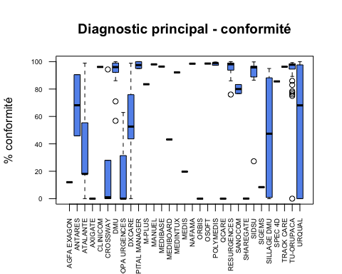

* taux de exhaustivité:

Min. 1st Qu. Median Mean 3rd Qu. Max. NA's   
 0.00 53.30 94.03 72.63 98.43 100.00 3

* exhaustivité par outil

Min Max moyenne ecart-type Nb  
AGFA EXAGON 12.00 12.00 12.00000 NA 1  
ANTARES 45.84 90.51 68.17500 31.58645992 2  
ATALANTE 0.00 98.95 38.23222 35.61581102 9  
AXIGATE 0.00 0.00 0.00000 NA 1  
CLINICOM 96.14 96.14 96.14000 NA 1  
CROSSWAY 0.00 94.40 24.68000 40.77636570 6  
DMU 56.90 100.00 91.40923 13.08995446 14  
DOPA URGENCES 0.00 62.90 20.96667 36.31533193 3  
DXCARE 0.00 98.90 55.91636 32.18636086 11  
HOPITAL MANAGER 95.00 100.00 97.50000 3.53553391 2  
M-PLUS 83.50 83.50 83.50000 NA 1  
MANUEL 99.00 99.00 99.00000 NA 1  
MEDIBASE 96.40 96.40 96.40000 NA 1  
MEDIBOARD 43.20 43.20 43.20000 NA 1  
MEDINTUX 100.00 100.00 100.00000 NA 1  
MEDIS 19.70 19.70 19.70000 NA 1  
NAFAMA 99.80 99.80 99.80000 NA 1  
ORBIS 0.00 0.00 0.00000 0.00000000 2  
OSOFT 98.60 98.60 98.60000 NA 1  
POLYMEDIS 97.40 99.70 98.74000 0.84734881 5  
QCARE 0.00 0.00 0.00000 NA 1  
RESURGENCES 76.00 100.00 96.17619 5.35447801 21  
SANOCOM 76.70 83.30 80.00000 4.66690476 2  
SHAREGATE 0.00 0.10 0.05000 0.07071068 2  
SIDSU 27.30 99.80 87.05556 22.82515669 9  
SIGEMS 8.40 8.40 8.40000 NA 2  
SILLAGE DMU 0.00 95.00 46.79000 43.62913018 10  
SPEC 4D 85.57 85.57 85.57000 NA 1  
TRACK CARE 96.30 96.30 96.30000 NA 1  
TU-ORUPACA 0.00 99.29 92.61837 15.96750434 43  
URQUAL 0.00 100.00 59.07167 42.92287387 24

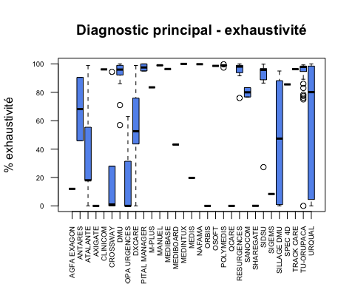

## Mode de sortie (MS)

* taux de conformité:

Min. 1st Qu. Median Mean 3rd Qu. Max. NA's   
 0.00 94.65 99.59 87.12 100.00 100.00 2

* conformité par outil

Min Max moyenne ecart-type Nb  
AGFA EXAGON 100.00 100.00 100.00000 NA 1  
ANTARES 83.99 84.48 84.23500 0.3464823 2  
ATALANTE 0.00 99.14 59.77889 37.0790394 9  
AXIGATE 99.90 99.90 99.90000 NA 1  
CLINICOM 100.00 100.00 100.00000 NA 1  
CROSSWAY 0.00 95.00 19.30000 42.3225708 6  
DMU 97.41 100.00 99.39071 1.0119096 14  
DOPA URGENCES 69.10 82.60 77.36667 7.2431577 3  
DXCARE 21.05 100.00 84.57545 31.5886994 11  
HOPITAL MANAGER 100.00 100.00 100.00000 0.0000000 2  
M-PLUS 16.80 16.80 16.80000 NA 1  
MANUEL 99.00 99.00 99.00000 NA 1  
MEDIBASE 65.70 65.70 65.70000 NA 1  
MEDIBOARD 99.96 99.96 99.96000 NA 1  
MEDINTUX 100.00 100.00 100.00000 NA 1  
MEDIS 13.50 13.50 13.50000 NA 1  
NAFAMA 99.80 99.80 99.80000 NA 1  
ORBIS 15.70 19.80 17.75000 2.8991378 2  
OSOFT 100.00 100.00 100.00000 NA 1  
POLYMEDIS 99.30 99.90 99.68000 0.2683282 5  
QCARE 0.00 0.00 0.00000 NA 1  
RESURGENCES 0.00 100.00 85.14286 35.6807092 21  
SANOCOM 100.00 100.00 100.00000 0.0000000 2  
SHAREGATE 100.00 100.00 100.00000 0.0000000 2  
SIDSU 98.20 100.00 99.45556 0.5659309 9  
SIGEMS 99.90 99.90 99.90000 NA 2  
SILLAGE DMU 68.50 100.00 95.38000 9.7412981 10  
SPEC 4D 99.97 99.97 99.97000 NA 1  
TRACK CARE 98.30 98.30 98.30000 NA 1  
TU-ORUPACA 0.00 100.00 94.40977 15.9900007 43  
URQUAL 14.29 100.00 92.29042 17.8575816 24

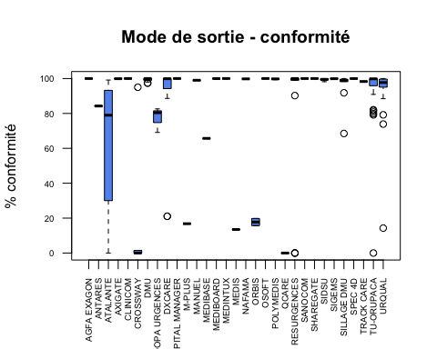

* taux de exhaustivité:

Min. 1st Qu. Median Mean 3rd Qu. Max. NA's   
 0.00 94.65 99.59 87.12 100.00 100.00 2

* exhaustivité par outil

Min Max moyenne ecart-type Nb  
AGFA EXAGON 100.00 100.00 100.00000 NA 1  
ANTARES 83.99 84.48 84.23500 0.3464823 2  
ATALANTE 0.00 99.14 59.77889 37.0790394 9  
AXIGATE 100.00 100.00 100.00000 NA 1  
CLINICOM 100.00 100.00 100.00000 NA 1  
CROSSWAY 0.00 95.10 19.32000 42.3672869 6  
DMU 97.41 100.00 99.39071 1.0119096 14  
DOPA URGENCES 69.10 82.60 77.36667 7.2431577 3  
DXCARE 21.05 100.00 84.57545 31.5886994 11  
HOPITAL MANAGER 100.00 100.00 100.00000 0.0000000 2  
M-PLUS 16.80 16.80 16.80000 NA 1  
MANUEL 99.00 99.00 99.00000 NA 1  
MEDIBASE 65.70 65.70 65.70000 NA 1  
MEDIBOARD 99.96 99.96 99.96000 NA 1  
MEDINTUX 100.00 100.00 100.00000 NA 1  
MEDIS 13.50 13.50 13.50000 NA 1  
NAFAMA 99.80 99.80 99.80000 NA 1  
ORBIS 15.70 19.80 17.75000 2.8991378 2  
OSOFT 100.00 100.00 100.00000 NA 1  
POLYMEDIS 99.30 99.90 99.68000 0.2683282 5  
QCARE 0.00 0.00 0.00000 NA 1  
RESURGENCES 0.00 100.00 85.14286 35.6807092 21  
SANOCOM 100.00 100.00 100.00000 0.0000000 2  
SHAREGATE 100.00 100.00 100.00000 0.0000000 2  
SIDSU 98.20 100.00 99.45556 0.5659309 9  
SIGEMS 99.90 99.90 99.90000 NA 2  
SILLAGE DMU 68.50 100.00 95.38000 9.7412981 10  
SPEC 4D 99.97 99.97 99.97000 NA 1  
TRACK CARE 98.30 98.30 98.30000 NA 1  
TU-ORUPACA 0.00 100.00 94.40977 15.9900007 43  
URQUAL 14.29 100.00 92.29042 17.8575816 24

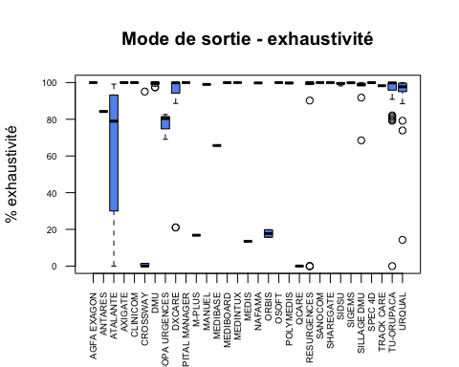

# Conformité par région

## Date de naissance

Min Max moyenne ecart-type Nb  
ALSACE 100.00 100 100.00000 0.00000000 18  
AQUITAINE 100.00 100 100.00000 0.00000000 35  
BOURGOGNE 100.00 100 100.00000 0.00000000 23  
BRETAGNE 99.80 100 99.99167 0.03677362 30  
CHAMPAGNE ARDENNES 99.80 100 99.98750 0.05000000 16  
LIMOUSIN 99.95 100 99.99333 0.01658312 9  
PACA 0.00 100 97.99800 14.14185177 50

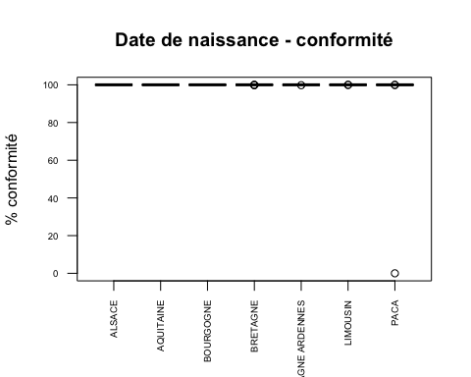

## Diagnostic (DP)

Min Max moyenne ecart-type Nb  
ALSACE 0.00 98.95 50.13176 34.316355 18  
AQUITAINE 0.00 99.80 63.42121 39.782563 35  
BOURGOGNE 0.00 100.00 63.86957 44.685064 23  
BRETAGNE 0.00 100.00 63.90567 40.977779 30  
CHAMPAGNE ARDENNES 0.00 99.70 67.61875 41.100790 16  
LIMOUSIN 85.57 98.98 96.81667 4.256727 9  
PACA 0.00 99.39 88.78780 23.584018 50

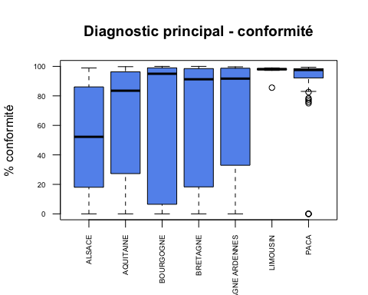

## Mode de sortie (MS)

Min Max moyenne ecart-type Nb  
ALSACE 15.70 100 68.77500 32.8245757 18  
AQUITAINE 0.00 100 89.24242 27.5958220 35  
BOURGOGNE 0.00 100 82.04348 38.5091232 23  
BRETAGNE 13.50 100 91.54533 21.6244593 30  
CHAMPAGNE ARDENNES 69.10 100 94.84375 9.6193533 16  
LIMOUSIN 99.39 100 99.88667 0.2200568 9  
PACA 0.00 100 87.24620 29.0773015 50

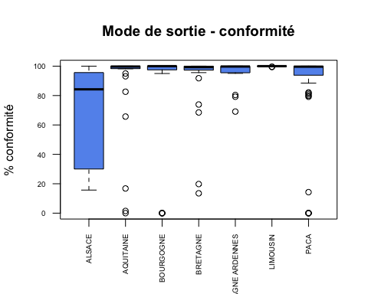

# Exhaustivié par région

## Date de naissance

Min Max moyenne ecart-type Nb  
ALSACE 100.00 100 100.00000 0.00000000 18  
AQUITAINE 100.00 100 100.00000 0.00000000 35  
BOURGOGNE 100.00 100 100.00000 0.00000000 23  
BRETAGNE 100.00 100 100.00000 0.00000000 30  
CHAMPAGNE ARDENNES 99.80 100 99.98750 0.05000000 16  
LIMOUSIN 99.95 100 99.99333 0.01658312 9  
PACA 0.00 100 97.99800 14.14185177 50

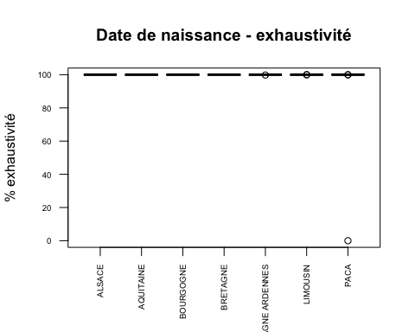

## Diagnostic (DP)

Min Max moyenne ecart-type Nb  
ALSACE 0.00 98.95 50.13176 34.316355 18  
AQUITAINE 0.00 99.80 63.42424 39.784993 35  
BOURGOGNE 0.00 100.00 63.91304 44.720255 23  
BRETAGNE 0.00 100.00 66.77667 39.331436 30  
CHAMPAGNE ARDENNES 0.00 99.80 74.30625 37.783161 16  
LIMOUSIN 85.57 98.98 96.81667 4.256727 9  
PACA 0.00 100.00 89.00340 23.627537 50

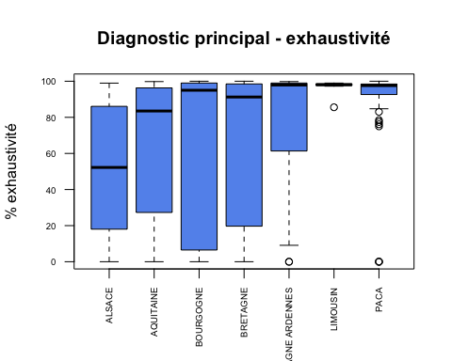

## Mode de sortie (MS)

Min Max moyenne ecart-type Nb  
ALSACE 15.70 100 68.77500 32.8245757 18  
AQUITAINE 0.00 100 89.24848 27.5976915 35  
BOURGOGNE 0.00 100 82.04348 38.5091232 23  
BRETAGNE 13.50 100 91.54533 21.6244593 30  
CHAMPAGNE ARDENNES 69.10 100 94.84375 9.6193533 16  
LIMOUSIN 99.39 100 99.88667 0.2200568 9  
PACA 0.00 100 87.24620 29.0773015 50

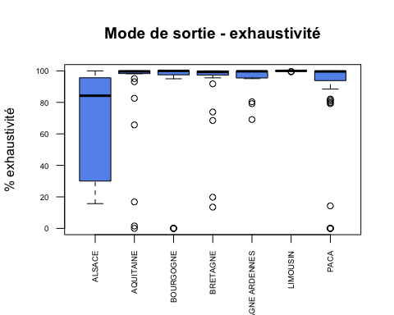

# Résultats secondaires

## % de SU ne faisant pas de remontée de RPU

NON OUI   
 10 171

[1] "5.52 %" "94.48 %"