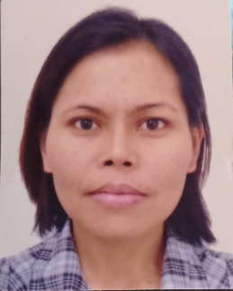**MARILYN R. BALILI**

Blk 6, Lot 9 & 10, Windfields Subd.

Danglag, Consolacion, Cebu

Cel. No. 0956-125-3688

marilynbalili@yahoo.com.sg

OBJECTIVE:

To be able to apply and secure a challenging job that I may able to enhance my knowledge and to work cooperatively with the members of the team while meeting the working environment’s goal.

PERSONAL DATA:

Age : 45

Gender : Female

Birthday : August 15, 1973

Citizenship : Filipino

Civil Status : Single

Religion : Christian

EDUCATIONAL BACKGROUND:

Tertiary : Undergraduate Bachelor of Science in Elementary

Education

1992- One semester only

Secondary: : Sierra Bullones Technical Vocational High School

1986 – 1990

Elementary : Sierra Bullones Central Elementary School

1980 – 1986

WORKING EXPERIENCE:

Domestic Helper

Singapore

March 13, 2003- April 4, 2019

Employer:

2017-2019 – British Family

2015-2017 – Spanish Family

2011-2015 – Australian Family

2009-2011 – Swiss Family

2003-2009 – Singaporean Family

2001-2003 – Johnson & Johnsons Corporation

Sucat, Parañaque, Metro Manila

1999-2001 – Berma Cenima Center

Berma Shopping Center, Baclaran

Parañaque, Metro Manila