Student: | Email:
Jose Cruz | jose.cruz2@udc.edu
Time on Task: | Progress:
10 hours, 6 minutes | 100%
Report Generated: Wednesday, April 5, 2023 at 9:52 PM

Section 1: Hands-On Demonstration

Part 1: Gather Basic System Information
4. Make a screen capture showing the Properties window for the process you selected.
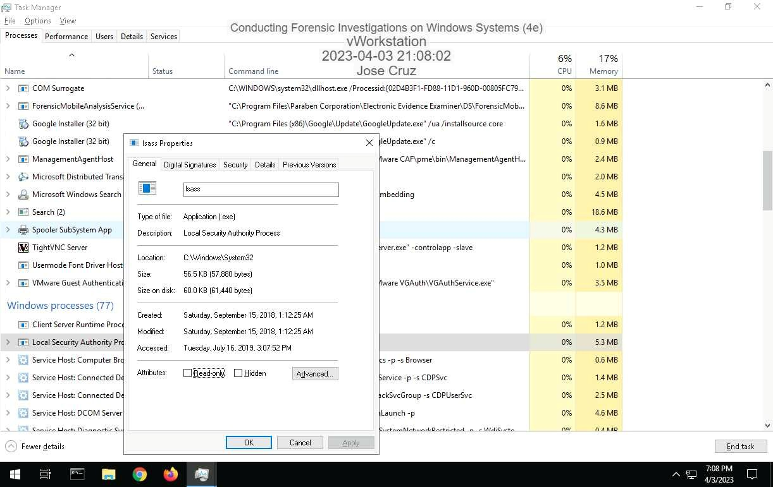
10. Listening Ports list.
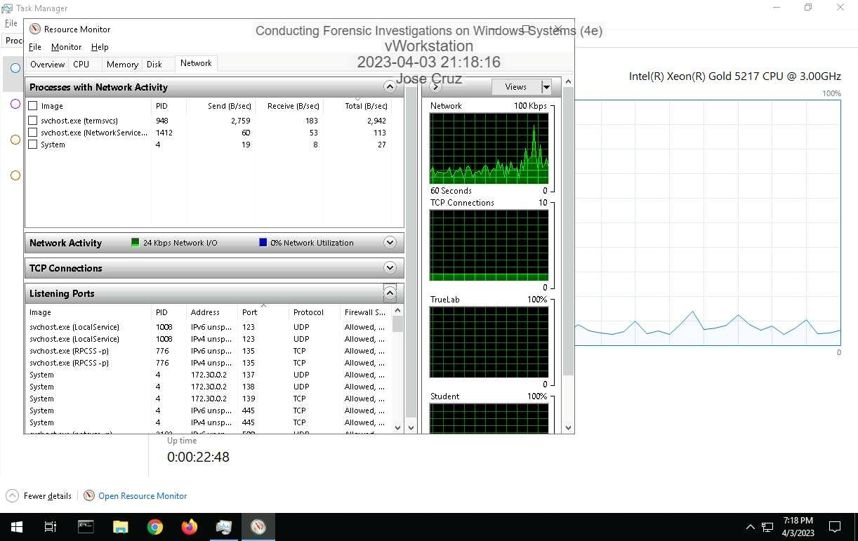
14. Make a screen capture showing the information about the C: drive.
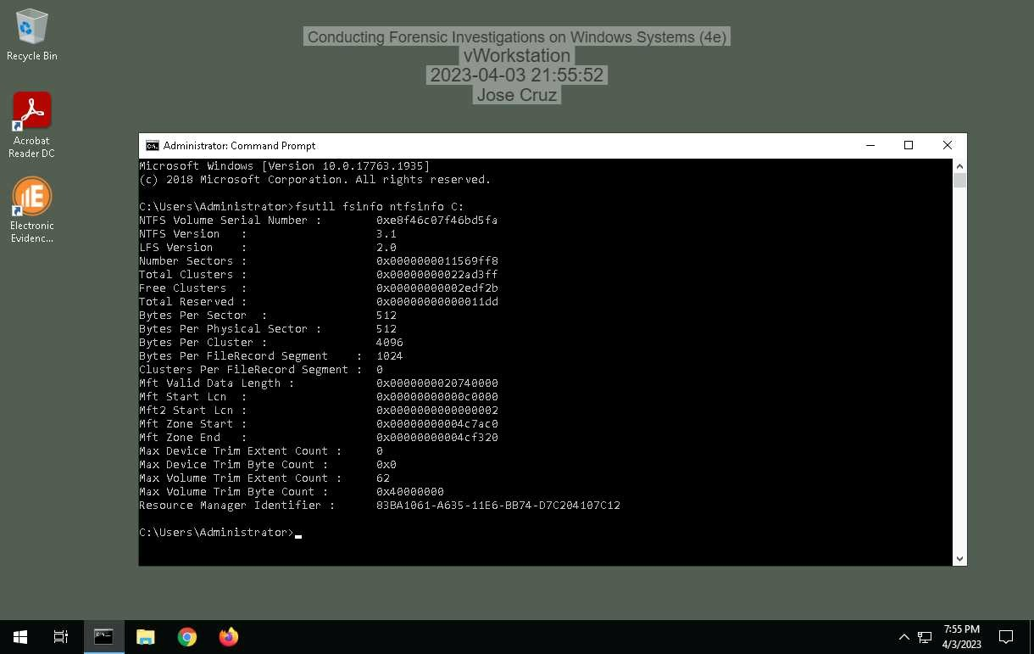
16. information about the vWorkstation's usn journal.
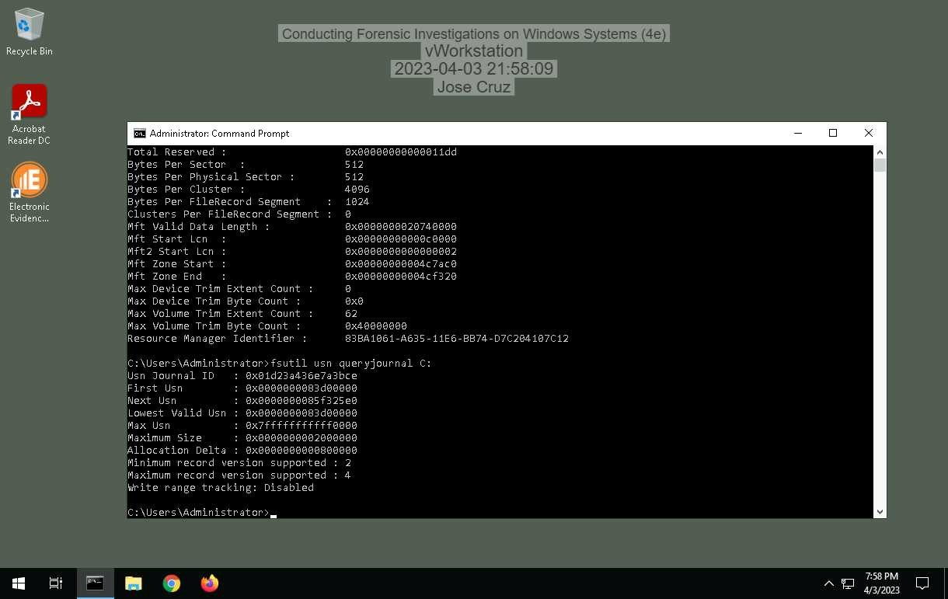
26. Make a screen capture showing the file path for the yourname.txt file.
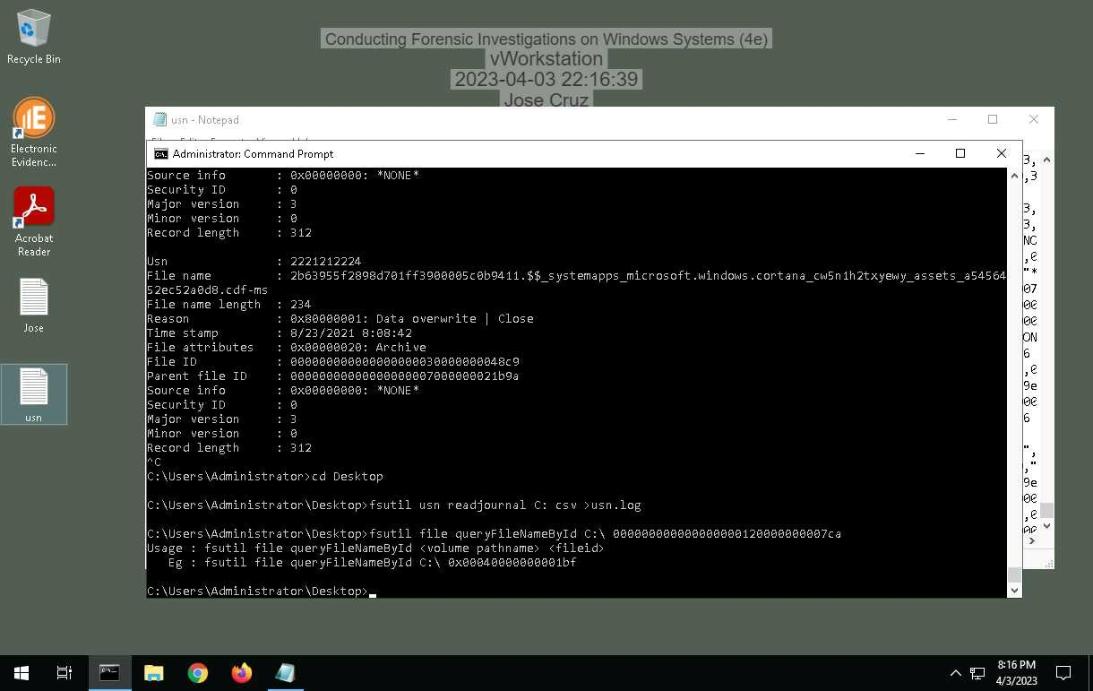

Part 2: Explore the Registry
10. vWorkstation Windows installation timestamp in a human-friendly format.
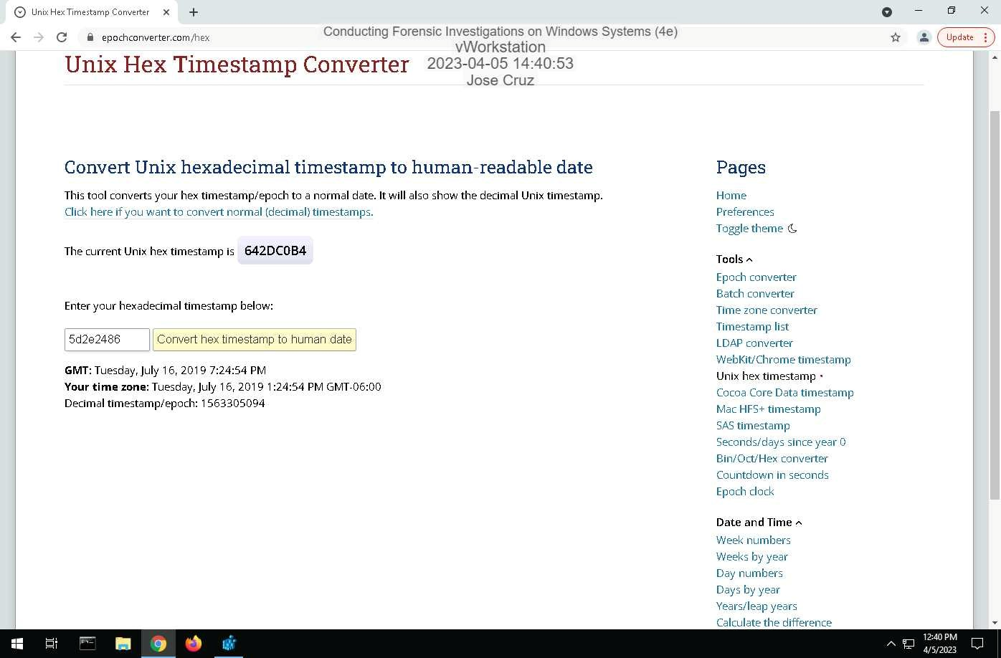
13. Make a screen capture showing the key values for the vWorkstation's default network interface.
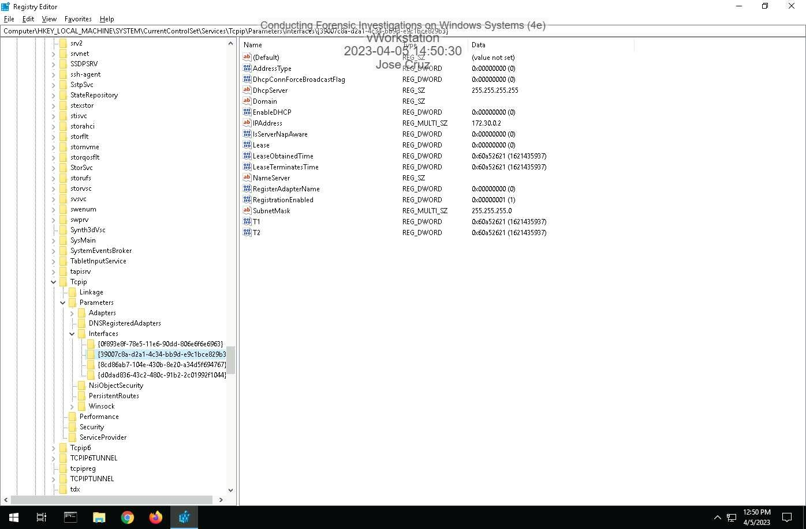
15. Winlogon key values.
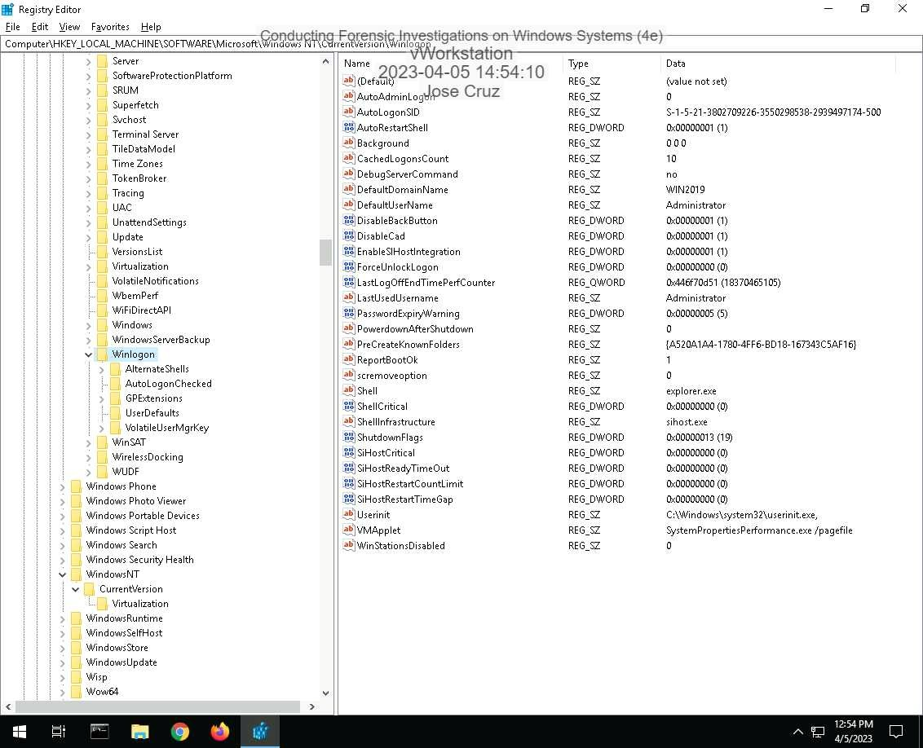
18. ShellBags key values.
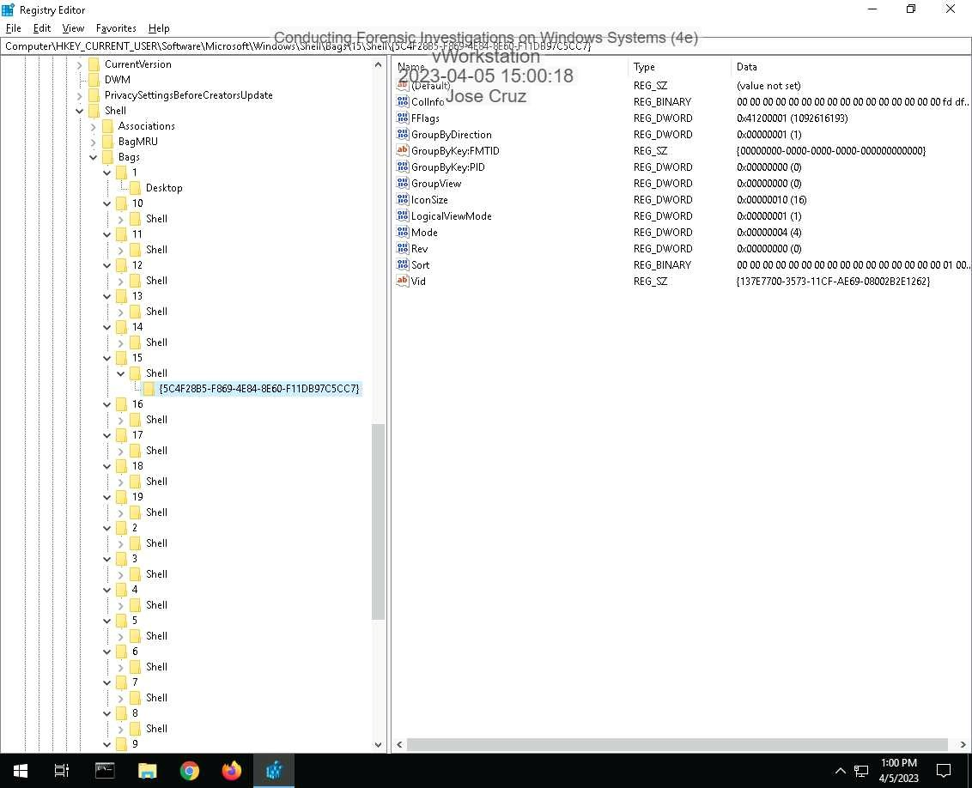
20. RecentDocs key values.
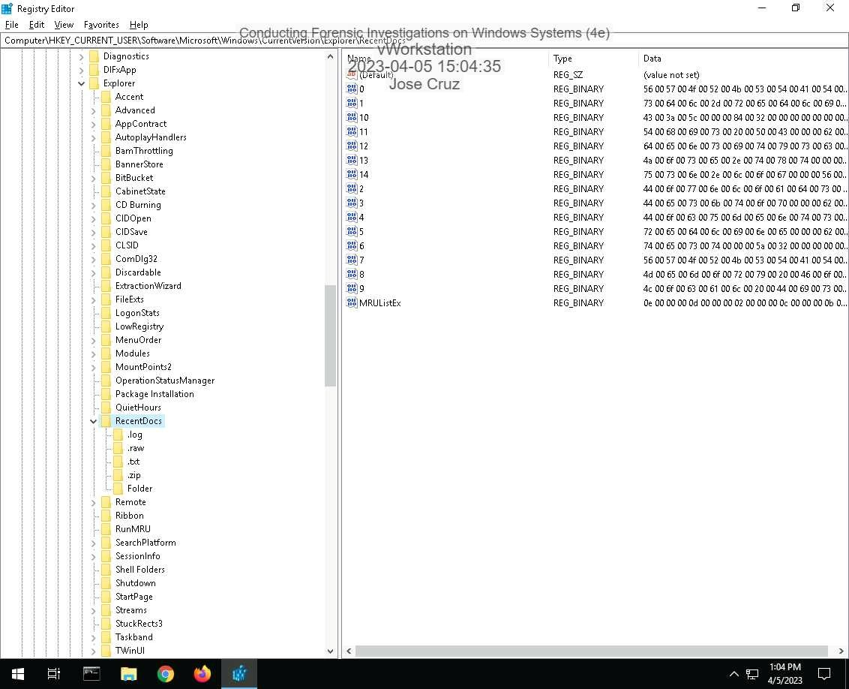

Section 2: Applied Learning

Part 1: Create and Sort a New Case File
14. Make a screen capture showing the Sorted Files.
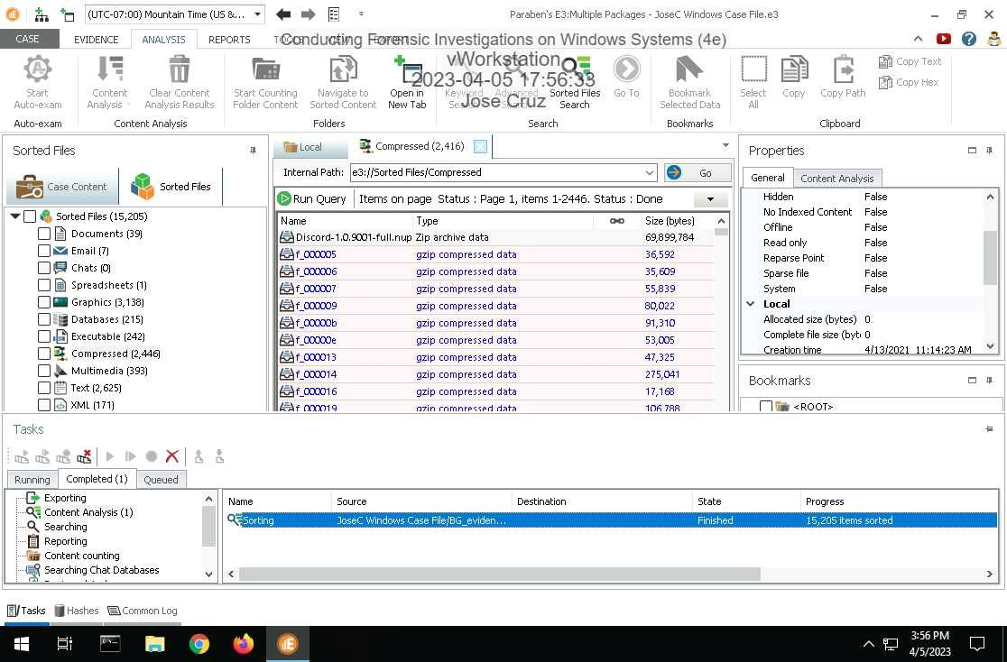

Part 2: Perform Forensic Analysis on a Windows Drive Image
6. showing the contents of the 777.jpg file in the Document View.
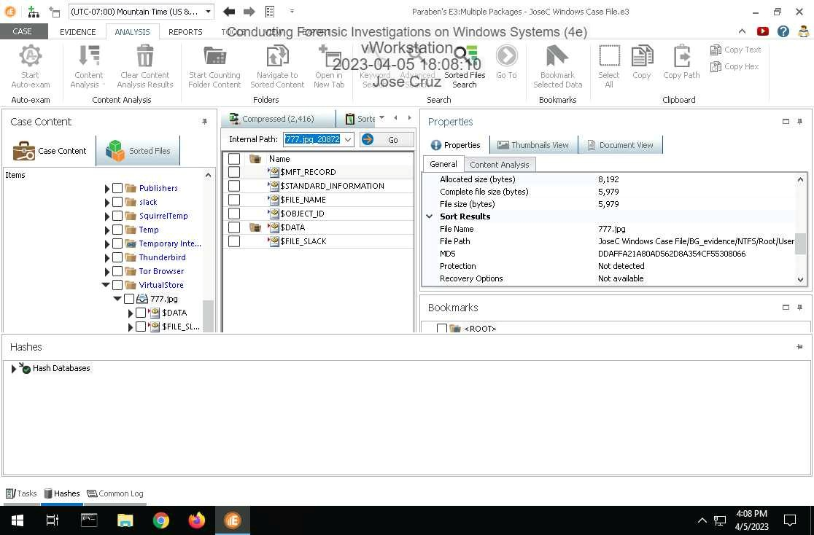
10. Make a screen capture showing the 777.lnk file contents including the path to the file in the system.
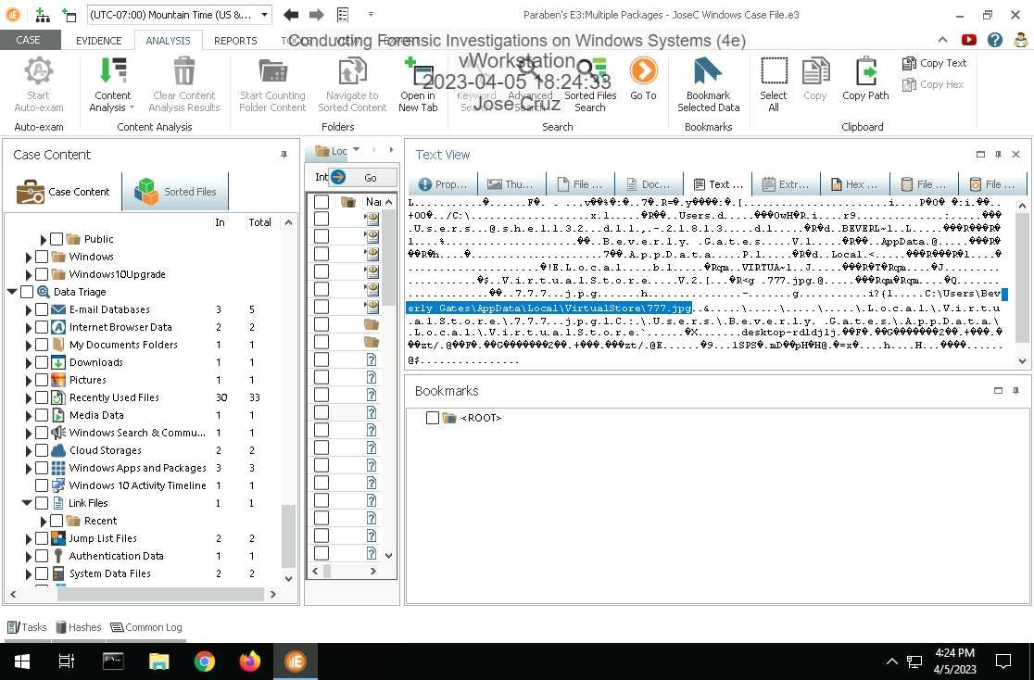
14. showing the installation files for suspicious apps in the Downloads category.
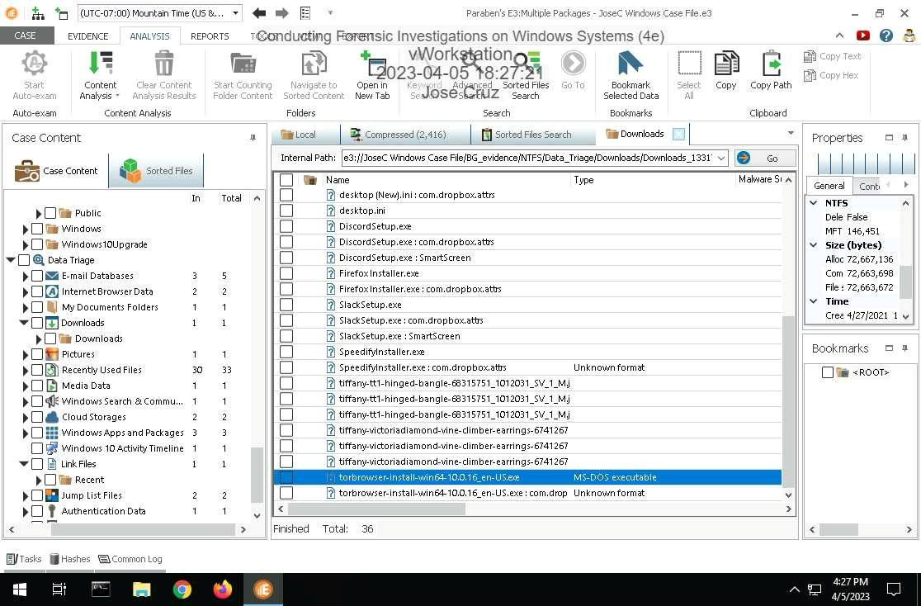
17. Make a screen capture showing the VPN application (Speedify) in the Uninstall folder.
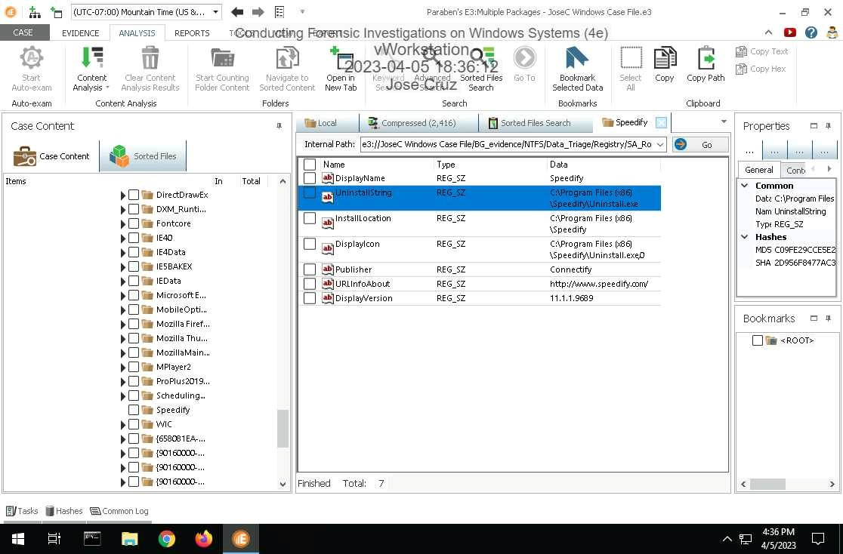
19. showing the users list.
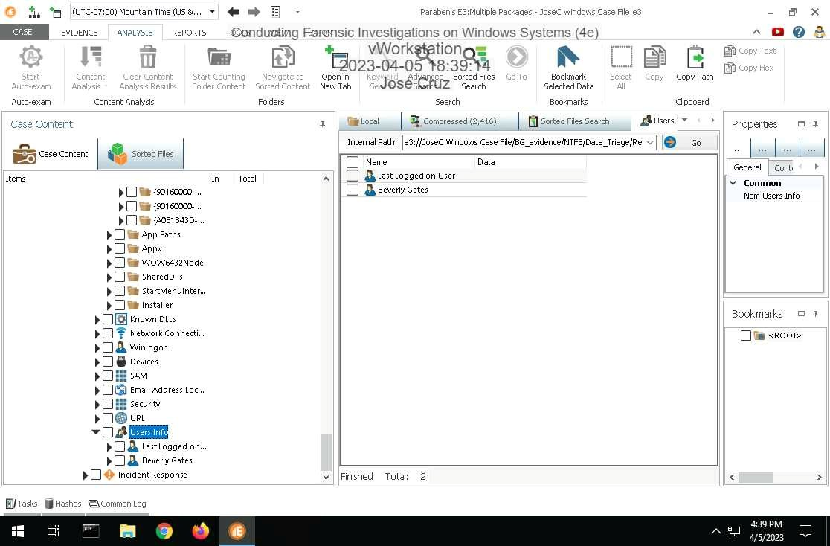
21. Make a screen capture showing the contents of the Beverly Gates / Run folder.
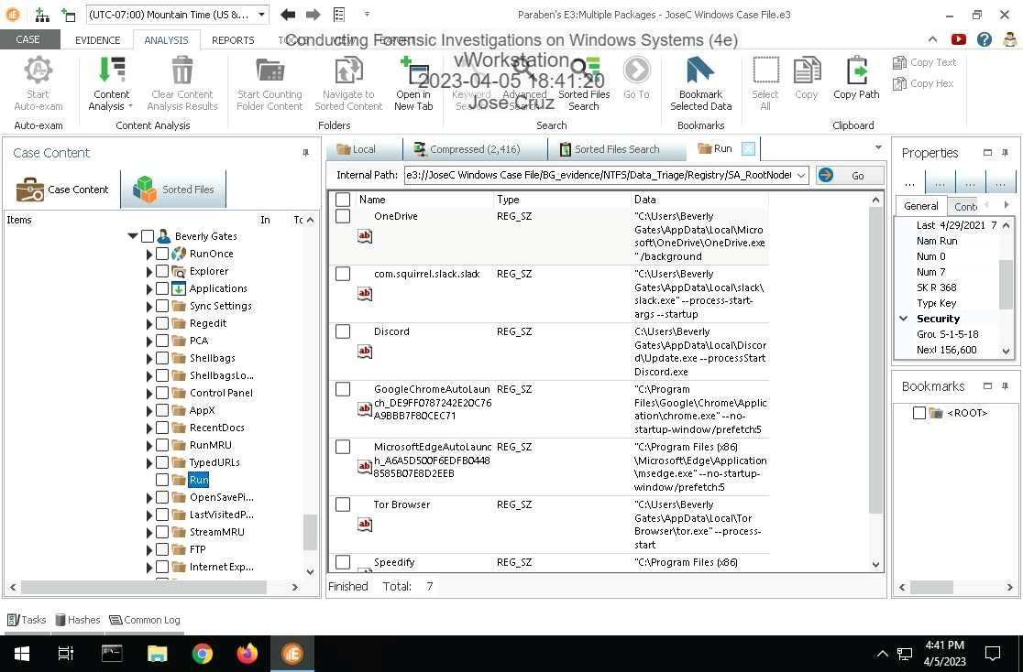

24. Make a screen capture showing at least one suspicious browsing record found in the History sub-node.
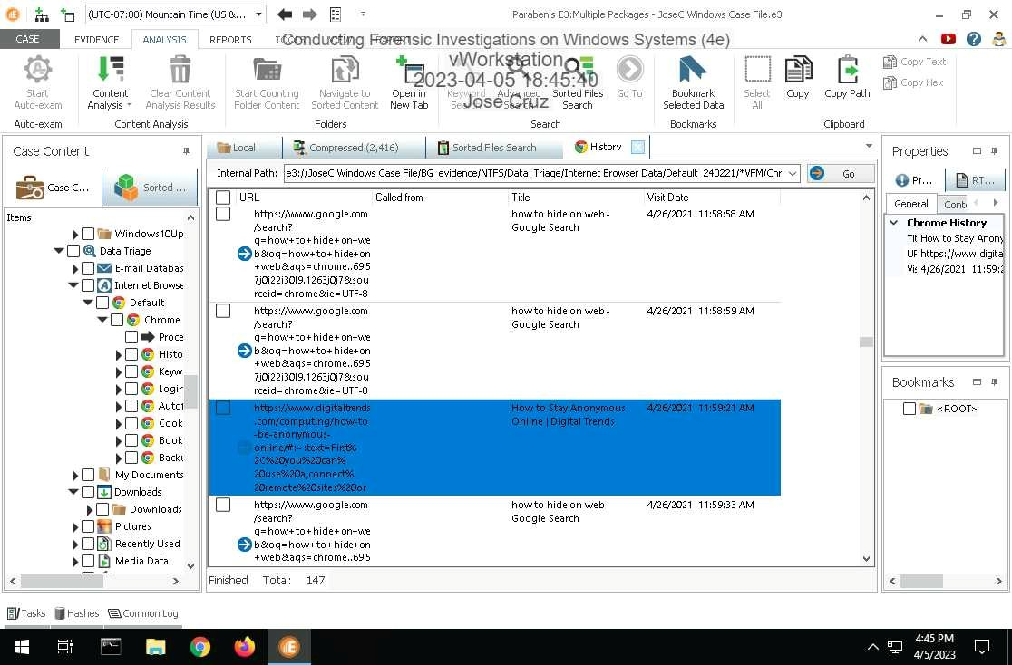
26. Make a screen capture showing at least one suspicious search found in the Keywords sub-node.
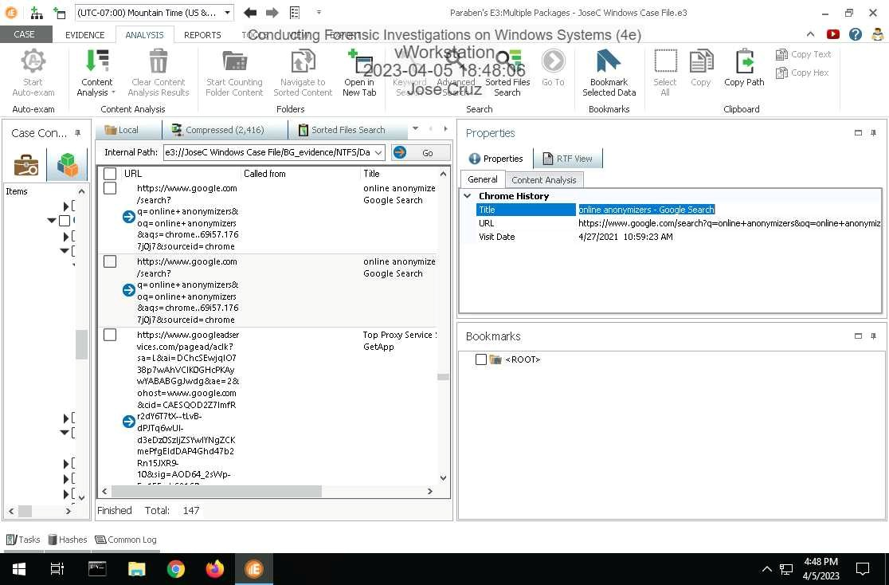

Section 3: Challenge and Analysis

Part 1: Use Advanced Search to Locate Additional Evidence
Make a screen capture showing the contents of the suspicious file in the Document View.
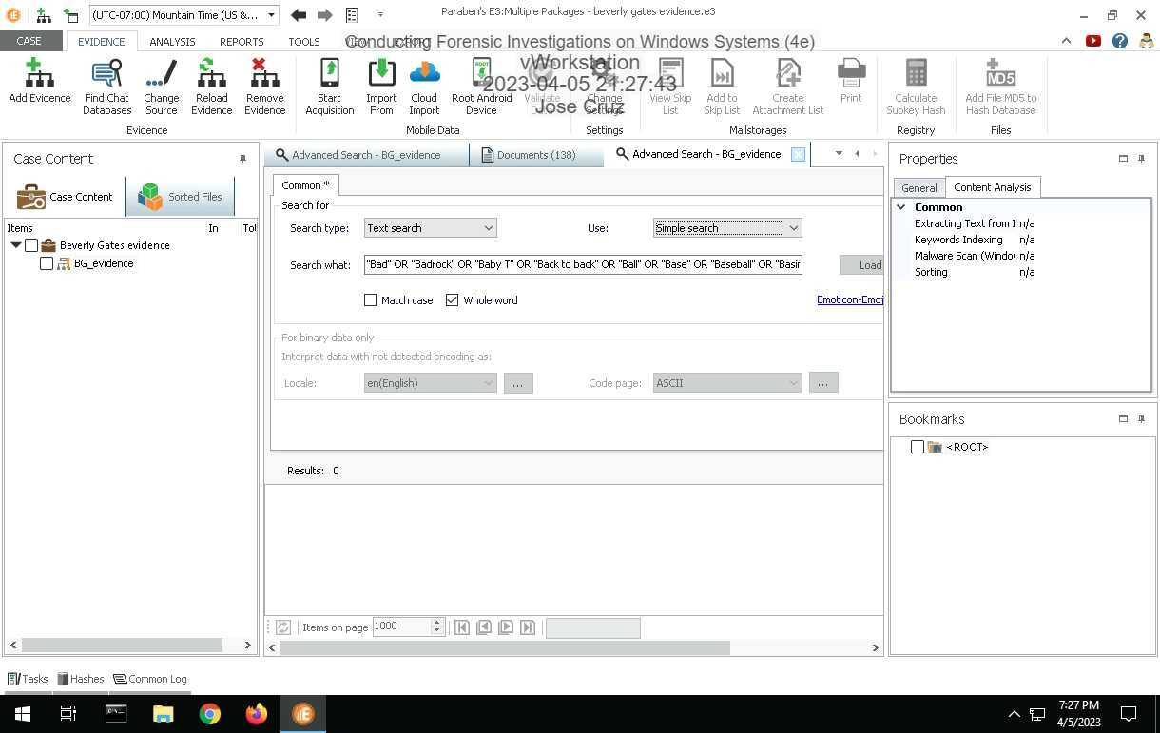

Part 2: Identify Suspicious Browser Activity
Make a screen capture showing at least one registry key with information associated with Tor and Firefox.
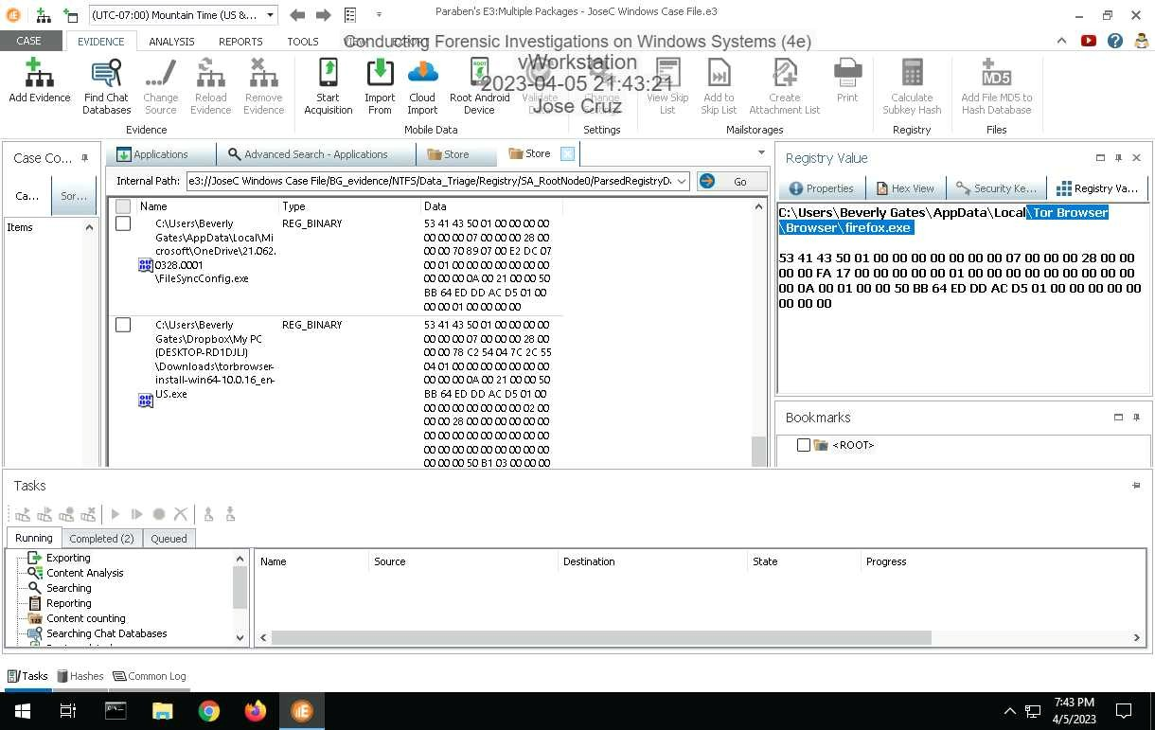
Powered by TCPDF (www.tcpdf.org)

