Jeremy Cruz, Jordan Le

Scary Maze Design Document

**Start Menu**

This is where the user sees when the game is first started. Click to interact with the game

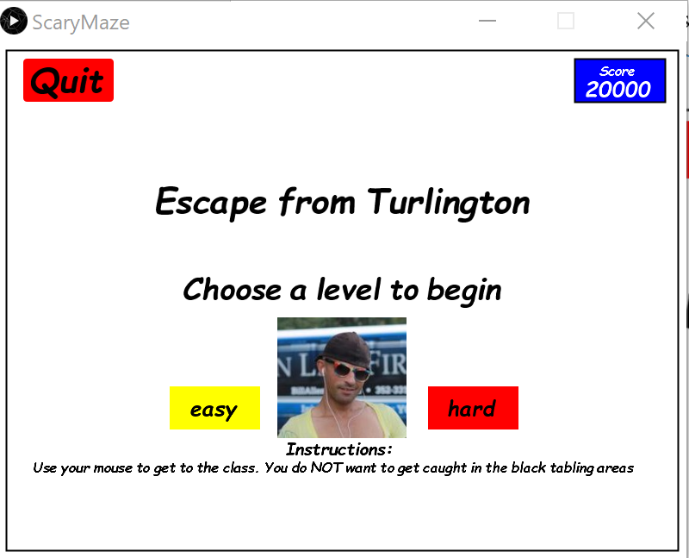

* Quit button – if quit button is clicked, program exits and therefore window exits
* Easy button – if easy button is clicked, easy mode will be selected
* Hard button – if hard button is clicked, hard mode will be selected
* Score (top right) – Display the current score

**How to Play:**

* User must get to Little Hall located in the top left of the window
* If the user touches any of the black area with mouse, the score reaches 0, or the user touches the ball, the user will lose.
* User must also move the paddle—located at the bottom of the screen—left or right to keep the ball from touching the bottom of the screen

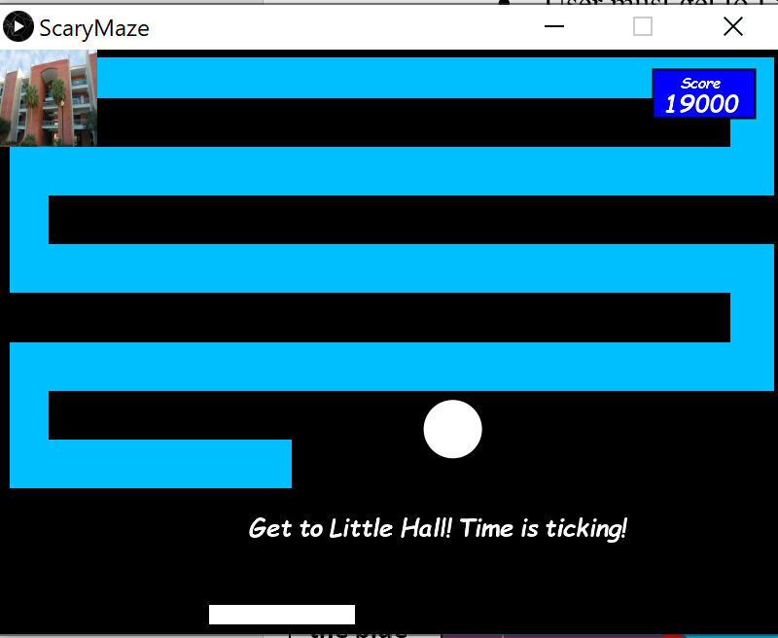

**Avoid Ball that bounces around the screen**

**Move paddle with “A” and “D” keys to keep ball away from the bottom**

**Get to here to win**

**Stay in the blue**

**Avoid black area**

**Displays current score. Will go down throughout game**

**Win State:**

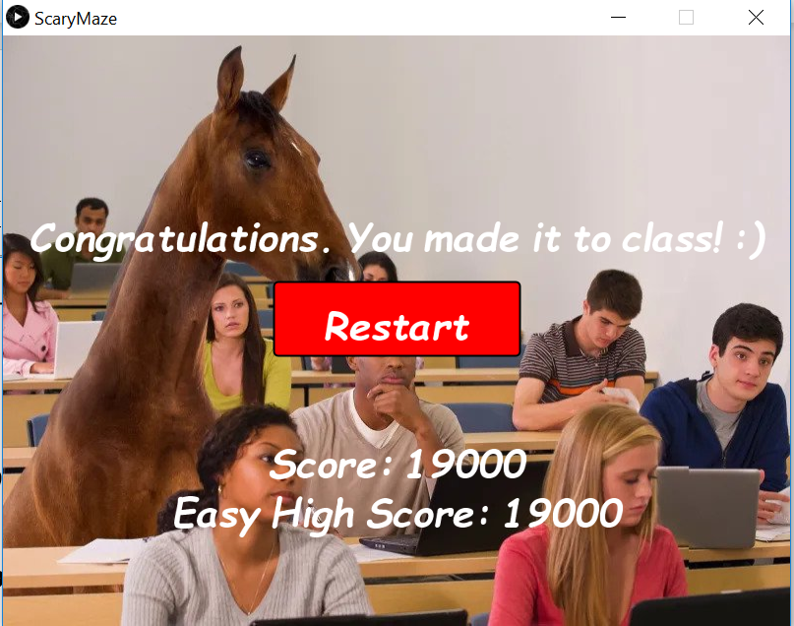

**Displays current score and highest score all time**

**Click here to restart back to main menu**

**Lose State:**

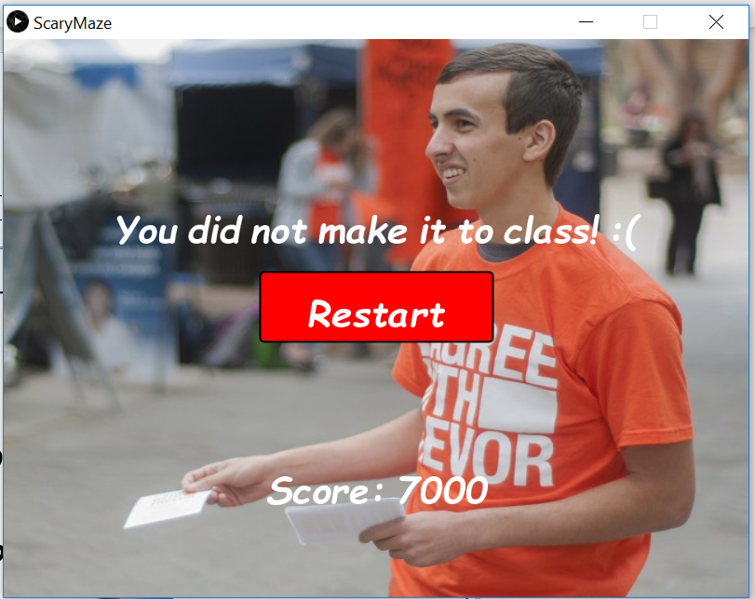

**Prints score of last run**

**Click here to go back to main menu**

**Work Distribution:**

|  |  |
| --- | --- |
| Menus | Jeremy |
| Lose & Win Classes | Jeremy |
| Ball & Paddle Classes | Jordan |
| Code Refactoring | Jordan |
| Music | Jeremy |
| Sound Effects | Jeremy & Jordan |

**Difficulties and Solutions:**

There were bugs with the ball physics that would cause the ball to collide with the walls multiple times leading to the ball’s angular velocity to glitch out. This was solved by using a timer to have the ball wait 3 frames before it can start to collide again.

We had trouble finding a way to check if the player was in the black area. It could be done, but it would require a lot of if statement checks. Jeremy was able to instead find a way to check for the colors on screen to see if the player was in a certain color region.