*Celebrate a full moon spring evening with drumming and dancing at the 15th annual…*

**Acton Drum and Dance Fire Circle**

a community rhythm experience

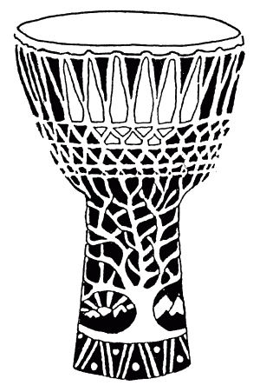

**Saturday, June 26th   
7:45pm to 10:30pm  
NARA Park, Acton, MA**

We'll dance and play to a mix of traditional African rhythms and organized rhythm jams on the meadow overlooking the lake.

You're welcome to bring your own hand drums and percussion, or simply come to dance and enjoy.

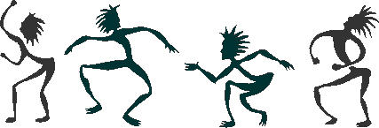 

It's free and open to all ages and experience levels.

Listen and co-create.

Bring your friends and family!

Spread the word.

For more information and to volunteer: www.actondrumdance.org