Celebrate a spring evening with drumming, dancing, and flow arts at the 19th annual…

# Acton Drum and Dance Fire Circle

a community drum and dance experience

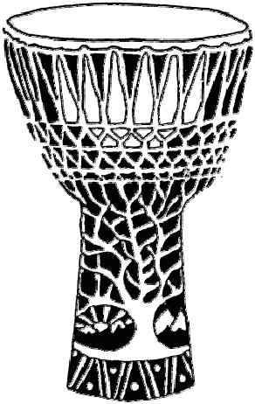

## Saturday, June 7th

**7:45pm to 10:30pm**

**NARA Park, Acton, MA**

We'll dance, play, and spin to a mix of rhythm jams, outdoors under the nearly full moon. Bring hand drums, percussion, and poi, or simply come to dance and enjoy.

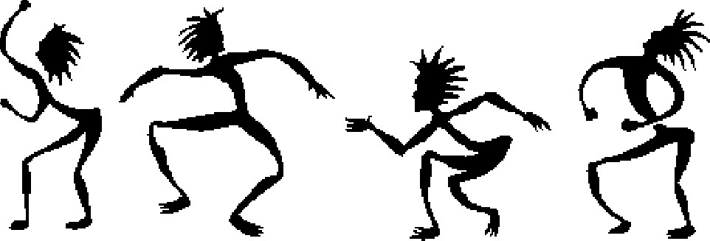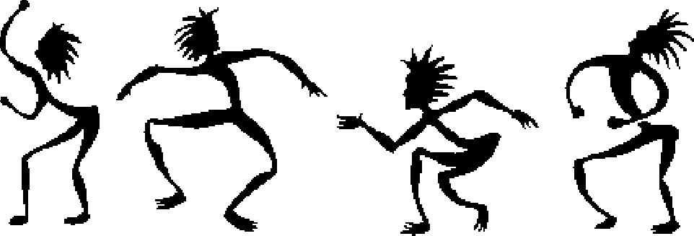

It's free and open to all ages! Listen and co-create.

Bring your friends and family! Spread the word.

For more information and to volunteer: www.actondrumdance.org