Celebrate a fall evening with drumming, dancing, and flow arts at our …

Fall Acton Drum, Dance, and Flow Fire Circle
a community drum and dance experience

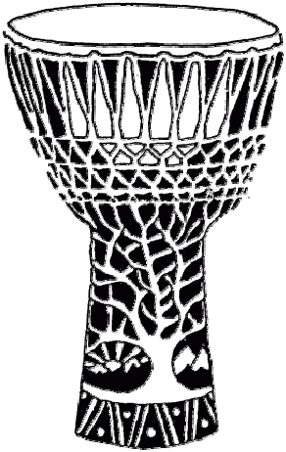

Saturday, October 4th
7:00pm to 10:30pm
NARA Park, Acton, MA

We'll dance, play, and spin to a mix of rhythm jams, outdoors under the nearly full moon. Bring hand drums, percussion, and poi, or simply come to dance and enjoy.

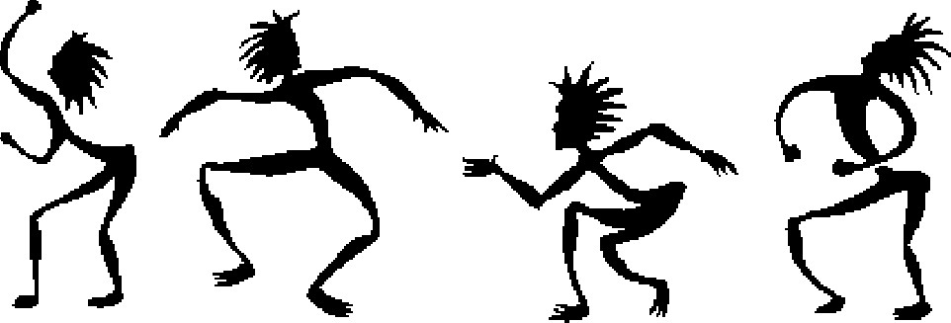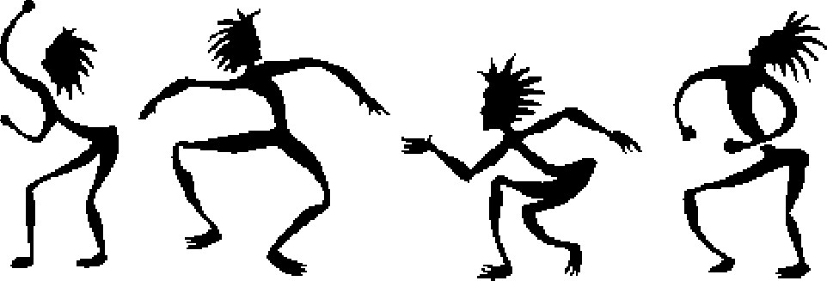

It's free and open to all ages! Listen and co-create.
Bring your friends and family! Spread the word.
For more information and to volunteer: www.actondrumdance.org

