Surgery for Esophageal and GE Junction Cancers

1 Team Members - Physicians
Primary Care Provider
Gastroenterologist
Medical Oncologist (chemotherapy)
Radiation Oncologist (radiation)
Surgeons
- Jonathan Salo MD
- Kelli Salter MD
- Michael Roach MD

2 Team Members - Support Staff
Physician Assistant - Kate Duncan PA-C
Dietitian - Liz Koch
Nurses
- Matthew Carpenter RN
- Brandon Galloway LPN
Navigators
- Laura Swift
- Lorna Espinal
Care Coordinator - Karen Julian-Martinez
# Cancer care team (MDs, PA-C, Dietitian, Schedulers, RNs, Navigators)

3 Nutrition Prior to Surgery
High-protein diet (most people need 60-80 grams protein/day)
- Protein shakes (Permier or Fairlife) with protein and minimal sugar
Important to avoid weight loss prior to surgery
Good nutrition before surgery improves wound healing and recovery

4 Exercies Prior to Surgery
Goal: 30minutes/day of vigorous exercise 6 days/week
Vigorous: Working hard enough you can’t carry a conversation
Types of Exercise:
- Walking: Outside, Treadmilll, or an indoor Mall
- Stationary Exercise Bike
Lifting light weights and stretching are helpful in addition
# General preop nutrition + exercise + PCP

5 Day Prior to Surgery
- Clear liquids for dinner evening prior
- You will receive instructions regarding medicines

6 Day of Surgery
Unless instructed otherwise:
- You will be notified regarding arrival time, which is usually 2-3 hours before the surgery time.
  - Surgery Monday, Tuesday, Wednesday, Friday: Arrive 4am
  - Surgery Thursday: Arrive 5am
- Nothing to eat or drink after midnight

7 Medicines the Day of Surgery
- Medicines with a sip of water or black coffee
- No milk or cream
- Surgery will be cancelled for milk/cream
# Immediate preop instructions: NPO, meds in the morning

8 Preparation for Surgery
Medical evaluation may be needed before surgery:
- Pulmonary Function Tests to test lung function
- Cardiology evaluation to test heart function
  - Echocardiogram
  - Stress Test
  - Holter monitor

9 Esophagectomy for Cancers of the Esophagus or GE Junction
Primary Surgery
- Superficial Tumors (T1) not completely removed by endoscopy
- Localized Tumors (T2 N0 M0)
- Surgery scheduled after medical evaluation
Preoperative Therapy $→$ Surgery
- Locally Advanced (T3 Nx M0)
- Surgery scheduled after
  - Recovery from preoperative therapy
  - Restaging scans (CT or PET)
  - Medical evaluation

10 Preoperative Visits
Medical Oncology - Monitor chemotherapy and side effects
Radiation Oncology - Monitor radiation and side effects
Surgical Oncology
- Consult visit with Dr Salo
- Mid-treatment visits with Dr Salo / Kate Duncan
- Preop visit with Dr Salo (may be virtual)
- In-person preop visit with Kate Duncan and Liz Koch

11 Surgery for Esophageal Cancer
Surgery for esophageal cancer is performed for:
- Superficial Tumors (T1) not removed by endoscopy
- Localized Tumors (T2 N0 M0)
- Locally Advanced (T3 M0) after preop therapy

12 Goals of Surgery
- Remove tumor from esophagus
- Remove surrounding lymph nodes
- Create a new esophagus
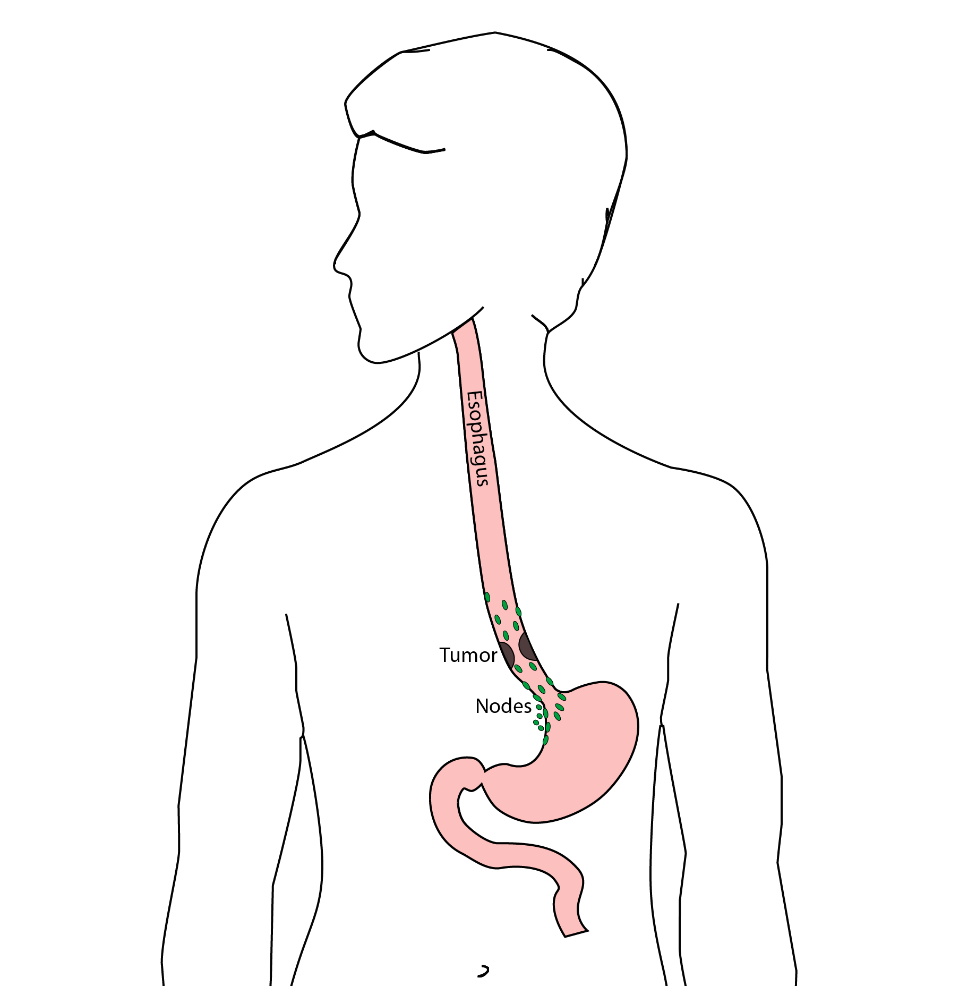

13 Ivor Lewis (Transthoracic) Esophagectomy
- Removes tumor and lower 1/3 esophagus
- Removes surrounding lymph nodes
- GI tract reconstructed
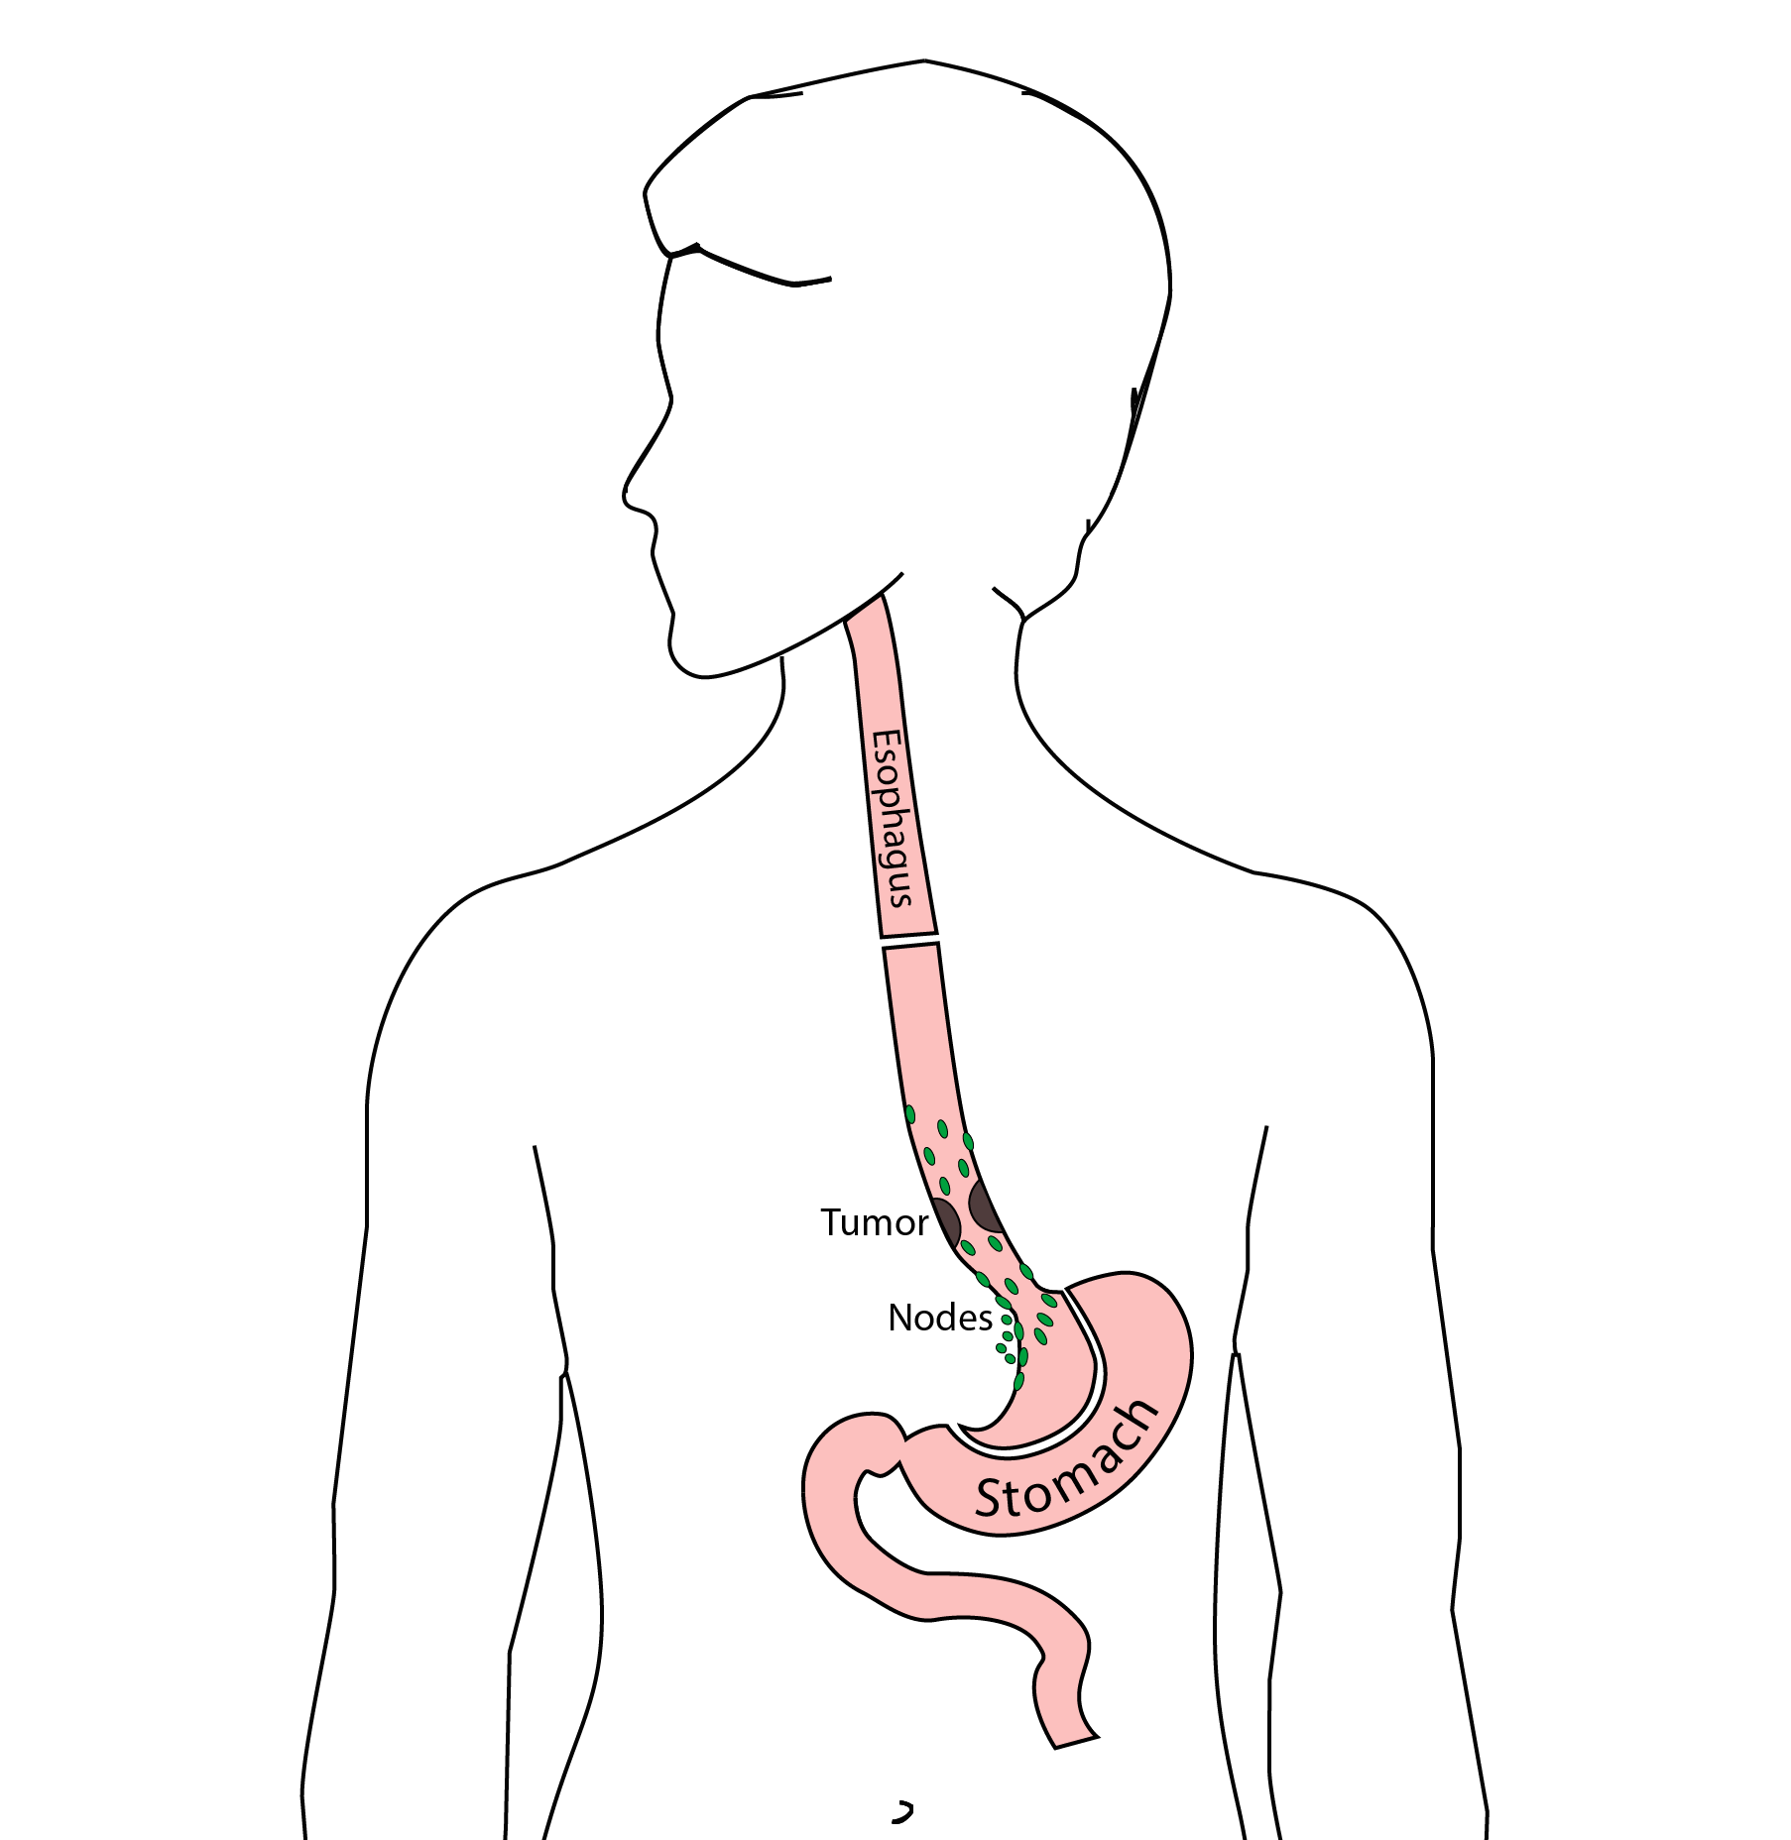

14 Reconstruction
New esophagus is created from the stomach in the abdomen by fashioning it into a tube.
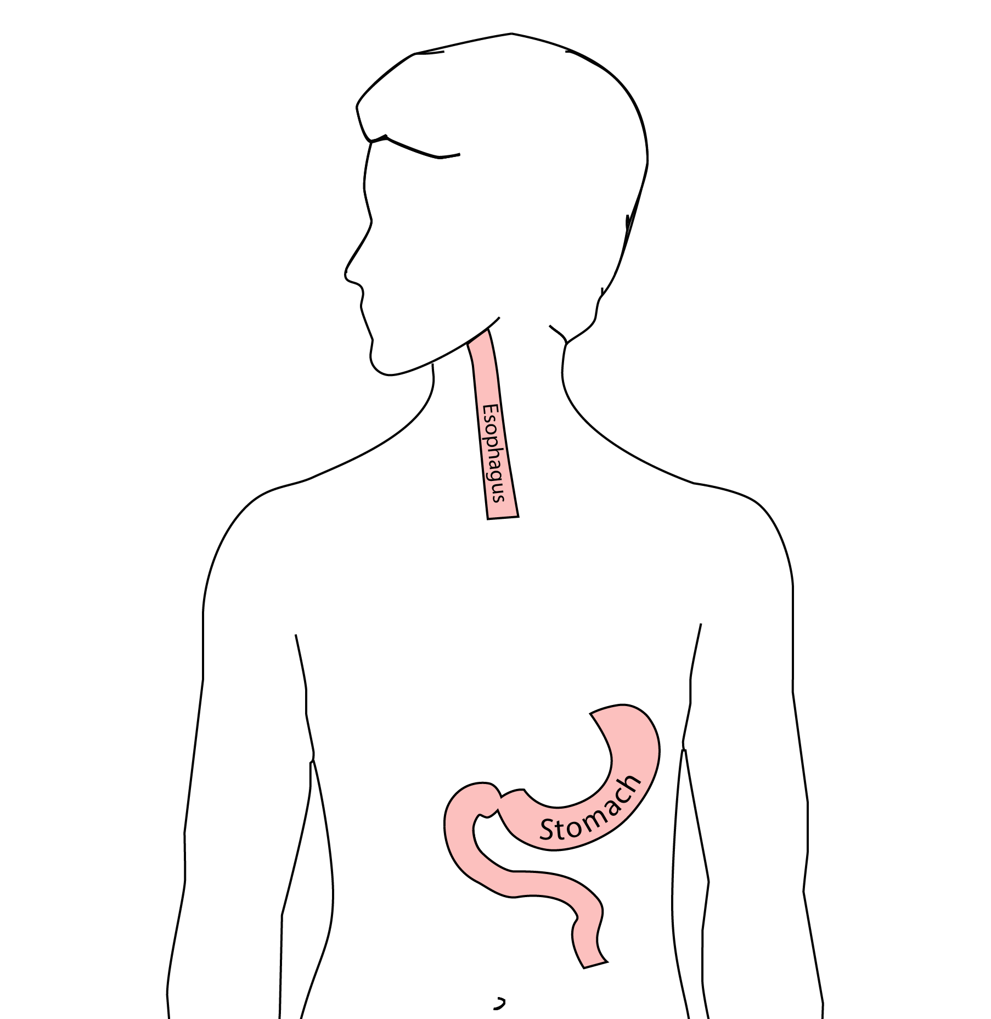

15 Ivor Lewis esophagectomy
The new esophagus is now brought up into the chest. A connection is made between the esophagus and the stomach, called an anastomosis.
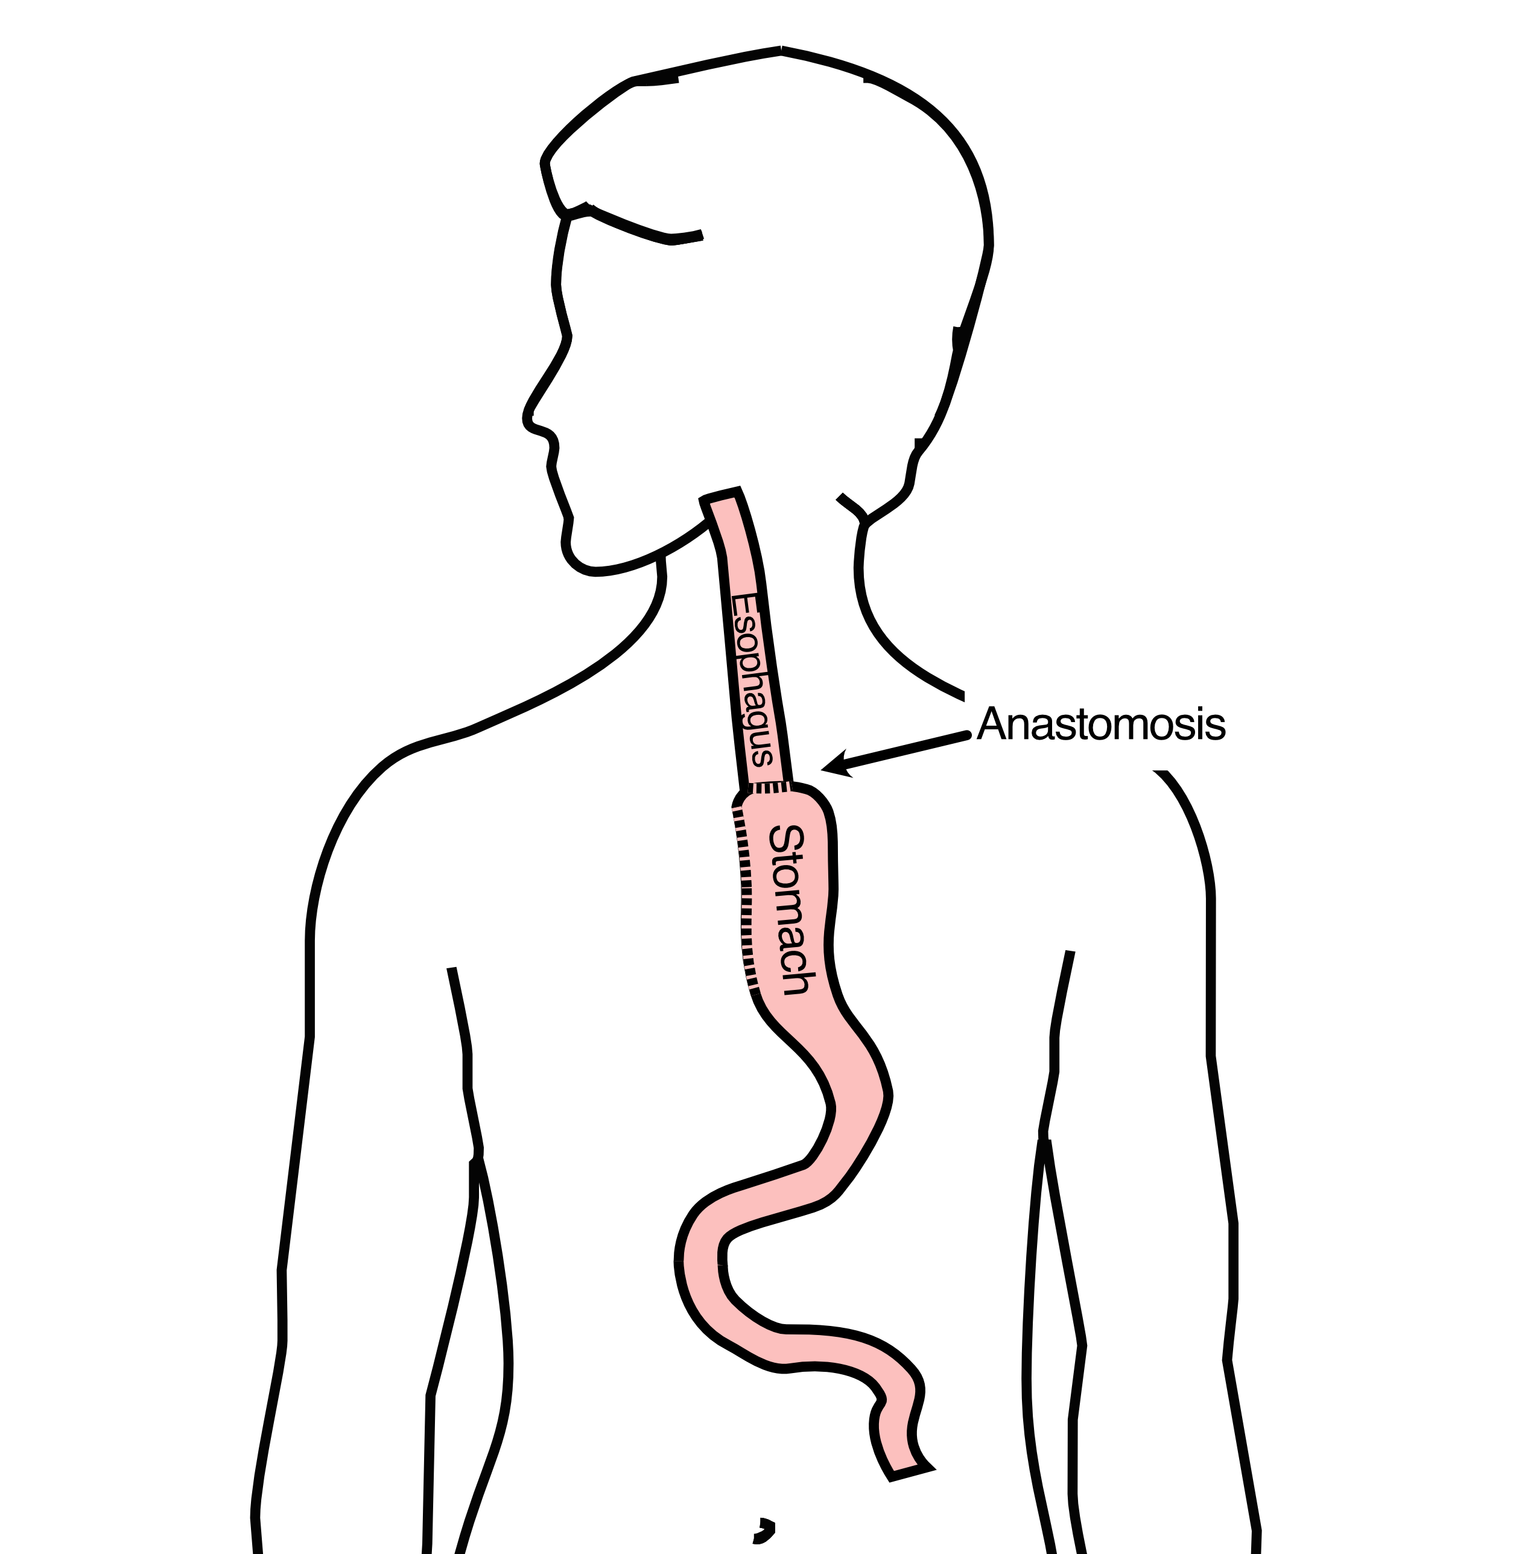

16 Minimally-invasive Ivor Lewis
- Small incisions abdomen and chest
- Surgical telescope and instruments
- Smaller incisions $→$ faster recovery and less discomfort
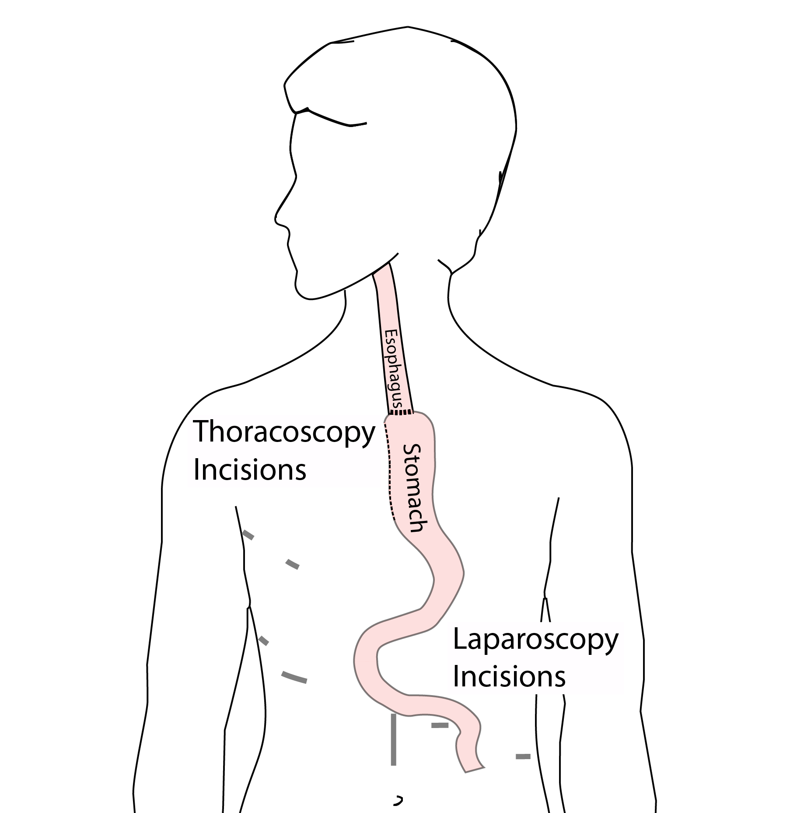

17 Open Ivor Lewis
Mininally-invasive approach feasible in 95% of cases
In some cases, an open approach is still necessary.
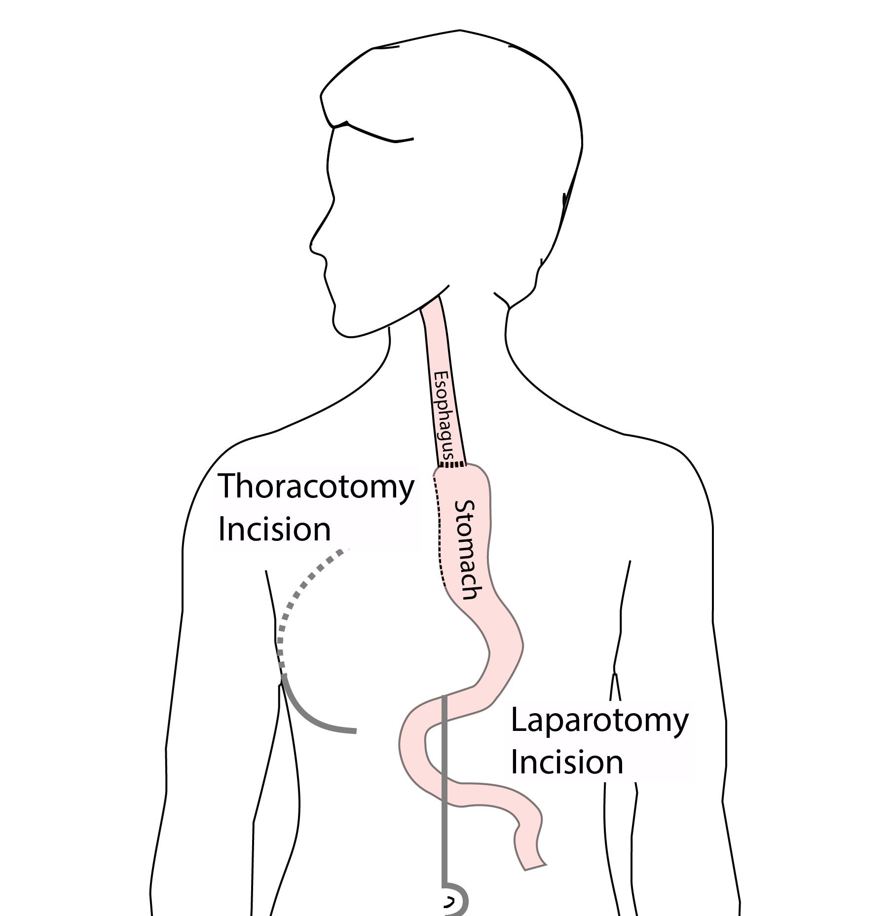

18 Total Esophagectomy
For patients with tumors in the upper esophagus, we need to remove more of the esophagus
We need to remove the whole esophagus, including the portion in the neck
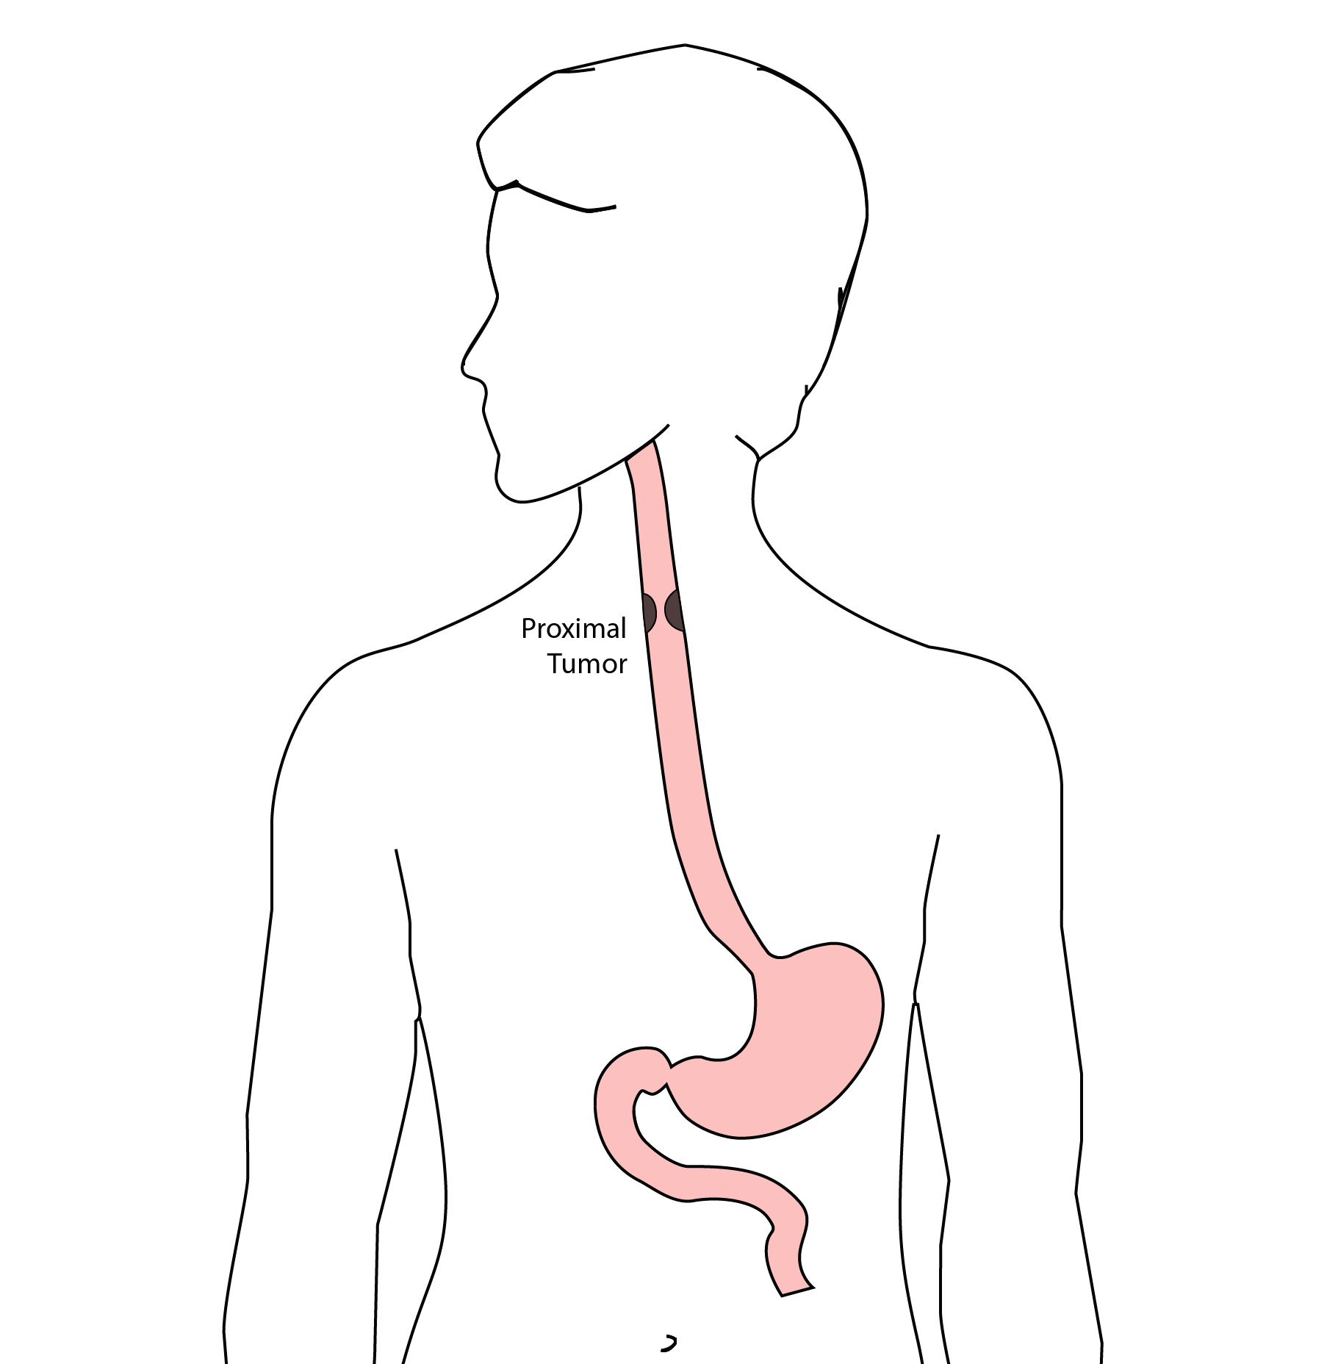

19 McKeown Esophagectomy
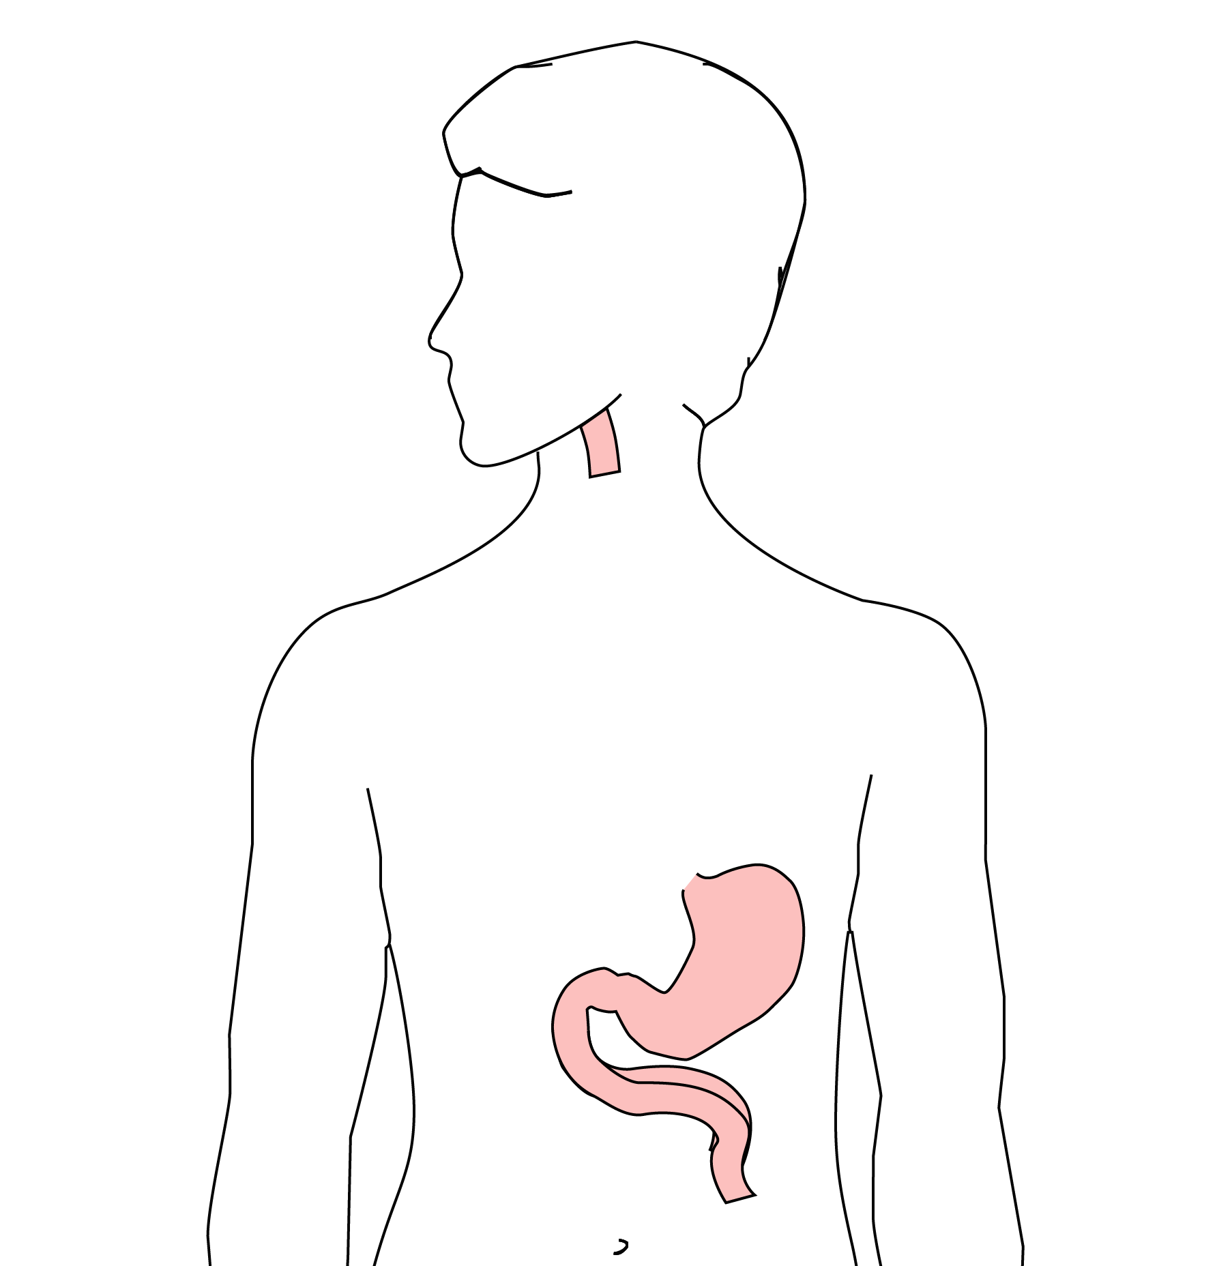 All of esophagus removed
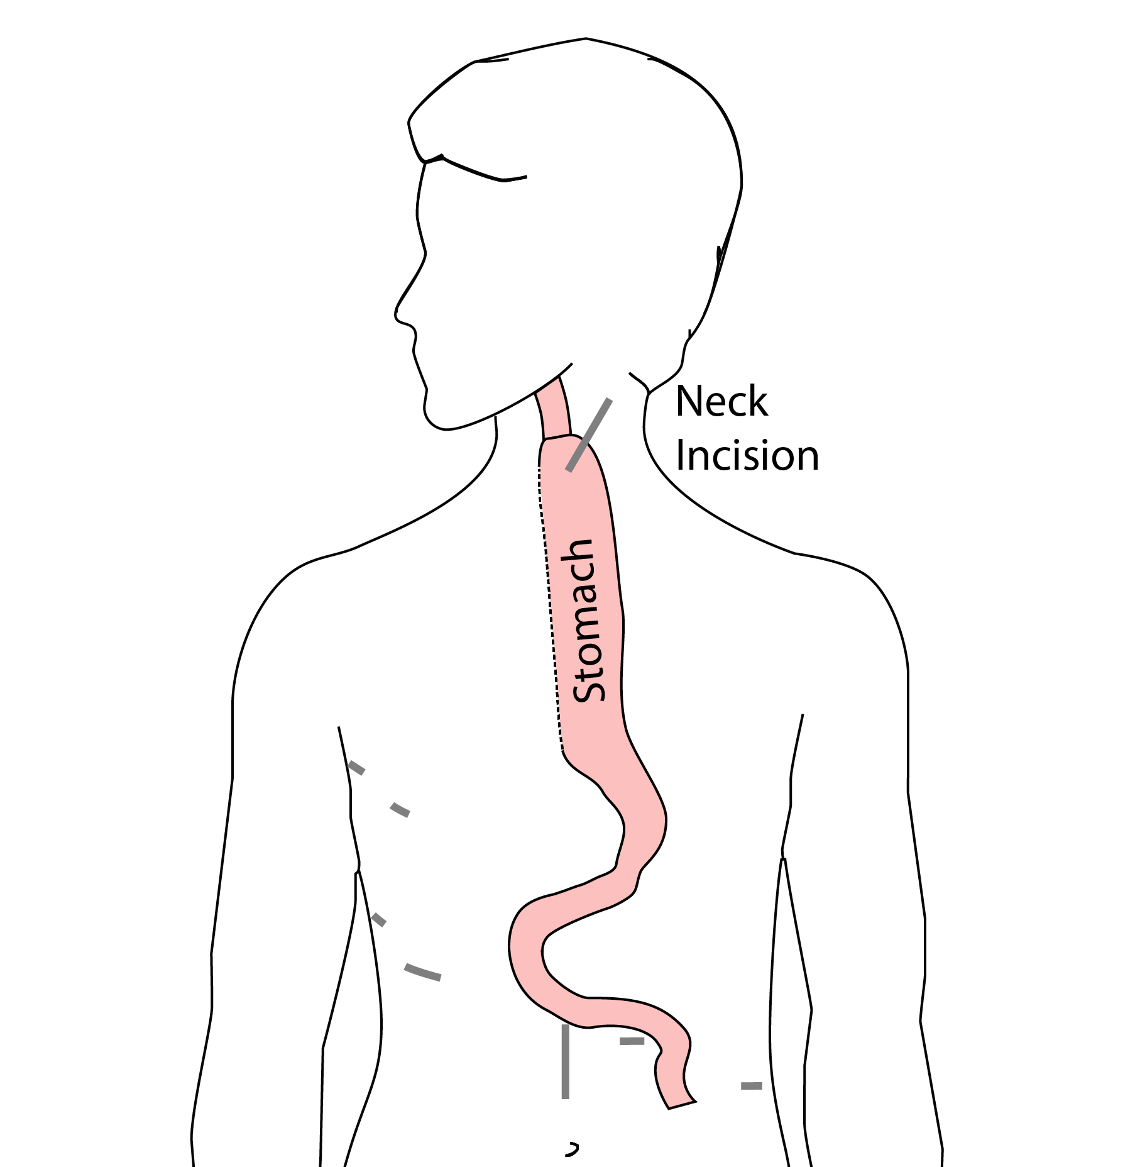 Connection made in the neck

20 Risks of Esophagectomy
Esophagectomy is a complex operation, with a real risk of complications.
Two significant complications:
- Anastomotic leak
- Pneumonia

21 Anastomotic Leak
The anastomosis is surgical connection between the esophagus and the stomach.

22 Anastomotic Leak
If healing doesn’t occur:
- Leakage of fluid from the esophagus
- Infection in the space between the lungs
- Requires additional time in the hospital
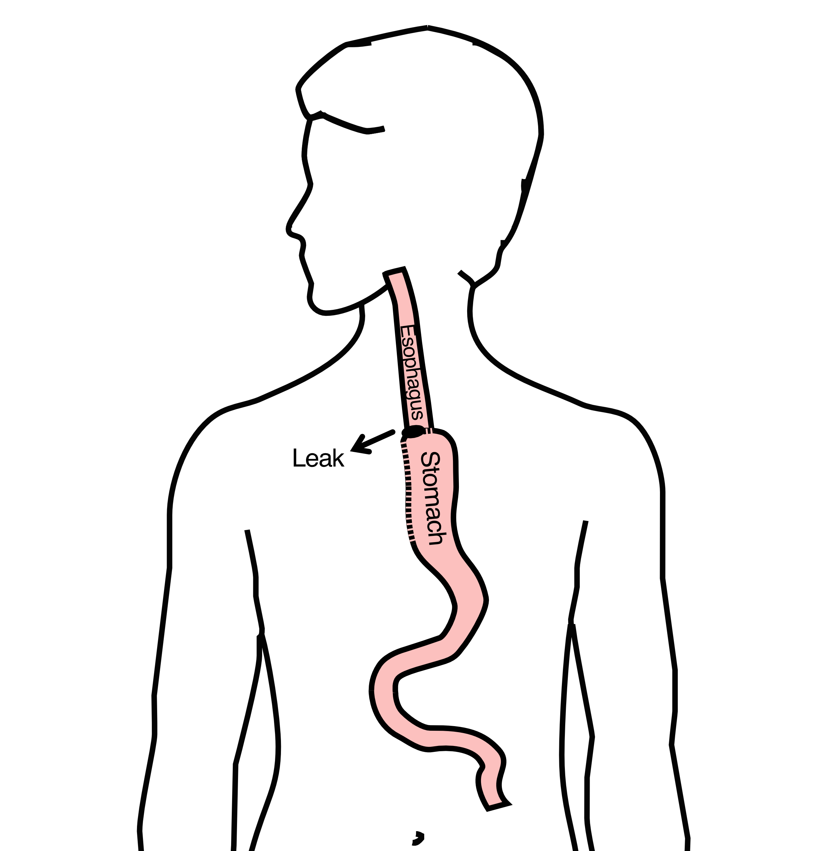

23 Anastomotic Leak
If leak occurs:
- Some leaks will seal
- Stent may be required to help healing
- Occasionally additional surgey is required

24 Anastomotic Leak
Risk of leak depends on:
- Type of operation performed
- Nutritional status of patient
- Experience of the surgeon

25 Pneumonia
- Occurs in 10-15% of patients after esophagectomy.
- Requires treatment with antibiotics
- Requires a longer hospitalization.
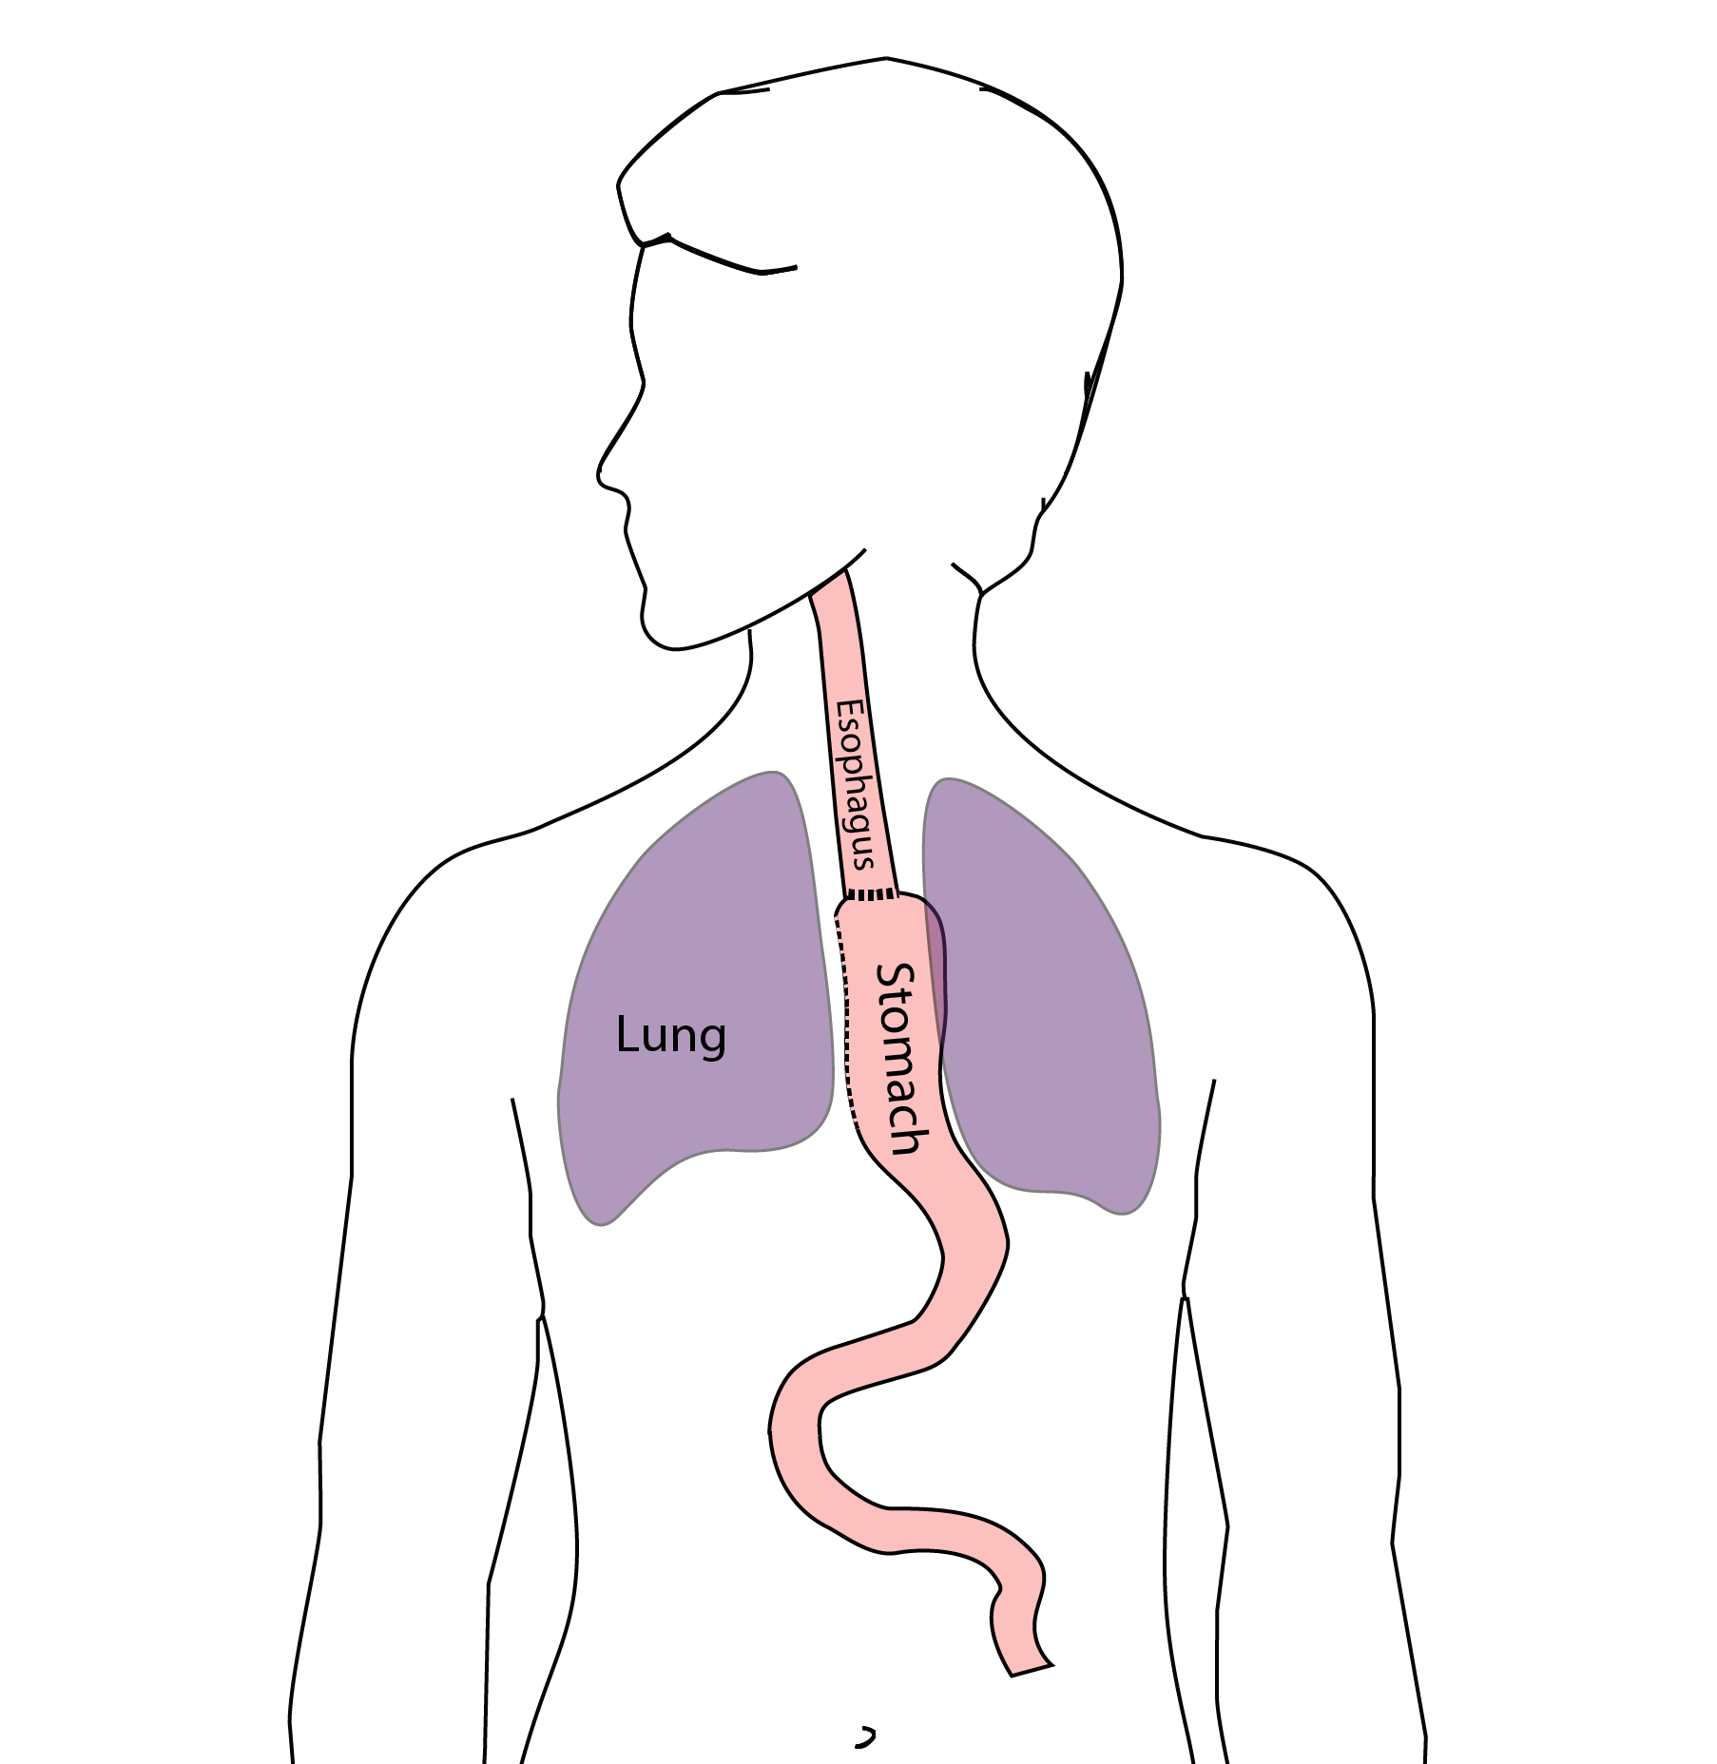

26 Preventing Pneumonia
Several ways to help prevent pneumonia:
- Deep breathing
- Coughing
- Walking
After surgery, this means:
- Sitting in a chair most of the day
- Walking in the halls as soon as possible

27 Minimally-invasive Esophagectomy
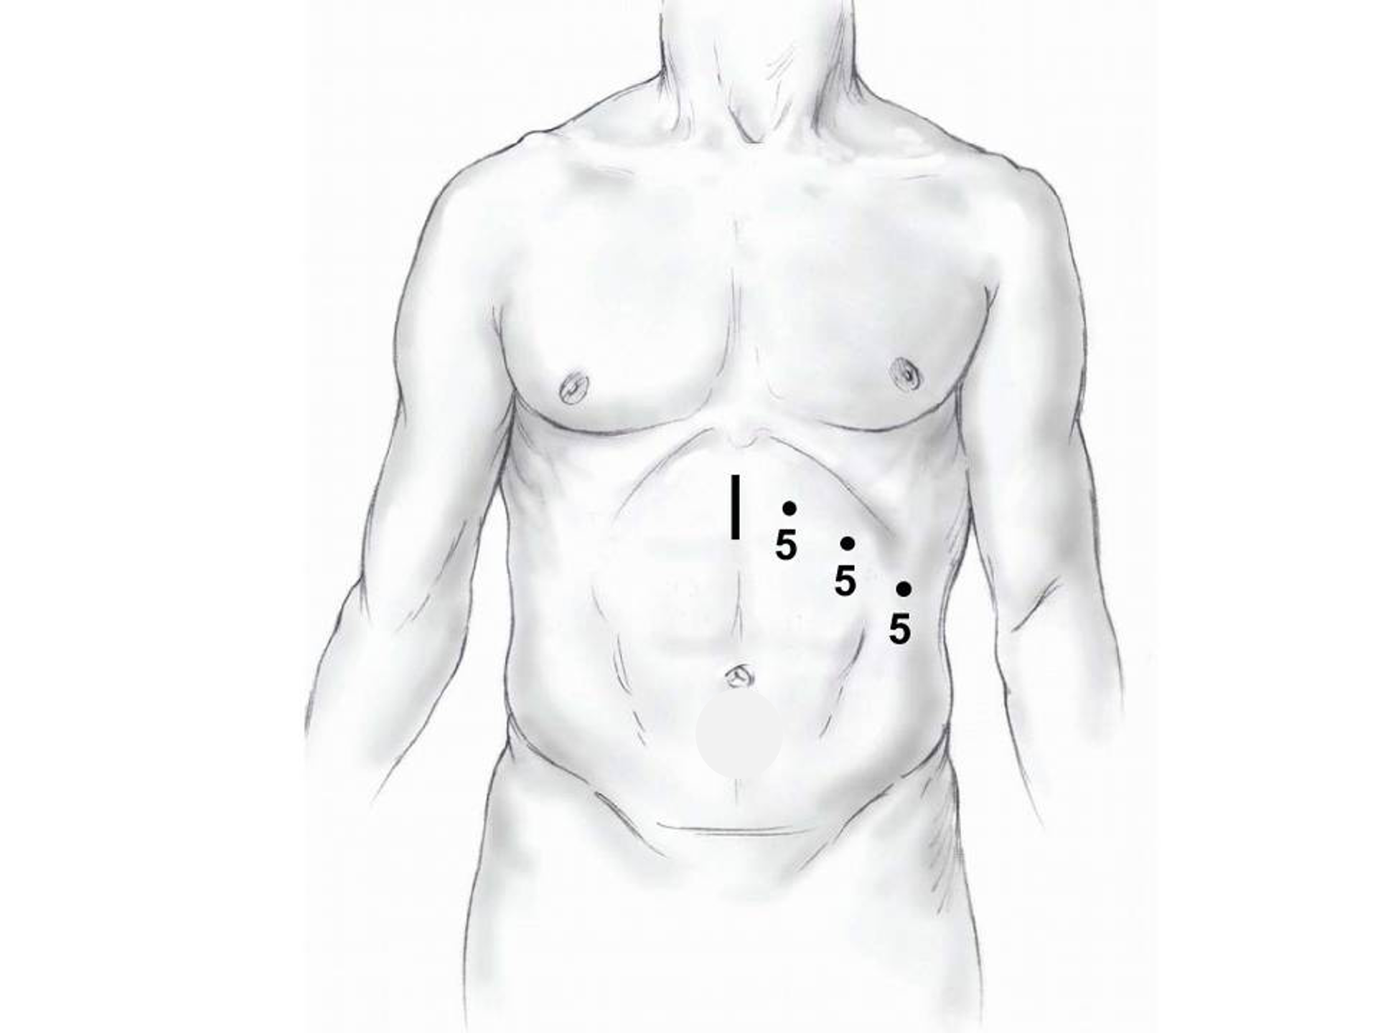
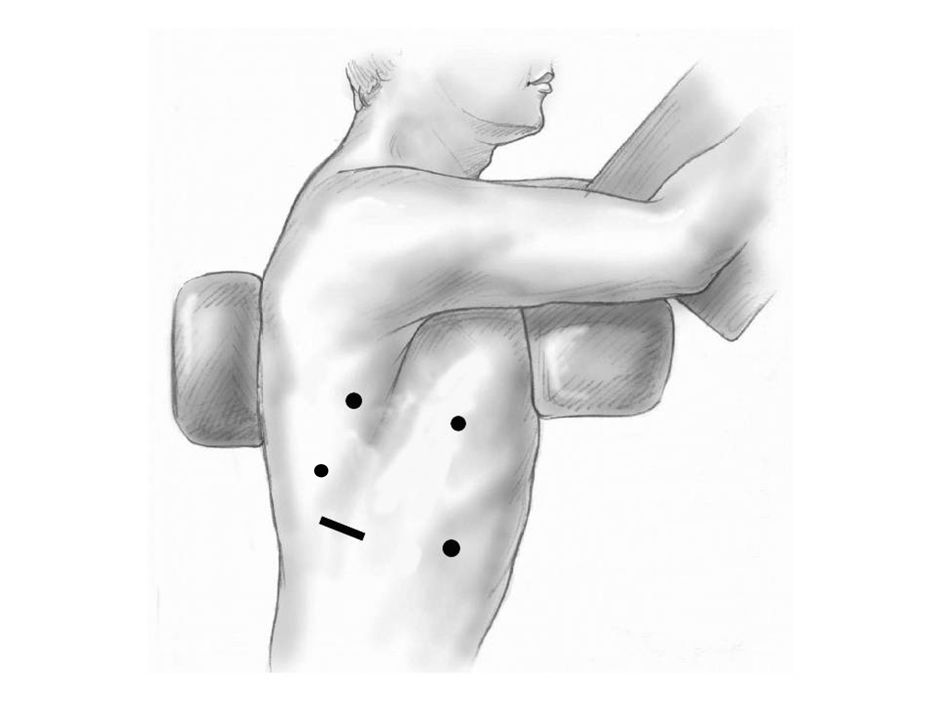

28 Risks of Surgery
Risks related to anesthesia
- Heart attack (5%)
- Irregular heart rhythm (15%)
- Pneumonia (10%)
- Blood clots in legs (<5%)
- Pulmonary embolism (2%)

29 Risks of Surgery
Risks related to Surgery
- Anastomotic leak (5%)
- Stricture at anastomosis (15%)
- Death within 90 days of surgery
  - Low risk patients = 2%
  - Intermediate risk = 10%
  - High risk = 30%

30 Risks of Surgery
Risks of Death within 90 Days of Surgery
 | Age <75 | Age >75
Normal Muscle (75%) | 2% | 10%
Low Muscle (25%) | 10% | 30%

31 Day Prior to Surgery
- Clear liquids for 24 hours prior to surgery
- Check with Pre-op nurse regarding medicines day prior to surgery
- No tube feedings the night before surgery

32 Day of Surgery
- Arrive at 5am – nothing to eat or drink after midnight.
- Medicines OK w/ a sip of water
- sip of black coffee but no cream.
- Surgery will be cancelled if you have cream/milk
- Waiting room for family and friends on 5th floor

33 Epidural Catheter for Pain Control
- Remains in place for 2-5 days
- Dosage can be adjusted as needed
- Can make it more difficult to urinate
- May require foley catheter in bladder
- Foley catheter removed after epidural removed

34 Intensive Care Unit (ICU) (2-4 days)
- Surgical ICU on 11th floor
- NG tube in nose to drain stomach and esophagus
- Catheter in bladder
- Chest tube right chest
- Abdominal drains (usually 2)
- Feeding jejunostomy (usually stays in 8 wks)

35 Intensive Care Unit (ICU)
- Bladder catheter removed → check that bladder empties properly
- Chest tube removed (day 2-4) → follow-up x-ray
- Fluid emptied from drains every few hours
- Start tube feedings by feeding
- Feeding jejunostomy (stays in 8 weeks)

36 Ward - 6Tower
- Jejunostomy feeds started
- Up in a chair most of the day
- Walking in the halls
  - Start with assistance
  - Improves lung function
  - Prevents loss of muscle strength

37 Jejunostomy Feeds
Jejunostomy tube feeds
- Start continuous (24 hours)
- Convert to night-time only (16 hours)
Water administered through feeding tube
- Usually 8oz 4 times/day
- Important to prevent dehydration

38 Jejunostomy Tube

39 Jejunostomy Typical Regimen
- Jejunostomy tube feeds for 16 hours (6pm-10am)
  - Men: 75mL/hour x 16 hours = 5 cartons
  - Women: 60mL/hour x 16 hours = 4 cartons
- Water 240ml (8oz) via syringe 4x/day
Hospital nurses will teach use of the feeding tube

40 Jejunostomy Feeds with Diabetes
Jejunostomy feedings elevate blood sugars
- Insulin may be required along with feeds
Typical Pattern for tube feeds
- Feeds run via pump from 6pm to 10am
- Insulin at 6pm (70/30 insulin)
- Insulin at Midnight (70/30 insulin)
- No insulin if tube feedings are not run

41 Jejunostomy Video

42 Activity after Surgery
- Up in chair most of the day
- Walking with help from nurse/Physical Therapist
- Goals:
  - Improve lung function
  - Prevent muscle loss

43 Nasogastric (NG) Tube
Tube passed through nose into stomach
- Drains fluid from stomach
- Prevents vomiting
Upper GI X-ray on 2nd or 3rd day after surgery
- If stomach empties well $→$ NG tube removed
- Otherwise, X-ray repeated 2-3 days later

44 Swallowing Evaluation
Once NG tube has been removed:
Modified barium swallow in radiology
- Drink a white chalky liquid (barium)
- Look for proper swallowing function
- 70% of patients $⇒$ liquids started by mouth

45 Oral Intake at Home
Most are taking protein shakes when they go home
Protein shakes are started after tolerating water
- 2 oz per hour to start
- 4 oz per hour if 2oz are tolerated well

46 Discharge
Goal: ready to leave day #6/7 after surgery
- Night-time tube feedings (6pm to 10am)
- Nutrition by mouth (70% of patients)
  - 1 oz of water per hour by mouth OR
  - Protein shakes 4oz every 2 hours
- Water through tube 8oz four times per day
- Home care nursing (feeding tube teaching)
- Home infusion (tube feeding supplies)

47 Nutrition after Surgery
At discharge home:
- Protein shakes 4oz every 2 hrs
- Tube feeds 4-5 cans at night (6pm-10am)
10-12 Days: Increase protein shakes
- Tube feeds 3-4 cans at night
Three weeks: Post-esophagectomy Diet
8-12 weeks: Remove feeding tube (in office)

48 Transition from Tube Feeds $→$ Eating
Dietitian will calculate daily protein goal
- Typically 60-75 grams protein/day
- Each carton of tube feeding has 15 grams
  - 75 grams protein = 5 cartons/night
- More intake by mouth $→$ tube feeds reduced
Spread out protein during the day (20gm/meal)
- Three meals + 2-3 high-protein snacks

49 Post-esophagectomy Diet
- Soft Consistency
- High Protein
- Avoid sugary liquids (can cause ‘dumping’)
- Avoid raw vegetables (and salads)
- Eating
  - Small, frequent meals
  - Sit up for 30-45 minutes after eating
  - Avoid eating within 2 hours of bedtime

50 Medicines at Home - Pain
Acetaminophen (Tylenol) 1000mg 4x/day
Gabapentin 300mg 3 times/day
Oxycodone
- As needed in addition to Tylenol/gabapentin
- Will begin reducing dose at first postop visit
- Can usually discontinue by 4 weeks
- NO DRIVING WHILE ON OXYCODONE

51 Non-steroidals Anti Inflammatory (NSAID)
Non-steroidal anti-inflammatories (Celebrex)
- 200 mg every 12 hours starting at 2 weeks
NO GOODY POWDERS OR BCs
- (Can cause permanent scarring at the surgery site)

52 Acid Blockers = Proton Pump Inhibitors
Examples include ompeprazole and pantoprazole
- Will stay on for at 1-2 years to prevent acid reflux
- Important in preventing scarring at anastomosis (new connection between esophagus and stomach)
- To administer through feeding tube, open capsule and resuspend beads in 60mL (2oz) of water

53 Medicines at Home
Reglan – Helps stomach empty
- Will plan to stop after six weeks
- 0.1% risk of tardive dyskinesia (nervous tic)
Remeron – Helps improve appetite
- Can cause vivid dreams
- Used for several weeks after surgery
- Will stop within first three months of surgery

54 Metoprolol = Beta Blockers
- Slows heart rate and lowers blood pressure
- Used to prevent rapid heart rate
- Patients not taking a beta blocker prior to surgery $→$ wean after after surgery
- Patients taking a beta blockerprior to surgery $→$ return to prior dose and drug after surgery

55 Sleeping at Home
Reflux can occur the first few weeks/months after surgery
This improves over the first few months
A wedge pillow can be helpful for sleep
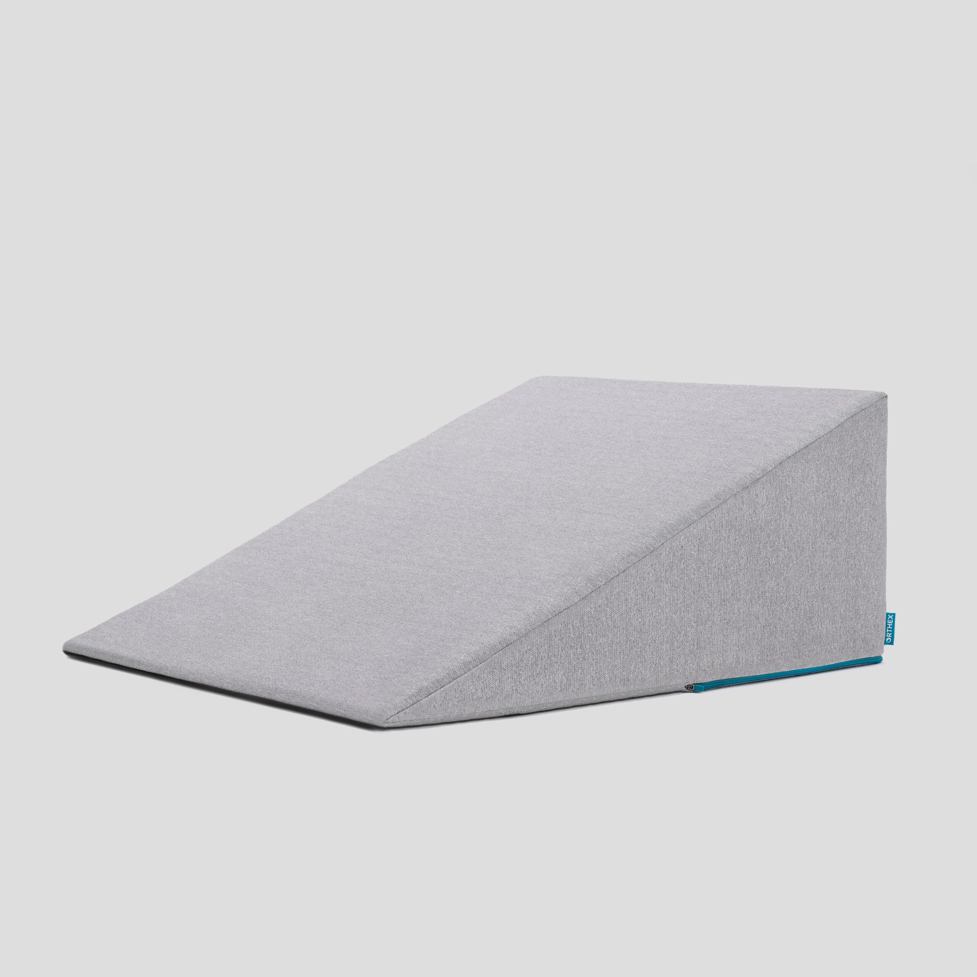

56 Postoperative Visit at 7-10 Days
Check surgical site
- Remove staples (if needed)
Adjust medicines as needed
- Insulin (for diabetic patients on insulin)
- Reduce beta blocker medicines
Advance diet
Reduce tube feeds

57 After surgery
Wean off medicines added after surgery
- Pain medicines
- Beta-blockers
- Reglan and Remeron
Continue acid blockers for at least 1 year

58 Jejunostomy Removal
Jejunostomy tube is removed in the office once you can take in enough nutrients by mouth
Removal usually around 8 weeks after surgery
May take 30 minutes and some local anesthetic to loosen up the tube for removal.

59 Nutritional Monitoring after Surgery
You may have difficulty absorbing some nutrients:
- Iron
- Vitamin B12
- Vitamin D

60 Nutritional Monitoring after Surgery
About 3 months after the jejunostomy tube is removed, we will check blood levels:
- Iron (ferritin)
- Vitamin B12
- Vitamin D

61 Nutritional Replacements after Surgery
Vitamin or iron replacements can be ordered by:
- Primary Care Provider (PCP)
- Medical Oncologist
- Surgeon
If levels are low
- Replacement
- Repeat testing in 3-6 months

62 Team Members - Physicians
Primary Care Provider
Gastroenterologist
Medical Oncologist (chemotherapy)
Radiation Oncologist (radiation)
Surgeons
- Jonathan Salo MD
- Kelli Salter MD
- Michael Roach MD

63 Team Members - Support Staff
Physician Assistant - Kate Duncan PA-C
Dietitian - Liz Koch
Nurses
- Matthew Carpenter RN
- Brandon Galloway LPN
Navigators
- Laura Swift
- Lorna Espinal
Care Coordinator - Karen Julian-Martinez

