Preparing for your Esophagectomy

1 Team Members - Physicians
Primary Care Provider
Gastroenterologist
Medical Oncologist (chemotherapy)
Radiation Oncologist (radiation)
Surgeons
- Jonathan Salo MD
- Kelli Salter MD
- Michael Roach MD

2 Team Members - Support Staff
Physician Assistant - Kate Duncan PA-C
Dietitian - Liz Koch
Nurses
- Matthew Carpenter RN
- Brandon Galloway LPN
Navigators: Laura Swift RN & Lorna Espinal RN
Care Coordinator - Karen Julian-Martinez
# Cancer care team (MDs, PA-C, Dietitian, Schedulers, RNs, Navigators)

3 Nutrition Prior to Surgery
High-protein diet (most people need 60-80 grams protein/day)
- Protein shakes (Permier or Fairlife) with protein and minimal sugar
Important to avoid weight loss prior to surgery
Good nutrition before surgery improves wound healing and recovery

4 Exercies Prior to Surgery
Goal: 30minutes/day of vigorous exercise 6 days/week
Vigorous: Working hard enough you can’t carry a conversation
Types of Exercise:
- Walking: Outside, Treadmilll, or an indoor Mall
- Stationary Exercise Bike
Lifting light weights and stretching are helpful in addition
# General preop nutrition + exercise + PCP

5 Day Prior to Surgery
- Clear liquids for dinner evening prior
- You will receive instructions regarding medicines
- Stop tube feeds at midnight night before

6 Morning of Surgery
Unless instructed otherwise:
- You will be notified regarding arrival time, which is usually 2-3 hours before the surgery time.
  - Surgery Monday, Tuesday, Wednesday, Friday: Arrive 4am
  - Surgery Thursday: Arrive 5am
- Nothing to eat or drink after midnight

7 Medicines the Morning of Surgery
- Medicines with a sip of water or black coffee
- No milk or cream
- Surgery will be cancelled for milk/cream

8 Hospitality House
- Guest house for patients and families
- Located walking distance from hospital
- Shuttle service available
- Make reservation request through clinic nurses
- Cost $50 per night

9 Parking and Arrival
- Blue Parking Deck: XXX Medical Center Drive, Charlotte ND 28204
- Enter Building through Dixon Tower (Traffic circle with Fountains)
- Check in at the desk and tell them you will have surgery
- Escort service will direct you to the Preoperative area on 5th floor

10 Day of Surgery
- Waiting Room on 5th floor for families
- Surgery completed 3pm - 5pm
- Transfer to Surgical Intensive Care Unit 4pm - 6pm
- Visitors permitted into the ICU 5pm - 7pm

11 What to Bring to the Hospital
- No jewelery or valuables
- Cell phone and charger
- Insurance cards??
- Underweaer??

12 Visitor’s Policy
Intensive Care Unit
- Two visitors at a time 8am - 8pm
- One “Care Partner” can stay overnight in ICU
Ward
- All rooms are private rooms
- Day bed available for a family member
- Visiting hours 8am - 8pm
No visitors please who have a cough or fever!
# Immediate preop instructions: NPO, meds in the morning

13 Preparation for Surgery
Medical evaluation may be needed before surgery:
- Pulmonary Function Tests to test lung function
- Cardiology evaluation to test heart function
  - Echocardiogram
  - Stress Test
  - Holter monitor

14 Esophagectomy for Cancers of the Esophagus or GE Junction
Primary Surgery
- Superficial Tumors (T1) not completely removed by endoscopy
- Localized Tumors (T2 N0 M0)
- Surgery scheduled after medical evaluation
- Aim for surgery within 6 weeks of consultation
Preoperative Therapy $→$ Surgery
- Locally Advanced (T3 Nx M0)
- Surgery scheduled after
  - Recovery from preoperative therapy
  - Restaging scans (CT or PET)
  - Medical evaluation
- Timing between end of preoperative therapy and surgery
  - Chemotherapy + radiation: 6-8 weeks
  - Chemotherapy: 4-8 weeks

15 Preoperative Visits
Medical Oncology - Monitor chemotherapy and side effects
Radiation Oncology - Monitor radiation and side effects
Surgical Oncology
- Consult visit with Dr Salo
- Mid-treatment visits with Dr Salo / Kate Duncan
- Preop visit with Dr Salo (may be virtual)
- In-person preop visit with Kate Duncan and Liz Koch

16 Surgery for Esophageal Cancer
Surgery for esophageal cancer is performed for:
- Superficial Tumors (T1) not removed by endoscopy
- Localized Tumors (T2 N0 M0)
- Locally Advanced (T3 M0) after preop therapy

17 Goals of Surgery
- Remove tumor from esophagus
- Remove surrounding lymph nodes
- Create a new esophagus
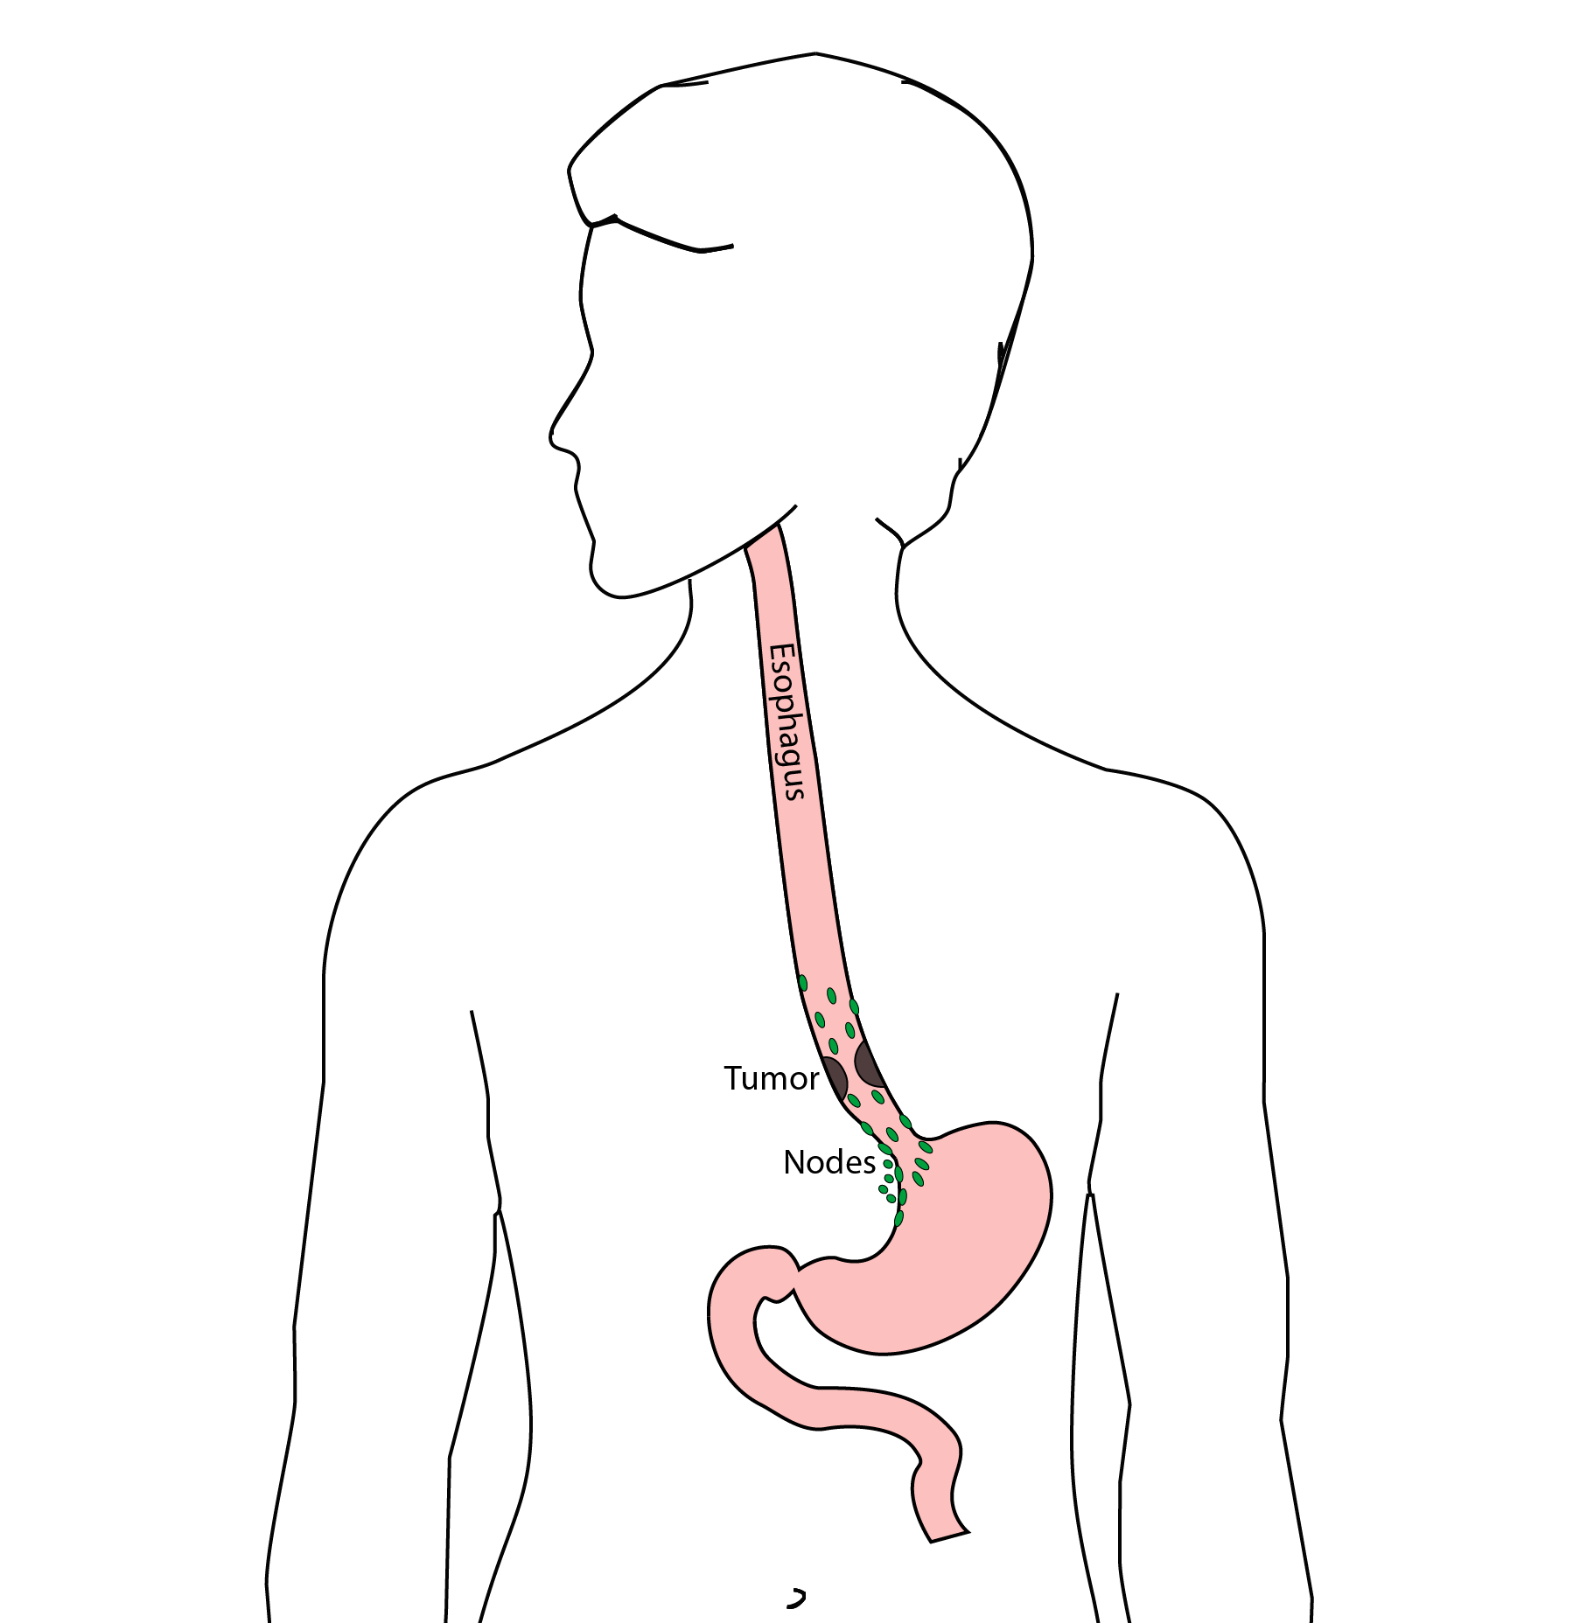

18 Ivor Lewis (Transthoracic) Esophagectomy
- Removes tumor and lower 1/2 esophagus
- Removes surrounding lymph nodes
- GI tract reconstructed
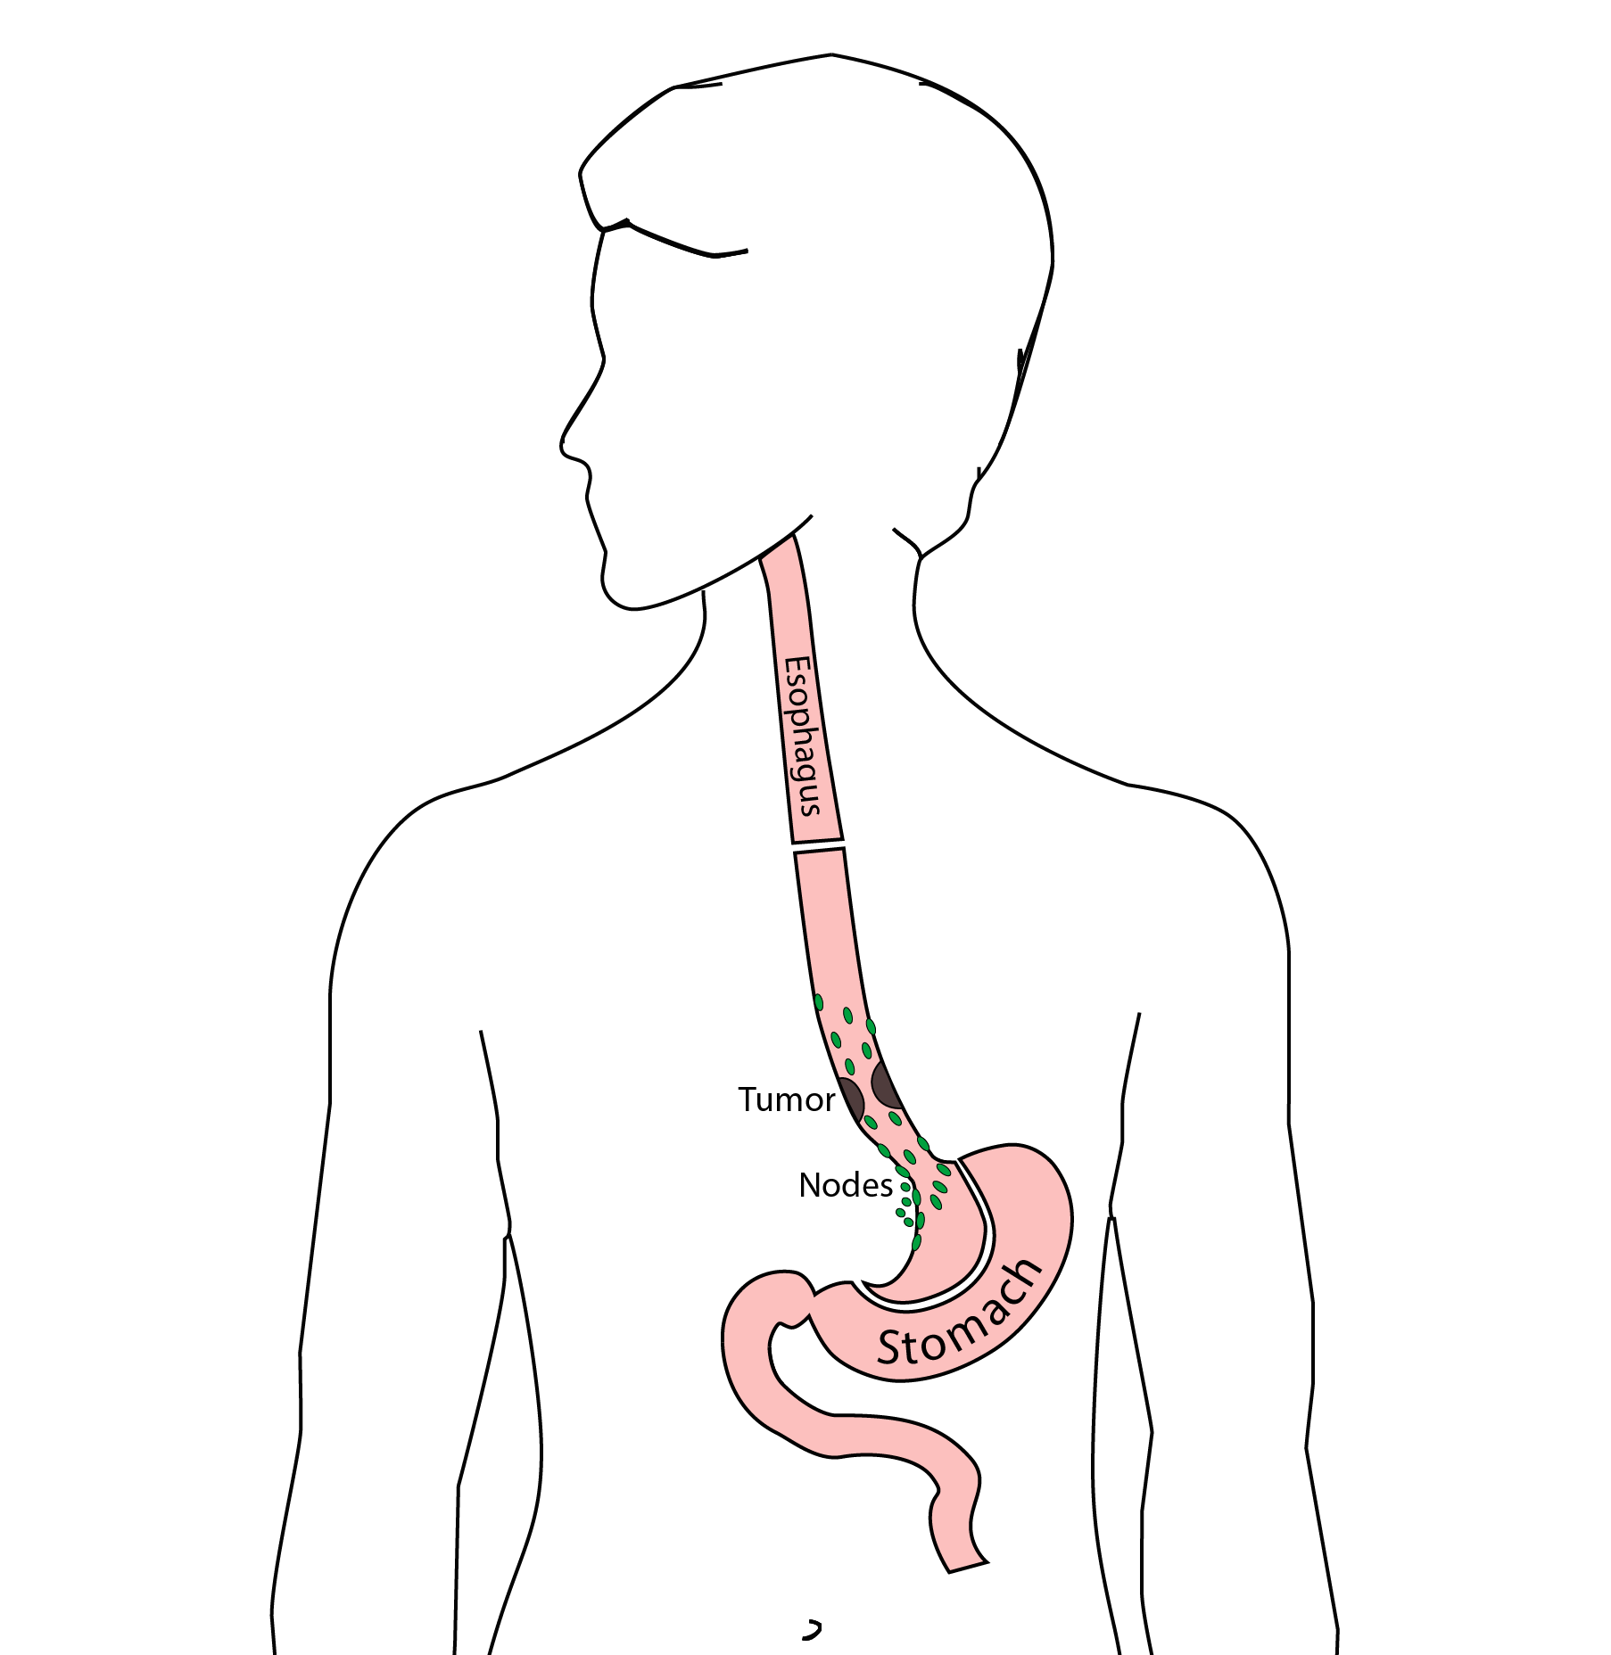

19 Reconstruction
New esophagus is created from the stomach in the abdomen by fashioning it into a tube.
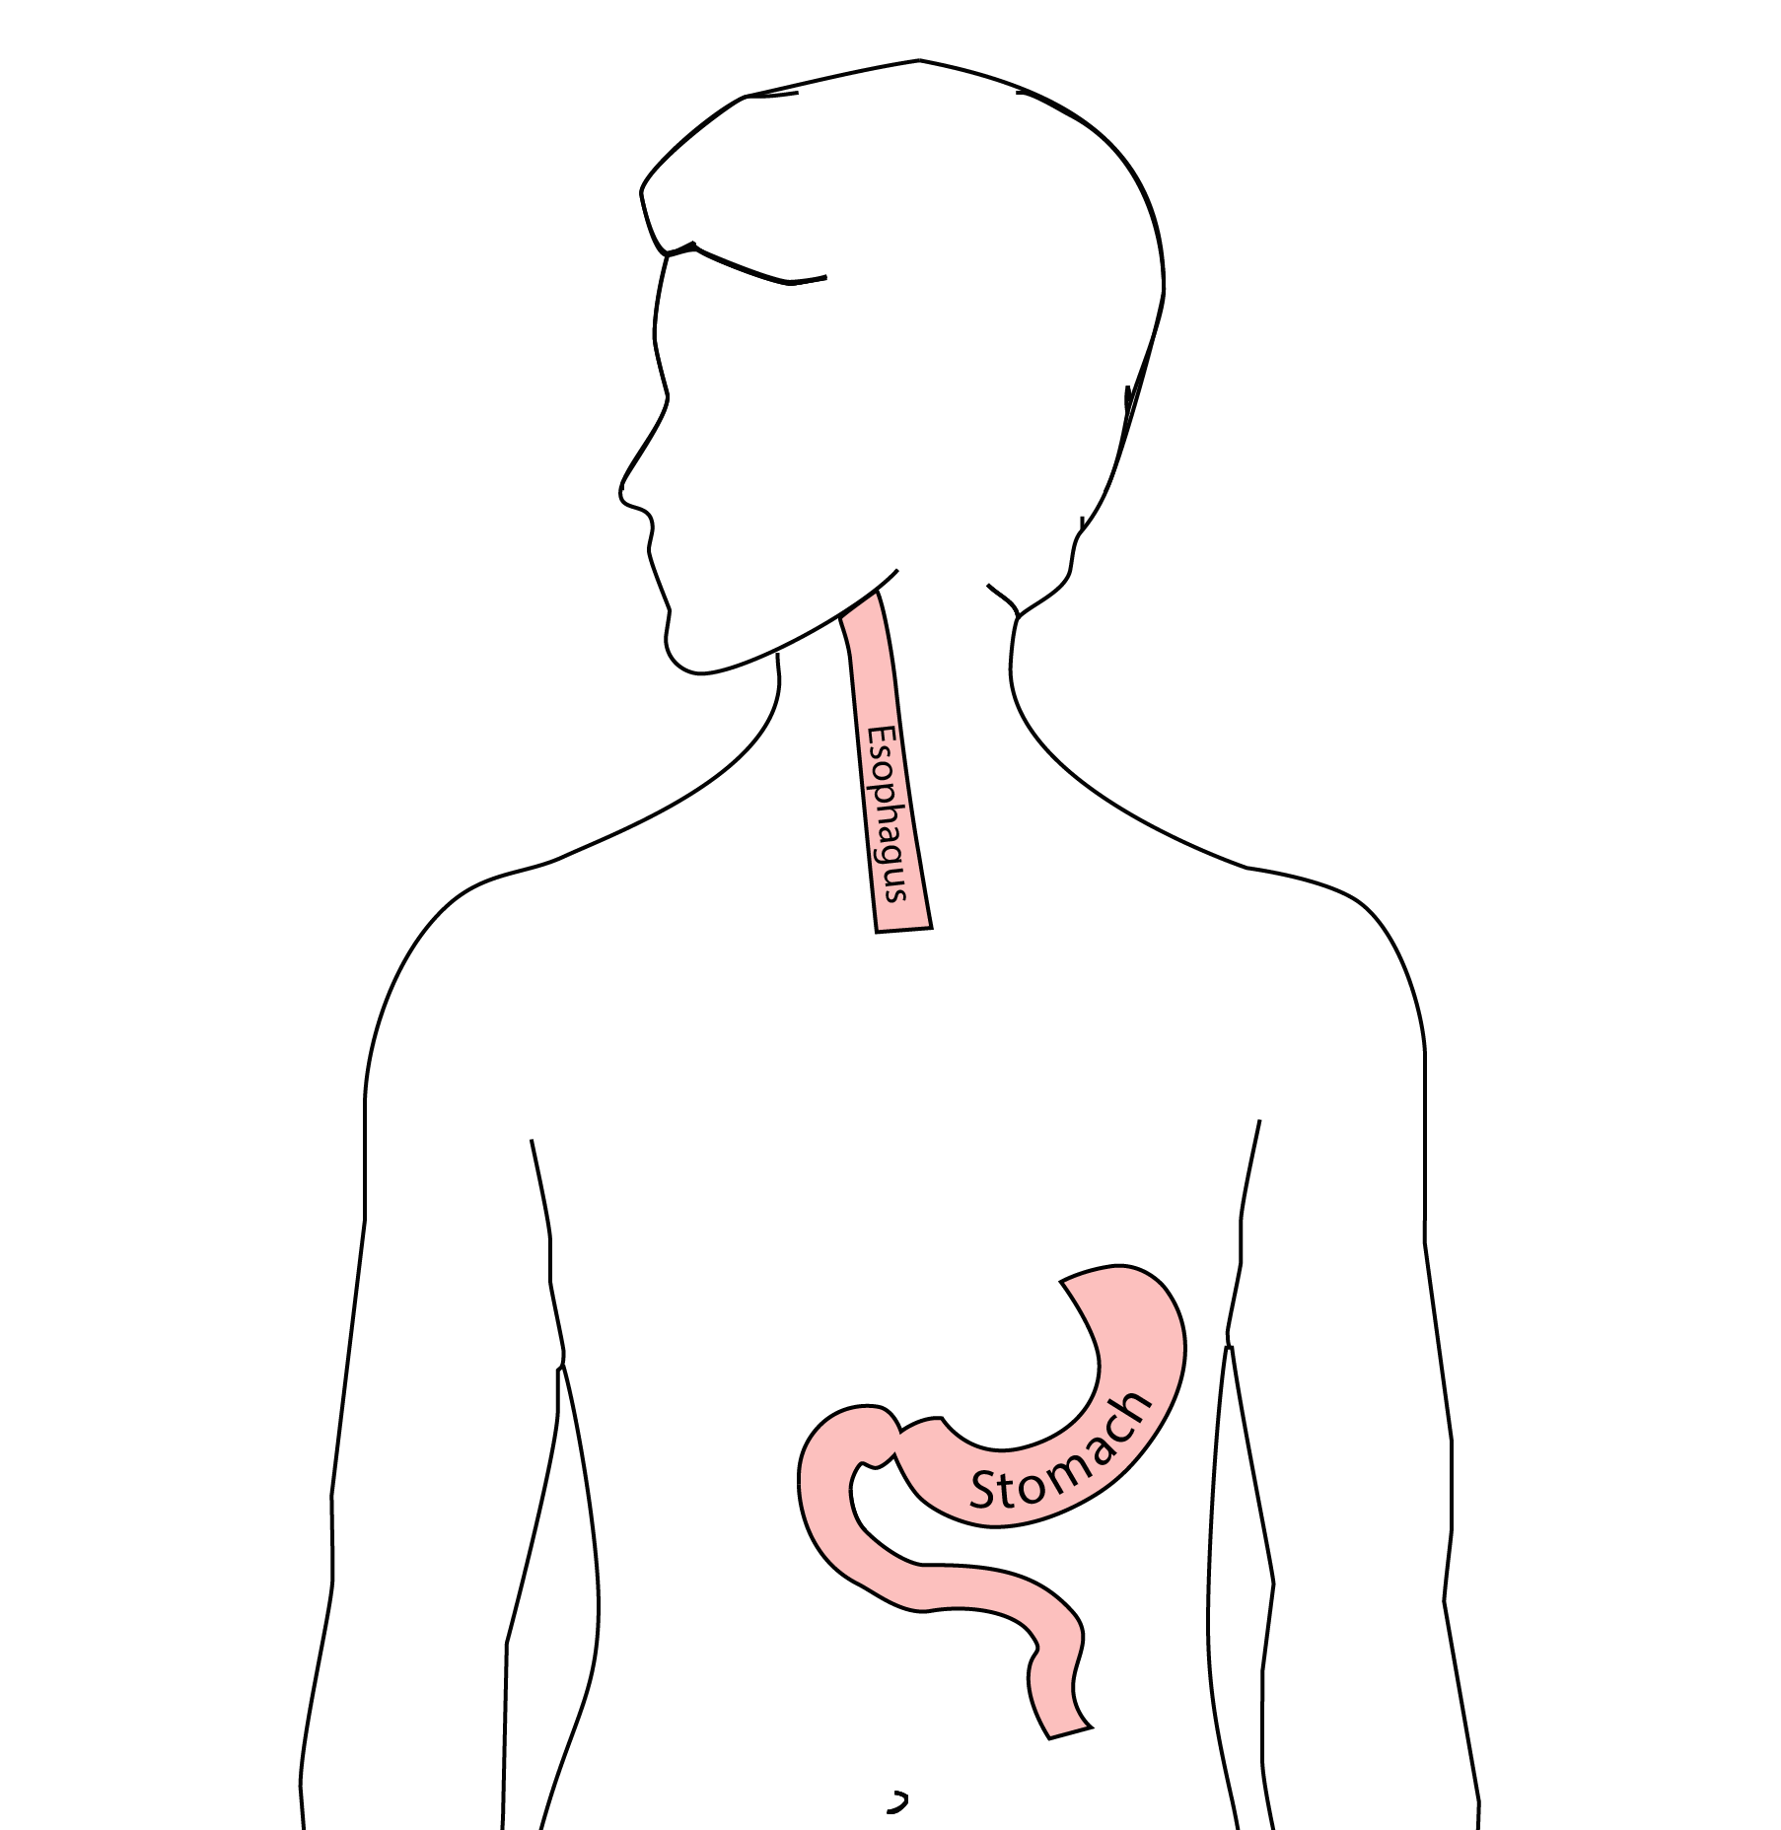

20 Ivor Lewis esophagectomy
The new esophagus is now brought up into the chest. A connection is made between the esophagus and the stomach, called an anastomosis.
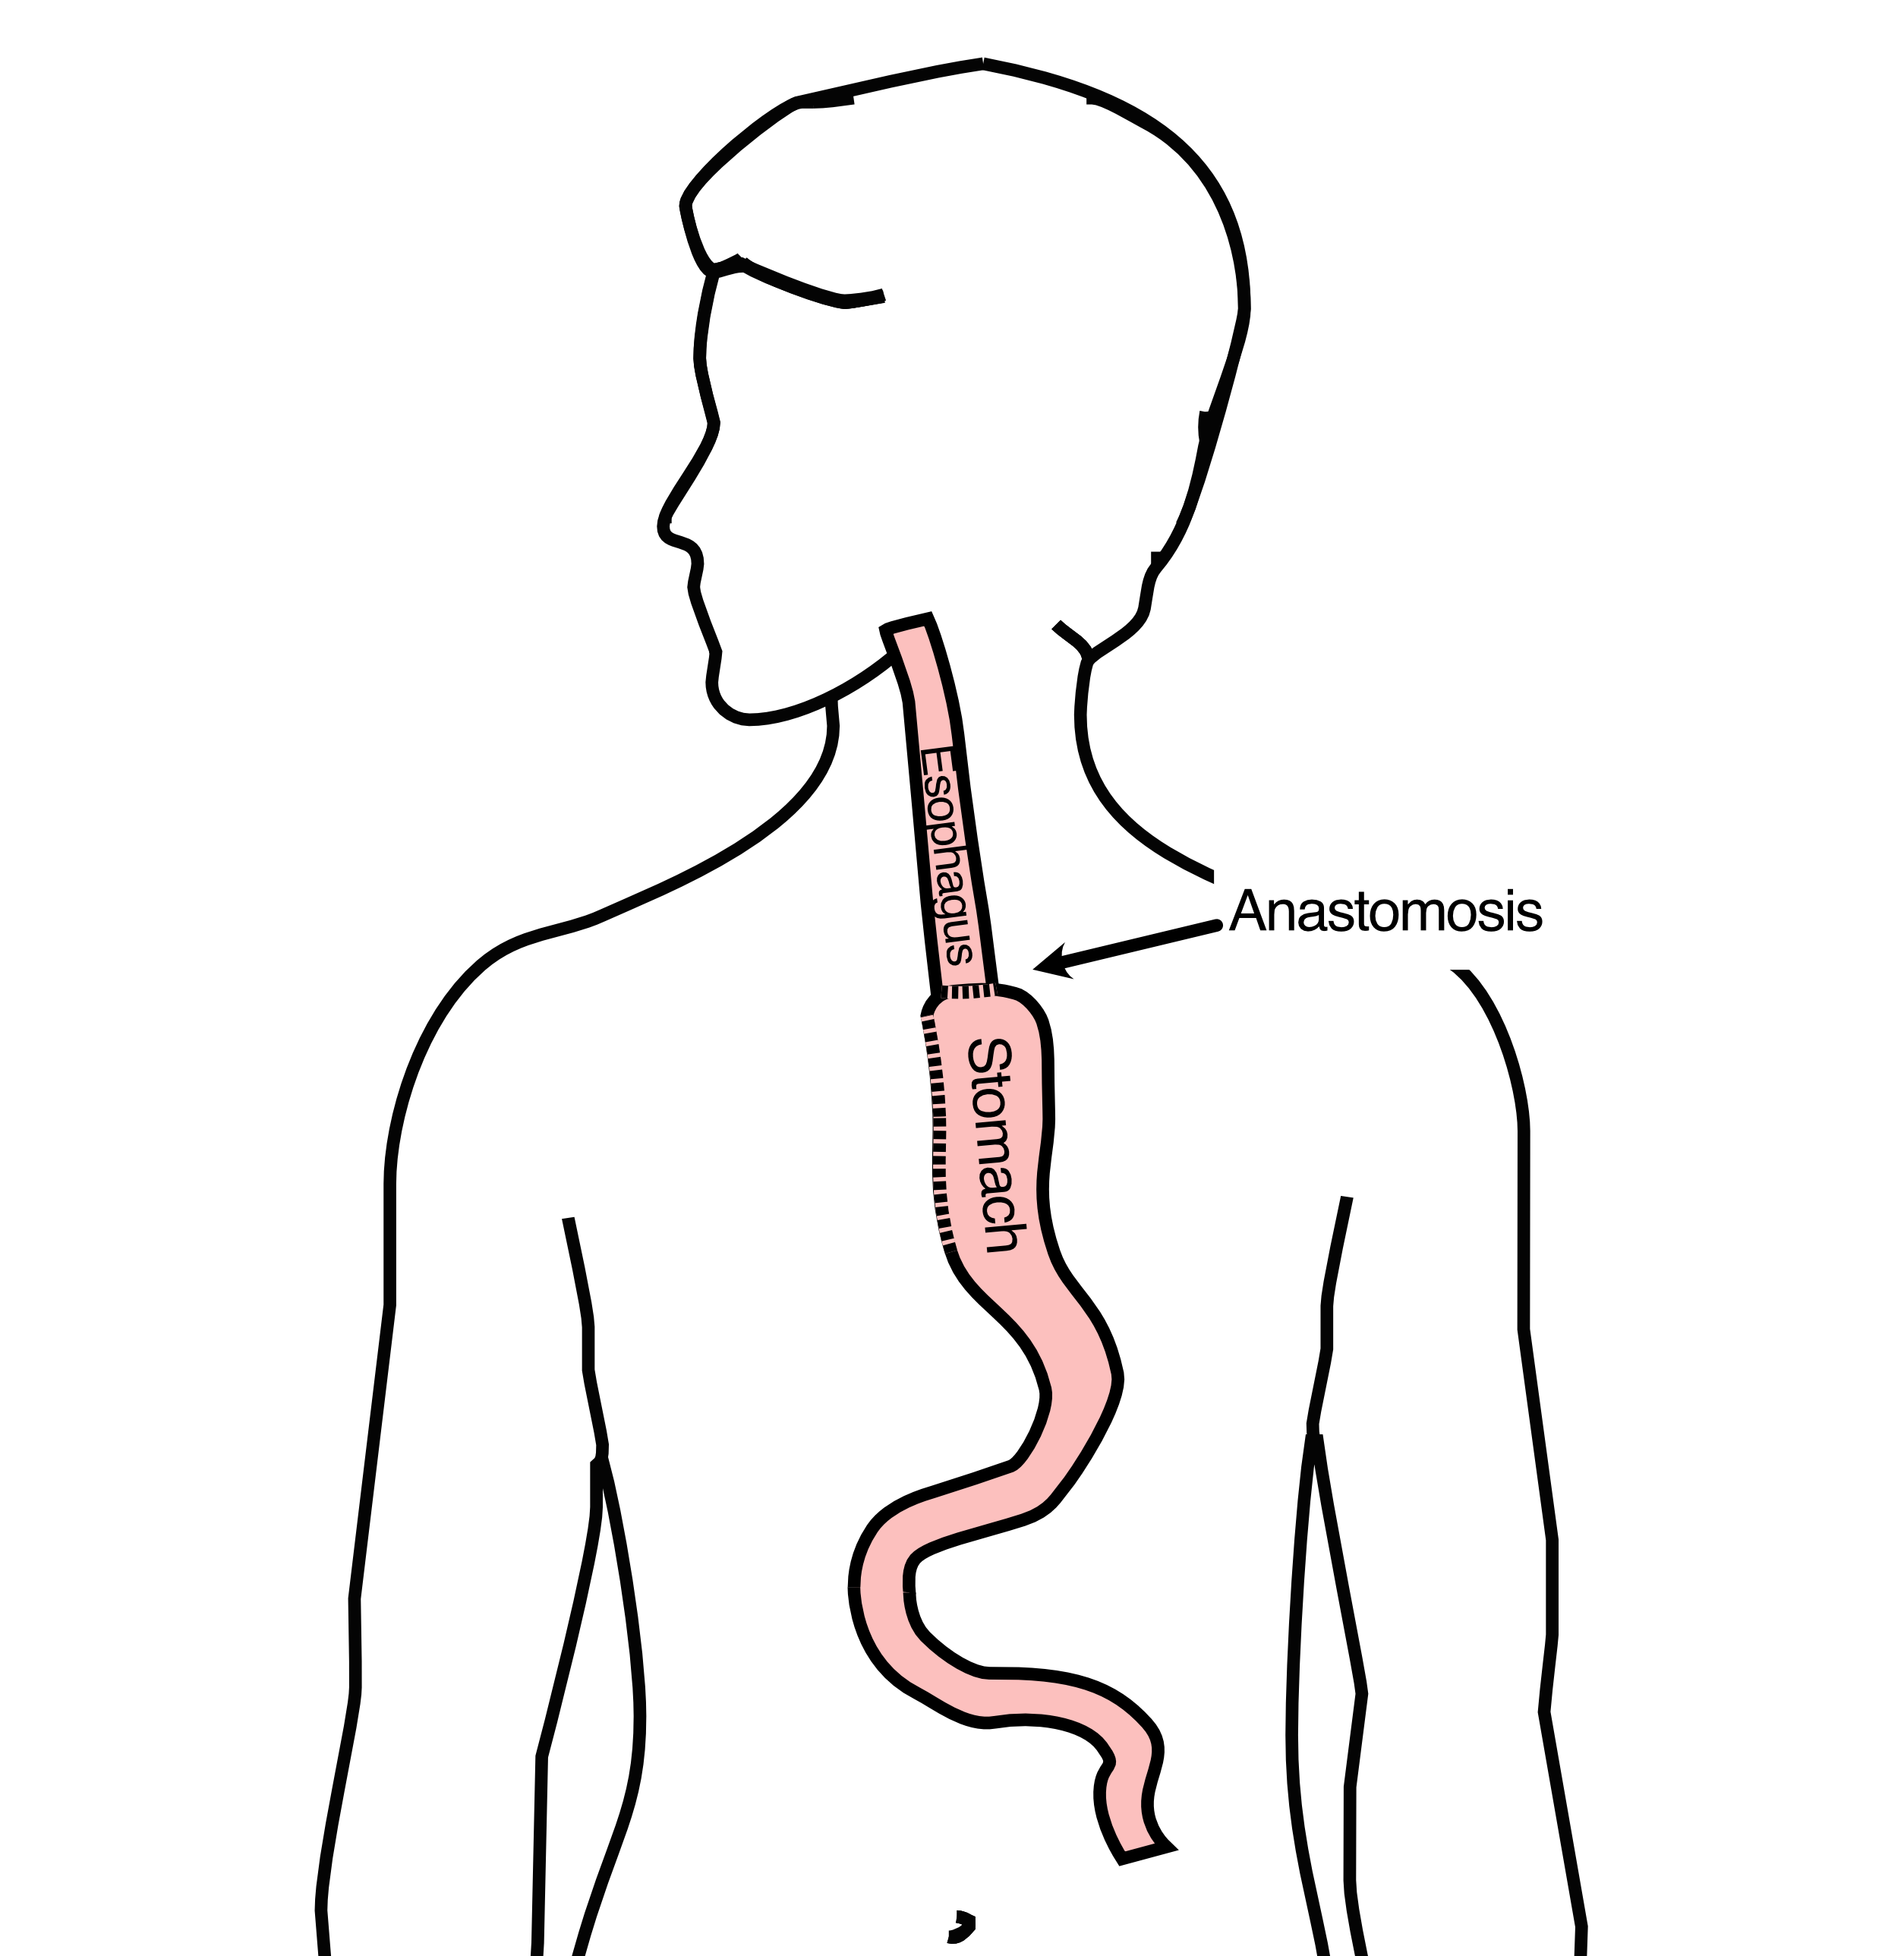

21 Minimally-invasive Ivor Lewis
- Small incisions abdomen and chest
- Surgical telescope and instruments
- Smaller incisions $→$ faster recovery and less discomfort
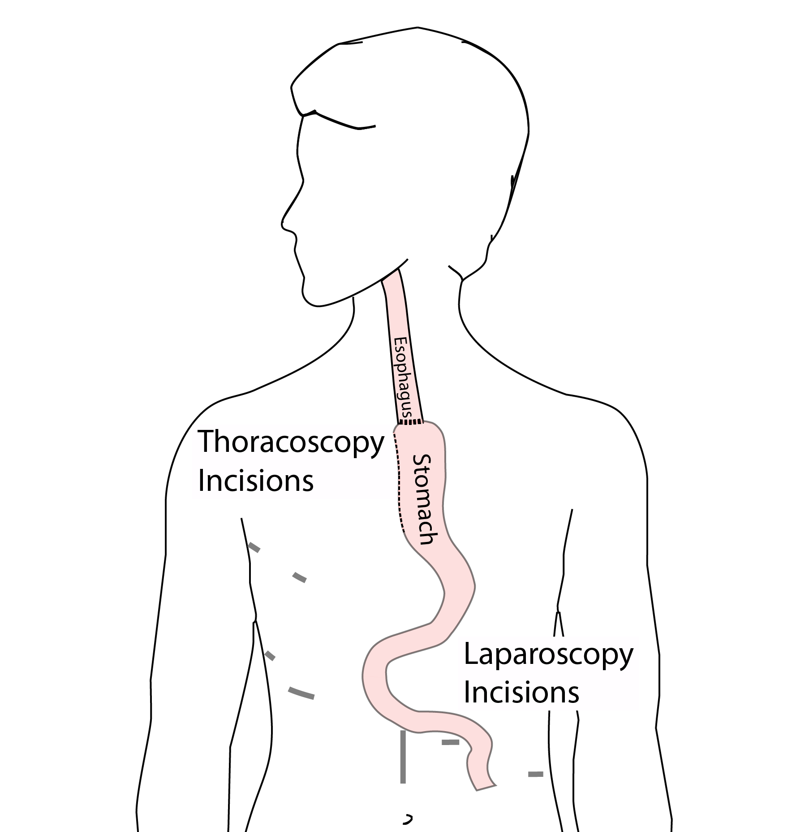

22 Open Ivor Lewis
Mininally-invasive approach feasible in 98% of cases
In some cases, an open approach is still necessary (2%)
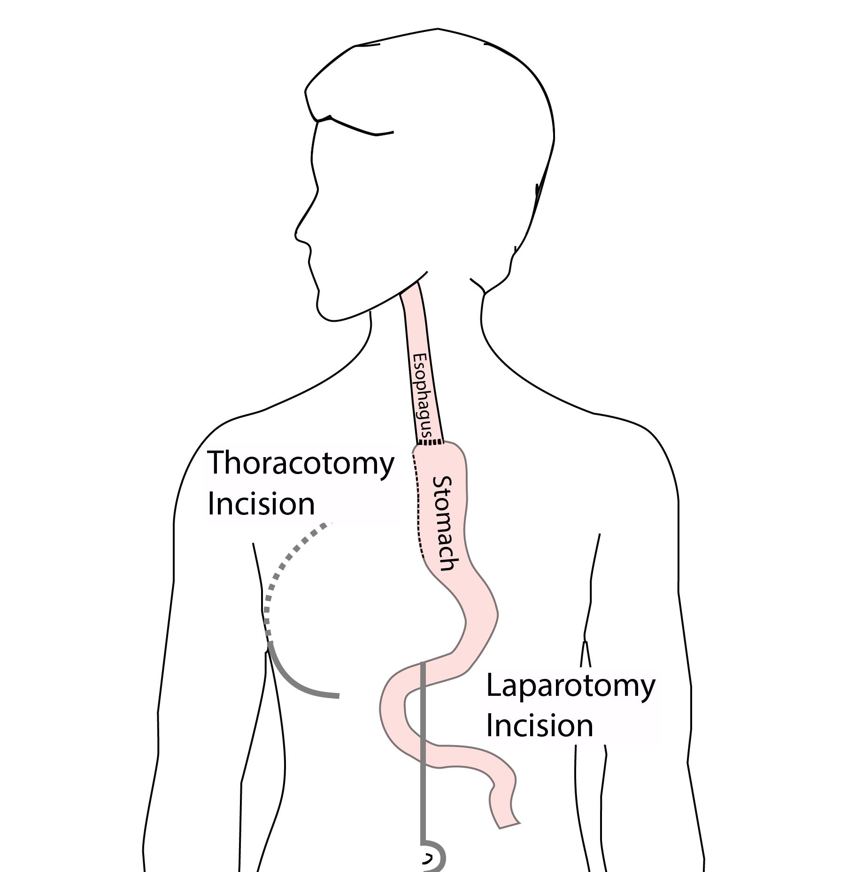

23 Total Esophagectomy
For patients with tumors in the upper esophagus, we need to remove more of the esophagus
We need to remove the whole esophagus, including the portion in the neck
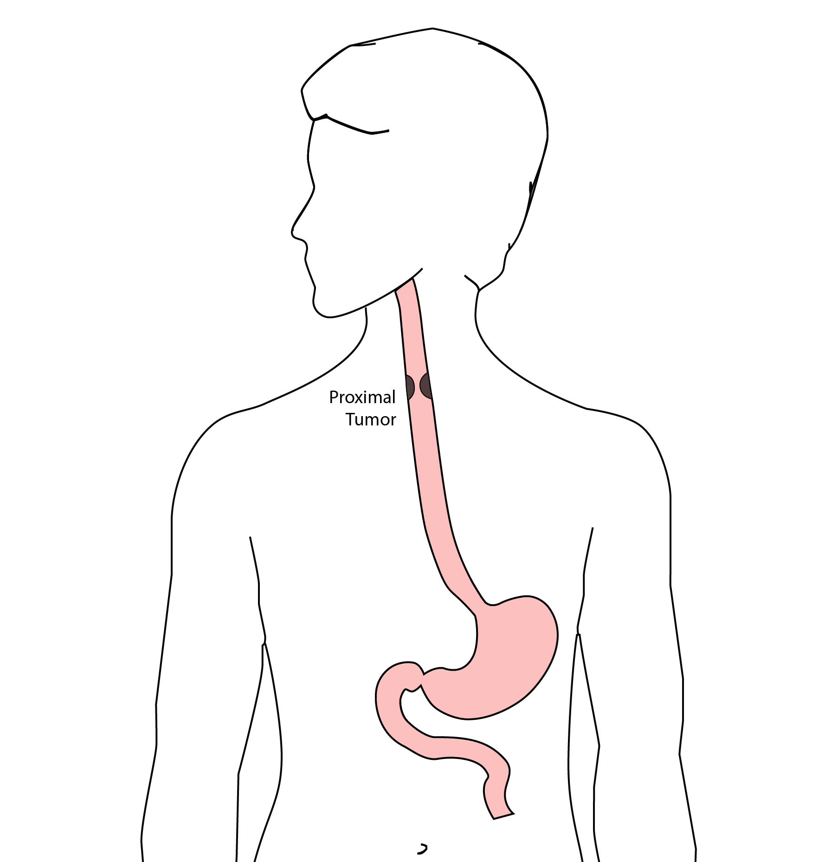

24 McKeown Esophagectomy
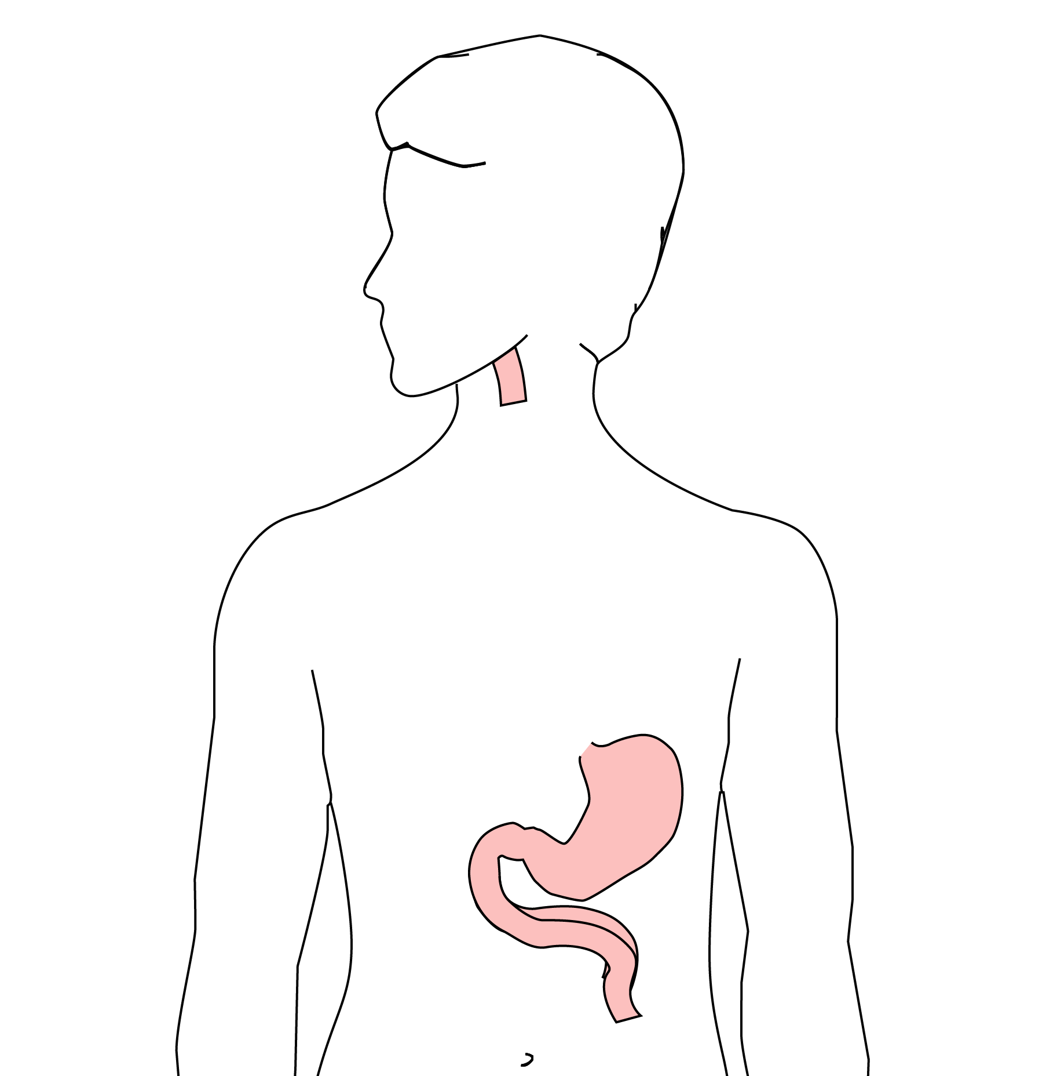 All of esophagus removed
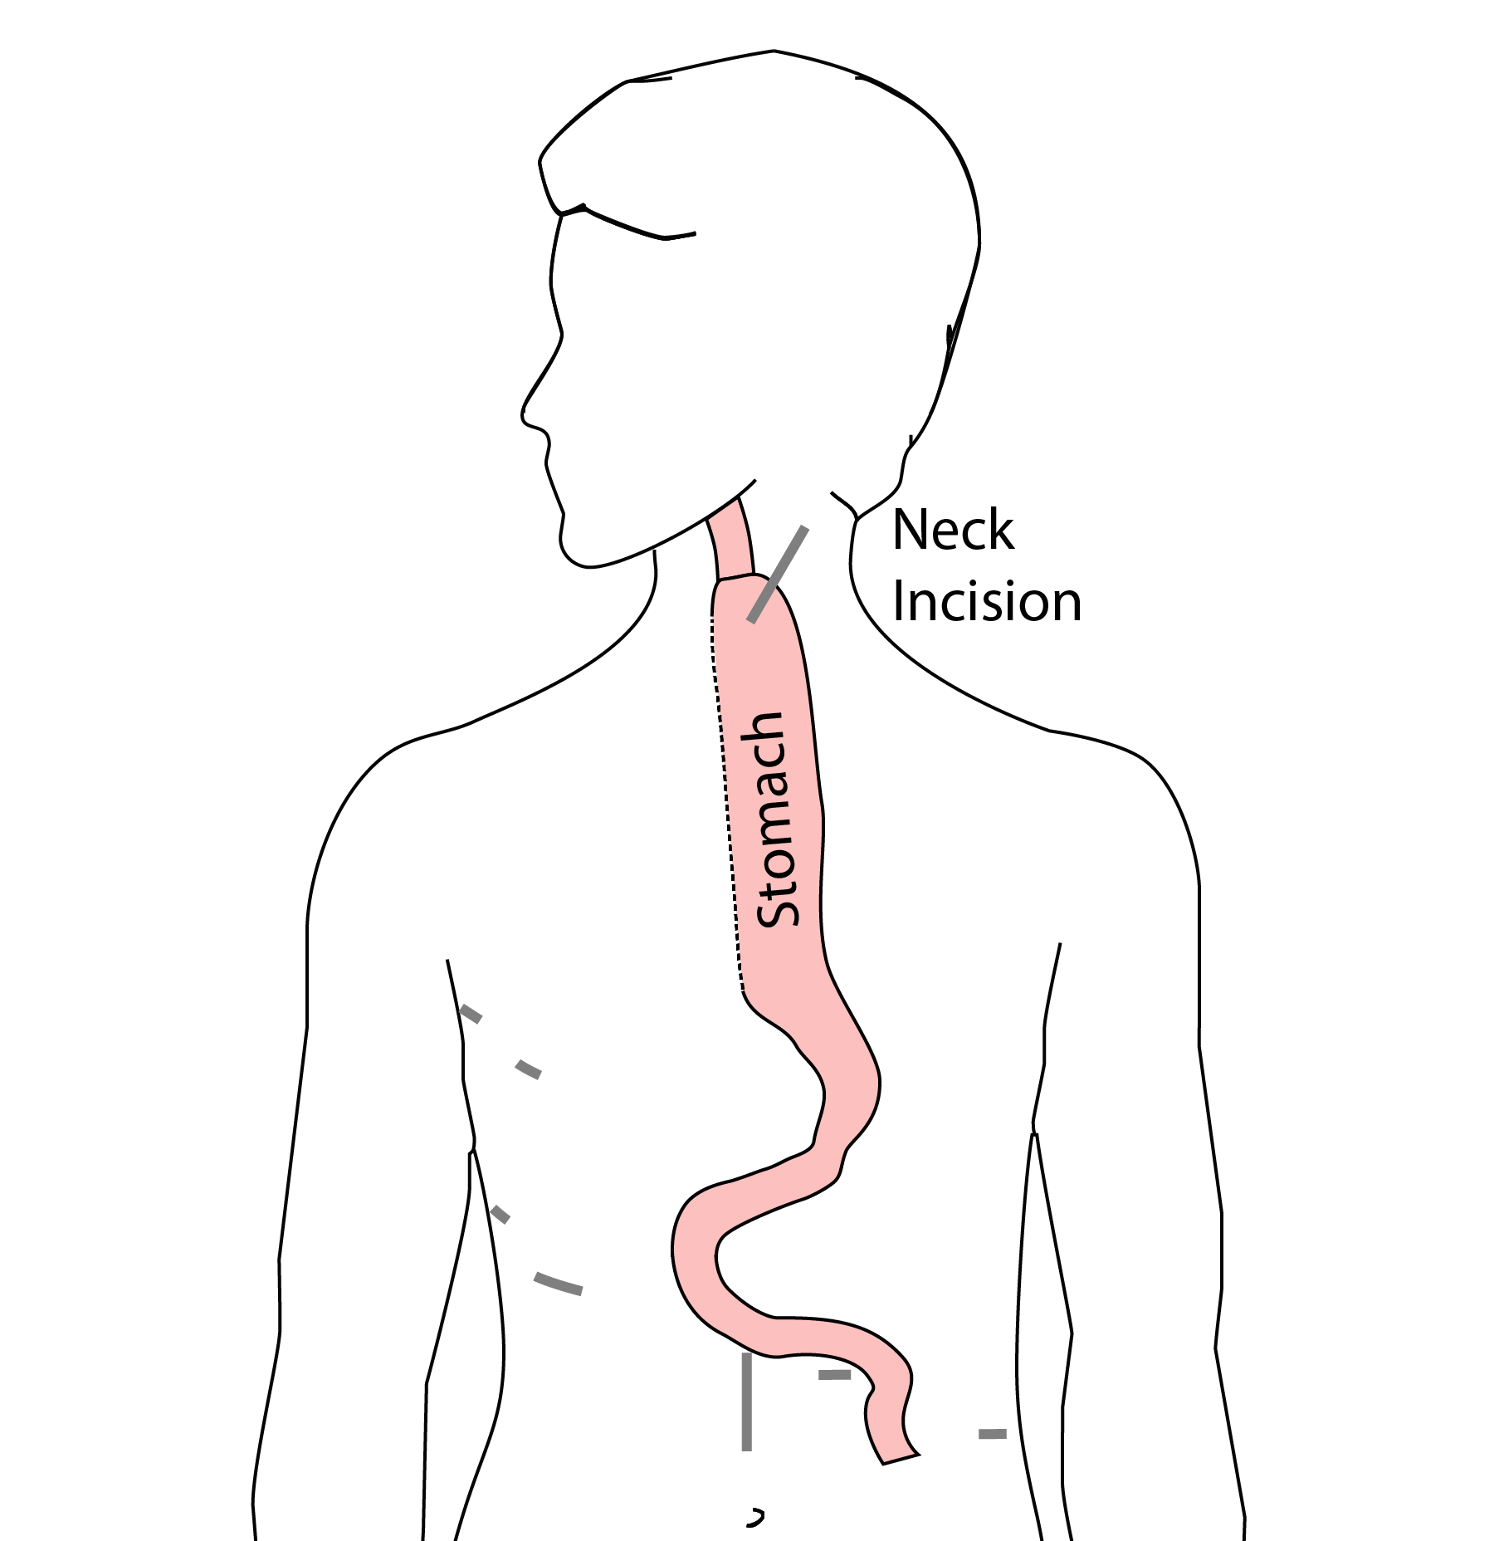 Connection made in the neck

25 Risks of Esophagectomy
Esophagectomy is a complex operation, with a real risk of complications.
Two significant complications:
- Anastomotic leak
- Pneumonia

26 Anastomotic Leak
The anastomosis is surgical connection between the esophagus and the stomach.

27 Anastomotic Leak
If healing doesn’t occur:
- Leakage of fluid from the esophagus
- Infection in the space between the lungs
- Requires additional time in the hospital
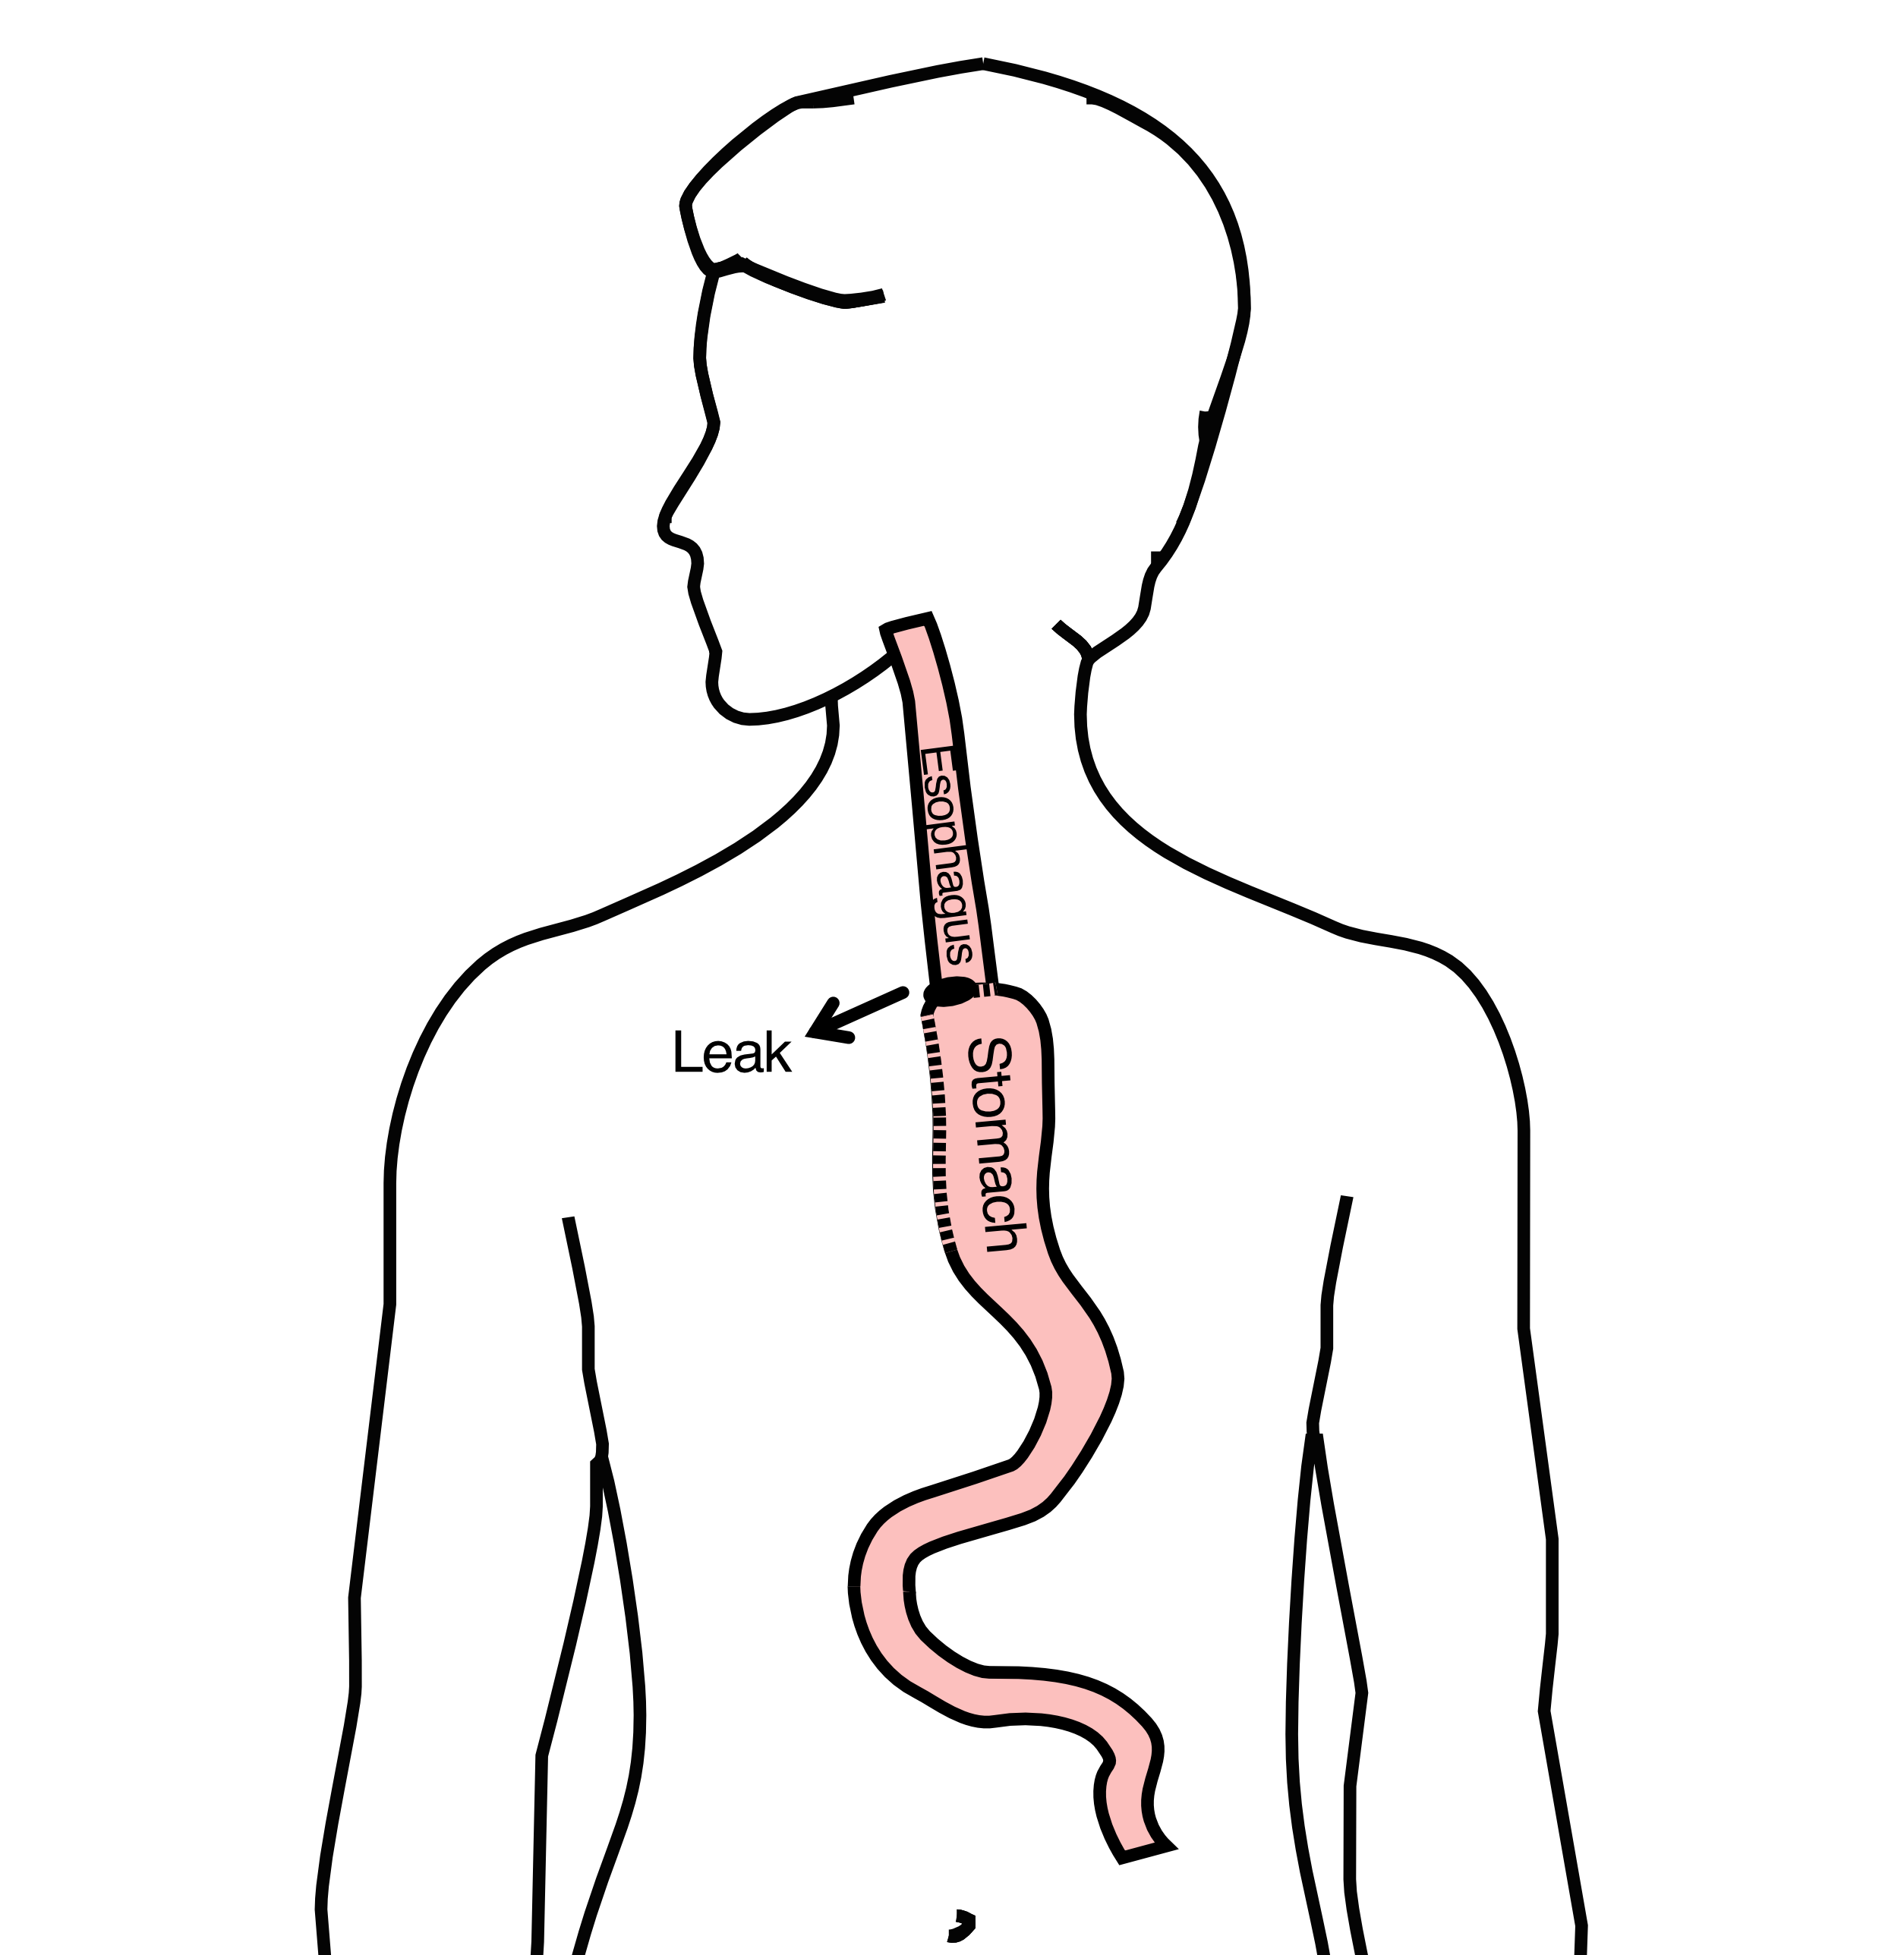

28 Anastomotic Leak
If leak occurs:
- Some leaks will seal
- Stent may be required to help healing
- Occasionally additional surgey is required

29 Anastomotic Leak
Risk of leak depends on:
- Type of operation performed
- Nutritional status of patient
- Experience of the surgeon

30 Pneumonia
- Occurs in 10-15% of patients after esophagectomy.
- Requires treatment with antibiotics
- Requires a longer hospitalization.
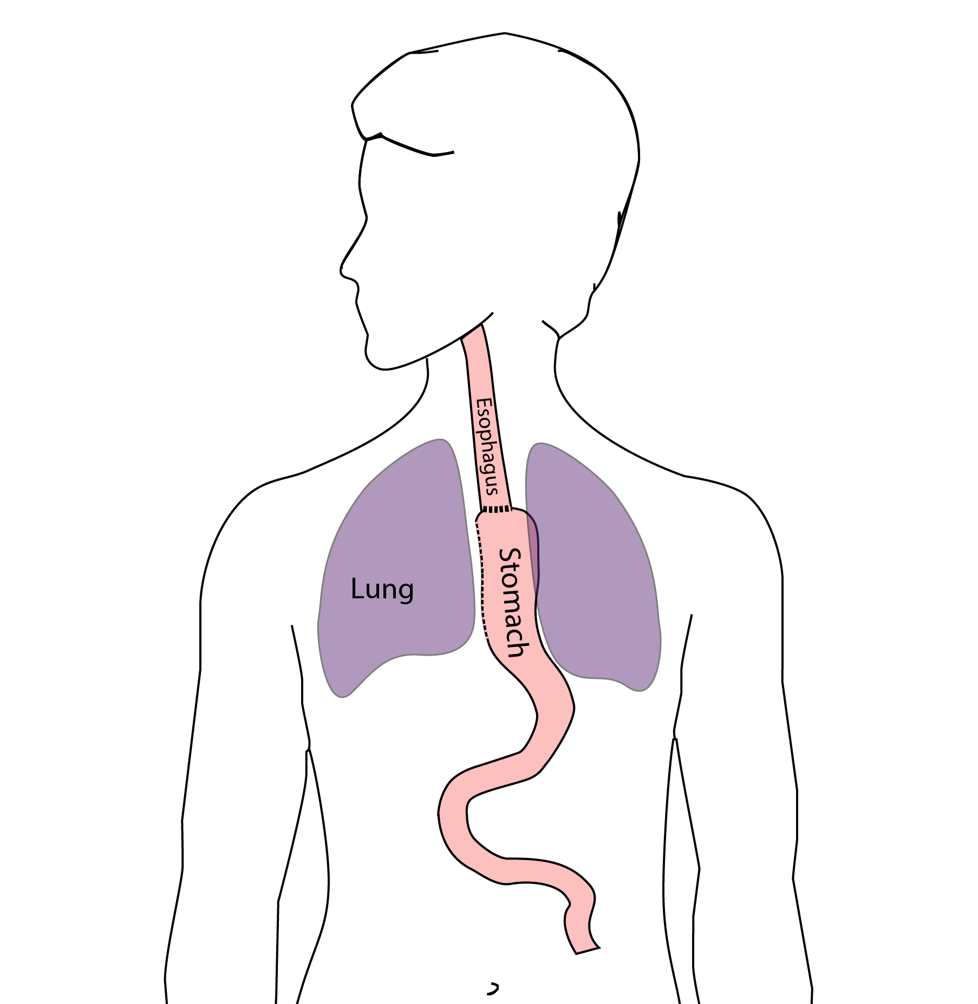

31 Preventing Pneumonia
Several ways to help prevent pneumonia:
- Deep breathing
- Coughing
- Walking
After surgery, this means:
- Sitting in a chair most of the day
- Walking in the halls as soon as possible

32 Minimally-invasive Esophagectomy
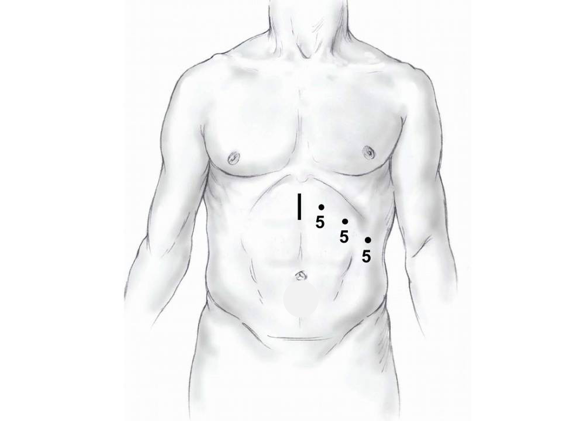
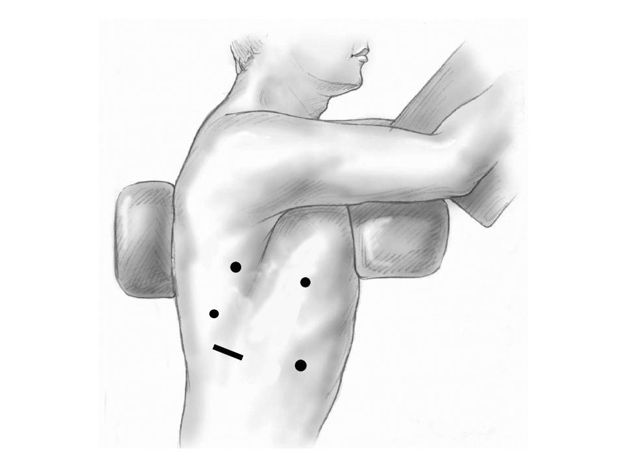

33 Risks of Surgery
Risks related to anesthesia
- Heart attack (5%)
- Irregular heart rhythm (15%)
- Pneumonia (10%)
- Blood clots in legs (<5%)
- Pulmonary embolism (2%)

34 Risks of Surgery
Risks related to Surgery
- Anastomotic leak (5%)
- Stricture at anastomosis (15%)
- Death within 90 days of surgery
  - Low risk patients = 2%
  - Intermediate risk = 10%
  - High risk = 30%

35 Risks of Surgery
Risks of Death within 90 Days of Surgery
 | Age <75 | Age >75
Normal Muscle (75%) | 2% | 10%
Low Muscle (25%) | 10% | 30%

36 Epidural Catheter for Pain Control
- Remains in place for 2-5 days
- Dosage can be adjusted as needed
- Can make it more difficult to urinate
- May require foley catheter in bladder
- Foley catheter removed after epidural removed

37 Intensive Care Unit (ICU) (2-4 days)
- Surgical ICU on 11th floor
- NG tube in nose to drain stomach and esophagus
- Catheter in bladder
- Chest tube right chest
- Abdominal drains (usually 2)
- Feeding jejunostomy (usually stays in 8 wks)

38 Intensive Care Unit (ICU)
- Bladder catheter removed → check that bladder empties properly
- Chest tube removed (day 2-4) → follow-up x-ray
- Fluid emptied from drains every few hours
- Start tube feedings by feeding
- Feeding jejunostomy (stays in 8 weeks)

39 Ward - 6Tower
- Jejunostomy feeds started
- Up in a chair most of the day
- Walking in the halls
  - Start with assistance
  - Improves lung function
  - Prevents loss of muscle strength

40 Jejunostomy Feeds
Jejunostomy tube feeds
- Start continuous (24 hours)
- Convert to night-time only (16 hours)
Water administered through feeding tube
- Usually 8oz 4 times/day
- Important to prevent dehydration

41 Jejunostomy Tube

42 Jejunostomy Typical Regimen
- Jejunostomy tube feeds for 16 hours (6pm-10am)
  - Men: 75mL/hour x 16 hours = 5 cartons
  - Women: 60mL/hour x 16 hours = 4 cartons
- Water 240ml (8oz) via syringe 4x/day
Hospital nurses will teach use of the feeding tube

43 Jejunostomy Feeds with Diabetes
Jejunostomy feedings elevate blood sugars
- Insulin may be required along with feeds
Typical Pattern for tube feeds
- Feeds run via pump from 6pm to 10am
- Insulin at 6pm (70/30 insulin)
- Insulin at Midnight (70/30 insulin)
- No insulin if tube feedings are not run

44 Jejunostomy Video

45 Activity after Surgery
- Up in chair most of the day
- Walking with help from nurse/Physical Therapist
- Goals:
  - Improve lung function
  - Prevent muscle loss

46 Nasogastric (NG) Tube
Tube passed through nose into stomach
- Drains fluid from stomach
- Prevents vomiting
Upper GI X-ray on 2nd or 3rd day after surgery
- If stomach empties well $→$ NG tube removed
- Otherwise, X-ray repeated 2-3 days later

47 Swallowing Evaluation
Once NG tube has been removed:
Modified barium swallow in radiology
- Drink a white chalky liquid (barium)
- Look for proper swallowing function
- 80% of patients $⇒$ liquids started by mouth

48 Jejunostomy tube
Jejunostomy tube bypasses the stomach and injects tube feeding formula directly in to the small intestine (jejunum)
Pump administers the feedings slowly over hours

49 Jejunostomy feeding
- Start with continuous feeds (24 hours/day)
- Convert to nocturnal (night-time): 6pm to 10pm
The feeding bag holds only 4 cartons of feeds - May need to “top off’ bag after a few hours
Water through the tube - Important to prevent dehydration - 250mL (8 oz) 4 times per day

50 Oral Intake at Home
Most are taking protein shakes when they go home
Protein shakes are started after tolerating water
- 2 oz per hour to start
- 4 oz per hour if 2oz are tolerated well

51 Drains and Tubes
Chest Tube (right side): Removed 4-6 days after surgery (depending upon output) Abdomiaal drains: Removed 4-7 days after surgery Discharge with 1 abdominal drain in 10% of cases Epidural catheter: Removed 4-5 days after surgery Bladder catheter: Removed after epicura catheter removed

52 Discharge
Goal: ready to leave day #7 after surgery
- Night-time tube feedings (6pm to 10am)
- Nutrition by mouth (90% of patients)
  - Protein shakes or water 4oz every 2 hours
- Water through tube 8oz four times per day
- Home care nursing (feeding tube teaching)
- Home infusion (tube feeding supplies)

53 Nutrition after Surgery
At discharge home:
- Protein shakes 4oz every 2 hrs
- Tube feeds 4-5 cans at night (6pm-10am)
10-12 Days: Increase protein shakes
- Tube feeds 3-4 cans at night
Three weeks: Post-esophagectomy Diet
8-12 weeks: Remove feeding tube (in office)

54 Transition from Tube Feeds $→$ Eating
Dietitian will calculate daily protein goal
- Typically 60-75 grams protein/day
- Each carton of tube feeding has 15 grams
  - 75 grams protein = 5 cartons/night
- More intake by mouth $→$ tube feeds reduced
Spread out protein during the day (20gm/meal)
- Three meals + 2-3 high-protein snacks

55 Post-esophagectomy Diet
- Soft Consistency
- High Protein
- Avoid sugary liquids (can cause ‘dumping’)
- Avoid raw vegetables (and salads)
- Eating
  - Small, frequent meals
  - Sit up for 30-45 minutes after eating
  - Avoid eating within 2 hours of bedtime

56 Medicines at Home - Pain
Acetaminophen (Tylenol) 1000mg 4x/day
Gabapentin 300mg 3 times/day
Oxycodone
- As needed in addition to Tylenol/gabapentin
- Will begin reducing dose at first postop visit
- Can usually discontinue by 4 weeks
- NO DRIVING WHILE ON OXYCODONE

57 Non-steroidals Anti Inflammatory (NSAID)
Non-steroidal anti-inflammatories (Celebrex)
- 200 mg every 12 hours starting at 2 weeks
NO GOODY POWDERS OR BCs
- (Can cause permanent scarring at the surgery site)

58 Acid Blockers = Proton Pump Inhibitors
Examples include ompeprazole and pantoprazole
- Will stay on for at 1-2 years to prevent acid reflux
- Important in preventing scarring at anastomosis (new connection between esophagus and stomach)
- To administer through feeding tube, open capsule and resuspend beads in 60mL (2oz) of water

59 Medicines at Home
Reglan – Helps stomach empty
- Will plan to stop after six weeks
- 0.1% risk of tardive dyskinesia (nervous tic)
Remeron – Helps improve appetite
- Can cause vivid dreams
- Used for several weeks after surgery
- Will stop within first three months of surgery

60 Metoprolol = Beta Blockers
- Slows heart rate and lowers blood pressure
- Used to prevent rapid heart rate
- Patients not taking a beta blocker prior to surgery $→$ wean after after surgery
- Patients taking a beta blockerprior to surgery $→$ return to prior dose and drug after surgery

61 Sleeping at Home
Reflux can occur the first few weeks/months after surgery
This improves over the first few months
A wedge pillow can be helpful for sleep
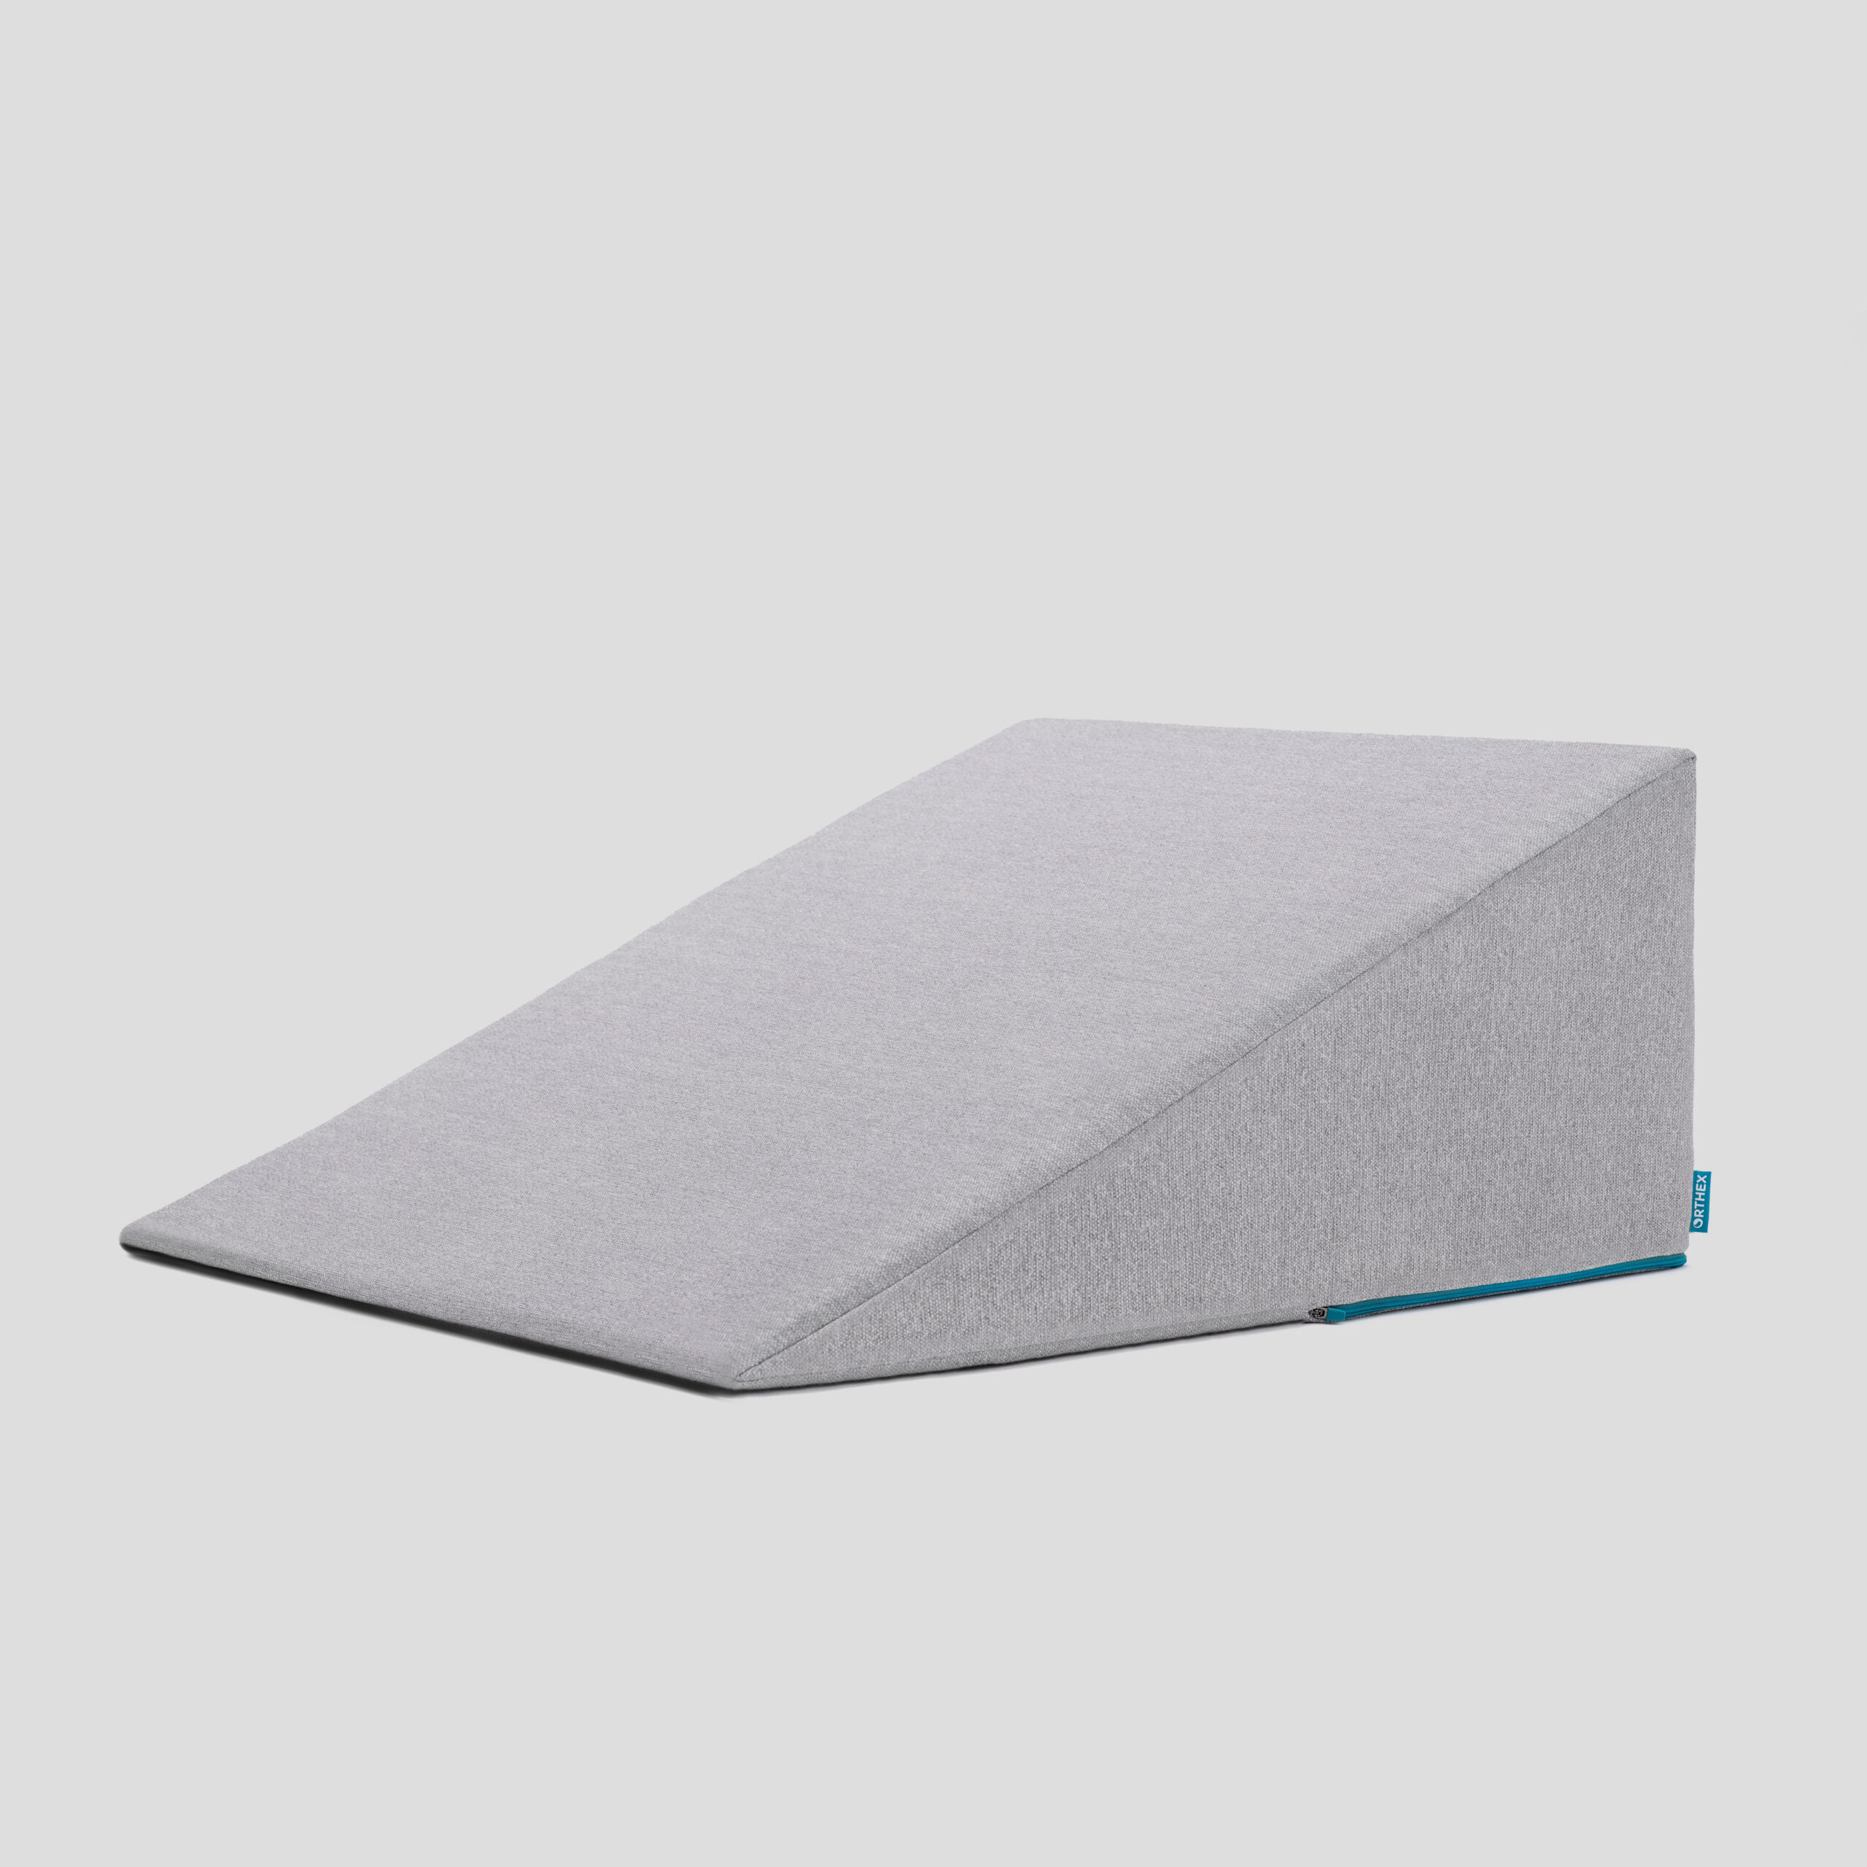

62 Follow Up Clinic Visit 7-10 days after Discharge
In-person clinic visit with Dr Salo or Kate Duncan
- Check surgical site
- Remove staples (if needed)
- Remove abdominal drains (if needed)
Meet with dietitian:
- Reduce tube feeds
- Advance diet by mouth

63 Adjust Medicines after Surgery
Reglan: Discontinue 6 weeks after surgery Remeron: Discontinue 12 weeks after surgery Pain Medicines:
- Wean oxycodone within 6 weeks of surgery
- Discontinue gabapentin and acetaminophen (Tylenol) within 8 weeks
Continue acid blockers (PPI) for at least 1 year
Reduce metoprolol to once/day for 7 dayus $→$ discontinue

64 Second Follow Up Visit
4-5 weeks after first post-operative visit
- Discuss diet
- Discuss medicines
- Plan for jejunostomy removal
- Evaluate readiness for chemotherapy after surgery (usually 6 weeks)

65 Eating after Surgery
First Postoperative Visit: Start soft foods (Phase I diet)
Weekly virtual visits with dietitian
Jejunostomy removal generally at 8 weeks after surgery

66 Jejunostomy Removal
Jejunostomy tube is removed in the office once you can take in enough nutrients by mouth
Removal usually around 8 weeks after surgery (may be longer if chemotherapy planned after surgery)
May take 30 minutes and some local anesthetic to loosen up the tube for removal.

67 Nutritional Monitoring after Surgery
You may have difficulty absorbing some nutrients:
- Iron
- Vitamin B12
- Vitamin D

68 Nutritional Monitoring after Surgery
About 3 months after the jejunostomy tube is removed, we will check blood levels:
- Iron (ferritin)
- Vitamin B12
- Vitamin D

69 Nutritional Replacements after Surgery
Vitamin or iron replacements can be ordered by:
- Primary Care Provider (PCP)
- Medical Oncologist
- Surgeon
If levels are low
- Replacement
- Repeat testing in 3-6 months

70 Team Members - Physicians
Primary Care Provider
Gastroenterologist
Medical Oncologist (chemotherapy)
Radiation Oncologist (radiation)
Surgeons
- Jonathan Salo MD
- Kelli Salter MD
- Michael Roach MD

71 Team Members - Support Staff
Physician Assistant - Kate Duncan PA-C
Dietitian - Liz Koch
Nurses
- Matthew Carpenter RN
- Brandon Galloway LPN
Navigators: Laura Swift RN & Lorna Espinal RN
Care Coordinator - Karen Julian-Martinez

