Squamous Cell Carcinoma of the Esophagus

1 Anatomy
Food moves from the throat
$→$ esophagus
$→$ stomach
$→$ small bowel (jejunum)
We’ll start with reviewing some anatomy about how the body digests food.
Food moves from the throat to the esophagus, and from there to the stomach.
From the stomach, food moved through a valve called the pylorus into the small intestines

2 Cancer Staging
Staging refers to the tests to determine
- How large is the tumor?
- Has there been spread to lymph nodes?
- Has it spread to other parts of the body?
Treatment options depend upon the cancer stage

3 Cancer Staging
- T = Tumor - Depth of growth into the wall
- N = Nodes - Spread to the lymph nodes
- M = Metastasis - Spread to liver, lungs, or bone

4 Early Stage Cancers
Early-stage cancers are those that are small and have not grown very far into the wall
Cancers start on the very inside layer called the mucosa

5 Locally-advanced Cancers
Over time, cancers can grow into the muscular wall
Locally-advanced cancers are those that have grown through the wall

6 Lymph Nodes
In some cases, cancer cells can break off from the main tumor and spread to lymph nodes
If the lymph nodes contain enough cancer cells, they can be seen on CT scans or PET scans

7 T Stage
Cancers are categorized based upon the thickness of the tumor, known as the T stage
T1 tumors are early stage, and T4 tumors more advanced

8 N Stage
Cancers are categorized by whether there is spread to the nodes.
- N0 cancers have not spread to the nodes
- N1 cancers have spread to the nodes.

9 M Stage
Some cancers spread to other parts of the body
- M0 cancers have not spread
- M1 cancers have spread to lungs, liver, bone, or within the abdomen

10 Carcinomatosis (M1)
Spread within the abdomen is carcinomatosis
Tumors can be very small (grain of rice)
Fluid can also build up: ascites

11 PET scan
Similar to CT scan
Tracer shows ‘hot spots’
- Cancer
- Inflammation or infection
- Normal organs (heart, kidneys)
In some cases, the PET scan is not performed until a CT scans b=has been done.

12 PET scan Preparation
- Nothing to eat or drink for 4 hours prior to exam
- High-protein low-carbohydrate diet the day prior
- No strenous activity day prior to study

13 PET scan Prepration - Diabetic Patients
PET scan uses a modified sugar as a tracer $⇒$ you will need to be careful about blood sugar and insulin before the study
- No insulin within 4 hours of the exam
- OK to take diabetes pills the day of the exam
- PET scans are generally best in the morning
- Plan to eat a meal after the PET scan, with half the usual morning dose of insulin

14 PET scan Prepration - Diabetic Patients
- If PET is scheduled after 10AM:
  - low-carbohydrate breakfast at least 4 hours before
  - half the usual regular (short-acting) insulin
- No long-acting insulin after midnight.
- Insulin pump: turn it off 4 hours before the study (or turn it down to basal/night-time rate)

15 Endoscopic Ultrasound
- Similar to upper endoscopy (EGD)
- Ultrasound in scope
- Evaluates T stage
Endoscopic ultrasound is most helpful in early stage cancers.

16 Treatment Plan Depends upon Stage
Superficial (T1): Endoscopic Therapy
Localized (T1b): Surgery (esophagectomy)
Locally-advanced (T2/3): Chemo+Radiation $→$Surgery
Metastatic (M1): Chemotherapy
This table summarizes four different treatment categories:
- Superficial cancers are T1 and can be treated by endoscopic therapy without the need for surgery
- Localized cancers are T1b or T2 and are frequently treated by surgery alone without the need for chemotherapy or radiation
- Locally-advanced cancers are T3 and M0 and are usually treated with some combination of chemotherapy and radiation prior to surgery
- Metastatic cancers are M1 and are treated primary by chemotherapy.

17 Locally-advanced cancers
Patients with locally-advanced esophageal cancer often have localized spread of cancer cells in the surrounding area

18 Locally-advanced cancers
If locally-advanced cancers are treated with surgery alone…

19 Locally-advanced cancers
If locally-advanced cancers are treated with surgery alone…
There is a risk that cancer cells can be left behind

20 Preoperative Therapy
It is helpful to start with therapy before surgery that will shrink the cancer.

21 Preoperative Therapy
It is helpful to start with therapy before surgery that will shrink the cancer.

22 Preoperative Therapy
It is helpful to start with therapy before surgery that will shrink the cancer.

23 Surgery after Preoperative Therapy
When surgery is then performed…

24 Preoperative Therapy
When surgery is then performed…
The risk of cancer recurrence is minimized

25 Preoperative Therapy
When surgery is then performed…
The risk of cancer recurrence is minimized

26 Chemotherapy + Radiation CROSS Trial
363 patients with esophageal cancer studied
Patients were treated in two groups:
Surgery Alone
vs
Chemo + Radiation $→$ Surgery

27 Chemotherapy + Radiation CROSS Trial
363 patients with esophageal cancer studied
Chemotherapy + radiation together over 6 wks
Surgery Alone
vs
Chemo + Radiation$→$Surgery $⇒$ Longer Survival
The results were quite dramatic: The group that was treated with all three therapies, chemotherapy and radiation and surgery, lived on average twice a long as patients who had surgery alone.

28 Chemo + Radiation CROSS Trial
Typical schedule for chemotherapy + radiation:
- Chemotherapy once per week for six weeks
- Radiation five days per week for six weeks (28)
- PET scan (or CT) 4 weeks after the end of radiation
- Surgery 8 weeks after the end of radiation

29 Chemo + Radiation - Side Effects
Kills cancer cells in the esophagus and lymph nodes
Can also irritate the lining of the esophagus.
Swallowing can be difficult the last 2 weeks.
Feeding tube may be needed for hydration/nutrition.

30 Chemotherapy Administration
Most chemotherapy is administered by vein.
Several options exist to administer chemotherapy:
- Intravenous catheter in peripheral veins
- Peripheral Intravenous Central Catheter (PICC)
- Central Venous port

31 Intravenous Catheter in Peripheral Vein (“IV”)
- IV catheter placed in vein of hand or arm
- Allows administration of chemo and fluids
- Placed for each dose
- Removed that day
- Not suitable for FLOT chemo
A peripheral IV catheter involves placing a small tube into the veins, which is then used to give fluids or chemotherapy
A new catheter is placed for each dose of chemotherapy
FLOT chemotherapy requires a home infusion pump, got which a peripheral IV won’t work

32 Central Venous Port
- Implantable device makes chemo easier
- May shower in 24 hrs
- No special care at home
- OK for FLOT chemo
- Allows for blood draws
A central venous port is an implantable device that makes the administration of chemotherapy easier.
Once it is in place, it requires no special care at home
With a port, you can shower, bathe, and swim without restriction
A central venous port is suitable for FLOT chemotherapy
A port can be used for blood draws for blood tests as well.

33 Central Venous Port
- Implanted under skin
- Neck incision (1/4”)
- Incision below the collarbone
- Sutures dissolve
- “Superglue” on incisions
A port is placed underneath the skin and usually below the right collarbone.
Two incisions are made for placement: a quarter-inch incision over the neck, and a one-inch incision below the collarbone.
Sutures are under the skin and dissolve on their own
Surgical “Super Glue” covers the incisions and flakes off after a week or so

34 Central Venous Port
When it is time for chemotherapy, a needle is inserted through the skin into the port
When it comes time for chemotherapy, the nurses can easily access the port with a needle that goes through the skin into the port, rather than placing an intravenous needle in a vein. The drugs can then be administered directly into the bloodstream. If blood needs to be drawn for tests, this can also be done through the port.

35 Restaging
CT or PET scan performed after initial therapy

- Surgery performed after restaging
- Timing depends upon recovery from therapy

36 Endoscopy after Initial Therapy
Performed to look for signs of persistent cancer
Biopsies show no cancer in 75% of cases
Disappearance of cancer in 40% of cases - Persistent cancer in 60%
$⇒$ cancer cells can hide in the wall of the esophagus
Regular endoscopy is important to look for regrowth of cancer

37 Surgery for Squamous Cell Carcinoma
Surgery is recommended for all patients who have:
- Biopsies showing cancer after chemo + radiation
- No signs of spread of disease on PET/CT scan
- Healthy enough to undergo surgery

38 Surgery for Squamous Cell Carcinoma
Surgery is also recommended for patients who:
- No signs of spread on disease on PET/CT scan
- Cancer in the lower part of the esophagus
- Healthy enough to undergo surgery

39 Surveillance if Surgery Not Performed
- Upper endoscopy (EGD) every 3-6 months
- PET every 6 months
$⇒$ Surgery if a recurrence in the esophagus is found

40 Protein Needs

41 Feeding Tubes
There are two types of feeding tubes:
- Jejunostomy tubes are placed in the small intestine
- Gastrostomy tubes are placed in the stomach
Your dietitian and physician will help you decide which tube is best for your situation

42 Gastrostomy Tube
Feeding Gastrostomy
- Feeding with a syringe several times per day.
- Tube can be hidden underneath clothing
- Tube does not interfere with eating by mouth
- Removed easily in the office when no longer needed

43 Gastrostomy Tube Methods
PEG: Tube placed by endoscopy
Laparoscopic: Tube placed surgically by laparoscopy
Preferred method depends upon whether esophagectomy is planned

44 Gastrostomy Tube
- Outpatient Placement (go home the same day)
- Central venous port can be placed at the same time (if needed)

45 Primary Care Practitioner (PCP)
Critical to coordinate care between specialists.
We will update your PCP after each visit
PCP Referral Line (844) 235-6998

46 My Atrium Patient Portal
- Critical to good communication with your care team
- Available for desktop or laptop or phone
- Sign up at my.atriumhealth.org

47 Exercise
- Reduces risk of complications from treatment
- Goal is 30min/day of vigorous exercise 6 days/wk
  - Working hard enough that you can’t converse
  - Start slowly and build up
  - Every day counts! (Aim for daily activity)

48 Smoking Cessation
- Smoking makes cancer treatment more difficult
  - Increases risk of complications after surgery
- Options for help with smoking cessation:
  - NC Quit Line 1-800-QUIT-NOW (1-800-784-8669)
  - American Lung Assn www.freedomfromsmoking.org
  - Smoking Cessation Counseling (Metro Charlotte)

49 Preparation for Surgery
Medical evaluation may be needed before surgery:
- Pulmonary Function Tests to test lung function
- Cardiology evaluation to test heart function
  - Echocardiogram
  - Stress Test
  - Holter monitor

50 Esophagectomy for Cancers of the Esophagus or GE Junction
Primary Surgery
- Superficial Tumors (T1) not removed by endoscopy
- Localized Tumors (T2 N0 M0)
- Surgery scheduled after medical evaluation
- Aim for surgery within 6 weeks of consultation

51 Esophagectomy for Cancers of the Esophagus or GE Junction
Preoperative Therapy $→$ Surgery (T3 Nx M0)
- Surgery scheduled after
  - Recovery from preoperative therapy
  - Restaging scans (CT or PET)
  - Medical evaluation
- Timing between end of preoperative therapy and surgery
  - Chemotherapy + radiation: 6-8 weeks
  - Chemotherapy: 4-8 weeks

52 Preoperative Visits
Medical Oncology - Monitor chemotherapy
Radiation Oncology - Monitor radiation
Surgical Oncology
- Consult visit with Dr Salo
- Mid-treatment visits with Dr Salo / Kate Duncan
- Preop visit with Dr Salo (may be virtual)
- Preop visit with Kate Duncan and Liz Koch

53 Goals of Surgery
- Remove tumor from esophagus
- Remove surrounding lymph nodes
- Create a new esophagus
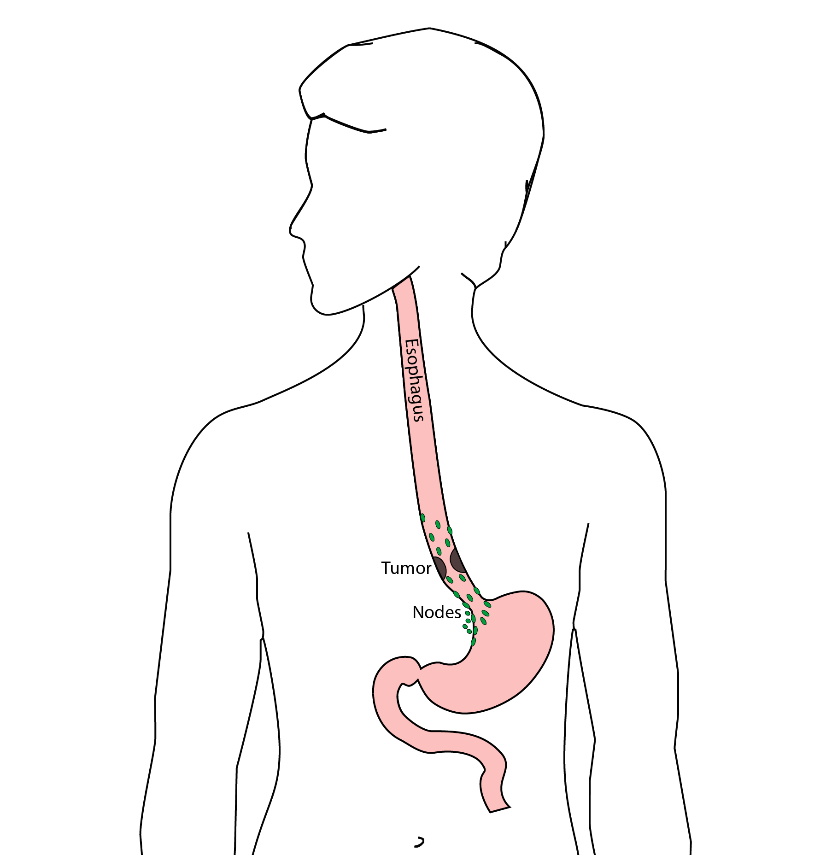

54 Ivor Lewis (Transthoracic) Esophagectomy
- Removes tumor and lower 1/2 esophagus
- Removes surrounding lymph nodes
- GI tract reconstructed
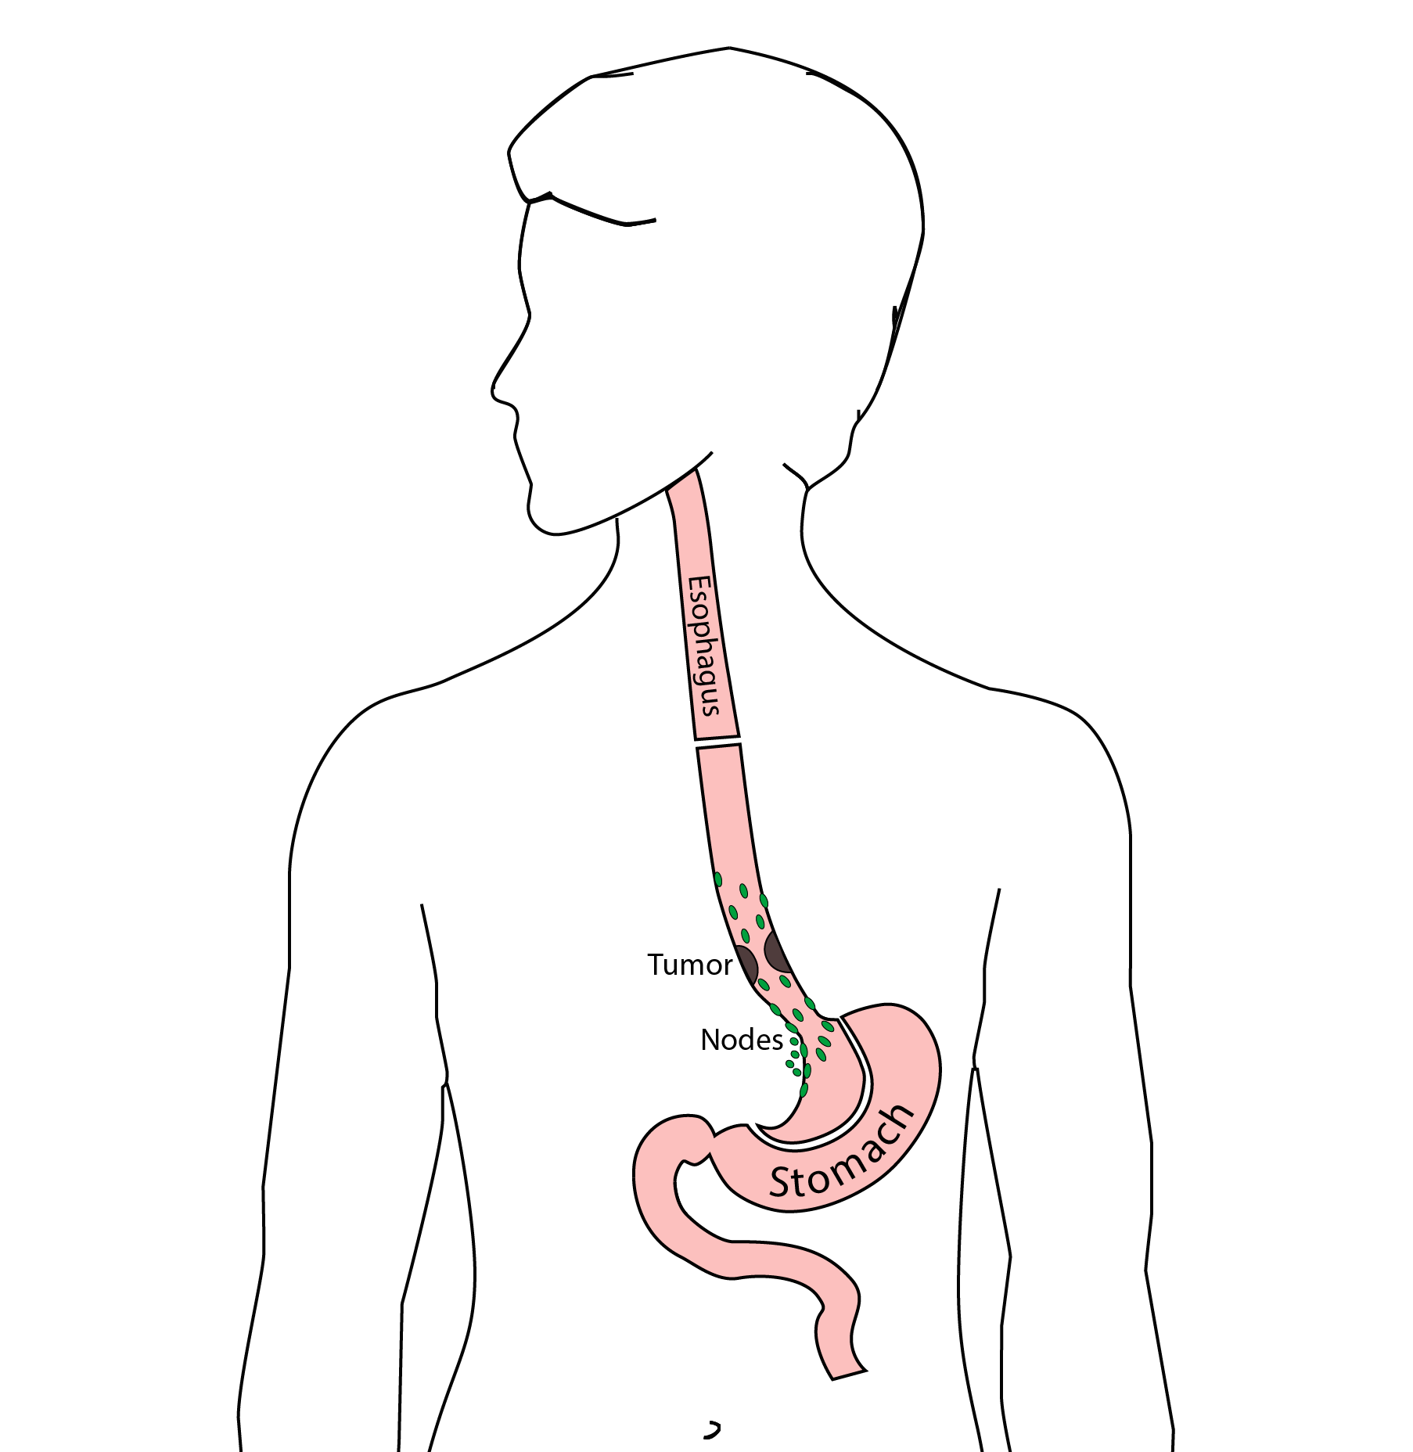

55 Reconstruction
New esophagus is created from the stomach in the abdomen by fashioning it into a tube.
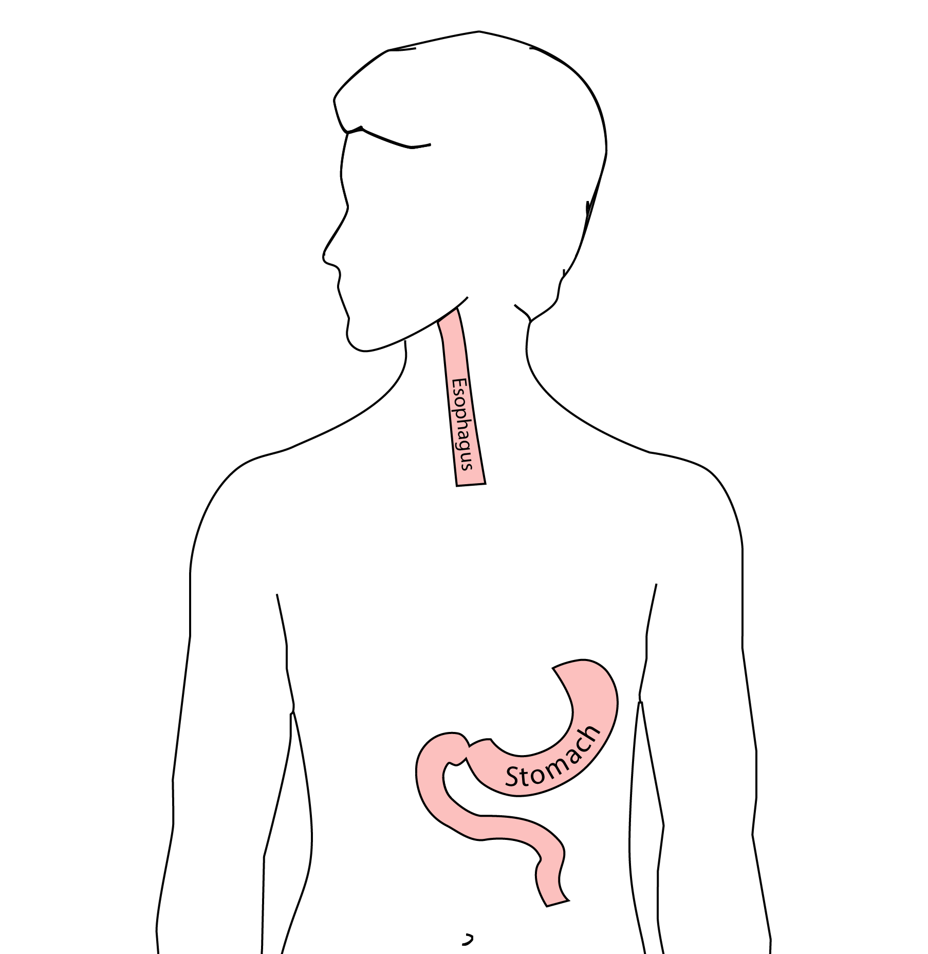

56 Ivor Lewis esophagectomy
The new esophagus is now brought up into the chest. A connection is made between the esophagus and the stomach, called an anastomosis.
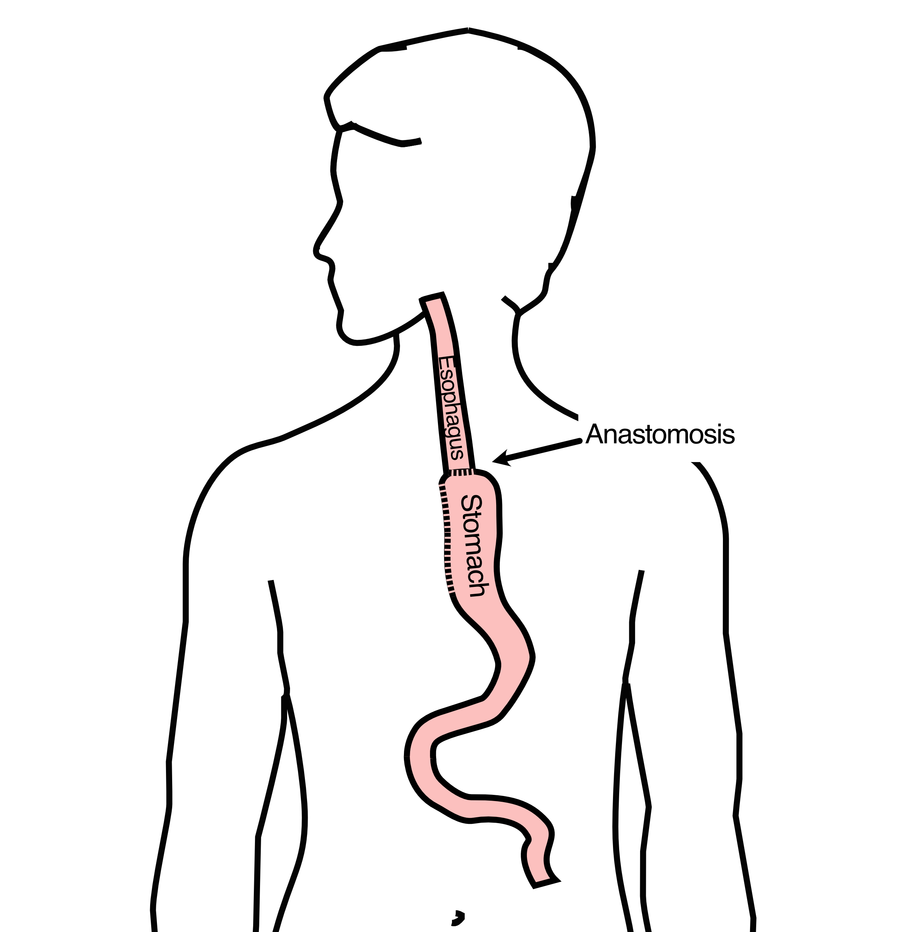

57 Ivor Lewis esophagectomy
:::::
:::::

58 Minimally-invasive Ivor Lewis Esophagectomy
- Small incisions abdomen and chest
- Surgical telescope and instruments
- Smaller incisions $→$ faster recovery and less discomfort
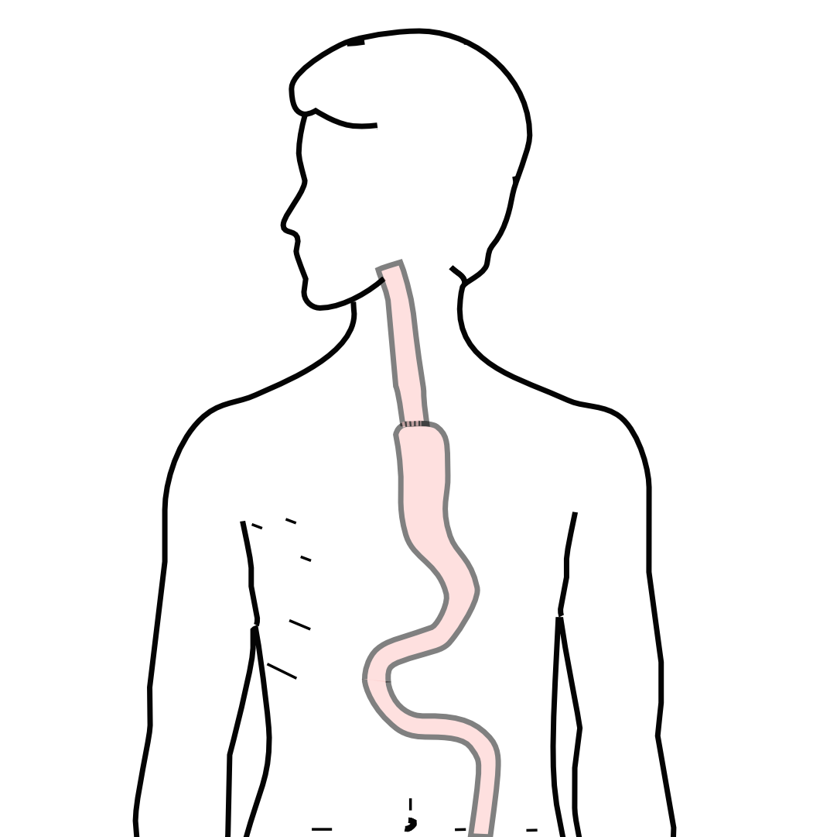
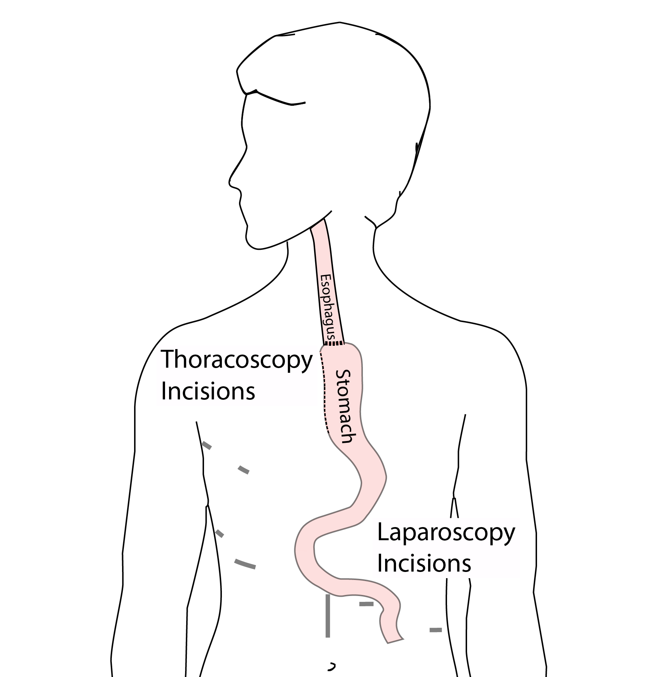
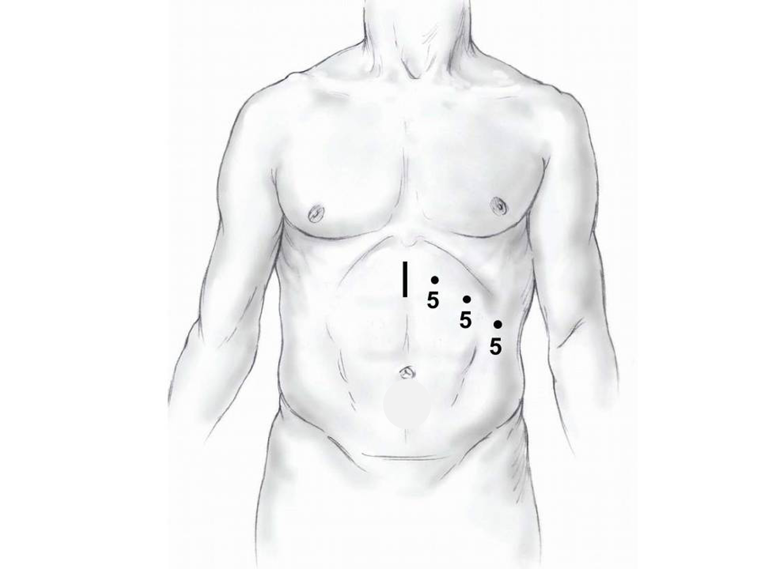
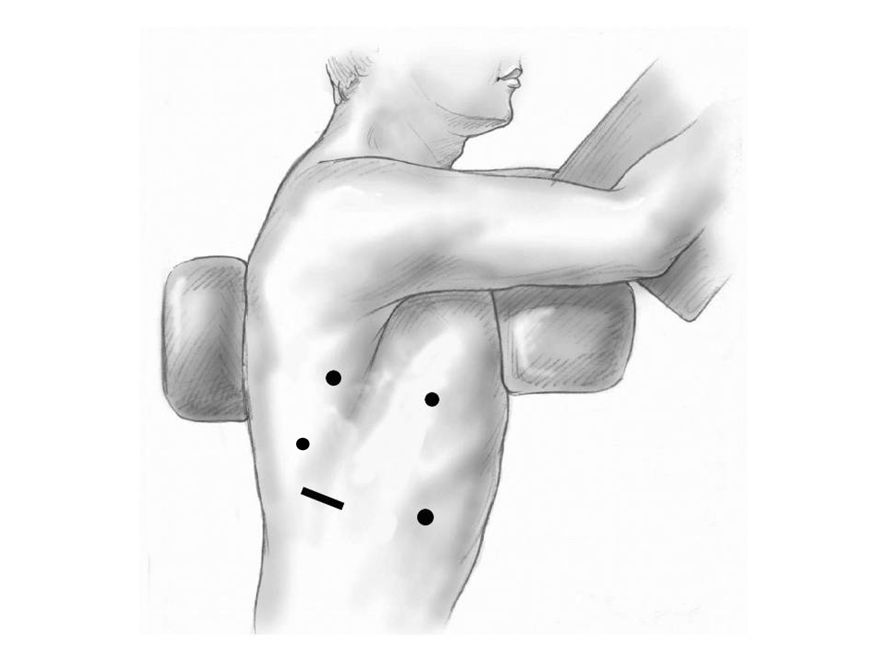

59 Open Ivor Lewis
Mininally-invasive approach feasible in 98% of cases
In some cases, an open approach is still necessary (2%)
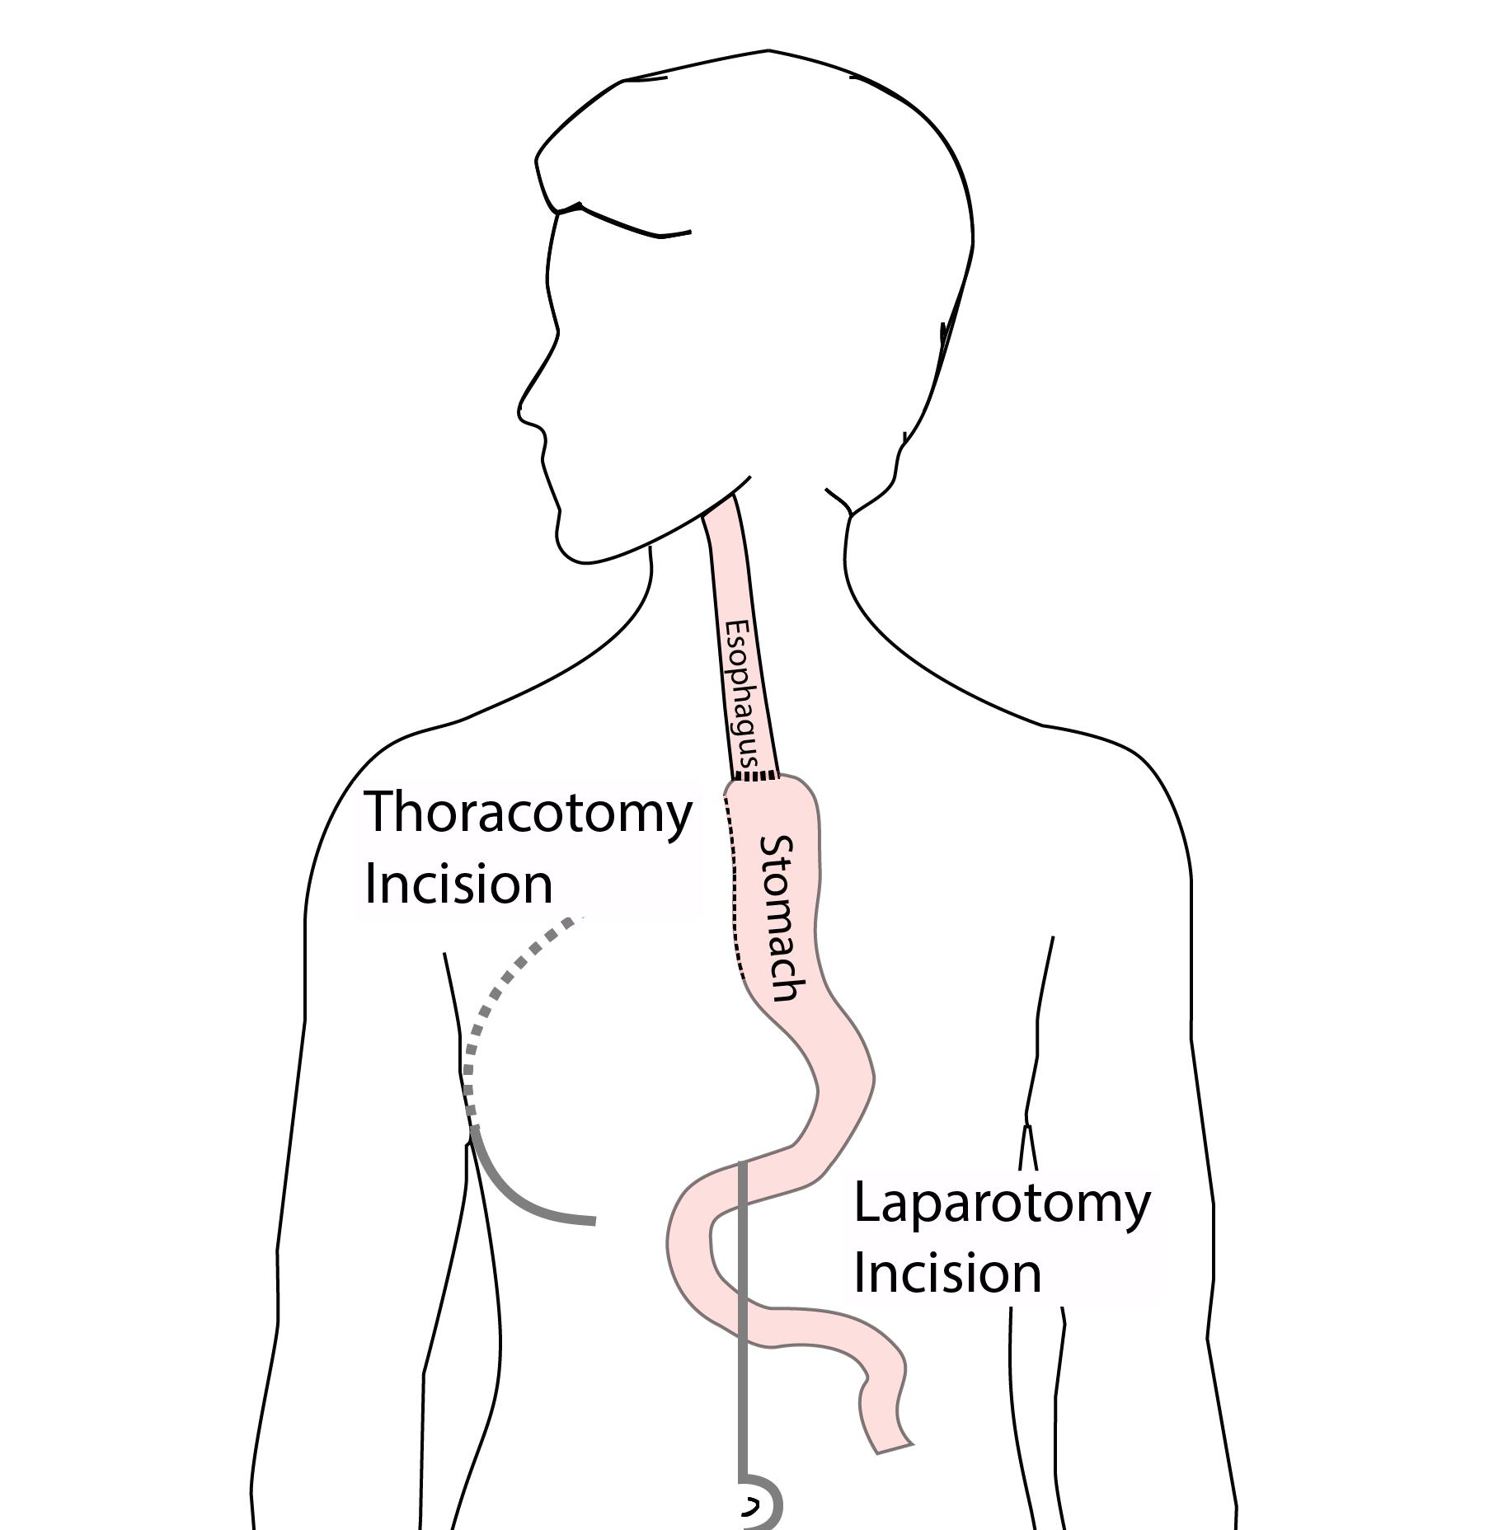

60 Total Esophagectomy
For patients with tumors in the upper esophagus, we need to remove more of the esophagus
We need to remove the whole esophagus, including the portion in the neck
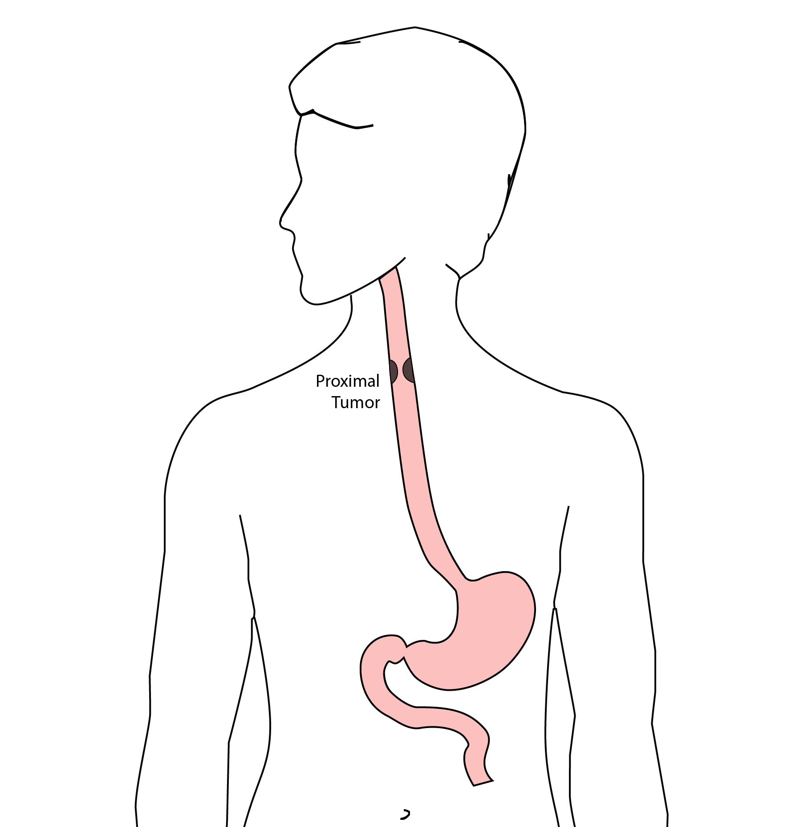

61 McKeown Esophagectomy
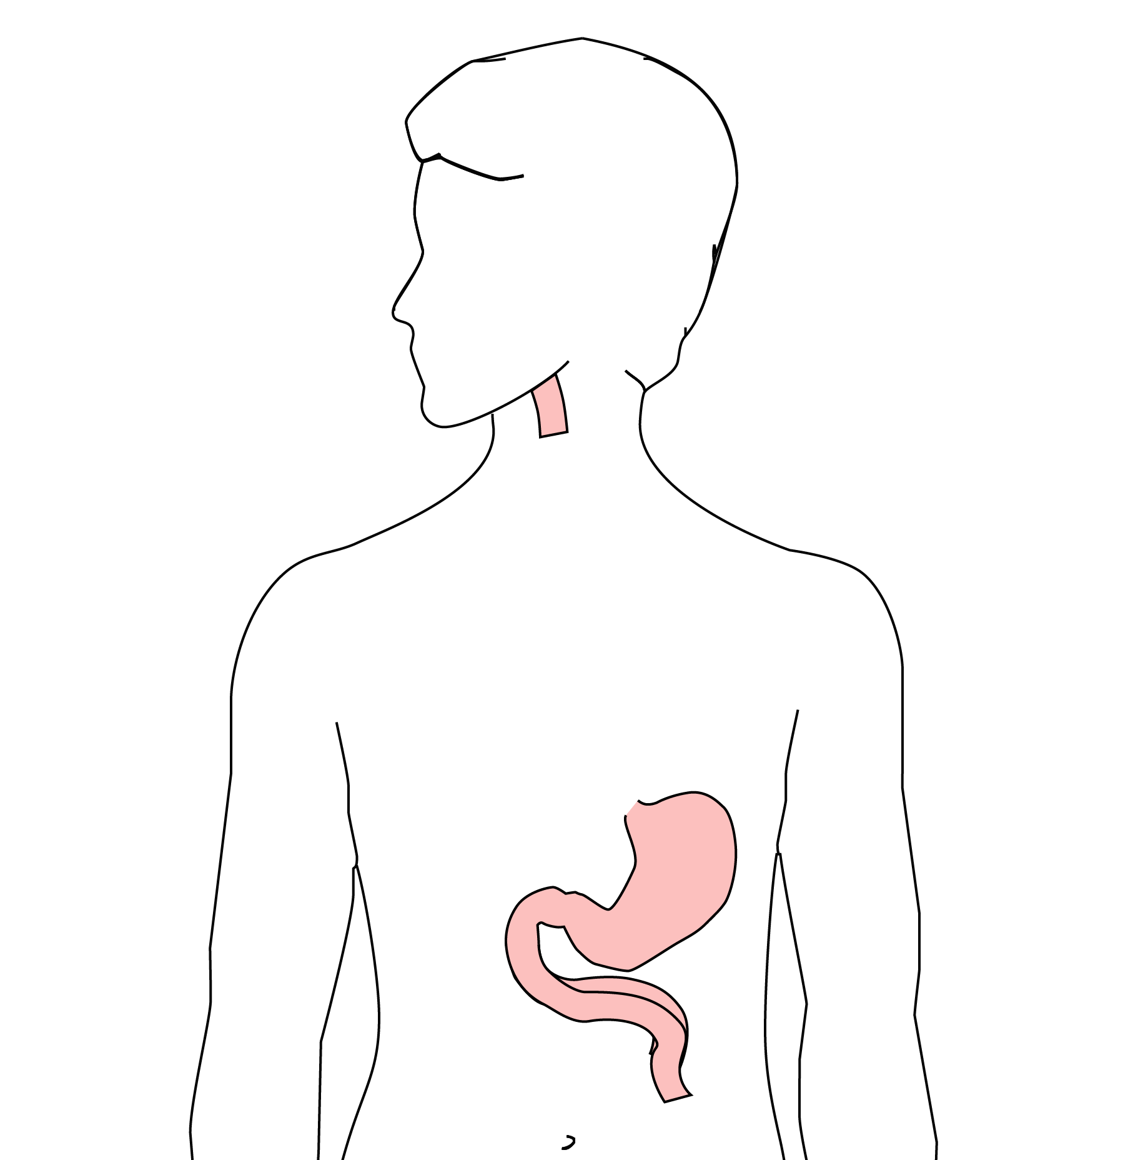 All of esophagus removed
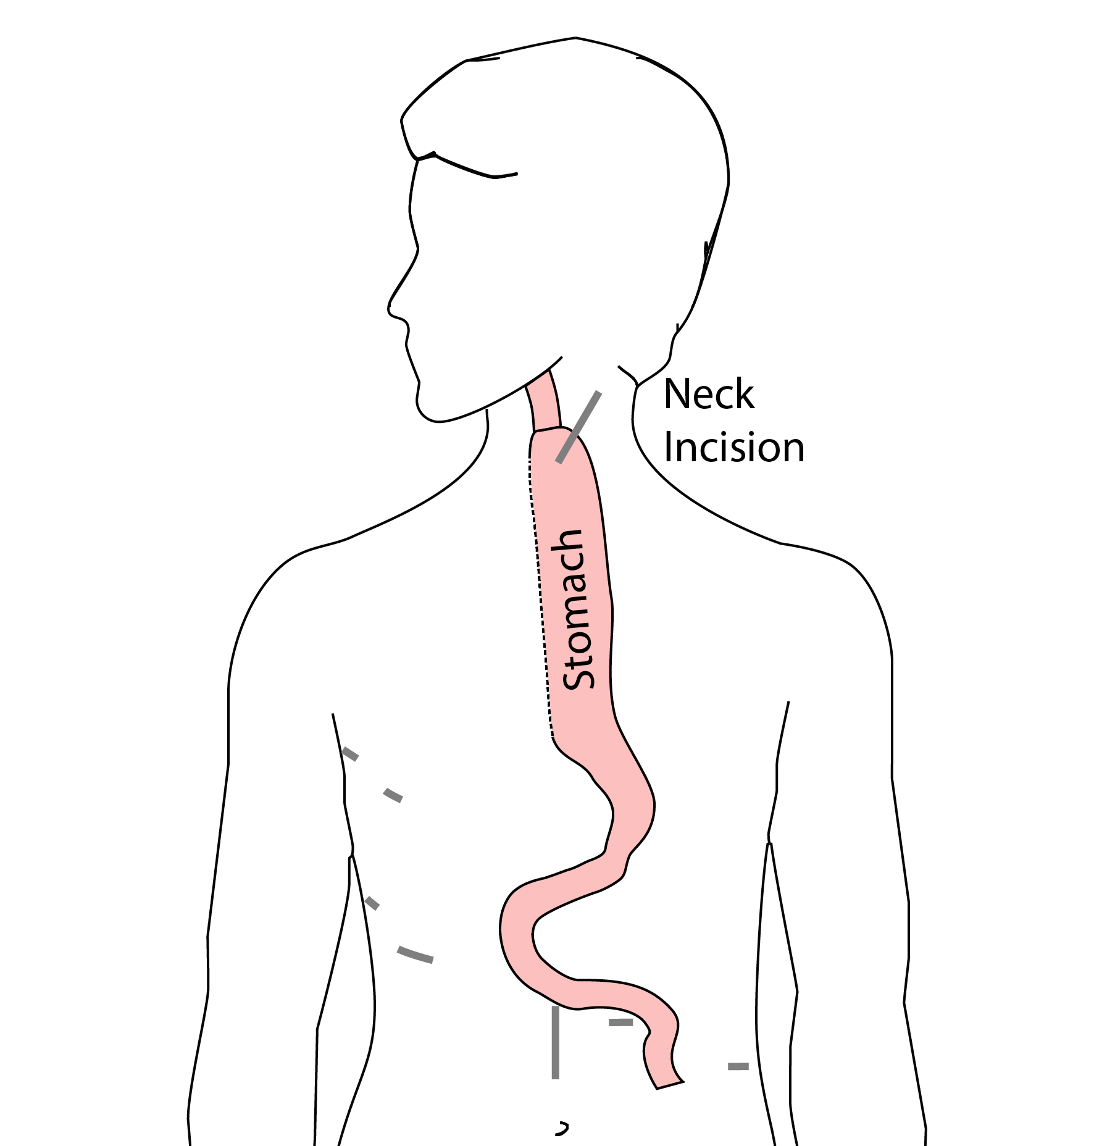 Connection made in the neck

62 Risks of Esophagectomy
Esophagectomy is a complex operation, with a real risk of complications.
Two significant complications:
- Anastomotic leak
- Pneumonia

63 Anastomotic Leak
The anastomosis is surgical connection between the esophagus and the stomach.

64 Anastomotic Leak
If healing doesn’t occur:
- Leakage of fluid from the esophagus
- Infection in the space between the lungs
- Requires additional time in the hospital
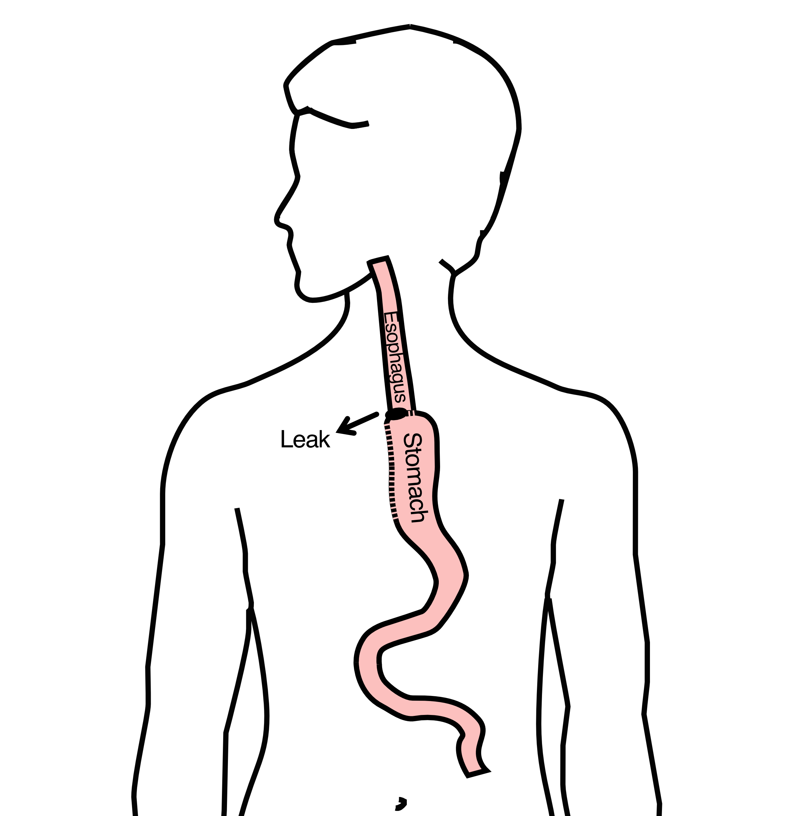

65 Anastomotic Leak
If leak occurs:
- Some leaks will seal
- Stent may be required to help healing
- Occasionally additional surgey is required

66 Anastomotic Leak
Risk of leak depends on:
- Type of operation performed
- Nutritional status of patient
- Experience of the surgeon

67 Pneumonia
- Occurs in 10-15% of patients after esophagectomy.
- Requires treatment with antibiotics
- Requires a longer hospitalization.
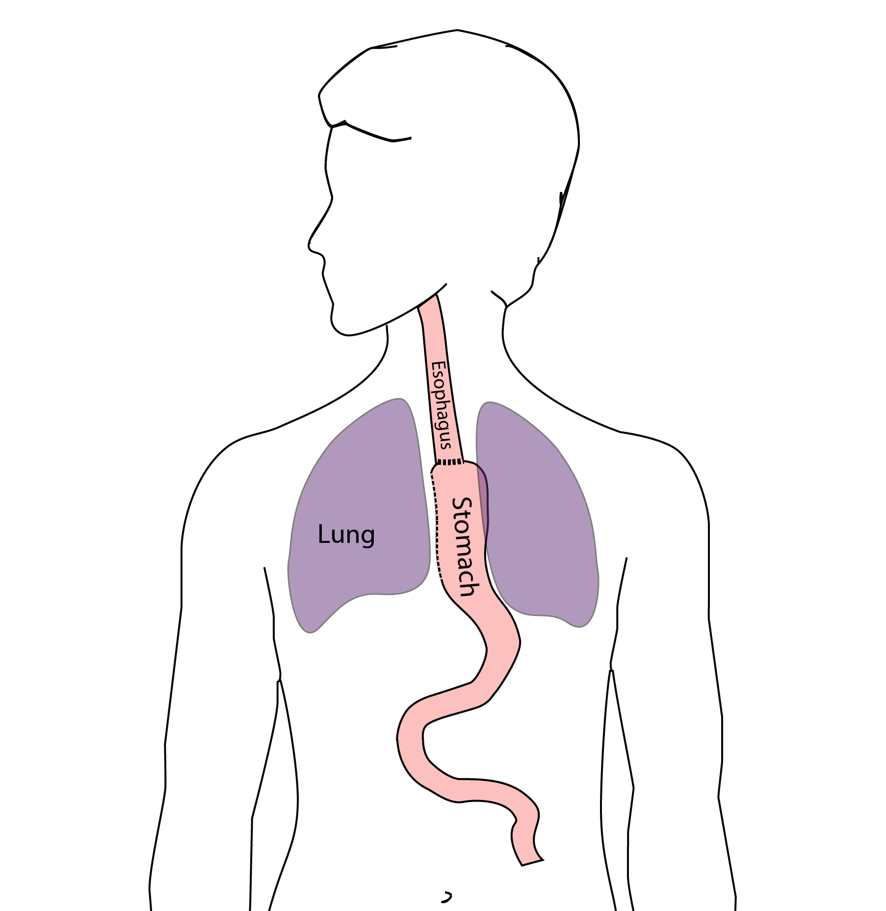

68 Preventing Pneumonia
Several ways to help prevent pneumonia:
- Deep breathing
- Coughing
- Walking
After surgery, this means:
- Sitting in a chair most of the day
- Walking in the halls as soon as possible

69 Risks of Surgery
Risks related to anesthesia
- Heart attack (5%)
- Irregular heart rhythm (15%)
- Pneumonia (10%)
- Blood clots in legs (<5%)
- Pulmonary embolism (2%)

70 Risks of Surgery
Risks related to Surgery
- Anastomotic leak (5%)
- Stricture at anastomosis (15%)
- Death within 90 days of surgery
  - Low risk patients = 2%
  - Intermediate risk = 10%
  - High risk = 30%

71 Risks of Surgery
Risks of Death within 90 Days of Surgery
 | Age <75 | Age >75
Normal Muscle (75%) | 2% | 10%
Low Muscle (25%) | 10% | 30%

72 Epidural Catheter for Pain Control
- Remains in place for 2-5 days
- Dosage can be adjusted as needed
- Can make it more difficult to urinate
- May require foley catheter in bladder
- Foley catheter removed after epidural removed

73 Jejunostomy Feeding Tube
A temporary feeding tube is placed to supplement nutrition by mouth.
This will stay in place for about 8 weeks after surgery
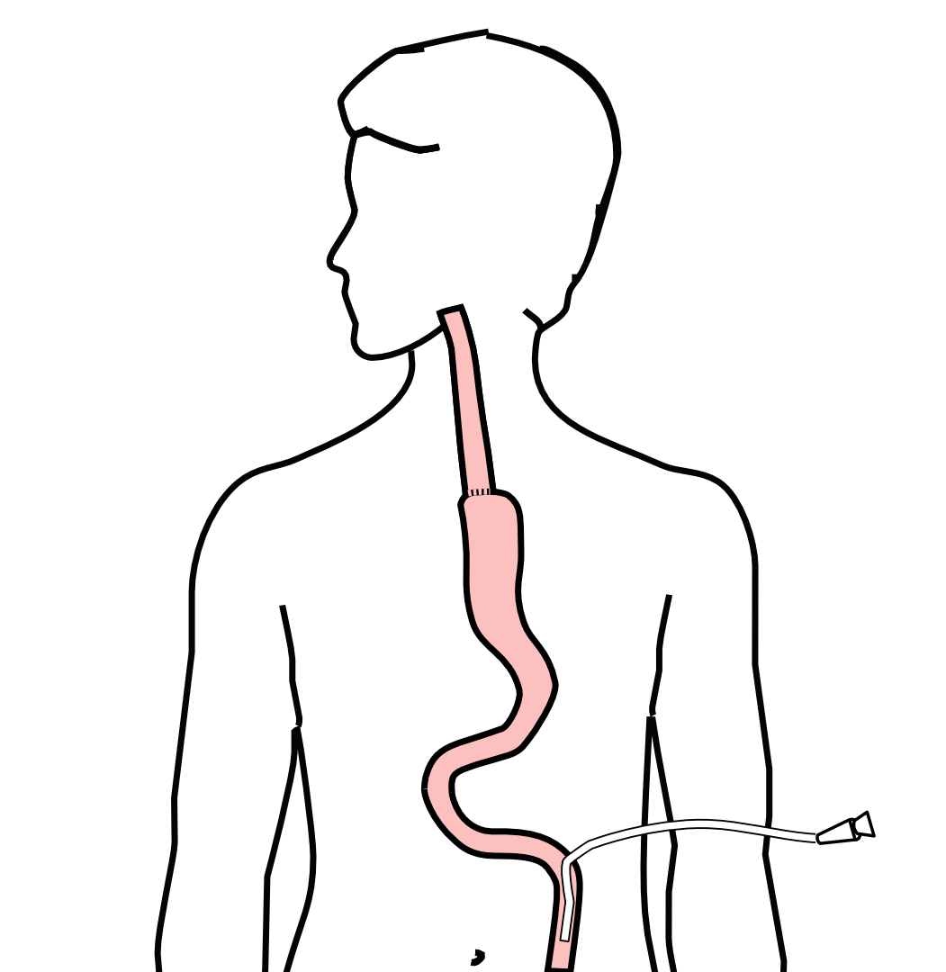

74 Intensive Care Unit (ICU) (2-4 days)
- Surgical ICU on 11th floor
- NG tube in nose to drain stomach and esophagus
- Catheter in bladder
- Chest tube right chest
- Abdominal drains (usually 2)
- Feeding jejunostomy (usually stays in 8 wks)

75 Intensive Care Unit (ICU)
- Bladder catheter removed → check that bladder empties properly
- Chest tube removed (day 2-4) → follow-up x-ray
- Fluid emptied from drains every few hours
- Start tube feedings by feeding
- Feeding jejunostomy (stays in 8 weeks)

76 Ward - 6Tower
- Up in a chair most of the day
- Walking in the halls
  - Start with assistance
  - Improves lung function
  - Prevents loss of muscle strength

77 Jejunostomy Feeding Tube
Feedings are administered through the jejunostomy at night by a pump
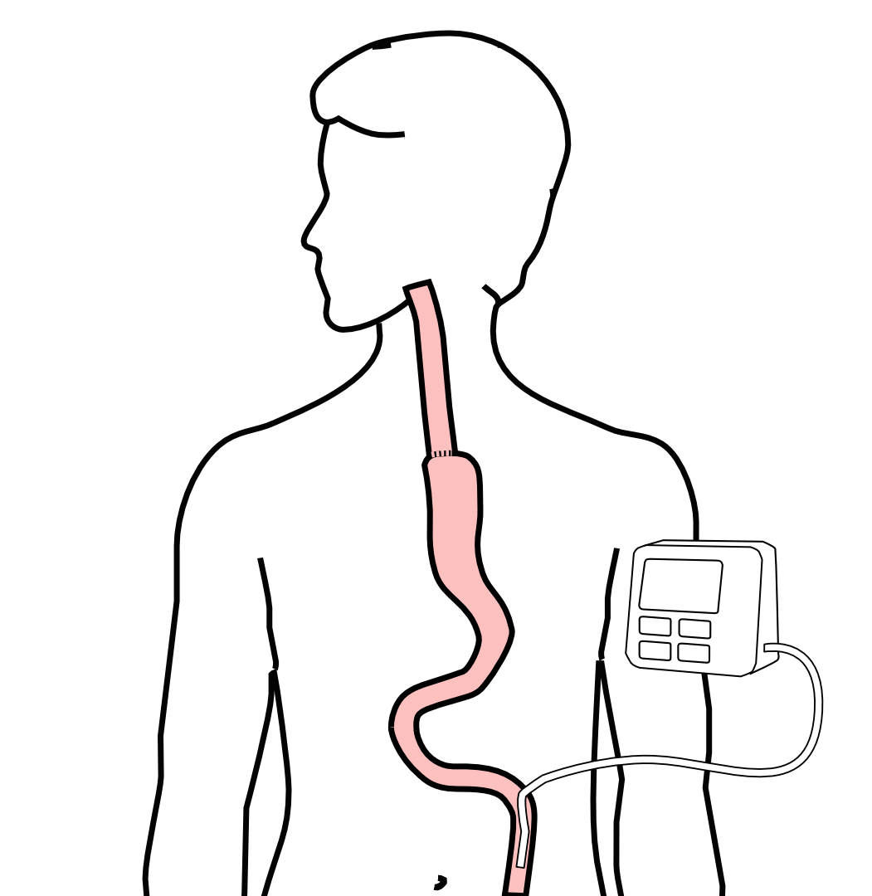

78 Jejunostomy Feeding
- Start with continuous feeds (24 hours/day)
- Convert to nocturnal (night-time): 6pm to 10pm
The feeding bag holds only 4 cartons of feeds - May need to “top off’ bag after a few hours
Water through the tube
- Important to prevent dehydration
- 240mL (8 oz) 4 times per day

79 Jejunostomy Tube

80 Jejunostomy Feeding Pump

81 Jejunostomy Typical Regimen
- Jejunostomy tube feeds for 16 hours (6pm-10am)
  - Men: 75mL/hour x 16 hours = 5 cartons
  - Women: 60mL/hour x 16 hours = 4 cartons
- Water 240ml (8oz) via syringe 4x/day
Hospital nurses will teach use of the feeding tube

82 Jejunostomy Feeds with Diabetes
Jejunostomy feedings elevate blood sugars
- Insulin may be required along with feeds
Typical Pattern for tube feeds
- Feeds run via pump from 6pm to 10am
- Insulin at 6pm (70/30 insulin)
- Insulin at Midnight (70/30 insulin)
- No insulin if tube feedings are not run

83 Jejunostomy Video

84 Activity after Surgery
- Up in chair most of the day
- Walking with help from nurse/Physical Therapist
- Goals:
  - Improve lung function
  - Prevent muscle loss

85 Nasogastric (NG) Tube
Tube passed through nose into stomach
- Drains fluid from stomach
- Prevents vomiting
Upper GI X-ray on 2nd or 3rd day after surgery
- If stomach empties well $→$ NG tube removed
- Otherwise, X-ray repeated 2-3 days later

86 Swallowing Evaluation
Once NG tube has been removed:
Modified barium swallow in radiology
- Drink a white chalky liquid (barium)
- Look for proper swallowing function
- 80% of patients $⇒$ liquids started by mouth

87 Oral Intake at Home
Most are taking protein shakes when they go home
Protein shakes are started after tolerating water
- 2 oz per hour to start
- 4 oz per hour if 2oz are tolerated well

88 Drains and Tubes
Chest Tube (right side): Removed 4-6 days after surgery (depending upon output) Abdominal drains: Removed 4-7 days after surgery
- Discharge with 1 abdominal drain in 10% of cases
Epidural catheter: Removed 4-5 days after surgery Bladder catheter: Removed after epidural catheter removed

89 Discharge
Goal: ready to leave day #7 after surgery
- Night-time tube feedings (6pm to 10am)
- Nutrition by mouth (90% of patients)
  - Protein shakes or water 4oz every 2 hours
- Water through tube 8oz four times per day
- Home care nursing (feeding tube teaching)
- Home infusion (tube feeding supplies)

90 Nutrition after Surgery
At discharge home:
- Protein shakes 4oz every 2 hrs
- Tube feeds 4-5 cans at night (6pm-10am)
10-12 Days: Increase protein shakes
- Tube feeds 3-4 cans at night
Three weeks: Post-esophagectomy Diet
8-12 weeks: Remove feeding tube (in office)

91 Transition from Tube Feeds $→$ Eating
Dietitian will calculate daily protein goal
- Typically 60-75 grams protein/day
- Each carton of tube feeding has 15 grams
  - 75 grams protein = 5 cartons/night
- More intake by mouth $→$ tube feeds reduced
Spread out protein during the day (20gm/meal)
- Three meals + 2-3 high-protein snacks

92 Post-esophagectomy Diet
- Soft Consistency
- High Protein
- Avoid sugary liquids (can cause ‘dumping’)
- Avoid raw vegetables (and salads)
- Eating
  - Small, frequent meals
  - Sit up for 30-45 minutes after eating
  - Avoid eating within 2 hours of bedtime

93 Medicines at Home - Pain
Acetaminophen (Tylenol) 1000mg 4x/day
Gabapentin 300mg 3 times/day
Oxycodone
- As needed in addition to Tylenol/gabapentin
- Will begin reducing dose at first postop visit
- Can usually discontinue by 4 weeks
- NO DRIVING WHILE ON OXYCODONE

94 Non-steroidals Anti Inflammatory (NSAID)
Non-steroidal anti-inflammatories (Celebrex)
- 200 mg every 12 hours starting at 2 weeks
NO GOODY POWDERS OR BCs
- (Can cause permanent scarring at the surgery site)

95 Acid Blockers = Proton Pump Inhibitors
Examples include ompeprazole and pantoprazole
- Will stay on for at 1-2 years to prevent acid reflux
- Important in preventing scarring at anastomosis (new connection between esophagus and stomach)
- To administer through feeding tube, open capsule and resuspend beads in 60mL (2oz) of water

96 Medicines at Home
Reglan – Helps stomach empty
- Will plan to stop after six weeks
- 0.1% risk of tardive dyskinesia (nervous tic)
Remeron – Helps improve appetite
- Can cause vivid dreams
- Used for several weeks after surgery
- Will stop within first three months of surgery

97 Metoprolol = Beta Blockers
- Slows heart rate and lowers blood pressure
- Used to prevent rapid heart rate
- Patients not taking a beta blocker prior to surgery $→$ wean after after surgery
- Patients taking a beta blockerprior to surgery $→$ return to prior dose and drug after surgery

98 Sleeping at Home
Reflux can occur the first few weeks/months after surgery
This improves over the first few months
A wedge pillow can be helpful for sleep
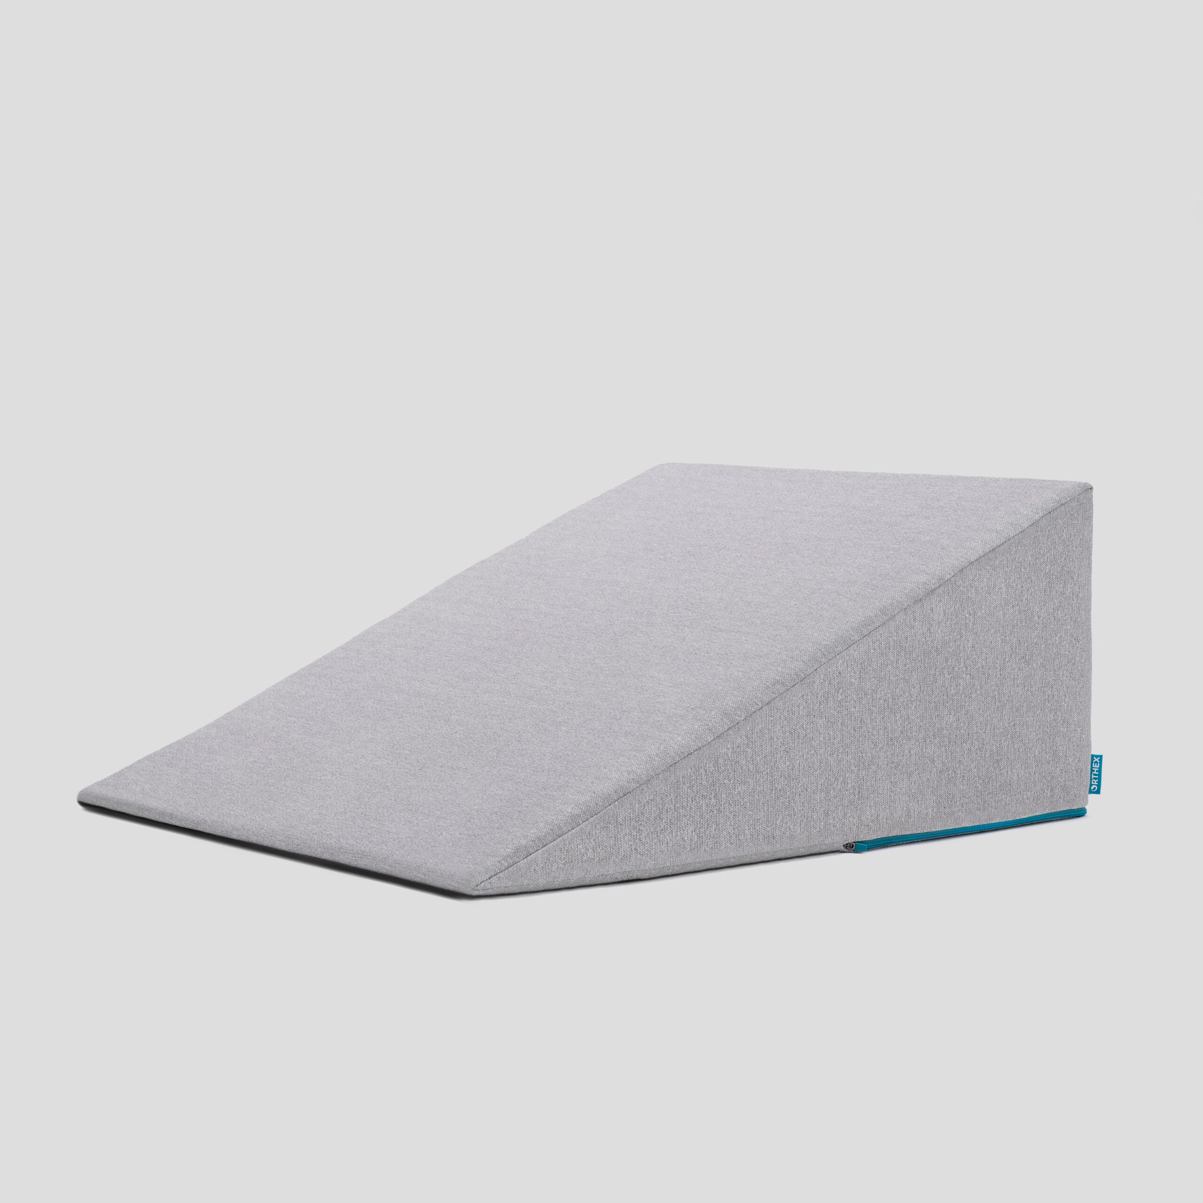

99 Follow Up Visit 7-10 days after Discharge
In-person clinic visit with Dr Salo or Kate Duncan
- Check surgical site
- Remove staples (if needed)
- Remove abdominal drains (if needed)
Meet with dietitian:
- Reduce tube feeds
- Advance diet by mouth

100 Adjust Medicines after Surgery
Reglan: Discontinue 6 weeks after surgery Remeron: Discontinue 12 weeks after surgery Pain Medicines:
- Wean oxycodone within 6 weeks of surgery
- Discontinue gabapentin and acetaminophen (Tylenol) within 8 weeks
Continue acid blockers (PPI) for at least 1 year
Reduce metoprolol to once/day for 7 dayus $→$ discontinue

101 Second Follow Up Visit
4-5 weeks after first post-operative visit
- Discuss diet
- Discuss medicines
- Plan for jejunostomy removal
- Evaluate readiness for chemotherapy after surgery (usually 6 weeks)

102 Eating after Surgery
First Postoperative Visit: Start soft foods (Phase I)
Weekly virtual visits with dietitian
Jejunostomy removal ~ 8 weeks after surgery

103 Jejunostomy Removal
Jejunostomy tube is removed in the office once you can take in enough nutrients by mouth
Removal usually around 8 weeks after surgery (may be longer if chemotherapy planned after surgery)
May take 30 minutes and some local anesthetic to loosen up the tube for removal.

104 Nutritional Monitoring after Surgery
You may have difficulty absorbing some nutrients:
- Iron
- Vitamin B12
- Vitamin D

105 Nutritional Monitoring after Surgery
About 3 months after the jejunostomy tube is removed, we will check blood levels:
- Iron (ferritin)
- Vitamin B12
- Vitamin D

106 Nutritional Replacements after Surgery
Vitamin or iron replacements can be ordered by:
- Primary Care Provider (PCP)
- Medical Oncologist
- Surgeon
If levels are low
- Replacement
- Repeat testing in 3-6 months

