Surgery of the Esophagus

1 Preparation for Surgery
Medical evaluation may be needed before surgery:
- Pulmonary Function Tests to test lung function
- Cardiology evaluation to test heart function
  - Echocardiogram
  - Stress Test
  - Holter monitor

2 Esophagectomy for Cancers of the Esophagus or GE Junction
Primary Surgery
- Superficial Tumors (T1) not removed by endoscopy
- Localized Tumors (T2 N0 M0)
- Surgery scheduled after medical evaluation
- Aim for surgery within 6 weeks of consultation

3 Esophagectomy for Cancers of the Esophagus or GE Junction
Preoperative Therapy $→$ Surgery (T3 Nx M0)
- Surgery scheduled after
  - Recovery from preoperative therapy
  - Restaging scans (CT or PET)
  - Medical evaluation
- Timing between end of preoperative therapy and surgery
  - Chemotherapy + radiation: 6-8 weeks
  - Chemotherapy: 4-8 weeks

4 Preoperative Visits
Medical Oncology - Monitor chemotherapy
Radiation Oncology - Monitor radiation
Surgical Oncology
- Consult visit with Dr Salo
- Mid-treatment visits with Dr Salo / Kate Duncan
- Preop visit with Dr Salo (may be virtual)
- Preop visit with Kate Duncan and Liz Koch

5 Goals of Surgery
- Remove tumor from esophagus
- Remove surrounding lymph nodes
- Create a new esophagus
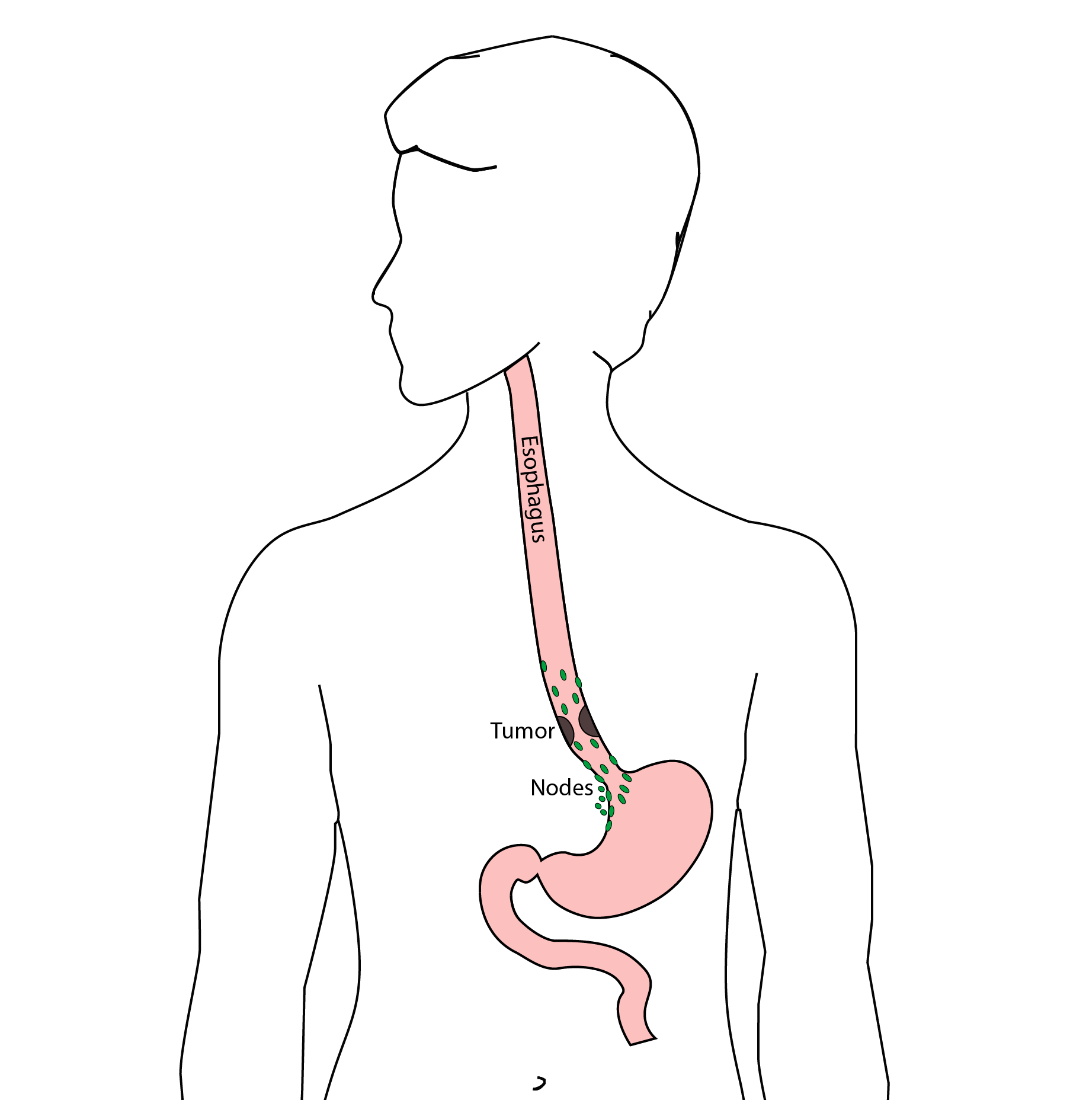

6 Ivor Lewis (Transthoracic) Esophagectomy
- Removes tumor and lower 1/2 esophagus
- Removes surrounding lymph nodes
- GI tract reconstructed
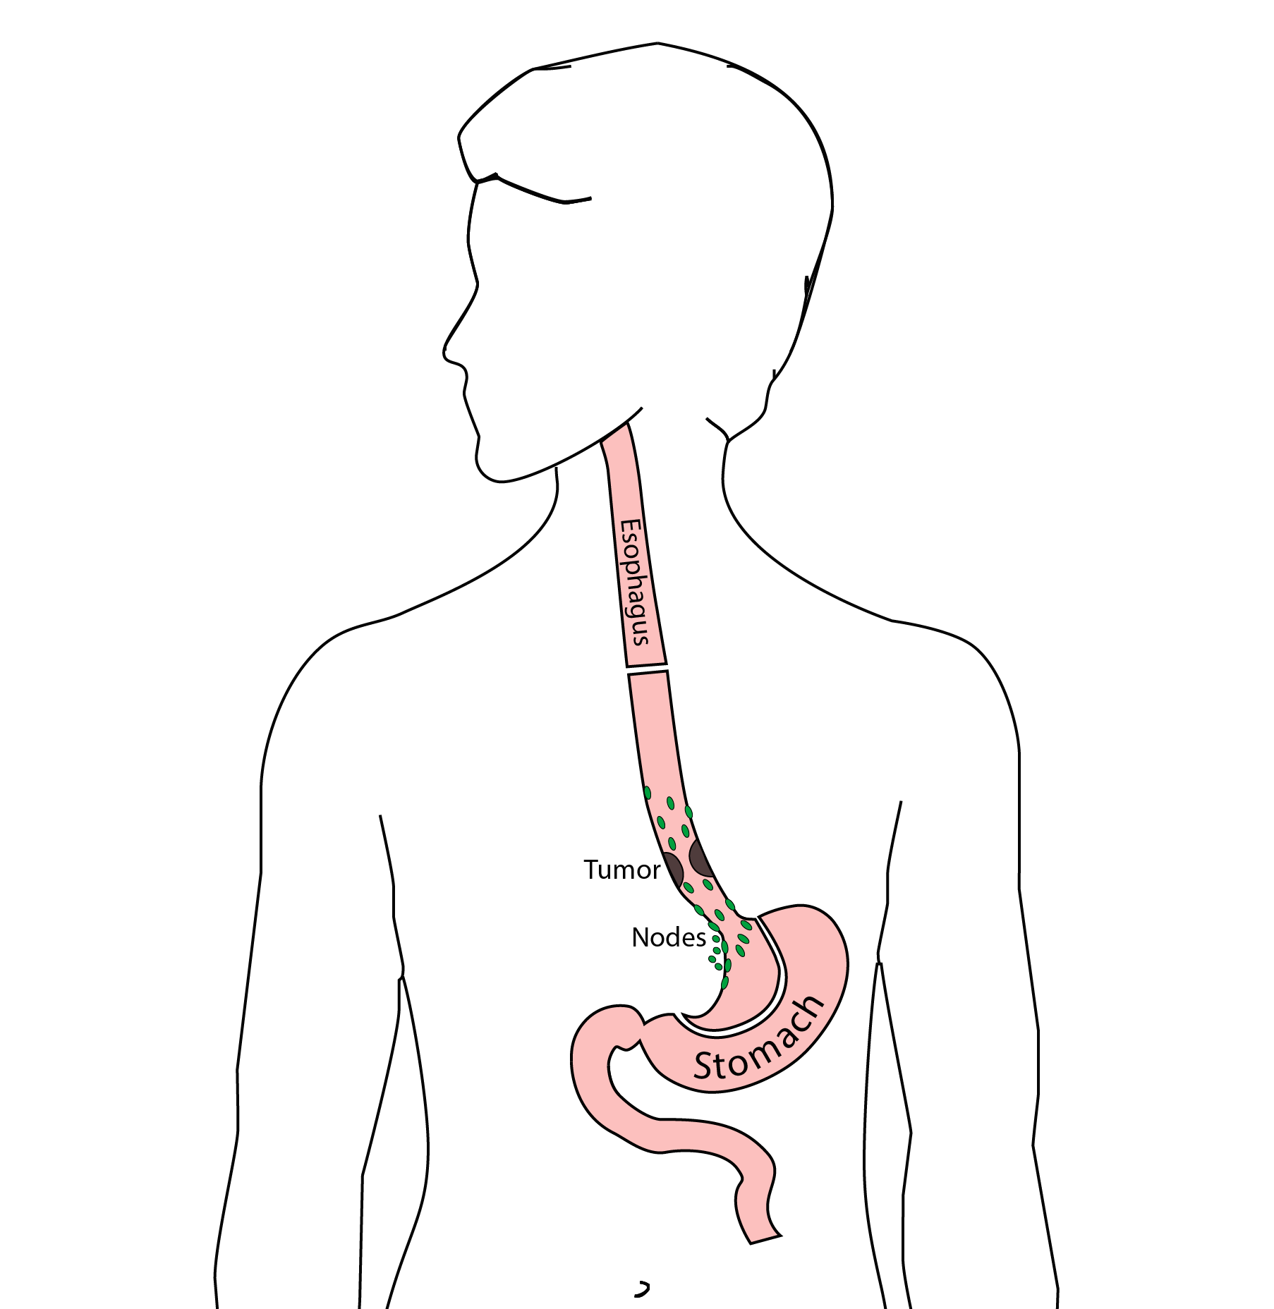

7 Reconstruction
New esophagus is created from the stomach in the abdomen by fashioning it into a tube.
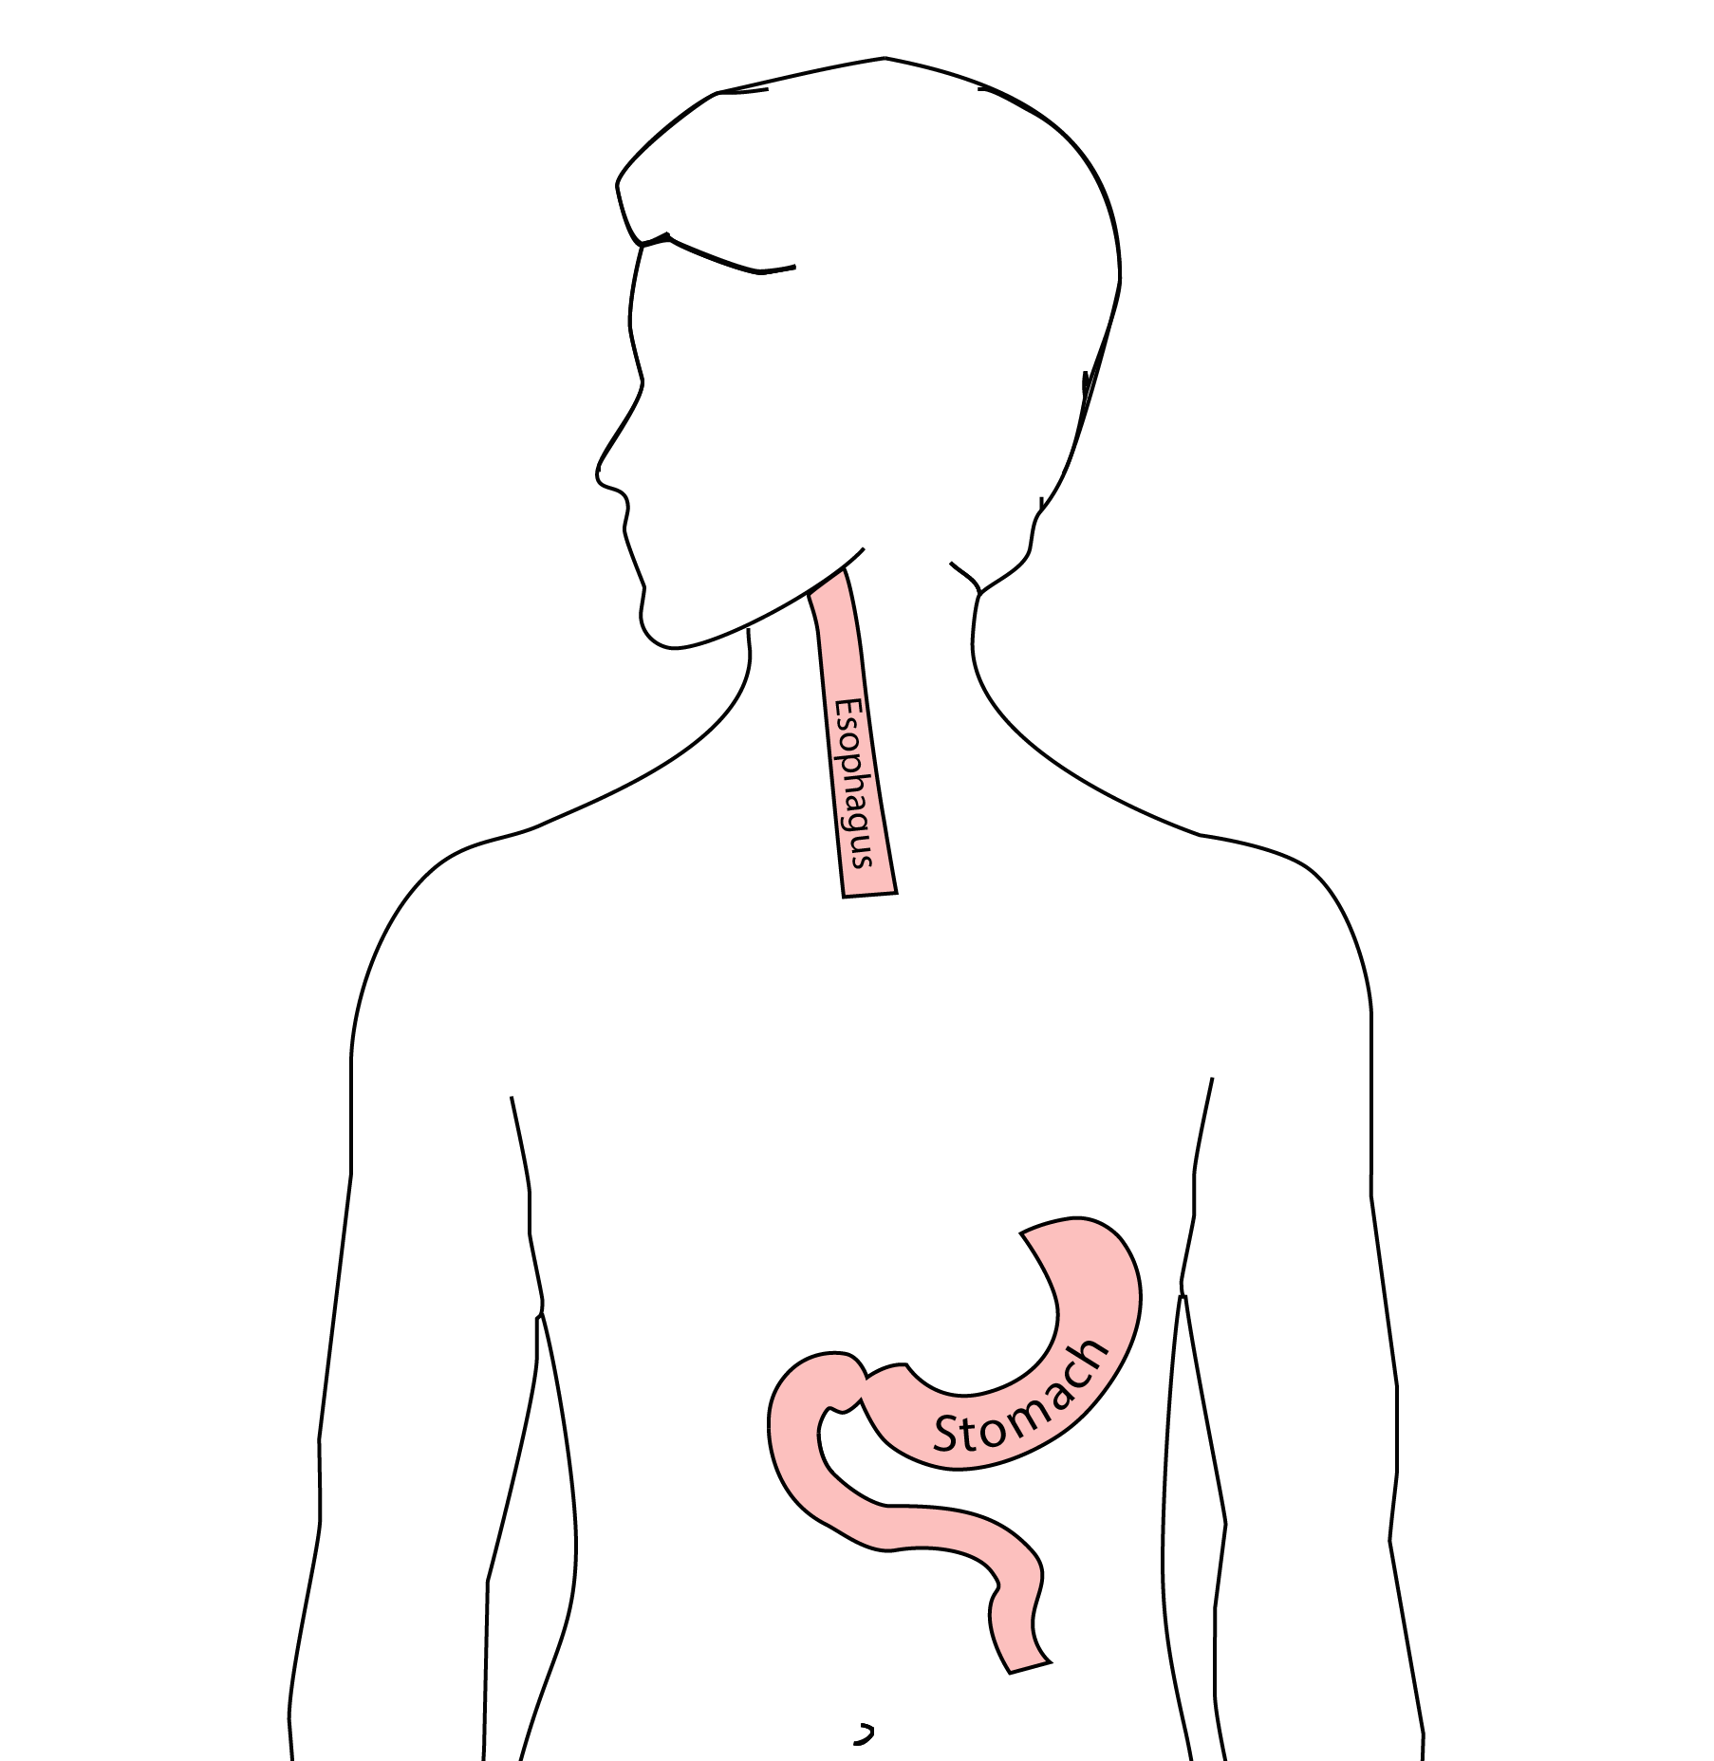

8 Ivor Lewis esophagectomy
The new esophagus is now brought up into the chest. A connection is made between the esophagus and the stomach, called an anastomosis.
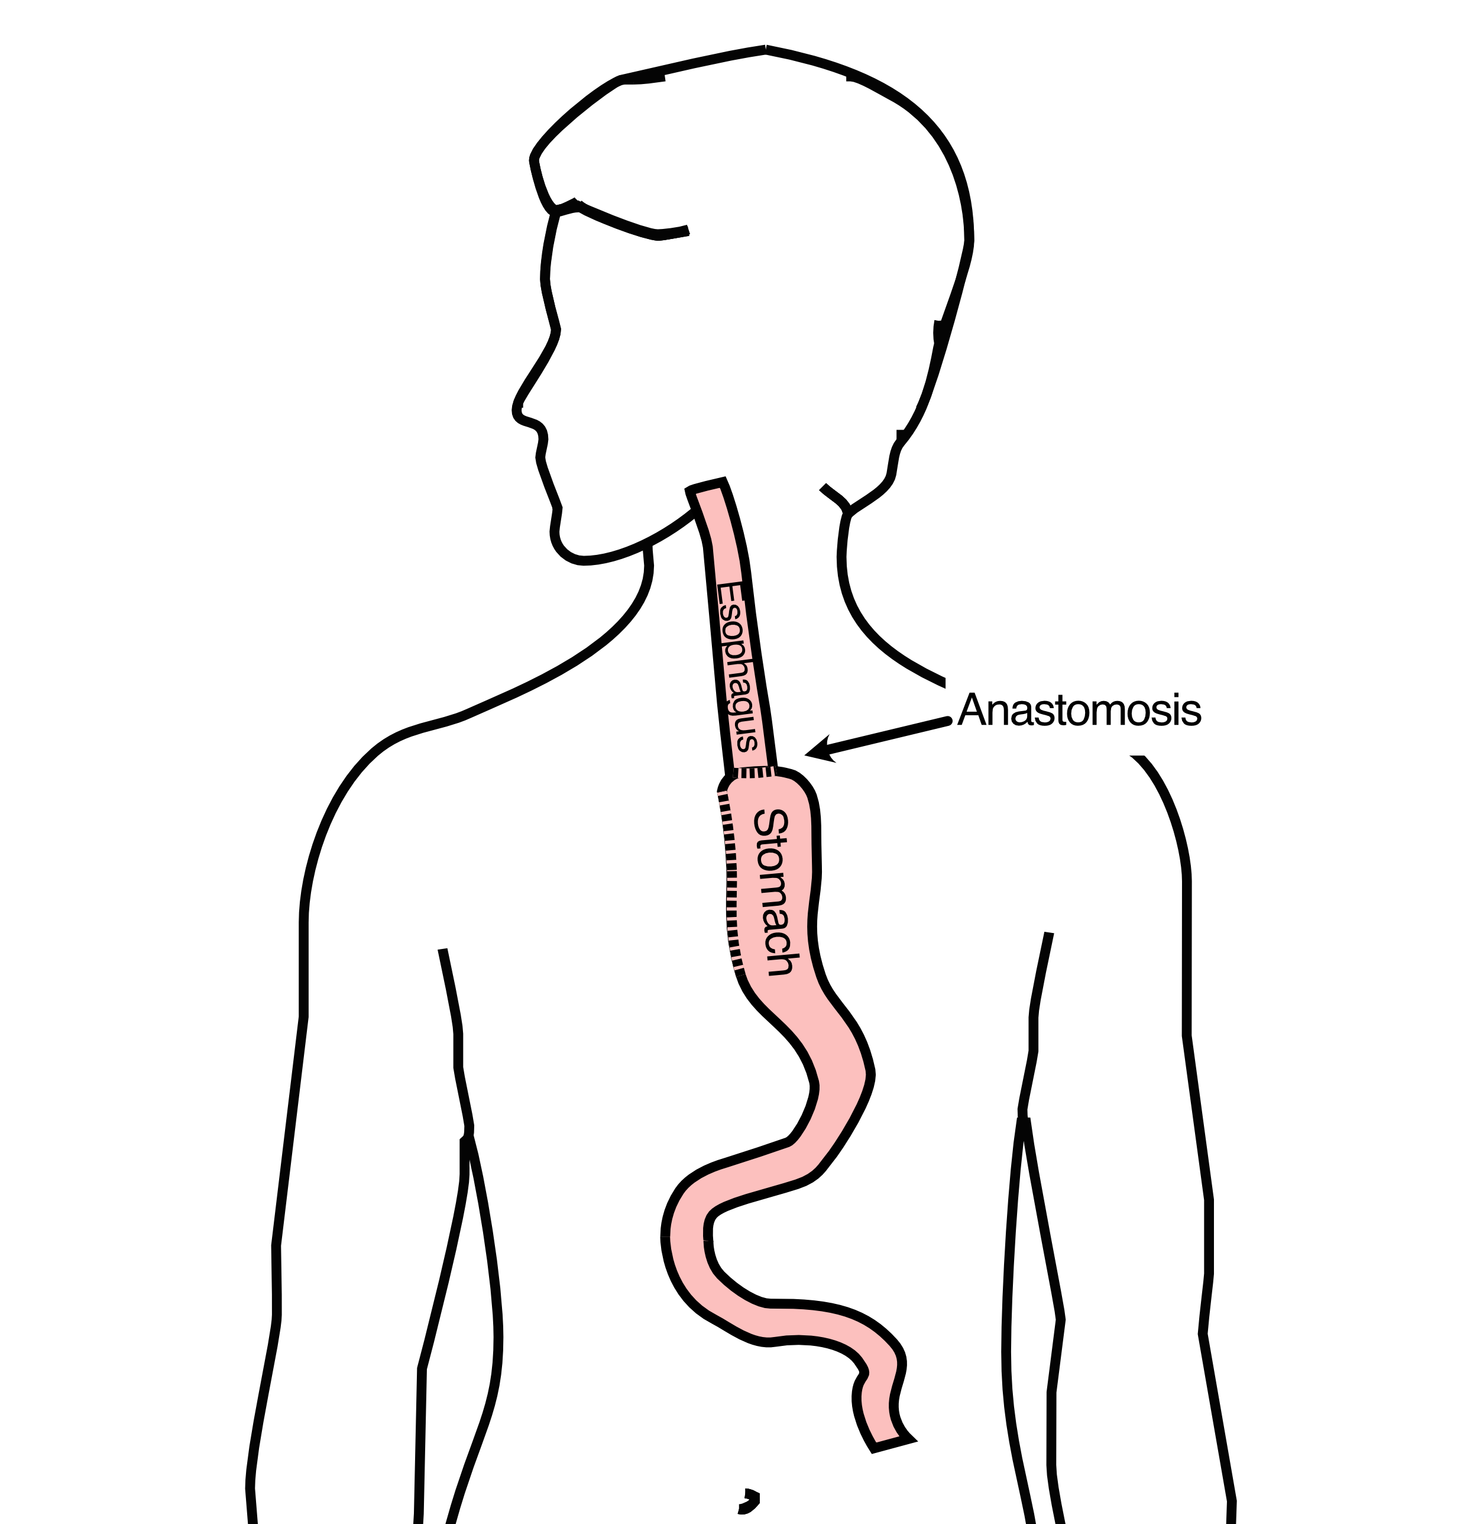

9 Ivor Lewis esophagectomy
:::::
:::::

10 Minimally-invasive Ivor Lewis Esophagectomy
- Small incisions abdomen and chest
- Surgical telescope and instruments
- Smaller incisions $→$ faster recovery and less discomfort
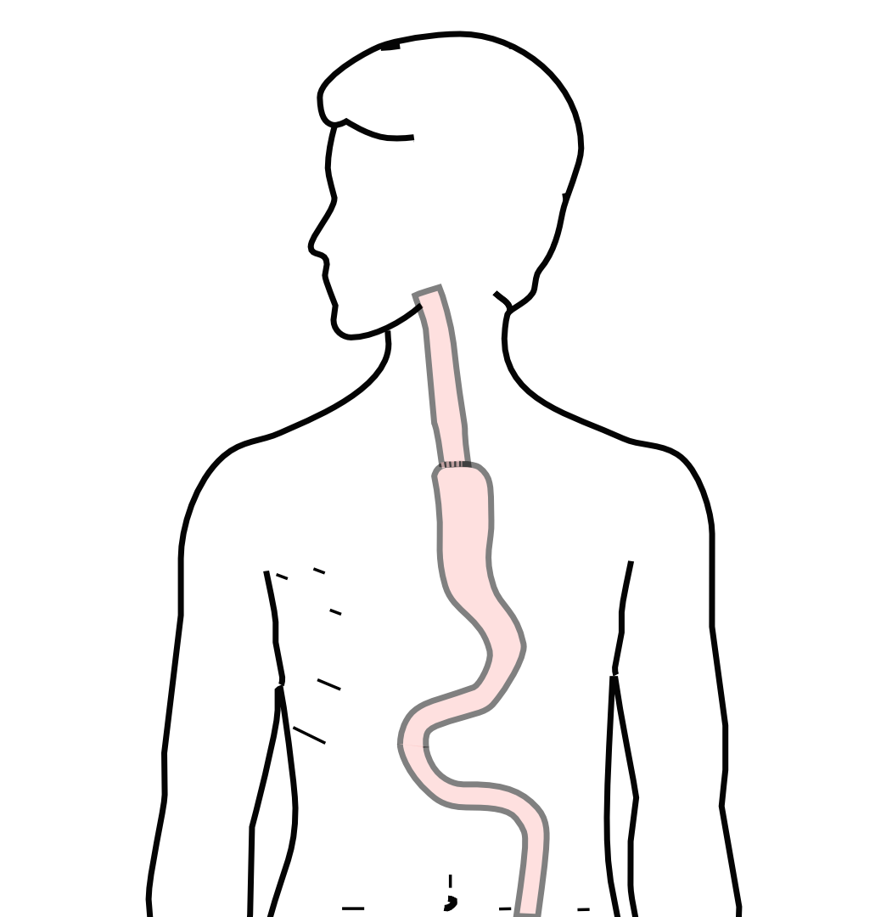
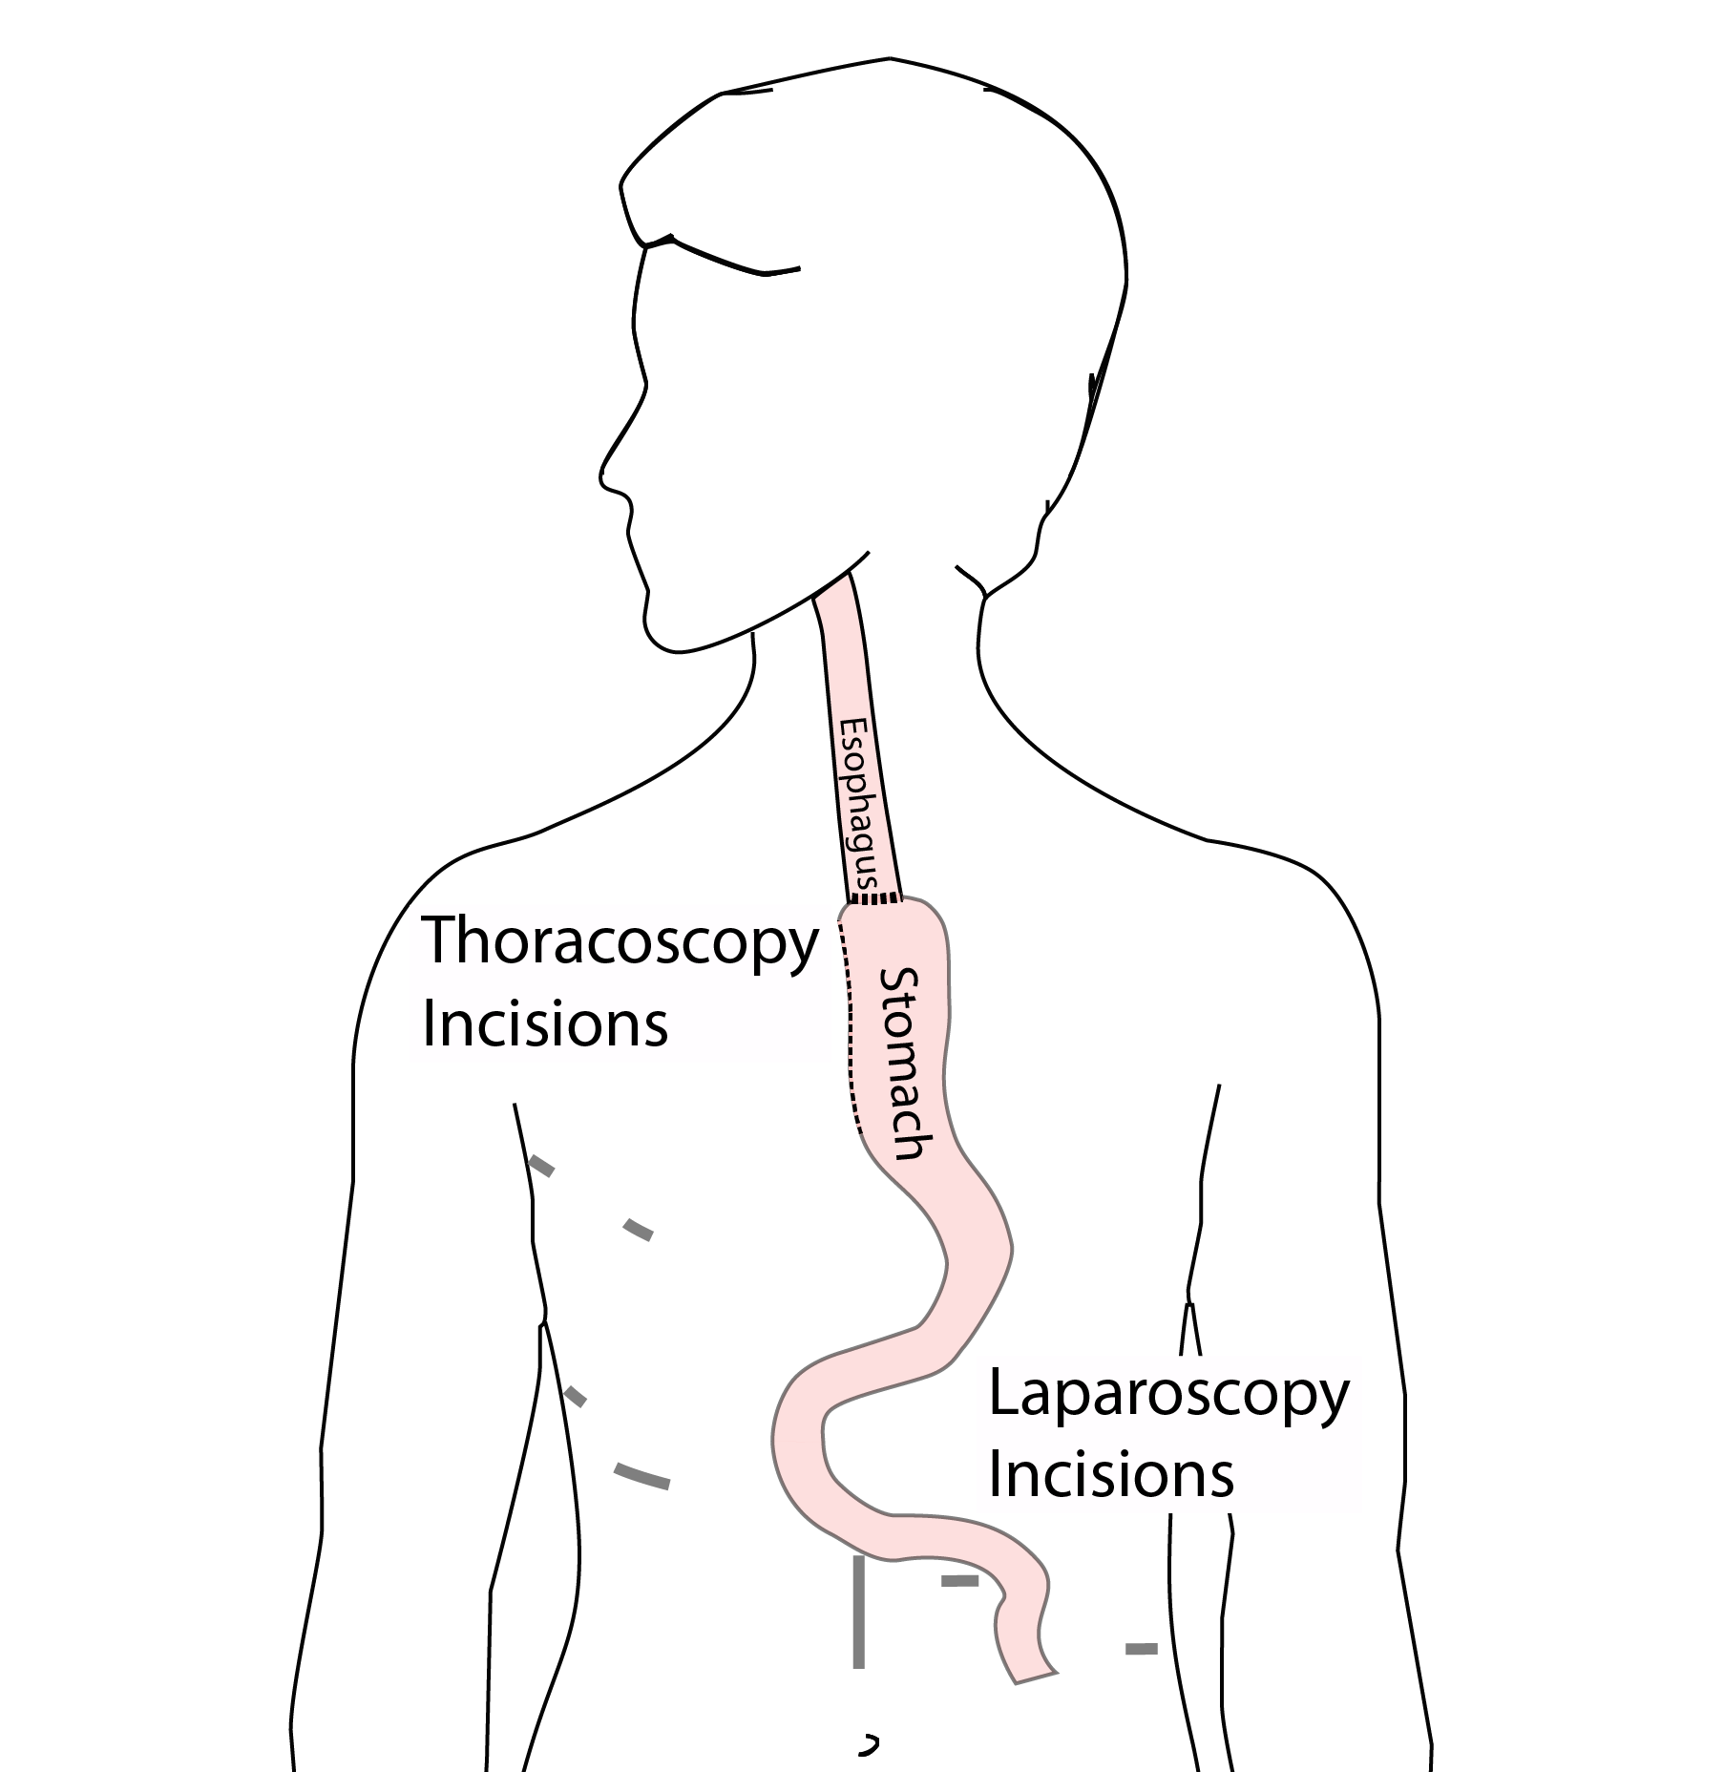
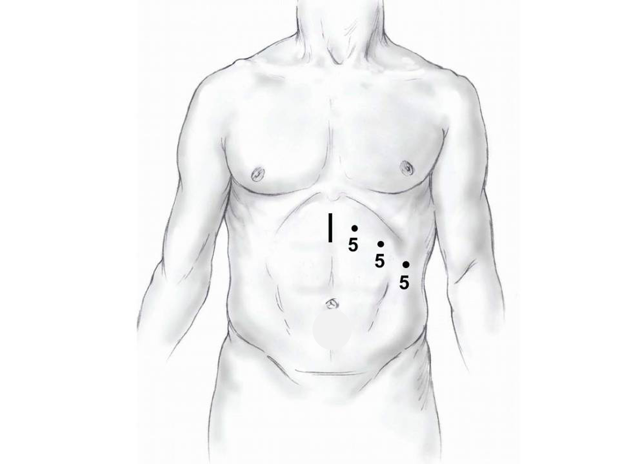
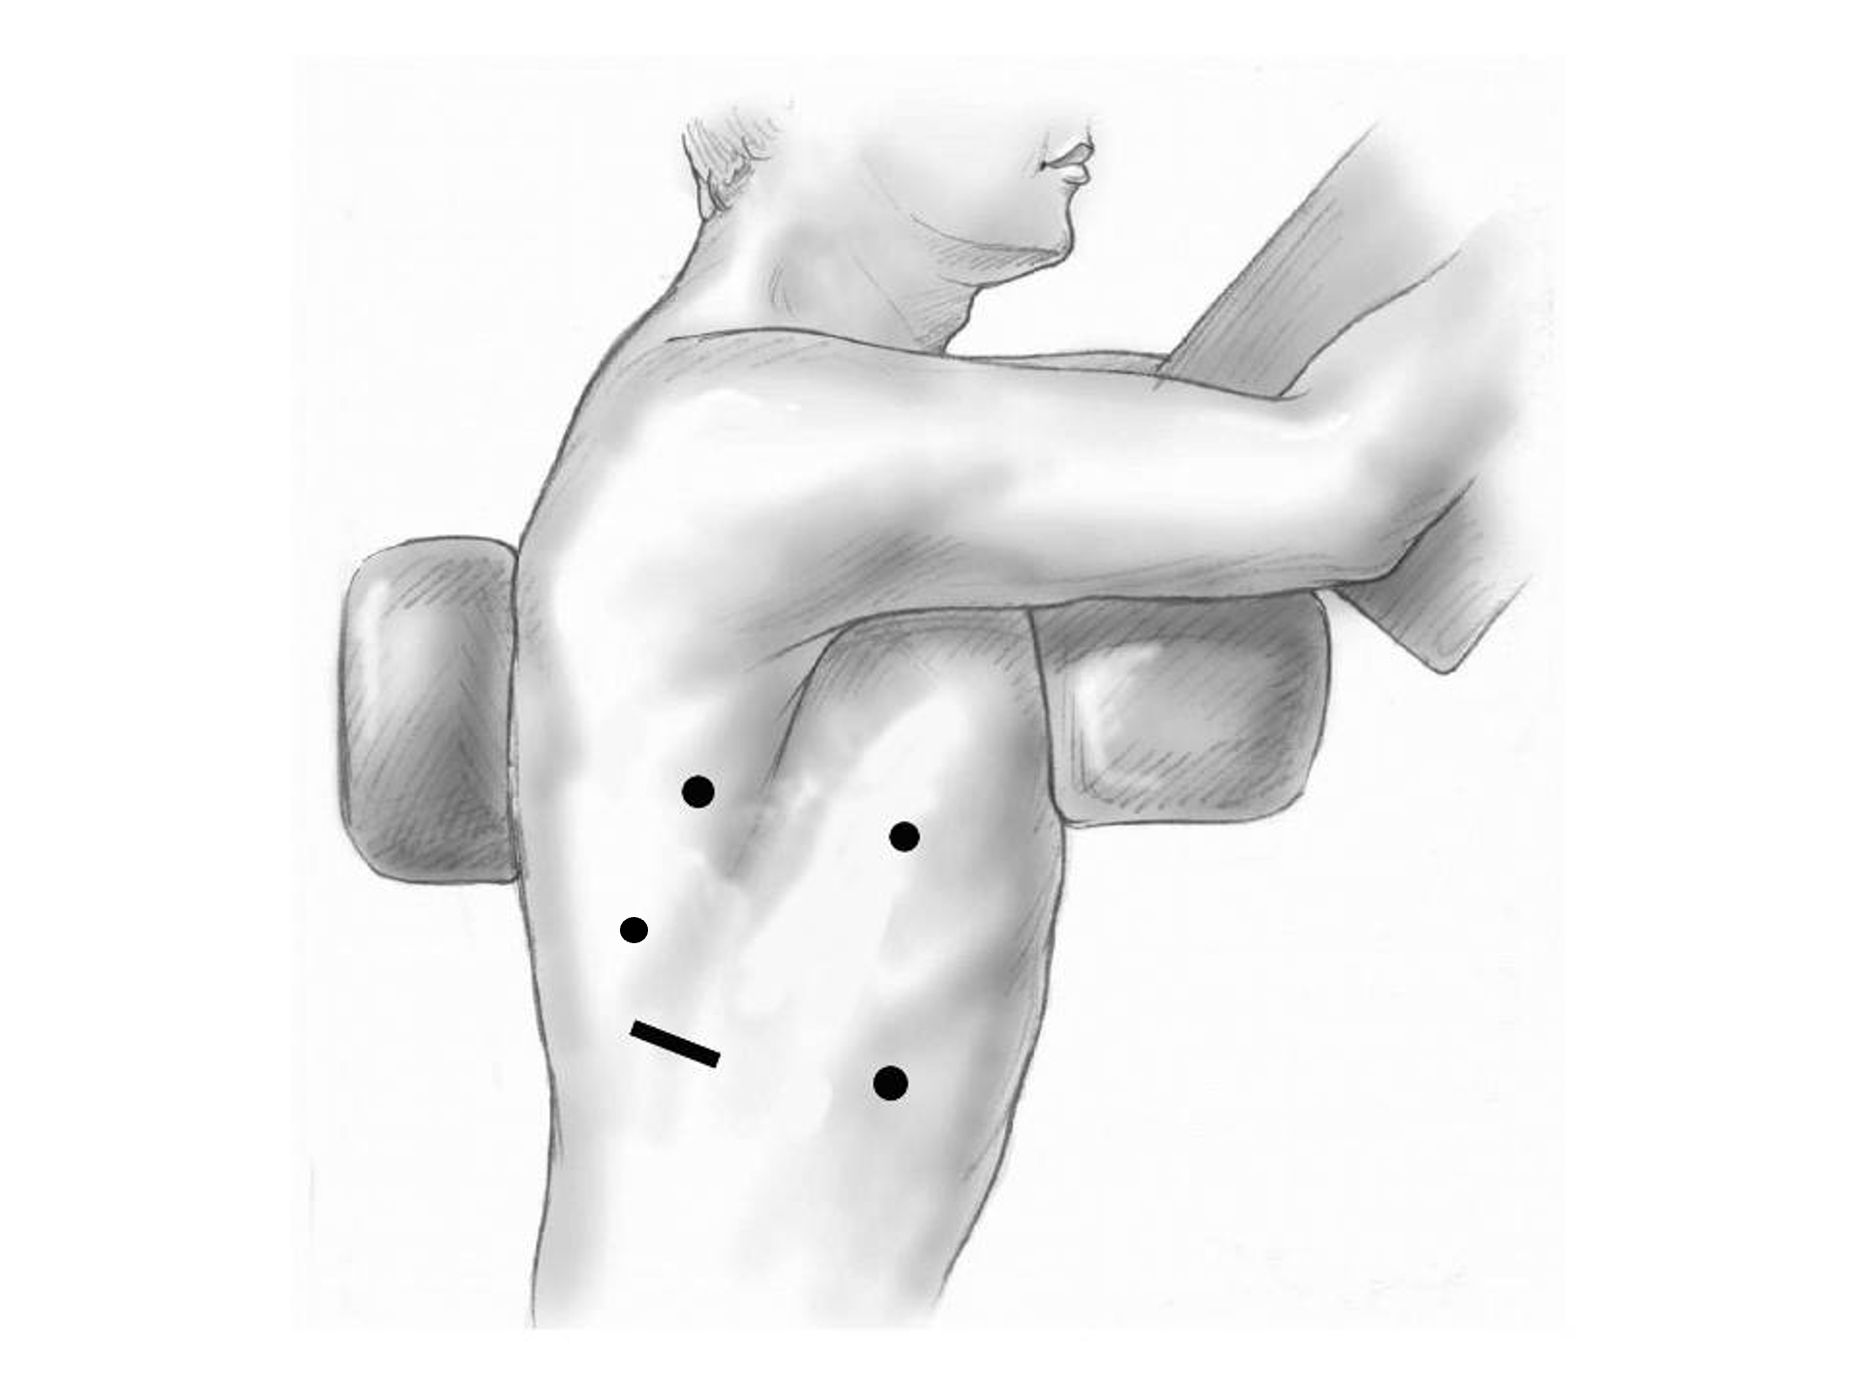

11 Open Ivor Lewis
Mininally-invasive approach feasible in 98% of cases
In some cases, an open approach is still necessary (2%)
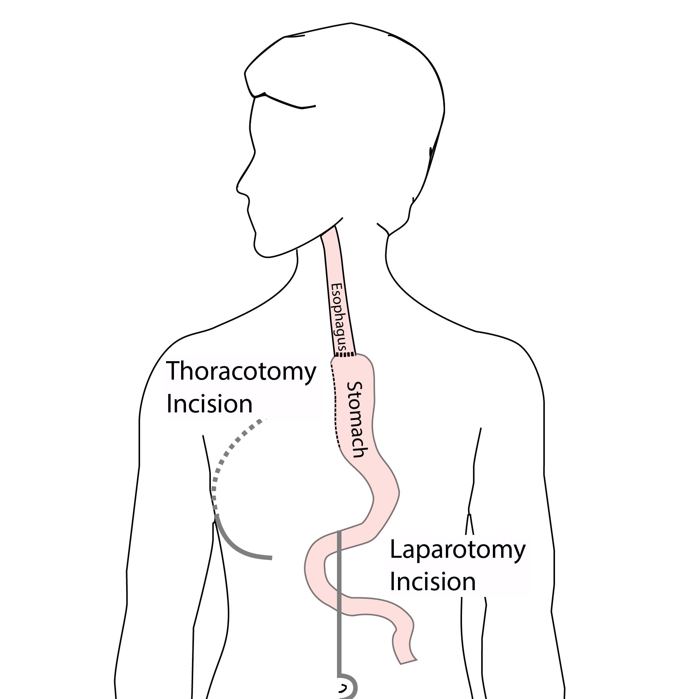

12 Total Esophagectomy
For patients with tumors in the upper esophagus, we need to remove more of the esophagus
We need to remove the whole esophagus, including the portion in the neck
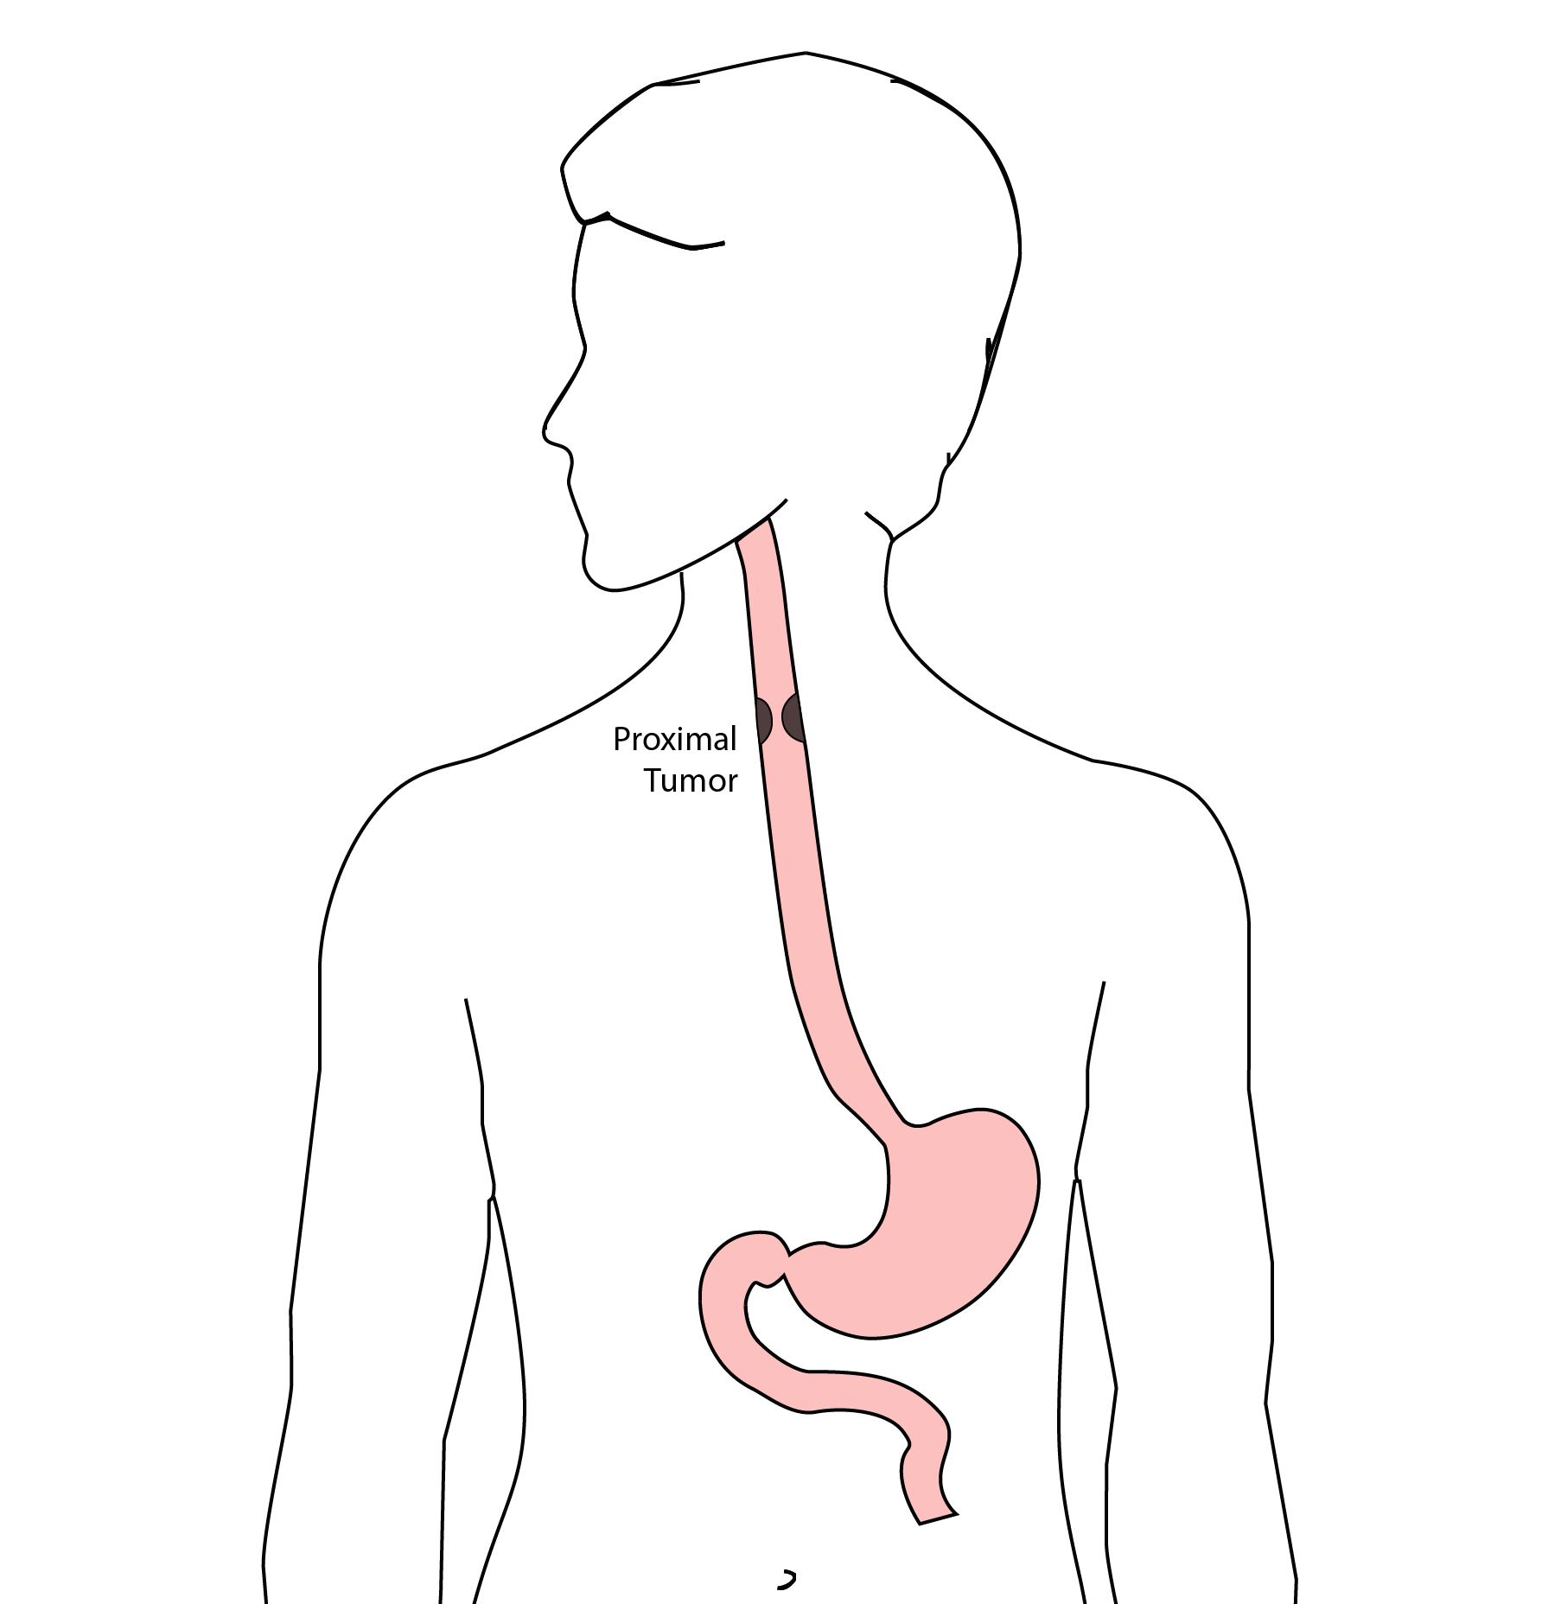

13 McKeown Esophagectomy
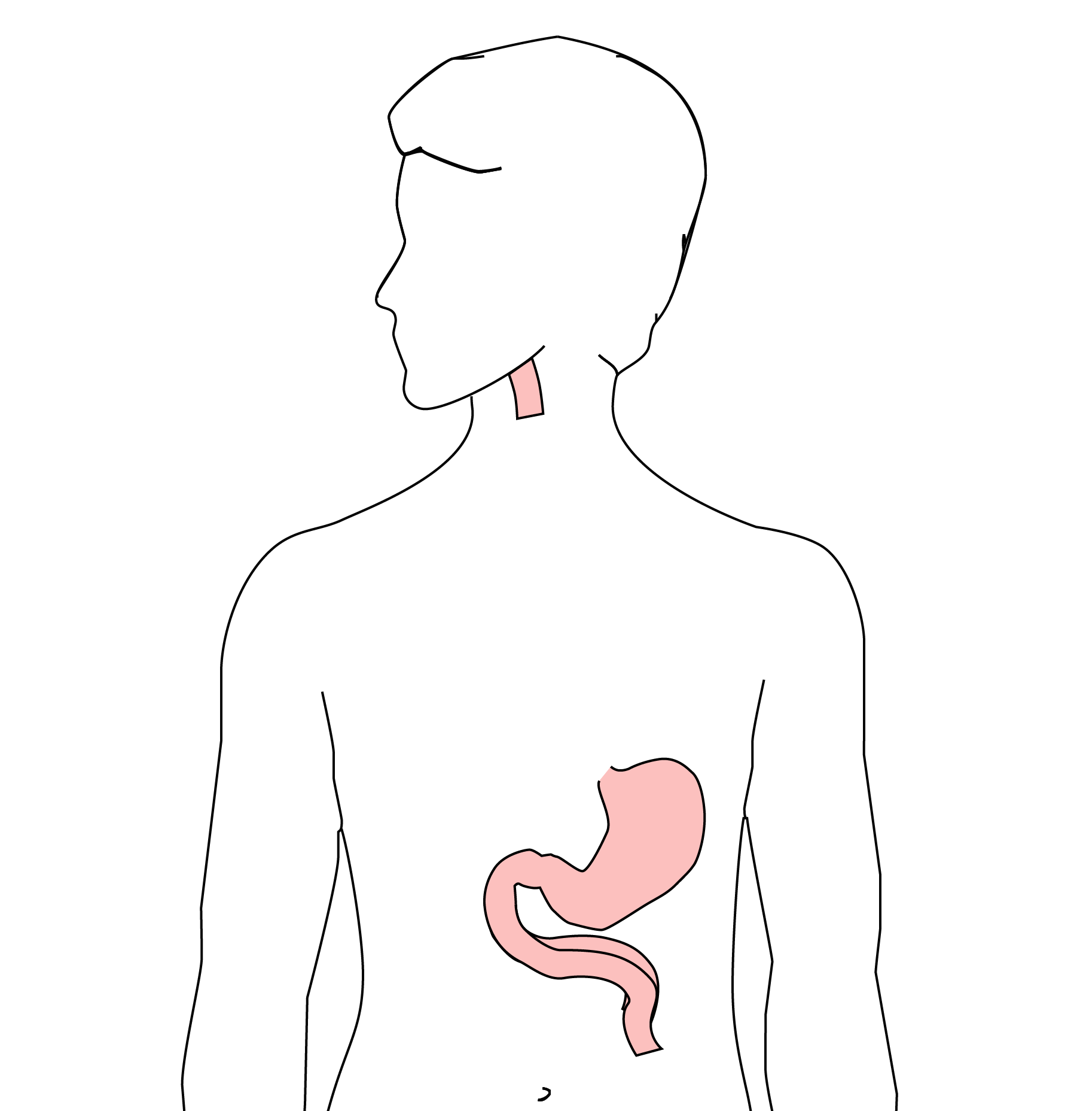 All of esophagus removed
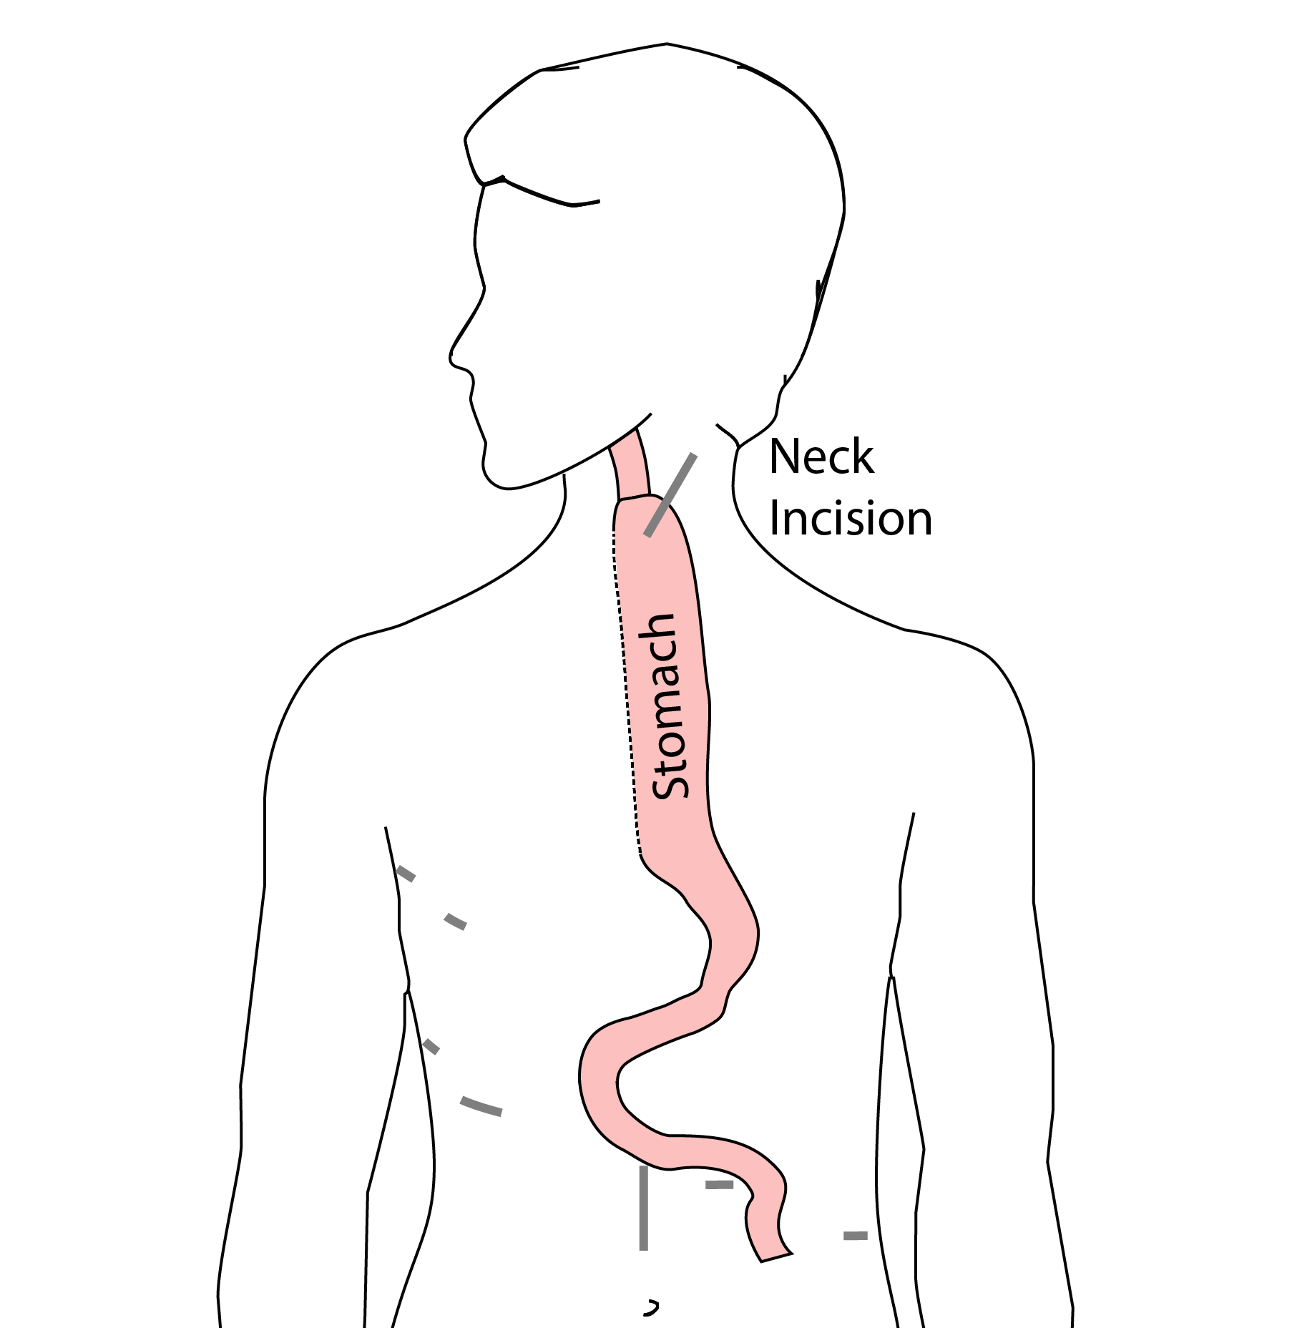 Connection made in the neck

14 Risks of Esophagectomy
Esophagectomy is a complex operation, with a real risk of complications.
Two significant complications:
- Anastomotic leak
- Pneumonia

15 Anastomotic Leak
The anastomosis is surgical connection between the esophagus and the stomach.

16 Anastomotic Leak
If healing doesn’t occur:
- Leakage of fluid from the esophagus
- Infection in the space between the lungs
- Requires additional time in the hospital
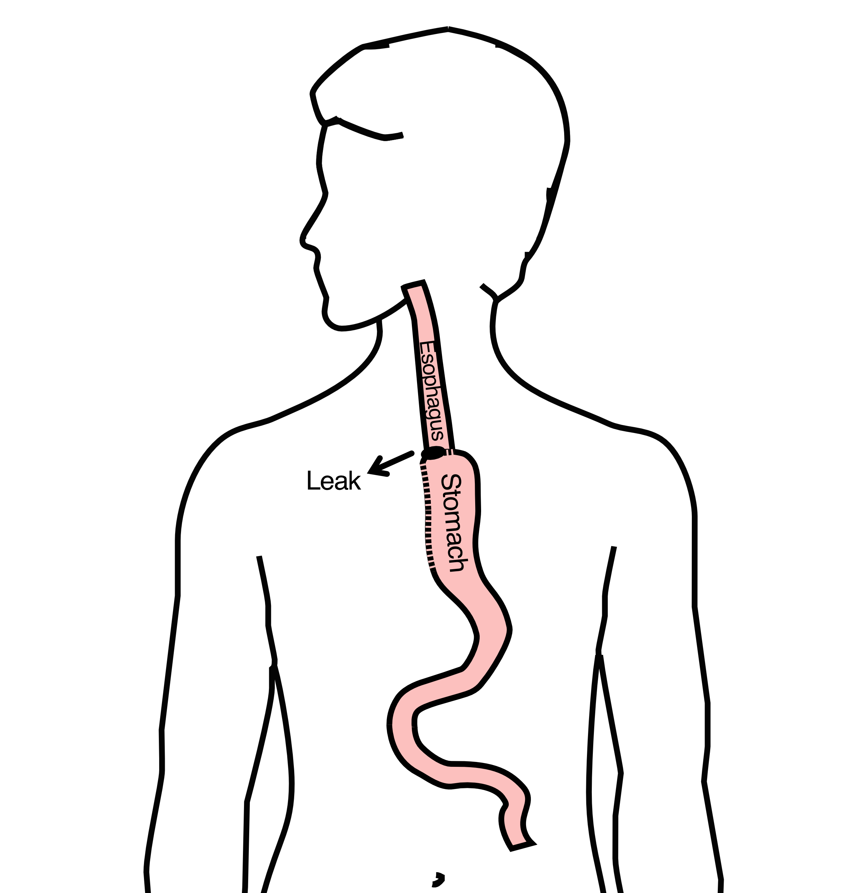

17 Anastomotic Leak
If leak occurs:
- Some leaks will seal
- Stent may be required to help healing
- Occasionally additional surgey is required

18 Anastomotic Leak
Risk of leak depends on:
- Type of operation performed
- Nutritional status of patient
- Experience of the surgeon

19 Pneumonia
- Occurs in 10-15% of patients after esophagectomy.
- Requires treatment with antibiotics
- Requires a longer hospitalization.
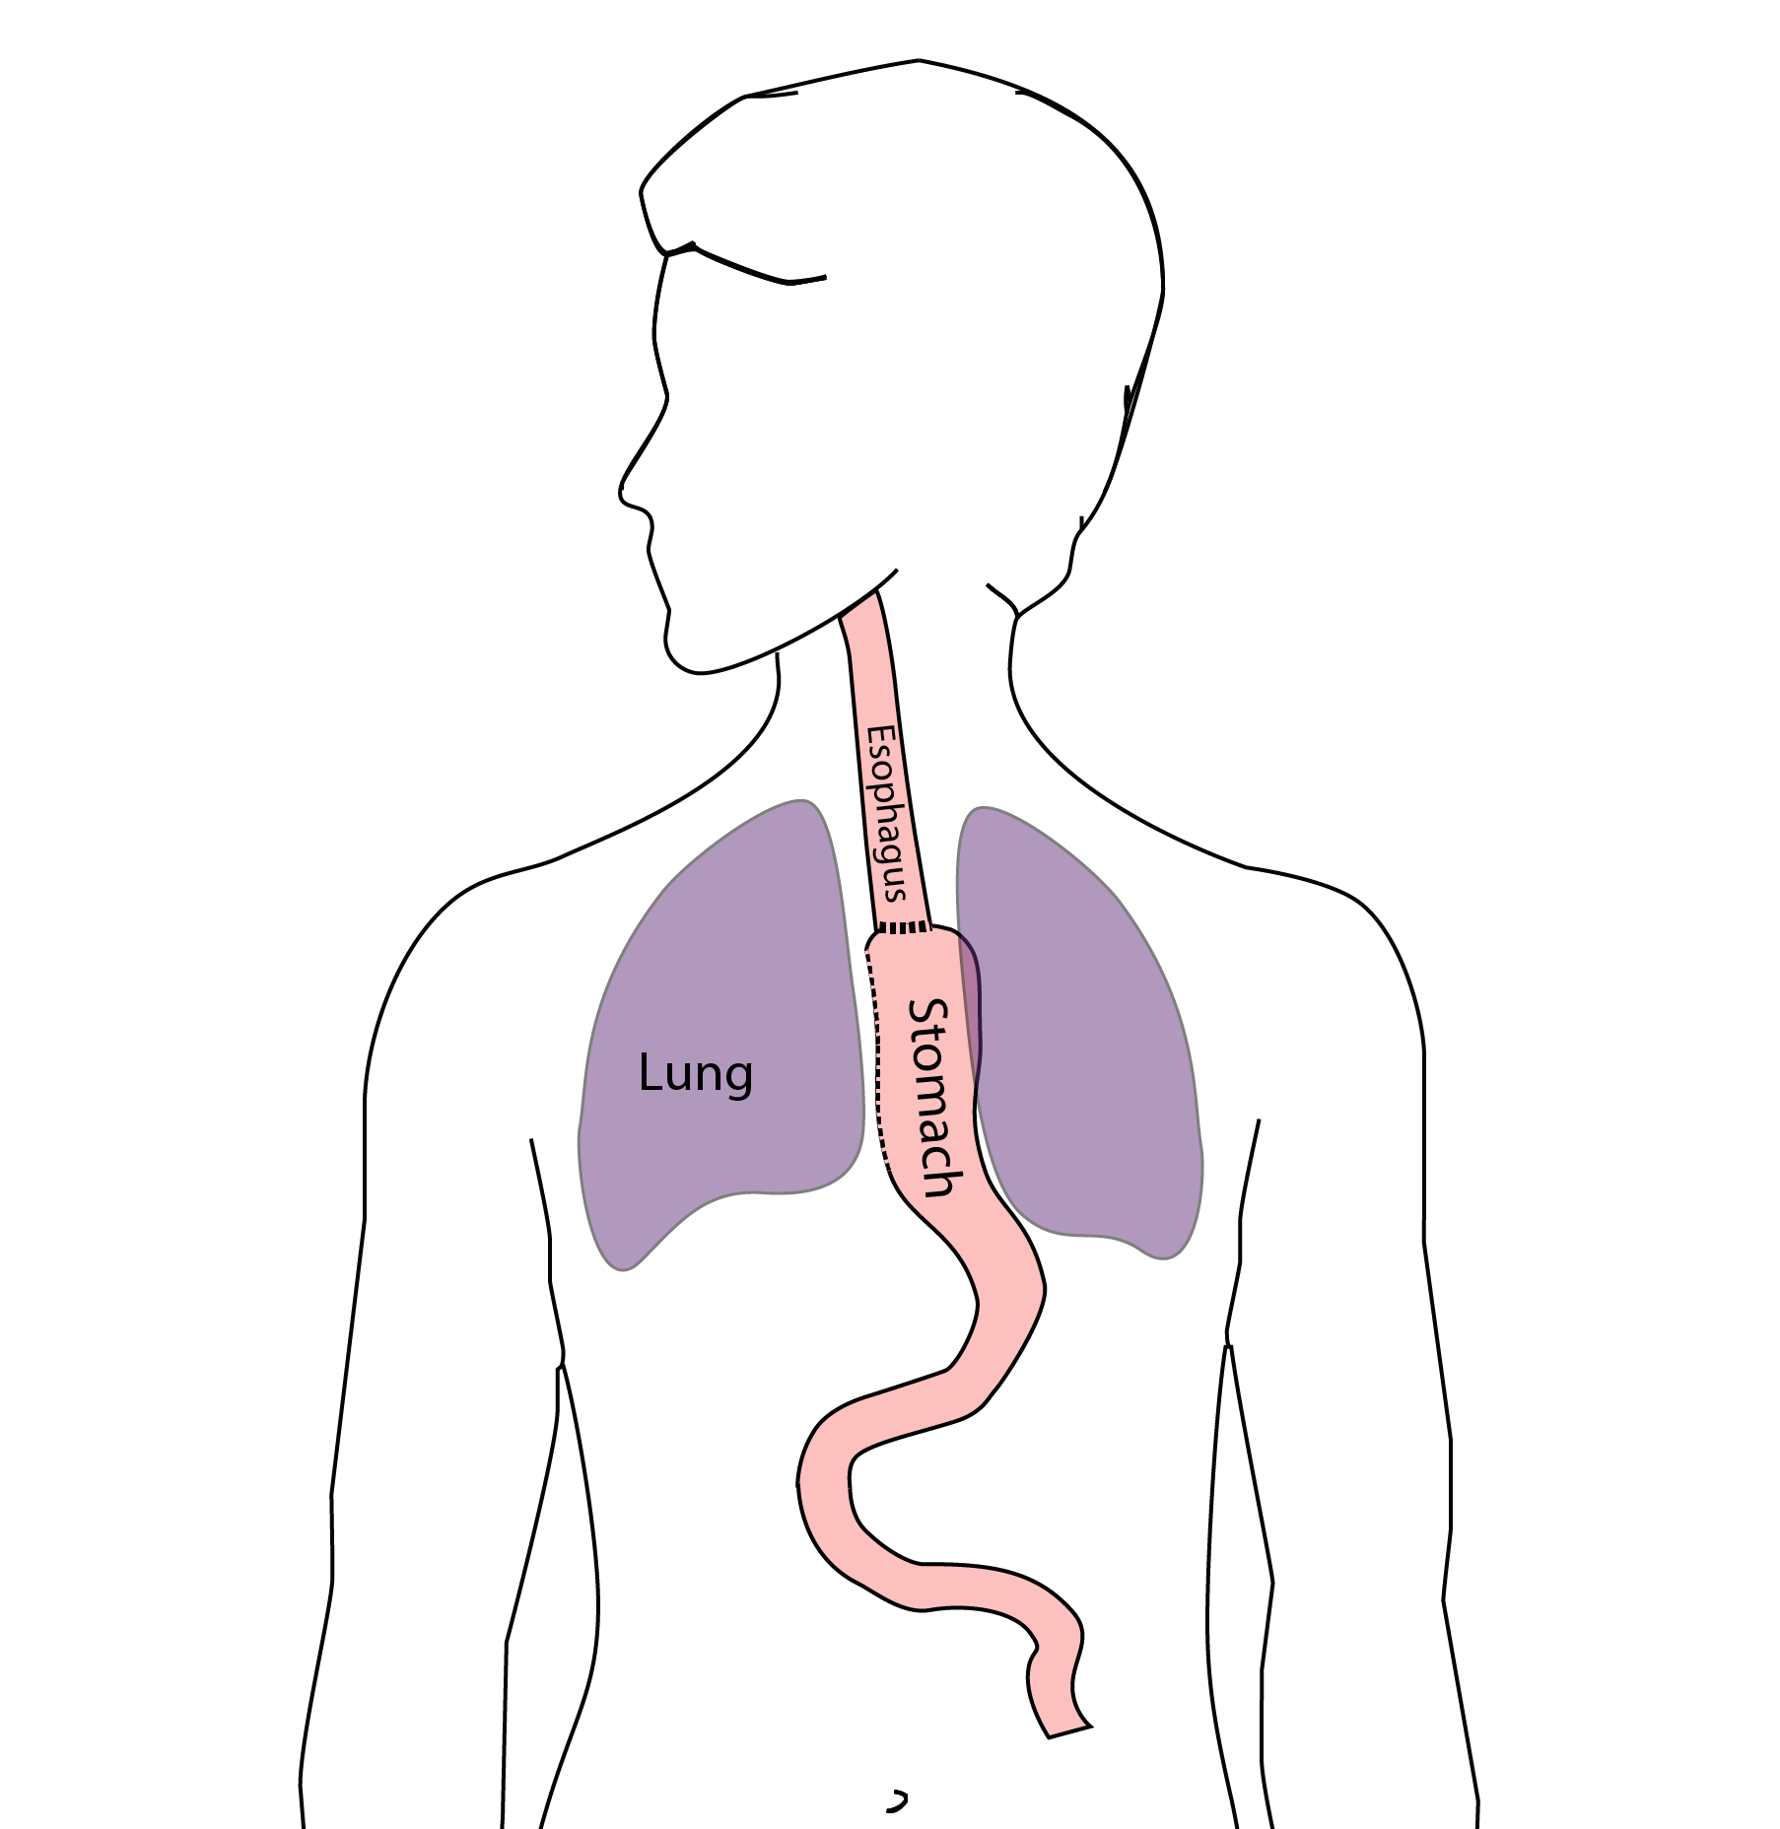

20 Preventing Pneumonia
Several ways to help prevent pneumonia:
- Deep breathing
- Coughing
- Walking
After surgery, this means:
- Sitting in a chair most of the day
- Walking in the halls as soon as possible

21 Risks of Surgery
Risks related to anesthesia
- Heart attack (5%)
- Irregular heart rhythm (15%)
- Pneumonia (10%)
- Blood clots in legs (<5%)
- Pulmonary embolism (2%)

22 Risks of Surgery
Risks related to Surgery
- Anastomotic leak (5%)
- Stricture at anastomosis (15%)
- Death within 90 days of surgery
  - Low risk patients = 2%
  - Intermediate risk = 10%
  - High risk = 30%

23 Risks of Surgery
Risks of Death within 90 Days of Surgery
 | Age <75 | Age >75
Normal Muscle (75%) | 2% | 10%
Low Muscle (25%) | 10% | 30%

24 Epidural Catheter for Pain Control
- Remains in place for 2-5 days
- Dosage can be adjusted as needed
- Can make it more difficult to urinate
- May require foley catheter in bladder
- Foley catheter removed after epidural removed

25 Jejunostomy Feeding Tube
A temporary feeding tube is placed to supplement nutrition by mouth.
This will stay in place for about 8 weeks after surgery
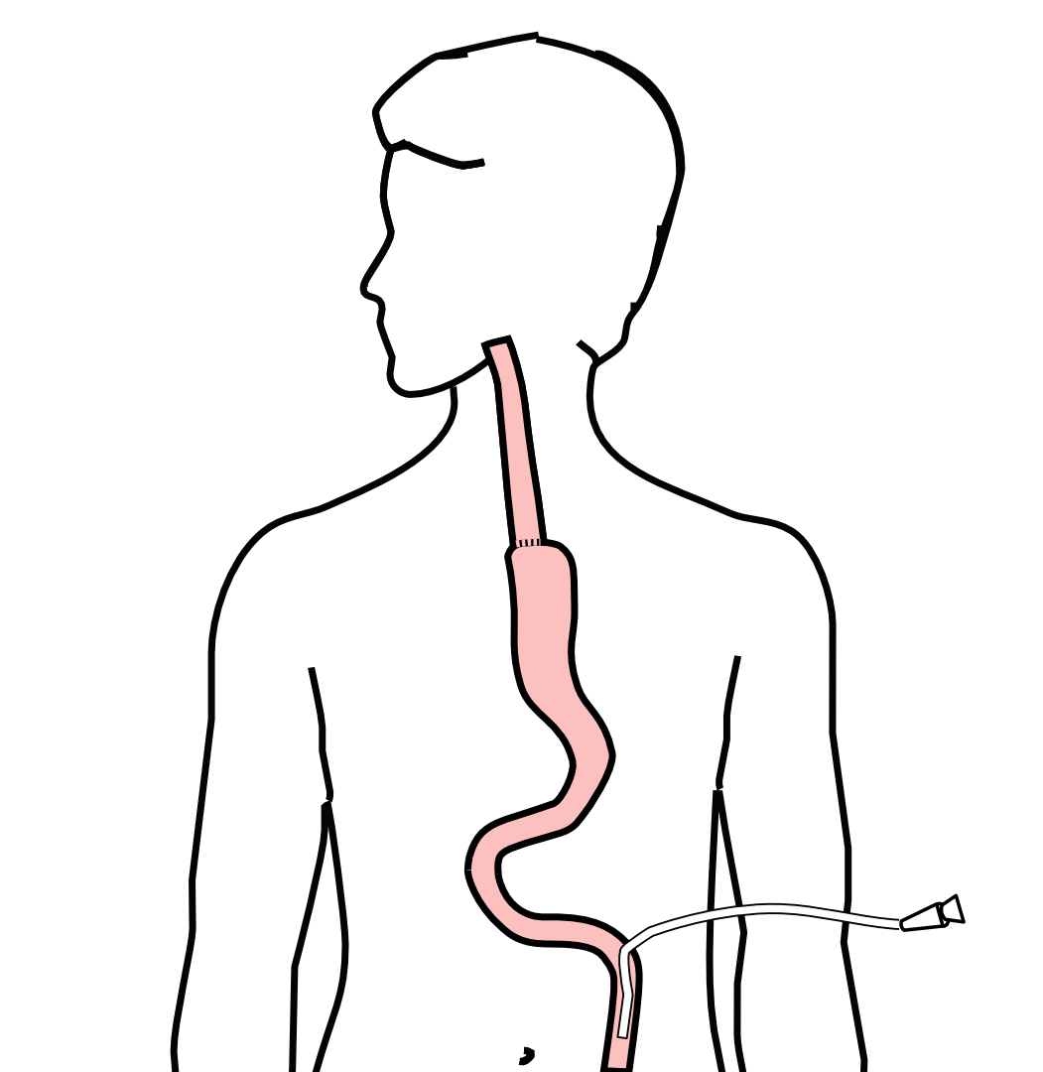

26 Intensive Care Unit (ICU) (2-4 days)
- Surgical ICU on 11th floor
- NG tube in nose to drain stomach and esophagus
- Catheter in bladder
- Chest tube right chest
- Abdominal drains (usually 2)
- Feeding jejunostomy (usually stays in 8 wks)

27 Intensive Care Unit (ICU)
- Bladder catheter removed → check that bladder empties properly
- Chest tube removed (day 2-4) → follow-up x-ray
- Fluid emptied from drains every few hours
- Start tube feedings by feeding
- Feeding jejunostomy (stays in 8 weeks)

28 Ward - 6Tower
- Up in a chair most of the day
- Walking in the halls
  - Start with assistance
  - Improves lung function
  - Prevents loss of muscle strength

29 Jejunostomy Feeding Tube
Feedings are administered through the jejunostomy at night by a pump
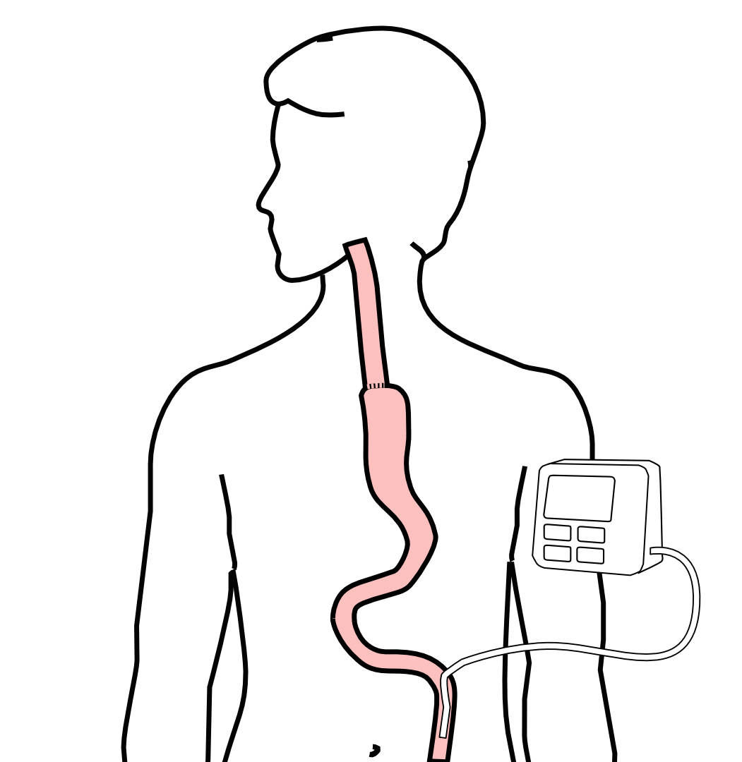

30 Jejunostomy Feeding
- Start with continuous feeds (24 hours/day)
- Convert to nocturnal (night-time): 6pm to 10pm
The feeding bag holds only 4 cartons of feeds - May need to “top off’ bag after a few hours
Water through the tube
- Important to prevent dehydration
- 240mL (8 oz) 4 times per day

31 Jejunostomy Tube

32 Jejunostomy Feeding Pump

33 Jejunostomy Typical Regimen
- Jejunostomy tube feeds for 16 hours (6pm-10am)
  - Men: 75mL/hour x 16 hours = 5 cartons
  - Women: 60mL/hour x 16 hours = 4 cartons
- Water 240ml (8oz) via syringe 4x/day
Hospital nurses will teach use of the feeding tube

34 Jejunostomy Feeds with Diabetes
Jejunostomy feedings elevate blood sugars
- Insulin may be required along with feeds
Typical Pattern for tube feeds
- Feeds run via pump from 6pm to 10am
- Insulin at 6pm (70/30 insulin)
- Insulin at Midnight (70/30 insulin)
- No insulin if tube feedings are not run

35 Jejunostomy Video

36 Activity after Surgery
- Up in chair most of the day
- Walking with help from nurse/Physical Therapist
- Goals:
  - Improve lung function
  - Prevent muscle loss

37 Nasogastric (NG) Tube
Tube passed through nose into stomach
- Drains fluid from stomach
- Prevents vomiting
Upper GI X-ray on 2nd or 3rd day after surgery
- If stomach empties well $→$ NG tube removed
- Otherwise, X-ray repeated 2-3 days later

38 Swallowing Evaluation
Once NG tube has been removed:
Modified barium swallow in radiology
- Drink a white chalky liquid (barium)
- Look for proper swallowing function
- 80% of patients $⇒$ liquids started by mouth

39 Oral Intake at Home
Most are taking protein shakes when they go home
Protein shakes are started after tolerating water
- 2 oz per hour to start
- 4 oz per hour if 2oz are tolerated well

40 Drains and Tubes
Chest Tube (right side): Removed 4-6 days after surgery (depending upon output) Abdominal drains: Removed 4-7 days after surgery
- Discharge with 1 abdominal drain in 10% of cases
Epidural catheter: Removed 4-5 days after surgery Bladder catheter: Removed after epidural catheter removed

41 Discharge
Goal: ready to leave day #7 after surgery
- Night-time tube feedings (6pm to 10am)
- Nutrition by mouth (90% of patients)
  - Protein shakes or water 4oz every 2 hours
- Water through tube 8oz four times per day
- Home care nursing (feeding tube teaching)
- Home infusion (tube feeding supplies)

42 Nutrition after Surgery
At discharge home:
- Protein shakes 4oz every 2 hrs
- Tube feeds 4-5 cans at night (6pm-10am)
10-12 Days: Increase protein shakes
- Tube feeds 3-4 cans at night
Three weeks: Post-esophagectomy Diet
8-12 weeks: Remove feeding tube (in office)

43 Transition from Tube Feeds $→$ Eating
Dietitian will calculate daily protein goal
- Typically 60-75 grams protein/day
- Each carton of tube feeding has 15 grams
  - 75 grams protein = 5 cartons/night
- More intake by mouth $→$ tube feeds reduced
Spread out protein during the day (20gm/meal)
- Three meals + 2-3 high-protein snacks

44 Post-esophagectomy Diet
- Soft Consistency
- High Protein
- Avoid sugary liquids (can cause ‘dumping’)
- Avoid raw vegetables (and salads)
- Eating
  - Small, frequent meals
  - Sit up for 30-45 minutes after eating
  - Avoid eating within 2 hours of bedtime

45 Medicines at Home - Pain
Acetaminophen (Tylenol) 1000mg 4x/day
Gabapentin 300mg 3 times/day
Oxycodone
- As needed in addition to Tylenol/gabapentin
- Will begin reducing dose at first postop visit
- Can usually discontinue by 4 weeks
- NO DRIVING WHILE ON OXYCODONE

46 Non-steroidals Anti Inflammatory (NSAID)
Non-steroidal anti-inflammatories (Celebrex)
- 200 mg every 12 hours starting at 2 weeks
NO GOODY POWDERS OR BCs
- (Can cause permanent scarring at the surgery site)

47 Acid Blockers = Proton Pump Inhibitors
Examples include ompeprazole and pantoprazole
- Will stay on for at 1-2 years to prevent acid reflux
- Important in preventing scarring at anastomosis (new connection between esophagus and stomach)
- To administer through feeding tube, open capsule and resuspend beads in 60mL (2oz) of water

48 Medicines at Home
Reglan – Helps stomach empty
- Will plan to stop after six weeks
- 0.1% risk of tardive dyskinesia (nervous tic)
Remeron – Helps improve appetite
- Can cause vivid dreams
- Used for several weeks after surgery
- Will stop within first three months of surgery

49 Metoprolol = Beta Blockers
- Slows heart rate and lowers blood pressure
- Used to prevent rapid heart rate
- Patients not taking a beta blocker prior to surgery $→$ wean after after surgery
- Patients taking a beta blockerprior to surgery $→$ return to prior dose and drug after surgery

50 Sleeping at Home
Reflux can occur the first few weeks/months after surgery
This improves over the first few months
A wedge pillow can be helpful for sleep
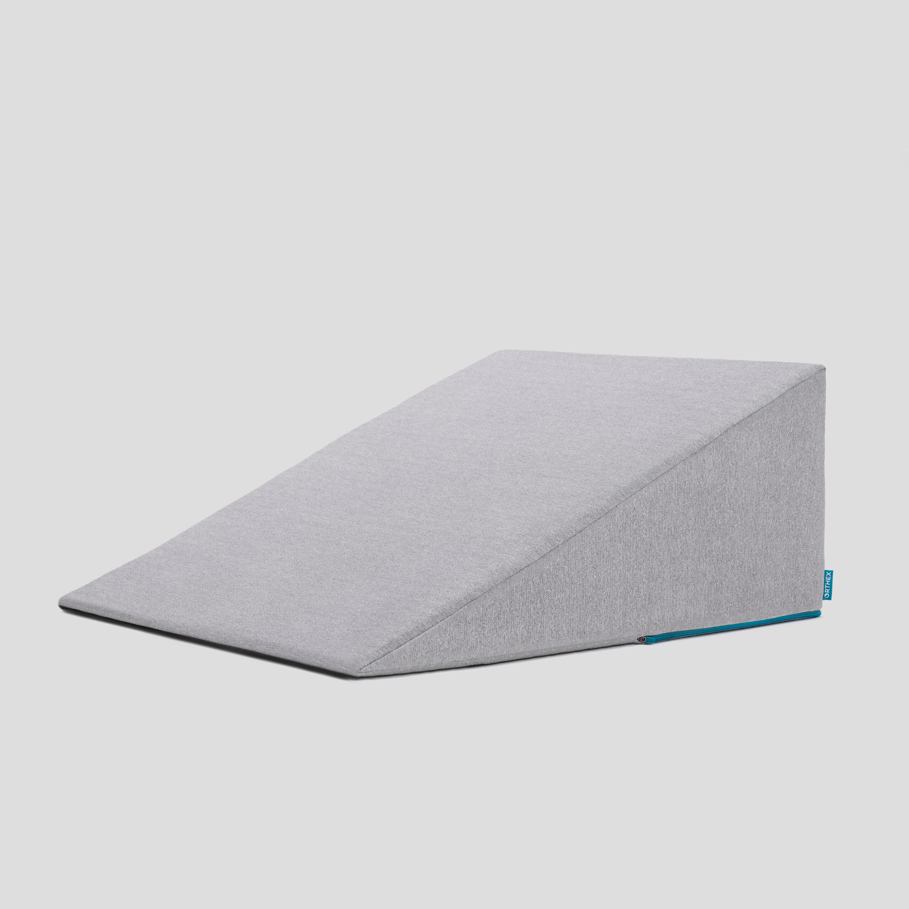

51 Follow Up Visit 7-10 days after Discharge
In-person clinic visit with Dr Salo or Kate Duncan
- Check surgical site
- Remove staples (if needed)
- Remove abdominal drains (if needed)
Meet with dietitian:
- Reduce tube feeds
- Advance diet by mouth

52 Adjust Medicines after Surgery
Reglan: Discontinue 6 weeks after surgery Remeron: Discontinue 12 weeks after surgery Pain Medicines:
- Wean oxycodone within 6 weeks of surgery
- Discontinue gabapentin and acetaminophen (Tylenol) within 8 weeks
Continue acid blockers (PPI) for at least 1 year
Reduce metoprolol to once/day for 7 dayus $→$ discontinue

53 Second Follow Up Visit
4-5 weeks after first post-operative visit
- Discuss diet
- Discuss medicines
- Plan for jejunostomy removal
- Evaluate readiness for chemotherapy after surgery (usually 6 weeks)

54 Eating after Surgery
First Postoperative Visit: Start soft foods (Phase I)
Weekly virtual visits with dietitian
Jejunostomy removal ~ 8 weeks after surgery

55 Jejunostomy Removal
Jejunostomy tube is removed in the office once you can take in enough nutrients by mouth
Removal usually around 8 weeks after surgery (may be longer if chemotherapy planned after surgery)
May take 30 minutes and some local anesthetic to loosen up the tube for removal.

56 Nutritional Monitoring after Surgery
You may have difficulty absorbing some nutrients:
- Iron
- Vitamin B12
- Vitamin D

57 Nutritional Monitoring after Surgery
About 3 months after the jejunostomy tube is removed, we will check blood levels:
- Iron (ferritin)
- Vitamin B12
- Vitamin D

58 Nutritional Replacements after Surgery
Vitamin or iron replacements can be ordered by:
- Primary Care Provider (PCP)
- Medical Oncologist
- Surgeon
If levels are low
- Replacement
- Repeat testing in 3-6 months

