Esophagectomy
I’m Dr Jonathan Salo, a GI Cancer Surgeon in Charlotte, North Carolina. These videos are designed to educate you about cancer and its treatment and help you and you cancer care team make the right decisions for you.
Of course, there is no substitute for the expert opinions of your cancer care team.
In this video, you will learn about (2)
- Preoperative Testing
- Heart
- Lungs
- Fitness
- Nutrition
- Exercise
- Smoking Cessation
The foods we eat provide three things to our bodies:
- Carbohydrates: fuel for energy
- Protein: building blocks for muscle
- Fat: fuel for storing energy
Thumbnails:
Preparing for Surgery - Muscle
Preparing for Surgery - Heart
Preparing for Surgery - Lungs
Fitness: muscle + lungs + heart
=> Should this be One video or 3 videos?
Muscle loss/Fitness
- Nutrition
- Exercise
Cardiology
- Echo (pump function)
- Stress test (adequacy of blood supply to the heart)
- Holter monitor (irregular rhythm)
Pulmonary function
- Pulmonary function tests
- Six-minute walk test
Lung health/pneumonia prevention
- smoking cessation
- dental hygiene
Muscle Loss in Cancer
Patients with GI cancers often start to eat less and can lose weight. For some patients this may seem at first like a good thing, becacuse they would like to lose weight.
The problem is that weight loss can be accompanied by loss of muscle mass, which is a problem for patients who need cancer therapy.
The reason is that having adequate muscle mass is important in being able to tolerate cancer therapy, particularly surgery
How do we know this?
Our group has researched what factors predict who will have complications after surgery. We have found that patients with inadqueate amounts of muscle have a risk of death after esophagectomy of five time that of patients with adequate muscle.
So we know that patients with weight loss also lose muscle, so how does this happen? and how can we prevent it?
The problem is that when there is an obstruction in the esophagus or stomach, patients start eating less meat, and for most people, meat is our primary source of protein in our diet.
Our muscles are in a constant state of repair and rebuilding muscle, like an around-the-clock road construction team. This process or constant rebuilding is necessary to maintain muscle mass and strength. Without adequate protein in the diet, the body can’t maintain and repair muscle. As a result, the muscles can get weaker and smaller.
There are two strategies to restore muscle mass:
- Adequate protein intake in the diet
- Exercise
Imagine for a moment a log cabin in the mountains. Before winter sets in, you would want to have enough firewood available for fuel during the cold weather
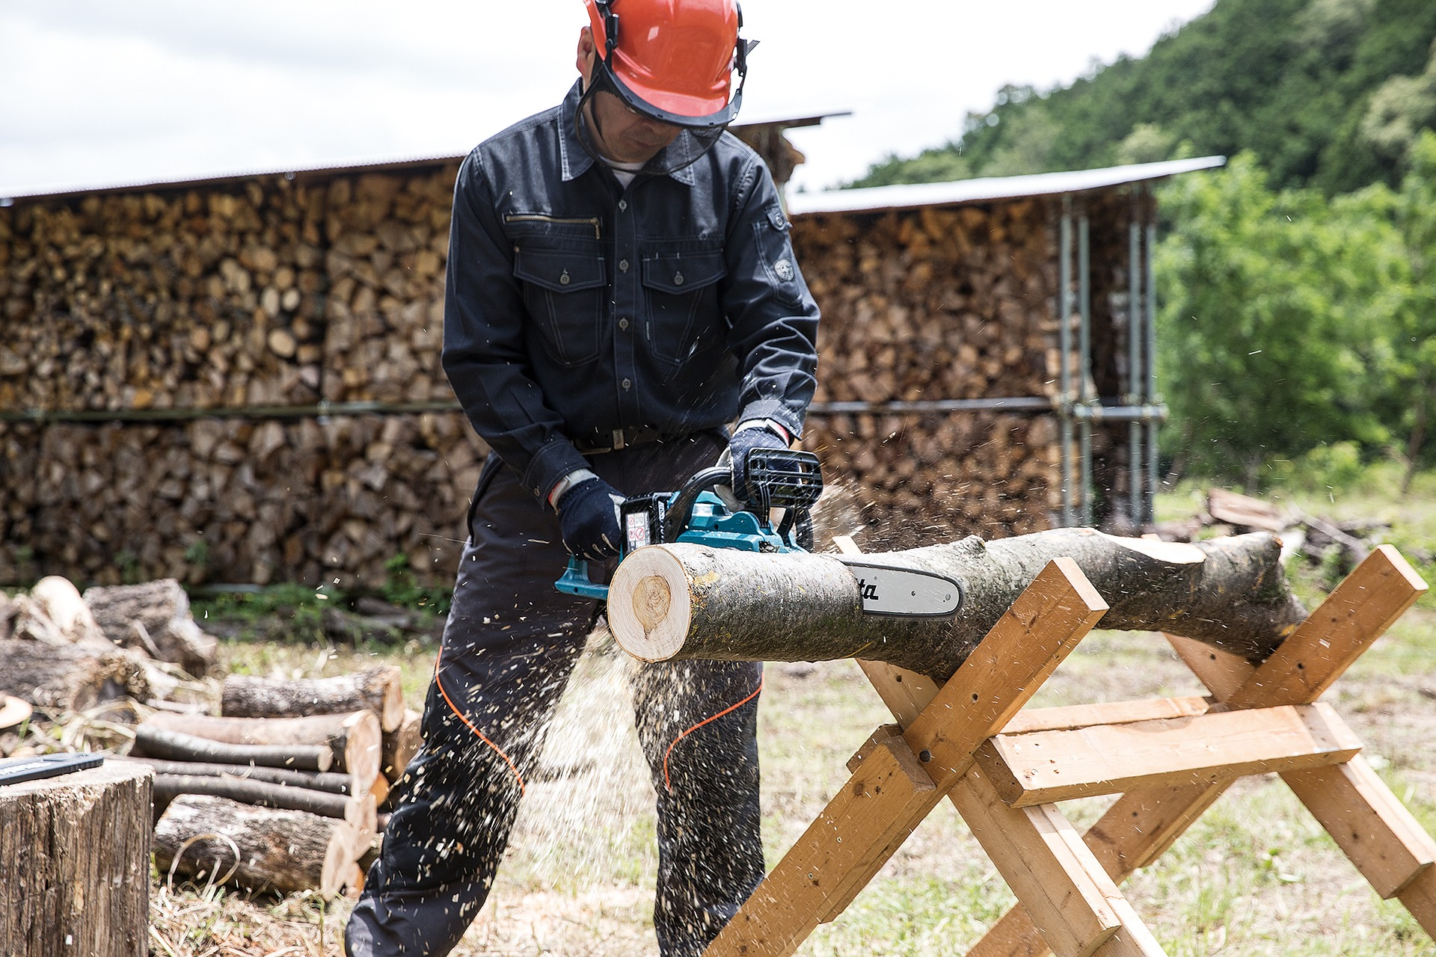

0.1
Once winter comes, you would use that firewood as fuel to stay warm
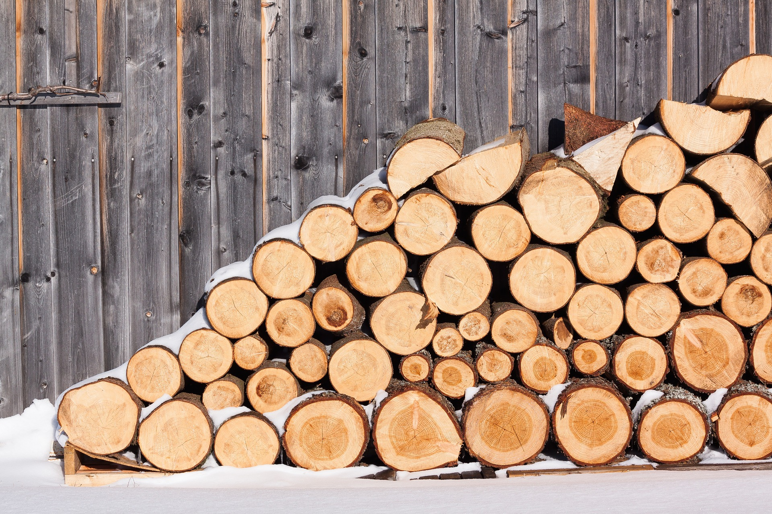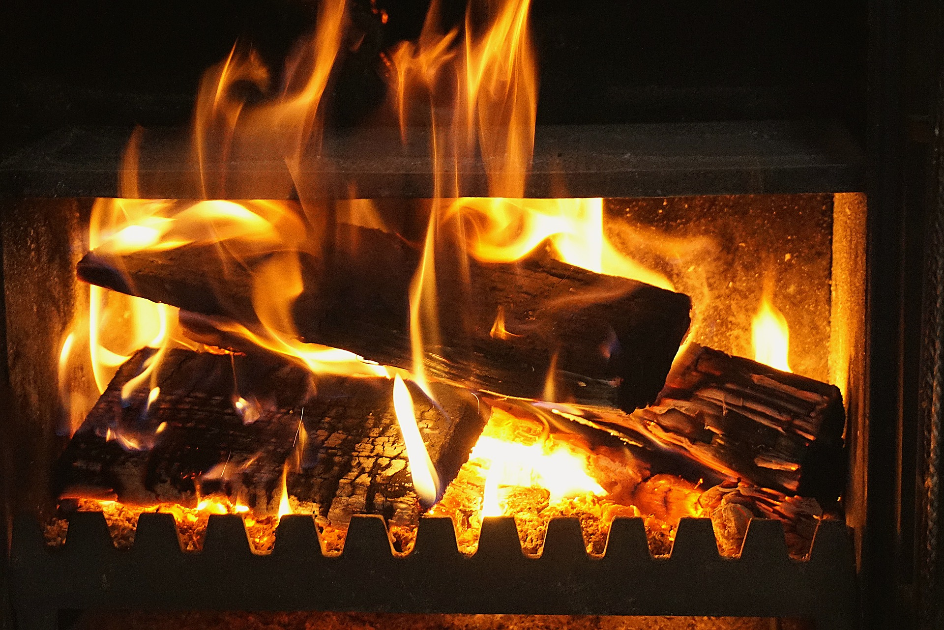

0.2
If you get snowed in, you might start running out of fuel.


1. Muscle Loss
The same thing happens to your muscle when you lose a lot of weight: If your body can’t get enough energy from the food you eat, it can start to use your muscle as a source of energy. The result can be a loss of muscle. It can be hard to notice, because it happens gradually, but this can cause fatigue and a decrease in energy.

2. Muscle Loss Evaluation
When we see patients in the office, we test their muscle strength. We frequently find that our patients with GI cancers have lost muscle strength.

3. Testing Muscle Strength
.pull-left[We can test your muscle strength with a simple gauge called a dynamometer.]
.pull_right[]

4. Patient Health and Esophagectomy Outcomes
About half of our patients have good strength, shown in green. A quarter are have low strength, shown in red Another quarter are in the middle, shown in yellow

Ignoring unknown labels:
• face : "bold"
• size : "14"
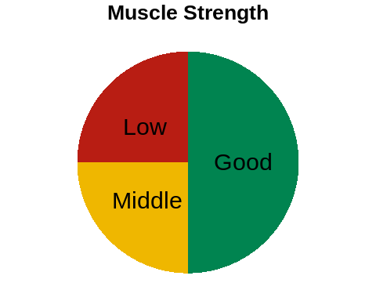

The risk of pneumonia after esophagectomy depends upon muscle strength. For patients with good strength, the rate of pneumonia is 5%. But for the group with low strength, the rate of pneumonia is 20%.

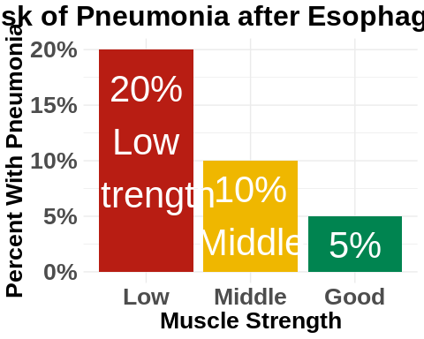

4.1 Muscle Strength and Esophagectomy
The results of our research suggest a simple answer: The risk of pneumonia after surgery is related to a patient’s muscle strength


4.2
Now this doesn’t mean that you need to look like this to be able to get through your esophagectomy

The good news is that you can increase your muscle mass before surgery in two very simple ways:
- Good nutrition with lots of protein
- Exercise

To rebuild muscle, the average man needs to consume 75 grams of protein per day, and women at least 60 grams.
If you haven’t watched our video on Nutrition for Esophageal Cancer Treatment, there will be a link at the end of the video.
When it comes to exercise, we ask our patients to engage in 30 minutes of vigorous exercise 6 days per week in preparation for surgery.
We define vigorous exercise as working hard enough that it’s hard to carry on a conversation while exercising. You should still be able to breath easily, but working just hard enough that talking is difficult.
It’s important to start slow, especially if you haven’t been used to exercising.
If you have heart disease, it is critical that you talk with your cardiologist before exercising. Ask your cardiologist what heart rate range would be ideal for you during exercise.

5. Heart Rate
Another way to judge your heart rate is to use a heart rate monitor. The following is an approximate range of heart rate during exerise:
Age | Minimum | Maximum
40 | 125 | 150
50 | 120 | 145
60 | 112 | 135
70 | 105 | 127

6. Heart Rate Monitors
A heart rate monitor doesn’t need to be expensive.
Here are some monitors from either WalMart or Amazon for less than $25:
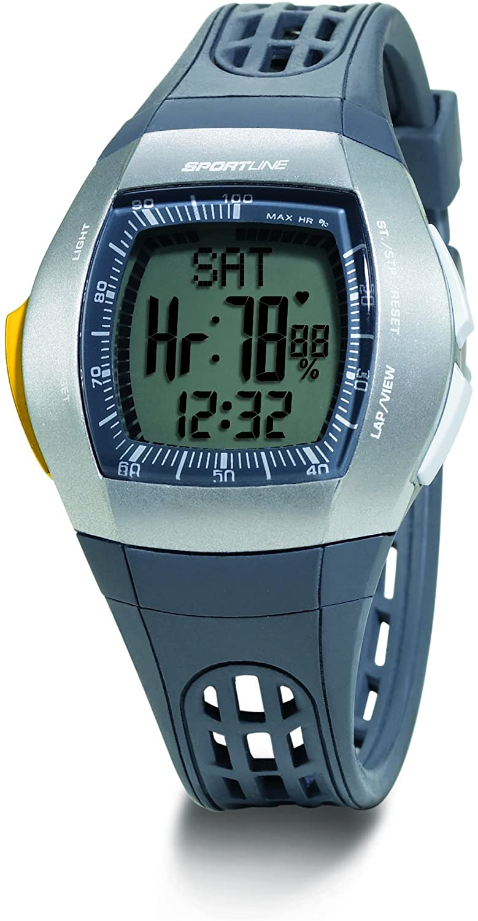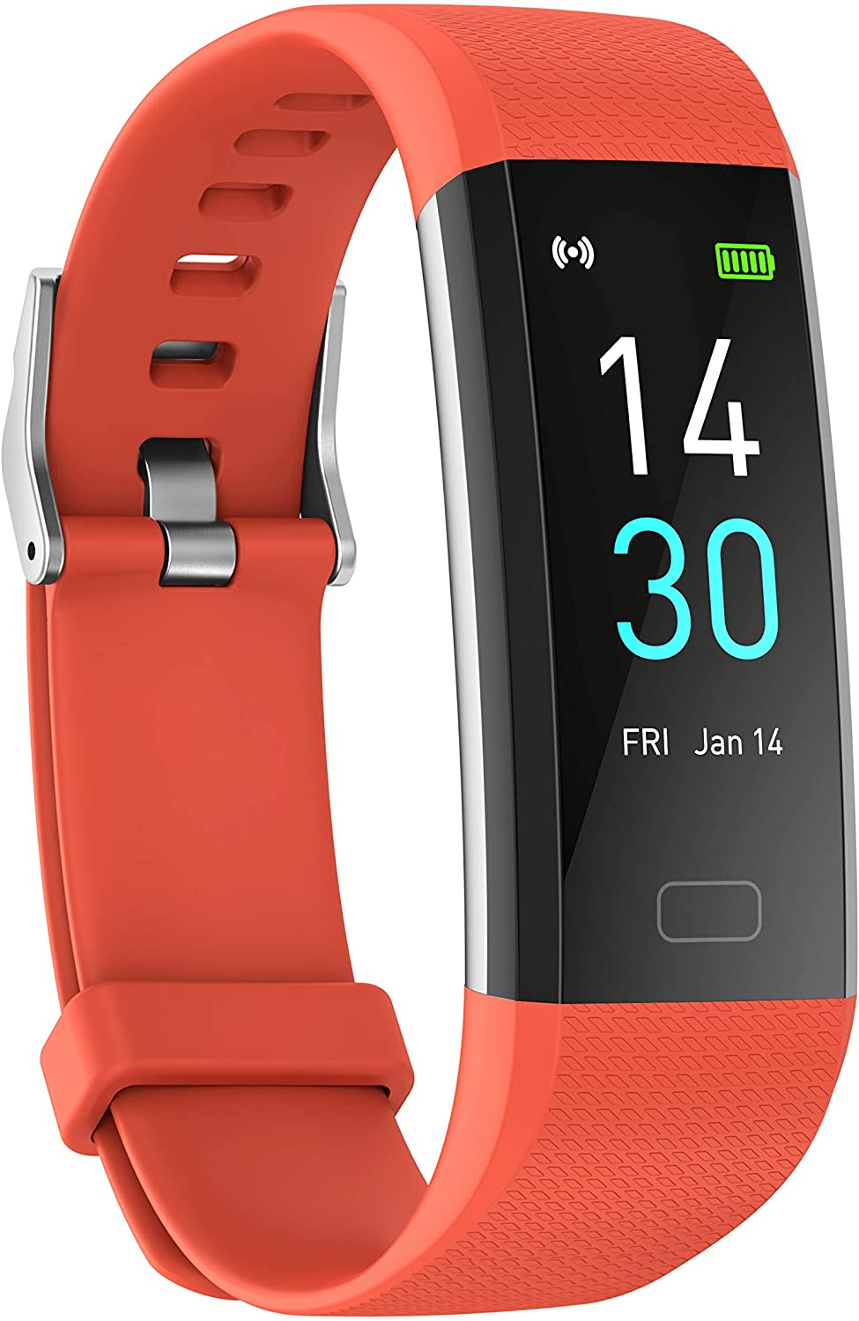

7. Exercise Options
If you have access to a gym, that would be an excellent option. You’ll be surrounded by other people who are exercising, and that can help you get started.
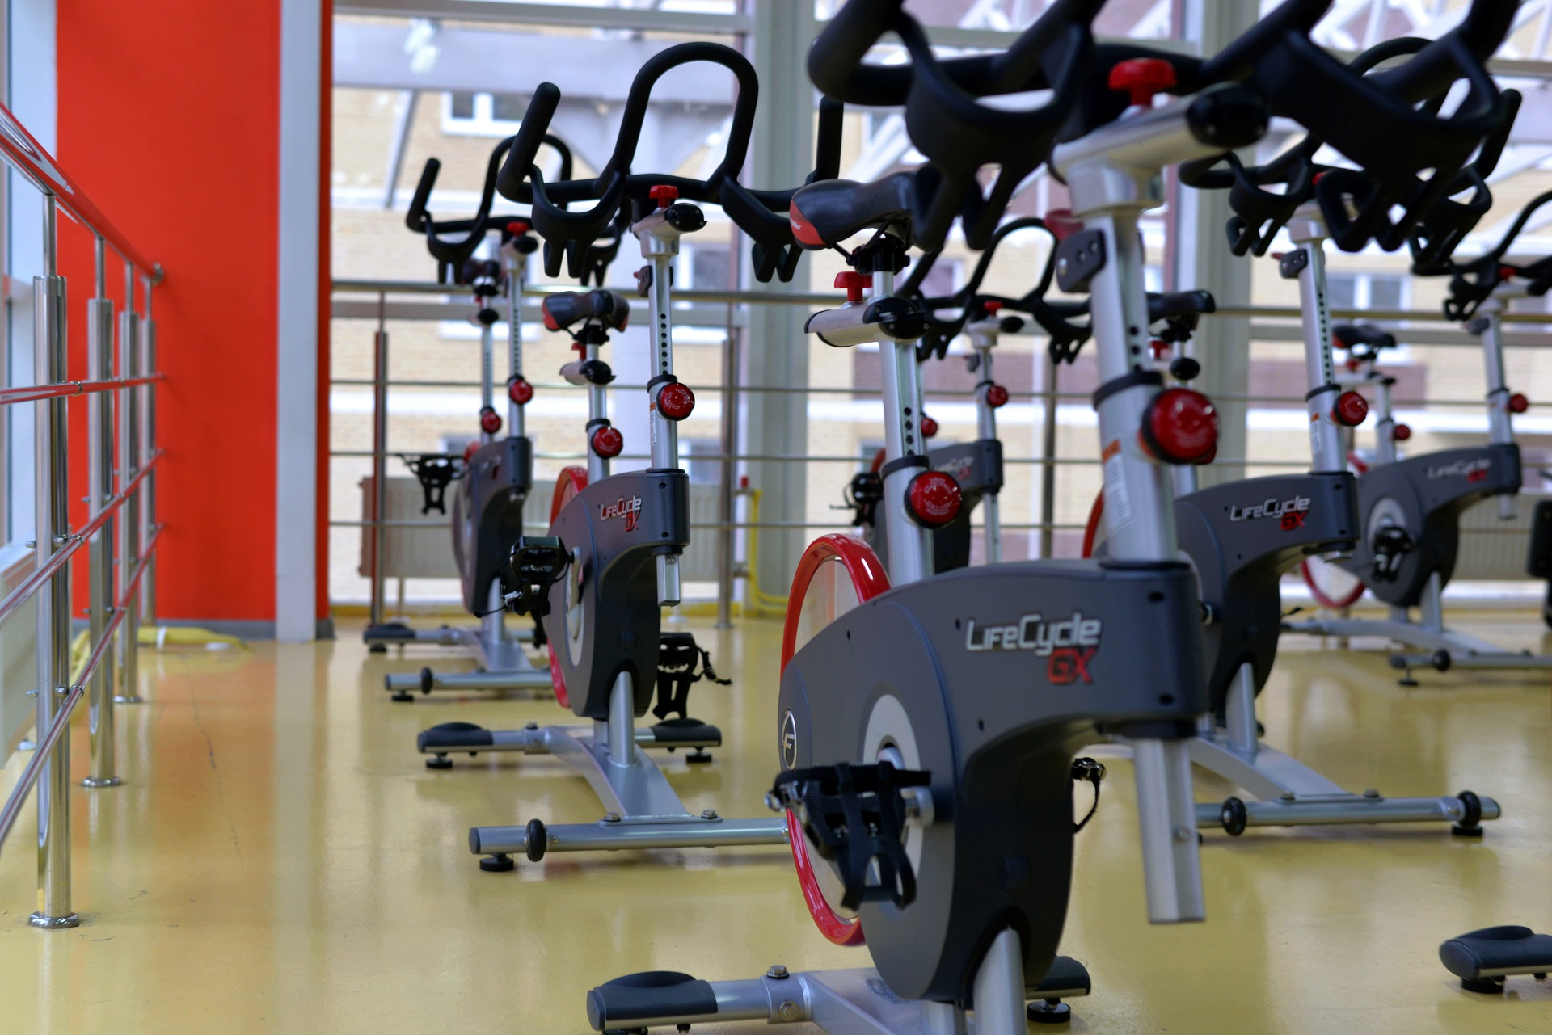

7.1 Exercise Bike
A stationary exercise bike is a great option. If allows you to exercise consistently despite the weather, and it’s more convenient than going to the gym.
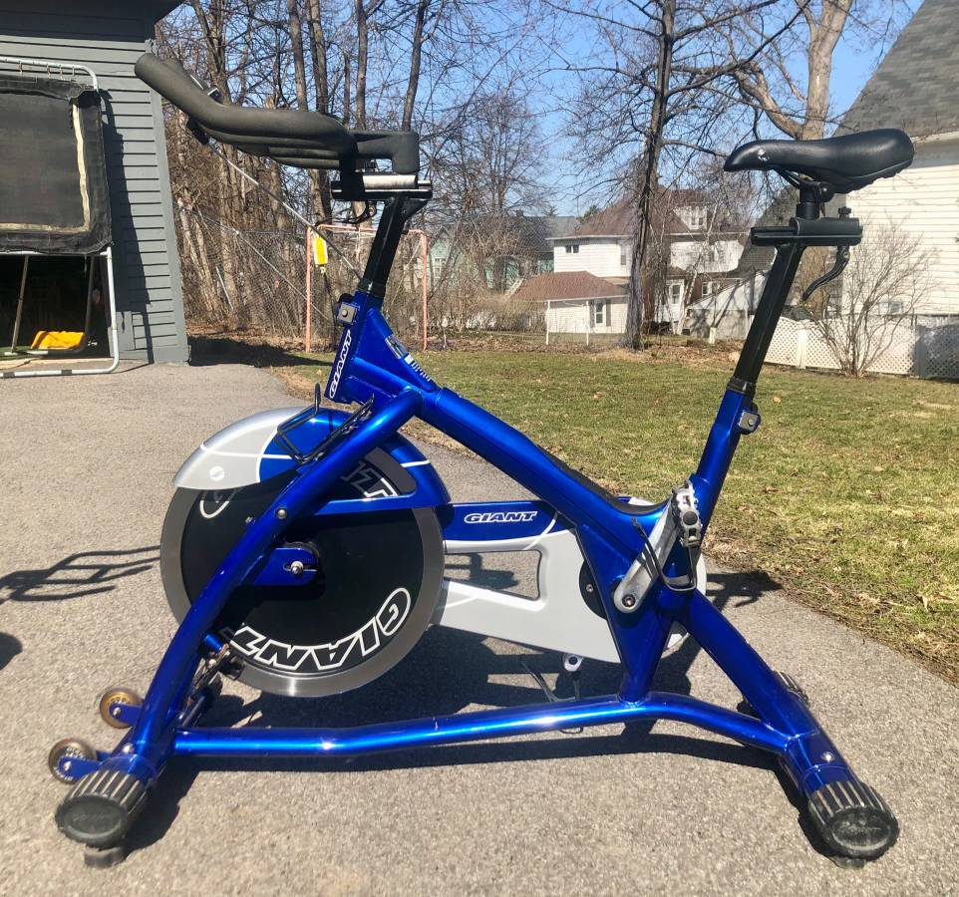

7.2 Exercise Bike
An exercise bike doesn’t need to be expensive. Here are some examples of bikes offered on Craigslist.
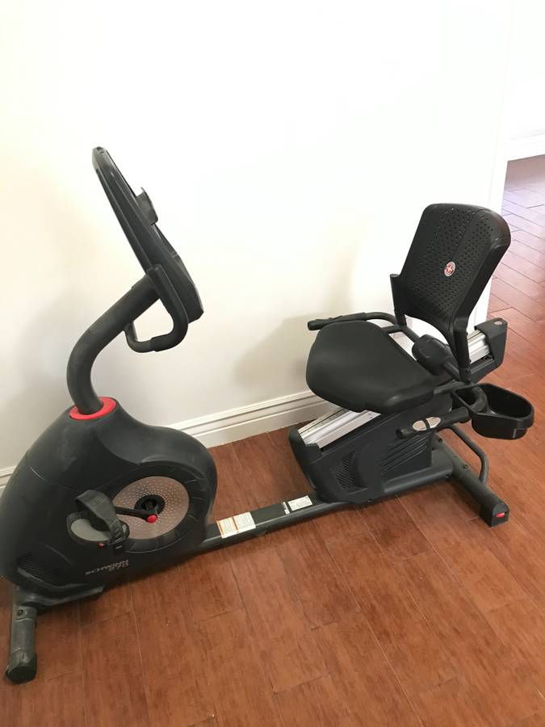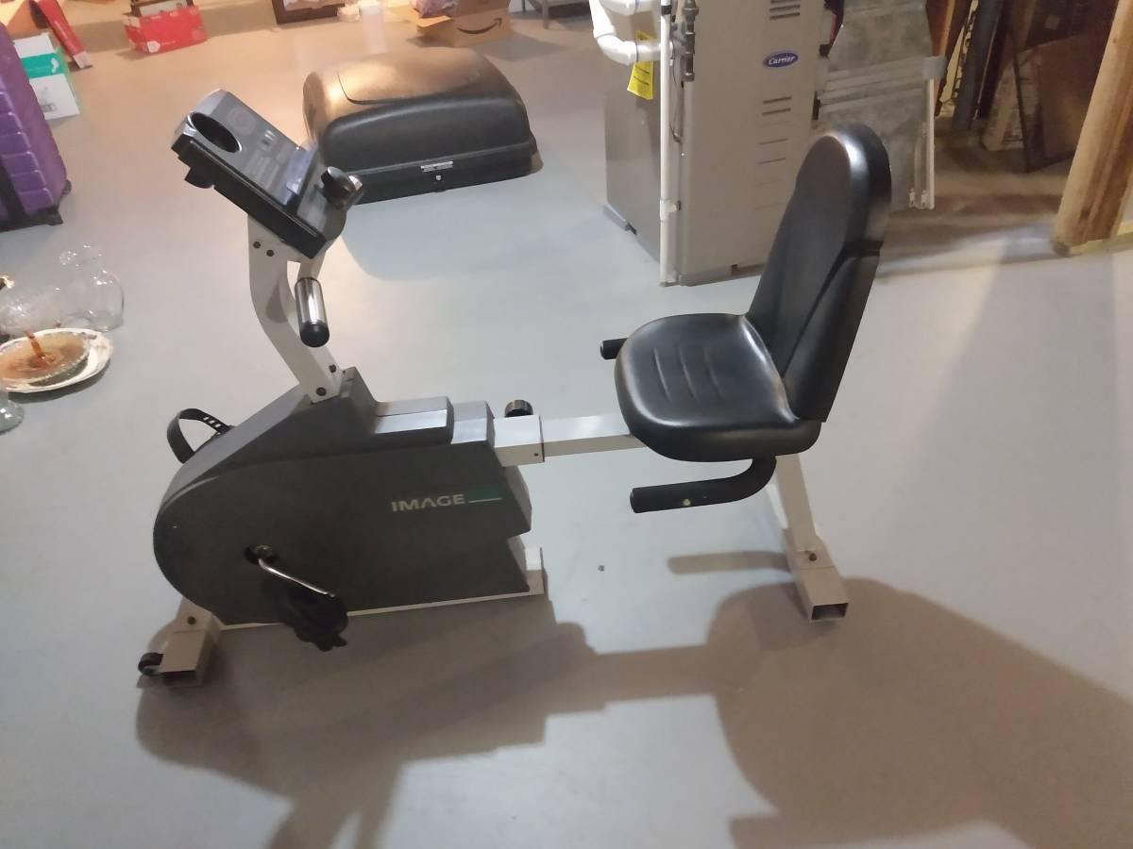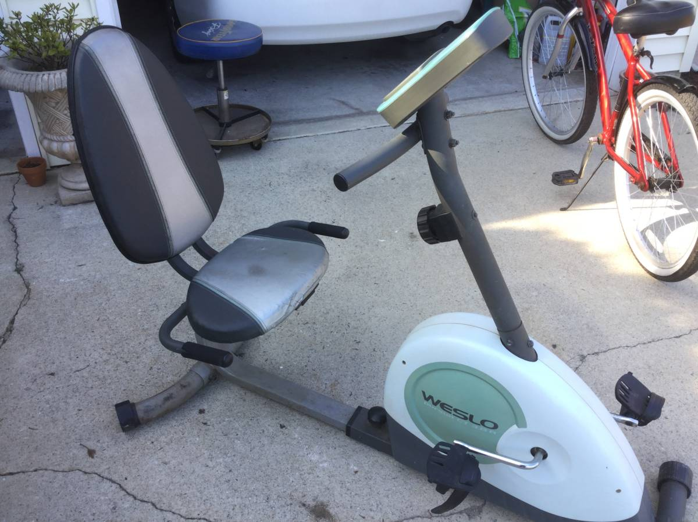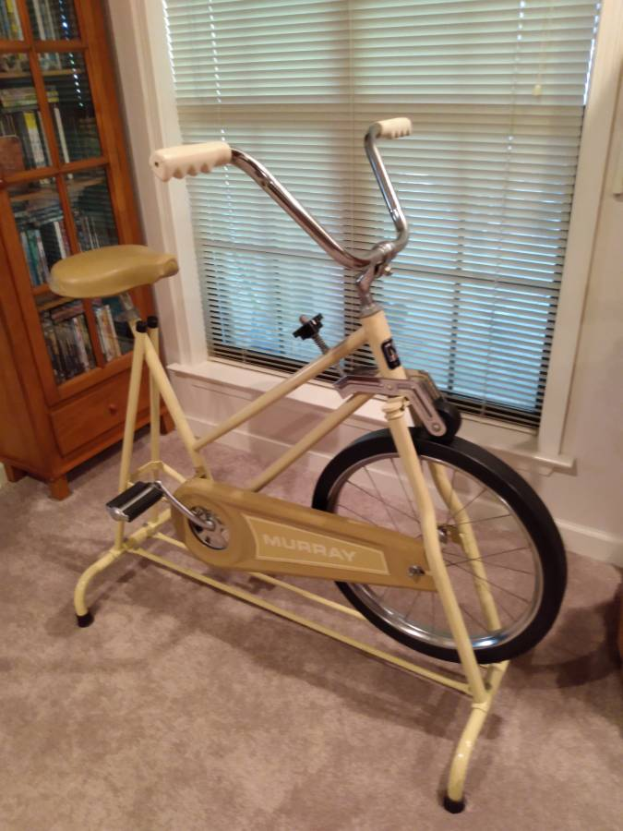
Keep in mind that a lot of people buy exercise equipment as part of a New Year’s resolution, but then by February 1st they are collecting dust.
Don’t be afraid to ask friends, family, and neighbors if anyone has a bike you can borrow as part of your cancer treatment.

7.3 Walking
Another option if you can’t get access to a gym or exercise equipment is walking. Bear in mind that if you want to get the most benefit from walking, it will need to be a brisk.


7.4
If you choose to walk for exercise, it will be important to use a heart rate monitor to make sure you can push yourself to walk at a brisk pace. Remember: the goal is to work hard enough that you have difficulty talking while you’re exercising.


7.5
If you have heart disease, or high blood pressure, I have one simple message before starting to exercise. Stop, and ask your primary care doctor or cardiologist before starting to exercise. They can help you design an exercise program that will be safe for you.


7.6 Good News
The good news is that with proper nutrition and exercise, you can increase your muscle strength, and we have good reason to believe this will reduce your risk of complications after surgery.

If you or a family member have had an encounter with preparing for esophageal cancer surgery, I would love to hear about your experience, so please take a minute to leave a comment below. We’re constantly creating new videos, so please subscribe to be notified of new videos when we post them.

Here are some additional videos you may find helpful

