Squamous Cell Carcinoma of the Esophagus

## 1 Anatomy

Food moves from the throat

esophagus

stomach

small bowel (jejunum)

We’ll start with reviewing some anatomy about how the body digests food.

Food moves from the throat to the esophagus, and from there to the stomach.

From the stomach, food moved through a valve called the pylorus into the small intestines

## 2 Cancer Staging

Staging refers to the tests to determine

* How large is the tumor?
* Has there been spread to lymph nodes?
* Has it spread to other parts of the body?

**Treatment options depend upon the cancer stage**

## 3 Cancer Staging

* **T** = Tumor - Depth of growth into the wall
* **N** = Nodes - Spread to the lymph nodes
* **M** = Metastasis - Spread to liver, lungs, or bone

## 4 Early Stage Cancers

Early-stage cancers are those that are small and have not grown very far into the wall

Cancers start on the very inside layer called the mucosa

## 5 Locally-advanced Cancers

Over time, cancers can grow into the muscular wall

Locally-advanced cancers are those that have grown through the wall

## 6 Lymph Nodes

In some cases, cancer cells can break off from the main tumor and spread to lymph nodes

If the lymph nodes contain enough cancer cells, they can be seen on CT scans or PET scans

## 7 T Stage

Cancers are categorized based upon the thickness of the tumor, known as the T stage

T1 tumors are early stage, and T4 tumors more advanced

## 8 N Stage

Cancers are categorized by whether there is spread to the lymph nodes.

* **N0** cancers have not spread to the lymph nodes
* **N1** cancers have spread to the lymph nodes.

## 9 M Stage

Some cancers spread to other parts of the body

* **M0** cancers have not spread to other parts of the body
* **M1** cancers have spread lungs, liver, or bone

## 10 PET scan

A PET scan is similar to a CT scan, and uses a small amount of tracer to light up areas of cancer.

In some cases, the PET scan is not performed until a CT scans bas been done.

## 11 Endoscopic Ultrasound

* Similar to upper endoscopy (EGD)
* Ultrasound probe in scope
* Evaluates T stage of cancer

Endoscopic ultrasound is most helpful in early stage cancers.

## 12 Treatment Plan

Superficial (T1) Endoscopic Therapy  
  
Localized (T1b/T2) Surgery  
  
Locally-advanced (T3) Chemo Radiation Surgery  
  
Metastatic (M1) Chemotherapy

This table summarizes four different treatment categories:

* Superficial cancers are T1 and can be treated by endoscopic therapy without the need for surgery
* Localized cancers are T1b or T2 and are frequently treated by surgery alone without the need for chemotherapy or radiation
* Locally-advanced cancers are T3 or N1 and are usually treated with some combination of chemotherapy and radiation prior to surgery
* Metastatic cancers are M1 and are treated primary by chemotherapy.

## 13 Locally-advanced cancers

Patients with locally-advanced esophageal cancer often have localized spread of cancer cells in the surrounding area

## 14 Locally-advanced cancers

If locally-advanced cancers are treated with surgery alone…

## 15 Locally-advanced cancers

If locally-advanced cancers are treated with surgery alone…

There is a risk that cancer cells can be left behind

## 16 Preoperative Therapy

It is helpful to start with therapy *before* surgery that will shrink the cancer.

## 17 Preoperative Therapy

It is helpful to start with therapy *before* surgery that will shrink the cancer.

## 18 Preoperative Therapy

It is helpful to start with therapy *before* surgery that will shrink the cancer.

## 19 Surgery after Preoperative Therapy

When surgery is then performed…

## 20 Preoperative Therapy

When surgery is then performed…

The risk of cancer recurrence is minimized

## 21 Chemotherapy + Radiation CROSS Trial

363 patients with esophageal cancer studied

Patients were treated in two groups:

**Surgery Alone**

vs

**Chemotherapy + Radiation** Surgery

## 22 Chemotherapy + Radiation CROSS Trial

363 patients with esophageal cancer studied

Chemotherapy + radiation given together over 6 weeks

**Surgery Alone**

vs

**Chemotherapy + RadiationSurgery** Longer Survival

The results were quite dramatic: The group that was treated with all three therapies, chemotherapy and radiation and surgery, lived on average twice a long as patients who had surgery alone.

## 23 Chemotherapy + Radiation CROSS Trial

Typical schedule for chemotherapy + radiation:

* Chemotherapy once per week for six weeks
* Radiation five days per week for six weeks (28)
* PET scan (or CT) 4 weeks after the end of radiation
* Surgery 8 weeks after the end of radiation

## 24 Chemotherapy + Radiation - Side Effects

Kills cancer cells in the esophagus and lymph nodes

Can also cause irritation of the lining of the esophagus.

Swallowing can be difficult the last 2 weeks.

Feeding tube may be needed for hydration/nutrition.

## 25 Chemotherapy

Chemotherapy drugs are administered intravenously.

There are several options for intravenous access:

* Peripheral IVs in the hand
* PICC line (Peripheral Inserted Central Catheter)
* Central Venous Port

[Central Venous Port](lci_cvport.htm)

## 26 Restaging

CT or PET scan will be performed after preoperative therapy

* Surgery performed after restaging
* Timing depends upon recovery from therapy

## 27 Restaging Endoscopy after Chemo + Radiation

Endoscopy is performed to look for signs of persistent cancer

Biopsies are negative in approximately 75% of cases

Complete disappearance of cancer is only found in 40% of cases

cancer cells can hide in the wall of the esophagus

## 28 Surgery for Squamous Cell Carcinoma

Surgery is recommended for all patients who have:

* Biopsies showing cancer after chemo + radiation
* No signs of spread of disease on PET/CT scan
* Healthy enough to undergo surgery

## 29 Surgery for Squamous Cell Carcinoma

Surgery is also recommended for patients who:

* No signs of spread on disease on PET/CT scan
* Cancer in the lower part of the esophagus
* Healthy enough to undergo surgery

## 30 Surveillance if Surgery Not Performed

* Upper endoscopy (EGD) every 3-6 months
* PET every 6 months

Surgery if a recurrence in the esophagus is found

## 31 Primary Care Practitioner (PCP)

A PCP is critical to coordinate care between specialists.

We will update your PCP after each visit

Call our referral line at (844) 235-6998 if you need a PCP

## 32 My Atrium Patient Portal

* Critical to good communication with your care team
* Available for desktop or laptop or phone
* Sign up at my.atriumhealth.org

## 33 Exercise

* Reduces risk of complications from treatment
* Goal is 30min/day of vigorous exercise 6 days/week
  + Working hard enough that you can’t converse
  + Start slowly and build up
  + Every day counts! (Aim for some activity every day)

## 34 Smoking Cessation

* Smoking makes cancer treatment more difficult
  + Increases risk of complications after surgery
* Options for help with smoking cessation:
  + NC Quit Line 1-800-QUIT-NOW (1-800-784-8669)
  + American Lung Assn www.freddomfromsmoking.org
  + Smoking Cessation Counseling (Metro Charlotte)

## 35 Protein Needs

## 36 Feeding Tubes

There are two types of feeding tubes:

* Jejunostomy tubes are placed in the small intestine
* Gastrostomy tubes are placed in the stomach

Your dietitian and physician will help you decide which tube is best for your situation

## 37 Gastrostomy Tube

Feeding Gastrostomy

* Feeding with a syringe several times per day.
* Tube can be hidden underneath clothing
* Tube does not interfere with eating by mouth
* Removed easily in the office when no longer needed

## 38 Gastrostomy Tube Methods

A gastrostomy tube can be placed either by endoscopy, which is called a PEG tube

A gastrostomy tube can also be placed by laparoscopy, which is usually preferred if surgery on the esophagus is planned in the future.

Your surgeon will help you decide which kind of tube is best for you. This is especially important if you will need esophageal surgery in the future, as the stomach is frequently used to make a new esophagus

## 39 Gastrostomy Tube

* Outpatient Placement (go home the same day)
* Central venous port can be placed at the same time (if needed)

## 40 Surgery for Esophageal Cancer

Surgery for esophageal cancer is performed for:

* Superficial Tumors (T1) not completely removed by endoscopy
* Localized Tumors (T2N0)
* Locally Advanced (T3) after preoperative therapy.

## 41 Goals of Surgery

* Remove tumor from esophagus
* Remove surrounding lymph nodes
* Create a new esophagus

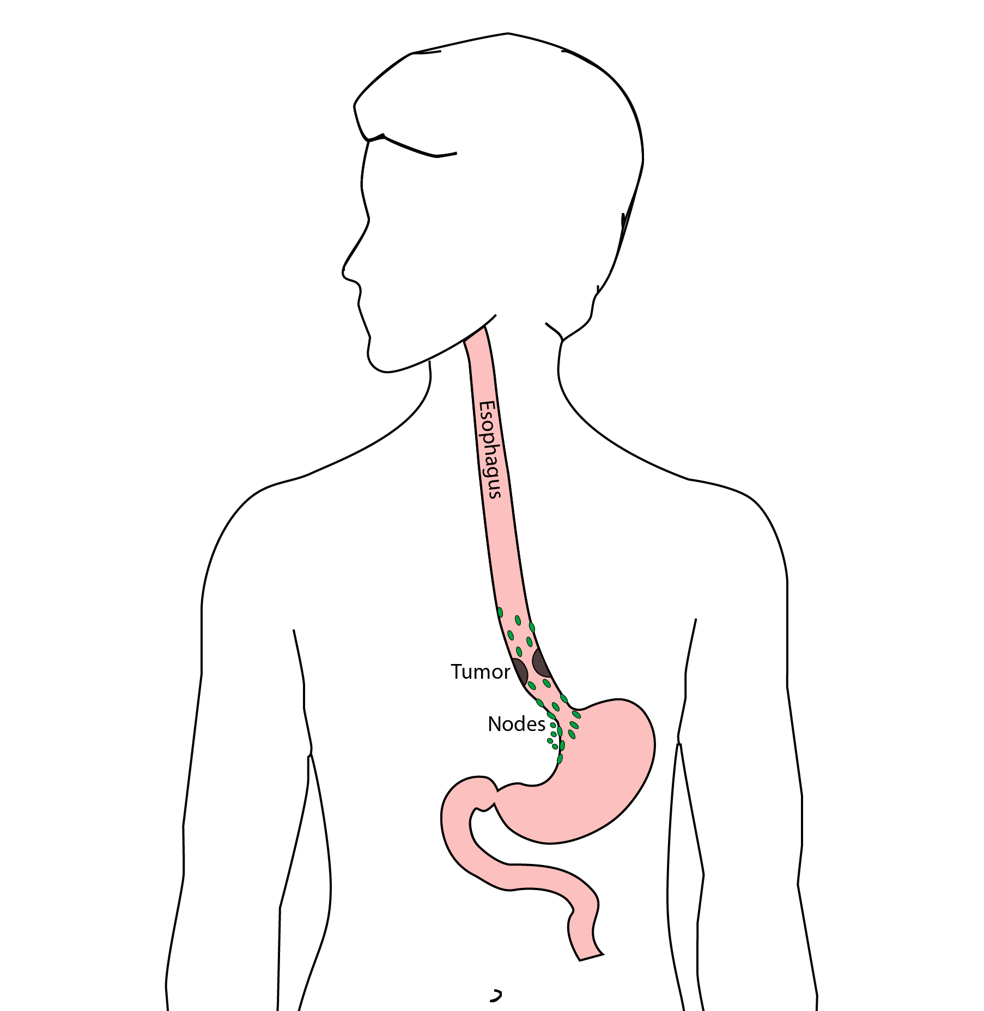

## 42 Ivor Lewis (Transthoracic) Esophagectomy

* Removes tumor
* Removes lower 1/3 of esophagus
* Removes surrounding lymph nodes
* Reconstruction of GI tract

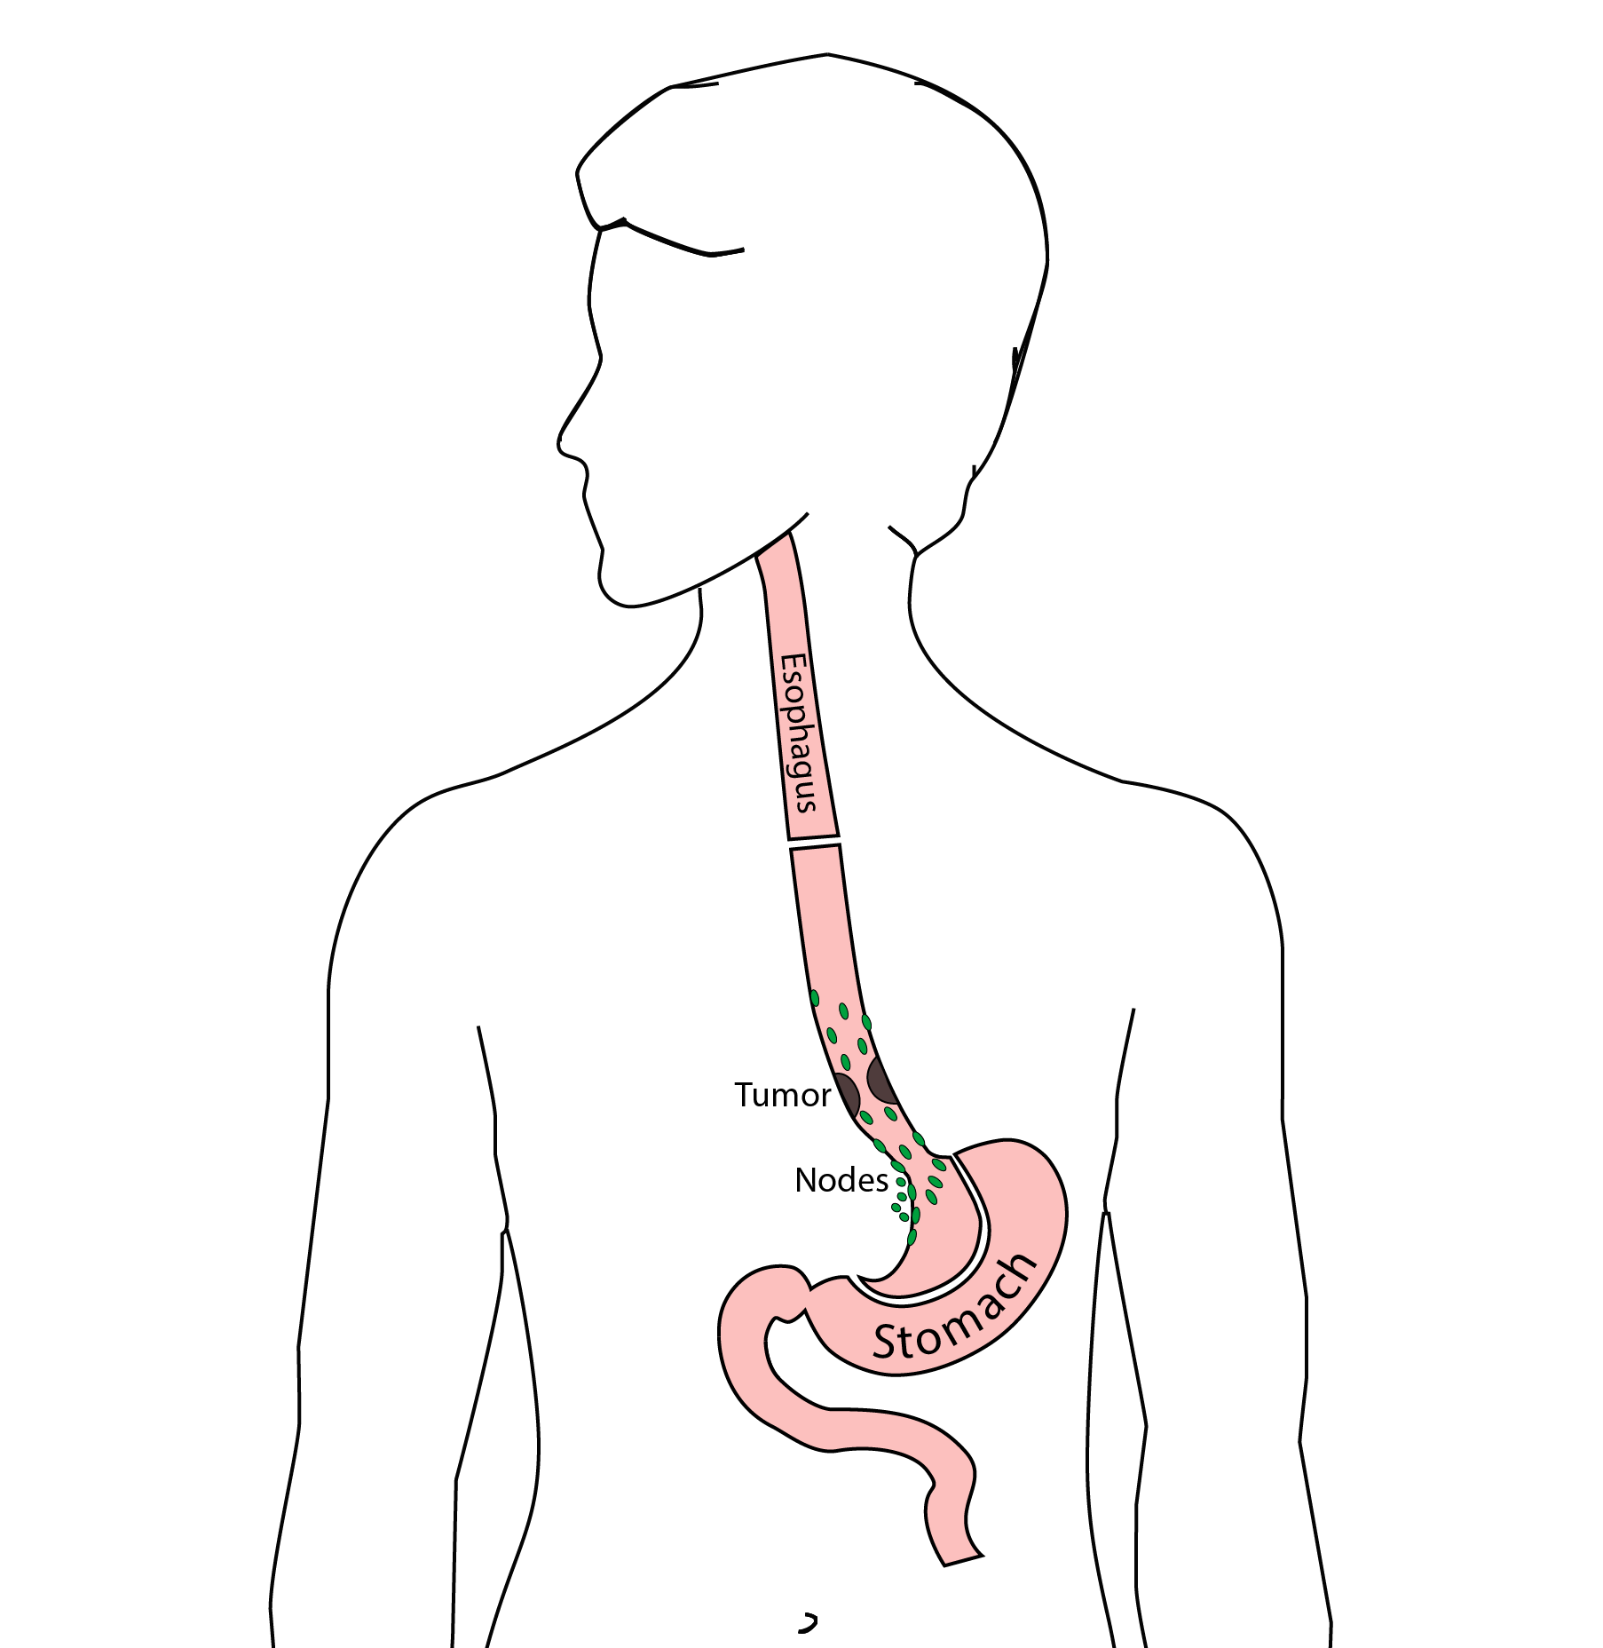

## 43 Reconstruction

A new esophagus is created from the stomach in the abdomen by fashioning it into a tube.

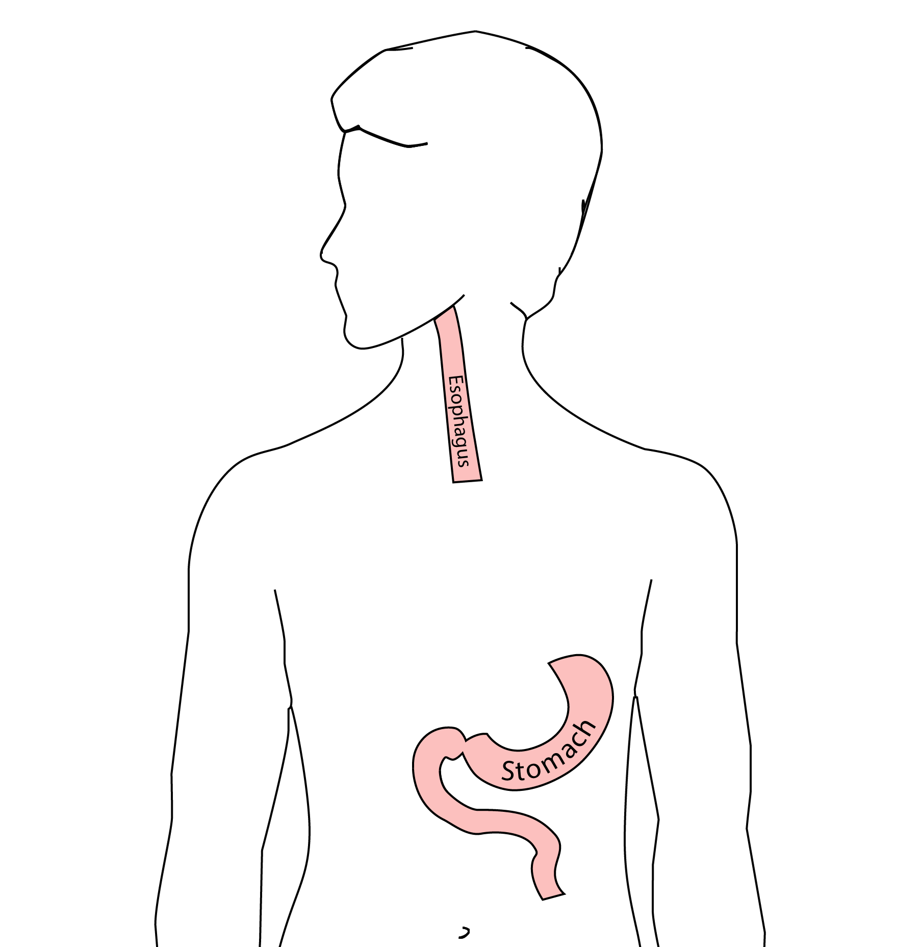

## 44 Ivor Lewis esophagectomy

The new esophagus is now brought up into the chest. A new connection is made between the esophagus and the stomach, called an *anastomosis*.

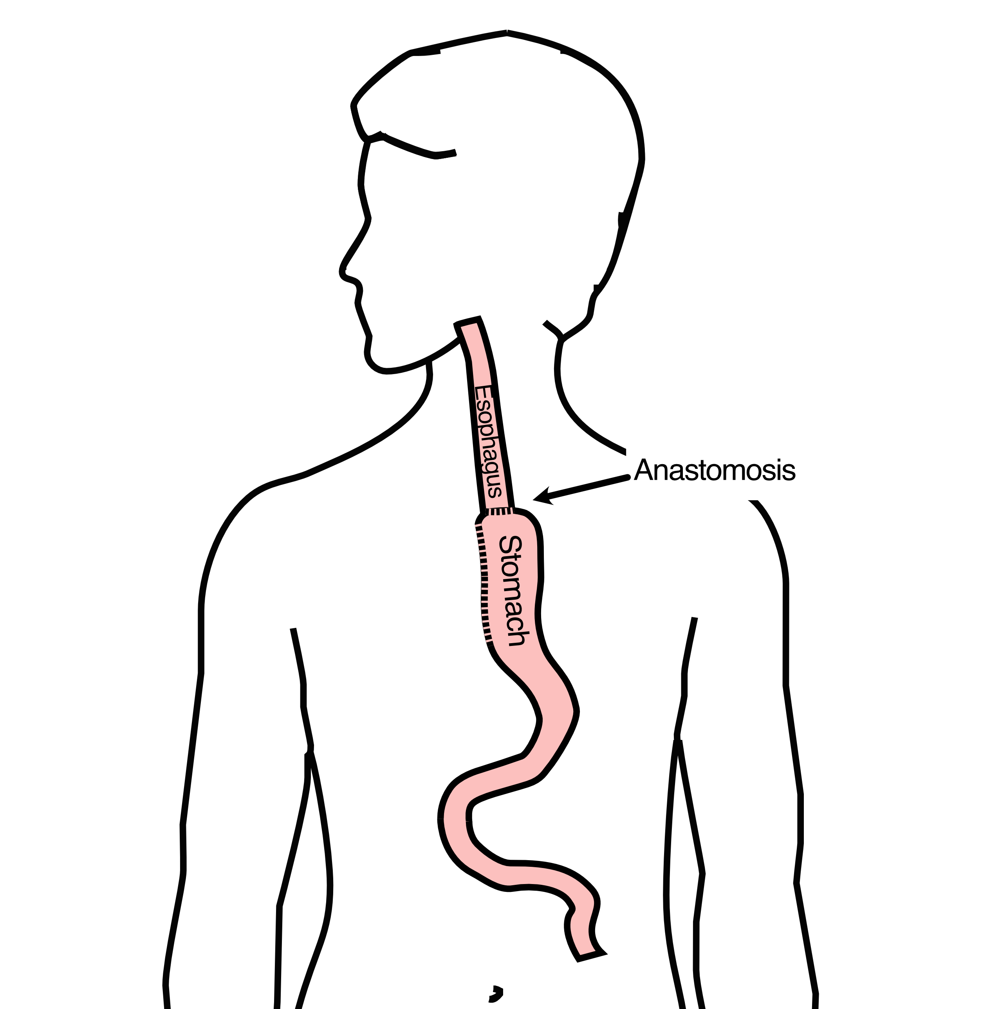

## 45 Minimally-invasive Ivor Lewis

* Small incisions abdomen and chest
* Surgical telescope and instruments
* Smaller incisions faster recovery and less discomfort

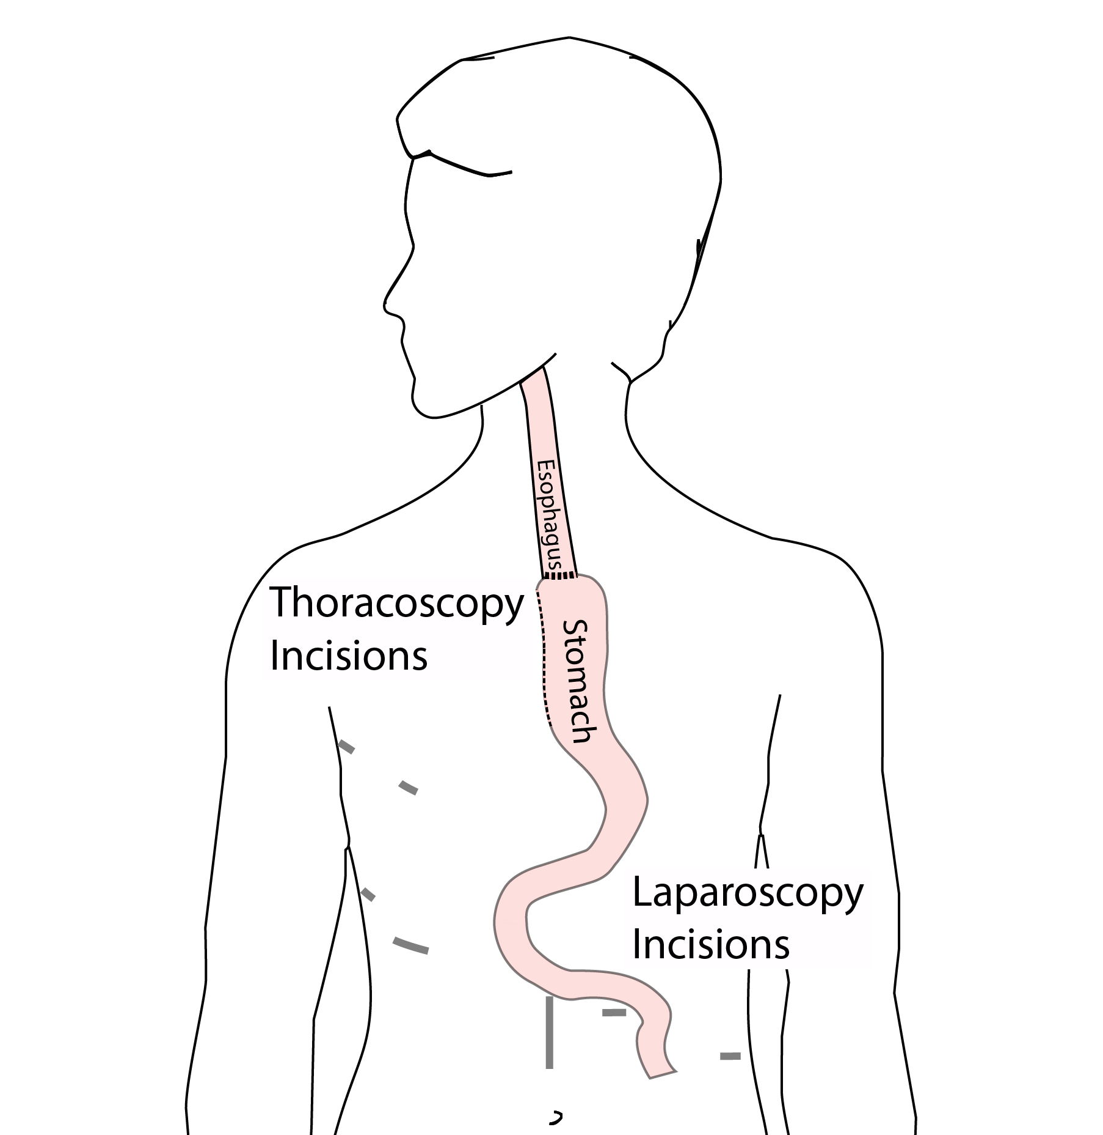

## 46 Open Ivor Lewis

We use the mininally-invasive approach in 95% of cases

In some cases, an open approach is still necessary.

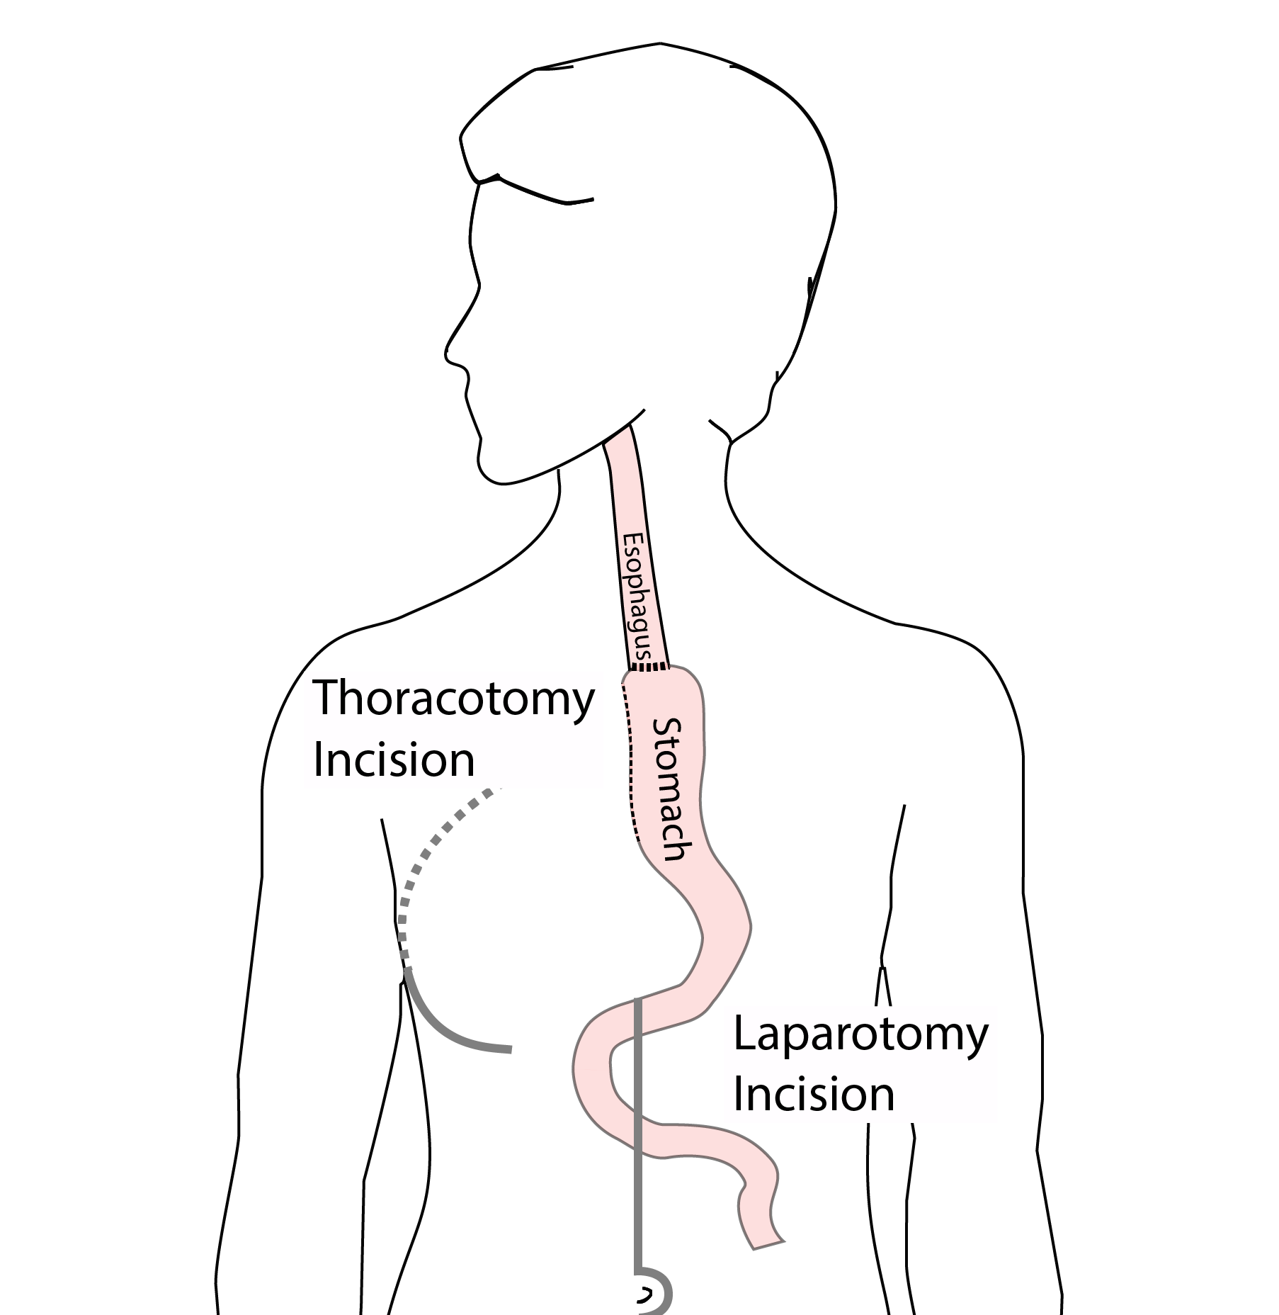

## 47 Total Esophagectomy

For patients with tumors in the upper esophagus, we need to remove more of the esophagus

We need to remove the whole esophagus, including the portion in the neck

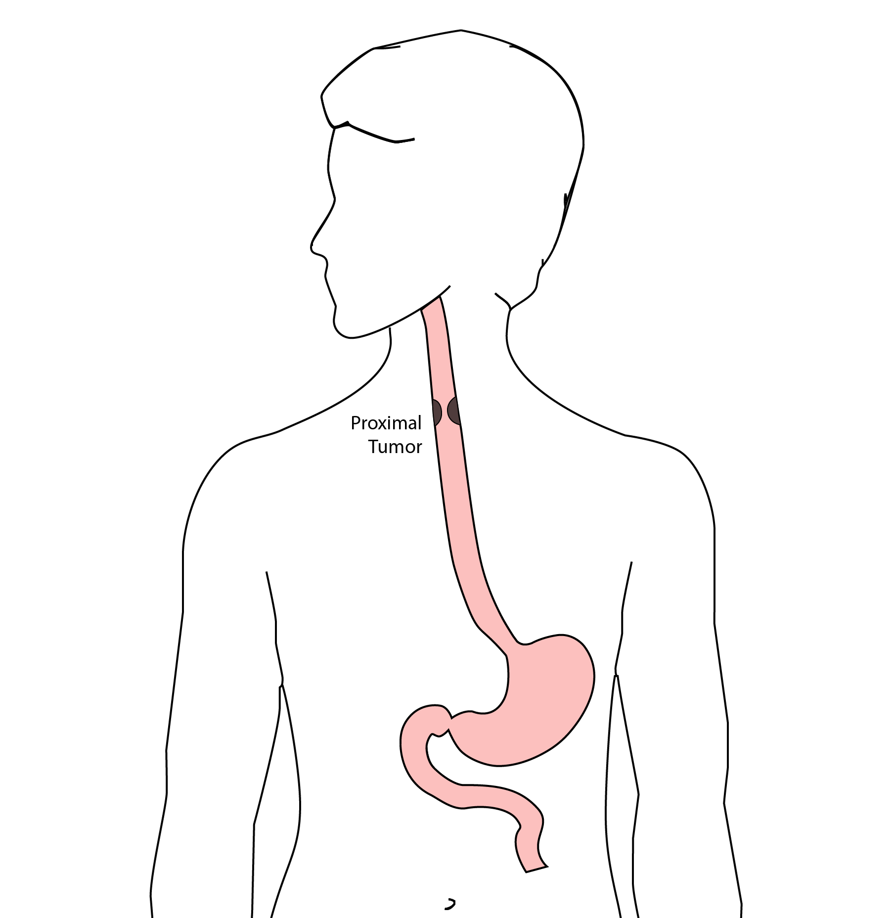

## 48 McKeown Esophagectomy

All of esophagus removed 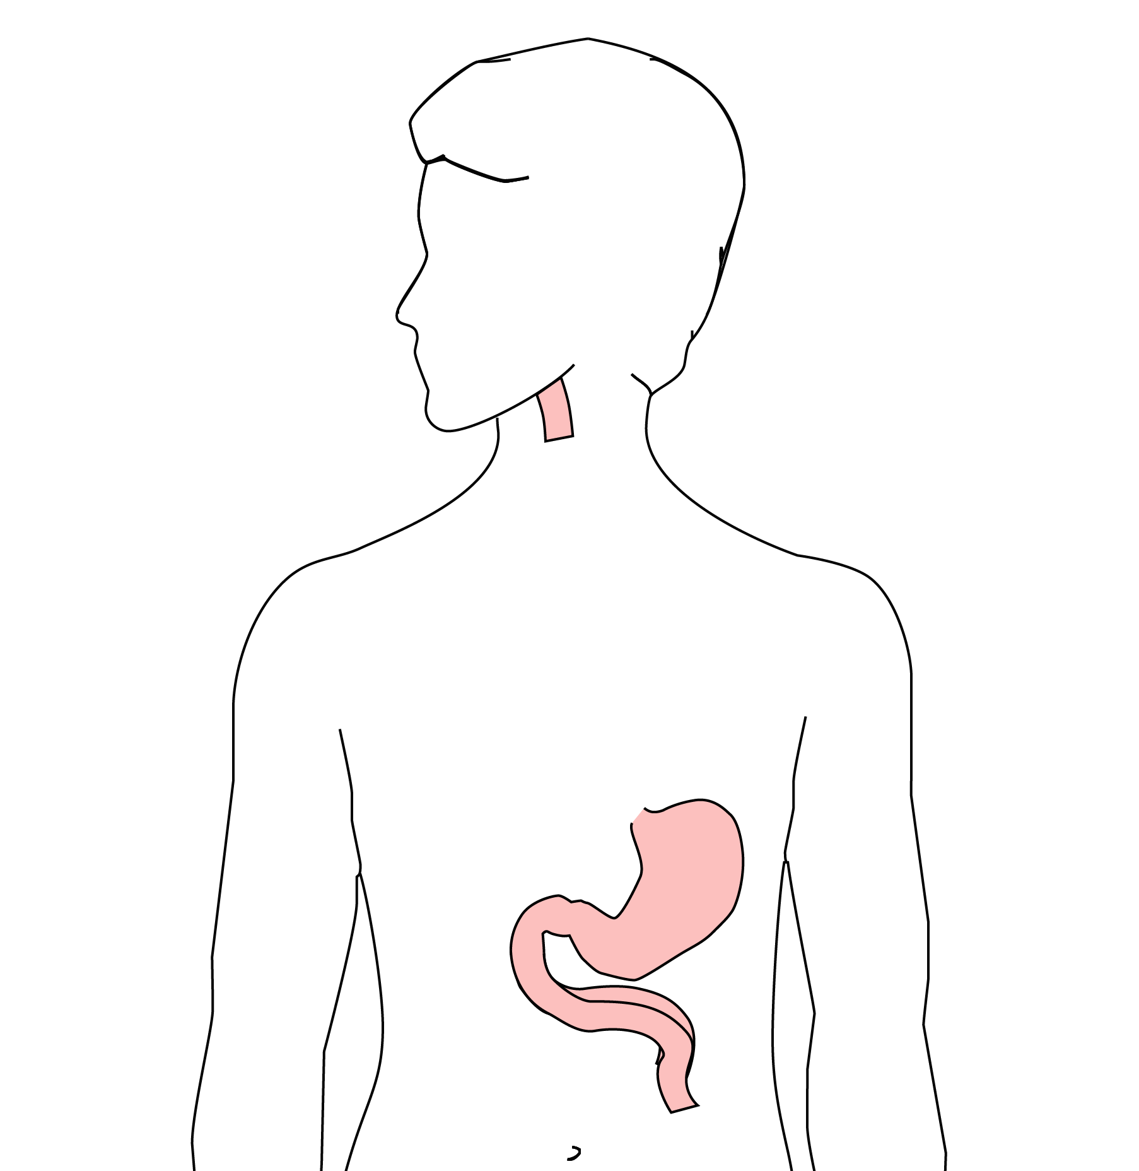

Connection made in the neck 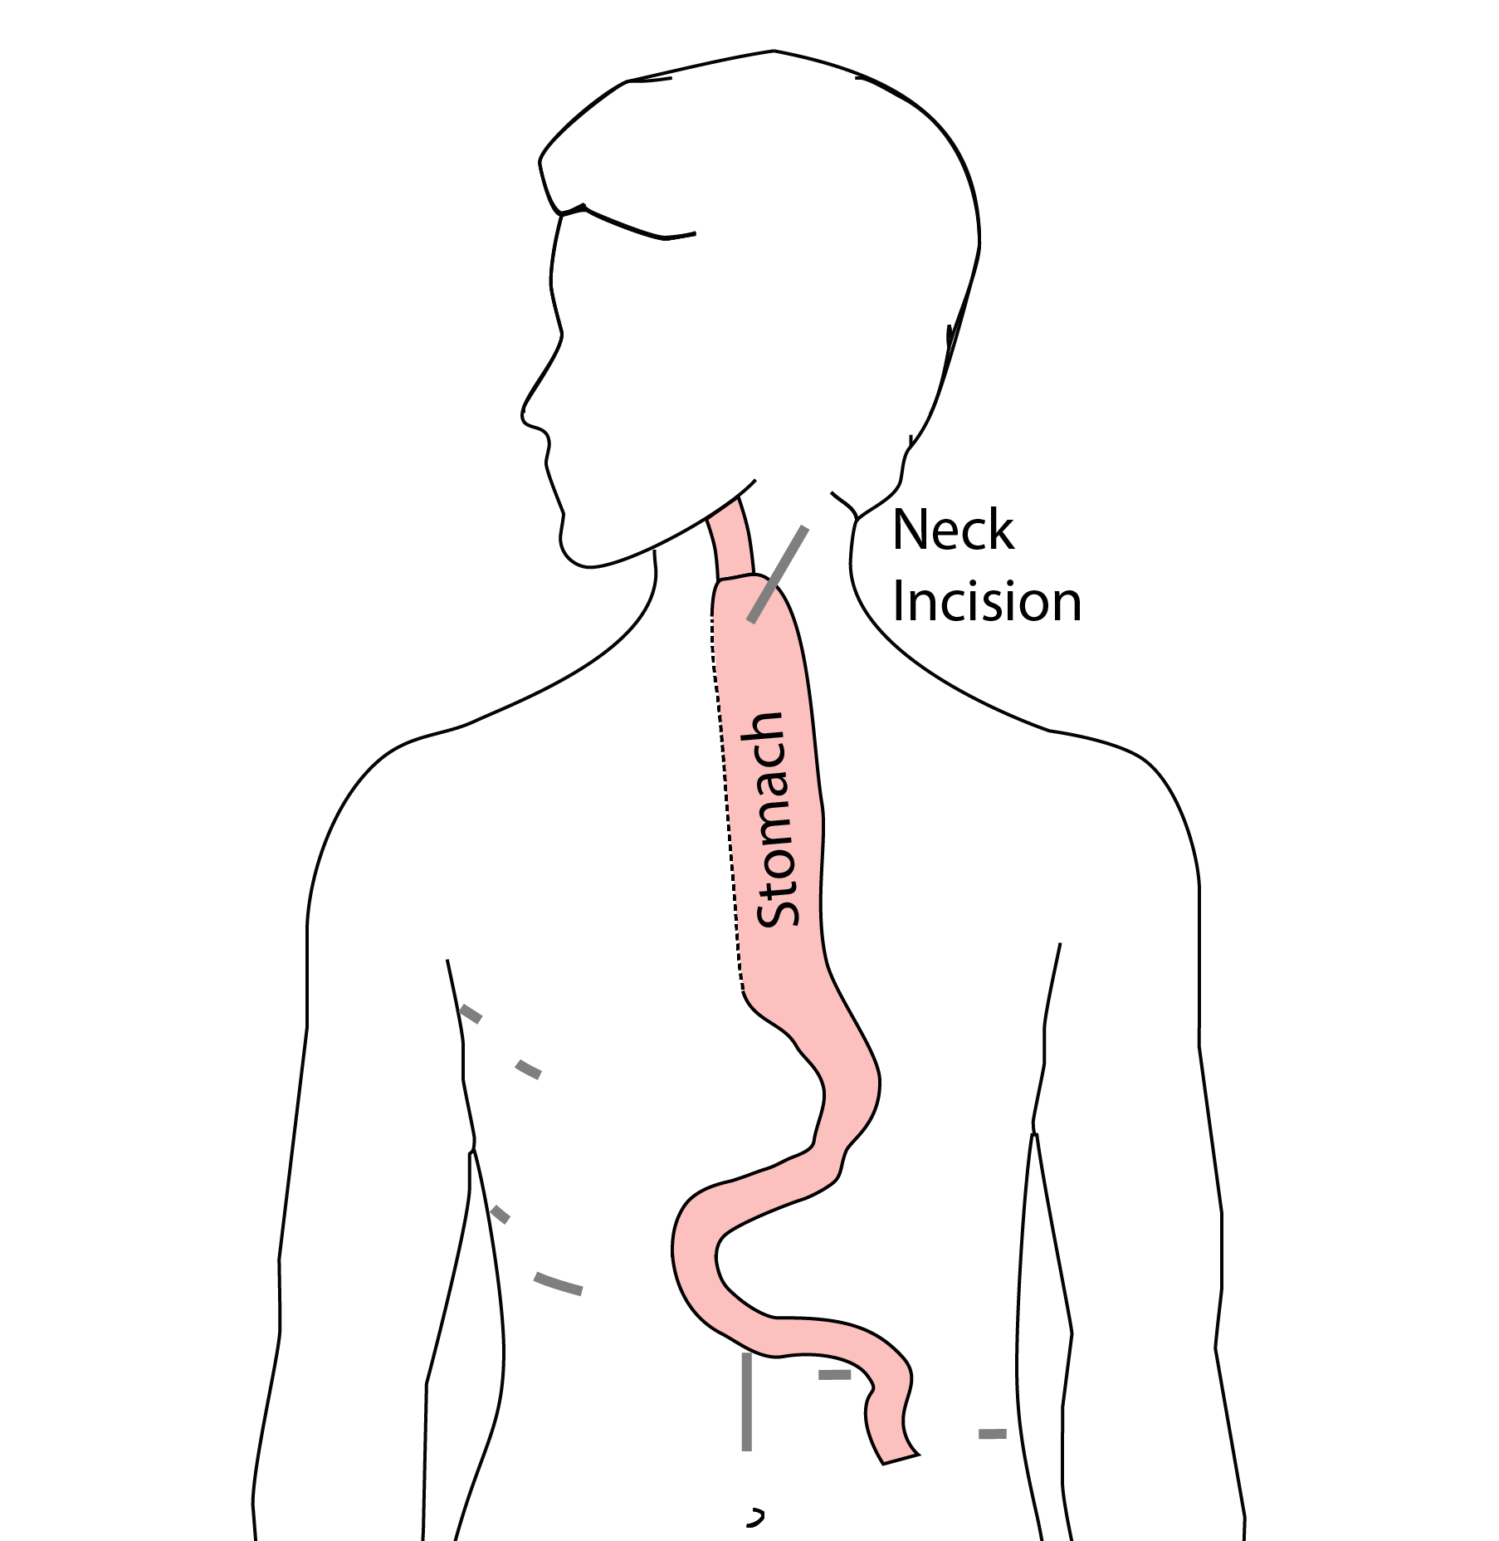

## 49 Colon Interposition

If the stomach is not suitable to make a new esophagus, the colon can be used to replace the esophagus

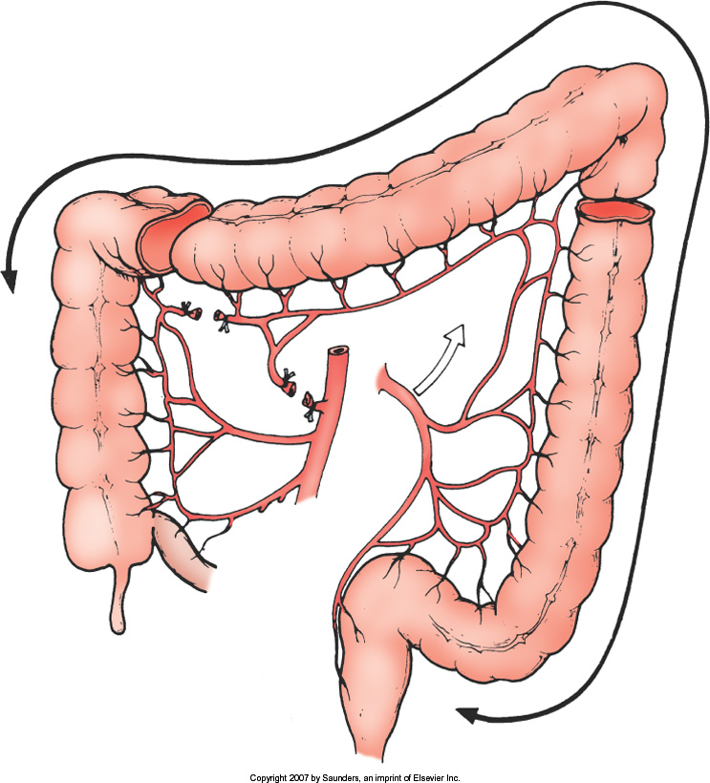

## 50 Colon Interposition

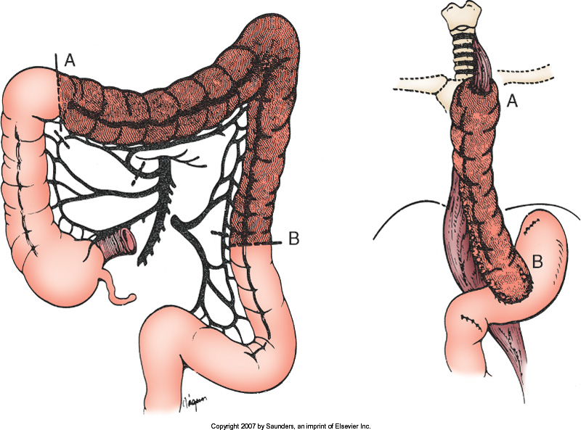

## 51 Risks of Surgery

An esophagectomy is a substantial operation, and in some cases there can be postoperative complications. We’re going to talk about two of these complications and what you can do to reduce your risk of complications:

* Anastomotic leak
* Pneumonia

## 52 Anastomotic Leak

The anastomosis is surgical connection between the esophagus and the stomach.



## 53 Anastomotic Leak

If anastomosis does not heal:

* Leakage of fluid from the esophagus
* Infection in the space between the lungs
* Requires additional time in the hospital

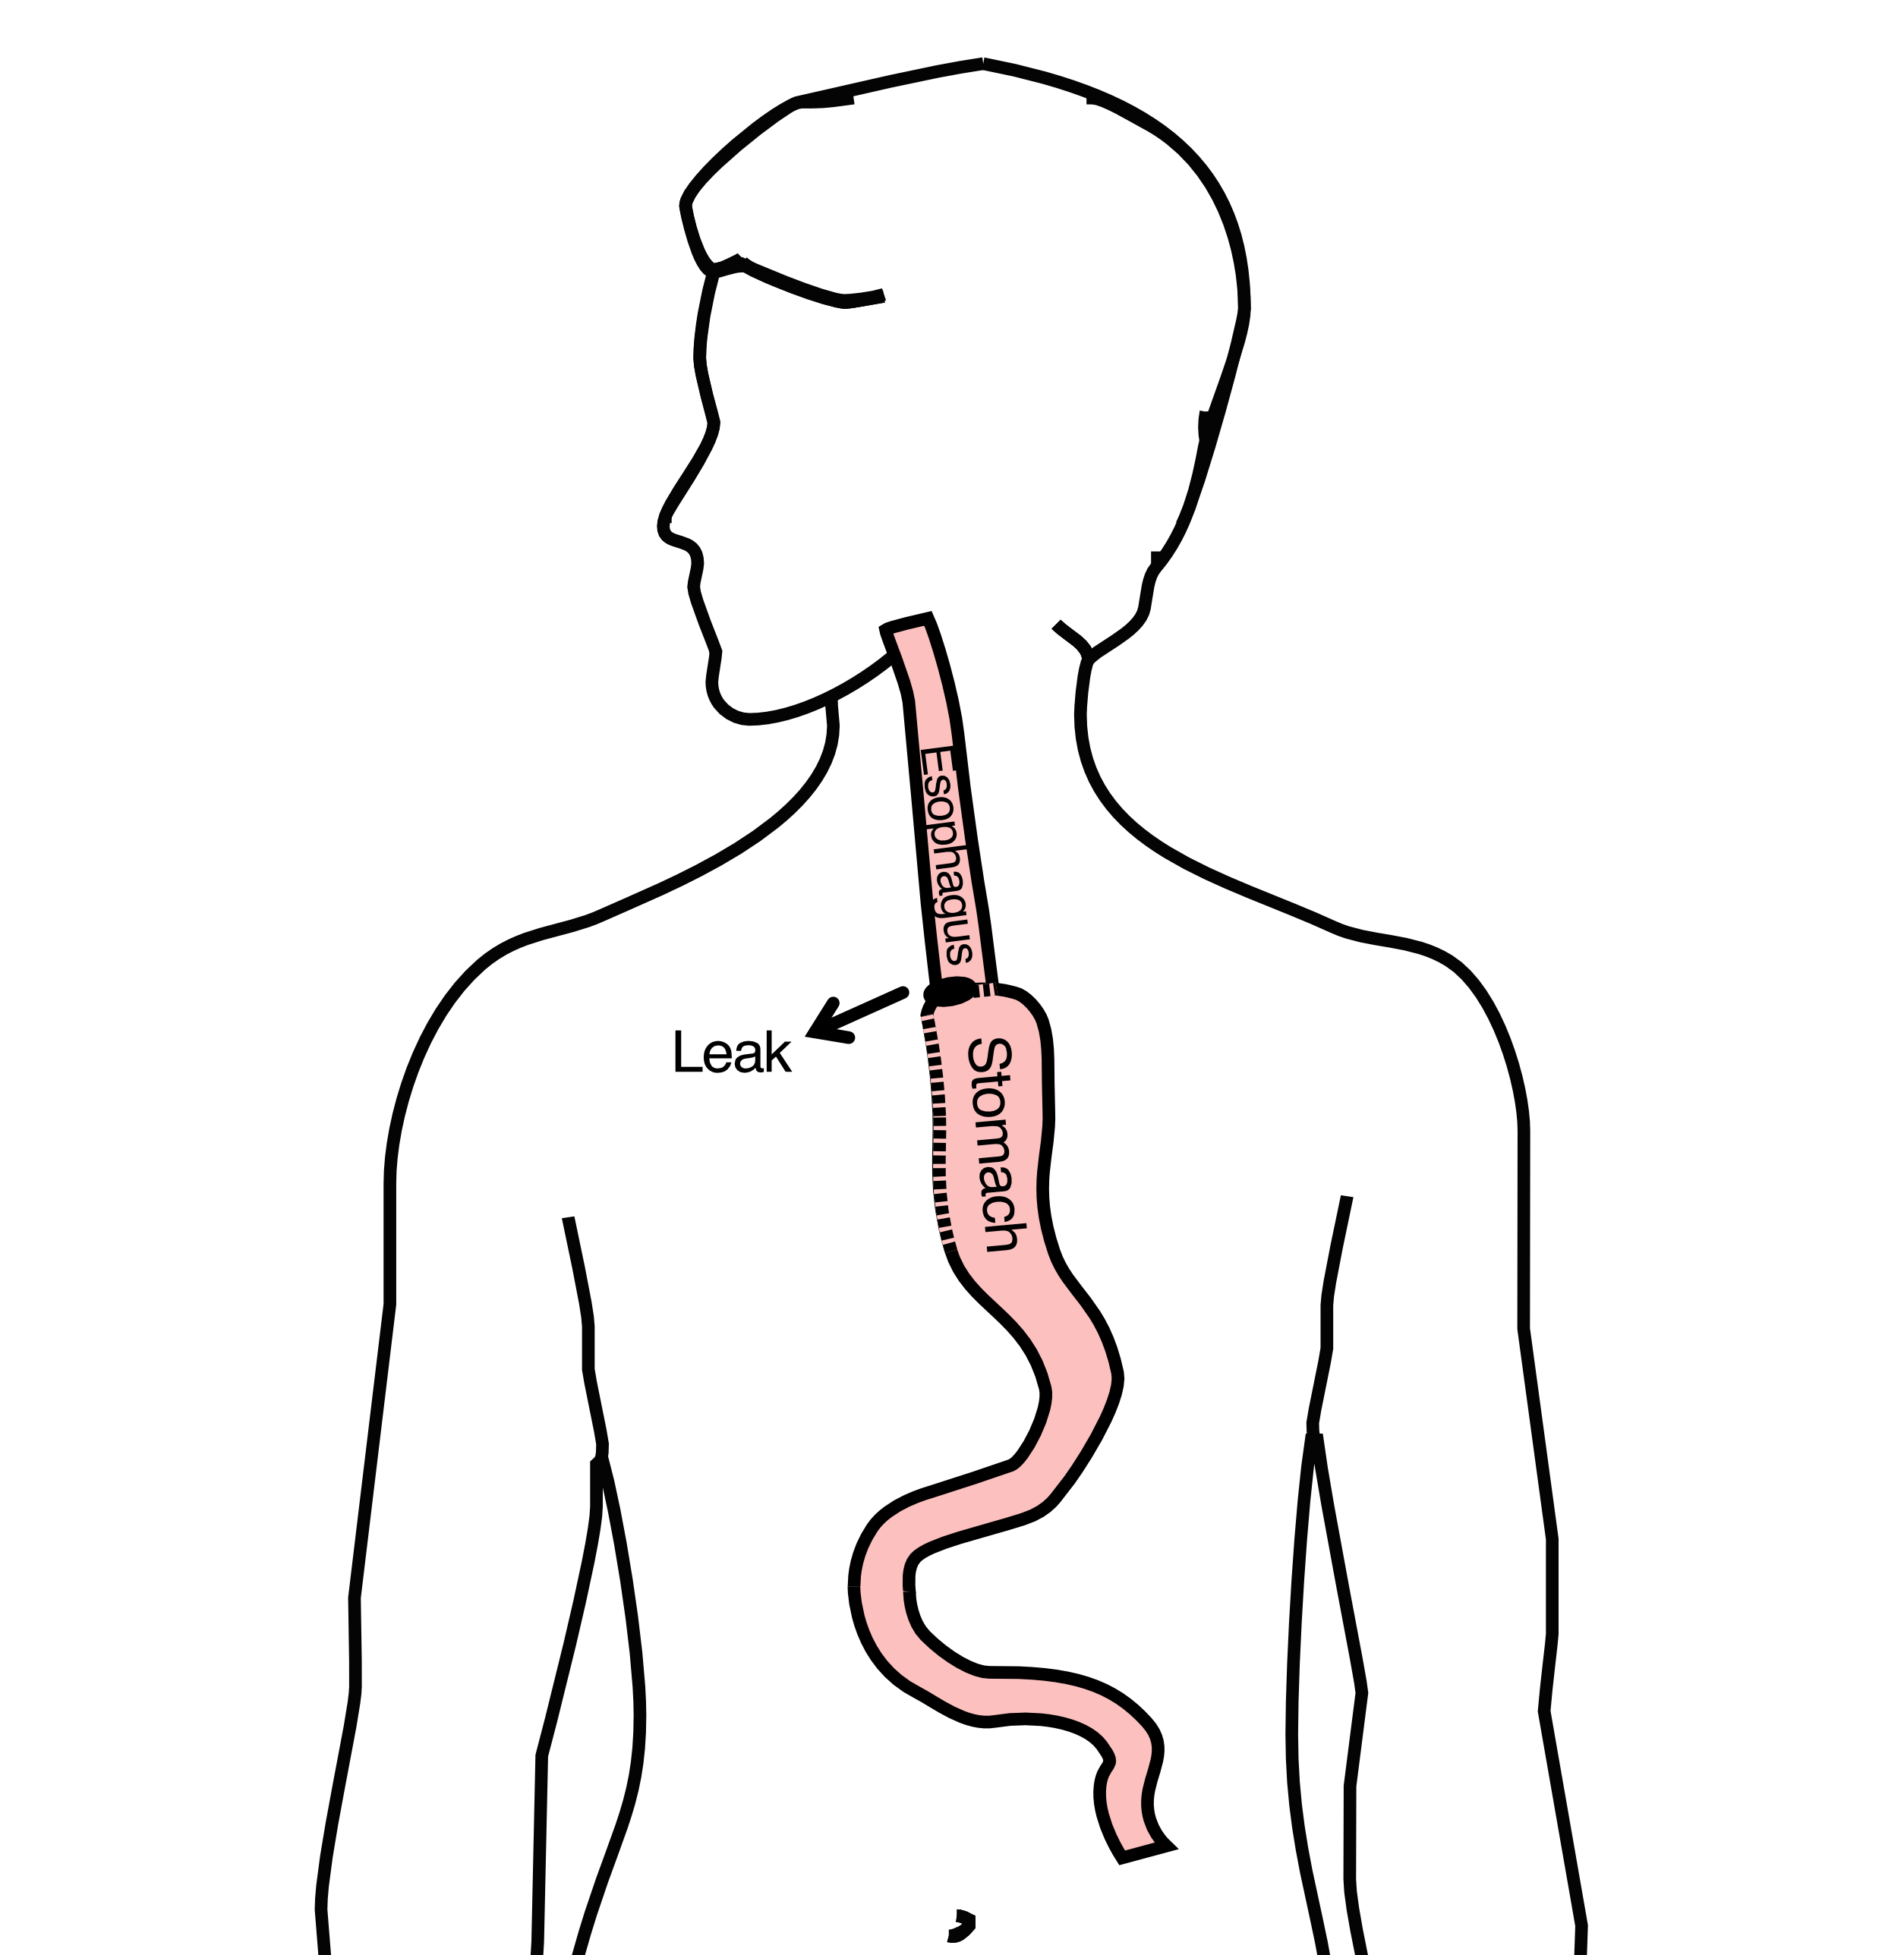

## 54 Anastomotic Leak

If an anastomotic leak occurs:

* Some leaks will seal on their own
* A stent may be required to help healing
* Occasionally additional surgey is required



## 55 Anastomotic Leak

Risk of a leak depends upon:

* Type of operation performed
* Overall nutritional status of patient
* Experience of the surgeon



## 56 Pneumonia

Pneumonia can occurs in about 10-15% of patients after esophagectomy.

Pneumonia requires treatment with antibiotics and frequently requires a longer hospitalization.

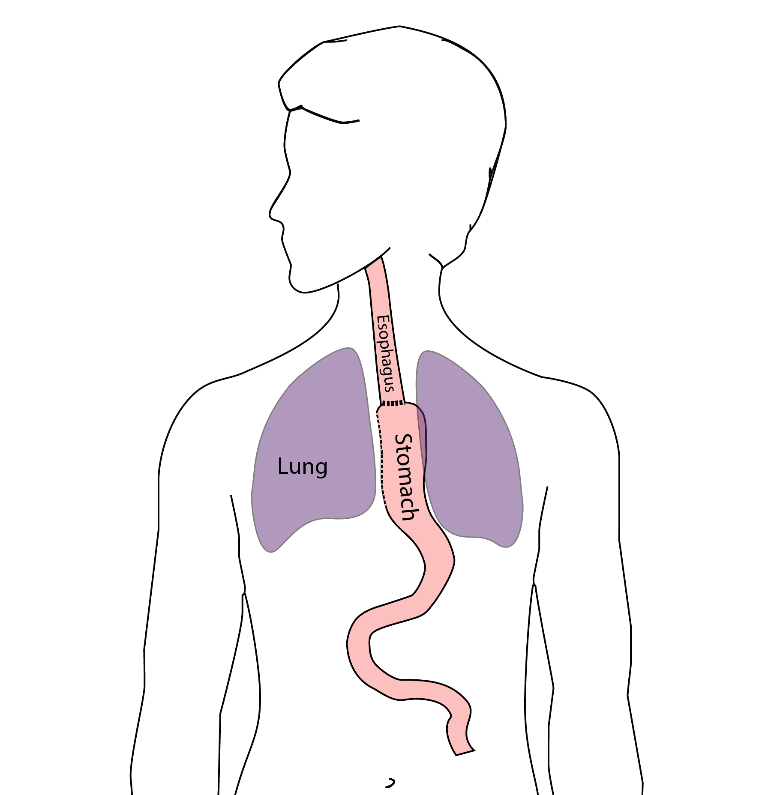

## 57 Preventing Pneumonia

Several ways to help prevent pneumonia after surgery:

* Deep breathing
* Coughing
* Walking

After surgery, this means:

* Sitting in a chair most of the day
* Walking in the halls as soon as possible

## 58 Minimally-invasive Esophagectomy

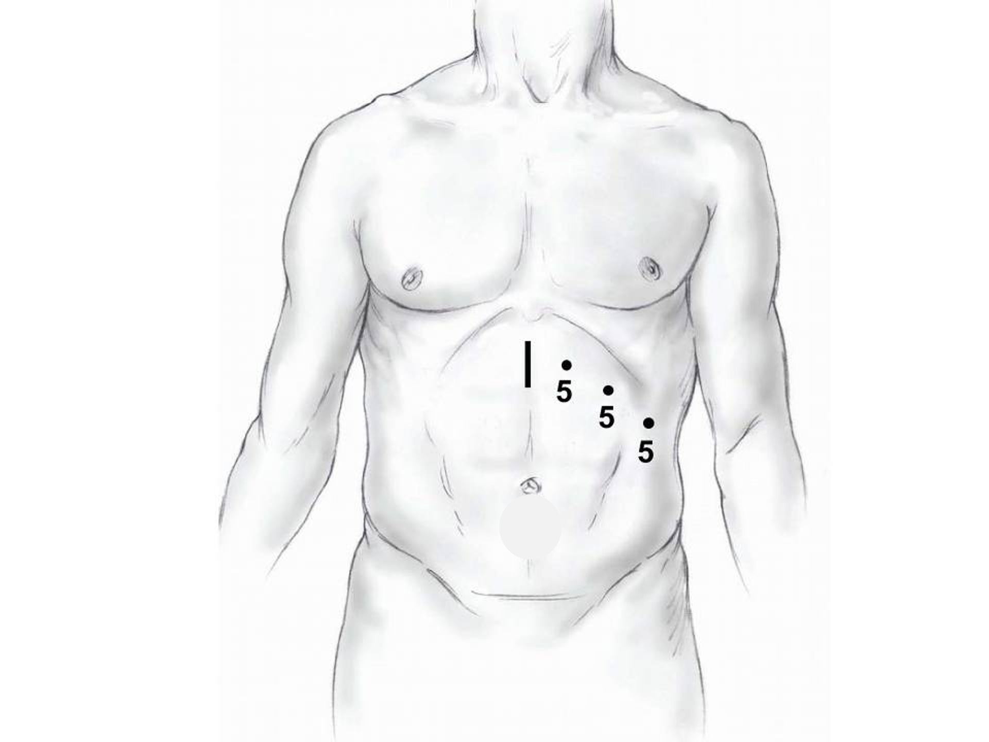

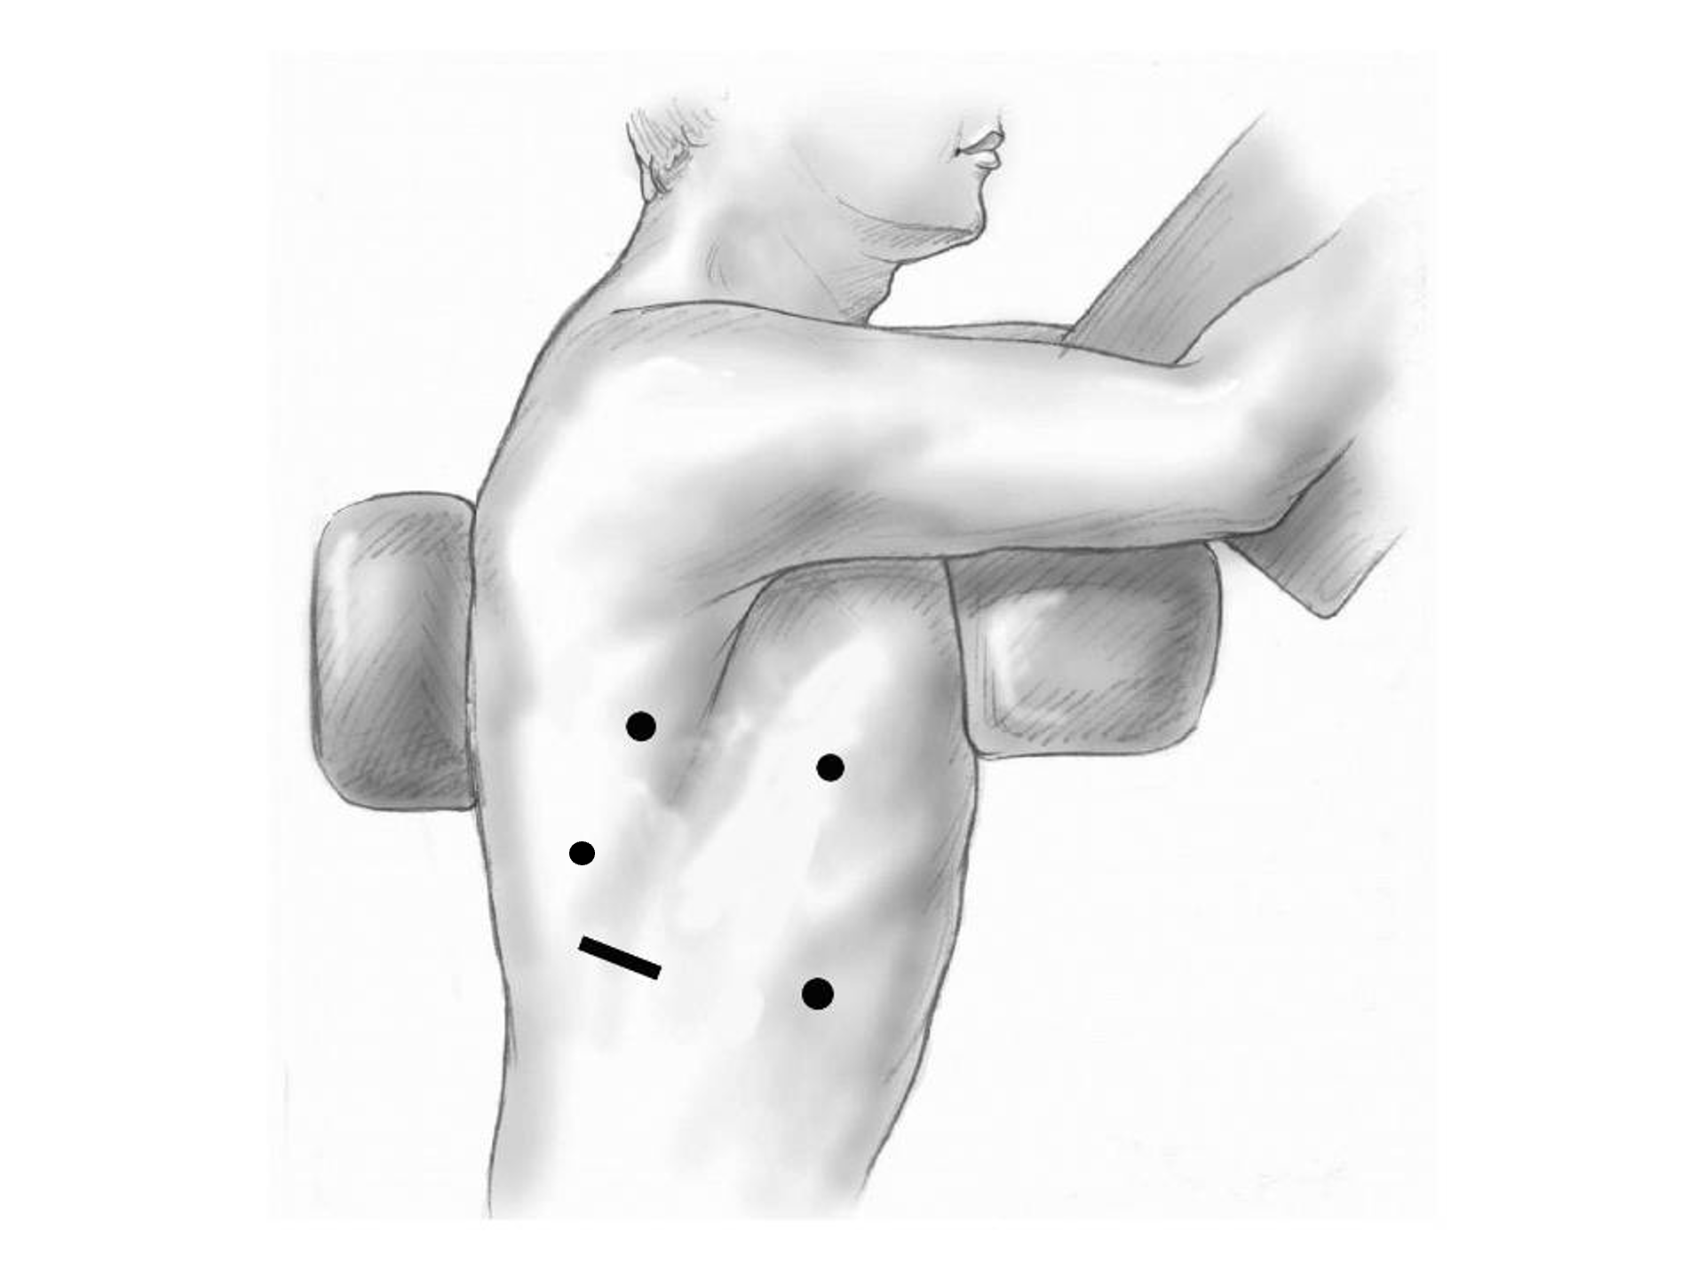

## 59 Risks of Surgery

Risks related to anesthesia

* Heart attack (5%)
* Irregular heart rhythm (15%)
* Pneumonia (10%)
* Blood clots in legs (<5%)
* Pulmonary embolism (2%)

## 60 Risks of Surgery

Risks related to Surgery

* Anastomotic leak (5%)
* Stricture at anastomosis (15%)
* Death within 90 days of surgery
  + Low risk patients = 2%
  + Intermediate risk = 10%
  + High risk = 30%

## 61 Risks of Surgery

Risks of Death within 90 Days of Surgery

|  | Age <75 | Age >75 |
| --- | --- | --- |
| Normal Muscle (75%) | 2% | 10% |
| Low Muscle (25%) | 10% | 30% |

## 62 Day Prior to Surgery

* Clear liquids for 24 hours prior to surgery
* Check with Pre-op nurse regarding medicines day prior to surgery
* No tube feedings the night before surgery

## 63 Day of Surgery

* Arrive at 5am – nothing to eat or drink after midnight.
* Medicines w/ a sip of water (or black coffee) but **no cream**.
* Surgery will be cancelled if you have cream/milk
* Waiting room for family and friends on 5th floor
* Post-operative care in STICU (11th floor)

## 64 Epidural Catheter for Pain Control

* Remains in place for 2-5 days
* Dosage can be adjusted as needed
* Can make it more difficult to urinate
* May require foley catheter in bladder
* Foley catheter removed after epidural removed

## 65 ICU Stay (2-4 days)

* NG tube in nose to drain stomach and esophagus
* Catheter in bladder
* Chest tube right chest
* Abdominal drains (usually 2)
* Feeding jejunostomy (usually stays in 8 wks)

## 66 ICU

* Bladder catheter removed → check that bladder empties properly
* Chest tube removed (day 2-4) → follow-up chest x-ray
* Fluid emptied from drains every few hours
* Start tube feedings by feeding
* Feeding jejunostomy (stays in 8 weeks)

## 67 Ward - 6Tower

* Jejunostomy feeds started
* Up in a chair most of the day
* Walking in the halls
  + Start with assistance
  + Improves lung function
  + Prevents loss of muscle strength

## 68 Jejunostomy Feeds

Jejunostomy tube feeds

* Start continuous (24 hours)
* Convert to night-time only (16 hours)

Water administered through feeding tube

* Usually 8oz 4 times/day
* Important to prevent dehydration

## 69 Jejunostomy Tube

## 70 Jejunostomy Typical Regimen

* Jejunostomy tube feeds for 16 hours (6pm to 10am)
  + Men: 75mL/hour x 16 hours = 5 cartons
  + Women: 60mL/hour x 16 hours = 4 cartons
* Water 240ml (8oz) via syringe 4x/day

Hospital nurses will teach use of the feeding tube pump

## 71 Jejunostomy Feeds with Diabetes

Jejunostomy feedings elevate blood sugars

* Insulin may be required along with feeds

Typical Pattern for tube feeds

* Feeds run via pump from 6pm to 10am
* Insulin at 6pm (70/30 insulin)
* Insulin at Midnight (70/30 insulin)
* No insulin if tube feedings are not run

## 72 Jejunostomy Video

## 73 Activity

* Up in chair most of the day
* Walking with help from nurse/Physical Therapist
* Goals:
  + Improve lung function
  + Prevent muscle loss

## 74 Nasogastric (NG) Tube

Tube passed through nose into stomach

* Drains fluid from stomach
* Prevents vomiting

Upper GI X-ray on 2nd or 3rd day after surgery

* If stomach empties well NG tube removed
* Otherwise, X-ray repeated 2-3 days later

## 75 Swallowing Evaluation

Once NG tube has been removed:

Modified barium swallow in radiology

* Drink a white chalky liquid (barium)
* Look for proper swallowing function
* 70% of patients liquids started by mouth

## 76 Protein Shakes

Most are taking protein shakes when they go home

Protein shakes are started after tolerating water

* 2 oz per hour to start
* 4 oz per hour if 2oz are tolerated well

## 77 Discharge

Goal: ready to leave day #6/7 after surgery

* Night-time tube feedings (6pm to 10am)
* Nutrition by mouth (70% of patients)
  + 1 oz of water per hour by mouth OR
  + Protein shakes 4oz every 2 hours
* Water through tube 8oz four times per day
* Home care nursing (feeding tube teaching)
* Home infusion (tube feeding supplies)

## 78 Nutrition after Surgery

At discharge home:

* Protein shakes 4oz every 2 hrs
* Tube feeds 4-5 cans at night (6pm-10am)

10-12 Days: Increase protein shakes

* Tube feeds 3-4 cans at night

Three weeks: Post-esophagectomy Diet

8-12 weeks: Remove feeding tube (in office)

## 79 Transition from Tube Feeds Eating

Dietitian will calculate daily protein goal

* Typically 60-75 grams protein/day
* Each carton of tube feeding has 15 grams
  + 75 grams protein = 5 cartons/night
* As intake by mouth increases, tube feeds are reduced

Spread out protein during the day (20gm/meal)

* Three meals + 2-3 high-protein snacks

## 80 Post-esophagectomy Diet

* Soft Consistency
* High Protein
* Avoid sugary liquids (can cause ‘dumping’)
* Avoid raw vegetables (and salads)
* Eating
  + Small, frequent meals
  + Sit up for 30-45 minutes after eating
  + Avoid eating within 2 hours of bedtime

## 81 Medicines at Home - Pain

Acetaminophen (Tylenol) 1000mg 4x/day

Gabapentin 300mg 3 times/day

Oxycodone

* As needed in addition to Tylenol/gabapentin
* Will begin reducing dose at first postop visit
* Can usually discontinue by 4 weeks
* NO DRIVING WHILE ON OXYCODONE

## 82 Non-steroidals Anti Inflammatory (NSAID)

Non-steroidal anti-inflammatories (Celebrex)

* 200 mg every 12 hours starting at 2 weeks

NO GOODY POWDERS OR BCs

* (Can cause permanent scarring at the surgery site)

## 83 Acid Blockers = Proton Pump Inhibitors

Examples include ompeprazole and pantoprazole

* Will stay on for at 1-2 years to prevent acid reflux
* Important in preventing scarring at anastomosis (new connection between esophagus and stomach)
* To administer through feeding tube, open capsule and resuspend beads in 60mL (2oz) of water

## 84 Medicines at Home

Reglan – Helps stomach empty

* Will plan to stop after six weeks
* 0.1% risk of tardive dyskinesia (nervous tic)

Remeron – Helps improve appetite

* Can cause vivid dreams
* Used for several weeks after surgery
* Will stop within first three months of surgery

## 85 Metoprolol = Beta Blockers

* Slows heart rate and lowers blood pressure
* Used to prevent rapid heart rate
* Patients not taking a beta blocker prior to surgery wean after after surgery
* Patients taking a beta blockerprior to surgery return to prior dose and drug after surgery

## 86 Sleeping

Reflux can occur the first few weeks/months after surgery

This improves over the first few months

A wedge pillow can be helpful for sleep



## 87 Postoperative Visit

Check surgical site

* Remove staples (if needed)

Adjust medicines as needed

* Insulin (for diabetic patients on insulin)
* Reduce beta blocker medicines

Advance diet

Reduce tube feeds

## 88 After surgery

Wean off medicines added after surgery

* Pain medicines
* Beta-blockers
* Reglan and Remeron

Continue acid blockers for at least 1 year

## 89 Jejunostomy Removal

Jejunostomy tube is removed in the office once you can take in enough nutrients by mouth

Removal usually around 8 weeks after surgery

May take 30 minutes and some local anesthetic to loosen up the tube for removal.

## 90 Nutritional Monitoring after Surgery

You may have difficulty absorbing some nutrients:

* Iron
* Vitamin B12
* Vitamin D

## 91 Nutritional Monitoring after Surgery

About 3 months after the jejunostomy tube is removed, we will check blood levels:

* Iron (ferritin)
* Vitamin B12
* Vitamin D

## 92 Nutritional Replacements after Surgery

Vitamin or iron replacements can be ordered by:

* Primary Care Provider (PCP)
* Medical Oncologist
* Surgeon

If levels are low

* Replacement
* Repeat testing in 3-6 months

## 93 Team Members - Physicians

Primary Care Provider

Gastroenterologist

Medical Oncologist (chemotherapy)

Radiation Oncologist (radiation)

Surgeons

* Jonathan Salo
* Jeffrey Hagen
* Michael Roach

## 94 Team Members - Support Staff

Dietitian - Liz Koch

Nurses - Brandon Galloway & Kit Sluder & Rebecca Wicks

Schedulers - Stacey Singleton & Tony Bethea

Navigator - Laura Swift