Surgery of the Esophagus

## 1 Surgery for Esophageal Cancer

Surgery for esophageal cancer is performed for:

* Superficial Tumors (T1) not removed by endoscopy
* Localized Tumors (T2 N0 M0)
* Locally Advanced (T3 M0) after preop therapy

## 2 Goals of Surgery

* Remove tumor from esophagus
* Remove surrounding lymph nodes
* Create a new esophagus

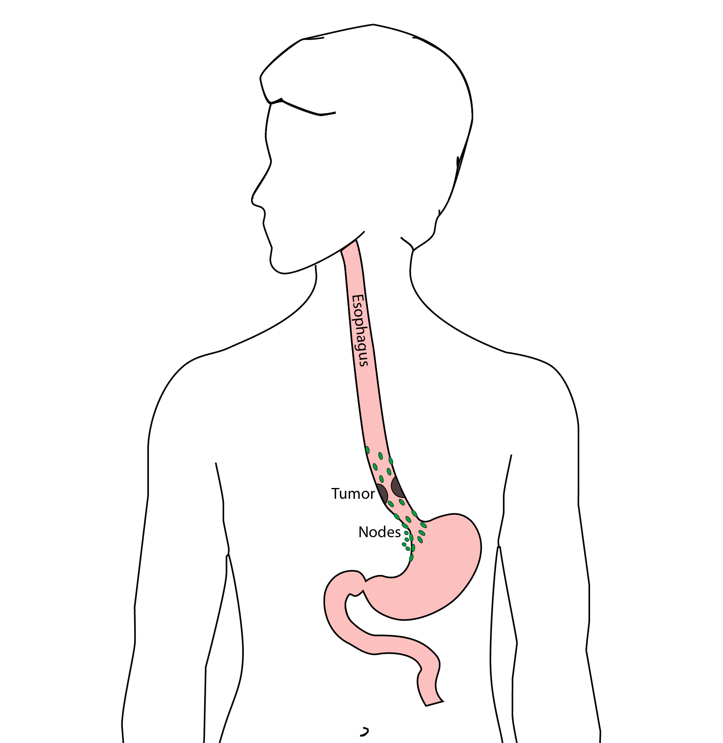

## 3 Ivor Lewis (Transthoracic) Esophagectomy

* Removes tumor and lower 1/3 esophagus
* Removes surrounding lymph nodes
* GI tract reconstructed

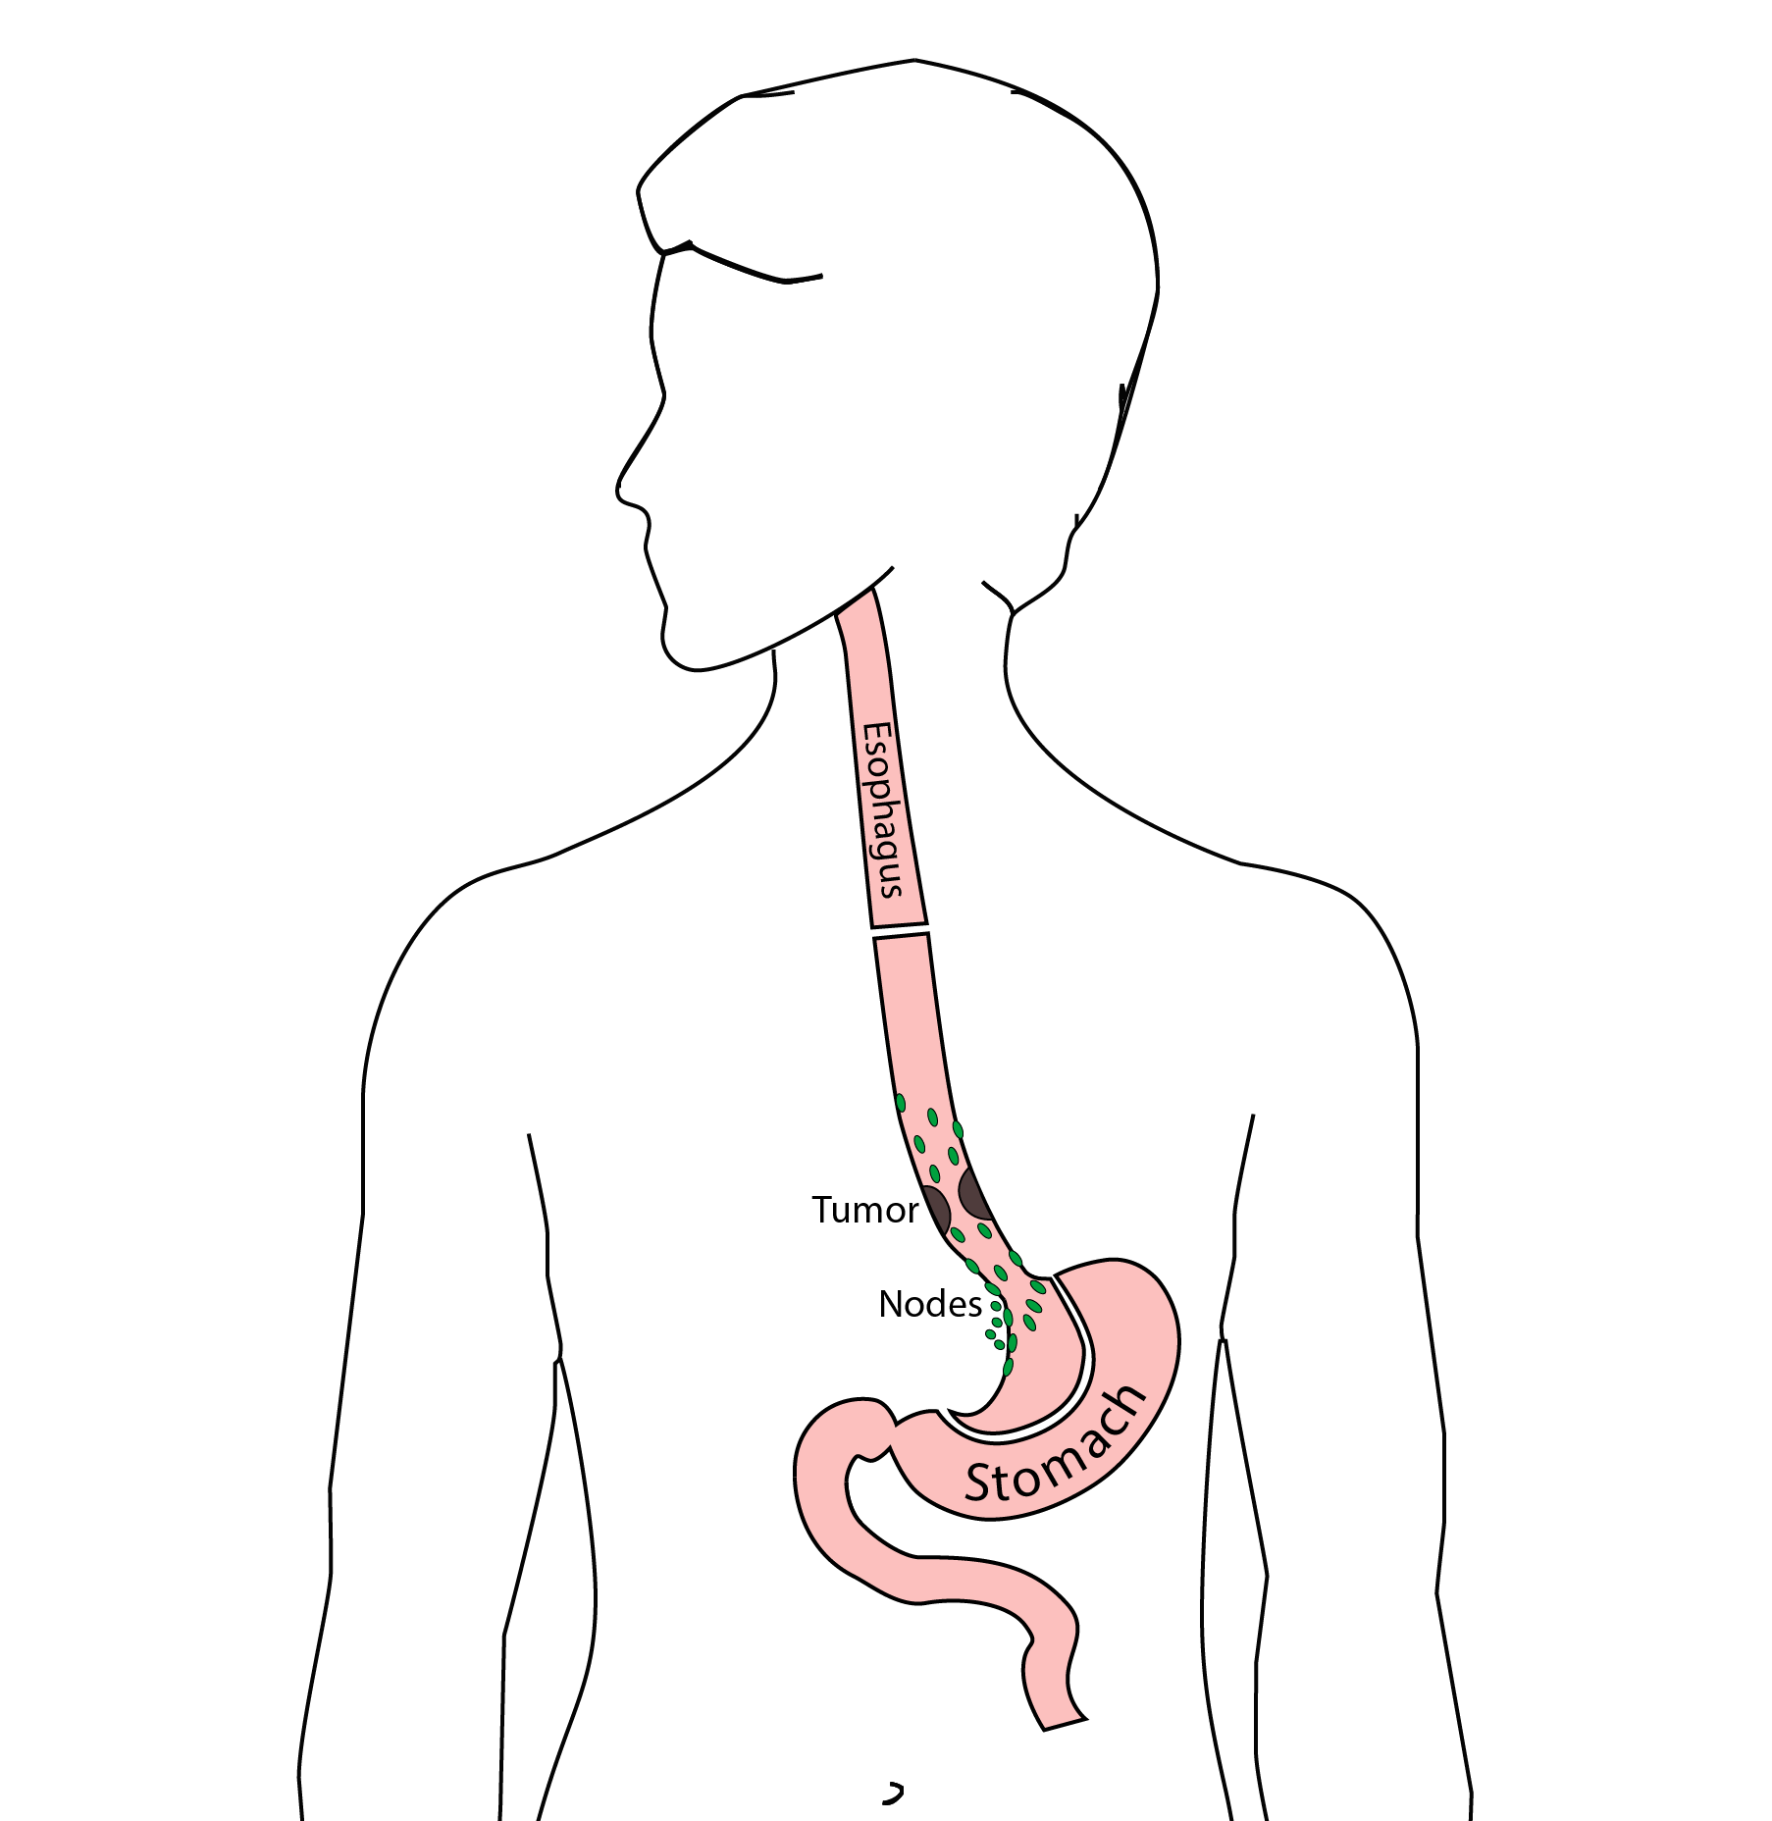

## 4 Reconstruction

New esophagus is created from the stomach in the abdomen by fashioning it into a tube.

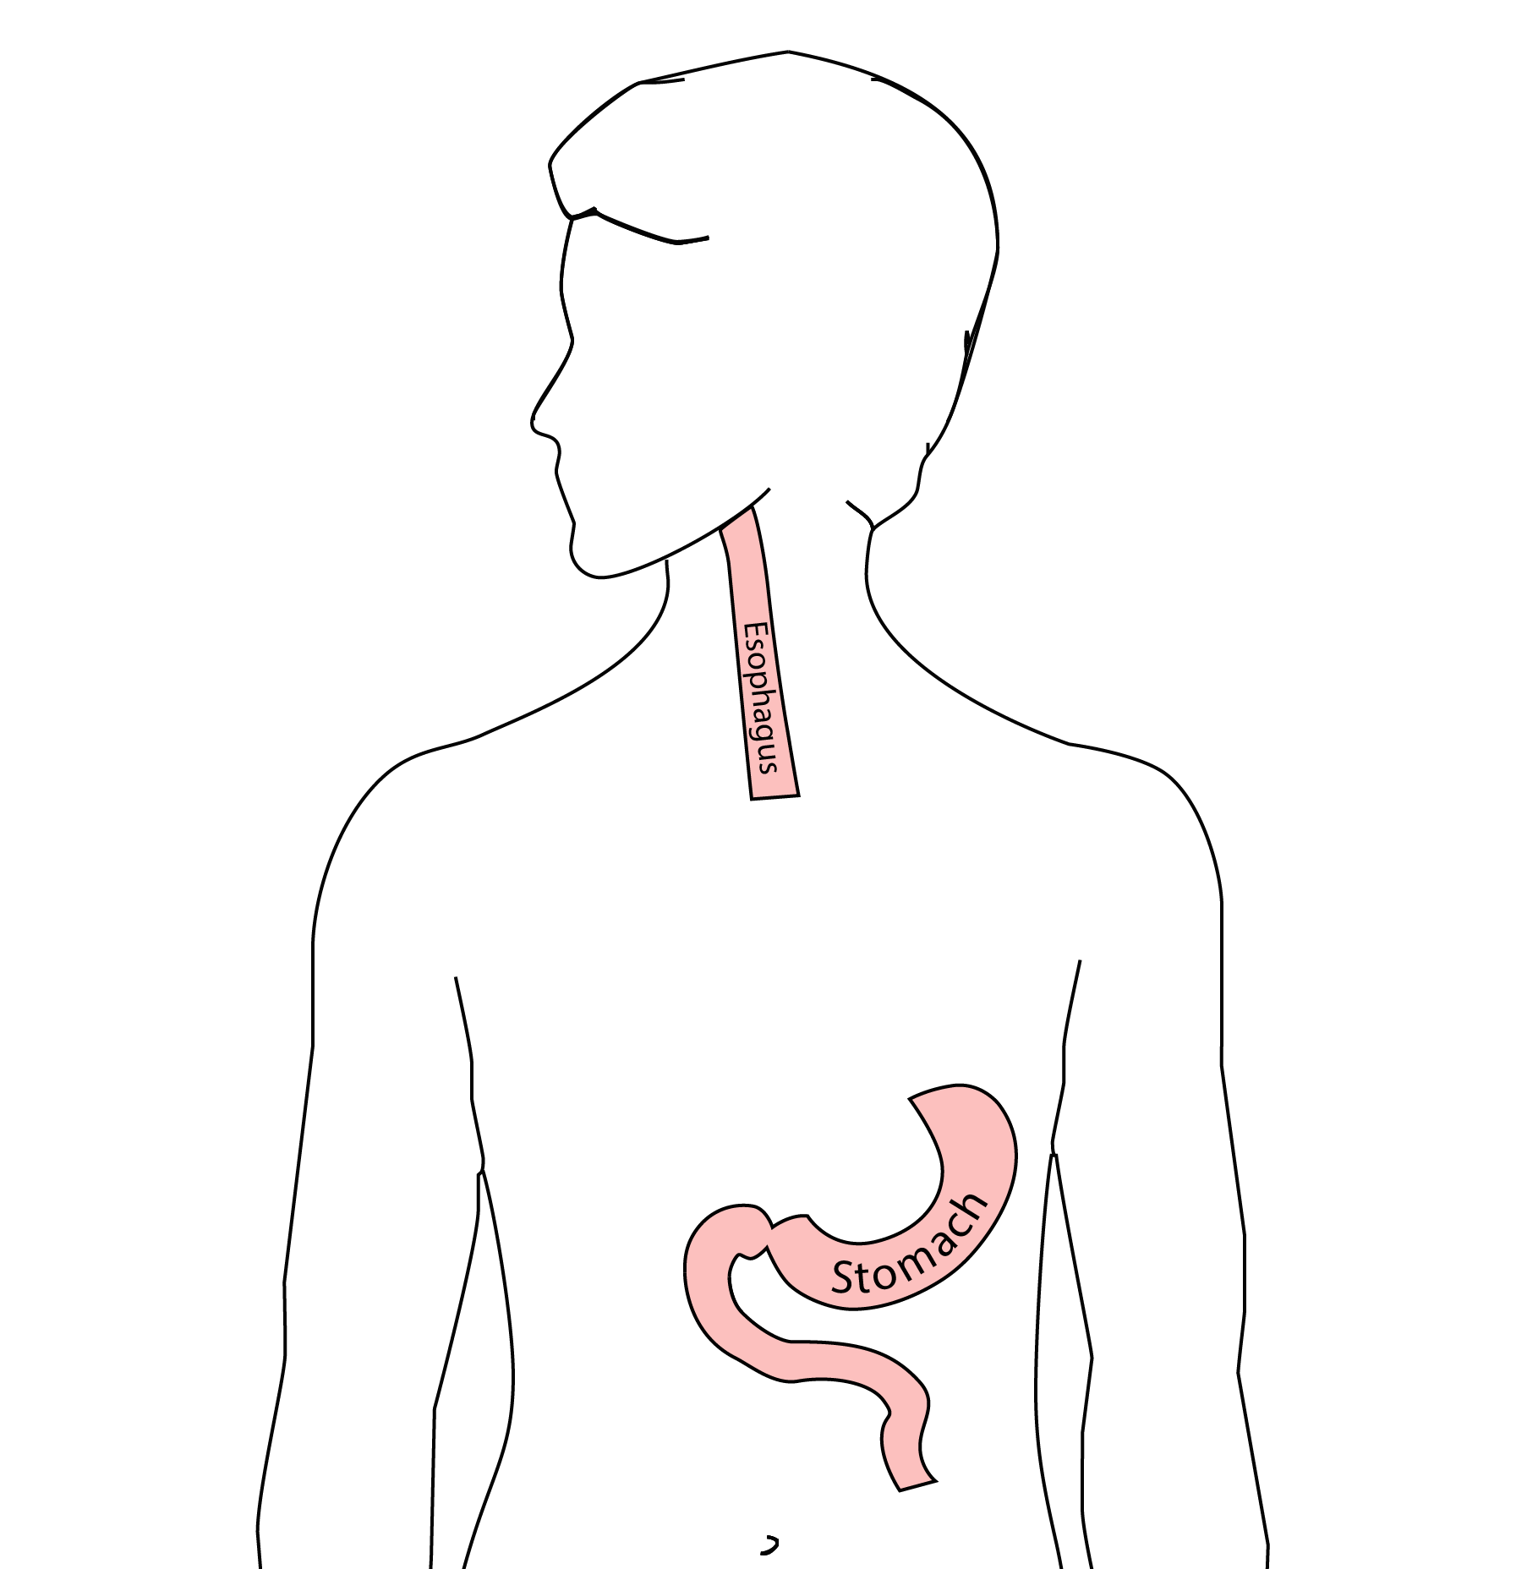

## 5 Ivor Lewis esophagectomy

The new esophagus is now brought up into the chest. A connection is made between the esophagus and the stomach, called an *anastomosis*.

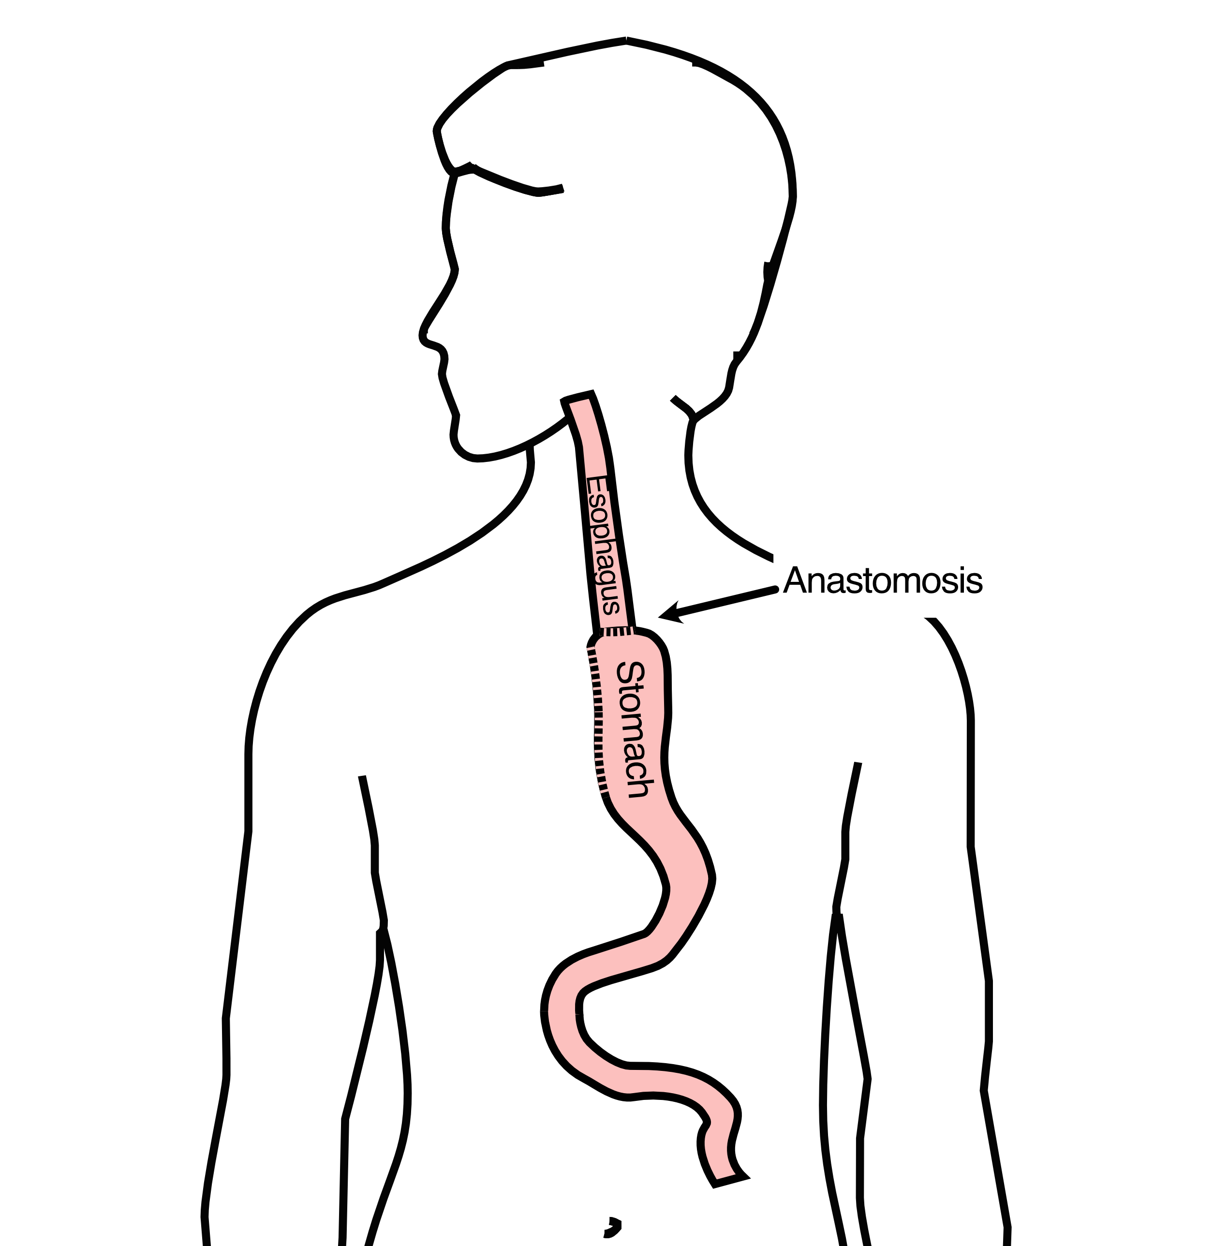

## 6 Minimally-invasive Ivor Lewis

* Small incisions abdomen and chest
* Surgical telescope and instruments
* Smaller incisions faster recovery and less discomfort

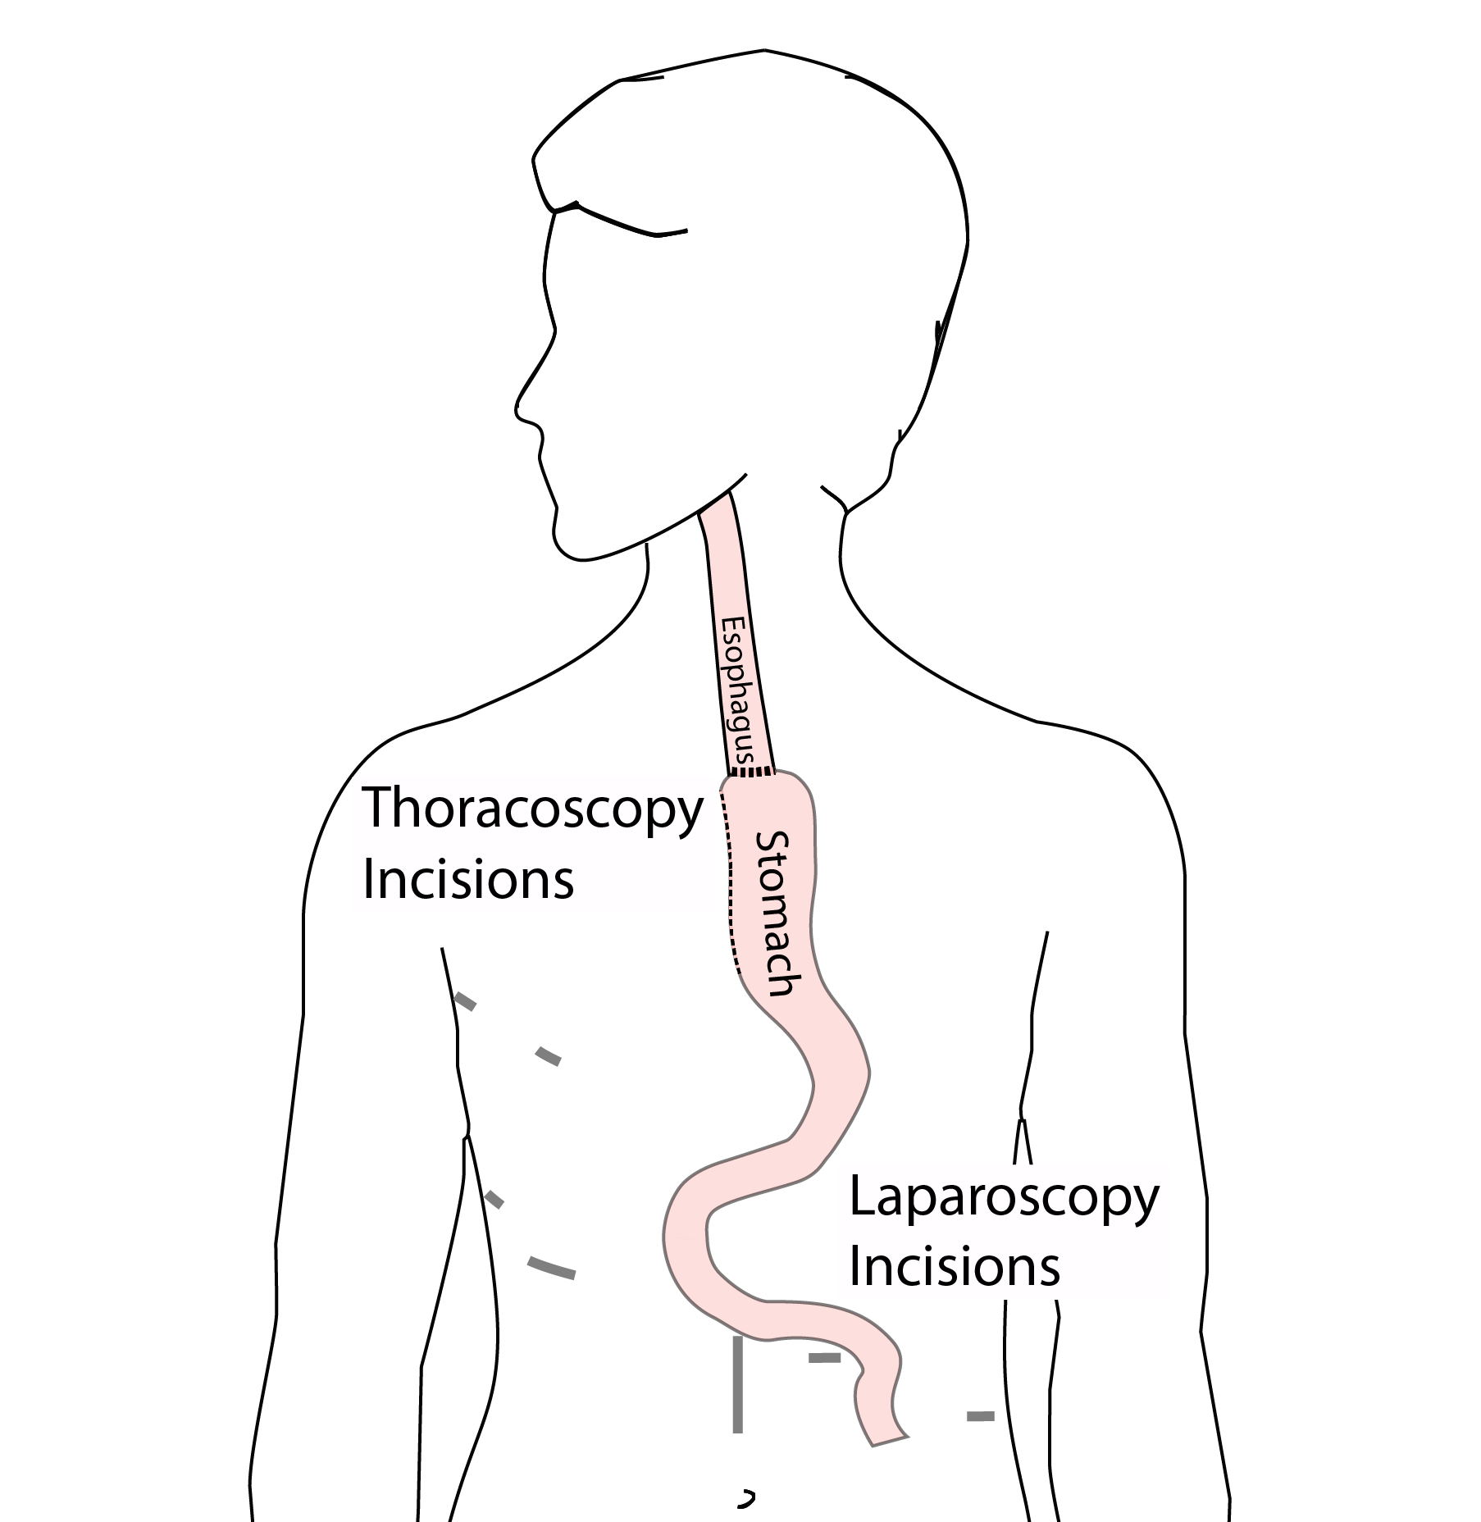

## 7 Open Ivor Lewis

Mininally-invasive approach feasible in 95% of cases

In some cases, an open approach is still necessary.

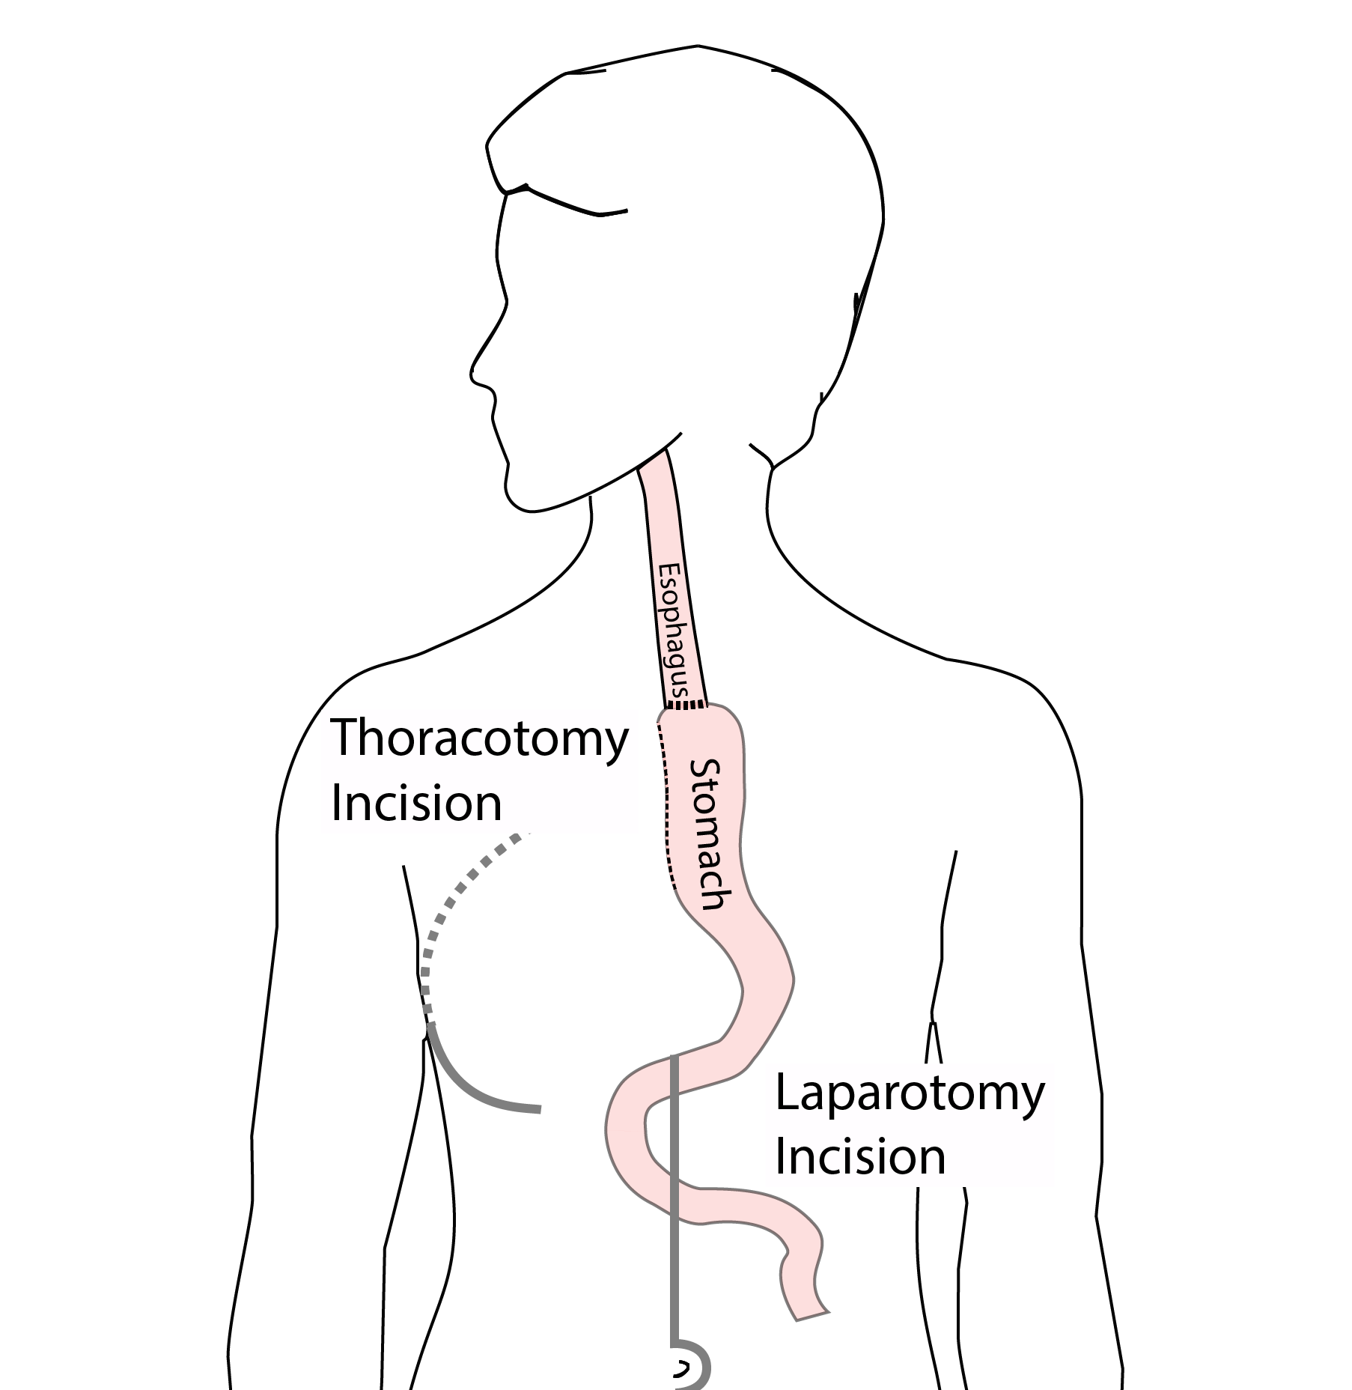

## 8 Total Esophagectomy

For patients with tumors in the upper esophagus, we need to remove more of the esophagus

We need to remove the whole esophagus, including the portion in the neck

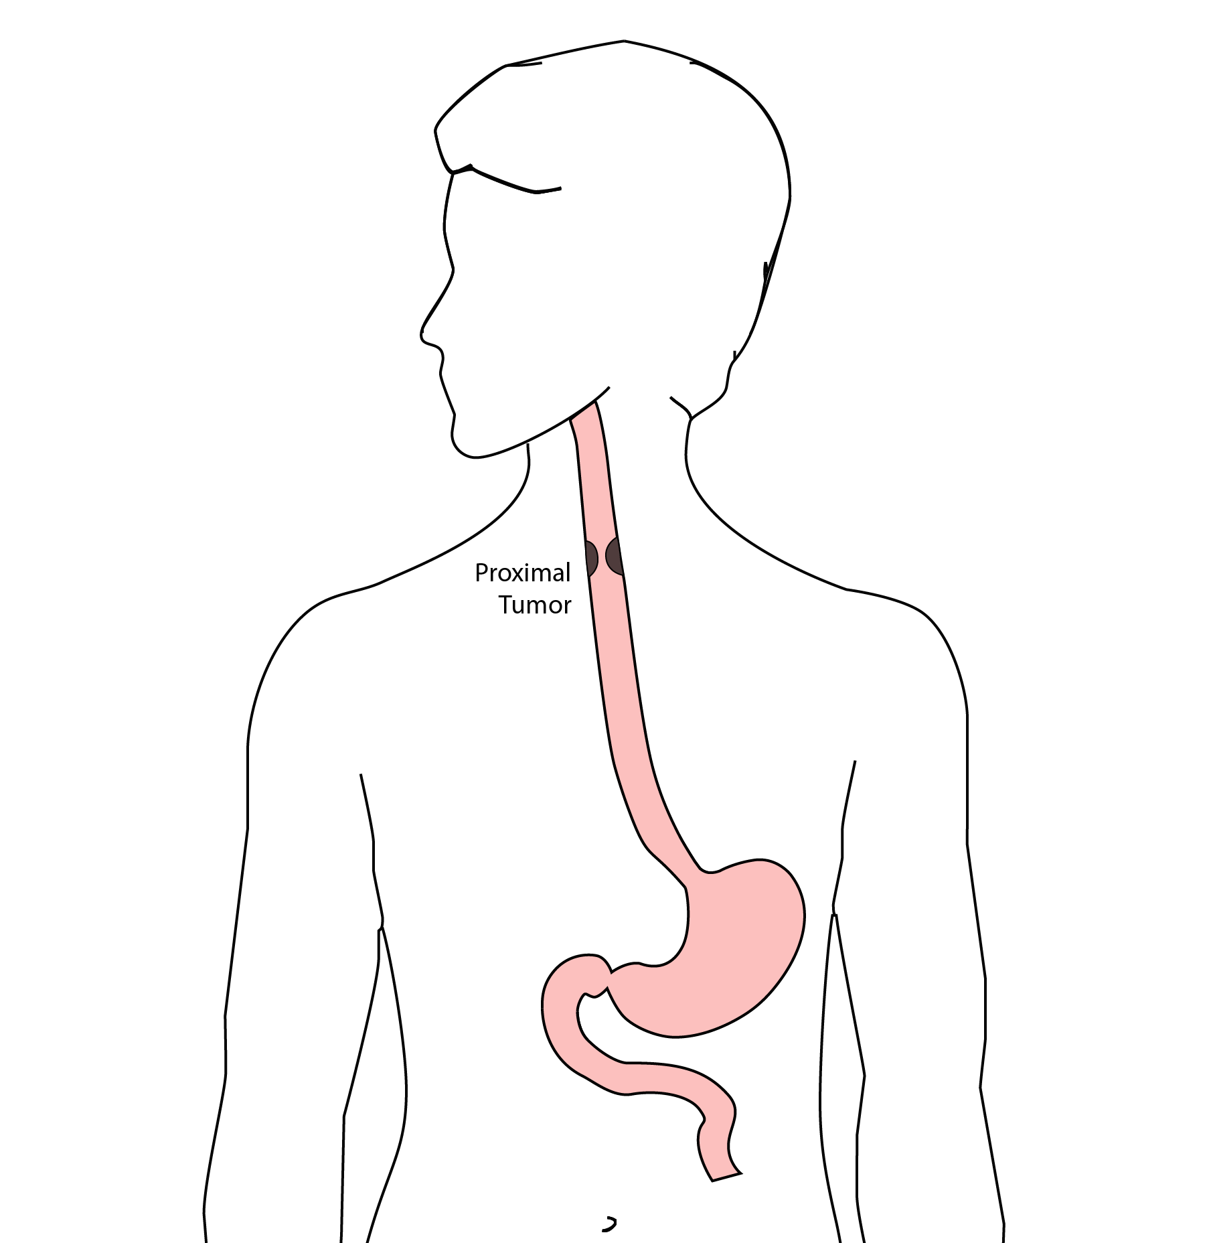

## 9 McKeown Esophagectomy

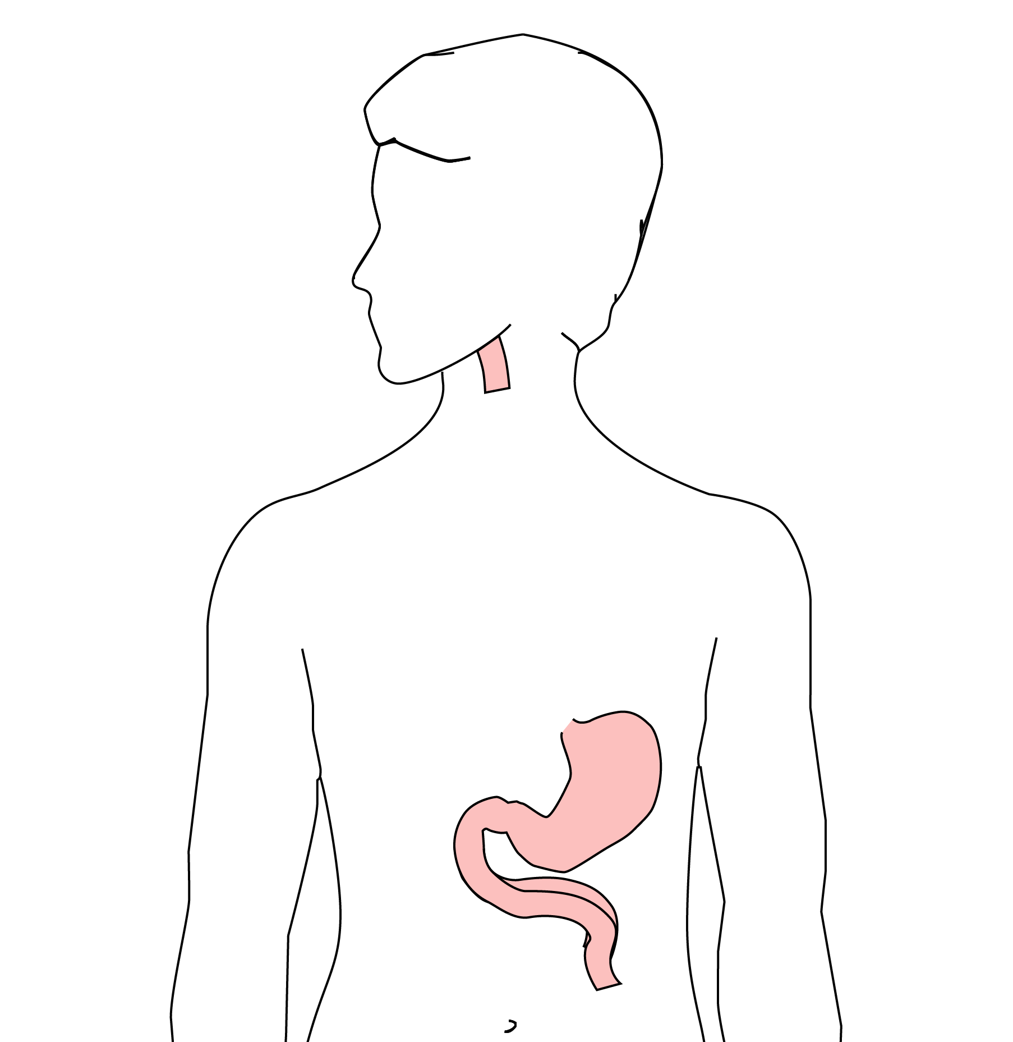 All of esophagus removed

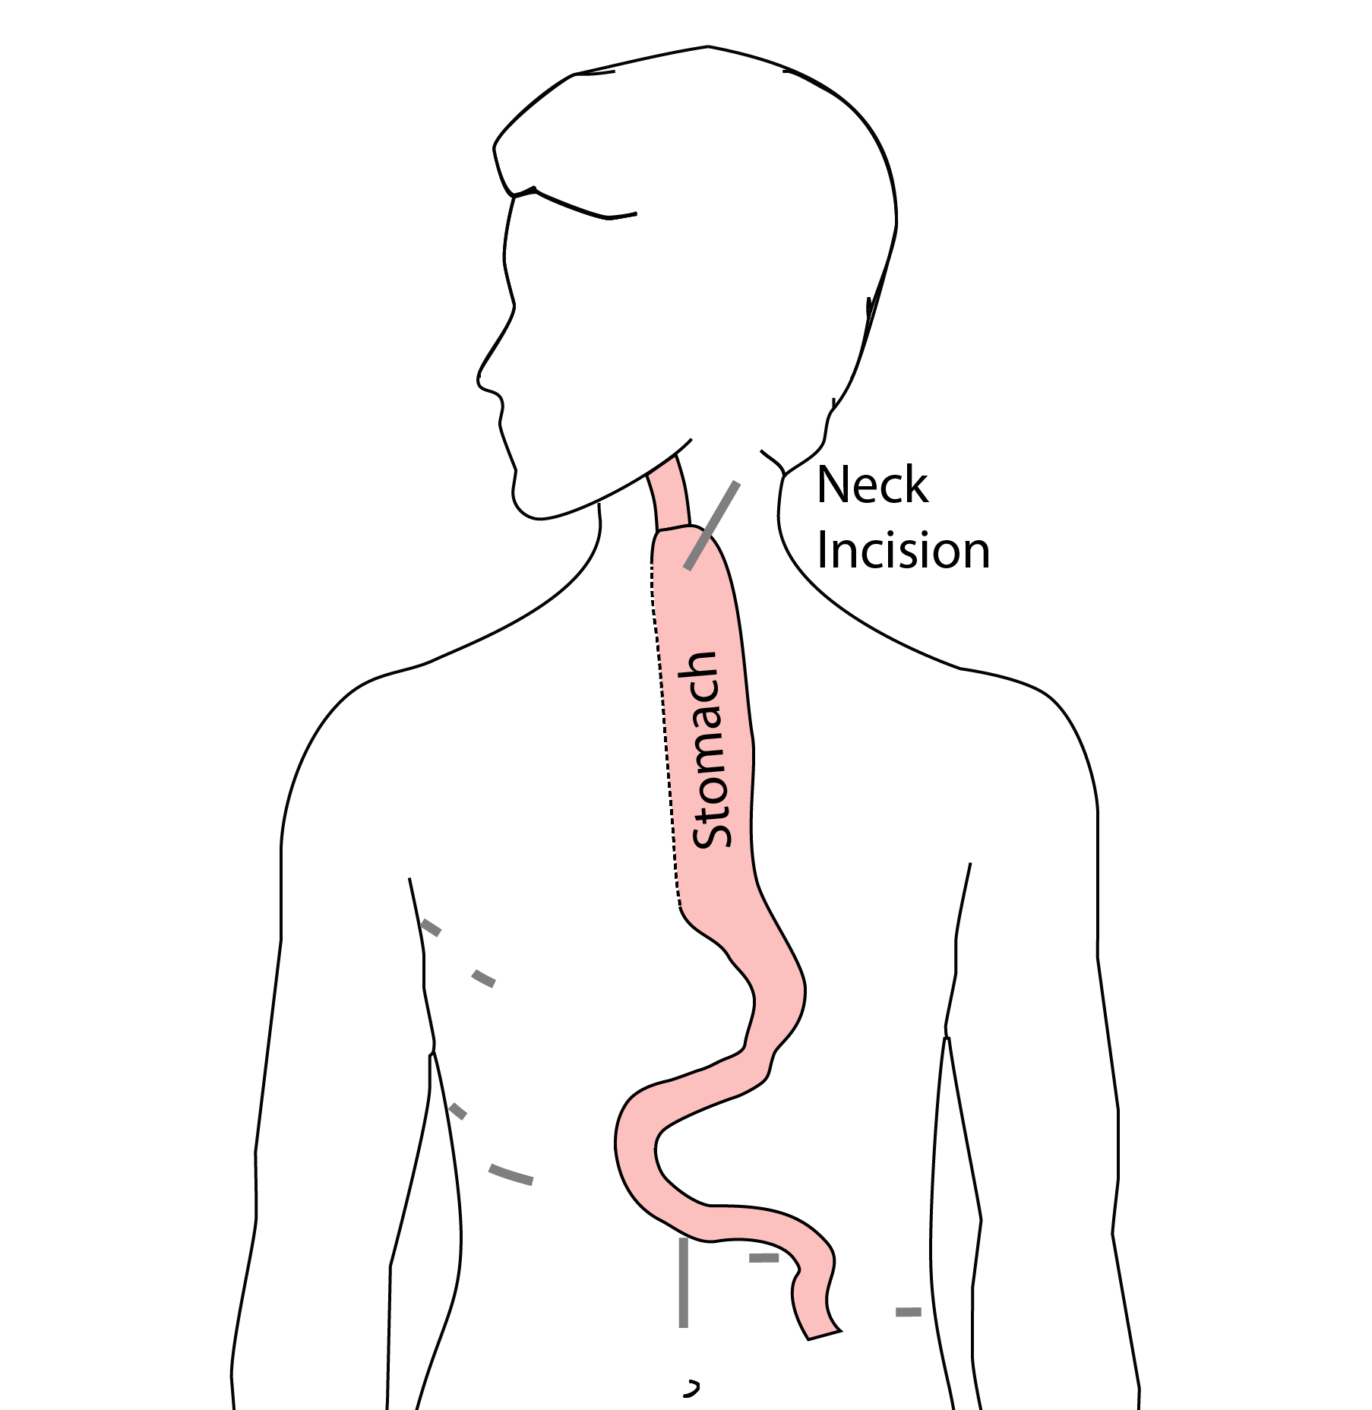 Connection made in the neck

## 10 Colon Interposition

If the stomach is not suitable to make a new esophagus, the colon can be used to replace the esophagus

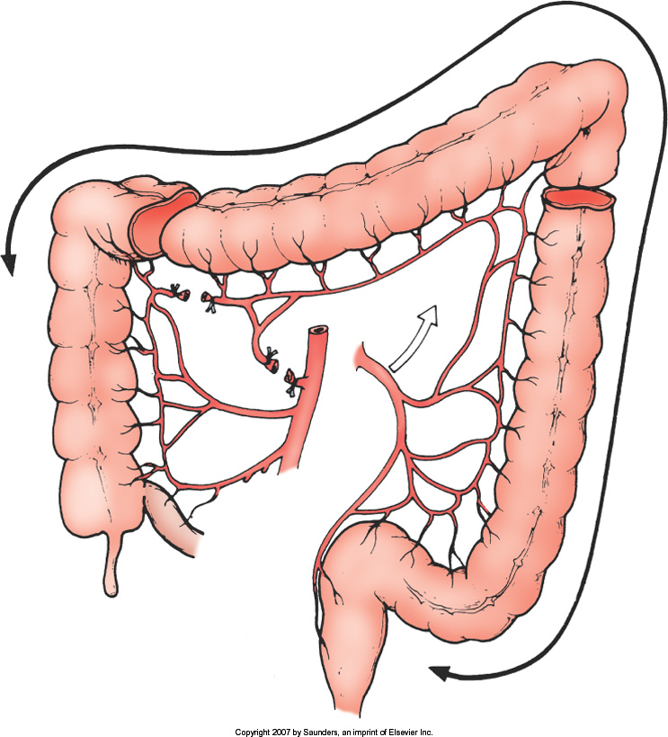

## 11 Colon Interposition

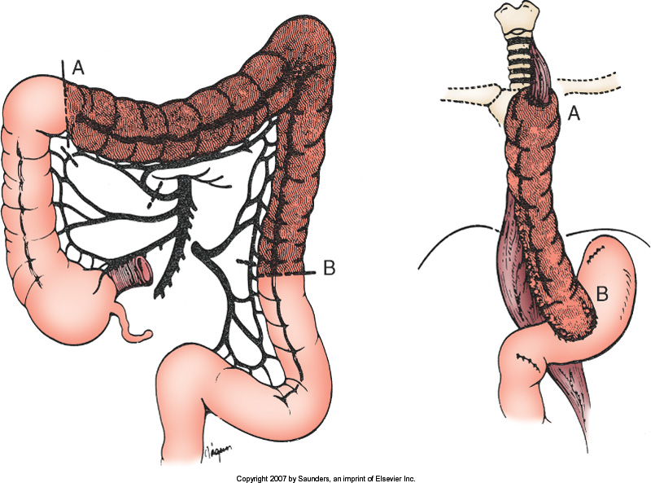

## 12 Risks of Esophagectomy

Esophagectomy is a complex operation, with a real risk of complications.

Two significant complications:

* Anastomotic leak
* Pneumonia

## 13 Anastomotic Leak

The anastomosis is surgical connection between the esophagus and the stomach.



## 14 Anastomotic Leak

If healing doesn’t occur:

* Leakage of fluid from the esophagus
* Infection in the space between the lungs
* Requires additional time in the hospital

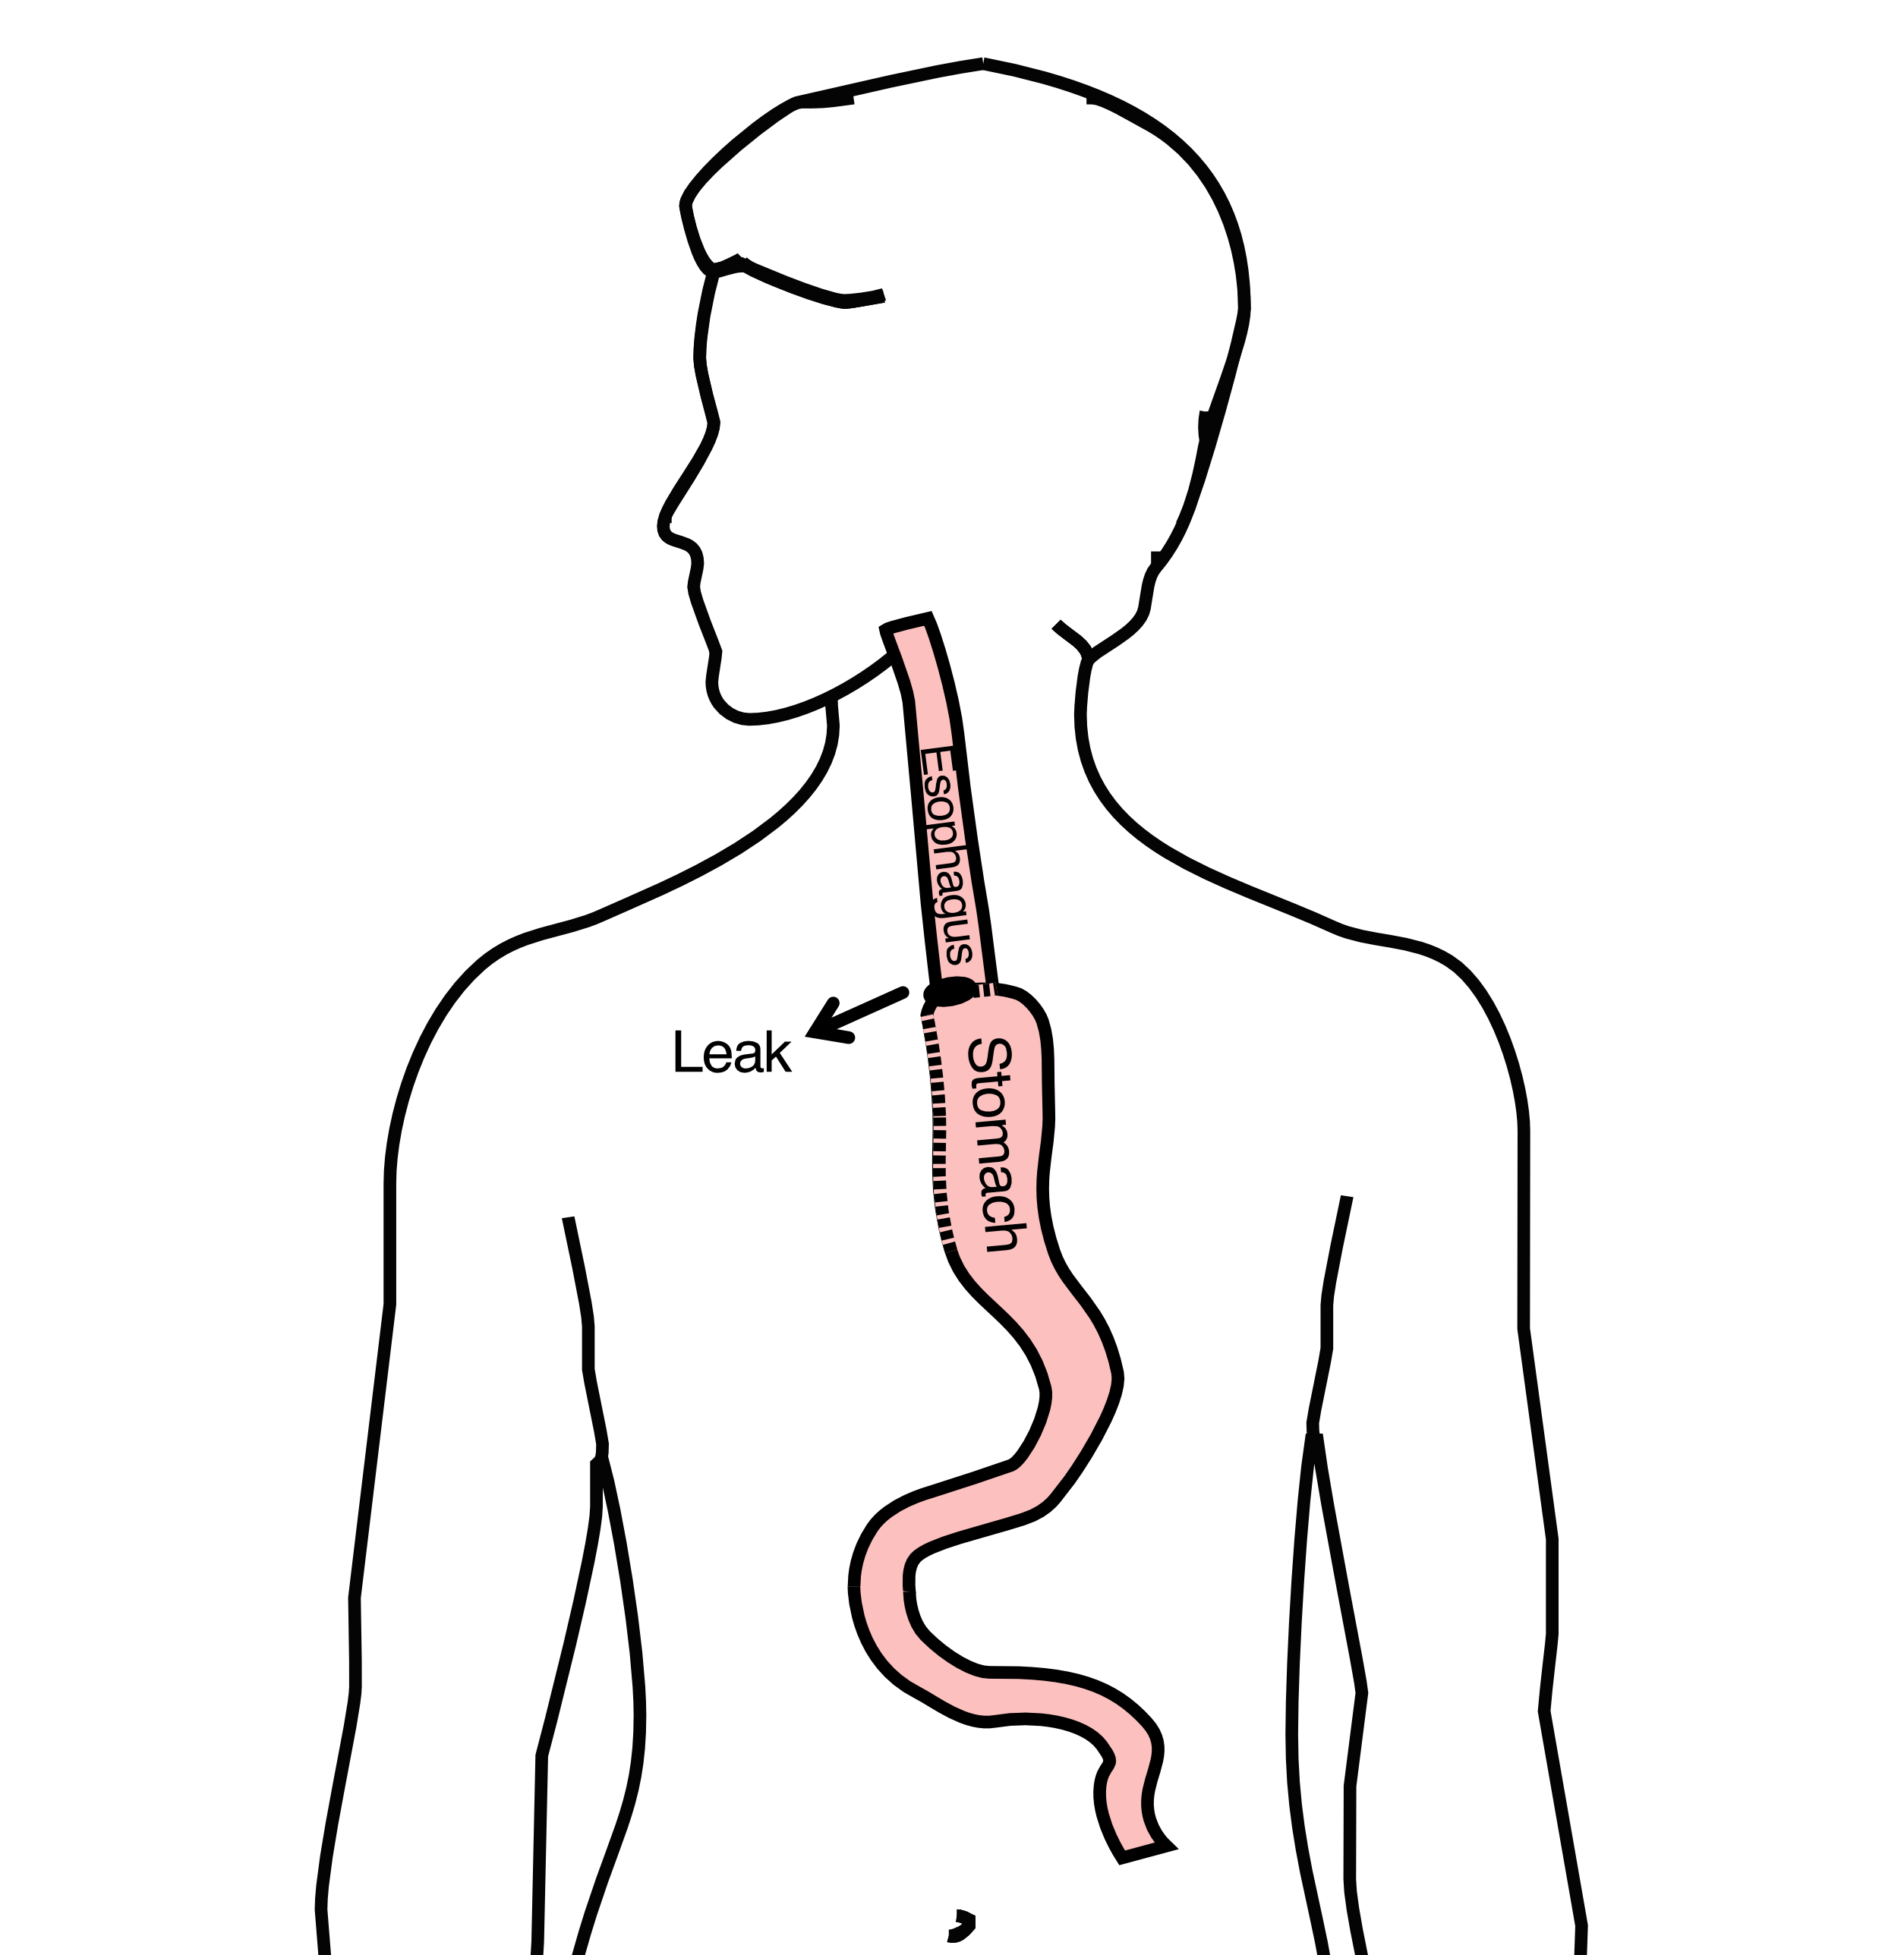

## 15 Anastomotic Leak

If leak occurs:

* Some leaks will seal
* Stent may be required to help healing
* Occasionally additional surgey is required



## 16 Anastomotic Leak

Risk of leak depends on:

* Type of operation performed
* Nutritional status of patient
* Experience of the surgeon



## 17 Pneumonia

* Occurs in 10-15% of patients after esophagectomy.
* Requires treatment with antibiotics
* Requires a longer hospitalization.

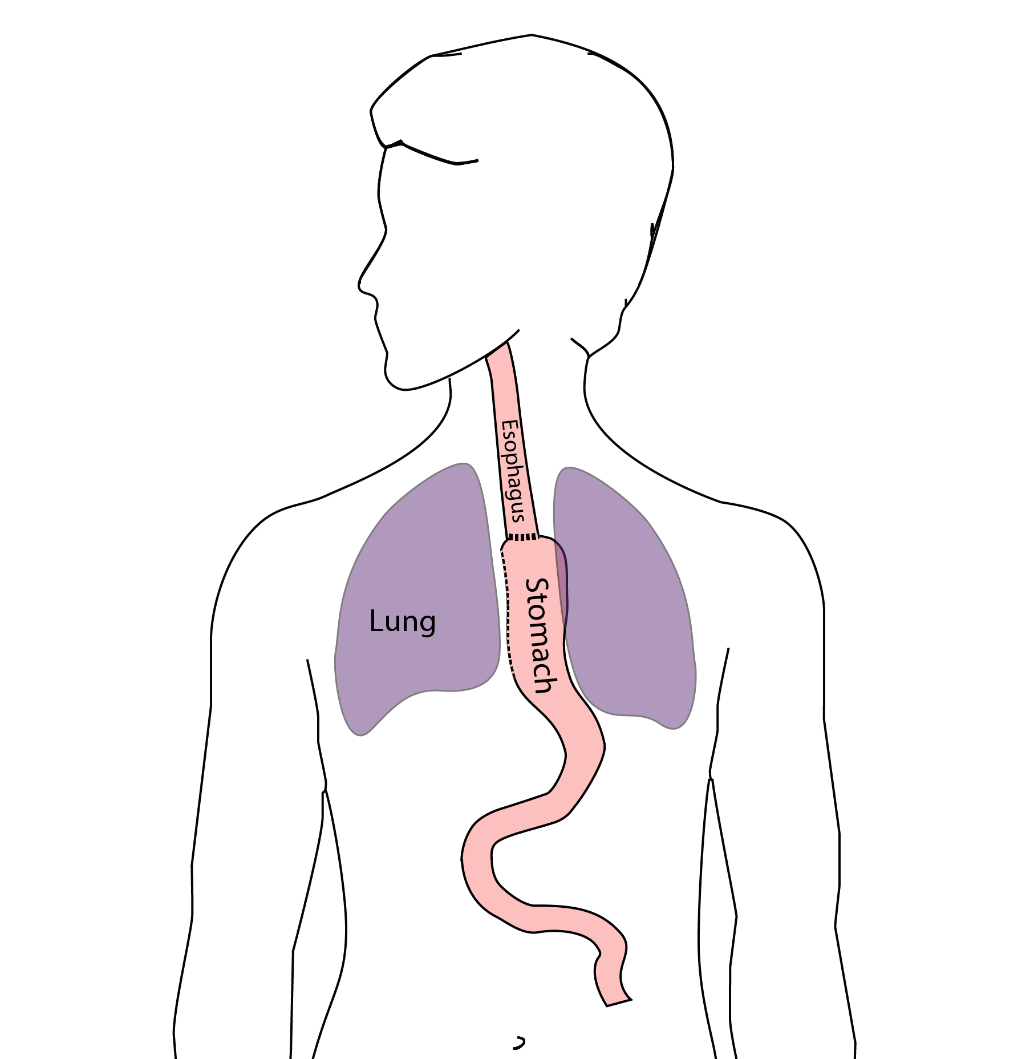

## 18 Preventing Pneumonia

Several ways to help prevent pneumonia:

* Deep breathing
* Coughing
* Walking

After surgery, this means:

* Sitting in a chair most of the day
* Walking in the halls as soon as possible

## 19 Minimally-invasive Esophagectomy

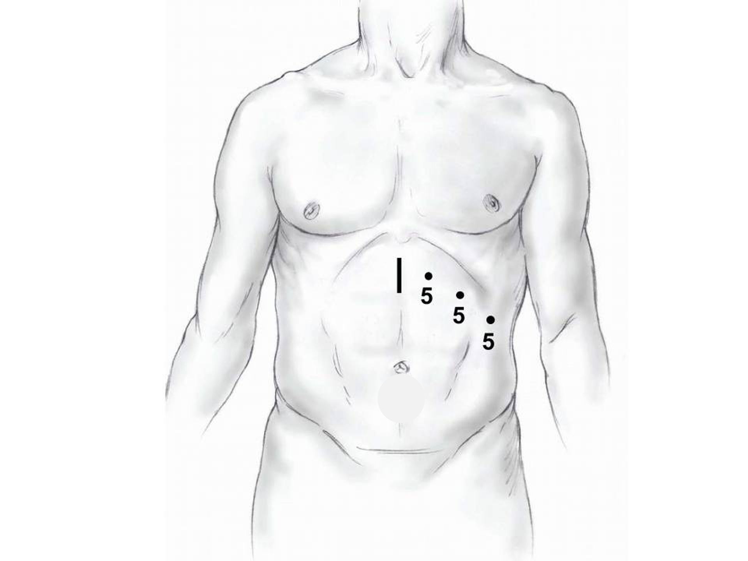

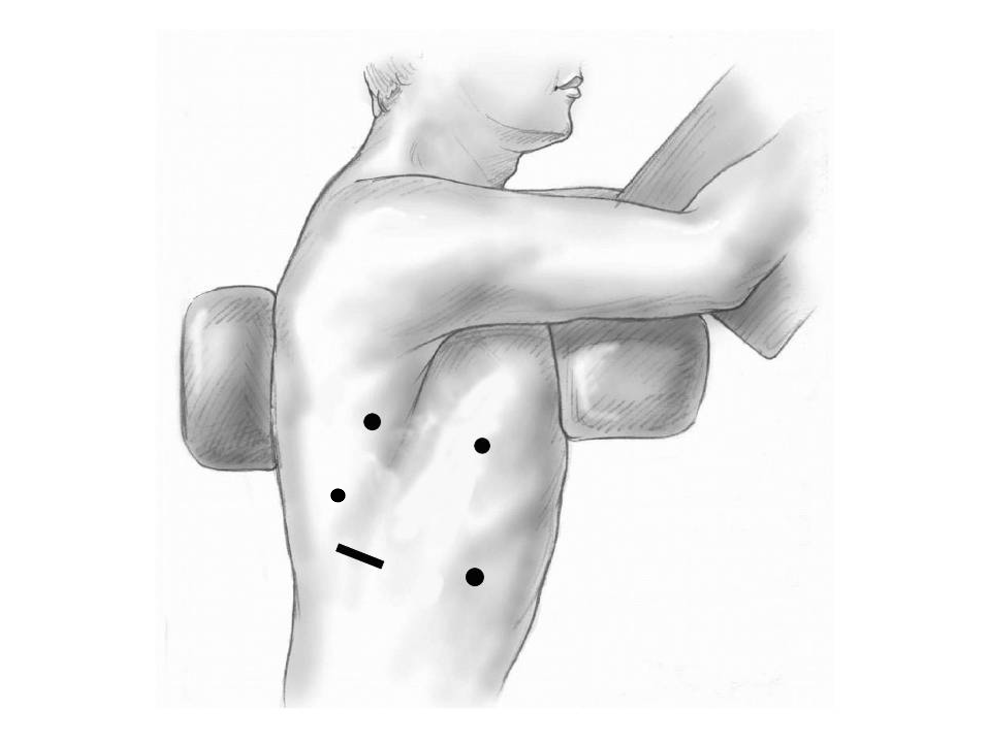

## 20 Risks of Surgery

Risks related to anesthesia

* Heart attack (5%)
* Irregular heart rhythm (15%)
* Pneumonia (10%)
* Blood clots in legs (<5%)
* Pulmonary embolism (2%)

## 21 Risks of Surgery

Risks related to Surgery

* Anastomotic leak (5%)
* Stricture at anastomosis (15%)
* Death within 90 days of surgery
  + Low risk patients = 2%
  + Intermediate risk = 10%
  + High risk = 30%

## 22 Risks of Surgery

Risks of Death within 90 Days of Surgery

|  | Age <75 | Age >75 |
| --- | --- | --- |
| Normal Muscle (75%) | 2% | 10% |
| Low Muscle (25%) | 10% | 30% |

## 23 Day Prior to Surgery

* Clear liquids for 24 hours prior to surgery
* Check with Pre-op nurse regarding medicines day prior to surgery
* No tube feedings the night before surgery

## 24 Day of Surgery

* Arrive at 5am – nothing to eat or drink after midnight.
* Medicines OK w/ a sip of water
* sip of black coffee but **no cream**.
* Surgery will be cancelled if you have cream/milk
* Waiting room for family and friends on 5th floor

## 25 Epidural Catheter for Pain Control

* Remains in place for 2-5 days
* Dosage can be adjusted as needed
* Can make it more difficult to urinate
* May require foley catheter in bladder
* Foley catheter removed after epidural removed

## 26 Intensive Care Unit (ICU) (2-4 days)

* Surgical ICU on 11th floor
* NG tube in nose to drain stomach and esophagus
* Catheter in bladder
* Chest tube right chest
* Abdominal drains (usually 2)
* Feeding jejunostomy (usually stays in 8 wks)

## 27 Intensive Care Unit (ICU)

* Bladder catheter removed → check that bladder empties properly
* Chest tube removed (day 2-4) → follow-up x-ray
* Fluid emptied from drains every few hours
* Start tube feedings by feeding
* Feeding jejunostomy (stays in 8 weeks)

## 28 Ward - 6Tower

* Jejunostomy feeds started
* Up in a chair most of the day
* Walking in the halls
  + Start with assistance
  + Improves lung function
  + Prevents loss of muscle strength

## 29 Jejunostomy Feeds

Jejunostomy tube feeds

* Start continuous (24 hours)
* Convert to night-time only (16 hours)

Water administered through feeding tube

* Usually 8oz 4 times/day
* Important to prevent dehydration

## 30 Jejunostomy Tube

## 31 Jejunostomy Typical Regimen

* Jejunostomy tube feeds for 16 hours (6pm-10am)
  + Men: 75mL/hour x 16 hours = 5 cartons
  + Women: 60mL/hour x 16 hours = 4 cartons
* Water 240ml (8oz) via syringe 4x/day

Hospital nurses will teach use of the feeding tube

## 32 Jejunostomy Feeds with Diabetes

Jejunostomy feedings elevate blood sugars

* Insulin may be required along with feeds

Typical Pattern for tube feeds

* Feeds run via pump from 6pm to 10am
* Insulin at 6pm (70/30 insulin)
* Insulin at Midnight (70/30 insulin)
* No insulin if tube feedings are not run

## 33 Jejunostomy Video

## 34 Activity after Surgery

* Up in chair most of the day
* Walking with help from nurse/Physical Therapist
* Goals:
  + Improve lung function
  + Prevent muscle loss

## 35 Nasogastric (NG) Tube

Tube passed through nose into stomach

* Drains fluid from stomach
* Prevents vomiting

Upper GI X-ray on 2nd or 3rd day after surgery

* If stomach empties well NG tube removed
* Otherwise, X-ray repeated 2-3 days later

## 36 Swallowing Evaluation

Once NG tube has been removed:

Modified barium swallow in radiology

* Drink a white chalky liquid (barium)
* Look for proper swallowing function
* 70% of patients liquids started by mouth

## 37 Oral Intake at Home

Most are taking protein shakes when they go home

Protein shakes are started after tolerating water

* 2 oz per hour to start
* 4 oz per hour if 2oz are tolerated well

## 38 Discharge

Goal: ready to leave day #6/7 after surgery

* Night-time tube feedings (6pm to 10am)
* Nutrition by mouth (70% of patients)
  + 1 oz of water per hour by mouth OR
  + Protein shakes 4oz every 2 hours
* Water through tube 8oz four times per day
* Home care nursing (feeding tube teaching)
* Home infusion (tube feeding supplies)

## 39 Nutrition after Surgery

At discharge home:

* Protein shakes 4oz every 2 hrs
* Tube feeds 4-5 cans at night (6pm-10am)

10-12 Days: Increase protein shakes

* Tube feeds 3-4 cans at night

Three weeks: Post-esophagectomy Diet

8-12 weeks: Remove feeding tube (in office)

## 40 Transition from Tube Feeds Eating

Dietitian will calculate daily protein goal

* Typically 60-75 grams protein/day
* Each carton of tube feeding has 15 grams
  + 75 grams protein = 5 cartons/night
* More intake by mouth tube feeds reduced

Spread out protein during the day (20gm/meal)

* Three meals + 2-3 high-protein snacks

## 41 Post-esophagectomy Diet

* Soft Consistency
* High Protein
* Avoid sugary liquids (can cause ‘dumping’)
* Avoid raw vegetables (and salads)
* Eating
  + Small, frequent meals
  + Sit up for 30-45 minutes after eating
  + Avoid eating within 2 hours of bedtime

## 42 Medicines at Home - Pain

Acetaminophen (Tylenol) 1000mg 4x/day

Gabapentin 300mg 3 times/day

Oxycodone

* As needed in addition to Tylenol/gabapentin
* Will begin reducing dose at first postop visit
* Can usually discontinue by 4 weeks
* NO DRIVING WHILE ON OXYCODONE

## 43 Non-steroidals Anti Inflammatory (NSAID)

Non-steroidal anti-inflammatories (Celebrex)

* 200 mg every 12 hours starting at 2 weeks

NO GOODY POWDERS OR BCs

* (Can cause permanent scarring at the surgery site)

## 44 Acid Blockers = Proton Pump Inhibitors

Examples include ompeprazole and pantoprazole

* Will stay on for at 1-2 years to prevent acid reflux
* Important in preventing scarring at anastomosis (new connection between esophagus and stomach)
* To administer through feeding tube, open capsule and resuspend beads in 60mL (2oz) of water

## 45 Medicines at Home

Reglan – Helps stomach empty

* Will plan to stop after six weeks
* 0.1% risk of tardive dyskinesia (nervous tic)

Remeron – Helps improve appetite

* Can cause vivid dreams
* Used for several weeks after surgery
* Will stop within first three months of surgery

## 46 Metoprolol = Beta Blockers

* Slows heart rate and lowers blood pressure
* Used to prevent rapid heart rate
* Patients not taking a beta blocker prior to surgery wean after after surgery
* Patients taking a beta blockerprior to surgery return to prior dose and drug after surgery

## 47 Sleeping at Home

Reflux can occur the first few weeks/months after surgery

This improves over the first few months

A wedge pillow can be helpful for sleep

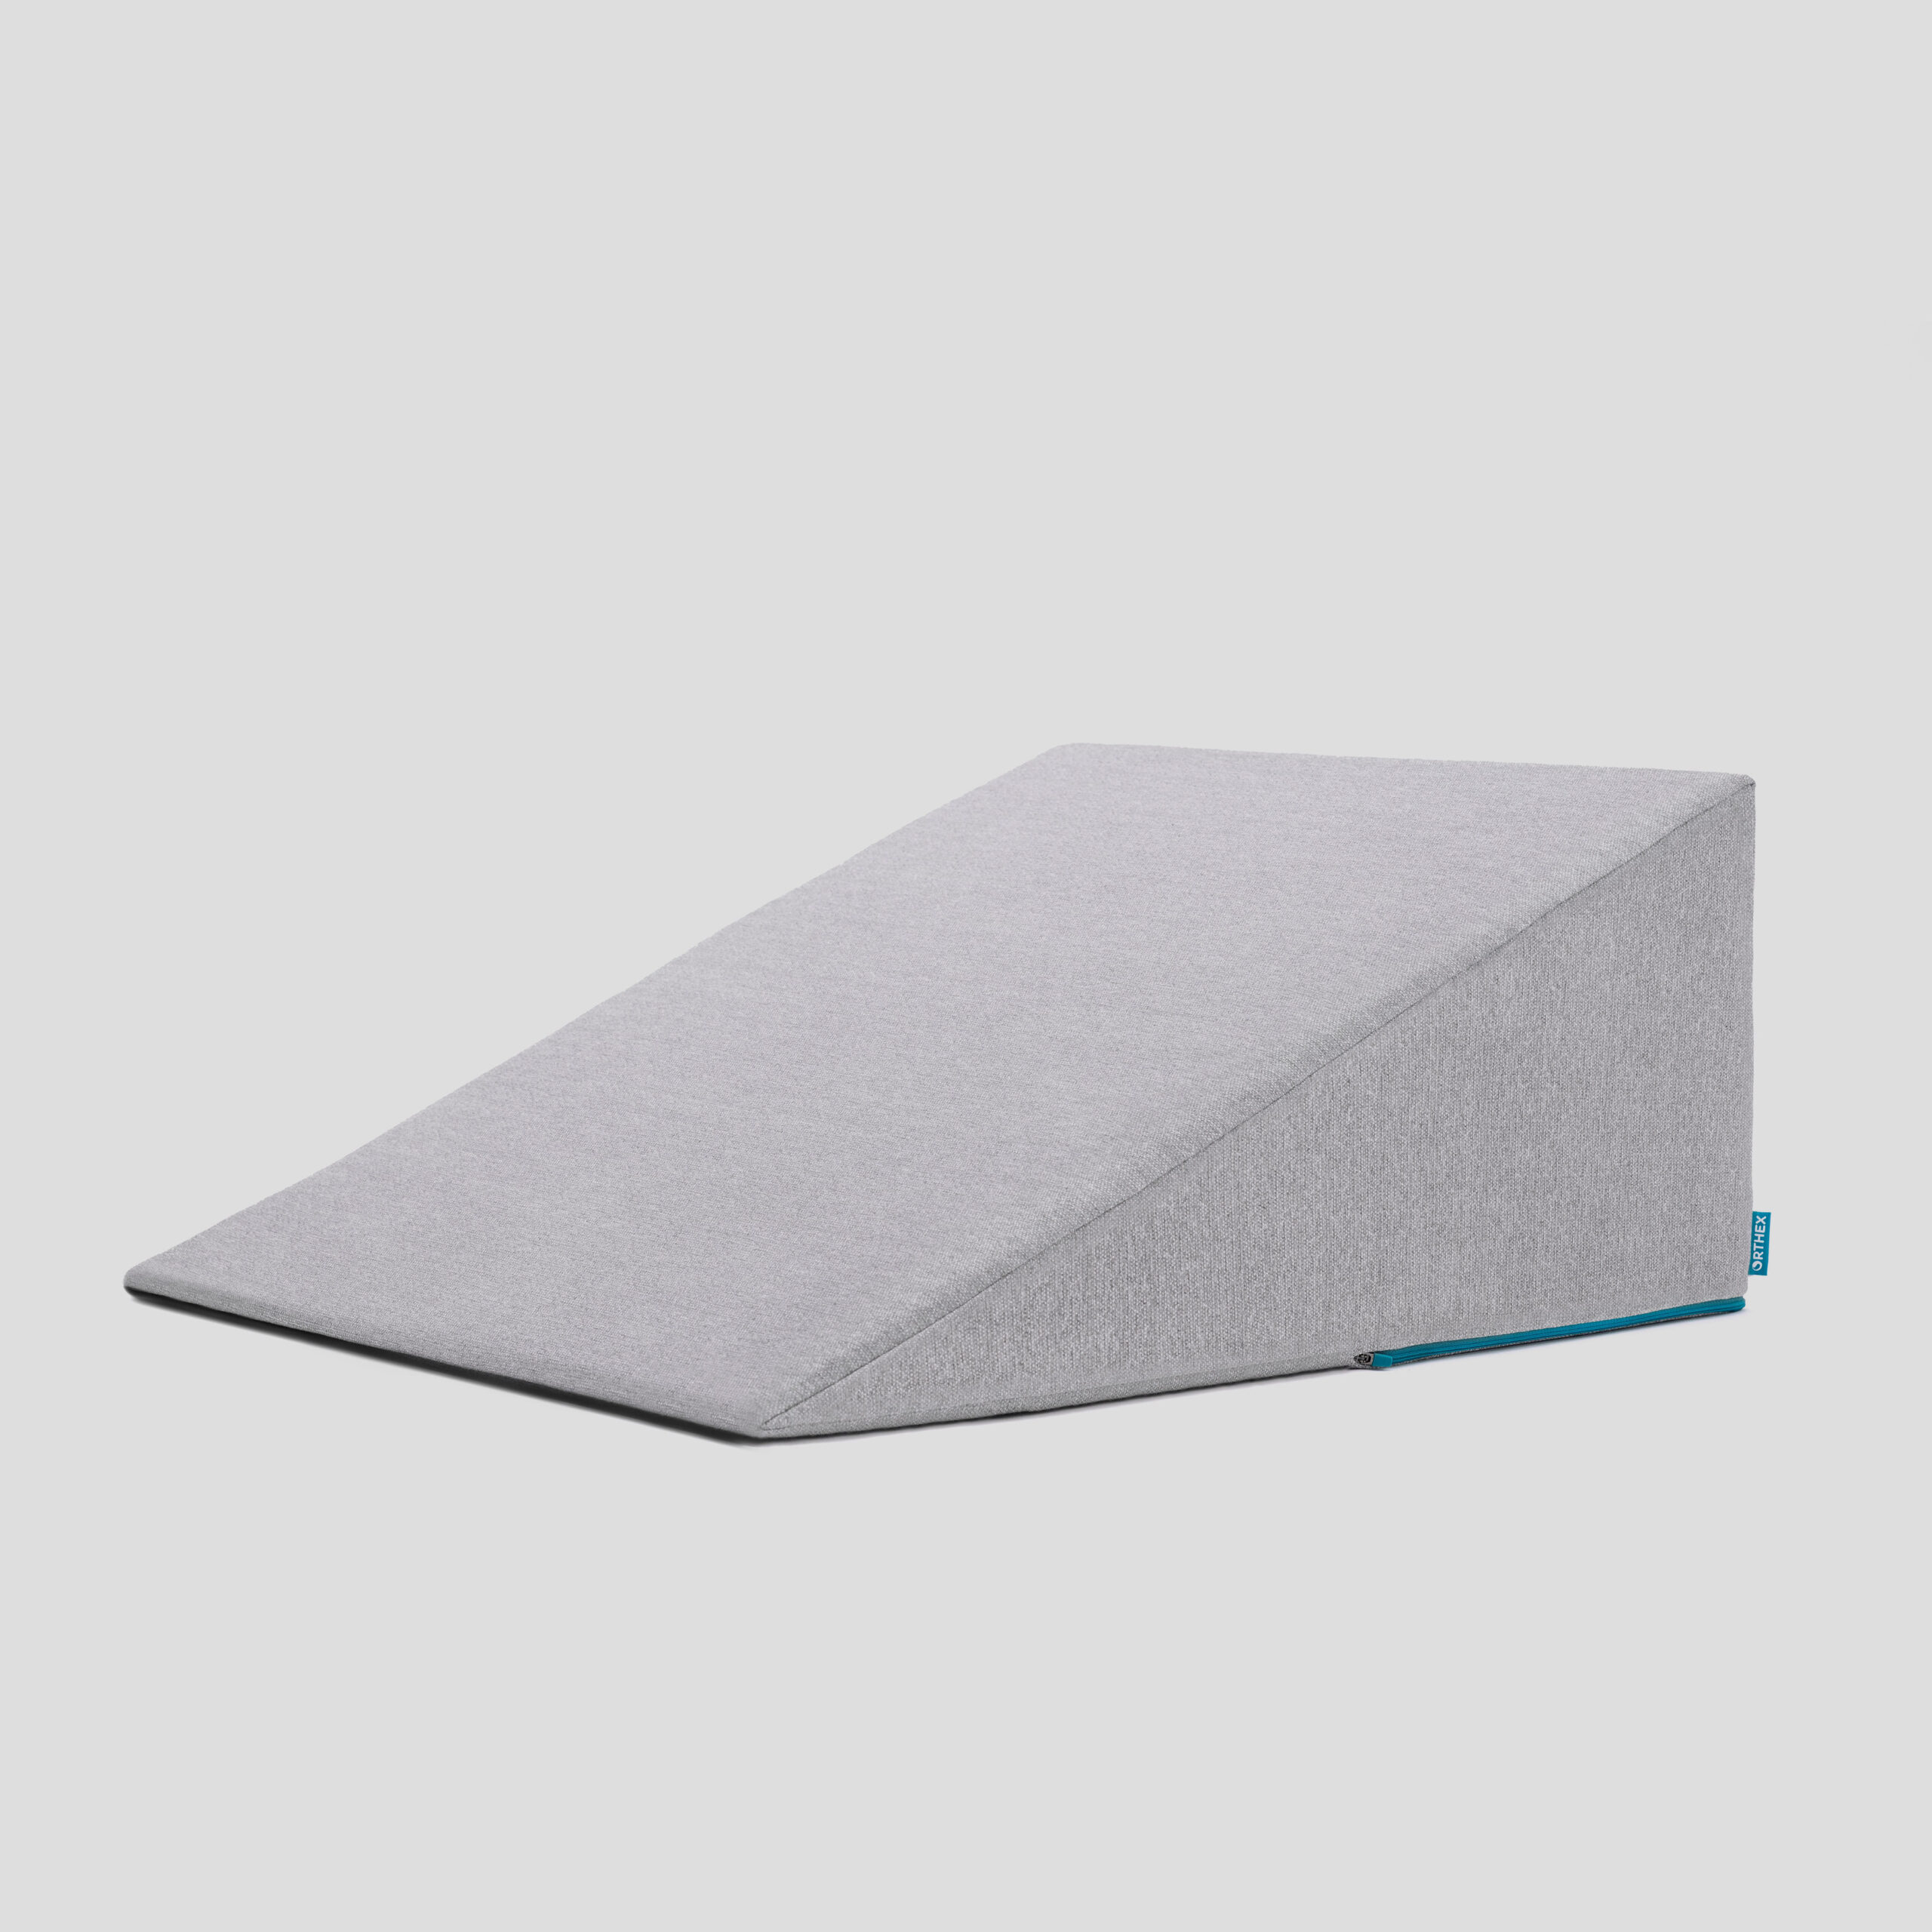

## 48 Postoperative Visit at 7-10 Days

Check surgical site

* Remove staples (if needed)

Adjust medicines as needed

* Insulin (for diabetic patients on insulin)
* Reduce beta blocker medicines

Advance diet

Reduce tube feeds

## 49 After surgery

Wean off medicines added after surgery

* Pain medicines
* Beta-blockers
* Reglan and Remeron

Continue acid blockers for at least 1 year

## 50 Jejunostomy Removal

Jejunostomy tube is removed in the office once you can take in enough nutrients by mouth

Removal usually around 8 weeks after surgery

May take 30 minutes and some local anesthetic to loosen up the tube for removal.

## 51 Nutritional Monitoring after Surgery

You may have difficulty absorbing some nutrients:

* Iron
* Vitamin B12
* Vitamin D

## 52 Nutritional Monitoring after Surgery

About 3 months after the jejunostomy tube is removed, we will check blood levels:

* Iron (ferritin)
* Vitamin B12
* Vitamin D

## 53 Nutritional Replacements after Surgery

Vitamin or iron replacements can be ordered by:

* Primary Care Provider (PCP)
* Medical Oncologist
* Surgeon

If levels are low

* Replacement
* Repeat testing in 3-6 months

## 54 Team Members - Physicians

Primary Care Provider

Gastroenterologist

Medical Oncologist (chemotherapy)

Radiation Oncologist (radiation)

Surgeons

* Jonathan Salo
* Jeffrey Hagen
* Michael Roach

## 55 Team Members - Support Staff

Dietitian - Liz Koch

Nurses - Brandon Galloway - Kit Sluder - Sarah Ezell - Rebecca Wicks

Navigator - Laura Swift

## 56 Day Prior to Surgery

* Clear liquids for dinner evening prior
* You will receive instructions regarding medicines

## 57 Day of Surgery

Unless instructed otherwise:

* You will be notified regarding *arrival* time, which is usually 2-3 hours before the *surgery* time.
* Nothing to eat or drink after midnight

## 58 Medicines the Day of Surgery

* Medicines with a sip of water or *black* coffee
* No milk or cream
* Surgery will be cancelled for milk/cream